Components of Neutrophil Extracellular Traps and their Origin
I. Introduction
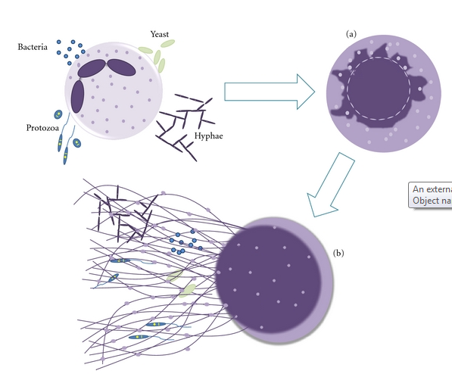
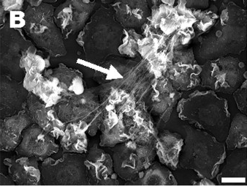
The body’s immune system, although extensively researched, is still not fully understood even as advanced as medical technology and research is today. The immune system is the body’s first line of defense against microbes, pathogens, and bacteria that attempt to invade and wreak havoc from within. In an effort to combat these antigens, neutrophils are sent to seek out and kill them. Neutrophils are the most abundant type of white blood cell and arguably the most viable in the immune system seeing as how they are the body’s first line of defense. Usually neutrophils kill bacteria via phagocytosis, by swallowing it up, but in just the past decade a new development in the structure of neutrophils has been observed, neutrophil extracellular traps. These neutrophil extracellular traps (NETs) were first observed and discovered in 2004, by Brinkman et al. where stimulated neutrophils were shown to release a DNA web structure containing several antimicrobial factors and enzymes (Figure 1)¹. Since then NETs have been shown as a secondary structure to capture bacteria² and play roles in autoimmune diseases, inflammation, and even cancer.³ In addition to neutrophils; macrophages/monocytes, mast cells, and eosinophils can produce extracellular traps (ETs).^{4,5} These leukocytes go through a process called ETosis where the cell dies and releases a series of DNA ETs. NETosis (Figure 2)⁶ can be triggered by synthetic and physiological molecules to release NETs, here are just a few in a long list (Figure 3).⁶
Figure 1: Electron microscope view of stimulated neutrophils producing NETs
Although NETs and ETs have been in involved in a wide range of experiments, there is still little to be known about where some of the enzymes in NETs derive from and the pathway that forms them. To discern what effects the neutrophils’ ability to produce NETs, Fuchs et al. (2007), exposed neutrophils to different bacteria and stimulation methods to produce NETs.⁷ First, NET formation was observed after neutrophils were dyed with a die that turns the cytoplasm of living cells blue and is lost after they die, which would indicate that the neutrophil dies in the process of NETosis.⁸ (Videos can also be viewed to visualize the process). Neutrophils were stimulated by phorbol myristate acetate (PMA) making the neutrophils activate every protein at its disposal, and viewed to see how long it took to produce NETs. The authors concluded that neutrophils only extended NETs when the cell was dying and after the cell membrane had been ruptured confirming the theory that NETosis kills the neutrophil. However, NETs were not formed when neutrophils went through regulated cell death or if they were already dead, meaning that NETosis is a different form of cell death. Next, to determine what specifically induced NETosis, Fuchs et al. referenced previous works that had determined two things needed to happen to activate neutrophils in the immune system. First NADPH oxidase had to bind to the cell membrane of neutrophils and transfer electrons to oxygen in the neutrophil so that it could make reactive oxygen species (ROS) like hydrogen peroxide.⁹ Then granules, small particles, interfused with the neutrophil resulting in the release of its antimicrobial factors and enzymes.¹⁰
Figure 2 shows a drawing of NETosis
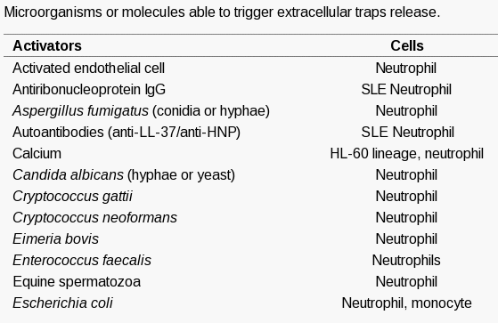
The combination of these two methods is what makes neutrophils so detrimental to bacteria. It was thought that ROS factors played an important role in the formation of NETs so the authors then used neutrophils from CGD (chronic granulomatous disease) patients and tried the same experiment. CGD patients are known to have mutations in NADPH oxidase and have a deficiency in the immune system.¹¹ Neutrophils were not able to produce NETs or induce NETosis due to the inability to produce ROS factors. Knowing this information, it was deduced that NADPH oxidase was an underlying regulator for NETosis, but the entire pathway is still unknown. Inhibiting factors for the production of NETosis would allow for experimentation to observe if all antimicrobial factors associated with neutrophils actually derive from them.
Figure 3: List of several physiological and synthetic molecules that can induce NETosis
In the ongoing process to distinguish how NETs work and what factors associate with them, Urban et al. (2009), experimented with NETs to discern what some of these factors may be. After stimulating neutrophils with PMA, and washing them to remove unbound proteins, they were able to find 24 different proteins and antimicrobial factors to be associated with NETs¹⁵, but what’s more important is what they did not find. Even after staining NETs, pentraxin3 (PTX-3) and cathelicidin (CAP-18), known proteins to associate with neutrophils could not be found. No matter how many times the neutrophils were stained or washed, these proteins did not appear in their results. To determine more about NETs and their origin, this proposal will incorporate strategies to manipulate neutrophil functions and test to see if all antimicrobial factors, proteins, and DNA actually derive from neutrophils.

II. Experiment
II.A. Summary
Neutrophils do not have the capability to produce all of the antimicrobial components or proteins necessary to fight off infection alone, instead they are obtained from a different source such as other leukocytes. The strategy used to test this will involve using 3 controls of mice in which 2, inflammation has been induced; a positive control where all neutrophils will have mutations of NADPH oxidase, a negative control in which neutrophils will be uninhibited, and a control that will undergo a sham surgery. The mice will then be injected with traceable neutrophils respectable to their strain that will travel to the infection site to produce NETs by NETosis or remain unstimulated. After this has been observed, mice will be euthanized then enzymatic activity and histology reports will be conducted on tissue samples from the trauma site to determine the results.
II.B. Inducing an Inflammatory Reaction
To cause an inflammatory reaction in mice strains SJL¹⁶ and JAX¹⁷ that will be known to stimulate neutrophils to produce NETs, a lipopolysaccharide will be sub-dermally implanted into each mouse. Lipopolysaccharides (LPS) have been proven by Brinkman et al. (2004) to induce inflammation severe enough to cause NETosis.¹ LPS derive from the membranes of Gram-negative bacteria, and once detected by the immune system will simulate the body into thinking there is a bacterial infection and order neutrophils be sent to the infectious site to combat it.
II.C. Culturing Mice Strains to Radioactively Label DNA and Proteins
For this strategy to work, the two mice strains SJL and JAX will need to culture neutrophils with radioactively labeled proteins. The JAX strain of mice is described to have mutations of NADPH oxidase; therefore the neutrophils will not be able to produce ROS factors to produce NETs. In contrast, SJL mice have no mutations and neutrophils will therefore be uninhibited. Both mice strains will be given daily injections of radioactive [³⁵S] methionine via the tail vein so that all new proteins created by the mouse will be labeled.¹⁸ Mice will also have the DNA of their neutrophils labeled by an injection of bromodeoxyuridine (BrdU) vectors prior to introducing them to the experimental mice. BrdU will replace thiamine in the DNA of the neutrophils without causing any detrimental effects to cellular or protein function.
II.D. Isolating Neutrophils
About 0.5 mL of blood will be taken from both SJL and JAX strains with radioactive neutrophils and the neutrophil isolation protocol is to be followed.¹³
- All materials are to be brought to room temperature.
- Put 1.65 mL of neutrophil isolation media in a centrifuge tube and layer 0.5 mL of blood over the media.
- Centrifuge
- This will result in 6 density layers, remove the top 3 layers and dispose
- Remove the neutrophils (4th layer) and the layer of isolation media below into a new centrifuge tube.
- Dilute the new solution with 3 mL of Hanks Buffer Salt Solution (HBSS) that does not have calcium or magnesium in it, and invert so the cells are suspended.
- Centrifuge
- Add 0.5 mL of Red Cell Lysis Buffer so that any remaining red blood cells are destroyed, and then mix the solution.
- Centrifuge and then remove any lysed red cells
- Add 500µL of the same HBSS solution and mix, dilute the solution to 3 mL.
- Centrifuge and remove any unwanted cells.
- Resuspend in 250µl of HBSS with calcium and magnesium.
II.E. His-Tagging Genes in Neutrophils
The method of polyhistidine-tagging (His-tag) genes in neutrophils will be implemented after neutrophils have been isolated. His-tagging will have an end result of adding a unique amino acid motif at either the N or C termini of the protein it is tagging. To execute this strategy, the DNA sequence that codes for each of the 4 proteins to be measured (Lactoferrin, Myeloperoxidase, Cathelicidin, and Pentraxin 3) needs to be determined. Next a DNA primer sequences that code for these proteins – His-tag conjugates will be multiplied into double stranded DNA by simple PCR. (Example²⁰) Following PCR the genes will then cloned into an expression vector. Expression vectors can be purchased so they will not have to be created in house. Antibodies that correlate to these His-tags will be used to attach fluorescent fluorophores to the His-tag so that they can be observed through a fluorescent microscope.
II.E. Tracking Neutrophils in vivo
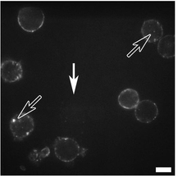
A non-invasive method for tracking neutrophils will be used as to not cause any additional inflammation than previously described. To do this Quantum Dots (QD) will be conjugated with an anti-body specific to the cell membrane of neutrophils. Doing this will cause the QD – antibodies to bind to only neutrophils of the mice and avoid tracking any other leukocytes and contaminate results. The QD – antibodies will be engulfed into the membrane and show a bright white dot when viewed by a high power laser (Figure 4).¹⁴ The antibody used will be anti-Ly6G, it specifically bonds to a protein (Gr-1) in neutrophil granulocytes making it an exceptional marker. Both the neutrophils and QD – antibodies will be injected via the tail vein. The neutrophils can be viewed using the high intensity laser described by Fig5 and will look something like (Figure 5).¹⁴
Figure 5 shows how the neutrophils can be viewed without having to disturb the mouse
Figure 4 displays neutrophils with QDs to identify them
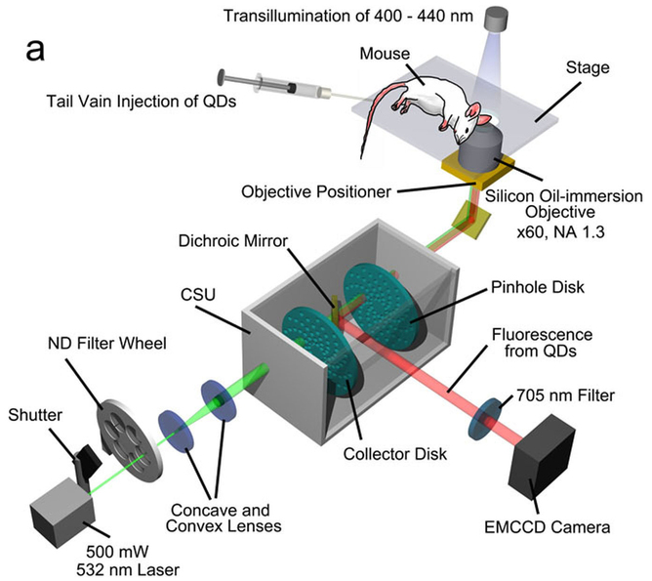
II.F. Measuring Enzymatic Activity
Tissue samples are to be taken from the inflammation sites of the mice and have Dnase₋₁ added solubilize unbound proteins, NET bound proteins and cell remains respectively. These three mediums will be separated and tested separately.¹⁷ ELISA kits will be used to mark proteins that are to have their enzymatic activity measured; therefore ELISA kits for the 4 proteins will be purchased and the Sandwich ELISA protocol followed. Each protocol is the same; a plate is coated with capture antibody, sample is added, and any antigen binds to the capture antibody, the detecting antibody is added and binds to the antigen, then the secondary enzyme-linked antibody is added and binds to the detecting antibody, finally the substrate is added and converted by the enzyme to a detectable form. Each of the kits contains a substrate that will be specific to said proteins, so only proteins that can catalyze the reaction will be detected and measured. Fluorescence assays will measure the difference of fluorescent light of the proteins absorbed from the substrates. The radiometric assay will measure how much radioactivity is incorporated into the substrate from the protein. Results from this coupled assay will provide a ratio of radioactive enzymatic activity versus total fluorescent enzymatic activity. (REA:FEA)
II.G. Immunofluorescence Staining of Tissue
To detect NET structures, antimicrobial proteins, DNA, and neutrophil DNA will be labeled. Antibodies containing fluorophores (chemical compound that can re-emit light upon excitation) will be used to attach to the His-tags of proteins and allow them to be viewed under a fluorescent microscope. Neutrophil histones can also be detected in this fashion by purchasing PicoGreen⁷ and incorporating it into the sample. When tissue samples are taken from the inflammation site they will first be dehydrated and sliced into 5µm samples. Next, they will be rehydrated and stained with hematoxylin and eosin. Hematoxylin binds to and colors DNA in samples while eosin binds to eosinophilic like structures (neutrophils/NETs) and allow them to be viewed. Lastly, the following proteins and molecules will be fluorescently labeled:
- Neutrophil DNA
- Lactoferrin
- Myeloperoxidase (MPO)
- Cathelicidin
- Pentraxin 3
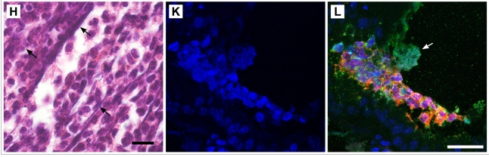
All of these molecules are known to be associated with neutrophils and NETs but have not always been found in the structure for studies in vitro.¹⁵ Methods for staining these molecules involves using rabbit antibodies, because they contain similar DNA strands and will effectively bind to the molecules. Doing a histology report combined with these methods will aid in determining the results. (Figure 7)¹⁵
Figure 7: What immunofluorescence staining looks like for epithelium of mice lungs. L shows NET structures and the staining of several proteins and molecules

III. Discussion
III.A. Desired Results
This research strategy is designed to yield obvious evidence of NETs in the histology reports of the inflammation areas of only one of the mice. The other should only show neutrophils and no NETs due to mutated NADPH oxidase being unable to produce ROS factors and stimulate neutrophils. If neutrophils do not contain all the required components they need for NET structures, there should be evidence of fluorescently labeled, but not radioactively labeled protein in NETs than in the inhibited neutrophils. Furthermore, the ratio of REA:FEA would show a higher value for FEA than REA suggesting that there are non-radioactive proteins attached to the DNA structure and did not originally derive from the neutrophil. The DNA webs that consist of these antimicrobial factors would only be stained with hematoxylin and any overlapping staining of neutrophil DNA would not be evident.

III.B. Potential Pitfalls and Alternative Approaches
If evidence suggests that the neutrophils contain every single factor they need for NETs then the REA:FEA ratio would be about 1:1. Inhibited neutrophils, when stained, should contain all the same proteins as the stimulated ones. In addition, histology reports would display that these proteins are local to neutrophils and indeed derive from neutrophils and not obtained by other means. Experiments should be run in vitro with blood samples and stimulated neutrophils to confirm they are unassisted by other leukocytes, then it could be concluded to state they have all the materials they need to fight antigens. Either way the world will be one step closer in discerning how these cells work and the mysteries behind them.
The problem is that there needs to be some way to track the neutrophils in vivo without causing any more harm to the mice, so if the non-invasive method does not work and it cannot be determined when/if neutrophils arrive at the inflammation site then there will be no way of knowing if they are even involved in the process other than previous research. If non-invasive tracking proves inconclusive then other means of tracking maybe implemented. This is why mice are grown up with labeled neutrophils. Blood samples can be taken from different sites on the body, including the inflammation spot, and measured for radioactivity to see if the labeled neutrophils are present.
Neutrophils that are being injected from one healthy mouse to an infected one may be rejected since they are not the own host’s cells. If this happens then neutrophils would have to be taken from the same mouse prior to surgery. The trouble with this is that neutrophils have a short lifespan and would have to be taken while the mice are still healthy and prior to sub-dermally implanting LPS. Then it would be required to wait for a reaction to occur and that could be as long as a few days after implantation. Another way of culturing labeled DNA and proteins would have to implemented, and by this time, the neutrophils lifespan is cut short and tracking may become obsolete. The neutrophils would have to be frozen or taken from a close relative to see if they were accepted into the host allowing for optimal results.
Staining may also produce results that are hard to determine since the hematoxylin and eosin mark everything and not just neutrophils and NETs. These cells may not even be at the cultured sample site and nothing may show up. If so, then considering taking tissue and blood samples from other sites may be required to see if NETs are produced could be a viable option. However, this would suggest that neutrophils can be stimulated by other means than by directly coming into contact with an antigen which would provide for more testing in the future.
Other leukocytes may play a role in an inflammatory reaction such as this and should be tracked and observed to see if they produce ETs in the same circumstances. Alternatively neutrophils may gain different proteins or molecules from other leukocytes rather than themselves. If this is not the case, then further experimentation and explanation of why some antimicrobial factors are not found but claim to associate with neutrophils needs to occur.

References

- Brinkmann V., Reichard U., Goosmann C., Fauler B., Uhlemann Y., Weiss D. S., et al. (2004).Neutrophil extracellular traps kill bacteria. Science 303, 1532–1535.10.1126/science.1092385 http://www.ncbi.nlm.nih.gov/pubmed/15001782

- McDonald B, Urrutia R, Yipp BG, Jenne CN, Kubes P. Intravascular neutrophil extracellular traps capture bacteria from the bloodstream during sepsis. Cell Host Microbe. 2012;12(3):324–333. doi: 10.1016/j.chom.2012.06.011. http://www.ncbi.nlm.nih.gov/pubmed/22980329

- Radic M, Kaplan J. M, Extracellular traps interconnect cell biology, microbiology, and immunology. Front Immunol. 2013; 4: 160. http://www.ncbi.nlm.nih.gov/pmc/articles/PMC3690543/

- von Köckritz-Blickwede M, Goldmann O, Thulin P, Heinemann K, Norrby-Teglund A, Rohde M, Medina E. Phagocytosis-independent antimicrobial activity of mast cells by means of extracellular trap formation. Blood. 2008 Mar 15; 111(6):3070-80. http://www.ncbi.nlm.nih.gov/pubmed/18182576/

- Yousefi S, Gold JA, Andina N, Lee JJ, Kelly AM, Kozlowski E, Schmid I, Straumann A, Reichenbach J, Gleich GJ, Simon HU. Catapult-like release of mitochondrial DNA by eosinophils contributes to antibacterial defense. Nat Med. 2008 Sep; 14(9):949-53 http://www.ncbi.nlm.nih.gov/pubmed/18690244/

- Guimarães-Costa A.B., Nascimento M.T., Wardini A.B., Pinto-da-Silva L.H., Saraiva E.M. ETosis: A Microbicidal Mechanism beyond Cell Death. J. Parasitol. Res. 2012;2012:929743. http://www.ncbi.nlm.nih.gov/pubmed/22536481/?ncbi_mmode=std

- Fuchs TA, Abed U, Goosmann C, et al. Novel cell death program leads to neutrophil extracellular traps. Journal of Cell Biology. 2007;176(2):231–241. http://www.ncbi.nlm.nih.gov/pubmed/17210947/

- http://www.jcb.org/cgi/content/full/jcb.200606027/DC1 (Videos must be viewed in FireFox Browser) Losman, M.J., T.M. Fasy, K.E. Novick, and M. Monestier. 1992. Monoclonal autoantibodies to subnucleosomes from a MRL/Mp(-)+/+ mouse. Oligoclonality of the antibody response and recognition of a determinant composed of histones H2A, H2B, and DNA. J. Immunol.148:1561–1569. http://www.ncbi.nlm.nih.gov/pubmed/1371530/

- Hampton, M.B., A.J. Kettle, and C.C. Winterbourn. 1998. Inside the neutrophil phagosome: oxidants, myeloperoxidase, and bacterial killing. Blood. 92:3007–3017. http://www.ncbi.nlm.nih.gov/pubmed/9787133

- Klebanoff, S.J. 1999. Oxygen metabolites from phagocytes. InJ.I. Gallin and R. Snyderman, editors. Inflammation: Basic Principles and Clinical Correlates. Lippincott Williams & Wilkins, Philadelphia. 721–768 pp.

- Heyworth, P.G., A.R. Cross, and J.T. Curnutte. 2003. Chronic granulomatous disease. Curr. Opin. Immunol.15:578–584. http://www.ncbi.nlm.nih.gov/pubmed/14499268

- Wang Y, Li M, Stadler S, Correll S, Li P, et al. Histone hypercitrullination mediates chromatin decondensation and neutrophil extracellular trap formation. J Cell Biol. 2009;184:205–213. http://www.ncbi.nlm.nih.gov/pmc/articles/PMC2654299/

- Oh, H., Siano, B., Diamond, S. Neutrophil Isolation Protocol. J. Vis. Exp. (17), e745, doi:10.3791/745 (2008). http://www.jove.com/video/745/neutrophil-isolation-protocol?ID=745

- Kikushima, Kenji, Kita, Sayaka, Higuchi, Hideo. A non-invasive imaging for the in vivo tracking of high-speed vesicle transport in mouse neutrophils. Sci. Rep. 2013/05/31/online. http://www.nature.com/srep/2013/130530/srep01913/full/srep01913.html#ref7

- Urban CF, Ermert D, Schmid M, Abu-Abed U, Goosmann C, et al. Neutrophil extracellular traps contain calprotectin, a cytosolic protein complex involved in host defense against Candida albicans.PLoS Pathog. 2009;5:e1000639 http://www.ncbi.nlm.nih.gov/pubmed/19876394/

- Ermert D, Urban CF, Laube B, Goosmann C, Zychlinsky A, et al. (2009) Mouse neutrophil extracellular traps in microbial infections. J Innate Immun 1: 181–193. http://www.ncbi.nlm.nih.gov/pubmed/20375576

- http://jaxmice.jax.org/strain/010606.html

- Tarver H, Reinhardt W. O. (1947). Methionine labeled with radioactive sulfur as an indicator of protein formation in the hepatectomized dog. J. Biol. Chem. 1947, 167:395-400. http://www.jbc.org/content/167/2/395.full.pdf

- Klempt M, Melkonyan H, Nacken W, Wiesmann D, Holtkemper U, et al. The heterodimer of the Ca2+-binding proteins MRP8 and MRP14 binds to arachidonic acid. FEBS Lett. 1997;408:81–84. http://www.ncbi.nlm.nih.gov/pubmed/9180273/

