Michael Vuong
BNFO 300
Proposal

Introduction:
Alcohol is a commonly abused substance among humans that presents a variety of social and health problems. Health problems of alcohol use disorder include greater risk of certain cancers, weakened immune system, heart disorders, and damage to the central nervous system (Morozova et al. (2006)). According to the National Institute on Alcohol Abuse and Alcoholism (NIAAA), an estimated 18 million people in the United States have an alcohol disorder in the form of abuse or dependence (National Institute on Alcohol Abuse and Alcoholism of the National Institutes of Health).
While previous studies have shown that genetic and environmental factors can predispose humans to behavioral responses, such as alcohol abuse, sensitivity, and tolerance, the actual genes and the mechanisms underlying these behavioral responses are largely unknown (Kong et al. (2010)). There are only a handful of genes that hold established roles in human alcohol disorders. Therefore, it is crucial to identify these genes and understand how they function in response to alcohol exposure in order to develop therapeutic treatments targeted at molecular/genetic level factors for people with alcohol disorder.
Since genetic and molecular pathway investigations are difficult to perform in human population due to the widespread variety of the genetic and environmental factors, model organisms, specifically Drosophila fruit flies, are used instead to conduct investigations in a relatively controlled environment. This model organism is also useful for these genetic experiments due to their similar genetics to humans as well as conserved behavioral responses to alcohol. Many genes identified in fruit flies may be mapped back to human genome and could provide similar results.
Through these experiments, the Chloride Intracellular Channel (CLIC) gene expression was identified by Bhandari et al (2012) to play a major role in development of ethanol sensitivity in Drosophila (Bhandari, P. et al (2012) ). They first identified the CLIC gene from a list of possible ethanol-responsive gene candidates provided through multiple DNA microarray studies, also known as DNA chip( discussed in more detail in experiment section). In order to test the gene, this experiment over-expressed and silenced the CLIC gene in flies, mice, and C.elegan worms, then measured organism activity in both scenarios after being exposed to ethanol. Manipulation of the CLIC gene was achieved through transgenic mutants of the flies where CLIC was either silenced or over-expressed. The flies were evaluated based on locomotor activity, anxiety, and loss of righting reflex(LORR) after ethanol exposure. Essentially, climbing speed of the flies to the top of a jar was measured after inducing ethanol. The results showed that CLIC played a huge factor in fly sensitivity to alcohol.
Further investigation revealed that CLIC4, a protein produced by expression of the CLIC gene, has multiple functions, such as cell trafficking between the cytoplasm and the nucleus as part of the TGF beta signaling pathway, a molecular pathway that leads to the expression of certain genes though transcription. The CLIC also interacts with and activates key proteins, Smad, in the TGF beta-signaling pathway as shown in figure 1(Shukla et al (2009)).
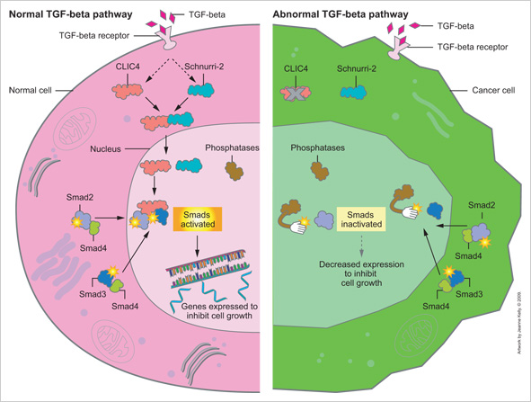
Figure 1

Smad proteins function as transcription factors that regulated the expression of certain genes, that are unknown at this point, but may relate to the development of ethanol sensitivity in flies due to the heavy involvement of CLIC. This leads to the purpose of this investigation, which involves determining whether the CLIC gene and the TGF-beta signaling pathway perform similar functions in Drosophila. The results of this experiment could lead to the opening of many branches of possible genetic experimentation to bring us closer to identifying the underlying molecular mechanisms and genetic factors, which, when mapped back to humans, can help develop therapeutic treatments for alcohol abuse.

Experiment:
The aim of this experiment is to identify whether or not the CLIC proteins and the TGF beta signaling produce the same effect in flies in terms of gene expression. Specifically, the experiment strives to assess, through a DNA microarray study, which genes are expressed under the conditions of silencing Smad proteins versus silencing CLIC proteins and if the CLIC and Smad perform similar functions within Drosophila. An additional control group of flies will also be used where none of the proteins are tampered with. Essentially, three comparisons of gene expression will be made: silenced CLIC (CLIC mutant flies) versus control, silenced Smad (Smad mutant flies) versus control, and silenced CLIC versus silenced Smad. Specifically, the genes that are over-expressed in the Smad mutant flies will be compared with the genes over-expressed in CLIC mutant flies and the same will be done for genes that are under-expressed in both. It can be predicted based on prior findings that there should be an overlap of gene regulation by CLIC and Smad, meaning they generally affect the same genes, leading to support of similar functions.
The main method used in this experiment is known as DNA microarray, or simply DNA chip. Originally, scientists in the 20th century studied genes by mapping them, sequencing, and analyzing the proteins they encode, one gene at a time. In the scale of 20,000 genes in the human genome, this would take many years as shown by the human genome project. Thus, the DNA microarray was invented in order to study massive amounts of genes in a single experiment. Essentially, all the genes are shown as microscopic DNA spots on a solid DNA chip. If a certain gene is being expressed or is "on", it means that molecules of messenger RNA, mRNA, are being produced. Through the microarray, it is possible to pinpoint differences in gene expression between cells that are exposed to different conditions, such as alcohol exposure or manipulation of proteins. The DNA microarray chips are made through sequencing the entire genome of the organism, Drosophila, identifying where each gene is located on the genome, and perform PCR to create complement primer pairs to make copies for every gene and form them into single strand DNA. These are ordered into proper rows and columns on a glass microscope slide/chip.
The DNA chip used for Drosophila genome may be made from scratch or purchase from Affymetrix, a company that manufactures DNA microarrays. Three groups of 200 flies each are prepared for the experiment. One group will have the CLIC mutant flies, another group will have the Smad mutant flies, and the third will be a control group where none of the genes and proteins are affected. The CLIC and Smad mutant flies are made through a process known as the GAL4-UAS system, a method invented by in 1993 Andrea Brand and Norbert Perrimon that is used to study gene expression specifically in flies (Board et al (2004). This system, shown in figure 2, involves crossing flies with the yeast transcription factor GAL4 in target genes with flies that contain the base pair sites of target gene known as Upstream Activating Sequences(UAS). The offspring of these flies, transgenic mutant flies, will possess cells specific the areas targeted by GAL4 where the experimenter can decide whether to activate the gene specified. This allows temporal control over any genes of interest, including the silencing or over-expression of the gene. The process used in this experiment specifically involves RNAi, the knockdown of Smad and CLIC genes to stop production of those specific proteins.
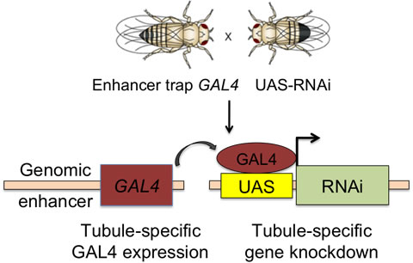Figure 2

The extraction and isolation of mRNA from the different groups of fruit flies are performed. Since alcohol tends to affect mainly the central nervous system, this is where the sample will be taken from the flies. These samples are centrifuged in order to separate the RNA from the rest of the cells and fly material. Protein, DNA, and other fly material will be in the bottom layer of the centrifuged tube and the RNA will be the upper layer. Since only mRNA reflects gene expression, the ribosomal RNA, rRNA, and transfer RNA, tRNA, are washed off to isolate only the mRNA. A complimentary copy, known as cDNA, of this isolated mRNA is made through the use of reverse transcriptase, which also includes a colored fluorescent label for easy identification on the DNA chip (figure 3). The fluorescence from each slot/gene on the microarray will appear in different colors based on the amount of mRNA being produced for that specific gene if transcriptions occur when cDNA of the mutant samples bind.

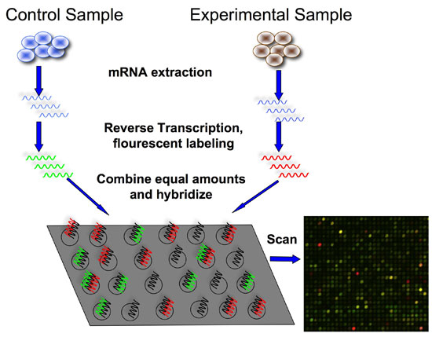
Figure 3

This cDNA also serves the purpose of being more stable than RNA, which reduces risk of error in the experiment. In this case, a green fluorescent label will indicate the cDNA of Smad mutant flies while the CLIC mutant flies will have a red fluorescent label. Genes that are regulated by both will be indicated by a yellow color. Since the microarray chip contains the complementary strand of every single gene in the Drosophila genome, the cDNA from the sample will match up, or hybridize, with its complement. Any cDNA that is not hybridized will be washed off. Any black areas will indicate genes that are not expressed since there is no fluorescence indicating production of any mRNA. The results will also be quantified in terms of which genes are overregulated or under-regulated in each comparison. This is done when each group of mutants is compared to the control. The genes that are over-regulated, meaning over-expressed compared to "normal" control genes, and the genes that are under-regulated meaning under-expressed compared to the control genes, will be used as the basis for comparison between Smad and CLIC. Statistical analysis, such as Chi-square and p-values, can be made on these ratios of gene regulation to determine the statistical significance of the results. The genes that have the highest ratio of regulation, meaning most over-regulated/under-regulated in comparison to the control and with the opposite mutants, will be cataloged and used for further experiments.

Discussion:
If everything goes well, there will be at multiple different microarray chips properly scanned and cataloged in terms of which genes were expressed in each unique group: over-regulated/under-regulated genes by CLIC mutants and over-regulated/under-regulated genes by Smad mutants. The best results would be an overlap of genes regulated by Smad and CLIC mutants in both the over-expressed and under-expressed categories. This would support the hypothesis that CLIC and Smad proteins share similar roles in gene expression of Drosophila if they activate and deactivate the same genes. On the other hand, if there is absolutely no overlap of genes between the two, then either there were errors in the microarray or CLIC and Smad proteins do not function similarly in the TGF beta pathway as prior studies have suggested.
The major error of this investigation is that it may be likely that the flies die as a result of silencing the Smad proteins, which would shut down the TGF beta signaling pathway, since it is a major life function pathway. It would be impossible to perform experiments on flies that die immediately. Therefore, it may be better to utilize ELAV-GAL4 system, which is a conditional GAL4 system where it is possible to only activate the system and silence the gene in certain conditions, such as inducing certain drugs. This way allows the experimenter to choose when the silence the proteins. Another issue would be if the genes that were over-expressed were similar between the two mutants, but no similarities between genes that were under-expressed. In this case, it would be difficult to conclude whether the two proteins work in similar ways in Drosophila. To amend this, further investigation would be done on the group of genes that differ, specifically in the group of genes that differed, whether the over-regulated or under-regulated genes, the top 10% will be used for further experimentation to determine what might cause the difference.
There is one major limitation involved in this investigation that would impair the results gained. Although the experiment aims to compare the functions of CLIC proteins and the TGF beta pathway, the actual variables used were Smad proteins, only known to be critical to TGF, but there are certainly Smad-independent effects of TGF beta as well as TGF-beta independent Smad proteins. Thus, it cannot be concluded from the results of the investigation that CLIC and TGF-beta share the same functions in Drosophila even if there is overlap between CLIC and Smad mutants. The opposite can also be applied in that if CLIC and Smad were found to not function similarly in terms of gene expression, it cannot be concluded that CLIC and the TGF-beta pathway do not function similarly.
Despite this, further investigation can be made in order to gain insight on the results from this experiment. For example, if it was found that the genes from the comparison of microarrays overlapped, meaning there is similarity in function between the two, the top 50 most over-regulated genes in terms over-expression of genes in comparison to control genes and the top 50 most under-regulated genes can be identified and used for future experiments. Furthermore, the results of this experiment can be augmented through behavioral response experiments, similar to Bhandari et al (2012), with the same conditions of silencing Smad and CLIC mutants. If the results of the two experiments match, there can be very strong evidence that the two proteins possess similar functions in gene expression. The most over-regulated/under-regulated genes, meaning most affected genes by the mutants, found in this experiment can be further exploited in terms of pathways they're from and functions related to alcohol response. Furthermore, similar microarray and behavioral investigations can be made on them as well. The results of this experiment can lead to paths that can be taken to move forward in genetic pathway research in alcohol response.

References:
Bhandari, P., J. S. Hill, S. P. Farris, B. Costin, I. Martin, C. L. Chan, J. T. Alaimo, J. C. Bettinger, A. G. Davies, M. F. Miles and M. Grotewiel (2012). "Chloride intracellular channels modulate acute ethanol behaviors in Drosophila, Caenorhabditis elegans and mice." Genes Brain Behav 11(4): 387-97
Board, P. G., M. Coggan, S. Watson, P. W. Gage and A. F. Dulhunty (2004). "CLIC-2 modulates cardiac ryanodine receptor Ca2+ release channels." Int J Biochem Cell Biol 36(8): 1599-612.
Dzitoyeva S, Dimitrijevic N, Manev H. " Gamma-aminobutyric acid B receptor 1 mediates behavior-impairing actions of alcohol in Drosophila: adult RNA interference and pharmacological evidence." Proc Natl Acad Sci U S A. 2003 Apr 29;100(9):5485-90.
Guarnieri, D. J. and U. Heberlein (2003). "Drosophila melanogaster, a genetic model system for alcohol research." Int Rev Neurobiol 54: 199-228.
Kapfhamer D, King I, Zou ME, Lim JP, Heberlein U, Wolf FW. " JNK pathway activation is controlled by Tao/TAOK3 to modulate ethanol sensitivity." PLoS One. 2012;7(12):e50594
Kong EC, Allouche L, Chapot PA, Vranizan K, Moore MS, Heberlein U, Wolf FW. " Ethanol- regulated genes that contribute to ethanol sensitivity and rapid tolerance in Drosophila." Alcohol Clin Exp Res. 2010 Feb;34(2):302-16
Morozova TV, Ayroles JF, Jordan KW, Duncan LH, Carbone MA, Lyman RF, Stone EA, Govindaraju. " Alcohol sensitivity in Drosophila: translational potential of systems genetics." Genetics. 2009 Oct;183(2):733-45, 1SI-12SI.
Ronnov-Jessen, L., R. Villadsen, J. C. Edwards and O. W. Petersen (2002). "Differential expression of a chloride intracellular channel gene, CLIC4, in transforming growth factor-beta1-mediated conversion of fibroblasts to myofibroblasts." Am J Pathol 161(2): 471-80.
Shukla, A., M. Malik, C. Cataisson, Y. Ho, T. Friesen, K. S. Suh and S. H. Yuspa (2009). "TGF-beta signalling is regulated by Schnurri-2-dependent nuclear translocation of CLIC4 and consequent stabilization of phospho-Smad2 and 3." Nat Cell Biol 11(6): 777-84.Berryman, M. A. and J. R. Goldenring (2003). "CLIC4 is enriched at cell-cell junctions and colocalizes with AKAP350 at the centrosome and midbody of cultured mammalian cells." Cell Motil Cytoskeleton 56(3): 159- 72.
Urizar, N. L., Z. Yang, H. J. Edenberg and R. L. Davis (2007). "Drosophila homer is required in a small set of neurons including the ellipsoid body for normal ethanol sensitivity and tolerance." J Neurosci 27(17): 4541-51.

