Signaling Pathways Produced By Combining DsRNA with Paclitaxal in order to Treat Ovarian Cancer

Introduction:

Epithelial ovarian cancer is ranked fifth among the malignant deaths of women in the United States and is considered to be more fatal than other gynecological tumors (Cannon, Santin & O’Brien, 2004). The actual cause of ovarian cancer is unknown, but one source of it can be invasive transformation of secretory cells in the fallopian tube. Ovarian cancer is classified into two categories: type I and type II. A type I tumor is when it has just begun its growth; it shows low levels of carcinomas and they are different from each other. Carcinomas are when the cancer starts to form on the lining of the internal organs and the epithelial tissue. A type II tumor has high levels of carcinomas and they are identical (Hennessy, Coleman and Markman, 2009). The most common therapy to treat ovarian cancer is cytoreductive surgery followed by chemotherapy. Approximately 60% of patients, treated in advanced stage, have a good response to the treatment. However, 80% of the patients treated during the late stages develop recurring diseases (Di, Boer, Figdor and Torensma, 2013).

Cytoreduction surgery is when the overspread or deoxygenated tissues are removed to prevent the tumor from being resistant towards chemotherapy. There are three steps in surgery: diagnosis, determination of the stage and cytoreduction. Initially the tumor is located and then, the growth of the tumor is determined to indicate the stage. After the stage has been confirmed, the tumors that are greater than 1 cm in diameter are removed. Patients who end up with bulky residual of the tumor have a low survival rate rather than the patients with little visible residual. Surgery only improves the condition of the patient overall but does not assure survival of the patient or provide a cure for the disease (Coleman, Monk, Sood & Herzog, 2013).

In addition to a cytoreduction surgery, chemotherapy is needed to remove the residuals of the tumor. Chemotherapy is when a patient is given doses of cytotoxic drugs to kill cells. The current drugs used to treat ovarian cancer are carboplatin and paclitaxel. Paclitaxel is a mitotic inhibitor that stabilizes microtubules hence blocking the normal break down during the cell division. This inability to divide induces prolonged activation of the mitotic checkpoint causing reversion to G-phase without cell division or apoptosis. Carboplatin damages the DNA of tumor cells by crosslinking the DNA. Loss of DNA repair mechanisms in tumor cells make it unable to repair sites of carboplatin induced crosslinking. The cell is unable to replicate this DNA and stops dividing leading to tumor cell apoptosis.

Other treatments involve using different drugs like cisplatin, bevacizumab, taxane and docetaxel. Carboplatin is derived from cisplatin with very little side effects but it is lower efficiency. Bevacizumab is a drug that blocks VEGF pathway which has a critical role in cancer. Taxane and docetaxel are both in the same class as paclitaxel, all of which are derived from Taxol. Another way to improve therapeutic response is to deliver the chemotherapy directly to the tumor site by intraperitoneal chemotherapy delivery. This type of chemotherapy is given through abdominal membrane linings also known as peritoneum. Even after getting doses of chemotherapy patients have a high recurrence risk. Due to the high recurrence risk, additional treatment is needed (Coleman, Monk, Sood & Herzog, 2013).

Though there have been various advancements in the treatment of cancer there is not yet a cure. Two-thirds of the patients with advanced stage ovarian cancer tumors eventually end up getting cancer again. For platinum based drugs like carboplatin the recurrence is categorized into platinum-refractory, platinum-resistant or platinum sensitive disease. Platinum-refractory disease is when the patient fails to respond to the therapy all. Platinum-resistant disease is when cancer has recurred within six months of the treatment, while platinum-sensitive disease is when cancer has recurred after six months. Many patients end up undergoing a secondary cytoreduction or getting additional chemotherapy. After various therapies the patient may become chemoresistant to platinum and taxol based therapies and consequently the tumor eventually grows back. (Coleman, Monk, Sood & Herzog, 2013).

One novel therapy is to focus on the patient’s immune system to improve on the patient’s survival rate. From the rapid growth to the development of the bulky tumor; the disease constantly interacts with the immune system, this process is known as cancer immunoediting. There are three phases of this process: elimination, equilibrium and escape. The elimination phase describes when immune system mediates tumor cell death. The equilibrium phase is where both tumor cell death and growth is caused by the immune system, while the escape phase is when tumor cells become resistant to immune system mediated tumor cell death (Di, Boer, Figdor and Torensma, 2013).

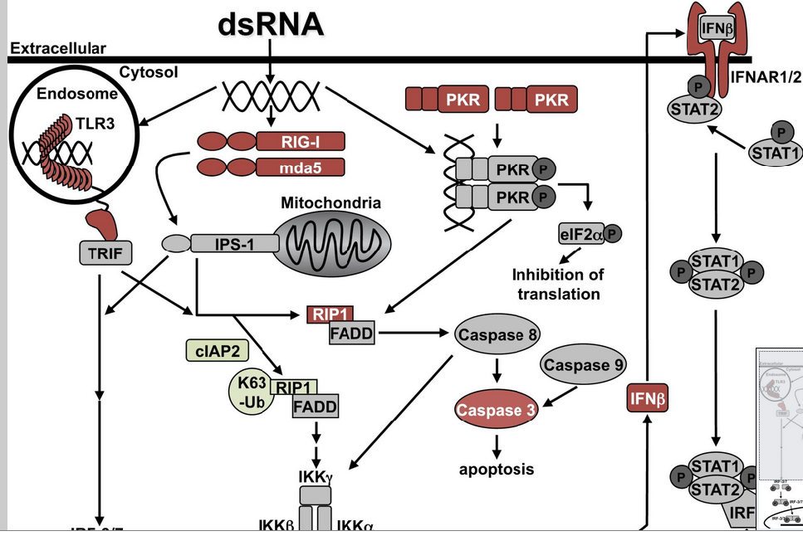
While many therapies have been studied to improve the condition of patients, not many treatments focus on a specific patient and their immune system. This is necessary because cancer in each individual is unique and plays a slightly different role (Di, Boer, Figdor and Torensma, 2013). To prevent cancer from growing, tumor immune receptors are activated by innate immune agonists like dsRNA, making them visible targets for chemotherapy. Double stranded RNA is known to stop the immunosuppression signals caused by ovarian tumor cells and activate four innate immune receptors, which activates caspase three and eventually leads to cell death (Van et al., 2012). Immunosuppression signals are signals which suppress the immune system, in this case by the tumor so it can act on its own and grow . The four receptors activated by dsRNAare: TLR3 ( L. et al., 2001), RIG-I (M. et al., 2004), mda5 ( Kang et al., 2002) and PKR ( Levin and London 1978). When stimulated, these receptors activate signaling pathways which lead to proinflammatory and apoptotic responses (Van et al., 2012).
Figure 1: DsRNA activating four receptors TLR3, RIG-I, mda5 and PKR (Van et al 2012)

In Van et al. (2012), the effect of dsRNA on ovarian cancer cell lines was shown. There were two populations identified: dsRNA resistant and dsRNA sensitive. DsRNA resistant ovarian cancer cells do not undergo cell death when stimulated with dsRNA, while dsRNA sensitive cells die when stimulated with dsRNA. Using those two subpopulations cell death pathways activated (in the dsRNA sensitive population) or blocked (in the dsRNA resistant population), were defined. Figure 2A shows the results of dsRNA (polyinosinic:polycytidylic acid), carboplatin (CARBO) and paclitaxel (PAX) treated dsRNA sensitive cells both individually and combined. Polyinosinic:polycytidylic acid was stimulated in cells because it very similar to dsRNA. The columns with the stars in Figure 1A indicate that the dual treatment caused a significant decrease in cell viability over the individual treatments. The results showed that treatments combining dsRNA with a cytotoxic agent significantly decreased cell viability. For example, dsRNA and paclitaxel combined decreased cell viability more than each treatment separately. Statistically, at four treatment concentrations, cell viability was significantly decreased with dsRNA and pactlitaxel whereas at three treatment concentrations, cell viability was significantly decreased with the combination of dsRNA and carboplatin. However, none of the treatment concentrations tested showed a significant decrease in cell viability with paclitaxel and carboplatin together.
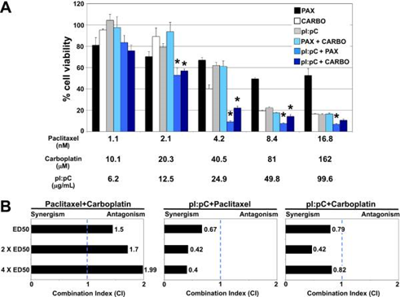
Figure 2: dsRNA potentiates paclitaxel- and carboplatin-mediated cytotoxicity. A) OVCAR-3
cells were treated for 48 h with paclitaxel, carboplatin, and pI:pC at the indicated concen-
trations, which correspond to 0.25X, 0.5X, 1X, 2X, and 4X the ED50 concentration (left to right). Cell viability was measured via MTT assay. Values are reported relative to untreated control. Data are means (+-) of 3 independent experiments. *P less than or equal to 0.05 for dual treatment vs. both individual treatments. B) Combination index (CI) values for each drug combination were calculated via isobologram analysis. Dot-ted line represents additivity, where CI = 1.
(Reproduced from Van et al. 2012)

Drug combinations can interact in three different ways: additive, antagonistic, and synergistic. Additivity is when the effect of the drug combination results in an effect that is the sum of the individual treatments. Antagonism is when two drugs combined have an effect that is less than the sum of the individual effect of treatment. Synergism is the opposite of antagonism. It is when two drugs combined have more than the additive effect of the individual treatments. Synergy is crucial to cancer chemotherapy because it is proved to be beneficial for patients. Synergy not only causes more cell death than expected by the combination of drugs, but also allows physicians to use a lower dose of chemotherapeutic drugs, often having serious side effects, while retaining high levels of tumor cell killing. If less drug can result in equivalent or more cell death when used in combination, then application of drugs to a broader patient population could be possible (Chou 2006). Figure 2 B shows the combination index (CI) of the tested drug combinations at three drug concentrations; synergistic (<1), antagonistic (>1) or additive (=1) effect. The CI of paclitaxel and carboplatin suggests an antagonistic effect and dsRNA combined with either paclitaxel or carboplatin has a synergistic effect. The results shown in Figure 2B led Van et al (2012)concludes that dsRNA combined with paclitaxel or carboplatin induces a synergistic decrease in cell viability and can be very beneficial in developing future treatments (Van et al. 2012).

In Van et al they have shown that the combination of dsRNA and paclitaxel causes synergistic cell death in ovarian cancer, however the mechanism by which this increased cell death occurs is unknown. We propose that these two therapeutic agents combined will induce overlapping signaling pathways that amplify activation of the extrinsic and intrinsic cell death cascades. For this proposal we will involve a PCR array approach to outline activated apoptotic pathways in either dsRNA or paclitaxel or the combination of dsRNA sensitive ovarian cancer cell and paclitaxel. This proposal will categorize the essential pathways of the apoptotic mechanisms necessary to induce this drug combination’s synergistic effect, by identifying which of several dozen genes are expressed differently in response to the two drugs.. These essential pathways will serve as biomarkers for individual patients retaining these signaling pathways. Furthermore, these studies of mapping essential pathways to induce apoptosis will provide additional targets for further therapeutic development. In conclusion, this proposal will improve our ability to target a synergistic combination of chemotherapeutic agents to patients which are highly responsive to this treatment.

Experiment:
The goal of this experiment is to examine apoptotic signaling pathways that contribute to the synergistic decrease in cell viability observed with the combination of dsRNA and paclitaxel. To accomplish this goal, an apoptosis PCR array will be performed to profile gene expression of proteins associated with cell death pathways. The apoptotic PCR array will be completed for untreated, dsRNA, Paclitaxel and dsRNA + Paclitaxel combined treatment in the dsRNA sensitive cell line, OVCAR3. The untreated cell will serve as a base line for the treated cell. As performed in Van et al. the OVCAR3 cells will be left untreated or treated with dsRNA (100 microgram/ml polyinosinic:polycytidylic acid, a synthetic dsRNA) or 17 nM paclitaxel or a combination of dsRNA + paclitaxel for 48 hours. Specifically these drug concentrations were chosen as they reduced cell viability to the greatest extent. With the RNeasy kit developed by Qiagen, cells will be harvested, lysed and total RNA will be collected.
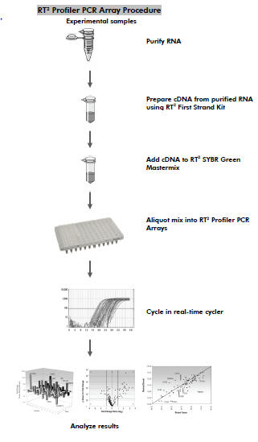
According to the manufacturer’s protocol, next, the RNase free DNase kit will be used to remove the genomic DNA from the samples. As per manufacturer’s protocol 0.5 micrograms total RNA will be used to produce cDNA using the RT2 First Strand kit (SAS Biosciences). This cDNA will be used in our PCR array, Human apoptosis RT2 Profiler PCR array (SAS Biosciences), to examine the expression of 84 genes related to programmed cell death in our four groups: untreated, dsRNA treated, paclitaxel treated, or dsRNA + paclitaxel treated. According to the procedure next, the cDNA will be mixed with the SYBR Green Mastermix and then aliquoted into the PCR array plate where each well contains gene specific primers (84 genes) or controls ( 5 housekeeping genes for data normalization between experiments, control for genomic DNA contamination, control for RT reaction efficiency (3 rxns), positive PCR control to examine PCR efficiency (3rxns)) (SAS Biosciences). As per the manufactures protocol the plate will be run in the Applied Biosystems HT7900 and the results will be anaylyzed. The CT or the threshold cycle for each well will be calculated using Applied Biosystems software. After the CT is calculated it will be exported for analysis using the SASBiosciences PCR Array Data Analysis Web Portal to generate ΔΔC_{T} values by comparing treated samples to the untreated or in this case the “control” sample. To get precise results three replicate plates will be completed for each condition.
Figure 3: PCR Array Procedure (SAS Biosciences)
Expected Results, Alternatives and Pitfalls:
We expect that the samples treated with combined therapeutic agents will have a higher levels of apoptotic pathway molecules or lower CT values, than the individual treated samples. Additionally, the individual treatments will not be expressed with pro-apoptosis pathway proteins or ΔΔC_{T} values. While, the combined treatments will increase the ΔΔC_{T} values. Alternatively, the combination treatment may downregulate anti-apoptosis proteins more effectively than the individual treatments or the synergism observed in the combination treatment may be both the upregulation of pro-apoptotic proteins in conjunction with the downregulation of anti-apoptotic proteins. By recognizing essential pathways, patients retaining these functional pathways will benefit from the treatment. Potential pitfalls with this experiment may be that similar pathways and levels of pro- versus anti-apoptosis gene expression will be observed in all treated samples. Alternative approaches can be blocking the apoptotic pathways specific to paclitaxel or dsRNA, to examine the impact on synergy observed in the combined treatment to identify essential cell death pathways contributing to the synergistic ovarian cancer cell death observed with both dsRNA and paclitaxel.
Discussion:
Many treatments like cytoreduction surgery followed by chemotherapy have been used to treat patients but none of them ensured the elimination of the tumor. After each surgery, chemotherapy with certain drugs was assigned according to the patient and the cancer, but eventually the tumor would grow back. If too much of a dose was given then it would harm the patient by killing its regular cells with the tumor cells. In that case, different drugs like cisplatin, bevacizumab, taxane and docetaxel are used in chemotherapy or a different approach which was mentioned earlier in the paper, intraperitoneal chemotherapy delivery can be used.
In order to give smaller amounts of doses and cause more cell death the combination of dsRNA and paclitaxel were used. Not only the patient can be treated with fewer doses but also they can have a higher cell death ratio resulted by the synergistic effect of two therapeutic agents treated together. In order to assure the presence of the synergistic effect, specific pathways of dsRNA and paclitaxel that lead to apoptosis were found through an apoptotic PCR array. For each patient these essential pathways will serve as biomarkers. Also, they will open pathways to many other treatments and ensure apoptosis of ovarian cancer cells.

References
SABiosciences. SABiosciences a QIAGEN Company, 2010. Web. 03 Dec. 2013.

Hennessy, Byan T., Robert L. Coleman, and Maurie Markman. "Ovarian Cancer." The Lancet 374.9698 (2009): 1371-382. ScienceDirect. Web. 6 Nov. 2013.

Chou, Ting-Chao. "Theoretical Basis, Experimental Design, and Computerized Simulation of Synergism and Antagonism in Drug Combination Studies." Pharmacological Reviews 58.3 (2006): 621-81. Pubmed. Web. 7 Nov. 2013.

Van DN, Roberts CF, Marion JD, Lépine S, Harikumar KB, Schreiter J, Dumur CI, Fang X, Spiegel S, Bell JK. "Innate Immune Agonist, DsRNA, Induces Apoptosis in Ovarian Cancer Cells and Enhances the Potency of Cytotoxic Chemotherapeutics." FASEB J 26:3188-3198.

Coleman, Robert L., Bradley J. Monk, Anil K. Sood, and Thomas J. Herzog. "Latest Research and Treatment of Advanced-stage Epithelial Ovarian Cancer." Nature Reviews Clinical Oncology 10 (2013): 211-24. PubMed. Web. 5 Nov. 2013.

Di, Jiabo, Tjitske Duiveman-de Boer, Carl G. Figdor, and Ruurd Torensma. "Aiming to Immune Elimination of Ovarian Cancer Stem Cells." Word Journal of Stem Cells 5.4 (2013): 149-62. Web. 6 Nov. 2013.

Cannon, Martin J., Alessandro D. Santin, and O'Brien J. Timothy. "Immunological Treatment of Ovarian Cancer." Ovid 16.1 (2004): 87-92. PubMed. Web. 5 Nov. 2013.

Alexopoulou L., Holt A. C., Medzhitov R., Flavell R. A. (2001) Recognition of double-stranded RNA and activation of NF-kappaB by Toll-like receptor 3. Nature 413, 732–738

Yoneyama M., Kikuchi M., Natsukawa T., Shinobu N., Imaizumi T., Miyagishi M., Taira K., Akira S., Fujita T. (2004) The RNA helicase RIG-I has an essential function in double-stranded RNA-induced innate antiviral responses. Nat. Immunol. 5, 730–737.

Kang D.-C., Gopalkrishnan R. V., Wu Q., Jankowsky E., Pyle A. M., Fisher P. B. (2002) mda-5: An interferon-inducible putative RNA helicase with double-stranded RNA-dependent ATPase activity and melanoma growth-suppressive properties. Proc. Natl. Acad. Sci. U. S. A. 99, 637–642

Levin D., London I. M. (1978) Regulation of protein synthesis: activation by double stranded RNA of a protein kinase that phosphorylates eukaryotic initiation factor 2. Proc. Natl. Acad. Sci. U. S. A. 75, 1121–1125.

