Inferring the Route of Odontotaenius disjunctus gut Microbiome Colonization
I. Introduction

Fossil fuels are a non-renewable source of energy. The world’s stores of coal, natural gas, and oil/petroleum will run out. In order to keep up with a rise in energy use [6] renewable sources of energy must be developed. The ability to convert cellulose into biofuel has been observed in bacteria [7]. Some of these bacteria form symbiotic relationships with other organisms. Some of these biological systems are important biological analogues to fuel production. Gaining an understanding of these systems may be important in developing alternative fuels. One such biological system is the symbiosis between the beetle Odontotaenius disjunctus and its gut microbiome.

Odontotaenius disjunctus is a beetle that lives in and subsists on woody biomass. The beetle’s gut microbiome has recently been characterized revealing the presence of a variety of bacteria some of which are able to convert cellulose to ethanol such as Clostridium cellobioparum[4,7]. Now that it has been shown that the rich gut microbiome of these beetles contain fermentative bacteria, some of which are capable of converting cellulose to ethanol, the question of how these beetles acquire their microbial community arises. More specifically, how do the larvae acquire these microbes? It is proposed that the larvae obtain at least part of the microbial community via consumption of woody biomass processed by adult beetles. This processing is essentially digestion and excretion of the woody biomass. It is already known that newly hatched larvae subsist solely on this processed biomass [9,15,16]. Proposed is an experiment that will elucidate if bacteria can survive this process and flourish in the gut of the larvae.

II. Experiment
The purpose of this experiment is to determine if excrement is a route for larval O. disjunctus microbiome acquisition. Microbial composition of a group of adult beetle guts will be partially characterized via a DNA microarray. The excrement of these adults will be given to groups of larvae in various combinations with the purpose of determining whether gut micro biome composition of larvae is affected by adult microbiome composition. To more directly test the possibility of excrement being the route, a separate group of adult beetles will be fed a strain of B.cereus that will contain a plasmid containing green fluorescent protein (GFP) and larvae will consume their excrement. A separate group of larvae will subsist on non-GFP bacteria containing excrement but will instead be exposed to the bacteria via the soil in their cage and surrounding woody biomass.

II.A. DNA Microarry and Characterization of Microbial Communities
To determine the composition of the gut microbiome, a microarray assay will be used. A library of probes of the 16s rRNA genes of many bacteria are hybridzed to sample rRNA molecules. Isolation of sample rRNA is achieved via chemical treatment of tissue samples to separate out nucleic acids as described in [4]. These nucleic acid extracts are further purified to separate the DNA and RNA fractions. The 16s rRNA from this total RNA sample is PCR amplified. The amplification products (16s rRNA) have a molecule that fluoresces in certain conditions added to their structure. The sample molecules are then exposed to the library of probes. Samples that have a high number of nucleotides in common with a probe hybridize strongly and those that do not match well do not hybridize strongly. The array is then washed to remove weak hybridizations. The fluorescent molecules remaining are excited and their fluorescence is measured. The result is a relative abundance of bacterial rRNA that is closely related to the known probes in the library. This can be used to infer the relative abundance of bacterial taxa present in the sample providing a higher level insight on the composition of the microbial community represented in the sample.

Using this assay, the microbial community of the gut and excrement of several adult beetles will be characterized. Following characterization, a group of larvae will be exposed to the excrement. Some larvae will be exposed to the excrement of their parents; others will be exposed to the excrement of others. After this exposure, the larval gut micro-biome will be characterized.

II.B. Bacterial Transformation
Bacillus cereus is chosen because it has been shown that it is culturable from the gut of O. disjunctus[14], it is a facultative anaerobe, and a transformation protocol has been previously elucidated[3,19]. A bacteria cultured from the gut of O. disjunctus is preferred as this demonstrates that the cultured bacteria is capable of surviving and possibly even flourishing in the gut of the beetle. A facultative anaerobe is ideal because the bacteria will be able to function in the aerobic beetle environment when it is fed to the beetles, will survive transmission via excrement, and will be able to function in the anaerobic environment of the beetle gut. An obligate anaerobe would be poisoned by atmospheric oxygen when fed to the beetles and an obligate aerobe would die in the anaerobic environment of the beetle gut.

The transformation protocol outlined in [3, 19] describes the use of electroporation. Electroporation is a process wherein an electrical field is applied to the cellular medium. It is thought that the electrical field causes the formation of temporary pores across the cell membrane. The plasmids enter through these pores. The peptidoglycan layer or cell wall is not affected by this electrical field. This is not a problem as this layer is naturally porous. After electroporation the cells are suspended in medium and given time to recover or allow for the reformation of the cell membrane via the closing of the temporary pores created during exposure to the electric field. Cells that are expressing the plasmid will be selected for by introducing an antibiotic into the medium. Cells that are expressing the GFP gene will also be expressing an antibiotic resistance gene. This means that only cells containing the plasmid will survive and flourish in a medium that contains an antibiotic. It is the case that when the bacterial cells divide chromosomal and plasmid DNA is replicated. This means the fluorescent tag is transmitted to the next generation of bacteria. This allows for experiments that will take longer than the life of a single generation.

In order to confirm not only the presence of marked B. cereus but also the active expression of genes at various stages in the proposed transfer pathway, a plasmid containing
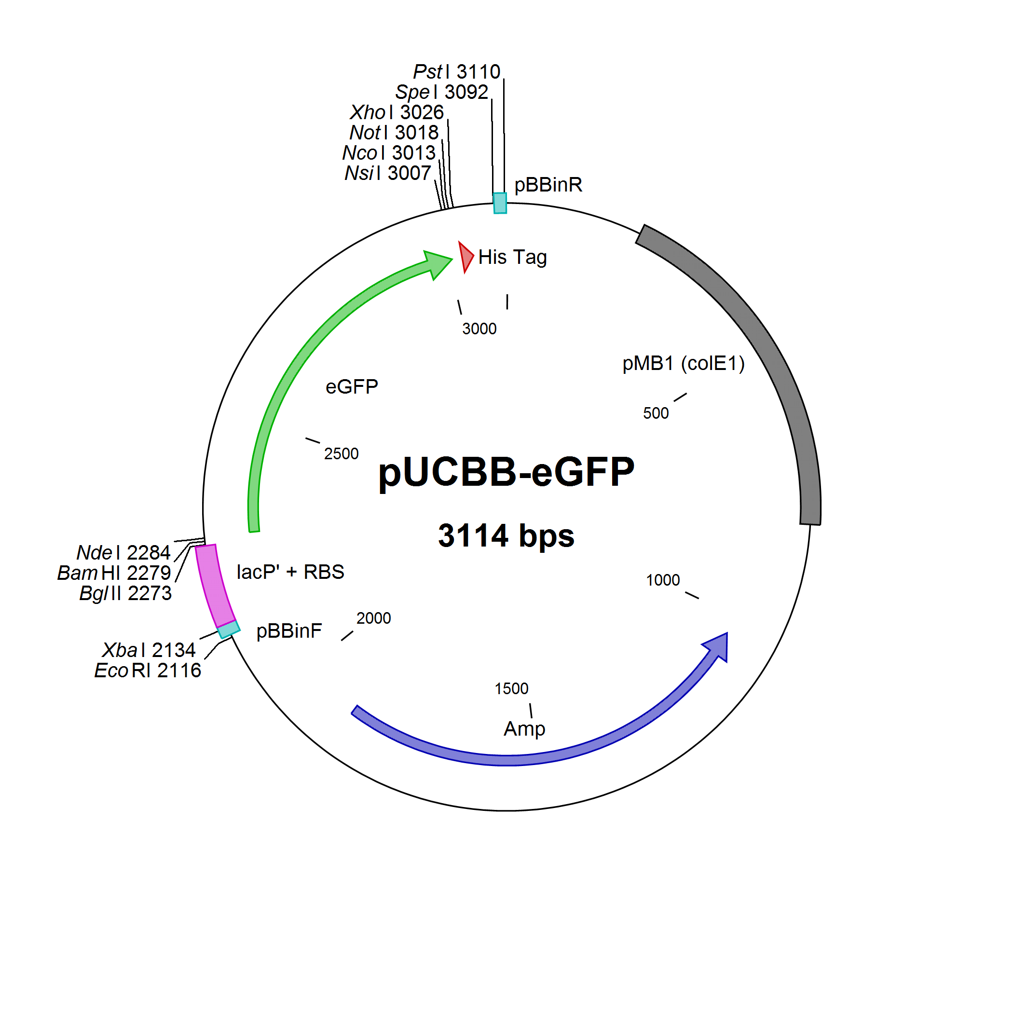
DNA that codes for a protein that fluoresces when irradiated with UV light will be transformed into bacteria Bacillus cereus. The detection of the green fluorescent protein suggests two important things: the bacteria containing the plasmid have survived digestion, and the bacteria are actively expressing genes[12]. Produced by the jellyfish Aequorea victoria, green fluorescent protein is a protein requiring no other cofactors or substrates for its function [5,13, 18]. The ability of the protein to fluoresce on its own is important as it does not require the utilization of cellular resources other than those employed in the construction of the protein. When irradiated with certain wavelengths of UV light, the protein will fluoresce.
Figure 1. Gene map of pUCBB-eGFP plasmid. The plasmid contains an enhanced green fluorescent protein gene engineered for use in B. cereus. It also confers resitance to Ampicillin and contains several enzymatic restriction sites.

The pUCBB-eGFP plasmid will be used here because it contains a GFP gene engineered for use in B. cereus: pPRS3a_01 (Geneid: 8382257). The plasmid also contains a gene coding for an enzyme that acts against beta-lactam antibiotic ampicillin conferring ampicillin resistance to bacteria that express this plasmid. This will aid in selecting for the bacteria containing the plasmid when culturing after transformation.

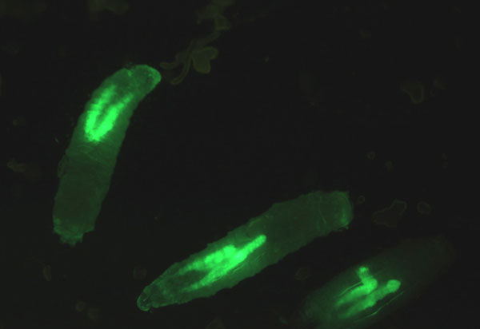
II.C. Visualization of Green Fluorescent Protein
Figure 2 Example of stereomicroscope visualization. Larvae of transgenic Drosophila melanogaster expressing GFP in their salivary glands.
Visualization of GFP is achieved via irradiation with UV light. The fluorescence of the protein may be affected by ambient pH. The pH range for all regions of O. disjunctus gut is 6.89 ±0.18 – 8.38 ±0.12[4]. The GFP remains stable and fluorescing in a pH range of about 7.5-8.5[2]. Protein may be visualized via several different methods. Fluorescence stereo microscopy will be used here to visualize the protein. The microscope will direct exciting light toward the sample consisting of gut tissue. Any GFP present will be excited by this light and emit light causing the characteristic green glow.

III. Discussion
In the case that the expectations are met, microbial community composition of larval gut will be affected by which adult their excrement food source comes from. Furthermore, GFP bacteria will be observed in the gut of larvae that have been exposed to GFP bacteria containing excrement. The larvae that were fed normal excrement and exposed to GFP bacteria in surrounding soil should not have communities of GFP bacteria in their guts.

It may be the case that the group of larvae exposed to the GFP bacteria environmentally does show GFP bacteria activity in their gut. This would be unexpected because the larvae feed exclusively on adult excrement immediately after hatching. It would not be implausible, however, and might suggest a mix of transfer pathways. The possible finding that there does not appear to be an association between excrement source and larval microbiome composition with successful detection of fluorescing protein in larval guts from the GFP group may indicate that only a specific group of microbes are transferred to young for colonization. Or this may be the result of genetic differences between individuals affecting the composition of the microbial community.
In the transformation of B. cereus with pUCBB-eGFP difficulty may be encountered. The transformation procedure was developed on a different strain of B.cereus than the strain to be used in this study. Should difficulty in transforming arise, optimization of transformation protocol will have to be performed. This may be done by altering the duration of the electric pulse, altering the strength of the pulse, altering the media, etc.

References
- Afzal I., Shah A. A., Makhdum Z., Hameed A., H. F. (2012). Isolation and characterization of cellulase producing Bacillus cereus MRLB1 from soil. Minerva Biotechnologica, 24(3), 101–9.
- Alkaabi KM, Yafea A, A. S. (2005). Effect of pH on thermal- and chemical-induced denaturation of GFP. Applied Biochemistry and Biotechnology, 126(2), 149–156.
- Belliveau, B. H., & Trevors, J. T. (1989). Transformation of Bacillus cereus vegetative cells by electroporation. Applied and environmental microbiology, 55(6), 1649–52. Retrieved from http://www.pubmedcentral.nih.gov/articlerender.fcgi?artid=202922&tool=pmcentrez&rendertype=abstract
- Ceja-Navarro, J. a, Nguyen, N. H., Karaoz, U., Gross, S. R., Herman, D. J., Andersen, G. L., … Brodie, E. L. (2013). Compartmentalized microbial composition, oxygen gradients and nitrogen fixation in the gut of Odontotaenius disjunctus. The ISME journal, Advanced O, 1–13. doi:10.1038/ismej.2013.134
- Chalfie, Martin; Tu, Yuan; Euskirchen, Ghia; Ward, William W.; Prasher, D. C. (1994). Green fluorescent protein as a marker gene expression. Science, 263(5148), 802–805. Retrieved from http://www.ncbi.nlm.nih.gov/pubmed/18051416
- Energy Information Adminsitration. (2013). World energy use to rise by 56 percent, driven by growth in the developing world. Energy Information Administration. Retrieved from http://www.eia.gov/pressroom/releases/press395.cfm
- Freier, D., Mothershed, C. P., & Wiegel, J. (1988). Characterization of Clostridium thermocellum JW20. Applied and environmental microbiology, 54(1), 204–211. Retrieved from http://www.pubmedcentral.nih.gov/articlerender.fcgi?artid=202422&tool=pmcentrez&rendertype=abstract
- Gross, S. R. (2010). A Study of Passalid Beetle Prokaryote and Yeast Gut Symbionts. Louisiana State University and Agricultural and Mechanical College.
- Gray, E. (2013). Observations on the Life History of the Horned Passalus, 35(3), 728–746.
- Ilya B. Tikh, Grayson T. Wawrzyn, Swati Choudhary, Jacob E. Vick, Claudia Schmidt-Dannert, Ethan T. Johnson, Poonam Srivastava, Sarah E. Bloch, F. L.-G. (2011). Optimized compatible set of BioBrickTM vectors for metabolic pathway engineering. Applied Microbiology and Biotechnology, 92(6), 1275–1286. doi:10.1007/s00253-011-3633-4
- Ito, Y., & Goto, T. (2005). Electrochemistry of nitrogen and nitrides in molten salts. Journal of Nuclear Materials, 344(1-3), 128–135. doi:10.1016/j.jnucmat.2005.04.030
- Leff, L. G., & Leff, a a. (1996). Use of green fluorescent protein to monitor survival of genetically engineered bacteria in aquatic environments. Applied and environmental microbiology, 62(9), 3486–8. Retrieved from http://www.pubmedcentral.nih.gov/articlerender.fcgi?artid=168148&tool=pmcentrez&rendertype=abstract
- Ma, L., Zhang, G., & Doyle, M. P. (2011). Green fluorescent protein labeling of Listeria, Salmonella, and Escherichia coli O157:H7 for safety-related studies. PloS one, 6(4), e18083. doi:10.1371/journal.pone.0018083
- Margulis, L., Jorgensen, J. Z., Dolan, S., Kolchinsky, R., Rainey, F. a, & Lo, S. C. (1998). The Arthromitus stage of Bacillus cereus: intestinal symbionts of animals. Proceedings of the National Academy of Sciences of the United States of America, 95(3), 1236–41. Retrieved from http://www.pubmedcentral.nih.gov/articlerender.fcgi?artid=18729&tool=pmcentrez&rendertype=abstract
- Nardi, J. B., Bee, C. M., Miller, L. A., Nguyen, N. H., Suh, S.-O., & Blackwell, M. (2006). Communities of microbes that inhabit the changing hindgut landscape of a subsocial beetle. Arthropod structure & development, 35(1), 57–68. doi:10.1016/j.asd.2005.06.003
- Pearse, A., Patterson, M., Rankin, J., & Wharton, G. (1936). The ecology of Passalus cornutus Fabricius, a beetle which lives in rotting logs. Ecological Monographs, 6(4), 455–490. Retrieved from http://www.jstor.org/stable/10.2307/1943239
- Smith, B. (2002). Nitrogenase reveals its inner secrets. Science, 297(5587), 1654–1655. Retrieved from http://www.jstor.org/stable/3832311
- Southward, C. M., & Surette, M. G. (2002). The dynamic microbe: green fluorescent protein brings bacteria to light. Molecular microbiology, 45(5), 1191–6. Retrieved from http://www.ncbi.nlm.nih.gov/pubmed/12207688
- Walter Schurter, Martin Geiser, D. M. (1989). Efficient transformation of Bacillus thuringiensis and B. cereus via electroporation: Transformation of acrystalliferous strains with a cloned delta-endotoxin gene. Molecular and General Genetics, 218(1), 177–181.

