Patriotic Songs

A PBL+MM for 3-5 Grades
(3.1, 4.1, 5.1 Music IMovie, Technology)
Music Skills: The students will sing in tune with a clear tone quality.
The students will sing melodies within the range of an octave (3.1) or more (4.1, 5.1).
The students will develop a repertoire of familiar songs. (3.1, 4.1. 5.1)
The student will participate in group singing using choral behaviors (5.1)
Technology Skill: The student will create a multimedia presentation.

Designed by

Anne Webb
arwebb@henrico.k12.va.us

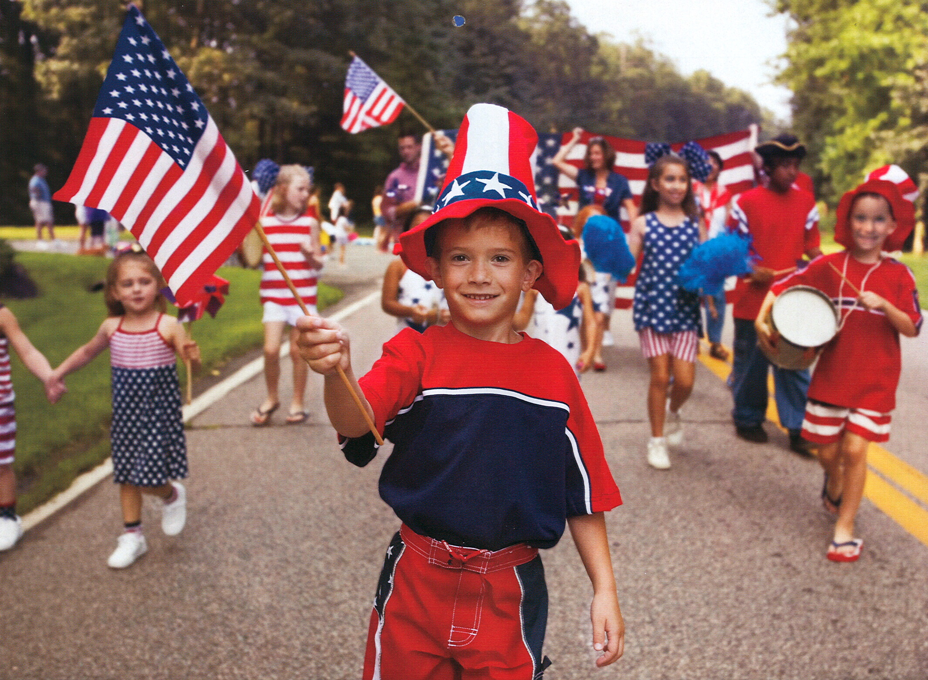

QUESTION
How can you help the librarian better present the Patriotic song during the morning announcements now that we have a production studio? Singing patriotic songs in the morning is a tradition at Carver. For years we sang with the tape recordings of the songs over the loud speaker. Now that we have the production studio and we watch the morning announcements. Shouldn’t we also watch the patriotic song?

PLAN
Patriotic Songs
Star Spangled Banner
America
America the Beautiful
God Bless America
Lift Every Voice and Sing
This Land is Your Land
There are Many Flags in Many Lands
You’re a Grand Old Flag

Each class will be divided into groups of four students to work on their chosen song. Each group will be given a journal with pages listing topics to be filled in by the group.
Group assignments will have the following members, director, recorder, researcher, and artist.
1. The director is responsible for setting rehearsals and scheduling work sessions on the computer.
2. The recorder is responsible for making the audiotape of the group singing and keeping the group journal.
3. The researcher is responsible for finding information about the composer and history of the song and writing the opening for the IMovie.
4. The artist is responsible for compiling the pictures that are produced by the group if original artwork or collected from the Internet or other sources.
All four members will work on the iMovie, sing for the recording and collect or draw the pictures. While working on this part of the project the students will keep a journal, listing rehearsals, discussion and definitions of the lyrics, picture ideas, sources of pictures, progress on the I-move and the last page group evaluation.

The first project each group will work on is learning to sing their song with the Patriotic Accompaniment CD. The singing on the audiotape will be assessed. Any lyrics the students do not understand will be listed in their journal with the definitions. The journal will also have a page to list ideas for pictures that might explain the words. After the song is learned and is ready for recording the director will schedule a time for the recording session.
The second project is to produce the pictures that go with the lyrics of the song. These may be original artwork, scanned from calendars, books or magazines, original photos or collected from the Internet. All sources of the pictures will be documented in the journal by the recorder. All pictures will be stored in the group’s folder on the stu_music folder on the server.
The final project is to create an IMovie importing the audio track and pictures. The artist will design the title page and the rolling credits at the end that will list the sources of the pictures and members of the group. The students will take turns adding titles using the lyrics to the pictures and timing the pictures to go with the audiotape. The researcher will insert a scrolling title before the pictures to explain the history behind the song and the composer (if a picture of the composer is available the researcher may insert this at the beginning also.) The IMovie and journal will be assessed.

Resources:
These items are in music room.
Patriotic song lyric sheets
Patriotic Accompaniment CD
The Red, White and Blue Book by Ace Collins
Grove’s Dictionary of Music History
Calendar Collections

Internet Image Search

Google Advanced Image Search

History of Patriotic songs
http://www.sbgmusic.com/html/teacher/reference/styles/patriotic.html History of Patriotic Songs

http://usinfo.state.gov/usa/infousa/facts/symbols.htm Star Spangled Banner, America, America the Beautiful

http://www.parlorsongs.com/issues/2002-7/thismonth/feature.asp Star Spangled Banner and Your a Grand Old Flag

http://www.parlorsongs.com/issues/2002-7/thismonth/feature.asp History of Star Spangled Banner and other songs

http://www.afn.org/~sigma1/jwjohn.html History of Lift Every Voice and Sing

http://www.miketodd.net/encyc/americasong.htm History of America

http://www.wordcentral.com/aol/ Student Dictionary for looking up word meanings

http://www.loc.gov/exhibits/treasures/trm019.html God Bless America

http://lcweb2.loc.gov/cocoon/ihas/html/patriotic/patriotic-home.html Library of Congress, all songs except Lift Every Voice and Sing

SCHEDULE
.
Project Schedule
Week
1 | Introduction of project | Group assignments | Selection of Patriotic Song | Members selecting jobs
2 | Practice singing song | Analyzing lyrics. Defining unknown words | Recording information in Journal | Schedule recording time for next week
3 | Recording of song | Discussing picture ideas | Deciding what kind of pictures to use, original artwork, photos, scanned material, internet pictures | Recording information or ideas in the journal
4 | Creation or collection of pictures | Recording pictures sources in journal
5 | Creation or collection of pictures | Recording pictures sources in journal
6 | Research of history of song and composer | Picture of composer if available | Compiling pictures in order to fit the lyrics | Schedule computer time for the team for the next five weeks
7 | Learning  IMovie skills | Inserting and saving pictures in IMovie | Writing a two paragraph history of song and composer | Recording IMovie progress in journal.
8 | Learning  IMovie skills | Inserting and moving audio track |  | Recording IMovie progress in journal.
9 | Learning  IMovie skills | Timing individual pictures to audio track |  | Recording IMovie progress in journal.
10 | Learning  IMovie skills | Inserting titles, scrolling text, and transitions | Adjusting timing with audio track | Recording IMovie progress in journal.
11 | Completing  IMovie | Group evaluation | Completing journal
12 | Presentation of IMovie to class | Transferring IMovie to video tape | Teacher evaluation with  group

Project and Student Checklist

The project is to chose a patriotic song and make an IMovie that gives a little history of the song and composer as well as pictures to express the meaning of the lyrics of the song. The students will be responsible for creating the three parts of the project.

The teacher will be an advisor to all aspects of the project if needed. The teacher and tech. instructor will teach the necessary skills needed to complete the IMovie.

Below is the Student Checklist for staying on task and completing the project within the allotted amount of time.
Individual Student Checklist
Name_______________________________________________________

Yes or No | Any question that is answer with a “no” needs to be discussed within the group and a solution needs to be found.
 | Project 1-Audio Tape
 | We have selected a patriotic song from the list.
 | We have our journal.
 | We have selected jobs and everyone is happy.
 | We have lyric sheet and accompaniment CD.
 | We have been practicing regularly and entered theses time in journal.
 | We have discussed the lyrics and understand what the composer is saying.
 | We have researched and defined all the words we had questions about.
 | We entered the definitions in the journal.
 | We have recorded our song.
 | We have let another group or teacher listen to our recording and discussed the clarity of the words and whether or not we sang in tune.
 | We have compared checklists and have solved any problems that have occurred?
 | We are happy with our recording and are ready to go on to project 2
 | Project 2-Pictures
 | We have broken our lyrics in to phrases and sub-phrases and entered them in the journal.
 | We have made a list of what kinds of pictures we want for each phrase or sub-phrase.
 | We have entered our ideas in the journal.
 | We have decided on how we want to create or find our pictures.
 | Original artwork
 | We have decided who in the group will draw each picture.
 | The work has been divided so each member in contributing to the best of his ability.
 | We have scanned and saved as jpeg’s all original artwork to stu_music, our group folder.
 | We have compared checklists and discussed and solved any problems that have occurred.
 | Collected Pictures
 | We have decided to use the internet and/or other sources for our pictures.
 | The work has been divided so each member in contributing to the best of his ability.
 | We have cited the sources of all of the pictures collected in the journal
 | We have scanned or saved the pictured to stu_music, our group folder.
 | We have converted and saved all pictures as jpeg’s.
 | We have compared checklists and discussed and solved any problems that have occurred.
 | We have a picture for each phrase or sub-phrase.
 | We have entered the sources for all pictures in the journal.
 | We are ready to start on our IMovie and have scheduled times for the next five weeks on a computer.
 | Project 3 IMovie
 | We have worked with the teacher or tech. instructor and understand how to import our pictures to IMovie
 | We have imported all our pictures to the clipboard.
 | We have arranged our pictures in the correct order on the clip view.
 | We have saved our work with the title of our song.
 | We have worked with the teacher or tech. instructor and understand how to import and move around our audio track into IMovie
 | We have learned how to use the timeline view in IMovie.
 | We have learned how to set the time for each picture.
 | We have imported our audio track in to IMovie
 | We have timed our pictures with the music and lyrics.
 | We have played our IMovie for another group or teacher for comments about our timing
 | We have learned how to add titles to each picture.
 | We have learned how to change the font and color of the text.
 | We have learned how to make a title page and scrolling credits or scrolling text.
 | We are all taking turns at the computer doing these jobs.
 | We have added the lyrics to each picture as titles.
 | We have checked our spelling and grammar.
 | We have added the title and scrolling text at the beginning and adjusted the audio line to stay under the lyric pictures
 | We have added the ending credits listing sources and our names.
 | We have shown our finished product to another group or teacher for suggestions.
 | We have compared our checklists and solved any problems that might have occurred.
 | We have completed our journal and group evaluation sheet and handed them in to the teacher.
 | We have asked the teacher to save our movie to videotape.
 | We are ready to show the class and school our patriotic song movie.
 | We gave our tape to the librarian.
 | We are proud of what we accomplished.

ASSESSMENT
Music Skills: The students will sing in tune with a clear tone quality.
The students will sing melodies within the range of an octave (3.1) or more4.1, 5.1).
The students will develop a repertoire of familiar songs.
The student will participate in group singing using choral behaviors (5.1)
Technology Skill: The student will create a multimedia presentation

Rubric for Group Evaluation

 | 1 | 2 | 3 | 4 | Score
Check the column that best describes the sentence. | Never | O.K | Most of the time | Awesome Job!!!!  (Definitely yes)
Audio Tape
Everyone knew the words
Everyone sang in tune
Everyone understands the meaning of the lyrics
Everyone can define all the words
Everyone worked well together
Everyone enunciated the words on the tape.
We finished this job in the allotted amount of time.
Pictures
Original artwork or collected pictures enhance the phrases or sub-phases
All sources were listed in the journal.
Everyone did their best on this project
We finished this job in the allotted amount of time
Everyone worked well together
IMovie
Has title page.
Has audio track.
Has lyrics as titles on pictures.
Has scrolling paragraphs about history and composer of song.
Has credits with all sources listed and student names
Audio is timed with the pictures.
Spelling and grammar is correct
Everyone took turns working on parts of the IMovie
We finished this job in the allotted amount of time.
Journal was neat and completed. (Triple the points 4 X 3=12)
Total Points

Your thoughts about the project. (Write a sentence or two to answer each questions on the back of this paper)

What would you have done different?
What was hard about the project?
Would you like to make another IMovie using another subject?
Would you use the cameras in your new project?

MULTIMEDIA PRESENTATION AND EVALUATION
The production studio staff will use the IMovies during the morning announcements. The following is the rubric for evaluating the IMovie

Rubric of IMovie
Patriotic Song
Group Members Director_____________________________________
Recorder____________________________________
Researcher___________________________________
Artist_______________________________________

 | 1 | 2 | 3 | 4 | Score
Pictures | Show little or no understanding of the lyrics | Show some understanding of some of the lyrics | Show understanding of most of the lyrics | Show complete understanding of the lyrics
Title | Title is missing | Has title by no composer |  | Has title and composer
Scrolling title | No scrolling title | Has little information about history and composer | Has some information about history and composer | Has plenty of information about history and composer
Titles/lyrics/credits  Spelling and grammar | Many misspelled words and poor grammar |  | 2.5 Score  A few misspelled words and grammar is fine | No spelling or grammar errors
Clear Audio track | Hard to understand,  muffled words | Some words are hard to understand | Only a few words are muffled | Clear and easy to understand
Timing | Lacks an understanding in how to time pictures | Some of the timing is correct | Most of the timing is correct | Timing matches all pictures
Credits list sources and group members | Lacks an understanding in how to list the credits | Some of the credits are correct and group members are listed | Most of the credits are correct and group member are listed | All credits are listed correctly and group members are listed
Creativity of the whole project | Shows little creativity | Few creative ideas | Many creative ideas | Shows lots of creative ideas
Total

Teacher and editing comments:

CREDITS & REFERENCES

Patriotic Picture from NYPD 2002 Benefit calendar

Flag image from http://www.kidsdomain.com/clip/

Adapted from a template from the WebQuest Page. Updated Fall 2005.

