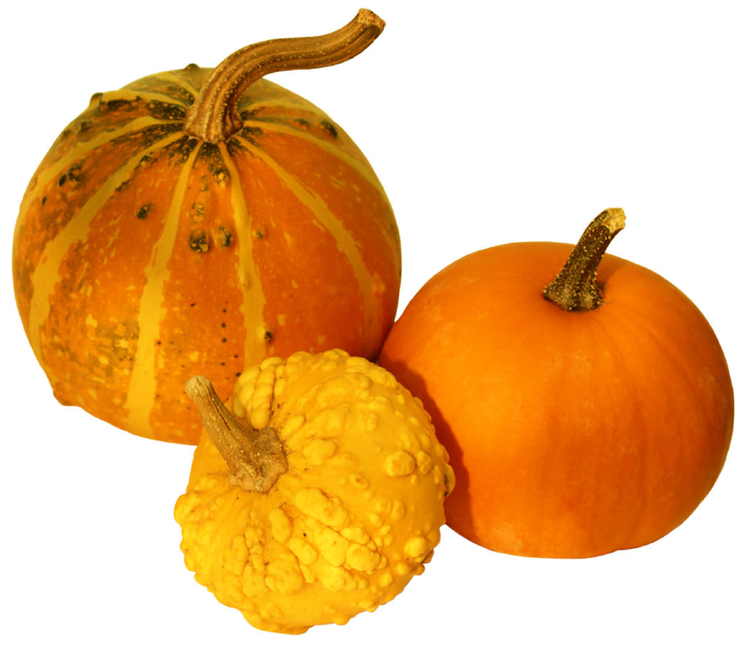

How to Grow A Pumpkin
Cyber Hunt
VA. S.O.L. K.6 The student will investigate and
understand basic needs and life processes of plants and animals.

Fill in the blanks!
Words to choose from:

sprout seed
pie jack-o-lantern
flower pumpkin
green pick
orange

Click on the underlined word
to fill in the blank.
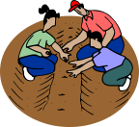
1. Plant a pumpkin
in the ground.

2. The seed grows a .

- The sprout becomes a
plant.

4. A grows on the
pumpkin plant.

5. Then a pumpkin grows from
the flower. At first its color is
.

6. The pumpkin grows bigger
and turns .

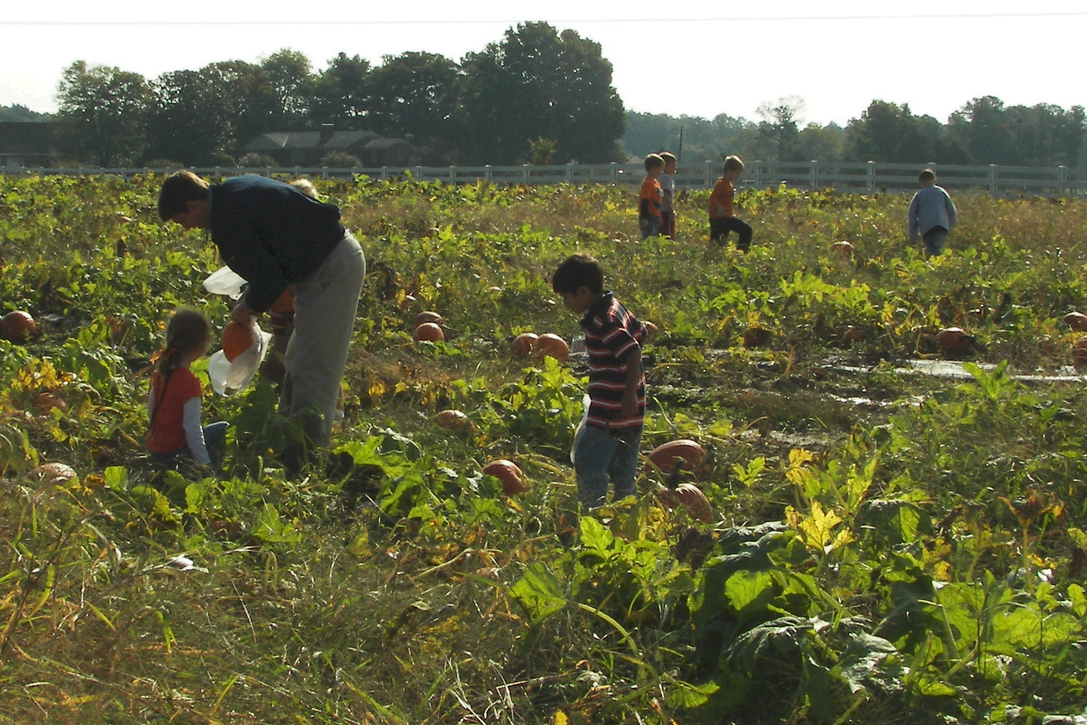7. Finally, it is time to
the pumpkin.

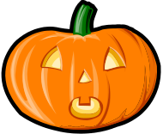8. You can make a face for your
pumpkin. Then it is called a
.

- Or you can make a pumpkin
 YUM!

