William Shakespeare
Scavenger Hunt

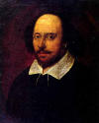

- What is the date of Shakespeare’s birth and death?

- What was the name of Shakespeare’s wife?

- What was the name of the town where Shakespeare grew up?

- How many children did Shakespeare have? What were their names?

- What is the name of William Shakespeare’s first published poem?

- What was the name of the acting group that Shakespeare joined in 1594 with Richard Burbage and Will Kempe?

- Name three tragedies that Shakespeare wrote.



- What were some special effects that he and his company made on stage during some of his plays?

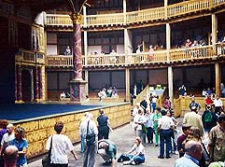

- What was the name of the group of people that stood on the ground in front of the stage and had the most fun?

- Where did Shakespeare get his information for Julius Caesar?

- What was the name of the theater where most of Shakespeare’s plays were made famous?

