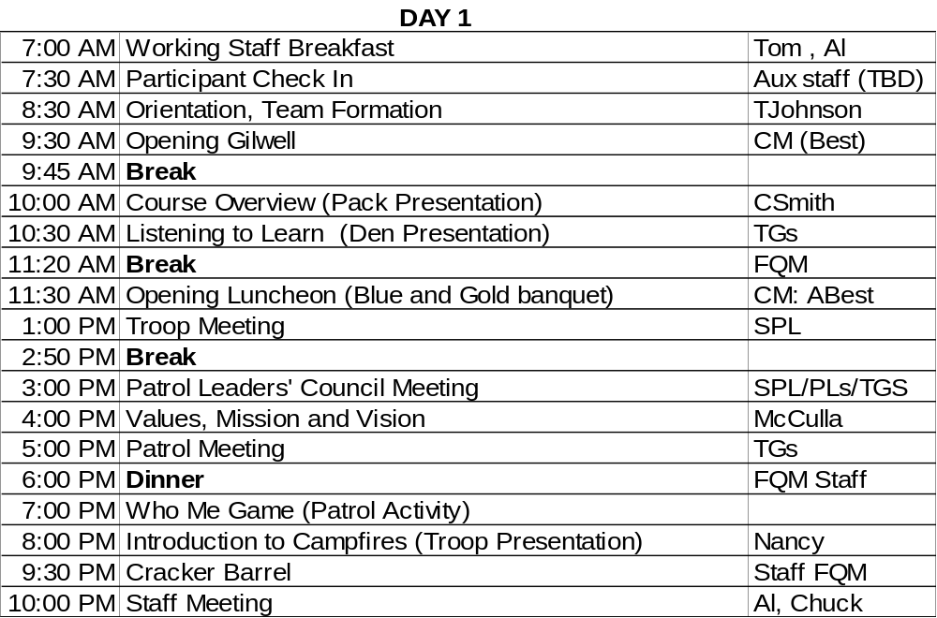
Day One: Working Staff Breakfast (07:00-30min)
Reminders:
• What’s the first stage of team development (Forming), and so
What’s the Teaching EDGE behavior (Explaining).
• Mingle, we’re glad they’re here
• Motto of the International Thespian Society: “Play your part well, for there the honor lies.”
Check in (7:30-60min)
• Pay attention to patrol counts.
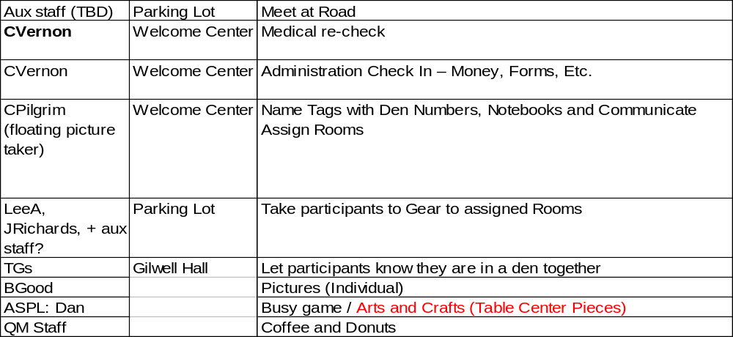
Day One: Team Formation and Orientation (07:30-60 min)
• Form teams that will stay together throughout the course.
• Meet the TG assigned to their team.
• Consider themselves for the moment to be a Cub Scout den led by a den chief.
• Enjoy several brief and entertaining get-acquainted activities.
• Locate the course facilities and Understand emergency response procedures.
• View the staff exhibit, both to gain from the material being presented and to see a model presentation of the sorts of exhibits they will later prepare themselves.

Forming Teams
- Staff members will greet participants as they arrive,
- TGs will help their participants find their teams.
- participants will receive copies of The Wood Badge Handbook.
- Point out: Day One edition of The Gilwell Gazette, including the schedule.

Cub Busy Games
Have participants note (see the center piece) that they are invited to a Blue and Gold banquet
Four things to do
• Make a table name plate (use glitter!)
• (individually) Do the Cub Promise & Law puzzle
• (as a Den) Fill in the Cub Scout Secrets form
To earn Arrow of Light, here’s to projects to help:
• What’s Next (Scout Law) cards
• Do the Scout Oath and Law puzzle
When each den has filled, the ASM-TG will circulate them thru the Staff Exhibit.
Staff Exhibit (08:30-59 min)
The staff exhibit illustrates the various programs that make up the family of Scouting. This exhibit serves as a model of the exhibits that patrols will be creating later in the program. It sets a high standard for what is acceptable in the development and presentation of a Wood Badge exhibit.
First Gilwell (09:30-15 min)
Bring:
• Cub Scout hat
• memorize: Cub scout Promise
• memorize: Law of the Pack
• the lyrics to “America the Beautiful” and “Cub Scout Spirit”
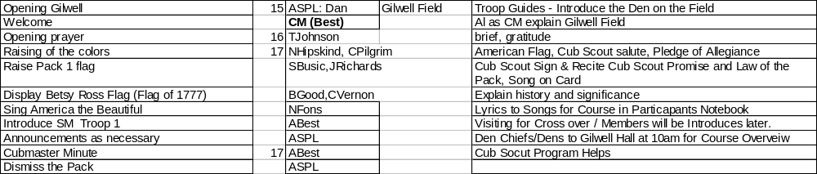
Welcome
In place on the field: PM (Best), APM (Cousino)
1. “Welcome Cub Scouts of Pack 1. This is your first Gilwell Field assembly of Wood Badge course SR917. I’m Al Best, your Cub Master.
2. “Gilwell Field was the home of the very first Wood Badge course. Gilwell Field serves as a symbol linking all Wood Badge courses through the years and throughout the world.
3. “In a moment, Cub Scouts we’ll be raising the flag so please use the Cub Scout salute while the flag is being raised.
“We’ll also be reciting the Cub Scout Promise and the Law of the Pack. You’ll remember to use the Cub Scout Sign when we do this.
4. “But first, our Chaplain Aid, Tom Johnson will lead us in an invocation.(… invocation)
5. “Assistant Pack Master, Mr Dan Cousino, please take charge of the pack.
Dan’s lines:
1. “Pack, A-Ten-Shun.”
2. “Den Chiefs report”
[each reports: “Den __ all present”]
3. “Color Guard, please raise the colors.”
[the color guard will: File into place
raise and salute the American flag,
raise and salute the Betsy Ross flag
Dan: Lead us in singing America the Beautiful (Proudly, NOT slow)
Raise the Pack 1 Flag
Return to their original place]
4. Ask the pack members to make the Cub Scout sign and recite the Cub Scout Promise and Law of the Pack.
5. “Pack at ease”
6. “Now let’s have another song! I don’t know about you but I’ve Got that Cub Scout Spirit …
7. “Also with us are visitors from Troop 1: Chuck Smith the Scoutmaster and members of his staff.”
“Very well. If there are no further announcements, [turning to CM] Do you have a Cub Master’s Minute?”
[AL Minute: Christopher Wren]
9. Dan “Please make sure you are in your seats in [gesturing towards the dining hall] Gilwell Hall by 10am.
“Den Chiefs, take charge of your Den.”
Break (09:45-15 min)
Minute
Leaders have vision. Followers who become leaders must share the leader's vision. Consider the question, “why are you here?”

The Great Fire of London in 1666 destroyed most of the city. The English architect, Sir Christopher Wren, volunteered his services to plan and superintend the building of St Paul’s cathedral. He was unknown to most of the workers, and he took advantage of this and would pass among them often and watch the construction. On one occasion, he put the same question to three separate stonecutters. He simply asked them what they were doing.

One of the answered, "I am cutting this stone." Another answered, "I am earning my three shillings per day." But the third stood up proudly and said, "I am helping Sir Christopher Wren build this magnificent cathedral."
Presentations – Course Overview
Al to Introduce
“I’m glad you all are having fun! I’d like to call up the Wood Badge Course Director to give us an overview of the course. The summary is on page __ of the Handbook. We’ve got a lot of handouts but we’re hoping you can answer a question, In addition to more fun, what are we in for?
Course Overview (Troop Presentation - Chuck) (10:00-30 min)
Al: “I know you’ve still got questions and we’ll definitely get to them all.
At this time, Follow your Den Chiefs to your Dens.
You’ll be back in an hour. Bring with you your WB Handbook and something to take notes with.
Listening to Learn (Patrol Presentation) (10:30-50 min)
Transform the Hall to Blue and Gold
They must be in their seats by 11:30am.
Blue and Gold (11:30-90 min)
AL: “Welcome to our Blue and Gold banquet, Webelos.
Dan do you have a song for us?”
Dan: “The more we get together”
Denners: Opening Ceremony (each Denner reads one of the 8 parts)
Al: “Please join me in the pledge of allegiance”
Chuck: Introductions
SPL: Skit
Blue and Gold props
See page ___ of the Handbook
•Ax and log. The ax and log is the totem of Gilwell Park. Baden-Powell held the first Wood Badge course at Gilwell Park near London. To this day, Gilwell is considered the international home of Wood Badge.
• MacLaren tartan. In 1919, a Scotsman named W. F. de Bois MacLaren, a district commissioner for Scouting in Scotland, purchased Gilwell Park and presented it to the British Boy Scout Association. He explained that one of his purposes in doing so was “to provide a training ground for the officers of the Scouting movement.” In perpetual appreciation for his generosity to Scouting, Wood Badge adopted the tartan of the MacLaren clan. It is this tartan that appears on the Wood Badge neckerchief.
• Wood Badge beads. In 1888 during a military campaign in Africa, Baden Powell acquired a necklace of wooden beads from the hut of a warrior chief named Dinizulu. Years later at the conclusion of the first Wood Badge course, Baden-Powell gave each course graduate a bead from the necklace. The “Wood Badge” program takes its name from those beads. Since then, more than 100,000 Scouters worldwide have completed Wood Badge courses and can wear replicas of the original wooden beads.
• Neckerchief and woggle. Held in place by a leather woggle, the Wood Badge neckerchief—tan with a patch of MacLaren tartan—may be worn by course graduates. Wood Badge beads, neckerchief, and woggle may be worn only with the official field uniform of the BSA.
• Kudu horn. During his military service in Africa, Baden-Powell observed members of the Matabele tribe blowing on the horn of a kudu to signal to one another. He brought a kudu horn back to England with him, and in the summer of 1907 when he held his first experimental camp on Brownsea Island, Baden Powell sounded the horn to assemble his campers. The same horn was entrusted to Gilwell Park in 1920 for use in Scout training courses. Since that time, the kudu horn has been a symbol of Wood Badge courses throughout the world.
And at the end of the Blue and Gold, you’ll be introduced to the final symbol of Wood Badge
Bridging
On the Cub side: ASM-P, ASM-TG, ASPL
On the Scout side: SM, SPL, QMs
• Sequence: Denner lead the Den up to the cub-side of bridge
• TG move (unobtrusively) to the Troop side of the bridge
• SM asks ‘the question’. Cubs answer. Cross over
• SM, SPL, TG shake hands of patrol; SPL gives flag to (ex) Denner
• TG picks up the flag stand (a block of wood)
• TG returns patrol to table
SPL: Announcments
Sing “Back to Gilwell” (only) with your assigned patrol AND with “staffers”
• Tell them they’ll be back in 2 hours (at 1pm).
Bridging
Cubmaster: Today you are taking a giant step—from Cub Scouting to Boy Scouting. Today we will be talking about the colors of the four winds and the meaning they have for us. Remember what is said today, and let the winds continue to guide you along the Scouting trail.
(Lights the blue candle.) Blue stands for the Cub Scout spirit and the north wind. You are a true-blue Cub Scout and live up to the Law of the Pack. It brings you only the warmest of winds.
(Light its time yellow candle.) Yellow stands for the south wind that carries the story of your achievements far and wide. As a Cub Scout you have been eager, fair, and a credit to your den and pack.
(Lights the white candle.) White stands for the east wind and the spirit of Scouting. The east wind carries the story of fun and happiness to your Scout troop and tells others how you live up to the Cub Scout Promise.
(Light the red candle.) Red stands for the west wind and represents your family. In Cub Scouting, your family helped guide you along the trail. They will go with you into Boy Scouting, but now it is you who will lead the way.
Scoutmaster: Hello, Webelos Scouts of Akela, what do you desire?
Cubmaster: Your answer is, “We desire to be Boy Scouts.”
Scouts: We desire to be Boy Scouts.
Scoutmaster:Then prepare to cross the bridge.
Cubmaster:Congratulations! We have been proud to have you as a member of this Cub Scout pack and we wish you well in Boy Scouting. As you cross the bridge, we’ll shake your hand one last time. Your Scoutmaster and senior patrol leader await you on the other side. Please cross over by dens.
Scoutmaster: (‘After each den has crossed over the bridge) Welcome to Boy Scouting. You are now members of the _____Patrol. May I present you with your patrol flag. (After all the dens in the group have crossed over) Later today each of you will be inducted into membership in Gilwell Troop 1 and presented with your troop neckerchief. Wear it with pride as many have done before you. Your senior patrol leader now wishes to express the troop’s pleasure in having you as a member.
Senior patrol leader leads the troop in a cheer for the new Scouts.
Scoutmaster: Cubmasters ______,we would like you to join the troop with your Webelos Scouts as an assistant Scoutmaster. Would you be willing to join Troop 1?
Cubmasters: Thank you, I would love to be a part of Troop 1. Scoutmaster, I turn the program over to you.

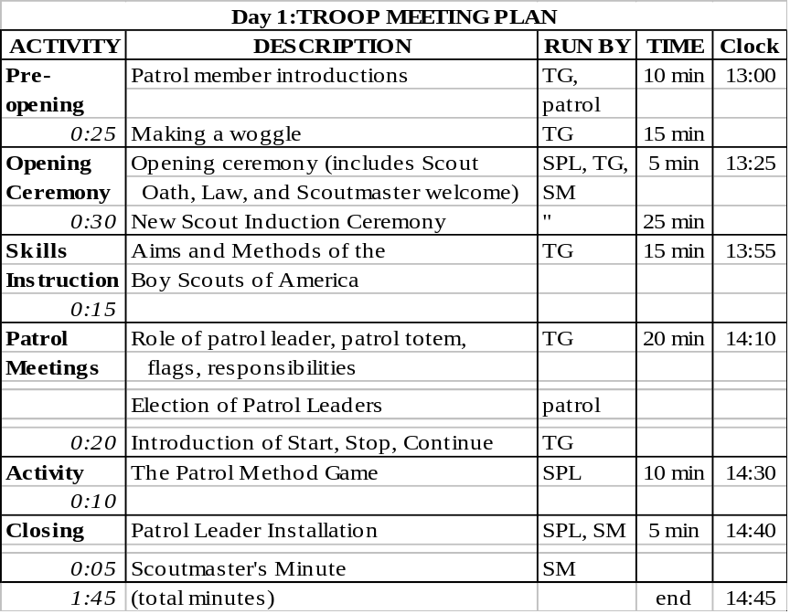
Making Introductions (13:00) 10 min

1. To begin the preopening activity, the troop guide asks each patrol member to learn about another member of the patrol and get ready to introduce that person to the patrol.

2. Patrol members pair off and take a few minutes to interview one another. They should give some thought to how they will make their introductions and what they will emphasize.

3. Patrol members take turns introducing the person each has interviewed. If some of the participants already know each other, the interviewers can shape their introductions to highlight interesting points that may not be commonly known.

Making a Woggle (13:10) 15 min
The second preopening activity is making a woggle. Participants should

• Experience the success of learning a new skill.
• Connect with a Wood Badge tradition.
• Model effective teaching techniques (use: “EDGE”)

The troop guide provides each patrol member with a 40-inch length of cord.

Note: Each troop guide must have extra woggles to lend to any patrol members who do not finish tying their own woggles in a timely fashion. Troop guides can then, later in the day, help patrol members finish tying their own woggles.

Note: A copy of the methods for tying a woggle handed out

Skills Instruction—The Aims and Methods of Scouting
(13:25) 15 min
15-minute facilitated by Troop Guide in “patrol corners”
Each participant has a copy of the Aims of Scouting worksheet.

The presentation will lead participants to

• Understand the underlying principles of Scouting.

• Realize how the aims of Scouting apply to Cub Scouting, Boy Scouting, Varsity Scouting, and Venturing.

• Relate the aims of Scouting to their own lives and BSA responsibilities.

Procedure
1. Ask patrol members to think about young people they know who are currently in Cub Scouting, Boy Scouting, Varsity Scouting, or Venturing.

2. Next, imagine the same people 10 years in the future. Consider what they might be doing, where they could be living, and how they will be spending their time.

3. Ask each patrol member to take two or three minutes to write down (on the back of the Aims of Scouting worksheet) some qualities that those young people will exhibit in the future that they have gained from their current Scouting experience. Answers might include:
• Self-motivation
• High expectations
• Focus
• Interest in the outdoors
• Technical skills
• Leadership ability
• Citizenship

4. Discuss with the patrol the following ideas.
• Baden-Powell called Scouting “a game with a purpose.”
The aims of Scouting— its purposes—are to help youth become better people and to fully realize their potential as they move into the future.

• The “game” part of Scouting is what we most often see—young people taking part in outdoor adventures, service projects, meetings, advancement efforts.
Those are the methods that the Scouting program uses to guide its members toward worthwhile aims.
(See Chart on Methods Of Scouting)

• Underlying the aims and the methods of the BSA is a solid foundation of ideals—the values upon which all of Scouting’s programs are built.
— Cub Scout Promise and Law of the Pack
— Scout Oath and Law
— Varsity Scout Oath
— Venturing Oath

5. Ask patrol members to list on their worksheets some specific ways that each BSA program brings to life the aims, ideals, and methods of Scouting.

6. Encourage participants to share what they have written. Use their responses to facilitate a discussion that relates their ideas about Scouting’s aims and values back to the young people—those they thought about at the beginning of this presentation and those who are not currently involved in Scouting but who could gain from the BSA message.
Patrol Meeting Agenda (Day One Troop Meeting)

• Roles and responsibilities of the patrol leader, assistant patrol leader, chaplain’s aide, and scribe.

• Patrol leader election

• Appointment of the assistant patrol leader, scribe, and chaplain’s aide

• Introduction of the daily Start-Stop-Continue tool

• (least important) Patrol totem

Role and Responsibilities of the Patrol Leader

In a traditional Boy Scout troop, patrols are smaller units designed to
- provide members with a greater sense of belonging,
- more opportunities to experience leadership, and a
- practical framework for conducting the troop’s program.

The same is true, with varying levels of sophistication, for the dens of a Cub Scout pack, the squads of a Varsity Scout team, and the teams of a Venturing crew.

A different member will serve each day as leader of your patrol, thus allowing each person to have at least one chance during a Wood Badge course to experience that leadership opportunity.

Role and Responsibilities of the Patrol Leader

• Take a leading role in planning and conducting patrol meetings and activities.
• Encourage patrol members to fully participate in the Wood Badge course and to achieve all they can.
• Represent the patrol as a member of the patrol leaders’ council (PLC).
• Set a good example by living up to the Scout Oath and Law.
• Practice using the leadership and team skills being presented during Wood Badge presentations.
• Ensure that daily patrol self-assessments are carried out in a timely, effective manner.
• Provide patrol members with all the resources and information they need to succeed.
• Empower the patrol to become a high-performance team.
• See that the patrol is prepared for all course presentations and activities.

Role and Responsibilities of the Assistant Patrol Leader

• Assume the responsibilities of the patrol leader whenever the patrol leader is unable to do so.
• Encourage patrol members to fully participate in the Wood Badge course and to achieve all they can.
• Assist the patrol leader in empowering the patrol to become a high performance team.
• Set a good example by living up to the Scout Oath and Law

Note: APL will rotate into the PL job on the following day

Role and Responsibilities of the Patrol Chaplain Aide

In concert with the chaplain aides of the other patrols and with the assistant Scoutmaster assigned to coordinate their efforts, the patrol chaplain aide will:
• Learn what resources are available that can be used for religious observances during the course and make that information available to the rest of the patrol.
• Develop and help present the participants’ Scouts’ Own religious service.
• Assist in conducting any other religious observances that may arise during the Wood Badge course.
• Set a good example by living up to the Scout Oath and Law
Note: Can NOT be the PL on Day 2 or 3 (meeting conflict with PLC)

Role and Responsibilities of the Patrol Scribe

• Provide interesting and timely material about the patrol to the publisher of The Gilwell Gazette—the daily newspaper of the course. (The publisher of the Gazette may hand out guidelines to help scribes fulfill their duties, or may briefly meet with all the patrol scribes to discuss how best they can assist in making the Gazette a worthwhile publication.)
• Set a good example by living up to the Scout Oath and Law

Role and Responsibilities of a Patrol Member

For a patrol to succeed as a team, each of its members must
• Fully participate in the Wood Badge course and achieve all he or she can.
• Practice using the team development skills introduced during Wood Badge presentations.
• Help his or her patrol meet its obligations to fulfill assignments including the development and presentation of the patrol project.
• Set a good example by living up to the Scout Oath and Law.
• Have fun!

Patrol Elections and Appointments
The troop guide will assist the patrol in electing a patrol leader who will, in turn, appoint an assistant patrol leader. The patrol will also determine who will hold those posts during subsequent days of the Wood Badge course. A chart for keeping track of elections and appointments can be found in the appendix.

• Each patrol member should have the opportunity to serve at least one clay as patrol leader. The person assigned to be assistant patrol leader will, on the following day, become the patrol leader.
• Enter the names in the Patrol Position Roster contained in the Patrol Leader’s Notebook.

The patrol will also select or appoint a Chaplain Aide and a Scribe. Each of these positions may be held by the same person for the duration of the course.
• On the day a person who is otherwise a chaplain aide or a scribe is serving as patrol leader, the duties of the appointed office may be assumed by other patrol members.
• A patrol’s chaplain aide will be involved on Day Six with the Scouts’ Own service.

Note: The chaplain aides of all the patrols will meet together on Day 2 and3 at the same time as the patrol leaders’ council. On Day Five, the chaplain aides will be involved in the Scouts’ Own service. Because of these scheduling issues, participants serving as chaplain aides should take their turns as patrol leaders at times other than Day 2 or Day 3 of the course.
D1 Troop Mtg — daily Stop-Start Continue Tool
Troop guides will discuss with their patrols the daily patrol self-assessment.
• A key to effective team development is self-assessment—regularly measuring the morale and productivity of one’s own group. The daily patrol self-assessment encourages course participants to do just that.
• The patrol self-assessment tool can be used just as effectively in other team settings within and beyond Scouting—district committees, church boards, camp staffs, business task forces, etc.
• The daily SSC form (see handout) is filled out in the morning during or just after breakfast.
• The patrol self-assessment need not be shared with anyone outside of the patrol. On the morning of Day Two, however, the troop guide may help facilitate the assessment process as patrol members work through it for the first time. After that, the troop guide will not be involved in the assessment process unless specifically requested to do so by the patrol leader.
• Completed SSC forms should be kept in the Patrol Leader’s Notebook.

D1 Troop Mtg —Patrol Totem—
The troop guide will share the following information with the patrol.

• Early Wood Badge tradition: design and develop totems to give a unique identity to yourselves and your patrol.

• The patrol totem is the logo of that team. Patrol members design it themselves and decide how and when it will be used.

• Explain where and how patrol members can acquire the materials and tools needed to make their own totems.

• Inform patrol members that they must present their totem design to the senior patrol leader for approval no later than the patrol leaders’ council meeting on Day Two.
Day One: Patrol Meeting
Tell the PL that he/she will have a Patrol Meeting in the Patrol Cabin (between 5pm and 6pm)

Remind the PL that the purpose of a patrol meeting is to

• Help each patrol build strong morale.
• Complete assigned tasks.
• Practice leadership and teamwork.
• Have lots of fun.

As with meetings of the troop and the patrol leaders, every patrol meeting taking place during a Wood Badge course should be organized in a manner that provides an ideal example of such a session.

Say “You may want to begin writing down what you think should be on the agenda.”
Materials Needed
• Patrol Meeting Agenda (Every patrol meeting should follow a written agenda. The Day One agenda is included in this section of the staff guide. The agenda for patrol meetings on subsequent days will be developed ahead of time by the patrol leader.)

Recommended Facility Layout
Each patrol will determine the location best suited for its meeting.

Delivery Method
The patrol leaders are the facilitators of the meetings of their patrols. They are responsible for developing the agenda and then using it as a guide for conducting efficient, orderly meetings. The leadership style each patrol leader uses is up to that person; the hands-on experience of leading is every bit as valuable as the progress made by a patrol during any particular meeting.
Presentation Procedure Patrol Meetings

Meeting Plan—Day One
1. Program Patrol/Service Patrol—Review the patrol’s assignments and responsibilities

2. Patrol Project—Initial planning

3. Patrol Totem—Initial planning

4. Wood Badge Ticket—Clarification with the troop guide
Guidelines for the Troop Guides
Patrol leaders are the facilitators of patrol meetings, not the troop guides. These meetings provide important opportunities for course participants to gain hands-on experience as leaders. At times they may struggle; that is often part of the learning process. Troop guides should allow each patrol leader time and space to gain the most from the experience, but should also be ready to make suggestions and give direction in a manner that does not overshadow the patrol leaders, but rather enhances their chances for success.

Day One Patrol Meetings
Troop guides may play a significant support role. Patrol members will be unfamiliar with the meeting format, and patrol leaders will have had little time to prepare themselves for their roles as facilitators.

Day Two Patrol Meetings
Troop guides will make a judgment call on their degree of involvement, basing their decisions on a patrol’s morale and productivity, and on the ability and performance of the Day Two patrol leaders.

Day Three Patrol Meetings
Troop guides may attend patrol meetings but ideally will not take part in any significant way.

Days Four and Five
Troop guides do not attend patrol meetings.
Because each day’s patrol leaders are new to their jobs, a patrol’s troop guide should meet with the patrol leader before the patrol meeting to discuss the agenda. Beyond that, though, troop guides should allow patrol leaders to plan and conduct daily patrol meetings with as much independence as possible.

Troop guides can use the following information as background to help them develop agendas and monitor the proceedings of patrol meetings.
Leading a Patrol Meeting
As the patrol leader opens each meeting, the written agenda should be shared with the patrol so that everyone understands why the meeting is being held, what the team needs to accomplish, and what will be expected of each person and of the team as a whole.

The patrol leader must be committed to conducting
- an efficient meeting
- that starts on time,
- accomplishes its objectives, and
- includes fun for the team and each patrol individual.

To achieve these ends, the patrol leader should encourage all members to fully participate in discussions and activities, and should publicly recognize their positive contributions and participation.

Service Patrol/Program Patrol Responsibilities

During a Wood Badge course, each patrol will serve at least once as a service patrol and once as a program patrol. With the help of the troop guide, the patrol leader can remind the patrol
- when they will take on service and program responsibilities,
- what will be expected of them, and
- how they can best carry out their tasks.

It is critical, for example, that flag ceremonies and presentations of the historic flag are fully understood by the patrol and practiced before the appropriate Gilwell Field Assembly. Patrols also need to know the correct way to lower the flags, fold them, and return them to the quartermaster.

See Guidelines for Conducting Flag Ceremonies in the appendix for instructions.
Patrol Exhibit

The portion of the meeting dealing with the patrol project requires the participation of every patrol member. The patrol as a whole needs to be clear about

- The scope of the undertaking,
- The materials needed,
- The process for assembling the exhibit, and
- The importance of working together efficiently.

The patrol project is a great opportunity for each patrol to excel, but patrol members must realize that the time they have to produce a quality exhibit is limited and that they must immediately begin applying themselves to the effort.
Totem

- The patrol leader can facilitate a discussion of a design for the patrol’s totem.

- The patrol should keep in mind that their totem design must be presented for approval by the senior patrol leader no later than the patrol leaders’ council meeting on Day Two.

- The troop guide can be a resource for the patrol regarding where and how they can acquire materials and tools to make their totem.

Note: Troop guides can help encourage the development of totems by displaying totems of their own from previous Wood Badge experiences.

Wood Badge Ticket

The troop guide can clarify the concept of the Wood Badge ticket by answering the questions of patrol members, helping them define their goals, and discussing with them the strategies that will help them succeed.

Summary

At the close of each meeting, the patrol leader should quickly
- summarize the meeting,
- answer any questions, and
- encourage the patrol to do its best.

With some patrols it may be helpful for the troop guide to offer observations and suggestions as an observer slightly removed from the circle of the patrol.

