WOOD BADGE
Handbook

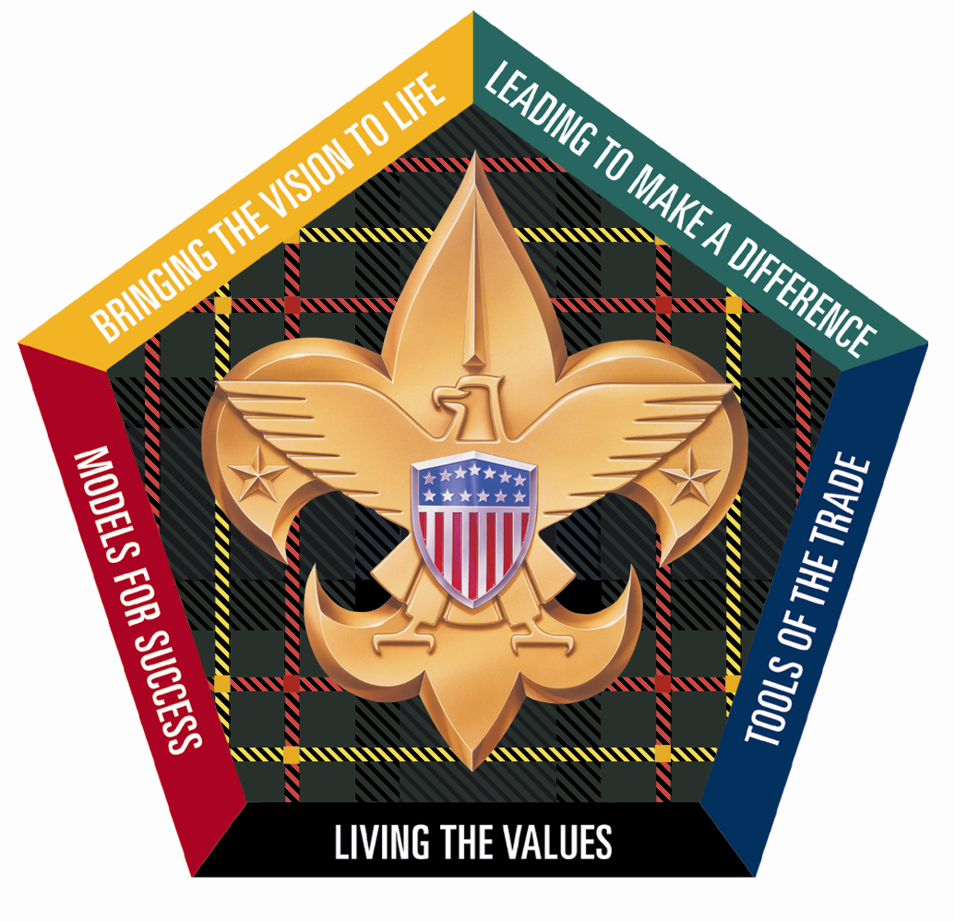
Heart of Virginia Council
SR-966



Table of Contents

Introduction
Letter to Our Fellow Scouters 1
Troop Organization 3
Emergency Procedures 4
Cub Adventure Camp 5
Camp T. Brady Saunders Map 6
Program and Service Patrol Assignments 7
Roles and Responsibilities Within the Patrol 8
Flag Ceremony Guidelines 9
Grace at Meals 11

DAY 1
Wood Badge Course Schedule 15
Check in, Orientation, Team Formation 16
Gilwell Field Assembly 17
Course Overview 18
Listening to Learn 22
Blue and Gold Banquet 24
Back to Gilwell 26
Patrol Roster 27
Notes and How to Keep ‘em 28
Troop Meeting 29
Turk’s Head or Woggle Neckerchief Slide 29
Aims of Scouting Worksheet 30
Patrol Leadership Roster 31
Daily Patrol Self-Assessment Form 32
Start, Stop, Continue Worksheet 33
Values, Mission, and Vision 35
Guidelines for Writing a Wood Badge Ticket 37
Introduction to Campfires & Instructional Campfire 39

DAY 2
Wood Badge Course Schedule 49
Gilwell Field Assembly 50
Troop Meeting 51
What Are You Most Afraid Of?” Worksheet 51
Inclusiveness 52
Stages of Team Development 54
Communication 56
Project Planning 58

DAY 3
Wood Badge Course Schedule 61
Gilwell Field Assembly 62
Interfaith Worship Service (Instructional Portion) 63
Have You Seen the Light? 67
Troop Meeting 69
Principles of Leave No Trace 69
Leading EDGE / Teaching EDGE 70
Conservation Project Planning 74
What Makes a Good Conservation Project? 74
Conservation Project Planning Checklist 77
Movie: “October Sky” 78

DAY 4
Wood Badge Course Schedule 81
Gilwell Field Assembly 82
Venturing Induction Ceremony 83
Leading Change 84
Valuing People and Leveraging Diversity 86
Problem Solving and Decision Making 88
Managing Conflict 90

DAY 5
Wood Badge Course Schedule 95
Gilwell Field Assembly 96
Coaching and Mentoring 97
Self Assessment 98

DAY 6
Wood Badge Course Schedule 103
Gilwell Field Assembly 104
Wood Badge Course Assessment 105
Leaving a Legacy 106
Summary Session 109

Appendix
Aims of Scouting Worksheet (answers) 111
The Mission Statement of the Boy Scouts of America 111
Wood Badge Ticket Workbook 113
Application for Training Recognition 125
Wood Badge History 127
Answers and Debriefing Material for “Have You Seen the Light?” Quiz 130
Wood Badge Course Assessment 133


Letter to Our Fellow Scouters
Heart of Virginia Council
Boy Scouts of America

My Fellow Scouters:
You hold in your hands the Wood Badge Handbook. While intended to provide resources needed for and to support you through the course, we hope you will continue to use it back at your home unit. Included among the pages that follow is course specific information such as duties and ceremonies, as well as some interesting facts about Wood Badge and Scouting in general
The founder of Scouting, Lord Robert Baden-Powell said, “Scouting is a game with a purpose” To us, Scouting should be FUN, yet instructional. The mantra for SR966 has been “Keeping it simple, making it fun”. Let us work together to find the fun in Scouting; both here at the course and in our units back home.
Wood Badge training has always provided an opportunity to improve leadership and personal skills within its participants. Along the way however, you will most likely develop lasting friendships with people whom, up until today, you had never met. Prepare to be challenged! Challenged to learn new concepts of teamwork and leadership and challenged to learn more about yourself all while having a great time with great people. To get the most out of the course, we need to stay focused and work together. For most participants, Wood Badge stands out as a highlight of their Scouting careers. Some have described it as a life-changing event. It is truly a mountaintop experience.
The staff of SR-966 began preparing over a year ago for the events that will unfold during these two weekends in September and October. After completing this part of your training, the Instructional Phase, staff members will continue to follow up with you for the next 18 months during the Application Phase. I tell you this to let you know how seriously we all take the charge to “Deliver the Promise” to our youth.
You will learn that feedback is a gift and at the end of the course, you will have an opportunity to share your thoughts and suggestions with the staff. Let us know how the course worked for you, and how you see it helping others. Please take time to do this; it will help those preparing for the next courses improve their programs. We want this to be a great experience for you so please let us know during the course if there is something you want to know further or if there is anything you need.
I have had the honor and privilege to handpick the staff that will present this course. I have watched for the last year as this team has formed and worked together to prepare for their responsibilities. This outstanding group of Scouters is now ready to perform! Your job as a participant is to now work with each other and the staff, have fun, and make this course a stepping stone to the betterment of Scouting in your units, districts, and councils. Thank you for participating, as that step alone distinguishes you as someone who cares and wants to make Scouting the best experience possible for our youth.

Yours in Scouting,

Craig Britt, Course Director
Troop Organization

Wood Badge is a Troop of Scouters. There are up to eight Patrols in the Troop and approximately 6-8 Scouters per Patrol. Each Patrol is led by a Patrol Leader. This responsibility changes daily. A staff member is associated with each Patrol and serves in the position as Troop Guide, much in the same way that the Troop Guide serves to help a new Patrol in the standard Scout Troop.
The Troop is led by a Senior Patrol Leader. The Troop Guides and the Patrol Leaders report to the Senior Patrol Leader. The Senior Patrol Leader reports to the Scoutmaster. The Senior Patrol Leader is in charge of the Troop when we meet at assemblies.
The staff is divided based on the functional areas. The Course Director/ Scoutmaster is responsible for the overall operation of Wood Badge. Assisting the Course Director are Three Assistant Scoutmasters—one for Program, one for Support and one for Troop Guides, in addition to the Quartermaster and Troop Scribe.
Each staff member has been working diligently for many months in preparation for Wood Badge. Some have been working for more than a year. We have assembled over 400 years of Scouting experience to serve you.

SR966 Wood Badge Staff
Scoutmaster Craig Britt
Assistant Scoutmaster - Program & Cubmaster Mark Larson
Assistant Scoutmaster - Support Bill Eggleston
Assistant Scoutmaster - Troop Guides Charlotte Pemberton
Senior Patrol Leader (SPL) Scott Street
Assistant SPL, Assistant Cubmaster, & Chaplain’s Aide Everett Winn
Course Mentor Karren Streagle
Staff Advisor Phillip Mumford
Friendly Quartermaster (FQM) Harry Davis
Assistant FQM Mike Andrews
Assistant FQM Greg Bresson
Assistant FQM Rey Hallion
Scribe Steve Hutchinson
Assistant Scribe Catherine Harding
Assistant Scribe Steve Busic
Troop Guide Ron Alexander
Troop Guide Robin Chandler
Troop Guide Shawn Coffey
Troop Guide Jeff DeHoff
Troop Guide Keith Dowler
Troop Guide John Long
Troop Guide Cindy Morris
Troop Guide Les Thorpe
Emergency Procedures

Medical Emergency
- In the event of a life-threatening injury, administer first aid immediately and send for help.
- For other medical conditions, illness or injury, report to the Course Health Officer (Keith Dowler). Anyone with special medical condition (back problem, severe allergies, etc) or on prescribed medication must inform the Course Health Officer.

Fire Emergency
Fire is a real and ever present danger. Extreme care must be taken when cooking. The Senior Patrol Leader will pass along any restrictions about open fires. In the event of a fire that can not be extinguished easily and safely, sound the alarm and send for help.
- All vehicles should be backed into parking spaces. They should be ready to leave promptly in case of fire or other emergency.
- If you hear sirens, bells, or horns in sets of three, evacuate the area and DO NOT return to your campsite for belongings. Go to the designated gathering spot immediately and form patrols.
  - During Weekend 1 - report to the main Cub Camp parking lot.
  - During Weekend 2 - report to the Eagle Plaza in front of the Dining Hall.

Patrol leaders are to report missing members to staff. DO NOT send anyone to look for missing patrol members.

Safety
Safety is the utmost concern in camp. All campsites must have fire fighting tools and ample water. Use sun screen and insect repellent as needed. Stay on trails and roads in camp area.

Phones for contact
In case of emergency or need of a message to be passed along, please try one of the following numbers:
Camp Brady Saunders: 804-556-3633
Cub Adventure Camp: 804-556-3170
Ranger’s Office: 804-556-4179

These staff phones will be kept on - but with a “vibrate” setting during the course day:
Craig Britt’s Mobile: 804-239-2189
Mark Larson’s Mobile: 804-405-6573

Map of Cub Adventure Camp
(Called Gilwell Field during Weekend One)
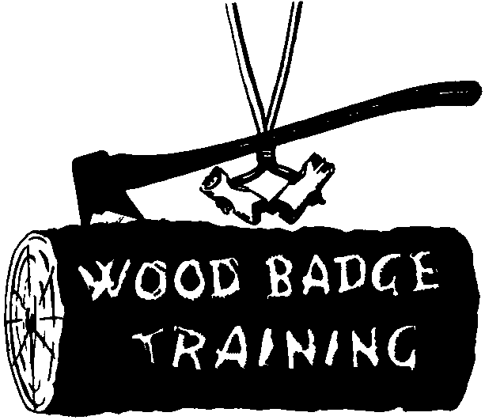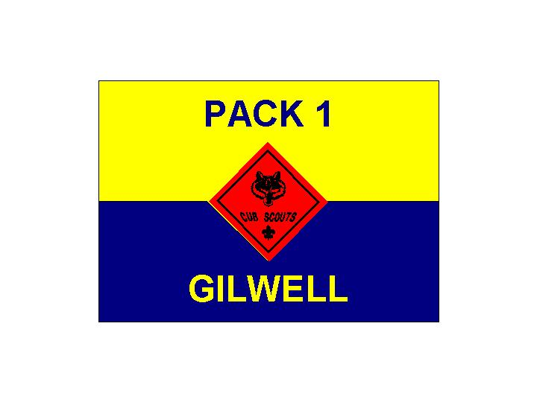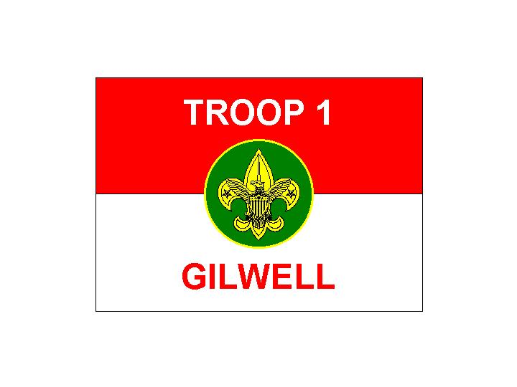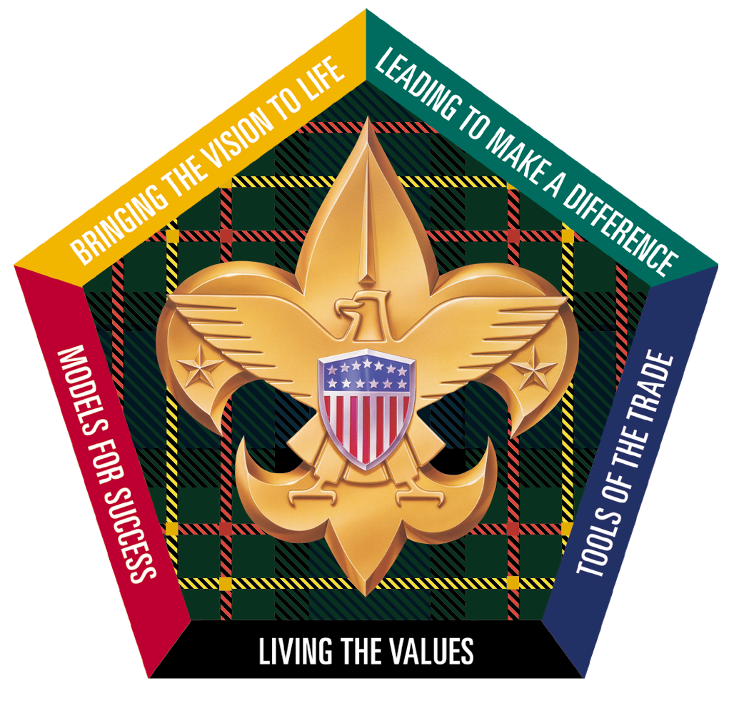
Cub and Webelos Adventure Camp
Heart of Virginia Council
Fort Ferguson
Participant
Quarters
TeePee Village
Mountain Cabins
Staff Quarters
Amphitheater
Patrol Cabins (PC)
Parking
To Route 6 & Route 522
Aspenwall House
Handicraft
To Boy Scout Camp T. Brady Saunders
Health Lodge
Welcome Center
Castle
(Pool)
Private Residence
Welcome to SR966
Wood Badge for the 21st Century
Private Residence
Emergency
Gathering Location
*
To Route 250 & I-64
MAIDENS ROAD
Gilwell Hall
Staff Office
Gilwell Field
Map of Camp T. Brady Saunders
(Called Gilwell Field during Weekend Two)

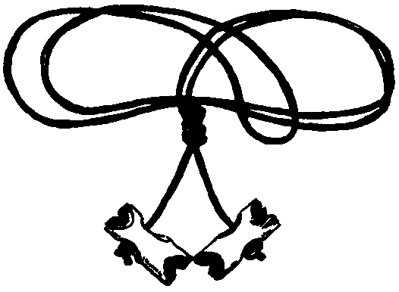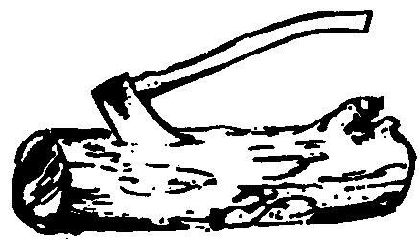

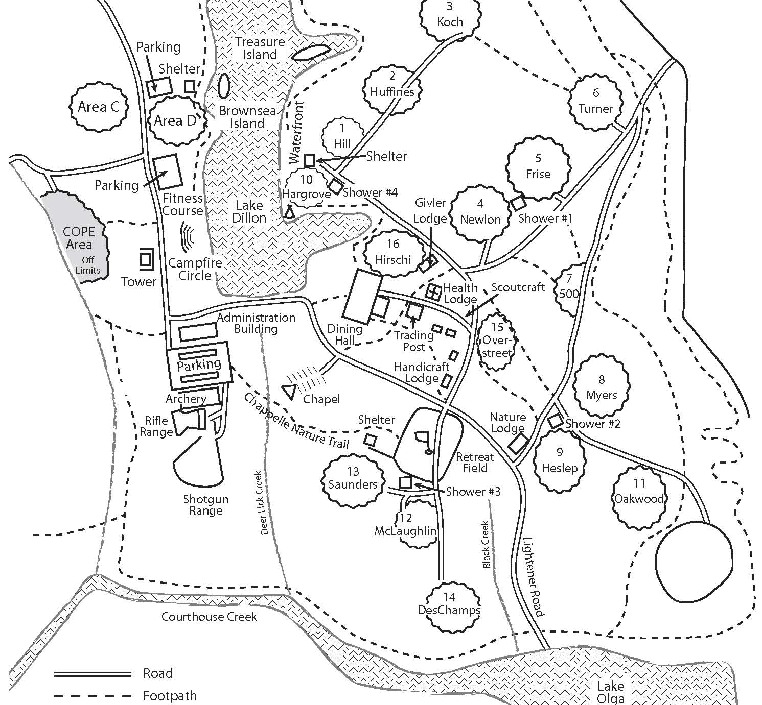
Gilwell Hall
Gilwell Field
Emergency
Gathering Location
*

Participant Camping Areas
Staff Camping Areas
Health Lodge

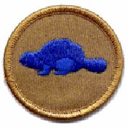 | 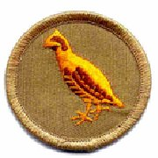 | 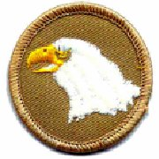 | 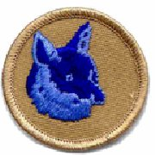 | 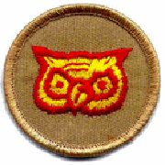 | 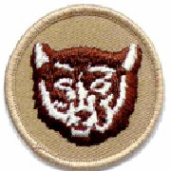 | 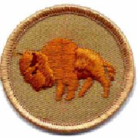 | 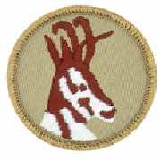
WOOD BADGE SR966

Program and Service Patrol Assignments
In Wood Badge, everyone helps with the program and service duties that make the camp experience great. The patrols will be on a rotation for maintaining cleanliness of the camp and leading program elements. At the Patrol Leaders Council each day, the Senior Patrol Leader will confirm the specific assignments and the material required. The chart below indicates the day on which each patrol is to have these responsibilities.

The rotation does not exactly follow change of day, but rather begins and ends at the close of each morning Gilwell Assembly (after exchange of the ceremonial symbols – large beads and shovel). To use an example, the Antelope patrol will begin their program duties after we complete the Day Two Gilwell. They will be responsible for all program assignments made by the Senior Patrol Leader through the Gilwell Assembly on Day Three (such as taking down the flags on Day Two and raising them at Gilwell on the morning of Day Three.)

Wood Badge Day
Day 1 Day 2 Day 3 Day 4 Day 5 Day 6
Friday Saturday Sunday Saturday Sunday Monday
9/18 9/19 9/20 10/17 10/18 10/19
_________________________________________________________________
Program
Patrol Buffalo Antelope Beaver Bobwhite Eagle Fox
_________________________________________________________________
Service
Patrol Owl Bear Fox Buffalo Antelope Beaver
_________________________________________________________________

Program and Service Patrol Responsibilities

Service Patrol
- Be responsible for the general cleanliness of the camp, especially for the latrines, washing places, meeting areas, and the campfire circle.
- Assist the quartermaster just prior to and after meals.
- Assist the quartermaster with the evening cracker barrels.
- Lay campfires, when requested, and extinguish the fires when done.

Program Patrol
- Conduct the morning flag-raising ceremony
- As part of the flag-raising ceremony, present a brief history of the historic flag for the day and lead the group in a song associated with that flag.
- Lower the flags in the evening.
- Ensure that necessary equipment is on hand before the start of each training session, as requested by the staff member in charge.
- Provide leadership for Day 4 participant campfire.

Roles and Responsibilities Within the Patrol

Role and Responsibilities of the Patrol Leader
- Take a leading role in planning and conducting patrol meetings and activities.
- Encourage patrol members to fully participate in the Wood Badge course and to achieve all they can.
- Represent the patrol as a member of the patrol leaders’ council (PLC).
- Set a good example by living up to the Scout Oath and Law.
- Practice using the leadership and team skills being presented during Wood Badge presentations.
- Ensure that daily patrol self-assessments are carried out in a timely, effective manner.
- Provide patrol members with all the resources and information they need to succeed.
- Empower the patrol to become the best it can be.
- See that the patrol is prepared for all course presentations and activities.

Role and Responsibilities of the Assistant Patrol Leader
- Assume the responsibilities of the patrol leader whenever the patrol leader is unable to do so.
- Encourage patrol members to fully participate in the Wood Badge course and to achieve all they can.
- Assist the patrol leader in empowering the patrol to become the best it can be.
- Set a good example by living up to the Scout Oath and Law.

Role and Responsibilities of the Patrol Chaplain Aide
In concert with the chaplain aides of the other patrols and with the staff member assigned to coordinate their efforts, the patrol chaplain aide will
- Learn what resources are available that can be used for religious observances during the course, and make that information available to the rest of the patrol.
- Develop and help present the participants’ interfaith worship service.
- Assist in conducting any other religious observances that may arise during the Wood Badge course.
- Set a good example by living up to the Scout Oath and Law.

Role and Responsibilities of the Patrol Scribe
- Provide interesting and timely material about the patrol to the publisher of The Gilwell Gazette—the daily newspaper of the course.
The Troop Scribe will hand out guidelines to help scribes fulfill their duties and may briefly meet with all the patrol scribes to discuss how best they can assist in making the Gazette worthwhile.
- Set a good example by living up to the Scout Oath and Law.

Role and Responsibilities of a Patrol Member
For a patrol to succeed as a team, each of its members must
- Fully participate in the Wood Badge course and achieve all he or she can.
- Practice using the team development skills introduced during Wood Badge presentations.
- Help his or her patrol meet its obligations to fulfill assignments including the development and presentation of the patrol project.
- Set a good example by living up to the Scout Oath and Law.
- Have fun!

Flag Ceremony Guidelines

Preparations
At the Day One Gilwell Field Assembly, a staff color guard conducts the flag-raising ceremony, setting the tone and providing an appropriate model for subsequent flag ceremonies.

During the remainder of the Wood Badge course, the PROGRAM PATROL takes responsibility for the flag ceremony. That patrol will have had program responsibilities since the end of the previous day’s Gilwell Field Assembly. That should give them ample time to plan and practice the ceremony - and to obtain the appropriate historic flag from the Friendly QM.

- The 3 flags will be set out on the desk of the Admin office before breakfast.
- Lyrics of the songs and poems associated with historic flags can be found in your course songbook.
- The reading associated with each day’s historic flag is found in this notebook under the “Gilwell Field Assembly” section for that day.

Before arriving at Gilwell Field, the program patrol should have with them all three flags to be raised. Each patrol member should know precisely what they are to do and have practiced the ceremony. Remember that Gilwell Field is a large area and you need to really raise your voice to be heard by all. The typical ceremony form is as follows; any deviation should be pre-approved by the Senior Patrol Leader.

Flag Raising Ceremony
After the senior patrol leader reports to the Scoutmaster, “The troop is formed,” the Scoutmaster replies:
“Proceed with the flag ceremony.”

At that point, the program patrol walks (together) counter-clockwise AROUND Gilwell field to the front of the flag area. When in position, the senior patrol leader turns the Flag-raising ceremony over to the patrol leader of the program patrol by saying:
“Program patrol, raise the colors.”

The patrol leader takes charge, calling the members of the troop to attention. The color guard approaches the flagpoles and attaches the flags – ready to be raised. The patrol leader asks the troop members to make the Scout salute, then instructs the color guard to:
“Raise the colors.”
(Note: the color guard will have their hands full of flag – so stay still and look at the pole if saluting is awkward.)

The U.S. flag should be hoisted rapidly. As soon as it reaches the top of the flagpole, the patrol leader ends the salute with the command:
“Two.”

The Patrol leader then leads the Troop in the Pledge of Allegiance.

The Troop flag is to be raised next. Raise it quickly to the top of the pole. Next, the Patrol leader tells the troop what page in their songbook they can find the Scout Oath and Scout Law – if they need it. After a few seconds pause, the patrol leader gives the scout sign and leads the Troop in the Scout Oath and Scout Law.

Last, the historic flag is to be unfurled and shown to the Pack/Troop with the associated reading that describes its history. At the conclusion of the reading, it is to be raised quickly to the top of the pole. Historic flags flown on Days 1-4 are official flags of the United States of America. Therefore, the patrol leader should ask that they be saluted when raised. As with the current US flag, signal the end of the salute with the command:
“Two”

After raising the historic flag, the program patrol leads the Troop with the designated verse or song associated with the historic flag. They then return to their position in the troop assembly (clockwise around the field on the outside of the assembled troop).

Grace at Meals
The 12th Point of the Scout Law is “A Scout is Reverent”

In place of the command “Let us pray,” more inclusive, nonsectarian ways to invite participation in a blessing include the following statements and invitations: “A Scout is reverent” “Would you join me in prayer?” or “Will you all assume an attitude of prayer?”
Day 1
Breakfast – Troop 1 Chaplain Aide
Our dear heavenly Father, we thank thee for rest and this new day. Bless this staff and lift them up as they get ready to deliver this Wood Badge Training they have worked so hard in preparing for. Be with us, guide us, and steady us as we go through this first hectic day and give us a sense of peace so that we may do our best. Let us rely on your strength for through you all things are possible. Now bless those that have prepared this food and it to the nourishment of our bodies and us to thy service. In your name we pray. Amen
Opening Gilwell Field –Troop 1 Chaplain Aide
Oh Great Scoutmaster, we thank you for bringing us safely to Gilwell field and SR966.
We thank you for those who have gone before us whose work has enriched our lives today. We remember especially the life of Baden-Powell: his faith and his love for you, his courage and dedication, his love for children and young people, His gift of Scouting to the world.
Help us to build wisely on the foundation built for us by others. Keep us true to the principles of Scouting, hold before us our Aim, enable us to live by our Promise, and deepen our love for boys and young people.
As we go through this course, open our hearts that we may listen to hear your will, open our minds that we may listen to hear what is being taught, so that we may better serve the youth, our units, our districts, our council and our fellow Scouters and help us to understand that as we serve one another we are also serving you.
Amen
(Excerpts taken from For Canadian Scouting)
Grace - Opening Lunch – Troop 1 Chaplain Aide
Dear Lord, we give you thanks for all the blessings you give to us. We thank you for Baden-Powell who gave us the gift of the Scouting program that helps our youth grow in leadership skills and to prepares them to make ethical and moral choices over their lifetime by instilling in them the values of the Scout Oath and Law. We also thank you for our guests here today who have devoted their lives to this Scouting program and the youth of our Council, for the staff of SR966 who have worked diligently in their preparation to be able to train the participants of this course, for the participants as they endeavor to improve themselves so that they may do their best in helping our youth and also for the hands that have prepared this food. May this food we are about to eat and all your other blessings help us to better serve you. Thank you for this food and gifts for our use and for our lives of humble service.

Dinner Day 1 – Troop 1 Chaplain Aide
Our Father God, we thank Thee for this evening meal. As Thou has been mindful of us, help us to be mindful of Thee, that we may know and do Thy will.
(Evening Grace #9)
Instructional Camp Fire – Troop 1 Chaplain Aide
God, thank you for keeping us safe this day and for all the blessings you have bestowed us. As we gather around the campfire, we thank you for fellowship and friendship. Help us to carry out our lives in the spirit of Scouting, that we may share it with others by living it ourselves. Help us also to understand the true meaning of service for others and that as we serve others we are also serving you. Finally help us to remember you, as you have remembered us throughout this day, so that we may know and do your will.
Day 2
Breakfast – Troop 1 Chaplain Aide
Gracious giver of all good,
We thank Thee for rest and food.
Grant that all we do and say
Is in thy service today.
(Morning Grace #1)
Gilwell Field Invocation – Troop 1 Chaplain Aide
Lord, be with us during this day in all that we do and say. Help us better see the differences in each and every one of us and that by including everyone, using that diversity and working together we can accomplish so much more. Also help us to better communicate with each other so that we can better serve one another and you. In thy name we pray. Amen
Lunch – Troop 1 Chaplain Aide
Heavenly Father, help us to see the beautiful things in earth and sky which are tokens of Thy love. Walk with us in the days we spend together here. May the food we eat and all Thy blessings help us to better serve Thee. Amen
(Noon Graces #4)
Dinner Grace – Antelope Patrol Chaplain Aide
Tireless Guardian on our way, Thou hast kept us well this day. While we thank Thee, we request Care continue, pardon, rest.
(Evening Graces # 7)
Day 3
Breakfast – Antelope Patrol Chaplain Aide
Heavenly Father, we thank Thee for Thy care through the night and for this new day. Guide us by Thy Spirit and at close of this day may we not be ashamed before Thee.
(Morning Grace #3)
Gilwell Invocation - Antelope Patrol Chaplain Aide
Dear God,
Help us to carry your spirit in our lives
That we may share it with others by living it ourselves.
Help us to offer all that we have and are in your service.
And help us to live the spirit of Scouting so the spirit will live on through us.
(Scout Prayer)
Lunch – Beaver Patrol Chaplain Aide
Oh Lord,
The giver of all good
We thank thee
For our daily food.
May Scouting friends,
And Scouting ways
Help to serve us all our days
(Gilwell Grace)
Day 4
Gilwell Field Invocation – Beaver Patrol Chaplain Aide
Dear Lord, We thank you for our safe return to Gilwell and SR966. Be with us as we continue to develop as a team. Help us to value each of us and that the uniqueness and the diversity each of us offers, that it makes us stronger as a team and helps us solve problems, make better decisions and lead change. That while we are all different, we are God’s children created for a purpose. May we remember as we serve each other, we serve You.
Day 5
Gilwell Field Invocation – Bobwhite Patrol Chaplain Aide
Oh, Great Scoutmaster, we thank you for this new day, grant that I may do my best today and strive to do better tomorrow. Let me remember, that in a Scout’s eyes, what I do speaks louder than what I say. Let me have the patience to let the Scouts lead, fail and succeed. Let me have the attentiveness to listen and respond completely. Let me have the necessary qualities and skill to instill the true meaning of the Cub and Scout Law, Oath, Motto and Slogan. Let me remember not to be burdened by, the responsibilities of my position. And please, Great Scoutmaster, help me to watch over the Scouts under my care.
(Excerpts taken from A Scout Leader’s Wish by Robert W. Holthausen, Troop 50 Asst Scoutmaster,
Wood Badge Course NE-IV-108)
Day 6
Gilwell Field Invocation – Eagle Patrol Chaplain Aide
(A Scoutmaster's Prayer for Wood Badge or Scouter functions)
A little boy came knocking at my Scout room door,
An awfully little fellow, just twelve and no more.
His eyes danced as he watched my gang at rowdy play.
"I would like to be a Scout," he said, "I'm 12 just yesterday."
In the weeks to come he found his place, a trim young Scout he made.
The tests he passed with eagerness, a thorough job sure paid.
The oath, the laws, the knots and flag were taken to his heart.
A better man he was sure to be tho he'd just begun to start.
By the candle-lighted darkness I watched his round face beam
As the oath and law he pledged to keep —just like a prayer it seemed.
The years to come were happy ones as we followed the trail –
That greater men had laid for us far up where eagles sail.
I watched him grow from boy to man, the days were far too few,
To try and teach the important things that Scouting said were true.
I didn't know so long ago our nation he would defend,
I only saw a job to do, a helping hand to lend.
Now he's flying higher still with silver wings up there.
I pray to God the job I did was better than just fair.
He thanked me once for what I did so many years ago.
It was not his thanks that paid me because he did not know
That greater thanks he'd given me a thousand times before
By his dancing eyes and smiling face — could one ask for more?
There are other boys a-knocking, I must invite them in.
Please, God, give me strength to make them better men.
(Bach Burshears, Scoutmaster - Koshare Indian Dancers, La Junta, Colorado)
Grace - Closing Lunch – Troop 1 Chaplain Aide
Dear Lord
As we gather here for our last meal together in SR966
Let us stop and give thanks for our time together and the fellowship we have enjoyed.
Let us live the values of Scouting and have a vision with a mission.
Let us bring that vision to life through better listening, communication, and inclusiveness. To value people and leverage diversity, and to be a coach and mentor.
Let us understand how to successfully lead through the forming, storming, norming and performing of our team by using the tools we learned to plan, lead change, make decisions, solve problems, manage conflict and to assess ourselves
For by acting on our vision we can impact the lives of youth and change the world
Finally, let us remember what Baden-Powell said that “No man is much good unless he believes in God and obeys His laws…Religion seems a very simple thing:
First, Love and serve God.
Second, Love and serve your neighbor.”
Now Lord,
We ask that you bless this food to the nourishment of our bodies, and us to thy service.
In thy precious and holy name we pray
Amen
DAY 1
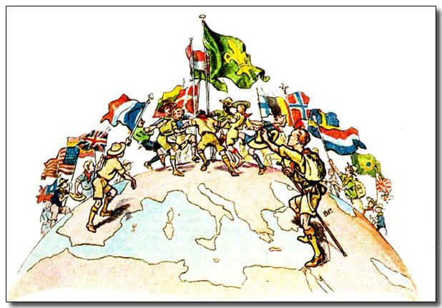
Flags (left to right). China, U.S.A., Spain, Great Britain, France, Lithuania, Denmark, Hungary, World Scout Flag, Finland, Belgium, Norway, Sweden, Netherlands, Brazil, Japan
Wood Badge Course Schedule
Note: We will be in the Field Uniform (normal Scout uniform) all day

7:30 am | Participant Check-In
8:30 am | Orientation Tour and Staff Exhibit
9:30 am | Gilwell Field Assembly
9:45 am | Break
10:00 am | Course Overview
10:30 am | Listening to Learn (Den Presentation)
11:30 am | Opening Luncheon
12:50 pm | Break
1:00 pm | Troop Meeting
3:00 pm | Break
3:10 pm | Patrol Leaders Council Meeting
4:00 pm | Values, Mission, and Vision / Ticket
5:00 pm | Patrol Meeting
6:00 pm | Dinner
7:00 pm | Who Me? Game (Patrol Activity)
8:00 pm | Introduction to Campfires
8:30 pm | Instructional Campfire
9:30 pm | Cracker Barrel
10:00 pm | Head to Fort for sleep
Check in, Orientation, Team Formation
DAY ONE, 7:30am to 9:30am
We gather together for the first time so that you may:
- Form teams that will stay together throughout the course.
- Meet the staff member assigned to your team.
- Consider yourself, for the moment, to be a Cub Scout den led by a den chief (a staff member).
- Enjoy several brief and entertaining get-acquainted activities.
- Locate the course facilities, meeting places, and other relevant landmarks.
- Understand emergency procedures.
- View the staff exhibit, both to gain from the material being presented and to see a model presentation of the sorts of exhibits you will later prepare yourselves.
- Have FUN!

Cub Pack
We gather as a Cub Pack to review Cub and Webelos-related information. However, you’ll be involved much like a new Cub Scout would be. That is, you’ll be thrown into a (well planned) blitz of fun activities. A few of the things you will learn this morning include:
- The split, two-finger Cub Scout sign and what it symbolizes?
- Do you know the Cub Scout Oath and Promise (or) the Law of the Pack?
- What the acronym “Webelos” stands for?

Staff Exhibit
The staff exhibit illustrates an important scouting topic and its application throughout the various programs of Scouting:
- Cub Scouts
- Boy Scouts
- Venture Scouts
- Varsity Scouts

The topic was chosen by the group of staffers who will be your Den Chiefs and Troop Guides during the course. They created the exhibit as a model for patrol exhibits that will be created later in the program. This presentation sets a standard for what is acceptable in the development and presentation of your patrol exhibit.

Gilwell Field Assembly
DAY ONE, 9:30am to 9:45am
Everyone is excited to be here! But where exactly is “here”? Gilwell Field of course! This name is one of the many key traditions that we uphold to link modern times to the long and rich heritage of Wood Badge. Gilwell Field was the home of the very first Wood Badge course – taking place exactly 90 years ago today! Gilwell Field serves as a symbol linking all Wood Badge courses around the world and through the years.
We’ll also see a flag ceremony demonstrated - a serious ceremony that you will participate in yourself. Wood Badge models “duty to country” frequently during the course.
This morning’s assembly is suited for Cub Scouts - for that is what you are right now! We use the Cub Scout salute as the US and historic flags are raised. We use the Cub Scout sign while reciting the Cub Scout Promise and the Law of the Pack.

Historic Flag Presentation
The Grand Union Flag

A nation’s flag is a stirring sight as if flies in the wind, representing a country’s land, its people, its government, and its ideals. The Egyptians flew the first flag-like symbols thousands of years ago, and people have been flying them ever since.
While many flags have flown over what is now the United States of America, the first flag to represent all the colonies was the Continental Colors, also called the Cambridge Flag or the Grand Union Flag. This flag, on which the British flag appeared at the upper left, was the unofficial American Flag in 1775-1776. On New Year’s Day, in Cambridge, Massachusetts, George Washington chose it to be flown to celebrate the formation of the Continental Army. Later that year, it became the first American flag to be saluted by another country – the Netherlands.

We will honor the men and women who founded this country by singing the first stanza of “America the Beautiful”. The words can be found in your songbook
Course Overview
DAY ONE, 10:00am to 10:30am
Ask yourself “why did I sign up for Wood Badge?” You may have many answers to this question. Hopefully somewhere on your list were Leadership and Teamwork. If they are not your first thoughts now, they will likely be there by the end of the course. The focus of this course is to provide solid training in the modern concepts of Leadership and Teamwork. An underlying concept is that Wood Badge is not so much about the leader attending the course as it is about the youth in his/her unit back at home. This course will provide you with training to go back to your unit, lead change in a positive manner and using teamwork, improve your program for your youth.

The purpose of the course overview is the help you:
- Understand the progression of BSA training opportunities and the place Wood Badge holds in that framework.
- Get an overview of the practical and application phases of Wood Badge.
- Understand why the Boy Scout troop is utilized during Wood Badge as the model for training and team building.
- Discard any misconceptions or anxiety regarding the course purpose, content, and methods of presentation.

Scouting and Leadership Training
The quality of the Scouting experience for Cub Scouts, Boy Scouts, Varsity Scouts, and Venturers depends upon the quality of those leading the units and those working in the districts and councils throughout the nation. The BSA offers leaders a progression of training opportunities to give them the skills they need to provide leadership for Scouting and leadership for America.
Here is what it looks like and how it works.
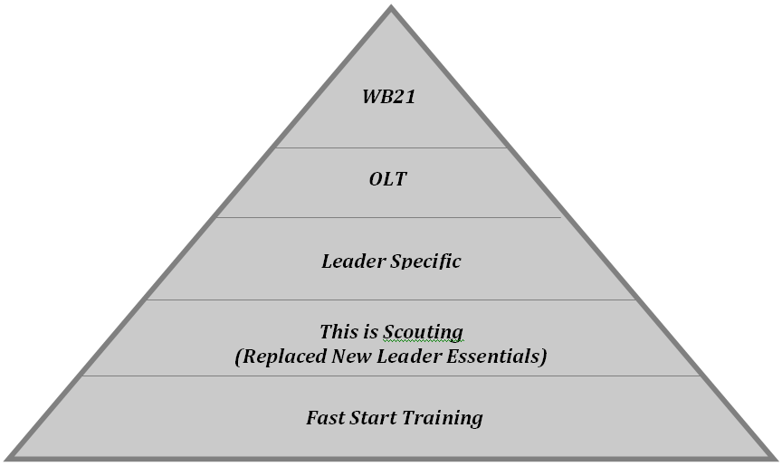

Leader Specific

OLT
- Orientation and Fast Start. Done on-line at myscouting.org, these provide a non-structured introduction to the Scouting organization.
- This is Scouting (formerly New Leader Essentials). This is a 90-minute overview of the mission, vision, and values of the BSA, and an introduction to each of the Scouting programs.
- Leader-Specific Training. Contained in this training are the nuts and bolts of specific positions in Scouting. Adult leaders can learn how best to fulfill their particular leadership roles in Cub Scouting, Boy Scouting, Varsity Scouting, or Venturing, or as district or council Scouters involved with multiple Scouting program areas.
- Appropriate Outdoor Skills Training. Training opportunities are targeted to enhance the outdoor skills needed by leaders in Scouting’s various programs.
- Wood Badge for the 21st Century. The BSA’s ultimate leadership training for adults, Wood Badge offers a six-day immersion in the theory, practice, and experience of appropriate skills for leading others within Scouting and in many environments beyond the BSA.
- Lifelong Learning. In addition to its progression of structured training, the BSA encourages leaders to take advantage of opportunities for continuous learning and supplemental training within the Scouting organization—roundtables, pow-wows, COPE courses, Scouting’s publications, special courses tailored to specific program areas of emphasis, etc.—and the great variety of possibilities beyond the BSA to increase skills. Lifelong learning is further enhanced when adults accept the challenge of teaching skills to others.

The front end of this BSA Training Continuum is skills-oriented. In the middle, the emphasis is on leadership. After that, the focus is on advanced skills that require leadership.

What Can You Expect From a Wood Badge Course?
As a result of attending this course, you will:
- Acquire a global view of Scouting as a family of interrelated, values-based programs providing age-appropriate activities for youth.
- Become familiar with contemporary team leadership concepts.
- Experience the stages of team development and practice leadership approaches appropriate for those stages.
- Have great deal of fun in the company of interesting, like-minded individuals.
- Develop a renewed commitment to provide Scouting with the best possible leadership.
- Leave physically and emotionally tired but fully inspired to lead your unit to better things.

The Central Themes of Wood Badge
The Wood Badge program is built on the concept of five central themes, each of which forms a side of the Wood Badge pentagon icon. Each of these themes is represented on the icon and throughout the course by one of the five colors of the MacLaren tartan. The themes are the threads of a course which, when woven together, form the pattern of the tartan and the full measure of Wood Badge.

Wood Badge accomplishes these goals by building all the pieces of the course on a foundation of the five central themes. The themes, and the presentations that directly support them, are as follows:
- Living the Values - Values, Mission, and Vision
- Bringing the Vision to Life - Listening to Learn; Communication; Inclusiveness; Valuing People and Leveraging Diversity; Coaching and Mentoring
- Models for Success - Stages of Team Development; The Leading EDGE ™; The Teaching EDGE™
- Tools of the Trade - Project Planning; Leading Change; Problem Solving and Decision Making, Managing Conflict, Self Assessment
- Leading to Make a Difference - Leaving a Legacy

The Tools of the Course
To build and deliver the course, many different tools and methodologies are employed by the staff. Among these are:

- The Boy Scout Troop Setting - Wood Badge is designed to be as valuable to leaders involved with Cub Scouting, Varsity Scouting, and Venturing as it is to those primarily involved with the Boy Scout program. Participants begin a Wood Badge course as Cub Scouts. The pack format is used initially, with the Cubmaster doing the leading and den chiefs assisting with the learning and activities.
When participants bridge over at the blue and gold luncheon, the troop format is incorporated with the Scoutmaster mentoring the senior patrol leader while the senior patrol leader takes over management of the troop. The troop guides will aid with instruction and the ticket. Later in the course, as the patrols advance in rank and no longer need a troop guide, the troop guides become part of the Venturing program. For the bulk of the course, participants and staff will consider themselves members of Gilwell Troop 1.
A troop setting provides a good framework to practice the leadership skills introduced during the course. Be assured, though, that the course content and leadership principles will be applicable to Scouters working throughout the movement and will provide a common foundation of leadership skills that can and should be used in all Scouting program areas.
There will be three troop meetings during this course, one on each of the first three days. These represent three weeks in the life of a Scout unit. The final portion of the course—the outdoor experience—parallels the sort of activity a Scout troop, a Cub Scout pack, a Varsity Scout team, or a Venturing crew would build toward for the final week of a month long program.

- The Gilwell Gazette - As the Wood Badge course progresses, participants will find that they are being provided with a great deal of information, both through presentations and through resource material explaining what is happening and why. Teams can develop most efficiently when they have full access to resources.
The Gilwell Gazette is the newspaper of the Wood Badge course. It is distributed each morning, with the intent of letting participants know as much as possible about the inner workings of the course and the particular events planned for that day. In it, participants will also find the schedule for the day, interesting stories about people and activities, articles submitted by patrol scribes, and lots of material that relates to the operation of the course.

Patrol Project – During the gathering activities on the first morning of the course everyone saw the exhibit developed by the Wood Badge staff. Each patrol is tasked during the course to plan and produce a project of its own.
The project must illustrate a universal aspect of Scouting that is clearly associated with Cub Scouting, Boy Scouting, Varsity Scouting, and Venturing, and it must consist of a self-explanatory display and an oral presentation. Patrols will present their projects to the rest of the troop on the fifth day of the course.

Wood Badge Ticket - One of the great traditions of Wood Badge is the ticket. In Baden-Powell’s day, those in the military were expected to pay their own way back to England at the end of their service. To economize, soldiers nearing completion of their duties would seek assignments at posts increasingly close to home—a process known as working your ticket.
During this course, participants are asked to develop a ticket—a list of goals that will allow them to use their new leadership skills in ways that strengthen Scouting in their home units, districts, and councils. Details of the ticket process are further discussed in the Values, Mission, amid Vision session.

Summary
In summary, we applaud your decision to sign-up and participate in this Wood Badge experience. Your staff promises to make every effort to deliver to you the mountaintop experience expected from the pinnacle of BSA training. We urge you to fully immerse yourself in the experience and truly do your best to absorb the information provided and the exposures to leadership and teambuilding opportunities. Become a contributing part of your patrol and the overall Troop. Always be sure to ask questions and strive to gain additional knowledge from our talented and highly experienced staff. Above all else we want you to have a good time while we Keep It Simple and Make if Fun!
Listening to Learn
DAY ONE, 10:30am to 11:20am
Patrol, welcome home to your own private space! Let’s settle in and do the following:
- Become aware of how we listen
- See how good listening works as a communication skill
- Practice active and empathetic listening
- Get some tips on how to receive and give feedback
Listening is…
- An essential part of communication
- Not taught in school
- A skill that can be learned
Why is Listening a Key Skill of Leadership?
- Connecting
- Decision Making
- Problem Solving
“Seek first to understand, then to be understood.”
—Stephen Covey
Two Parts of Effective Listening
- Active Listening
- Empathetic Listening
Active Listening Requires…
- Rephrasing and Confirming
- Nonjudgmental Attitude
Empathetic Listening Requires…
- Putting oneself in the speaker’s place
- Imagining the speaker’s viewpoint
- Understanding the speaker’s feelings
Monitoring Our Listening Level
- Awareness
- Adjustments
- Powerful Tools
Listening in Adversarial Situations
- Nonjudgmental
- Productive Framework
- Positive Conversation
Listeners should always strive to create a positive present as opposed to a negative past.
Giving and Receiving Feedback
- Can be difficult
- Basic part of team development, leadership, and friendship
- Both parties must use effective listening
Tips on Giving Feedback
- Is it helpful?
- Do others want it?
- Can it change a behavior?
- Is it specific?
- Does it describe behavior?
- How does it impact you?
- Does it contain an “I” statement?
- Did the recipient understand what you said?
You can give caring feedback without a good technique, but the slickest technique in the world will not hide a lack of caring.
Tips on Receiving Feedback
- Seek out feedback.
- Listen carefully.
- Listen actively.
- Listen empathetically.
- Monitor your emotions.
Consider feedback to be a gift. It truly is one.
Effective Listening
- A learned skill
- Important to relationships and problem solving
- Active and empathetic
- Turns a negative situation into a positive one
- Give and receive feedback

Ticket
Can this be part of your ticket?
Blue and Gold Banquet
DAY ONE, 11:30am to 12:50pm
During a Wood Badge course, it is said that you will be fed by a fire-hose. That is just our way of saying to hold on; there will be a lot of information coming at you. For nourishment of the physical kind, we will make sure you get plenty to eat and that it tastes good. You must keep up your strength to absorb all that is here to experience.
At lunch on Day One, we celebrate Cub Scouting with a banquet and entertainment – Cub Scout style! This is designed to be a fun start to the course. Also, you will:
- Become more acquainted with other Scouters, course staff, and council visitors
- Learn about the traditions of Wood Badge and those who propelled its vision
- Cross over into Boy Scouts and become patrols!
- Understand the responsibilities of the service and program patrol

Webelos-to-Scout Bridging Ceremony
Near the end of the Pack 1 Blue and Gold Banquet, you (our Webelos) will make the transition to Boy Scouts using a brief and simple ceremony. The ceremony will include four candles and a footbridge. The footbridge is symbolic of the “crossing over” or “bridging” into the Boy Scout program. The 4 different-colored candles represent the 4 points on a compass and the wind that comes from each direction.
After congratulations to the Webelos, the Cubmaster asks them to stand with their dens and prepare to cross over to Troop 1. On one side of the bridge, the Webelos gives one final Cub Scout handshake to the Webelos and on the other side, the Senior Patrol Leader and the Scoutmaster welcome them individually and present their patrol flag.

Wood Badge Traditions
There are many traditions that unite our course with all other Wood Badge courses around the world. Some traditions go back to the beginning of Wood Badge. Chief among these are:
- Gilwell Field: Baden-Powell held the first Wood Badge course at Gilwell Park near London. To this day, Gilwell is considered the international home of Wood Badge. Wherever on the globe a course takes place, the main assembly area is known as Gilwell Field.
- Ax and log: The ax and log is the totem of Gilwell Park. The ax is the symbol of the English freeman. Whereas serfs could only gather wood from the forest floor, a freeman was given the right of loppage. Earned as a right by service, a freeman could cut limbs from the nobleman’s forest as high as they could reach with an ax. The ax became the badge of a freeman.
- MacLaren tartan: In 1919, a Scotsman named W. F. de Bois MacLaren, a district commissioner for Scouting in Scotland, purchased Gilwell Park and presented it to the British Boy Scout Association. He explained that one of his purposes in doing so was “to provide a training ground for the officers of the Scouting movement.” In perpetual appreciation for his generosity to Scouting, Wood Badge adopted the tartan of the MacLaren clan. It is this tartan that appears on the Wood Badge neckerchief.
- Wood Badge beads: In 1888 during a military campaign in Africa, Baden Powell acquired a necklace of wooden beads from the hut of a warrior chief named Dinizulu. Years later at the conclusion of the first Wood Badge course, Baden-Powell gave each course graduate a bead from the necklace. The “Wood Badge” program takes its name from those beads. Since then, more than 100,000 Scouters worldwide have completed Wood Badge courses and can wear replicas of the original wooden beads.
- Neckerchief and woggle: Held in place by a leather woggle, the Wood Badge neckerchief - tan with a patch of MacLaren tartan—may be worn by course graduates. Wood Badge beads, neckerchief, and woggle may be worn only with the official field uniform of the BSA.
- Kudu horn: During his military service in Africa, Baden-Powell observed members of the Matabele tribe blowing on the horn of a kudu to signal to one another. He brought a kudu horn back to England with him, and in the summer of 1907 when he held his first experimental camp on Brownsea Island, Baden Powell sounded the horn to assemble his campers. The same horn was entrusted to Gilwell Park in 1920 for use in Scout training courses. Since that time, the kudu horn has been a symbol of Wood Badge courses throughout the world.

Service Patrol and Program Patrol Responsibilities
Each day, one patrol will act as the service patrol and one patrol will be the program patrol. These duties are Wood Badge traditions and not necessarily part of a typical Troop’s operation. The service and program patrols for Day One assume their duties during this lunchtime presentation. All others will rotate at the conclusion of Gilwell.

Service and Program Patrol Symbols
The senior patrol leader will ask a member of the Day One service and program patrols to come forward to receive the symbols of office for those patrols.
- Service patrol symbol — a small shovel
- Program patrol symbol — a large set of beads

The patrols are encouraged to decorate (but not desecrate) the symbols in their keeping – by attaching some version of their totems, though are free to be creative.

Gilwell Song
The Gilwell Song has been sung by generations of Wood Badge Scouters - always energetically, but with wildly varying degrees of harmonic success. Found on the next page, the song is always sung in patrol order. Listen for the cue: “Is there a beaver in the house?”

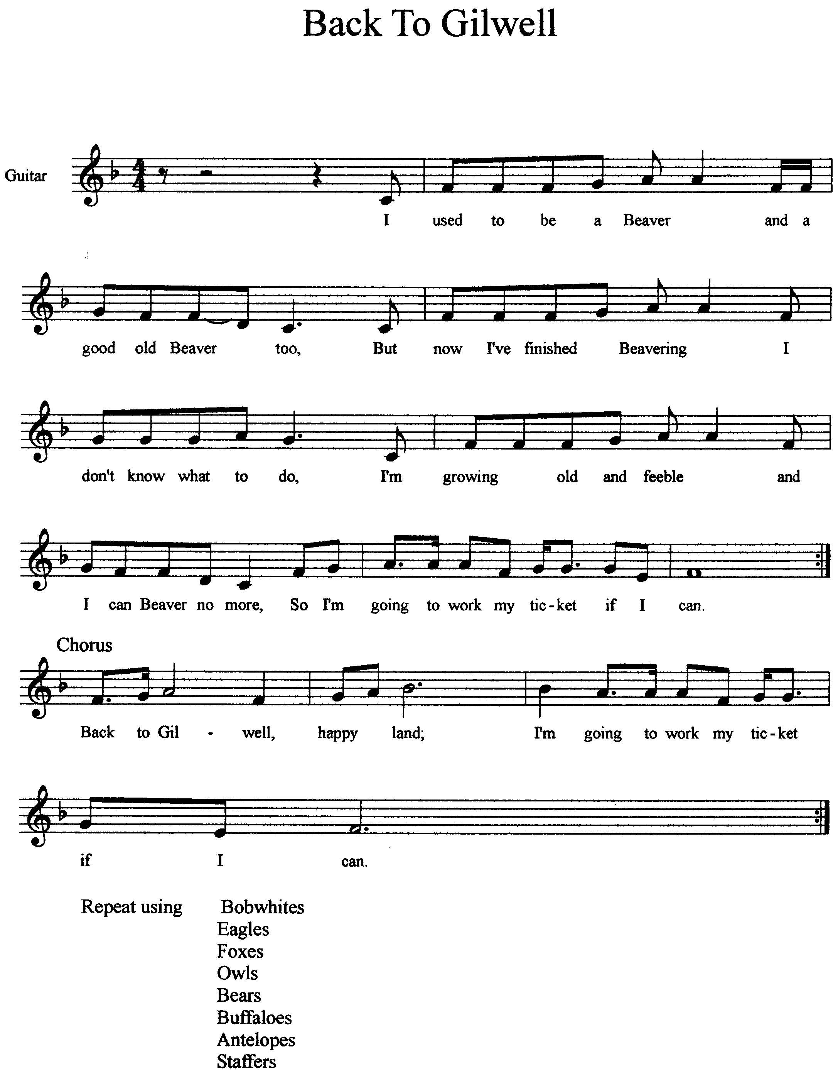
Patrol Roster
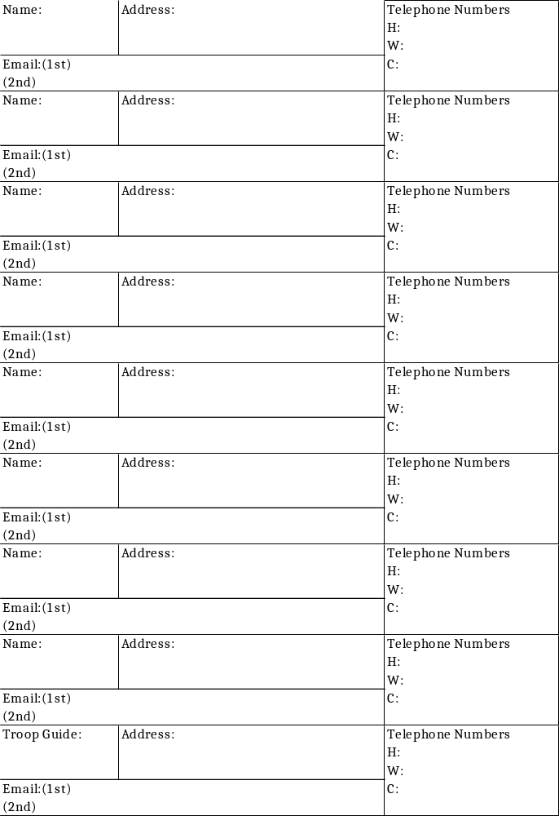
Notes and How to Keep ‘Em
Did you ever hear a really great idea that you wanted to use with your Patrol or troop—and then discovered that when you needed it you couldn’t remember the details? It happens to all of us! So, taking notes of good ideas is important.
There is nothing hard or complicated about taking notes. Remember that they are for your personal use and you’ll soon work out your own way of doing it. Here are some ideas that may help.
- Don’t try to write everything down. Just note the key words with enough detail so you’ll be able to recall what you saw or heard.
- Do write down enough information. It’s frustrating to read the words like “paper plate gimmick” in your notes but not being able to recall what the gimmick was.
- Use the outline form. It’s a good way to organize your notes. A detailed system starts with major topics; the details are then filled in. Numbers or bullets keep things sorted. Here’s an example of an outline form:

I. Notes taking tips
A. Notes help you remember details.
B. Taking notes of good ideas is important
C. Note-taking isn’t complicated
1. They’re for your own use
2. Work out your own system.
D. Helpful hints
1. Don’t write everything down.
a. Note key words
b. Add details to aid recall.
II. Write down enough information
III. Use the outline form.
A. Good way to organize notes
B. List of numbered items is simplest
C. Outline starts with major topics
D. Details are then filled in.

If you are a visual person, don’t hesitate to use sketches. You don’t have to be an artist. Here are some simple examples:
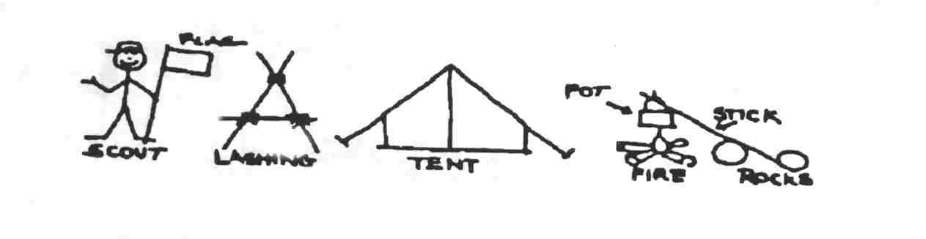
Finally, go over your notes before they get “cold” and be sure you recall everything. Fill in more detail if too vague. When you are reviewing them ask yourself: “Will I be able to remember the main points in a week or a month?” Then put them in a place where you will find them and use them. They can be a very valuable resource.
Troop Meeting
DAY ONE, 1:00pm to 3:00pm
Turk’s Head or Woggle neckerchief slide
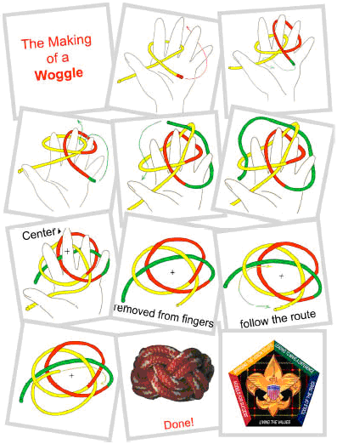
2 Strand x 4 Bight Turkshead Woggle
Aims and Methods Worksheet
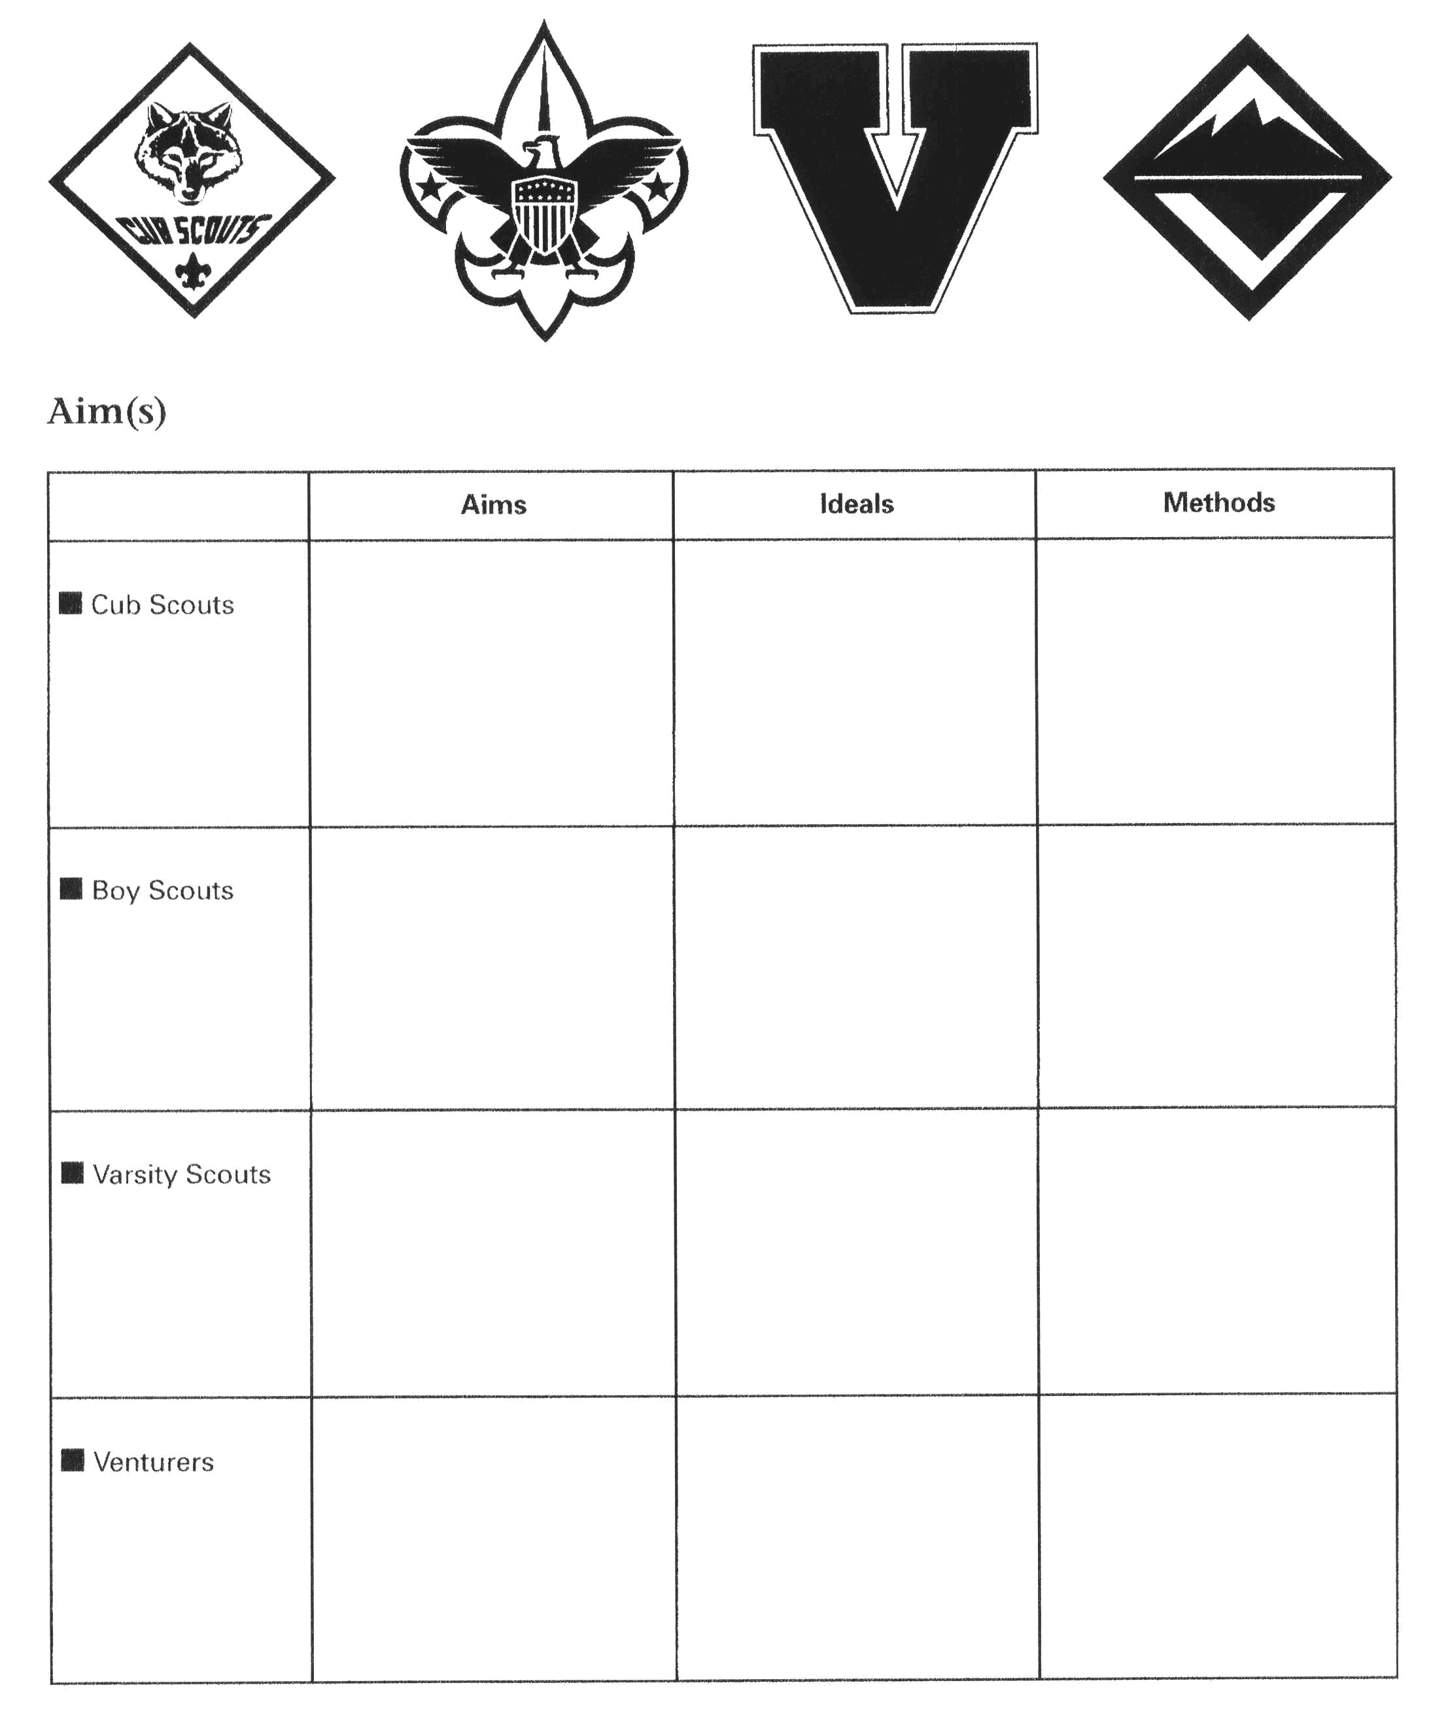
Patrol Leadership Roster
Daily Roster

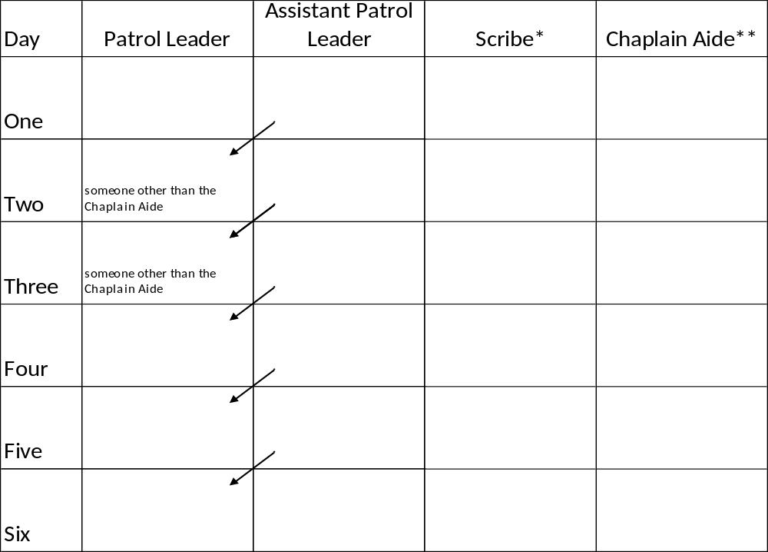

Each day, a different member will serve as leader of your patrol. This will allow each person to have one chance during a Wood Badge course to experience that leadership opportunity. The person assigned as Assistant Patrol Leader will become Patrol Leader on the following day.
* The patrol scribe may be held by one person throughout the course or the position may rotate among several or all members of the patrol.
** It is best that the position of chaplain aide be held by the same individual throughout the course. Because of their involvement with the chaplain aides meeting on Day Two and Day Three, the person serving as chaplain aide should be patrol leader on days other than Day Two or Day Three.
Daily Patrol Self-Assessment Form
The assessment process is meant to provide members with hands-on experience in making assessments. It may also give you fresh insights into ways that the patrol can more effectively develop into a high-performance team. An effective way to evaluate performance is to use the Start, Stop Continue evaluation tool for the daily patrol self assessment.
The Start, Stop, Continue (SSC) tool is used for a variety of purposes. In the process of developing your Patrol, it will be very helpful to assess team interaction and to modify actions and behaviors to move you towards a stronger performing team. Here is a brief outline of the steps to follow in using the Start, Stop, Continue worksheet.
Think about your patrol’s activities for the day. Think about what you are doing as it pertains to actions within both your Patrol and in the Troop. Ask yourself these questions:
- In our patrol, what should we put in place to improve?
(Something we should START.)
- In our patrol, what is not working?
(Something we should STOP.)
- In our patrol, what is working well?
(Something we should CONTINUE.)
Before, during, or after an activity you can always stop and check how it’s going by using the SSC tool. (Perhaps you know this tool by another name: Thorns, Roses, and Rosebuds.)
A key to effective team development is self assessment — regularly measuring the enthusiasm and skill level of the group. The daily self–assessment encourages course Scouters to do just that.
The Daily Patrol Self-Assessment takes place each morning during or just after breakfast. Members use the following discussion points to assess their patrol’s activities of the previous 24 hours.
The evaluation is discussed only within the patrol. It is not shared with the patrol leaders’ council or the rest of the troop. A copy of each day’s assessment form should be kept in the Patrol Leaders Notebook for future reference.
Your Boy Scouts learn to use Start, Stop, Continue in Buckskin Leader Training!
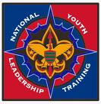
Stop, Start, Continue Worksheet
Category | Assessment
Start | In our patrol, what should we put in place to improve? (Some things we should START)  1.  2.  3.
Stop | In our patrol, what is not working? (Some things we should STOP)  1.  2.  3.
Continue | In our patrol, what is working well? (Some things we should CONTINUE)  1.  2.  3.

The Art and Skill of Creating a Totem
Creating a totem is a method by which members of a Wood Badge patrol can have a distinguishing symbol for themselves and their patrol. The totem becomes a life long identifying characteristic of the patrol that all members can use as a reminder of their time at Wood Badge Troop 1.
A totem is unique to a particular patrol. It is unlike any other totem, even those for patrols with the same name. For example, not all Beaver totems are the same, but they all have symbols that reference a Beaver while differing in design.
The totem is to be one which all members of the patrol can easily reproduce on their own from memory It should not require any special artistic talent or equipment Simplicity and creativity in design are important elements to keep in mind when designing a totem. The totem design incorporates the Wood Badge course number, and represents the patrol animal or bird. Some totems also include a part that is unique to each individual patrol member. The totem for your patrol should be presented to your Troop Guide for review and guidance.
When the practical phase of your Wood Badge training is completed the totem will be with you for the remainder of your Scouting career. It is not something that is changed or modified after the course. Your fellow patrol members will expect you to maintain the totem you created as a patrol in its original form. Here are some examples:

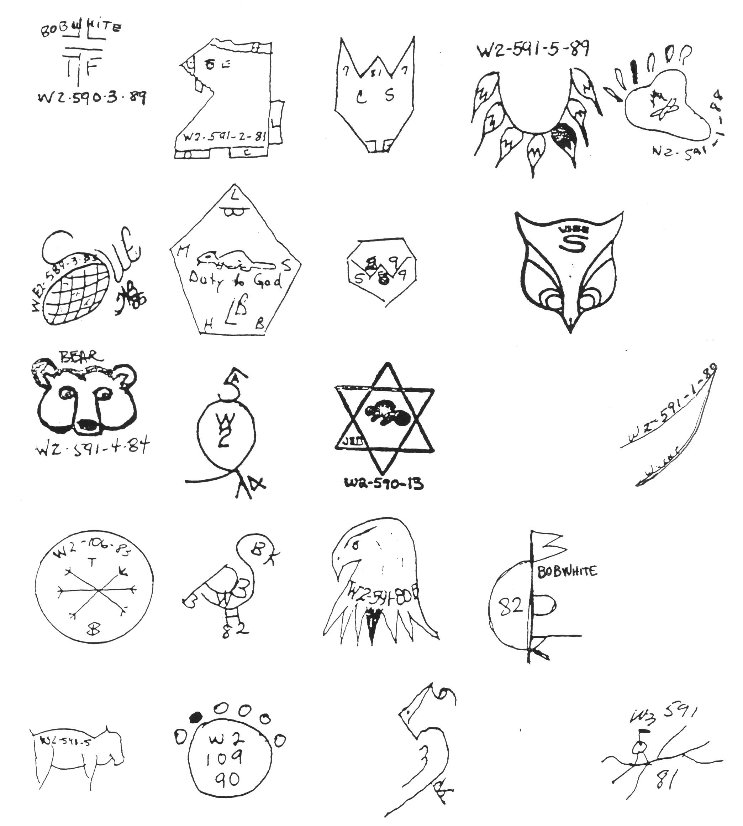
Values, Mission, and Vision
DAY ONE, 4:00pm to 4:30pm
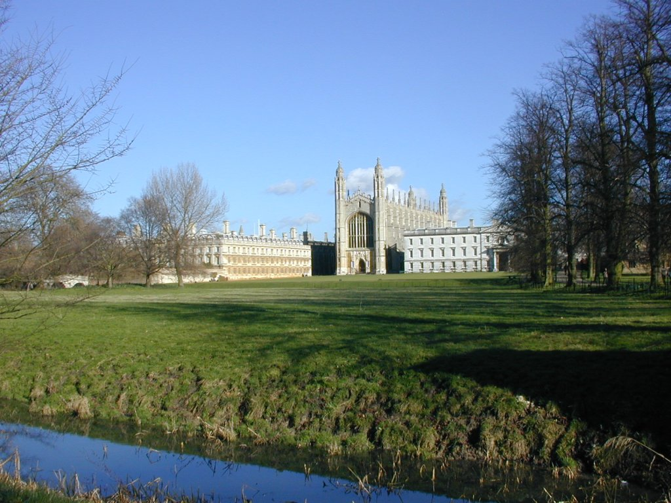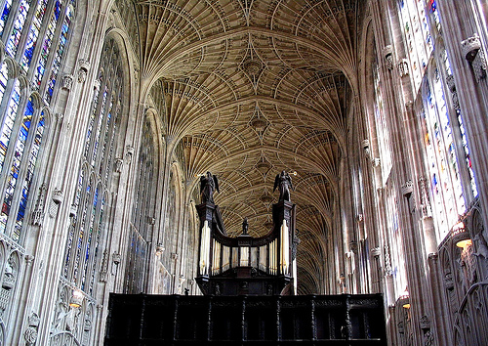
Kings College Chapel at Cambridge University Interior of Chapel

Values are core beliefs or desires that guide or motivate our attitudes and actions. They can take a variety of forms:
- Principals and standards like “Be Prepared” or “Do a Good Turn Daily”
- Personal qualities such as honesty and being organized
- Character traits like loyalty, enthusiasm, and openness to others
- Codes of Ethics including the BSA Outdoor Code and Ten Commandments
- Lifestyle goals like living a healthy life or caring for others

Earlier today, you gave thought to Scouting’s aims, methods, and ideals. These ideals (or values) are articulated in the Scout Oath and Law. Now refer to the 20 questions about yourself that you filled out before arriving. Your answers can help you understand what your own values are.

A Mission is a brief statement that reflects the core values and communicates long-term objectives. A mission statement aligns people with a purpose and creates unity. It can define directions for change and growth.

The Mission Statement of the BSA
The mission of the Boy Scouts of America is to prepare young people to make ethical and moral choices over their lifetimes by instilling in them the values of the Scout Oath and Law.

Vision is a picture of future success. Take a minute to imagine how things would be if you could snap your fingers and instantly make scouting better in some way. What may come to mind is a well organized Boy Scout troop that is led by its youth. Perhaps you imagine a Cub program that is so fun that the kids can’t wait to come back each week. Is your “picture of success” about a Venture crew that has an active outdoor program?
This presentation shows 4 large visions that you might be familiar with:
- President Kennedy challenging Americans to go to the Moon within a decade.
- Dr. Martin Luther King Jr. explaining his “Dream” that envisioned a nation where children would be judged by the content of their character and not with the color of their skin.
- Margaret Thatcher explaining vision as a tool of leadership: “I cannot change the past…it is my unique responsibility as a leader to shine a spotlight on the future and marshal the support of countryman to create that future.
- Robert Baden-Powell believed that a common moral code shared by scouts around the globe could eventually lead to world peace.

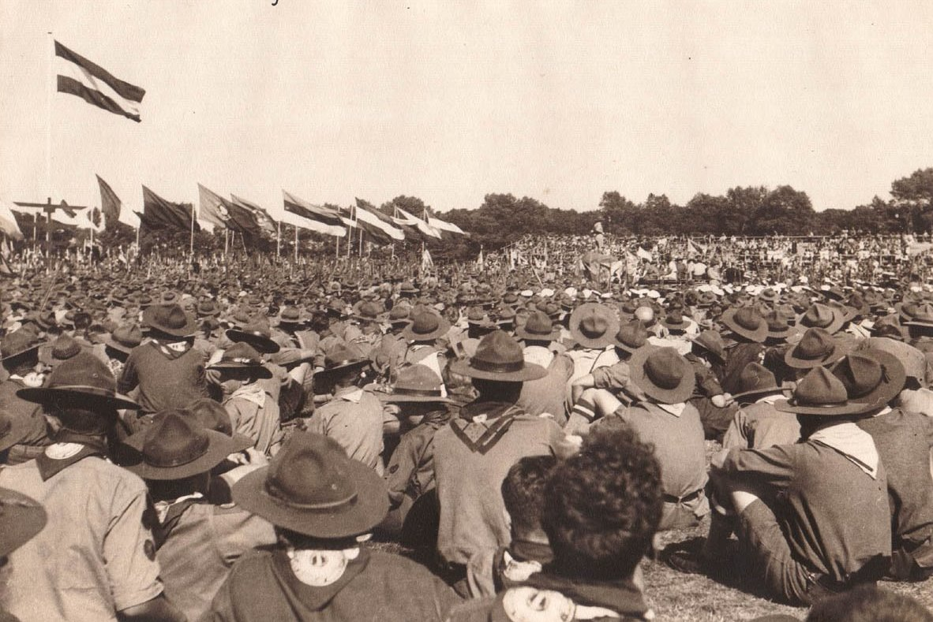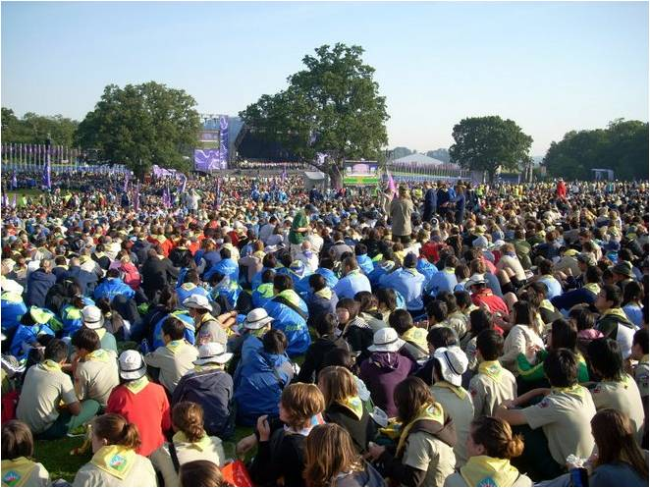
Netherlands World Jamboree 1937 World Jamboree 2007
A meaningful vision will have these criteria: it must engage the heart and spirit, lead to a worthwhile goal, be simple and attainable, and be flexible enough to change over time.

The Vision Statement of the BSA
The Boy Scouts of America is the nation’s foremost youth program of character development and values-based leadership training. In the future, Scouting will continue to
- Offer young people responsible fun and adventure
- Instill in young people lifetime values and develop in them ethical character as expressed in the Scout Oath and Law
- Train young people in citizenship, service, and leadership
- Serve America’s communities and families with its quality, values-based program.

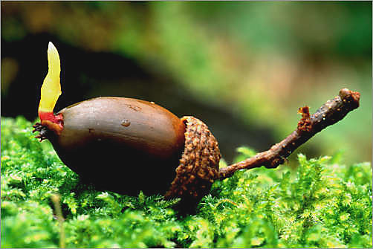
Now it’s your turn to develop a vision with a plan that will make it a reality.
Guidelines for Writing a Wood Badge Ticket
DAY ONE, 4:30pm to 5:00pm
A primary purpose of the wood Badge experience is to provide leadership for Scouting and leadership for America. Your ticket is a commitment to complete a set of goals that will significantly strengthen the BSA program in which you are involved. Additionally, the ticket provides and opportunity for you to practice leadership skills that will be of value in many areas of your life, both within and beyond Scouting.

Your ticket will include five significant goals.
The goals will be written in support of your current Scouting responsibilities and should be designed to provide maximum positive impact for youth membership.
At least one of the five goals will incorporate some aspect of diversity. Possibilities include goals that promote diversity in units, districts, and/or councils; that encourage a more diverse BSA membership; of that help young people better understand the nature and importance of diversity in Scouting and in America. This will be discussed in detail on Day Four during “Valuing People and Leveraging Diversity.”
If you wish, one of the five goals may involve developing and applying a self-assessment tool to measure your progress and effectiveness in relation to the other goals on your ticket. (This will be discussed in detail on Day Five during the “Self-Assessment” presentation.)

The goals written for your ticket should be SMART:
Specific - Describe this Ticket Goal in enough detail so that you and your ticket counselor know specifically what is to be done; how it is important, or how it will have an impact on the program. Is it challenging?
Measurable - Describe how this Ticket Goal is Measurable. How will you know when the goal has been accomplished?
Attainable - Describe how this Ticket Goal is Attainable. Can it be accomplished?
Relevant - Describe how this Ticket Goal is Relevant. How does it relate to your Scouting job?
Timely - Describe how this Ticket Goal is Timely. Can it be accomplished in a reasonable amount of time? "A Goal Without a Deadline is Only a Dream!"

Answering “Who, What, Where, When, Why, and How?”
An effective way of defining your ticket goals is to use the Who, What, Where, When, and Why steps. By describing each step for each goal, you can be assured that you will have a well-defined ticket goal. Then, after you have completed your ticket goal, perform a self-assessment to evaluate your goals. This is a good time to review your goal with your troop guide or ticket counselor.
For each goal, you will also indicate
- Who - Who is involved?
- What - What, specifically, will you do to help realize your vision through this goal?
- Where - Where will you work on the goal?
- When - When will you work on the goal?
- Why - Why is this goal important to realizing your vision?
- How measured - How do you measure the completion of your goal?
- How verified - How do you verify whether your goal helped to achieve your vision?

The troop guide assigned to your patrol will help you prepare your ticket and will approve it when it is completed.
You will be assigned a Ticket Counselor to help you in the completion of your ticket.
Upon returning home after your Wood Badge course, you will work with your ticket counselor. You will meet with your counselor to finalize your ticket and establish a review plan for completion.
The five goals of the ticket must be completed within 18 months of the end of the Wood Badge course.
When you and your ticket counselor have agreed that you have fulfilled all the items on your ticket, the following course of action should take place:
Your ticket counselor will:
- Submit your Wood Badge completion form to your council.
- Verify with your council that the form has been received and that your regalia is available.
- Arrange with you when you would like to have your “Beading Ceremony”.
It is appropriate to hold this ceremony is the area where your ticket was worked. For example; if you are a Cub Scout leader a pack meeting, Cub Scout Roundtable, or a ceremony where you invite family, friends, and fellow Scouters would be appropriate. A similar format would hold true for all others working at the unit level. For District or Council positions, a District or Council Dinner or recognition event (with approval of the appropriate executive) would be appropriate for you.
Your ticket counselor can help you arrange your ceremony and can enlist staffers to present your regalia to you. If you have specific people in mind to participate in your ceremony, let your troop guide know. A sample Wood Badge Ticket Ceremony is available

Introduction to Campfires & Instructional Campfire
DAY ONE, 8:00pm to 9:30pm
Campfire programs are a part of the great game of Scouting. Planning and directing a campfire develops leadership skills, performing with fellow scouts fosters friendship, understanding, and team skills, and the content can inspire positive character traits and citizenship in participants and audience members alike.
To win this part of the game of Scouting, there are some very basic “do’s” when planning a campfire program with youth.

Plan
This is the key to a successful campfire. Everyone knows their part and the material can be vetted if the program is laid out in advance. An easy way to schedule the entertainment is to “follow the flames”: in the early part of the evening when the flames are big and bright, the performances should be too. As the fire dies down, the program should calm and become more meaningful as the embers glow. Use interfaith openings and closings – unless your group consists of adherents to one faith, choose prayers that have a universal message, not a specific doctrine.
Sandwich this program between a ceremonial lighting of the fire and a BSA approved extinguishing and get ready to have an evening your scouts will be talking about until the next amazing campfire!
A campfire program planner like the one at the end of this section can help the director of your campfire put all the pieces together.

Build
A successful campfire is built on the four S’s:
- Showmanship – the presentation of the program, especially the enthusiastic attitudes of the performers, the location and the atmosphere make the campfire shine.
- Stunts – aka “skits”, will mostly be funny but can also teach or inspire.
- Songs – action, audience participation, Scout, inspirational, and silly; songs can set the tone of that portion of a program.
- Stories – Ghost stories are a traditional favorite, but must be considered carefully for gory descriptions and excessive fright value. Adventure, humor and heroic stories are also options to consider.
Including these elements in your campfire provide the fun and entertainment your Scouts are looking for.

Use
The Scout Law, especially the points friendly, courteous and kind. If the material your Scouts want to perform doesn’t meet those criteria, ask for an alternate. In general, topics of religion, politics, and mental or physical abilities should be avoided. There’s nothing humorous or entertaining about these issues. Additionally, for the target there’s rarely anything funny about being doused in water or any other kind of even pretend bullying behavior.
Inside jokes can be funny, but only to the few people who were there and can leave the rest of the audience feeling left out and bored. Material about bodily functions, toilet humor, and the use of drugs, alcohol, and tobacco are simply inappropriate as are cross gender impersonations for the sake of lampooning members of the opposite sex.

Prepare
Make sure the performers rehearse their parts. Public speaking and performing are stressful situations which can be eased by simply following the Scout motto: Be Prepared. Not only will this benefit the performers but it creates a better experience for the audience as well.
Have a back up plan in case issues arise that prevent the building of an actual fire. Be ready to recognize guests and new campers by including them in an opening or lighting ceremony to symbolize their joining the group.

Sometimes, even when we plan our campfire, building it to include a variety of positive entertainments, using the Scout Law as our test of appropriateness, and preparing carefully, offensive or un-Scout-like material makes it to the stage. What’s a Scout Leader to do?

Stop:
Don’t hesitate to stop the action and get the campfire back on the Scout track. The Master of Ceremonies, who may be an adult leader, the Senior Patrol Leader (if you work with a Boy Scout Troop), or the Venture Crew President, has the responsibility to step in. Performers and audience alike should be reminded of Scouting’s ideals and values and then presented more appropriate material. If the campfire is abruptly ended, disappointment will be the lingering memory of the evening, so it’s important to simply redirect the focus and continue the show.
Not only do the performers have a responsibility to provide a positive experience for the audience, the audience has a responsibility to provide a positive experience for the performers. A word to the assembly about etiquette before the campfire can set the standard for behavior for the evening’s entertainment. Any razzing or booing that does occur must be immediately halted. If a polite request for friendliness and courteousness doesn’t work, make the heckler part of the program. Moving the source of the disturbance out of the audience and into the show provides the attention they’re craving, and allows the participants and audience to enjoy the rest of the evening.

When campfire time comes, make sure your Scouts see the adult leadership participating enthusiastically in the proceedings and abiding by the same criteria for our contributions of the campfire. “We do not have a choice in whether we are setting the example; we only have a choice of the kind of example we set.”

CAMPFIRE PROGRAM

Place  Date  Time  Camp Director's approval: | Campers notified:  Campfire planning meeting  M.C.  Song leader  Cheermaster | Area set up by  Campfire built by  Fire put out by  Cleanup by

Spot | Title of Stung, Song or Story | By | Time
1
2
3
4
5
6
7
8
9
10
11
12
13
14
15
16
17
18
19
20 | Closing
THE CAMPFIRE PROGRAM PLANNER
How to use this sheet: Be sure that every feature of this campfire program upholds Scouting's highest traditions.
1. in a campfire planning meeting, fill in the top of the "Campfire Program" sheet (over)
2. On the "Campfire Program Planner" (below), list all units and individuals who will participate in the program
3. From each get and write down the name, description, and type of song, stunt or story they have planned.
4. The master-of-the-campfire organizes songs, stunts, and stories in a good sequence, considering timing, variety, smoothness, and showmanship.
5. M.C. makes out the campfire program sheet (over).
6. Copies of the program are given to all participants.

Cheer Planner | Spot |  | Campfire Program Planner
 |  |  | Group or Individual | Description | Type | Spot
Song Planner | Spot
CAMPFIRE PROGRAM

Place First Landing State Park  Date September 5, 2009  Time 8:30 pm  Camp Director's approval: | Campers notified: August 3, 2009  Campfire planning meeting Aug. 12  M.C. SPL Scott Scout  Song leader John Scout  Cheer Master Jake Scout | Area set up by Green Platypus Patrol  Campfire built by Furry Slinky Patrol  Fire put out by Crunchy Milk Patrol  Cleanup by Sunflower Pig Patrol

Spot | Title of Skit, Song or Story | By | Time
1 | Invocation | Chaplain’s Aide
2 | Story: “Give Me Time to Dream” | Steve Scout
3 | Song: “America the Beautiful” | All  Led by: John Scout
4 | Lighting of the Campfire | Scott Scout | 15 min  for spots 1-4
5 | Skit: “Bandana, Not a Banana” | Furry Slinky Patrol | 20 min
6 | Cheer: Chuck Norris Cheer | Jake Scout | 30 sec
7 | Song: “Hagalena Magalena” | Crunchy Milk Patrol  Chorus: All | 5 min
8 | Cheer: Desert Yell | Jake Scout | 30 sec
9 | Skit: “Brains For Sale!” | Sunflower Pig Patrol | 2 min
10 | Cheer: Neckerchief Cheer | Jake Scout | 30 sec
11 | Story: “The Story of the Ging Gang Gooli Song” | Green Platypus Patrol | 15 min
12 | Cheer: Watermelon Cheer | Jake Scout | 30 sec
13 | Skit: “The Brotherhood of Scouting” | Silly Sumo Patrol | 15 min
14 | Cheer: Stomp and Slap Cheer | Jake Scout | 30 sec
15 | Scout Master’s Minute | Craig Scouter | 1 min
16 | Song: “Philmont Hymn” | All  Led by: John Scout | 1 min
17 | Closing: Extinguish Fire | Scott Scout  Crunchy Milk Patrol | Total:  ~1:15

THE CAMPFIRE PROGRAM PLANNER

How to use this sheet: Be sure that every feature of this campfire program upholds Scouting's highest traditions.
1. In a campfire planning meeting, fill in the top of the "Campfire Program" sheet (over).
2. On the "Campfire Program Planner" (below), list all units and individuals who will participate in the program.
3. From each get and write down the name, description, and type of song, stunt or story they have planned.
4. The master-of-the-campfire organizes songs, stunts, and stories in a good sequence, considering timing, variety, smoothness, and showmanship.
5. M.C. makes out the campfire program sheet (over).
6. Copies of the program are given to all participants.

Cheer Planner | Spot |  | Campfire Program Planner
Chuck Norris Cheer | 6 |  | Group or Individual | Description | Type | Spot
Desert Yell | 8 |  | Furry Slinkys | Bandana, not Banana  Scout tries to fold a banana according to Scoutmaster directions | Skit | 5
Neckerchief Cheer | 10 |  | Sunflower  Pigs | Brains for Sale!  Scoutmaster “victim” | Mini - Skit | 9
Watermelon Cheer | 12 |  | Green Platypi | Story of the Ging Gang Gooli  Song  Great Grey Ghost Elephant story of B-Ps “global” song | Story / Skit | 11
Stomp and Slap | 14 |  | Silly Sumo | Brotherhood of Scouting  If you grow up with Scouting, you are never alone | Skit | 13
 |  |  | Scott Scout | Give Me Time to Dream  Modified prayer | Story | 2
 |  |  | Everett Scout | Invocation |  | 1
Song Planner | Spot
America the Beautiful | 3
Hagalena Magalena | 7
Philmont Hymn | 16

CAMPFIRE PROGRAM

Place Cub Camp Dining Hall  Date September 18, 2009  Time 8:30 pm  Camp Director's approval: | Campers notified:  Campfire planning meeting  M.C. Catherine Harding  Song leader Everett Winn  Cheer Master | Area set up by FQM Staff  Campfire built by FQM Staff  Fire put out by FQM Staff  Cleanup by

Spot | Title of Skit, Song or Story | By | Time
1 | Invocation | Everett Winn
2 | Story: “I am Old Glory” | Steve Busic
3 | Song: “God Bless America” | All  Led by: Everett Winn
4 | Lighting of the Campfire | Scott Street | 15 min  for spots 1-4
5 | Skit: OA Dance Presentation | OA Dance Team | 10 min
6 | Cheer: Grand Cheer | Catherine | 30 sec
7 | Song: “If I Were Not a Staffer” | Troop Guides | 5 min
8 | Cheer: Holy How Cheer | Catherine | 30 sec
9 | Skit: “CPR” | FQM Staff | 2 min
10 | Cheer: Politician’s Cheer | Catherine | 30 sec
11 | Skit: “The Princess & The Knave” | Karren Streagle  Scott Street | 15 min
12 | Cheer: Bell Ringer | Catherine | 30 sec
13 | Story: “The Founder: Baden-Powell” | Mike Oxford | 15 min
14 | Scout Master’s Minute | Craig Britt | 1 min
15 | Song: Scout Vespers | All  Led by: Everett Winn | 1 min
16 | Closing: Dismiss to Cracker Barrel | Scott Street | Total Time: approx 1:06

THE CAMPFIRE PROGRAM PLANNER

How to use this sheet: Be sure that every feature of this campfire program upholds Scouting's highest traditions.
1. In a campfire planning meeting, fill in the top of the "Campfire Program" sheet (over).
2. On the "Campfire Program Planner" (below), list all units and individuals who will participate in the program.
3. From each get and write down the name, description, and type of song, stunt or story they have planned.
4. The master-of-the-campfire organizes songs, stunts, and stories in a good sequence, considering timing, variety, smoothness, and showmanship.
5. M.C. makes out the campfire program sheet (over).
6. Copies of the program are given to all participants.

Cheer Planner | Spot |  | Campfire Program Planner
Grand Cheer | 6 |  | Group or Individual | Description | Type | Spot
Holy How Cheer | 8
Politician’s Cheer | 10
Bell Ringer Cheer | 12
Song Planner | Spot
God Bless America | 3
If I Were Not a Staffer | 7
Scout Vespers | 15
Campfire Resources for Scouters

This list is provided as a convenience. The stories, skits, and songs at these sites may or may not meet your needs or even the test of Friendly, Courteous, or Kind. Be sure your Scouts print out scripts and lyrics so a Leader can look them over for appropriateness. Remember, the Scout Shop also has publications to add to your library!

US Scouting Service Project – an outstanding clearing house for all kinds of information pertaining to scouting.
Songs: http://www.usscouts.org/usscouts/songs.asp
Skits: http://www.usscouts.org/usscouts/skits.asp
Cheers: http://www.usscouts.org/usscouts/cheers.asp

USSSP also houses Baloo’s Bugle, a cub level newsletter designed to supplement a Leader’s Roundtable resources. Each issue contains songs, skits, and cheers related to the monthly themes.
http://usscouts.org/bbugle.asp

Scoutarama – Scouting information for all level Scouts.
Skits: http://www.scoutorama.com/skit/
Songs: http://www.scoutorama.com/song/

We Know Campfire Skits – Campfire skits for all occasions for all types of campers.
465 skits of varying length and complexity are arranged alphabetically.
http://www.weknowskits.com/index.html

ScoutingAround – A variety of Scout related material and a large collection of songs, divided into categories.
http://www.scoutingaround.com/boy_scouts/scoutsong/songlist

Netwoods.com – contains a creative campfire handbook with resources on skits, cheers, songs, openings & closings.
http://www.netwoods.com/campfire/campfires/campfire.html

Whootie Owl’s Stories – Stories and Play Scripts from around the world, grouped by age of audience, and origin, type, and theme of story.
http://www.storiestogrowby.com/choose.php

First People of America and Canada – Turtle Island – Stories, Poems, and Prayers of Native North Americans, perfect for Scouting campfires.
http://www.firstpeople.us/

Now go have a great campfire and create some lasting memories, the BSA way!

DAY 2
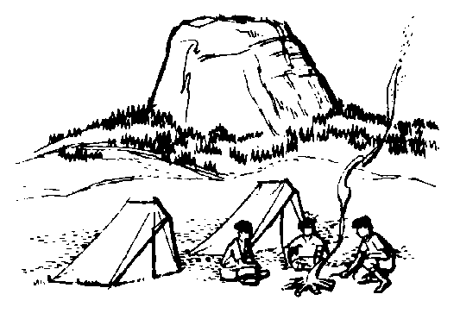
Wood Badge Course Schedule
Note: We will be in the Field Uniform (normal Scout uniform) except the time between lunch and dinner when you are to wear your new activity shirt.

7:00 am | Breakfast
8:00 am | Gilwell Field Assembly
8:30am | Pre-opening Game
8:40am | Troop Meeting
9:45am | Interpatrol Activity
10:15am | Break
10:30am | Inclusiveness
11:00am | Stages of Team Development
11:50am | Break
12:00pm | Lunch
12:15pm | Patrol Leaders Council Meeting /  Chaplain’s Aide Meeting
1:10pm | Photos
2:10pm | Communication (Patrol Presentation)
3:00pm | Break
3:10pm | Project Planning
3:40pm | Ticket Talk
3:50pm | Rocket Competition
5:10pm | Rocket Project Reflection
5:20pm | Patrol Meeting
6:20pm | Dinner
7:00pm | Wood Badge Game Show
8:00pm | Win All You Can Game
9:00pm | Flag Retirement Ceremony
9:30pm | Cracker Barrel
10:00pm | Head to Fort to sleep

Gilwell Field Assembly
DAY TWO, 8:00am to 8:30am
We assemble at Gilwell Field to begin our day. As you’ll see, we look forward to a day filled with team building games. B-P said “Scouting is a game with a purpose.” So, Scouting is meant to be “hands on.” Join in! (But, please try to not bloody yourself.)

Historic Flag Presentation

The Serapis Flag

Designed with 13 stripes alternating red, white, and blue, this flag was raised by Captain John Paul Jones on the British frigate Serapis during the most famous Revolutionary War naval Battle.
In 1779, after conducting sea raids on the coast of Britain, Jones took command of a rebuilt French merchant ship that had been renamed the U.S.S Bonhomme Richard in honor of Benjamin Franklin. In September of that year, Jones engaged the British Frigate Serapis in the North Sea, sailing in close, lashing his vessel to the British ship, and fighting the battle at point blank range. During the fight, two cannon burst on the Bonhomme Richard. The British Captain asked Jones if he was ready to surrender. Jones replied, ‘Sir, I have not yet begun to fight!’ Eventually it was the crew of the Serapis that surrendered, though the Bonhomme Richard was severely damaged. The American sailors boarded the Serapis and watched form the deck as the Bonhomme Richard sank beneath the waves.

Song
Today’s featured song is “Columbia, Gem of the Ocean” which is found in your songbook. In our country’s early days, this song was at times considered to be our national anthem. The “Columbia” was a famous warship but the Columbia in this song likely refers to the United States as a ship of state - with a crew of citizens riding safely through a storm.

O Columbia! Gem of the ocean, the home of the brave and the free,
The shrine of each patriot's devotion, a world offers homage to thee;
Thy mandates make heroes assemble, when Liberty's form stands in view;
Thy banners make tyranny tremble, when borne by the red, white, and blue,
When borne by the red, white, and blue; when borne by the red, white, and blue;
Thy banners make tyranny tremble, when borne by the red, white and blue.
Troop Meeting
DAY TWO, 8:40am to 9:45am
What Are You Most Afraid Of?” Worksheet
Below is a list, in alphabetical order, of 14 common fears. You have two tasks:
- Working on your own, rank all 14 items in the order in which you think a survey of respondents from throughout the United States ranked them.
Rank them from “1” (most feared) to “14” (least feared).
- Once everyone has completed the individual ranking, work together as a patrol to come up with a group ranking of the items, again using “1” for most feared, up to “14” for least feared.
Fear | Individual Ranking | Team Ranking
Darkness | ______________ | _____________
Death | ______________ | _____________
Deep water | ______________ | _____________
Dogs | ______________ | _____________
Driving/riding in a car | ______________ | _____________
Elevators | ______________ | _____________
Escalators | ______________ | _____________
Financial problems | ______________ | _____________
Flying | ______________ | _____________
Heights | ______________ | _____________
Insects and bugs | ______________ | _____________
Loneliness | ______________ | _____________
Sickness | ______________ | _____________
Speaking before a group | ______________ | _____________

Inclusiveness
DAY TWO, 10:30am to 11:00am
Learning Objectives
- Understand a basic definition of diversity.
- Recognize the importance of Inclusiveness to a team.
- Understand what simple behaviors that can make inclusiveness work for you.

The Usual Suspects
Think for a minute about the people in your unit at home. Think about the people you work with. Are there people you count on all the time? When it really needs to get done do you turn to “the usual suspects” to make it happen? Why?
- Do they work as you do?
- Are you alike in many ways?
- Do you know them better than others?
- What about the other folks? How are they different?

Diversity, Inclusiveness
For our purposes, diversity is any dimension that can be used to differentiate groups and people from one another.
Inclusiveness is our actions to help someone become part of a group.
What happens when a patrol makes diversity work?
- All skills and life experiences are put to work to achieve success.
- The experience is richer for all.
But what happens if diversity isn’t made to work?
- People feel disrespected—lack of communication and cooperation.
- Strong emotions build that get in the way—isolation, hostility.
We are not talking about discrimination. It can be as simple as always turning to “the usual suspects.”

Patrol = People
- Successful patrols put differences to work.
- Successful patrols will function as a team.
- Members of a team are responsible for the whole group.
How do you make diversity work in a patrol? Include everyone on the team!

What can I do?
- When you lead, make sure everyone has challenging opportunities to contribute and learn.
- Consider how your leadership behavior affects the team environment.
- Take time to show you care.
- Recognize individual and team achievements.
- Reach out and learn something from everyone.

Food for Thought
- Does everyone understand and agree on what success looks like for your group?
- Do you actively sense how team members are doing and do something about it?
- Are you teaching each other skills so all can more fully participate?
- Does the team support each other during times of conflict?
- Does the team work to ensure everyone is performing at their best?
- Do you celebrate individual success as a group?
- Does everyone feel like they are contributing something to and getting something from the patrol?

Powerful Concepts, Simple Behaviors
- Diversity and inclusiveness are powerful concepts.
- Make them work and the team will grow!
- Make them work and you will grow.
How will you include a diversity/ inclusiveness goal in your ticket? In addition to your unit, consider other areas such as your district or council.

Stages of Team Development
DAY TWO, 11:00am to 11:50am
- Recognize the stage of development associated with a team.
- Understand the characteristics of each of the four stages of team development.
- Understand how enthusiasm and skill level relates to the four stages.
There are a variety of ways to illustrate team development. We’ll use the following:
“Pickup Sticks”  Forming | “At Odds”  Storming | “Coming Around”  Norming | “As One”  Performing
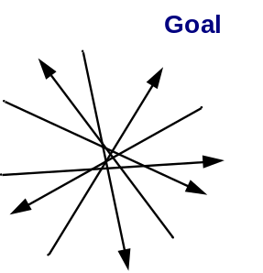 | 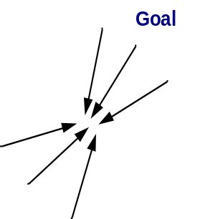 | 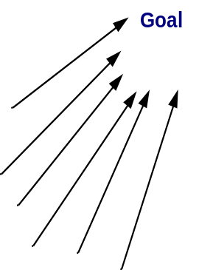 | 

- First stage: Forming stage (“Pickup Sticks”).
Most team members are fairly eager to be on the team. However, they often come with high, unrealistic expectations. These expectations are accompanied by some anxiety about how they will fit in, how much they can trust others, and what demands will be placed on them. Team members are also unclear about norms, roles, goals, and timelines. In this stage, there is high dependence on the leadership figure for purpose and direction. Behavior is usually tentative and polite. The major issues are personal well being, acceptance, and trust.
- Second stage: Storming stage (“At Odds”).
As the team gets some experience under its belt, there is a dip in enthusiasm as team members experience a discrepancy between their initial expectations and reality. The difficulties in accomplishing the task and in working together lead to confusion and frustration, as well as a growing dissatisfaction with dependence upon the leadership figure. Negative reactions to each other develop, and subgroups form, which polarize the team. The breakdown of communication and the inability to problem-solve results in lowered trust. The primary issues in this stage concern power, control, and conflict
- Third stage: Norming stage (“Coming Around”).
As the issues encountered in the second stage are addressed and resolved, enthusiasm begins to rise. Task accomplishment and technical skills increase, which contributes to a positive, even euphoric feeling. There is increased clarity and commitment to purpose, values, norms, roles, and goals. Trust and cohesion grow as communication becomes more open and task-oriented. There is a willingness to share responsibility and control. Team members value the differences among themselves. The team starts thinking in terms of “we” rather than “I.” Because the newly developed feelings of trust and cohesion are fragile, team members tend to avoid conflict for fear of losing the positive climate. This reluctance to deal with conflict can slow progress and lead to less effective decisions. Issues at this stage concern the sharing of control and avoidance of conflict.
- Fourth stage: Performing stage (“As One”).
At this stage, both skill level and enthusiasm are high, and they reinforce one another. There is a sense of pride and excitement in being part of a high-performing team. The primary focus is on performance. Purpose, roles, and goals are clear. Standards are high, and there is a commitment to not only meeting standards, but to continuous improvement. Team members are confident in their ability to perform and overcome obstacles. They are proud of their work and enjoy working together. Communication is open and leadership is shared. Mutual respect and trust are the norms. Issues include continued refinements and growth.

There are two important variables that are woven through the four stages of team development: Enthusiasm and Skill Level. Unlike skill level, enthusiasm starts out high in the Forming stage. Then realizing the teams low skill level and inability to meet expectations enthusiasm takes a sudden dip as the team moves into the Storming stage. As differences are explored, expectations are aligned with reality, and the team achieves results with increasing skill levels, enthusiasm begins to rise in the Norming stage. Ultimately, both enthusiasm and skill level are high as the team becomes a high-performing team in the Performing stage.
Understanding the stages enable us to anticipate what a team is likely to go through. This will prevent team members from being surprised or depressed by various events such as disagreements during the “Storming” stage.
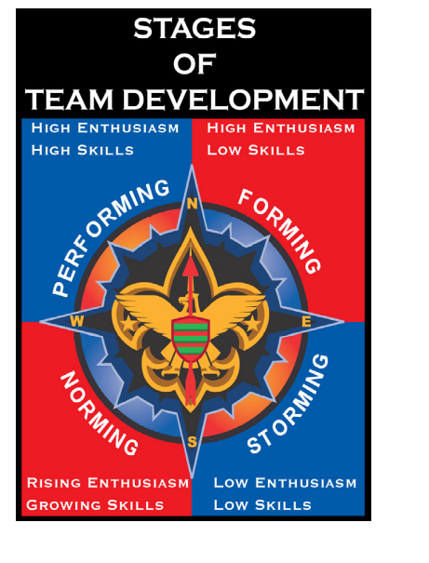
The stages enable us to use appropriate strategies to smooth the progress of a team as it evolves. For example, we can suggest a procedure for establishing ground rules for a team in the “Norming” stage.
Different teams may proceed through different stages at different speeds, a process that can be affected by the fact that team members may also have varying rates of progress. Members should avoid making self fulfilling prophecies about how long each stage will last.
A team may sometimes regress to an earlier stage. For example, team members may return to a previous stage if they discover that a team’s mission or membership has changed, such as when a significant number of new boys are added to a patrol.
It is possible for a team to be in different stages with respect to different aspects of its mission. For example, it may still be in the “Storming” stage with respect to implementing its final plan, even while it is in the “Performing” stage with respect to efficiently generating ideas for the plan.

Communication
DAY TWO, 2:10pm to 3:00pm

Learning Objectives:
- Use listening skills learned in our previous session
- Develop strategies to overcome communication barriers
- Practice effective instruction skills
- Look for feedback

Communication can be in various forms, verbal and non-verbal
- Visually & Auditory i.e., spoken word, performance (dance/theatre/song), symbols (icons), written (stories, and many more).

What makes communication really effective?
- Importance of the message
- Presenting ideas with relevance to the listeners
- Establish authority on the subject
- Have conviction and passion for the subject
- Use the skills of voice, tone, body language

President John F. Kennedy and Dr. Martin Luther King Jr. speeches grip the listener to this day

Basic Blueprint of Communication
- A sender
- A message
- A receiver

Effective Communication…
- Good listening on the part of both speaker and the audience
- Engage the audience
- Two-way process

Engaging the audience…
- Presentation should not be all one way
- Consider the listener’s perspective
- Understanding the speaker’s feelings

From the audience point of view, “What do you want?”
- Knowledge
- Skill
- Understanding

Barriers to Effective Communication
- Lack of common ground
- Lack of sincerity
- Lack of authority
- Lack of skill
- Lack of clarity
- Lack of receptiveness
- Poor environment

Consider how to overcome each barrier

Ways to assure Good Communications
- Know your audience
- Truly show sincerity
- Know the subject
- Be receptive and willing to learn something while teaching
- Be clear and concise
- Pace your presentation to the audience
- Physical environment has a impact

Effective Communication and the Teaching E.D.G.E
- Explain what is going to happen
- Demonstrate “how to”
- Guide by asking questions
- Enable by encouraging others to try it

Use EDGE whenever teaching

Summary
- Communications is a tool of leadership
- Communication is essential to effective teams
- Communications happens on common ground
- Communication should be clear and concise.
- Sender and receiver consider each other
- Communication is written, verbal, and nonverbal.
- Feedback is a gift. It truly is one!
- Be generous in support and praise!

Great leaders are great communicators.

By the way…
How can this be part of your ticket?
Project Planning
DAY TWO, 3:10pm to 3:40pm

Objectives
- Identify the five stages of team-based project planning.
- Understand the importance of selecting an appropriate approach or method.
- Avoid the “activity trap.”
- Develop a work breakdown structure.
- Implement and track a project plan.

Five Stages of Team-Based Project Planning
- Project overview
- Work breakdown structure
- Activity assignments
- Putting the plan into action
- Project closeout

Stage One: Project Overview
Create a strategic decision-making document that
- Identifies the problem or opportunity
- States the scope of the project
- Establishes project goals
- Lists important objectives
- Explains how success is measured
- Determines the approach or methodology
- Identifies assumptions and risks

Project Overview
Problem, opportunity, or situation to be changed:
_________________________________________________________________
Project goals:
_________________________________________________________________
Objectives:
_________________________________________________________________
Measure of success:
_________________________________________________________________
Approach or method:
_________________________________________________________________
Assumptions and risks:
_________________________________________________________________

Goals and Objectives
Establish project goals and objectives that pass the “SMART” test:
S Specific: Is it specific in targeting an objective?
M Measurable: What are the measurable indicators of success?
A Attainable: Is it attainable by someone on the team?
R Relevant: Can it be achieved within the resources and time allowed?
If not, then the goal is irrelevant to project success.
T Time-based: When will the project be completed?

Measures of Success
The project overview should
- Identify problems early and determines the feasibility.
- Help others understand and commit to the project.
- Provide the basis for a detailed plan.
- Help avoid “activity trap” and “scope creep.”

Approach or Method
Consider the following when choosing an approach or method:
- Focus on goals and objectives.
- Challenge assumptions regarding usual approaches.
- Explore out-of-the-box solutions.
- Invent new methods when appropriate.

Assumptions and Risks
To help identify the project’s assumptions and risks, answer these questions.
- What resources are required?
- What risks are associated with obtaining these resources in a timely manner?
- What problems or delays could we have?
- What effects will delays have?

Stage Two: Work Breakdown Structure
The work breakdown structure helps keep the team focused and helps prioritize tasks.
- Following the network of high-level objectives, break down each objective into separate activities that will be necessary to accomplish it.
- Order the activities by what must be done and when.

Characteristics of Project Activities
Project activities should:
- Pass the “SMART” test.
- Have clear start and stop events.
- Incorporate easily estimated time/cost.
- Be assignable and manageable.

Stage Three: Activity Assignments
When assigning activities, be sure team members have:
- Clarity regarding their assignment
- Clarity about the project’s purpose
- Clarity about resources and deadlines
- A good match to their skills
- Established milestones and reporting procedures

Stage Four: Putting the Plan Into Action
The implementation and tracking leader should:
- Provide leadership to the team.
- Provide additional resources.
- Assist with decision making and problem solving.
- Monitor the critical path.
- Monitor each team member’s performance.

Stage Five: Project Closeout
When closing out the project:
- Recognize team members.
- Write a 360 review report.
-Were goals and objectives achieved?
-Was the project completed on time?
-What lessons were learned?
- What ideas and recommendations do you have for next time?
- Maintain a record for use in future projects.


DAY 3

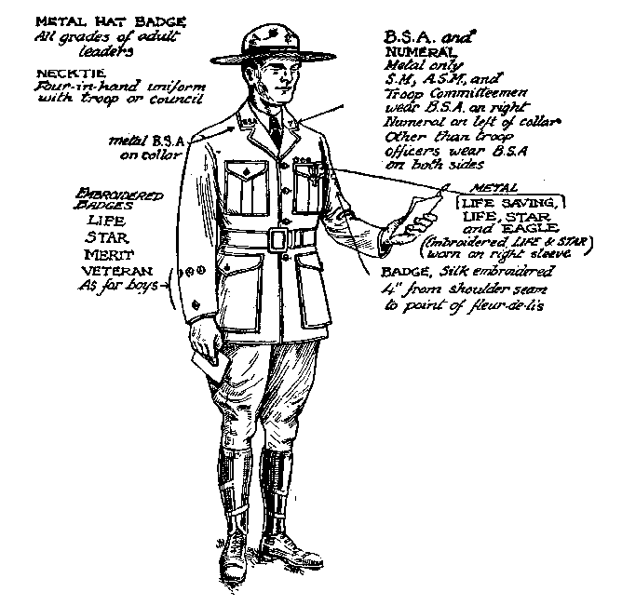
Wood Badge Course Schedule
Note: We will be in the Field Uniform (normal Scout uniform) through lunch. After lunch, you may wear your activity shirt for the rest of the afternoon.

7:00 am | Breakfast
8:00 am | Gilwell Field Assembly
8:30am | Interfaith Worship Service
9:20am | Break
9:30am | Troop Meeting
10:50am | Break
11:00am | Leading EDGE / Teaching EDGE
12:00pm | Lunch
12:15pm | Patrol Leaders Council Meeting /  Chaplain’s Aide Meeting (if needed)
1:20pm | Conservation Project Planning
2:20pm | Break
2:30pm | Movie: “October Sky”
4:30pm | Closing Gilwell Assembly
5:00pm | Patrol Time
6:00pm | Departure from Camp

Gilwell Field Assembly
DAY THREE, 8:00am to 8:30am
Have we come along way in just two days! Today we give thanks, through our spiritual practice and through practical service. We’re also leading our Patrols toward our outdoor adventure during the second weekend of Wood Badge.

Historic Flag Presentation

The Star-Spangled Banner

By 1795, Vermont and Kentucky had joined the union, bringing the number of states to 15. The new flag, featuring 15 stars and 15 stripes, flew over the nation for the next 23 years and the administrations of five presidents. It was this flag that flew over Fort McHenry the memorable night of its bombardment by British in 1814, inspiring Francis Scott Key to write the verses are national anthem.
The actual flag that flew over Fort McHenry that night is now preserved in the Smithsonian National Museum of American History.

Song
Let us honor this flag with our national anthem, The Star-Spangled Banner
Oh, say can you see by the dawn's early light
What so proudly we hailed at the twilight's last gleaming?
Whose broad stripes and bright stars thru the perilous fight,
O’er the ramparts we watched were so gallantly streaming?
And the rocket's red glare, the bombs bursting in air,
Gave proof through the night that our flag was still there.
Oh, say does that Star-Spangled Banner yet wave
O'er the land of the free and the home of the brave?
Interfaith Worship Service
DAY THREE, 8:30am to 9:20am

Objectives
- Explore issues that can affect the content and presentation of an interfaith worship service.
- Involve staff members in the presentation.
- Draw upon a diversity of resources.
- Be a model for conducting an interfaith worship service. (The second service, on Day Five, is prepared and presented by the patrol chaplain aides.)

Why Include Religious Services in Scouting?
The Charter and Bylaws of the Boy Scouts of America recognize the religious element in the training of the BSA’s members, but the BSA is absolutely nonsectarian in its attitude toward that religious training. Religious instruction is ultimately the responsibility of the home and the religious institution.

From the BSA’s Charter and Bylaws:
The Boy Scouts of America maintains
that no member can grow into the best kind of citizen
without recognizing an obligation to God.

From the Boy Scout Handbook, 11th edition:
A Scout is reverent. A Scout is reverent toward God.
He is faithful in his religious duties.
He respects the beliefs of others.
Wonders all around us remind us of our faith in God.
We find it in the tiny secrets of creation and the great mysteries of the universe.
It exists in the kindness of people and
in the teachings of our families and religious leaders.
We show our reverence by living our lives according to the ideals of our beliefs.

Throughout your life
you will encounter people expressing their reverence in many different ways.
The Constitution of the United States guarantees each of us
complete freedom to believe and worship as we wish without fear of punishment.
It is your duty to respect and defend the rights of others to their religious beliefs even when they differ from your own.

What is an Interfaith Worship Service?
The explanation provided by Baden-Powell is as valid today as when he wrote it:

Some Ideas on Interfaith Worship Service
For an open Troop, or for Troops in camp,
I think the interfaith worship service should be open to all denominations,
and carried on in such manner as to offend none.
There should not be any special form,
but it should abound in the right spirit,
and should be conducted not from any ecclesiastical point of view,
but from that of the boy.
Everything likely to make an artificial atmosphere should be avoided.
We do not want a kind of imposed church parade,
but a voluntary uplifting of their hearts by the boys
in thanksgiving’ for the joys of life,
and a desire on their part to seek inspiration
and strength for greater love and service for others.
An interfaith worship service should have as big an effect on the boys
as any service in church,
if in conducting the interfaith worship service
we remember that boys are not grown men,
and if we go by the pace of the youngest and most uneducated of those present. Boredom is not reverence, nor will it breed religion.
To interest the boys,
the interfaith worship service must be a cheery and varied function.
Short hymns (three verses are as a rule quite enough-never more than four); understandable prayers; a good address from a man who really understands boys (a homely “talk” rather than an address), which grips the boys,
and in which they may laugh or applaud as the spirit moves them,
so that they take a real interest in what is said.
If a man cannot make his point to keen boys in ten minutes
he ought to be shot!
If he has not got them keen,
it would be better not to hold an interfaith worship service at all.
-Baden-Powell
Printed in The Scouter, November 1928

Basic Concepts for Planning an Interfaith Worship Service
- Choose a setting that lends itself to the occasion and promotes reverence, a grove of trees, a site with a view of a lake, pond, brook, etc. For small groups, sitting in a circle can be a very effective arrangement.
- Everything must be in good taste.
- The service should be planned, timed, and rehearsed. (Generally 30 minutes maximum.)
- It should go without saying that those attending an interfaith worship service will be courteous, kind, and reverent. They should respect the rights and feelings of others even if their beliefs and religious practices differ from their own.
- Everyone in attendance should have opportunities to participate, if they wish, through responsive readings, silent and group prayer, singing, etc.

Recognizing Diversity in a Interfaith Worship Service
Scouts practice many faiths and many units are composed of Scouts from a variety of faiths. When this is the case during a Scout outing, ask them to suggest materials, to participate in the planning, and to assist in leading the service. If the group represents a mixture of religions, you may choose to use inspirational passages instead of particular religious materials.
Because different faiths observe different religious practices and have a variety of holy days, it is not always possible to conduct an interfaith service in a time frame that fully recognizes individual religious obligations. This should be acknowledged and explained. Other time may need to be built into the schedule to allow individuals to meet their obligations.
“Interfaith” means a service that all Scouts and Scouters may attend. Therefore, much attention must be paid to recognize the universality of beliefs in God and reverence.
Encourage Scouts and Scouters to participate in religious services. Let them know ahead of time the nature of a service so that those anticipating a multifaith experience do not find themselves surprised by a service that espouses the beliefs of a particular faith or religious tradition.

Summary
Whenever possible, BSA outings and activities should include opportunities for members to meet their religious obligations. Encourage Scouts and Scouters to participate. Even the opportunity to share the uniqueness of various faiths, beliefs, and philosophies with other members may be educational and meaningful. Planning and carrying out religious activities can be as simple or complex as the planners choose to make them.
Care must be taken to support and respect all the faiths represented in the group. If services for each faith are not possible, then an interfaith, nonsectarian service is recommended. Scout leaders can be positive in their religious influence without being sectarian.

Interfaith worship service (Example)
- Call to worship
- Hymns or songs
- Scripture(s) or readings from a variety of religious or inspirational sources
- Responsive reading
- Personal prayer
- Group prayer
- Inspirational reading or message
- Offering (World Friendship Fund)
- An act of friendship
- Benediction or closing

The World Friendship Fund

World Friendship Fund donations are sent to the International Division of the BSA.

Have You Seen the Light?
How enlightened are you when it comes to knowing and applying the religious principles of the Boy Scouts of America? It is a little more involved than simply understanding the 12th point of the Scout Law. Take a few minutes to complete this quiz.

1. True or False—Circle one
The Boy Scouts of America maintains that no member can grow into the best kind of citizen without recognizing an obligation to God.

2. Multiple Choice— Circle the correct answer(s)
The 12th point of the Scout Law includes the following responsibilities:
a. personal religious obligations
b. duty to country
c. respect for the beliefs of others
d. all of the above

3. Multiple Choice— Circle the correct answer(s)
The word “nonsectarian” means
a. nondenominational
b. ecumenical
c. not affiliated with any specific religion
d. all of the above

4. Multiple Choice— Circle the correct answer(s)
Which of the following could be a violation of a religious belief?
a. recitation of the Pledge of Allegiance to the United States of America
b. removing one’s hat when indoors and/or during a meal
c. expecting everyone to taste a particular food
d. attending a program event or activity on a Saturday
e. drinking coffee, tea, or cola

5. True or False— Circle one
In accordance with their agreement with the Boy Scouts of America, some churches sponsoring Cub Scout, Boy Scout, Varsity, or Venturing units can require members of their units to participate in religious ceremonies and services distinctive to that church.
6. True or False—Circle one
An interfaith worship service is one that all Scouts and Scouters may attend. It requires careful planning to ensure that it does not violate the beliefs of any religion.

7. True or False—Circle one
Some religions have specific requirements that cannot be fulfilled through an interfaith worship service. Other arrangements might be necessary for Scouts of those faiths to fulfill such commitments.

8. True or False— Circle one
Of the eight major religions in the world, all are represented in the BSA’s religious emblems program.

9. Multiple Choice— Circle the correct answer(s)
“Duty to God” and “religious duties” are important components of
a. The Cub Scout Promise
b. The Law of the Pack
c. The Scout Oath
d. The Scout Law
e. The Venturing Oath
f. The Venturing Code
g. All of the above

10. True or False— Circle one

Appropriate graces for meals at Scouting events do not refer specifically to a “central figure”—Jesus Christ or Allah, for example.
Troop Meeting
DAY THREE, 9:30am to 10:50am
Principles of Leave No Trace
1. Plan Ahead and Prepare
Proper trip planning and preparation helps hikers and campers accomplish trip goals safely and enjoy-ably while minimizing damage to natural and cultural resources. Campers who plan ahead can avoid unexpected situations, and minimize their impact by complying with area regulations such as observing limitations on group size.
2. Travel and Camp on Durable Surfaces
Damage to land occurs when visitors trample vegetation or communities of organisms beyond recovery. The resulting barren areas develop into undesirable trails, campsites, and soil erosion.
3. Dispose of Waste Properly (Pack It In, Pack It Out)
This simple yet effective saying motivates backcountry visitors to take their trash home with them. It makes sense to carry out of the backcountry the extra materials taken there by your group or others. Inspect your campsite for trash or spilled foods. Accept the challenge of packing out all trash, leftover food, and litter.
4. Leave What You Find
Allow others a sense of discovery, and preserve the past. Leave rocks, plants, animals, archaeological artifacts, and other objects as you find them. Examine but do not touch cultural or historical structures and artifacts. It may be illegal to remove artifacts.
5. Minimize Campfire Impacts
Some people would not think of camping without a campfire. Yet the naturalness of many areas has been degraded by overuse of fires and increasing demand for firewood.
6. Respect Wildlife
Quick movements and loud noises are stressful to animals. Considerate campers observe wildlife from afar, give animals a wide berth, store food securely, and keep garbage and food scraps away from animals. Help keep wildlife wild.
7. Be Considerate of Other Visitors
Thoughtful campers travel and camp in small groups, keep the noise down, select campsites away from other groups, always travel and camp quietly, wear clothing and use gear that blend with the environment, respect private property, and leave gates (open or closed) as found. Be considerate of other campers and respect their privacy.
Leading EDGE / Teaching EDGE
DAY THREE, 11:00am to 12:00pm
The primary function of team leadership is to help the team move through the stages of development.

Objectives
- Describe the four leadership behaviors included in the Leading EDGE™, and explain which behavior is most appropriate for each stage of team development.
- Describe the four skills instruction behaviors included in the Teaching EDGE, and explain which behavior is most appropriate for each stage of skills development.
Effective leaders usually have more than one leadership style. A key to good leadership is to match the style of leadership to the people and the situation. A powerful tool for choosing the right leadership style is the Leading EDGE.
The letters EDGE stand for
- Explain
- Demonstrate
- Guide
- Enable
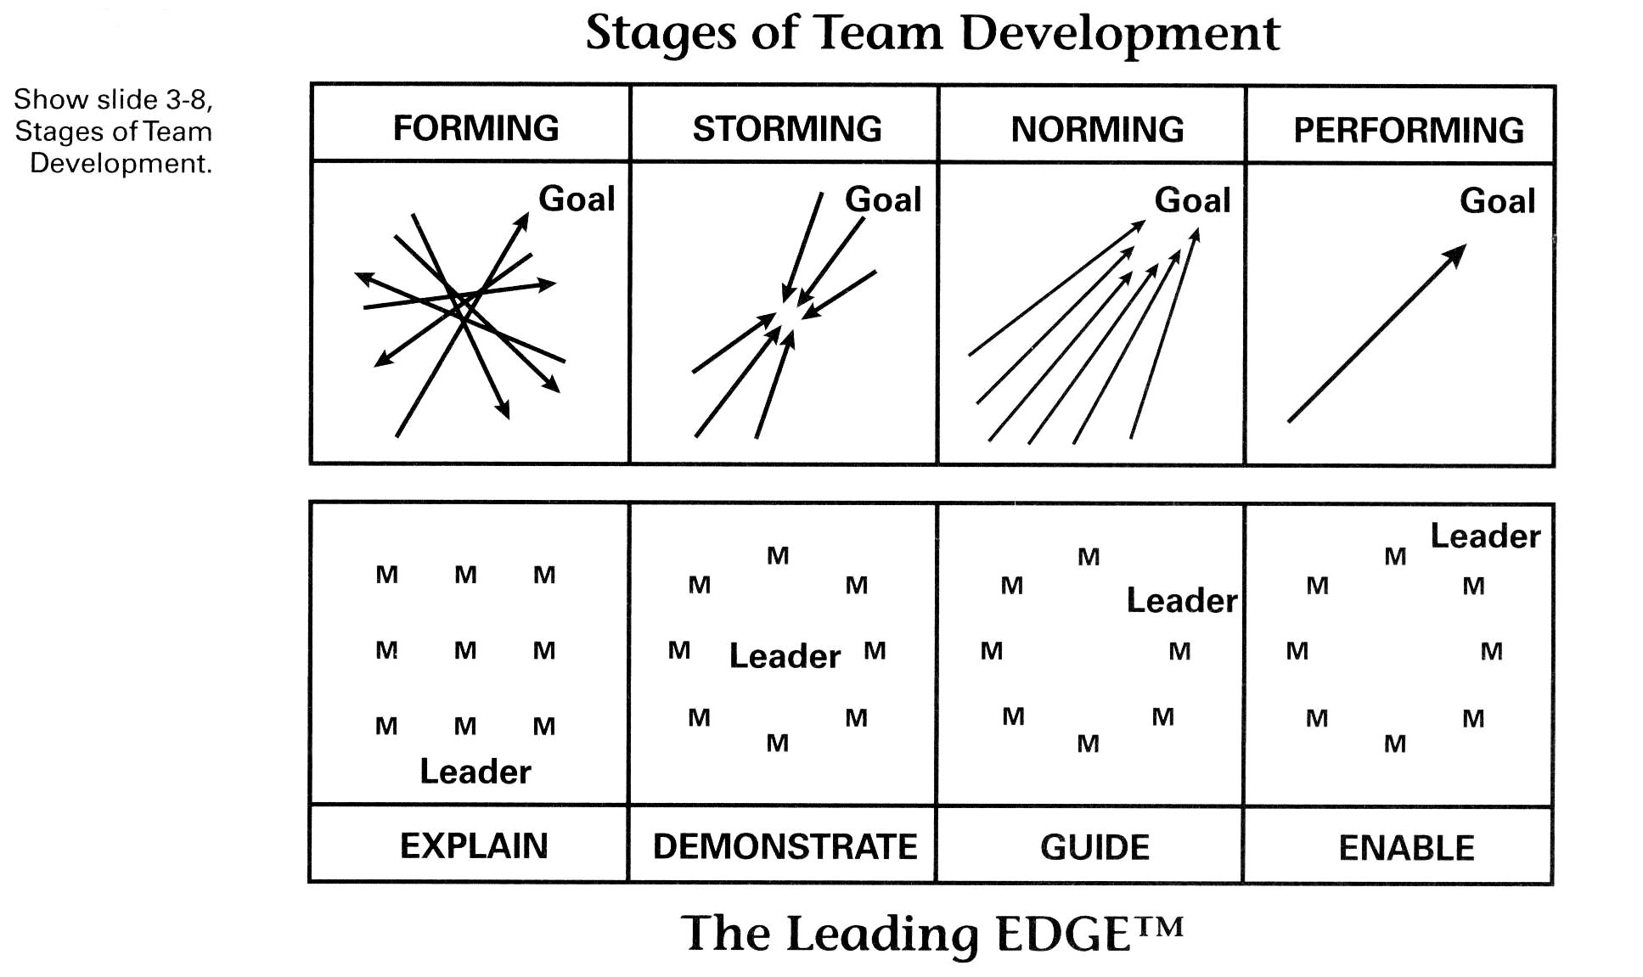

The Relationship between Stages of Team Development and the Leading EDGE™
Together the stages of team development and The Leading EDGE™ provide a framework for matching each stage of team development with an appropriate leadership behavior.
Remember, when serving as a team leader, identify the current stage of team development by accessing the team’s level of enthusiasm and skill, and select an appropriate leadership style to use.

The Teaching EDGE™
The ability of a team to succeed at a particular task often depends upon the need for the members to individually or collectively learn new skills.
It is the leader’s responsibility to provide skills instruction when the need is recognized. The leader may serve as instructor if he or she has mastered the requisite skills, or arrange for an instructor.
A learner responds best to skills instruction tailored to the stage of skills development the individual is experiencing at the moment. To provide a appropriate style of skills instruction. The instructor must access the level of enthusiasm and skill demonstrated by the learner.
A powerful tool for choosing the right instruction style is the “Teaching EDGE; again, Explain, Demonstrate, Guide, or Enable?

Review
Recall from the Stages of Team Development discussion yesterday:

Leading teams in Forming stage (High Enthusiasm, Low Skills) (Pick-up Sticks)
An effective leader of a team that is Forming will do lots of careful explaining to help the team understand exactly what the leader expects them to do. There is high dependence on the leader, some anxiety about fitting in norms, roles, timelines, etc.
Teaching someone in the Forming stage (High Enthusiasm, Low Skills)
A person is enthused about something new and motivated to learn, but has a low level of skill during the Forming stage. An instructor will need to do lots of careful explaining - telling the learner exactly what to do and how to do it.

Leading teams in the Storming stage (Low Enthusiasm, Low Skills) (At Odds)
In the Storming stage an effective leader will continue to make things clear by demonstrating to the team how to succeed. There is some discrepancy between initial expectations and reality. Negative subgroups form, with confusion & frustration.

Teaching someone in the Storming stage (Low Enthusiasm, Low Skills)
A person has been at it long enough to realize that mastering a skill may not be easy and that lots of work remains to be done. As a result, his enthusiasm and motivation are low. Skills are still low, too. An instructor must demonstrate the new skill to the learner, clearly showing him what to do and how to do it.

Leading teams in Norming stage (Rising Enthusiasm, Growing Skills) (Coming Around)
Leaders of teams in the Norming stage can find success by giving team members lots of freedom to act on their own, but being ready to provide guidance (coaching) when a little help is needed. Trust and cohesion grow as communications become more task oriented. Start to think of team as “we”. They avoid conflict fearing losing positive climate.

Teaching someone in Norming stage (Rising Enthusiasm, Growing Skills)
As a learner keeps at it, his level of skill will rise. He realizes he is making progress, and so motivation and enthusiasm will rise, too. An instructor will need to guide the person – giving him more freedom to figure out things on his own, supporting him with encouragement, and helping him move closer to the goal.

Leading teams in the Performing stage (High Enthusiasm, High Skills) (As One)
During the Performing stage a leader will enable team members to make decisions on their own and to keep progressing toward completion of the task. Focus is on performance, pride/excitement in being part of high performance team. Roles, goals and purpose are clear.
To enable a team to make decisions and move ahead on their own, the leader must provide access to relevant information and necessary resources.

Teaching someone in the Performing stage (High Enthusiasm, High Skills)
Skills are high and so is enthusiasm and motivation. A learner has reached the point where he can act independently and be very productive. An instructor will need to enable the person—offer the learner plenty of freedom to make decisions on their own and to keep moving ahead.

Regression (Going Backwards)
Regression, or moving back a stage or two, can take place when there are changes in leadership, task, roadblocks or membership. Teams and/or individuals can ‘regress’.

Explain, Demonstrate, Guide, or Enable?
Skill Development Stage | Enthusiasm (Morale) | Skill Level (Productivity) | Teaching EDGE Behavior
Forming Storming Norming Performing | High  Low  Increasing  High | Low  Low  Increasing  High | Explain  Demonstrate  Guide  Enable

A team responds best to leadership tailored to the stage of the team at the moment.
A learner responds best to skill instruction tailored to the stage of skill development of the moment.
Conservation Project Planning
DAY THREE, 1:20pm to 2:20pm
What Makes a Good Conservation Project?
Cub Scouts, Boy Scouts, Varsity Scouts, and Venturers undertaking conservation work are volunteering their time and energy for the good of the environment. A worthwhile project allows them to feel pride in what they are doing. It gives them a chance to experience something new. Though the work may be hard, it should also be satisfying.
The following guidelines will help Scout leaders and agency personnel plan conservation work that serves the needs of Scouts, of agencies, and of the environment.

Involve Scouts in All Aspects of a Project
A sense of project ownership is important to young people. Scouts should understand the purpose of a conservation project. Increase their commitment to conservation by involving them in planning as well as in carrying out the work.

Make Projects Fun
Whenever possible, combine conservation efforts with other Scout activities such as a hike, a campout, a swim, or a nature walk with someone who can discuss the area’s ecology. That will enrich the experience for everyone and also reinforce the idea that caring for the environment is a fundamental part of the Scouting program.

Choose Reasonable First Projects
The first projects undertaken by a Scouting unit should be limited in scope and last no more than a few hours or an afternoon. As the young people gain experience and confidence, projects can become more lengthy and complex.

Consider Skill Levels
A good project is within the skill levels of the young people doing it and is age-appropriate. Work that is too demanding sets up young people to fail and to lose interest. On the other hand, the best opportunities challenge Scouts to push a little beyond their current abilities and master new skills.

Set Reasonable Goals
Everyone likes a sense of completion to their work. Some conservation efforts can be finished in a few hours, an afternoon, or a day. Longer-term projects may be broken into intermediate goals achievable in shorter amounts of time ~ planting a certain number of trees, for example, or repairing the sites in just one area of a campground.

Make a Difference
Appropriate projects allow young people to see that their efforts have a positive effect on the quality of their environment. They learn about the importance of conservation and gain a sense of pride in having done a Good Turn for the environment and for those who will enjoy the outdoors in the future.

Sample Conservation Projects
Conservation projects come in all shape and sizes. Among those that have been successfully completed by Scouts are the following:
HABITAT AND WILDLIFE
- Improve fish and wildlife habitat, riparian areas, streams, and shorelines.
- Stabilized threatened stream banks.
- Collect discarded Christmas trees and install them as revetments to protect stream banks, or submerge them to provide shelter for fish.
- Re-vegetate damaged meadows and hillsides.
- Plant trees, shrubs, and grasses to control erosion, produce shade, and provide wildlife with sources of food and shelter.
- Remove exotic plant species and restore native vegetation.
- Establish and care for urban greenbelts, neighborhood parks, or other open spaces.
- Clean up urban waterways, paint DUMP NO WASTE / DRAINS TO STREAM on storm drains, and distribute informational fliers that outline appropriate ways of disposing of oil, chemicals, and other toxic wastes.
- Construct and set up nesting boxes and feeders for waterfowl and other wild birds.
- Help fisheries officials stock lakes and streams
- Build structures in arid regions to hold water for wild animals.
TRAILS AND CAMPSITES
- Return unwanted and abandoned campsites and trails to their natural conditions.
- Increase accessibility of resource area facilities for handicapped visitors.
- Upgrade, maintain and help construct trails for hikers, horseback riders, bicyclists, and other users.
MONITOR
- Monitor the quality of streams.
- Conduct an ongoing census of selected wild animals.
- Conduct measurements of snow depth at backcountry monitoring locations and forward the information to meteorological stations.
STRUCTURES
- Maintain picnic pavilions, lifeguard towers, boat docks, playground equipment, and other outdoor recreational facilities.
- Build fences to prevent the overgrazing of riparian areas.
- Construct observation decks and blinds in wildlife refuges.
- Prepare and install educational signs along nature trails.
EDUCATIONAL
- Develop and maintain outdoor classroom sites.
- Teach environmental awareness skills to young people visiting resource areas.
- Provide training in appropriate camping, hiking, and other recreational skills that are easy on the land.
- Offer conservation-oriented presentations and slide shows to youth organizations and civic groups.
- Prepare informational brochures to be distributed at agency visitor centers.
- Develop interpretive demonstrations, tours, and living history exhibits, and help present them to visitors of resource areas.
HISTORICAL
- Clean and repair statues, gravestones, and other historic monuments.
- Restore historic buildings.
- Prepare and present research about the people and events important to the heritage of an area.
- Assist archaeologists in protecting and studying archaeological sites.
Conservation Planning Checklist
Scouting leaders and agency personnel can use the following checklist to assist them in planning conservation projects.
What is the task to be done?
__________________________________________________________________________________________________________________________________________________________________________________________________
Why is it important?
__________________________________________________________________________________________________________________________________
How many Scouts and Scouters can take part in the work?
__________________________________________________________________________________________________________________________________
What is the time frame for completing the project
__________________________________________________________________________________________________________________________________
What tools and materials will be needed, if any, and who will provide them?
___________________________________________________________________________________________________________________________________________________________________________________________________
What leadership skills are required to oversee the work?
__________________________________________________________________________________________________________________________________
Who will provide project leadership? (List youth and adult Scouting leaders and any agency personnel.)
___________________________________________________________________________________________________________________________________________________________________________________________________
How will youth reach the work area?
___________________________________________________________________________________________________________________________________________________________________________________________________
What safety factors are involved and how will they be addressed?
___________________________________________________________________________________________________________________________________________________________________________________________________
Movie: “October Sky”
DAY THREE, 2:30pm to 3:300pm

Opening comments
Why watch a movie about a bunch of boys building rockets during a training course for Scout Leaders?
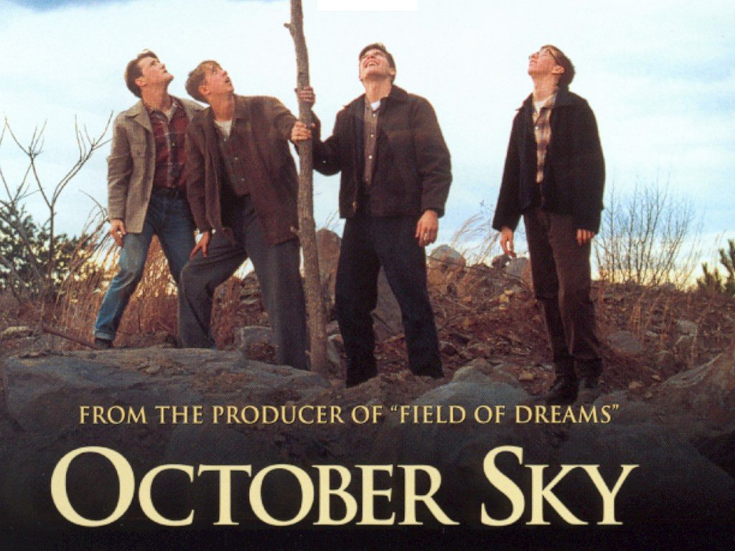
So far you have learned about listening, inclusiveness, communication and stages of team development (forming/storming/norming/
performing), all items relating to running a Troop, or Pack, and working with youth, other leaders, and unit committees.
This movie provides dynamic examples of these throughout different circumstances, with vastly different characters. See which of these you recognize, and the situations where you notice them. Pay particular attention to John Hickam, Homer Hickam, Miss Riley, the “Rocket Boys” and the way they interact with each other and those around them. What drives John Hickam? What drives Homer Hickam? Why is it inevitable that they will clash? How does Miss Riley affect Homer’s destiny?

Post Movie analysis/discussion
What was the driving force of this entire story ?
- Did you witness examples of-
- Listening? Communicating? Inclusiveness

Team Development?
- Purpose
- Empowerment
- Relationships, and communication
- Flexibility
- Optimal production
- Recognition
- Moral

What types of leadership did you witness?
- Authoritarian?
- Participative?
Discuss the strengths and weaknesses of the different leadership styles.

What roles did listening and communication play in this story?
Did you see examples of enabling?
Did the conflict between Homer and John Hickam get resolved?
What is Miss Riley’s impact on Homer?

In your role as a Scout Leader (father, mother, supervisor, etc.) would you say you are more like John Hickam? Or Homer?
Do you encourage, motivate and support others like Miss Riley
DAY 4

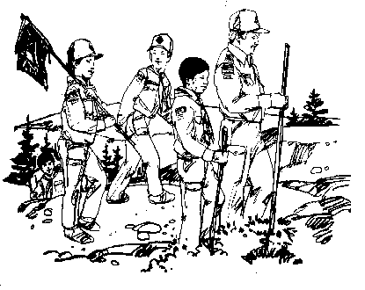
Wood Badge Course Schedule
Note: You may arrive at camp in non-BSA clothes that are appropriate for hiking and setting up camp. You are expected to be your Field Uniform (normal Scout uniform) for the 9:45 AM Gillwell assembly and evening dinner at your patrol site. Any other time during the day, you may wear your activity shirt.
7:00 am | Arrival at Camp T. Brady Saunders Parking lot (behind Admin Building) and walk as a group to the Model Campsite Demonstration
8:00 am | Set up patrol campsite
9:45am | Gilwell Field Assembly
10:20am | Overview of Weekend 2
10:30am | Leading Change
11:20am | Break
11:30am | Patrol Leaders Council Meeting
12:00pm | Lunch at patrol campsites
1:00pm | Valuing People & Leveraging Diversity
1:50pm | Break
2:00pm | Problem Solving and Decision-Making
2:40pm | Problem Solving Round Robin
4:00pm | Managing Conflict
5:00pm | Patrol Meeting
6:00pm | Dinner
7:30pm | The Diversity Game (Patrol Activity)
8:30pm | Participant’s Campfire
9:30pm | Patrol Cracker Barrel

Gilwell Field Assembly
DAY FOUR, 9:45am to 10:20am
Back again so soon? The Patrols have been off preparing themselves for a great weekend. The staff has been doing likewise—and we can’t wait to see what you’ll be cooking for us! Although we’ve all done our best to “Be Prepared,” who knows what surprises are in store during our campout.

Historic Flag Presentation

The 46-Star Flag

By 1908, the United States of America had grown to encompass states from the Atlantic to the Pacific. Nearly all the territory in between had also been recognized with statehood. When Oklahoma join the union, the US flag changed to include 46 stars, a design that would last for only four years and the administrations of two presidents, Theodore Roosevelt and William Taft.
For us, there is further significance. This is the flag that was flying over America in 1910 when the Boy Scouts of America had its beginnings.

Song
Today’s song is a very familiar one. Originally written by Irving Berlin in 1918, it was revised in 1938 as a song of peace and popularized by Kate Smith. Interestingly, Woody Guthrie did not like the song and wrote “This Land is Your Land” as a response. To honor our country – the people and the land, we will sing this section of the song:

God Bless America,
Land that I love.
Stand beside her, and guide her
Thru the night with a light from above.
From the mountains, to the prairies,
To the oceans, white with foam
God bless America, My home sweet home.

Venturing Induction Ceremony
Scouting is diverse by design. Volunteers work in Cub Scouting, Boy Scouting, Venturing, and Varsity Scouting (although there are none in our council). Additionally, volunteers also work at the district, council, and regional levels of scouting.
At the campfire put on by our fellow Scouters, the Troop Guides will move up into a Venture Crew. Venturing is for young men and women between 14-20 years old. Crews can be co-ed, all men, or all women. Although many crews focus on high-adventure, others focus on religious and community life. HOV council even has a few “Ships”—Sea Scouts! There is even a possible focus on arts and hobbies. The result is a great program of exciting and meaningful activities that help youth pursue their special interests, grow, develop leadership skills, and become good citizens.
All use the Venturing Code and Oath. If you are interested in more information, contact anyone with a dark-green shirt.

Venturing Code
As a Venturer,
I promise to do my duty to God
and help strengthen America;
To help others,
and to seek truth, fairness,
and adventure in our world.

Venturing Oath
As a Venturer, I believe that America’s strength lies in our trust in God and in the courage, strength, and traditions of our people.
I will, therefore, be faithful in my religious duties and will maintain a personal sense of honor in my own life.
I will treasure my American heritage and will do all I can to preserve and enrich it.
I will recognize the dignity and worth of all humanity and will use fair play and goodwill in my daily life.
I will acquire the Venturing attitude that seeks truth in all things and adventure on the frontiers of our changing world.
Leading Change
DAY FOUR, 10:30am to 11:20am
Change is Inevitable, Progress is Not, You Must Lead the Way
You can be fearful and resistant to change but then you will be setting yourself up for a reactive approach, not a proactive one.
The Objective of Leading Change is to bring about a Goal, or Vision, that has the results we desire.

The 6 Steps of Leading Change

Step 1 – Recognize That Change Happens

“Be Prepared” for change, know it is coming, know it is happening, be ready to lead it.

Step 2 – Empower Others to Help You Lead Change

You need your team to be on board with the changes that are necessary, they are an integral part to ensure success. Include them in the process of leading change and they will be supporters of leading the necessary change.

Step 3 – Lead Change Based on Vision, Mission, and Values
You must have a goal for what you want to accomplish. This is determined by your Vision, Mission and Values
- VISION is a picture of future success.
- MISSION is made up of the steps that lead to the realization of a vision.
- VALUES are core beliefs or desires that guide and motivate our attitudes and actions.

Step 4 – Establish Urgency

Your team, and those involved and affected by the changes you wish to implement, must be made to understand the necessity for enacting change and doing so now.

Step 5 – Move Ahead, Regardless

If change is necessary, and you have some that are resistant to it, Move Ahead, Regardless. Not moving ahead will allow change to occur in a negative fashion.

Step 6 – Create a Culture That Embraces Change
You must develop an attitude that progressive change is a positive action that should be anticipated with eagerness. Once you have instilled this attitude in your team, organization, or group, you will then be truly Performing.

Three Characteristics of a Good Incremental Goal
- It’s visible (people will see what it will accomplish)
- It’s unambiguous
- It’s clearly related to the change effort

The Ultimate Step - Lead Change Through Lifelong Learning
If we do not keep up with the technical and social changes going on around us, we may as well become one of those old fogies sitting around solving the world’s problems by talking about what we would do if…
Keep up with what is going on through continued training, education, reading, talking and Listening to others, particularly the youth of our units.

Mental Habits That Support Lifelong Learning
- Risk Taking
- Humble self-reflection
- Solicitation of opinions
- Careful listening
- Openness to new ideas

If we always do
As we have always done

We will always be
Where we have always been

We will always receive
What we have always gotten

Valuing People & Leveraging Diversity
DAY FOUR, 1:00pm to 1:50pm

Three Categories of Diversity
- Human Diversity
- Cultural Diversity
- Organizational Diversity

Human Diversity
Human diversity is the raw material of who we are:
- Gender
- Race
- Age
- Physical Appearance
- Health
Human diversity is the accumulation of our life experiences:
- Education
- Marital and Parental Status
- Occupation
- Geographic location

Cultural Diversity
Cultural diversity arises from differences in:
- Language
- Lifestyle
- Heritage
- Belief systems
- Religious beliefs
- Traditions

Organizational Diversity
Organizational diversity is characterized by differences inherent in the values, vision and mission of organizations:
- Teamwork
- Roles
- Relationships
- Leadership
- Empowerment
- Education and training
- Affiliations

How Can We Use Diversity?
- Aggressively recruit diverse membership
- Immediately identify and challenge unacceptable behavior
- Encourage all members to contribute their talents and strengths regardless of backgrounds
- Serve as a role model

Barriers to Diversity
- Comfort in sameness
- Learning in differences
- Naturally resist change when change is positive

When We Fall Short
- Everyone will make mistakes
- Admit our mistakes and offer sincere apologies
- Keep trying

How We Respond
- As leaders and role models we have a responsibility to young people to help them understand those values that may differ from our own.

Leading change
- Diversity generates change

Diversity Makes Us Stronger
- Value and embrace difference
- Organizations, community, nation
- Stronger together than we are apart
Problem Solving and Decision-Making
DAY FOUR, 2:00pm to 2:40pm
In Scouting, there will be numerous opportunities when effective planning is necessary to achieve a desired goal. On Day Two, participants were introduced to the five steps of team based project planning. These steps include a project overview, work breakdown structure, activity assignments, action on the plan and a closeout report. By following these five steps, the chances of success in achieving a goal is greatly enhanced.
However, within the scope of the entire project, problems will arise that require immediate attention. Like project planning, the steps taken in resolving a problem play a big role in achieving the desired outcome. However, be aware that problems can arise even outside of any specific project; using a project plan approach to these problems may not be quick enough or flexible enough for these situations. Let’s use a real scouting example and walk through the steps of effective problem solving and decision making.
In Boy Scouts, camping trips represent the major activity of most units. A neat camp is an important part of taking responsibility in the use and care of troop equipment. The Griffin Patrol has left a mess of both their patrol equipment and their personal gear. How do we resolve this?

There are five steps to systematic and effective problem solving. Let’s apply them to our example.
- Describe the problem. Do this as accurately and completely as possible. The better you understand the problem, the more efficiently you can solve it.
The Griffin Patrol appears to have left personal gear strewn around and cooking gear is not getting clean. They have already eagerly left the campsite to participate in the troop’s activities.
- Gather information. Consider quantitative information (facts that can be measure) and qualitative information (how people feel about the situation).
There are six members of the Griffin Patrol in attendance. This is a young patrol and while not on their first camping weekend with the troop they are still very inexperienced and some have only earned their Tenderfoot rank. The patrol leader is one of their peers, and their troop guide could not attend this trip. None appear concerned with the state of the camp, focusing on the activities instead. The rest of the troop is annoyed because their stuff is in the way of the fire pit and other common areas.
- Determine the most important factors that contribute to the problem. Figure out what is causing the problem. Factors may include timing, personality, the setting, a combination of all three or something completely unforeseen.
For the Griffin Patrol, the cause appears to be lack of knowledge about cleaning and caring for gear, lack of understanding of each member’s role, lack of understanding about the duty roster, or a weak patrol leader unable to properly lead the patrol.
- Visualize what success looks like. Describe how things will be when the problem is solved and everything is working well.
For the Griffin Patrol, success is having each patrol member knowledgeable about cleaning and taking care of their gear, and fulfilling their responsibilities on the camping trip.
- Create action steps that will lead to that success. Action steps close the gap between the current situation and your visualization of success.
The action steps include the Griffin Patrol leader working with a more experienced scout such as the assistant senior patrol leader or another patrol leader who can instruct members of the patrol on caring for their gear and then supervising them while they clean up. After the initial clean up, a review of the duty roster and everyone’s responsibilities would be beneficial.
For problem solving, the solution is not always obvious. A systematic approach as outlined above can solve problems quicker, more efficiently and increase the odds for success.

When an individual or team is working on a project or addressing a problem, decisions have to be made. The nature of the team, its experience together and the situation it finds itself in can all contribute to the way a team makes a decision. There are many ways that teams can reach decisions:
- Brainstorming allows for the free flow of ideas. Everyone participates, and everyone’s ideas are valuable. To encourage thinking outside the box, no idea should be criticized. One idea can build, or piggyback, on the ideas of others.
- Consensus occurs when a discussion leads to an agreement without resorting to a vote. This requires trust on the part of the members. Be careful that a true consensus is reached, not one driven by a particularly vocal person. Call on the quiet ones, too!
- Multivoting occurs when there are many acceptable options and no consensus can be reached or there is open disagreement. Each team member has an equal number of votes. If sorting a list, members rank the items; if reducing the list, members cast out the poorest choices. It may take several votes, so if necessary, repeat the voting process.
For example, assume that there are a large number of options resulting from brainstorming. Some of these options have been combined with others that are similar, but there are still 15 left. Decide the number of votes that each member can have – typically 1/3 of the total options – and have each person cast a vote for the options they consider most desirable. After the votes are tallied, those options with the least votes or no votes are discarded. Repeat the process until there are only a few options left that the group can use consensus for a final decision, or continue until there is only one option left from the final vote.
- Parking Lot involves tabling part of a discussion that is not immediately relevant or is not directly related to finding a solution to the problem at hand. This can be revisited at the next troop meeting. The most important point is not to forget!

Advantages of Systematic Problem Solving
The problem-solving process is a time-saver. With an organized approach to a problem, issues can be dealt with in an orderly and timely fashion.
As teams become accustomed to using a systematic approach, they can solve problems more quickly and efficiently. A systematic approach increases the odds of success.
Managing Conflict
DAY FOUR, 4:00pm to 5:00pm
We’d all like to:
- Better understand conflict from a leadership point of view.
- Acquire new tools for successfully managing conflict situations.
Leadership is easy when everything is going well—or when everybody is sound asleep. Much of the rest of the time, leadership involves managing conflict by finding common ground among individuals, providing tools for people to settle their own disputes, and on rare occasions stepping in to make unilateral decisions.
Specifically we want to:
- Consider the fact that we can’t make people do what they don’t want to do.
- You can encourage others to act in a specific way.
- Be aware of the boundaries of your authority.
- Get some tips on how to receive and give feedback
Ultimately, you can only empower yourself. Then, within boundaries, you can encourage others to act in certain ways.

Be Aware of Yourself
The first thing to do in any relationship, but especially one that may involve conflict, is to look at yourself.
- Why is this issue important to you?
- How important is the issue?
- Should you really intervene?
You may stumble upon a the self-resolving conflict—a situation that, if given time, will work itself out without confrontation or argument.

Be Aware of Others
Aside from when there is a safety risk, look around and see if there are others working thru the situation. Perhaps you do not really need to intervene.
However, if there is a problem and no one is moving to solve it then leadership is called for. However, when are people most likely to do what you ask them to do, especially if it is something they are less than excited about?
- When they trust you
- When they have experience with you and have found you to be a reliable leader and ally
- When they understand that you are making decisions for the good of the group
- Most of all, when they sense that you care about them

Active and Empathetic Listening
Early in this Wood Badge course, we discussed the importance of Listening to Learn. Listening is the most important skill in resolving any conflict, whether the conflict involves you as a participant or as a moderator. Unless you make a conscious effort to listen, you will miss vital facts and beliefs that could lead to a satisfactory resolution.

Set the Scene for Cooperative Resolutions
Think back to the Who-Me Game we did earlier in this course. Think of how you and others in your patrol have shared information about yourselves with one another. Remember the experiences you have shared in the last few days. Those are all points of contact, connections that provide a foundation of trust, understanding, and familiarity for further communication and, if necessary, for resolving conflicts.
In real estate, the rule is “Location, location, location!” In leadership, and especially when dealing with conflict, the bottom line is “Involvement, involvement, involvement!”
As a leader, the more you have shared with those you lead, the greater your chances of finding cooperative resolutions for conflicts. Developing that kind of connection cannot happen overnight, though. It is one of the ongoing challenges and rewards of good leadership.

Questions for Conflict Resolution
Whenever you work with people, the most important question to ask them is,
“What do you want?”
Think about that. When was the last time somebody asked you that? When was the last time somebody really listened to your answer?
Once you’ve gotten the answer to “What do you want?” there are three follow-up questions.
• “What are you willing to do to get what you want?”
• “Is what you are doing working?”
• “Do you want to figure out another way?”
Think about the power of these questions when asked in this order. The first one focuses people’s attention on what their real needs are and helps you see more clearly other people’s points of view. The subsequent questions put responsibility on other people to be a party in examining where they are and then in finding pathways to reach where they want to be.
Questions 2 and 3 are vital. Don’t skip them. They are questions that empower people. Give people the time and encouragement to figure out the answers, to understand their own path. Too often we as leaders skip questions 2 and 3. We ask, “What do you want?” and then jump immediately to a variation of question 4, telling someone what we think they should do.
Questions 2 and 3 help people figure things out on their own and discover their own path. Question 4 gives them a way to invite you to help them explore other approaches to a problem. It encourages a cooperative effort—working together to help everyone get what they want.
Remember, you can’t control another person. But you can persuade. You can join forces with him or her in a mutual search. You can encourage him or her to become an active seeker after meaningful answers.

Effective Communication in Conflict Situations
In the Wood Badge session on Communication, we talked about the fact that there is much more to conveying a message than simply repeating the words. Body language sends powerful messages, as does tone of voice.
If anger or frustration or some other emotion is clouding your ability to see an issue as objectively as possible, it’s probably wise to step back for a minute or an hour, or even a day or more. Allow time to collect yourself before going forward. Remember the parenting trick of counting to 10 before reacting to a child’s confrontational actions? The same principle holds true when you are engaged in difficult interactions with teenagers or adults.
Work on issues in the present and the future, not in the past. Rather than looking for blame and recrimination, steer conversations toward seeking solutions.
Any time you feel that you aren’t making progress or that you don’t know what to do next, return to the basic four questions.

A Proscriptive Approach
Sometimes cooperation fails. Leaders sometimes must make the decision that certain behavior will not be tolerated. Perhaps the most dramatic instances are when safety is being compromised and someone must take action immediately.
Within the context of making such decisions—that is, proscribing behavior and then demanding that it happen that way—it is still possible to act in a manner that is effective for you and understandable to those you are leading.
Rather than four questions, proscriptive conflict resolution is built on four statements:
- This is what I want.
- This is what I understand you are doing.
- This is why that isn’t working for me.
- Here’s what I need for you to do.
While the end result is an immediate change in behavior, this approach gives leaders tools to explain themselves and provide a basis for a decision. It allows a leader and group members to interact on a healthy level, and it provides the opportunity for proscriptive decisions to evolve into arrangements developed through a more cooperative approach.
As with any sort of leadership, being able to step in, if necessary, and set certain boundaries is easier to do if leaders have already established a relationship of trust and understanding with those they are leading. Leaders who have taken the time to listen and learn and care for people in their groups will have a much easier time negotiating with group members and individuals to establish the needs and solutions of everyone, leaders included. After the proscriptive approach is used make time to explain the action so learning can be incorporated. This reinforces their trust in you.
You can be open with people in your group about your understanding of your responsibilities and what you expect from them. At its most basic, the contract between leaders and those who are led is as follows.
My Job Is Your Job Is
To do all I can to ensure your safety. To tell me when you don’t feel safe.
To help you get the most out of this To help me ensure your safety.
experience. To be honest with you To be honest with me and treat
and treat you with respect. me with respect

Ideas we don’t share often enough with others include these:
- “If I’m doing something that bothers you, I’d like you to tell me in a respectful way.”
- “How will it be if we really get along? What will that be like?”
- “If I see you’re having a problem, what do you want me to do?”

Conclusion
The right words will change things for the better, but it takes awareness and understanding to discover what those words are. It is well worth the time and the effort.
The ultimate goal of conflict resolution—to build on common ground, to listen, to find solutions to situations that allow us to grow closer to one another rather than farther apart.

DAY 5

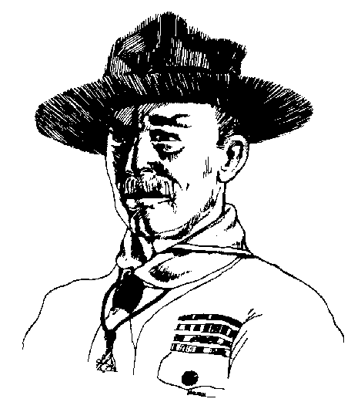
Wood Badge Course Schedule
Note: We will be in the Field Uniform (normal Scout uniform) in the morning until 10:45 when we begin our conservation project. This activity can be messy so wear appropriate non-BSA clothing. After that activity is over, change into your activity uniform until Dinner. It is always appropriate to wear your Field Uniform for dinner.
7:00 am | Breakfast
8:00am | Gilwell Field Assembly
8:30am | Interfaith Worship Service (by participants)
9:15am | Patrol Project Setup and Demonstrations
9:30am | Round 1 of Patrol Presentations (15 min each)
10:45am | Break
11:00am | Conservation Project
12:30pm | Lunch (at conservation project site)
12:30pm | Patrol Leaders Council (working lunch)
1:30pm | Round 2 of Patrol Presentations (15 min each)
2:50pm | Break
3:00pm | Coaching and Mentoring
3:55pm | Assessments
4:30pm | Ticket Review and Collection by Troop Guide
5:00pm | Scoutmaster visits each patrol
6:00pm | Patrol Dinner / Patrol Meeting
8:00pm | Campfire(s) and Cracker Barrel

Gilwell Field Assembly
DAY FIVE, 8:00am to 8:30am
Patrols, you’ve done extraordinarily well. Good work. Just like in a Scout Troop, the staff is confident in your abilities.
At the end of this day, the staff will depart and you will be on your own. Enjoy the experience, reflect on your time at Wood Badge, and get to know all the great Scouters around you.

Historic Flag Presentation

The Virginia State Flag

Virginia, one of the original thirteen British colonies in America, became the tenth state on June 25th, 1788. Virginia’s official state flag was adopted in 1861. The flag has a deep blue background with a white circle in the center. In the center are the words “VIRGINIA,” and “SIC SEMPER TYRANNIS” (Latin for “thus always to tyrants”).
Depicting the state’s motto on the flag is the goddess Virtue (who is holding a sword and a spear), who has defeated a tyrant, who is lying on the ground, and is holding a chain and a scourge (a whip). Nearby is the tyrant’s fallen crown. Virtue symbolizes Virginia and the tyrant symbolizes Britain. Red Virginia creeper and green leaves surround the scene.

Reading
Since Virginia no longer has an official State Song, this poem (found on the back of an old postcard) seemed to fit our occasion. The first verse is shown below but the entire poem is printed in your songbook.

The roses nowhere bloom so white
As in Virginia;
The sunshine nowhere shines so bright
As in Virginia;
The birds sing nowhere quite so sweet
And nowhere hearts so lightly beat,
For Heaven and Earth both seem to meet
Down in Virginia
Coaching and Mentoring
DAY FIVE, 3:00pm to 3:55pm

Responsibilities of Mentors and Coaches
- First, we must realize that when we accept positions of leadership, people will be looking up to us. We have a responsibility to listen to them, to pay attention to them, and to attempt to understand what it is they want and need.
- We also have a responsibility to convey our values through our actions. We must be willing to live by the standards that we are expecting others to uphold.

Coach
A coach is an individual who develops skills and capabilities in another person or in a group of people (a team).

Mentor
A mentor is an experienced Scout or adult leader who becomes a trusted guide and counselor of a less experienced individual.

What Coaches DO
- Provide task direction and vision
- Provide skill instruction
- Build team and individual capabilities
- Provide resources
- Facilitate relationships for individuals and teams
- Transfer responsibility for success to the team
- Support the growth and progress of individuals in the program
- Remember Explain Demonstrate Guide Enable

Tips on Being a Good Coach
- Listen—verbal and no-verbal cues
- Supply energy
- Provide focus
- Provide information
- Influence, don’t control
- Recognize team and individual success
- Recognize what’s right versus what’s wrong
- Value differences between individuals
- Evolve and grow with the team’s life cycle
- Remember Stages of Team Development – Forming, Storming, Norming, Performing

Self Assessment
DAY FIVE, 3:55pm to 4:30pm
During this course, a lot has been talked about on assessing team performance; measuring team progress, working on projects, personal interaction and how they have progressed through various stages of development: forming, storming, norming and performing.
- Each Troop meeting was assessed during the Patrol Leader’s Council. Each member of the council was given the opportunity to answer the questions... “How are you feeling?” “How are we doing?”
- After the presentations of the patrol projects you will be given the opportunity to assess your project and presentation.
- Near the end of the course, on day 6, you will also be asked to assess this Wood Badge course.
Assessment can help a team and its leaders to understand from where they have come; where they are; and can help more effectively chart a course to where they wish to go.
This session take a few moments to consider the importance of another type of assessment; self-assessment.
In many ways, we assess ourselves all the time. We measure ourselves against each other and against all kind of social standards.
We set goals for ourselves and have a fairly good sense of where we are in fulfilling those goals and objectives.
But there are limitations to listening only to ourselves. We all see the world from our own particular perspectives, based on our unique histories and backgrounds. All of that is further shaded by the way we want to see things rather than the way things really are.
A much more complete picture of our progress comes through receiving feedback from others.

On day one, during the “listening to learn” session we discussed the gift of feedback.

Tips on Giving Feedback
- Consider your motives. Feedback should always be helpful; otherwise, there is no reason to offer it.
- Find out if the other people involved are open to receiving feedback. Listen carefully, and then rephrase what they say to be sure you understand them.
- Deal only with behavior that can be changed.
- Deal with specifics, not generalities.
- Describe the behavior and do not evaluate it.
- Let the other person know the impact the behavior has on you.
- Use an “I” statement to accept responsibility for your own perceptions and emotions.
- To make sure the recipients of feedback have understood your message in the way you intended it, ask them to rephrase what they heard you say.
You can give caring feedback without a good technique, but the slickest technique in the world will not hide a lack of caring.

Tips on Receiving Feedback
- Seek out feedback. It will nearly always provide you with information that will in some way help you improve your performance.
- Listen carefully. Receiving feedback requires a heightened awareness of yourself and the person offering the feedback.
- Listen actively. Restate the feedback in your own words so that the speaker knows that the message you are receiving is the same as the one the speaker intended to send.
- Listen empathetically. Put feedback in its proper context by observing the speaker’s body language, tone of voice, and emotions. Consider the speaker’s reasons for offering feedback.
- Notice how you are feeling when someone offers you feedback. Becoming angry or defensive can cloud your ability to listen effectively.

Feedback Empower Us
By giving us information that can lead to change that will lead to success and improve performance.

Consider feedback to be a gift. It truly is.

One of the best ways for leaders to encourage effective feedback is by developing and using a 360-degree assessment.
A 360-degree assessment is based on the idea that feedback comes from all directions and depends on people considered “stakeholders”; ones that have a stake or interest in the outcome of your success or failure. Each stakeholder is viewing all aspects of your success or failure through their own perspective and can provide valuable feedback and productive opinions about your progress in reaching your goals.
As you embark on the mission of completing the goals set out in your Wood Badge tickets, each of you will discover that you have stakeholders.
In Scouting, your stakeholders may be fellow unit leaders, parents of Scouts, your district executive, roundtable chair, Cubmaster, commissioners, representatives of your chartered organization, and other Scouters who have direct knowledge of your leadership.
Each of these stakeholders represents a different perspective. Each has seen you in different circumstances and from a unique point of view. Through a 360-degree assessment, these stakeholders can provide you with valuable feedback.
Instructions: Here are step-by-step instructions for developing and using a 360-degree assessment.
- Determine the goals for which you wish to be assessed. The goals you are writing for your Wood Badge ticket are a good example. Ideally, the goals need to be clear, attainable, measurable, and challenging.
- Join with a facilitator to help with the assessment process. This person should understand how a 360-degree assessment works. If your assessment is to be of your Wood Badge ticket goals, an appropriate facilitator may be your Wood Badge ticket counselor.
- Develop an assessment survey that will provide the kind of feedback that will help you more effectively move toward your goals.
- Identify 5 to 10 of your stakeholders who can offer a wide range of perceptions about your progress. Provide each with a copy of the survey and a stamped envelope addressed to your facilitator. Assure each stakeholder that only the facilitator will see the surveys.
- Upon receiving the completed surveys, your facilitator will compile the results, and then meet with you to discuss the assessment and to talk about ways that you can use the results to more effectively progress toward your goals.
- Finally, make assessment an ongoing part of your Scouting responsibilities and, where appropriate, in other areas of your life. Self-assessment should not be a one-time event, but rather a constant tool for gaining a clearer perception of your strengths and the areas where you can improve.

Pointers on Developing a 360-Degree Assessment Survey
- Instructions to the stakeholders should be clear and unambiguous. Stakeholders should understand why they are taking part in the assessment, how it will be used, and that only the facilitator will see their answers.
- Questions must be developed based on the goals you are striving to reach. The feedback the questions generate should lead to real changes that will bring you closer to your goals.
- Feedback comes from what those completing the form have actually observed and can measure. There is nothing to be gained in asking them to assess what they have not seen or cannot in some way quantify.
- Answers to the questions can be simple and straightforward. Offer stakeholders two or three options such as the following
  - Green Light (This is good. Keep Going.)
  - Yellow Light (This could be better)
  - Red Light (Some serious concerns here.)
Or
- Way to go
- Ways to grow
Or
- Start
- Stop
- Continue

The survey should also encourage stakeholders to add any comments and suggestions they feel would be helpful. This kind of feedback can be extremely helpful.
Use Assessment as a tool for Leading Change
Good 360-degree assessments help people discover differences between how they perceive themselves and how others perceive them.

Sample 360-Degree Assessment Survey
I am seeking productive feedback on my progress toward reaching these four goals that have to do with my leadership in Scouting:
1. _______________________________________________________________

2. _______________________________________________________________

3. _______________________________________________________________

4. _______________________________________________________________

With those goals in mind, please provide an assessment of how I am doing. Of the following questions, answer those for which you have personal knowledge. Your answers may be either “Way to Go!” or "Ways to Grow." If an answer is “Ways to Grow,” please feel free to suggest how I can do better in that area.
When you have finished the survey, please mail it in the enclosed envelope to my assessment facilitator. The facilitator will provide me with a summary of all the surveys. No one but the facilitator will see your answers.

 | Way to Go! | Ways to Grow
1. Produces work on time
2. Communicates well with others
3. Encourages diversity in Scouting
4. Develops creative solutions to problems
5. Demonstrates a good knowledge of Scouting
6. Treats Scouts and Scouters in a respectful, considerate manner
7. Creates an environment that makes progress possible for all
8. Serves as a good role model
9. Shares knowledge with others
10. Takes active steps to ensure lifelong learning

DAY 6

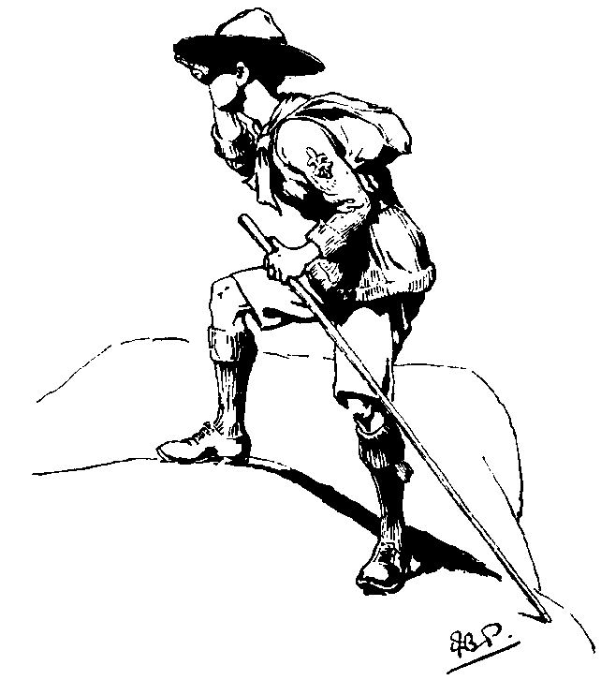

Wood Badge Course Schedule
Note: We will be in the Field Uniform (normal Scout uniform) all day.
7:00 am | Breakfast
9:00am | Gilwell Field Assembly
9:30am | Patrol Cleanup and Load Vehicles
9:30am | Concurrent Patrol Leaders Council
11:15am | Course Assessments
11:45am | Closing Luncheon
1:30pm | Leaving a Legacy
2:45pm | Break
3:00pm | Summary Session
3:30pm | Closing Gilwell Assembly
4:15pm | Participants Depart

Gilwell Field Assembly
DAY SIX, 9:00am to 9:30am
Today the Troop has work to do before return from the back country. We look back on our time together as we renew our commitment to servant leadership.

Historic Flag Presentation
WOSM Flag

Scouting is world wide, serving 28 million individuals in over 150 countries under the umbrella of the World Organization of the Scout Movement (WOSM). All member organizations (including the BSA), may wear the purple World Scout emblem above their left shirt pocket. The emblem includes a rope which encircles the fleur-de-lis and is tied by a square knot. The rope is there to symbolize unity. Royal purple as seen in the WOSM flag is the color of leadership and service.

Reading
Today, we will be reading excerpts from Baden-Powell’s final message to scouting. Found among his papers after his death in 1941, these words were no-doubt written during his final 3 years while living in Kenya. He was buried Nyeri, within sight of Mt. Kenya and a simple stone marks his gravesite. On it are the symbols for boy and girl scouting as well as a circle with a dot inside – the symbol for “gone home”.

Dear Scouts,
…I have had a most happy life and I want each one of you to have as happy a life too.
I believe that God put us in this jolly world to be happy and enjoy life. Happiness doesn’t come from being rich, nor merely from being successful in your career, nor by self-indulgence. One step towards happiness is to make yourself healthy and strong while you are a boy, so that you can be useful and so can enjoy life when you are a man.
Nature study will show you how full of beautiful and wonderful things God has made the world for you to enjoy. Be contented with what you have got and make the best of it. Look on the bright side of things instead of the gloomy one.
But the real way to get happiness is by giving out happiness to other people. Try and leave this world a little better than you found it and when your turn comes to die, you can die happy in the feeling that at any rate you have not wasted your time but have done your best. “Be Prepared” in this way, to live happy and to die happy – stick to your Scout promise always… and God help you do it.

Course Assessments
DAY SIX, 11:15am to 11:45am
The purpose of this course assessment is to learn from your evaluation of the Wood Badge training program. We are genuinely interested in knowing how we can improve the communication and the delivery of the course, how what you learned will help you, and how we did in helping you increase your knowledge about each of Scouting’s programs.

Please use the form in the appendix to provide feedback.
Leaving a Legacy
DAY SIX, 1:30pm to 2:55pm

With all of the information presented in this course, and in this handbook, it is difficult to believe there is more to be said on the subject of Leadership. As Scouters and trainers however, we can always find another point to make. The final point here is to share with you The Greatest Leadership Secret. As you will come to know, it is hardly a secret and something that you probably already know. Here are a few hints and ideas to help you out:

1) It is a Palindrome – Sort of

A palindrome is a word or phase that reads the same either forwards or backwards. Words like mom, dad, eye, and racecar are palindromes as well a phrases like “ a man, a plan, a canal, panama”.

2) Lead from the Inside Out

Remember the demonstration of the rocks, sand, and water in the glass jar. As a leader, you must determine what the “BIG” rocks are in your life. Do not let others dictate them to you! You must know and understand these rocks so that you may learn to lead from the inside out. Good leaders know they must lead themselves before they can lead others. You must accept responsibility for you own actions, your growth your progress – take care of your big rock first.

Once you have taken care of those big rocks in your life, you will soon see you now have more room for the smaller things in life just as there was more room in the jar. By taking care of the big rocks, you now have time and space to serve and lead others. Interestingly, because you have learned to lead yourself, you will be a much better leader of others.

3) Great Leaders are Great Teachers

Another human quality needed to be a great leader is to be a great teacher.

A key to a successful scouting program is to establish an environment where youth and other leaders can learn to lead as well. Using the principals of Leading EDGE and Teaching EDGE, good leaders help others learn to plan, act, evaluate, and motivate others to action. If you are not teaching, you simply are not fulfilling your whole responsibility as a LEADER.

A good leader must not only know how to teach but perhaps more importantly, how to learn. You made the choice as a leader to take Wood Badge training and hopefully you learned much from the experience. Like the rest of us, you have much more to learn. Learning is a life-long endeavor and good leaders have an unquenchable thirst for knowledge.

Perhaps the best thing a leader can learn is to learn from their mistakes. Not everything they will try to do will go well or just as it was planned. It is important to access both the good and the bad. You were given two tools in this course to help with this: Self-Assessment, and Stop-Start-Continue. Using these tools properly will show you most anything we do as individuals, or as part of a team can be improved over time with continual careful and honest evaluations.

4) Build Heart Connections

We all work hard in our lives to build networks of business and personal contact and this is very important thing to do. Great leaders however build heart connections with those they lead and those do not. This is simply about expressing genuine care and respect for others. It involves the act of reaching out to others and connecting with them on a very simple human level – respect.

Like its family member love, respect only has a value when it is given out freely and in a genuine manner. False respect, like false love, is easy to see and will be met with suspicion and rejection of those who depend upon us for leadership.

5) It’s in Every Once of Us

In the first clue, we discussed taking responsibility for our own life and empowering ourselves to lead. As you learn to accomplish this task successfully, you must learn to turn that ability outward to others and empower them to lead as well. Help others to see and utilize their own leadership abilities

Every one of us has untapped leadership potential. Like a good coach that helps to bring an athlete’s full potential to the surface, you should be willing to work to help others practice leadership. As you do, they will get much better as it.

Great leaders not only know to empower themselves but also know the importance of empowering others to bring out the best in Every One of Us.

6) Leave a Legacy

One of the amazing things about leadership is that is can be seen, studied, taught, and practiced. Each of us can get better at it. We all have the ability to win the Game of Life and we can all leave legacies that can bring joy, satisfaction, and pride.

What will you legacy be? What impact will you make on others? What will you do to help the youth of your units? How will you lead others to bring leadership to Scouting and our great country?

Conclusion:

So, what is the Greatest Leadership Secret? Let us look at the clues on more time:
- Lead from the inside out
- Great leaders are also great teachers
- Build heart connections
- It’s in every one of us
- Leave a legacy

The greatest leadership secret has been with us throughout human history. It is a simply message that you most likely already know and hopefully already practice. Like a palindrome, it message flows in both directions. In its simplicity, it captures the five important attributes of leadership along with many other qualities. It has been expressed through the ages by many different people and cultures:

“What you do not want done to yourself, do not do unto others” – Confucius

“What you hate, do not do to anyone” – Judaism

“Hurt not others that which pains thyself -- Buddhism

"Do not wrong or hate your neighbor, for it is not he who you wrong, but yourself.” Pima Indian proverb

“The real way to get happiness is by giving out happiness to others – Lord Robert Baden Powell

In the form most familiar to us, the Greatest Leadership Secret is the Golden Rule:

“Do unto others as you would have them do unto you”

It seems simple and obvious but the Greatest Leadership secret provides us with all we kneed to know. It is a principal to live by and a challenge of a lifetime. If we as humans, and as Scouters strive to achieve these, our lives are forever enriched by knowing we are doing our best!

You have the knowledge and ability within you to be a great leader. Develop that ability in yourself and in others. Seek out and act up on opportunities to change lives for the better. You can leave a legacy in this world but it will not happen if you do not take action. What will you legacy be?

It is your move!
Summary Session
DAY SIX, 3:00pm to 3:30pm

Living the Values

Values, Vision, Mission
- Effective leaders create a compelling vision that they inspire others to create as a reality.
- Your ticket will help you turn your personal vision into reality.

Bringing the Vision to Life

Listening to Learn
- We can all improve our ability to listen
- Listening is a key element in communicating, learning, and leadership.
- Feedback is a gift.

Communicating
- Communication is essential to effective leadership and high-performance teams.

Coaching and Mentoring
- Small things have big consequences.

Valuing People and Leveraging Diversity
- We are stronger when we are diverse.
- We are stronger when we make diversity work for us.
- Leading change to become more diverse is critical for Scouting to remain relevant.

Models for Success

Stages of Team Development

Leading/Teaching EDGE
- The job of the leader is to move the team through the stages of development to become an empowered high-performance team.

Tools of the Trade

Project Planning
- Before starting anything, establish goals and agree on an approach.

Leading Change
- Change is inevitable, but leading change can make it a positive experience.

Conflict Management
- High-performance teams quickly resolve conflict.

Problem Solving and Decision Making
- When teams use an effective approach to problem solving, they can move more quickly toward high performance.

Self-Assessment
- Self-assessment is important to realize your full potential as a leader.
- This tool equips a leader to do his or her job in the unit or council.

Leading to Make a Difference

Leaving a Legacy
What’s the key take-home message of “Leading to Make a Difference”? That’s for you to determine in your own life. It’s for you to make the most of the opportunities and challenges you find along the way. You will write you own legacy.

Three messages that you might consider are:
- Values, vision and mission can change the world.
- The choice of how you will lead to make a difference in Scouting is up to you.
- Ask yourself, “What will my legacy be?” Then act to make it real.


Aims of Scouting Worksheet (answers)

The Aims of Scouting
Character development, citizenship training, and mental and physical fitness

The Methods of Scouting
Cub Scouting | Boy Scouting | Venturing
Boys grades 1-5 | Boys ages 11-18 | Young men and women
 |  | ages 14-20
 |  | 
The ideals | The ideals | The ideals
Den | Patrol | Group activities
Advancement | Advancement | Recognition
Family Involvement | Adult association | Adult association
Activities | Outdoors | High adventure
Home- and neighborhood-  centered | Personal growth | Teaching others
Uniform | Uniform
 | Leadership | Leadership

Mission Statement of the Boy Scouts of America

The mission of the Boy Scouts of America is to prepare young people to make ethical choices over their lifetimes by instilling in them the values of the Scout Oath and Law.

Wood Badge Ticket Workbook

Purpose
The purpose of a Wood Badge Ticket is to help you realize your personal vision of your role in Scouting. Ideally, you will write your ticket around your primary job in Scouting.

Three parts of a ticket
A ticket consists of three parts:
- A description of your Scouting role
- A statement of your vision of success
- A plan of action composed of five significant goals that can be attained within 18 months from the end of the Wood Badge course.

Realization of your vision
You should not expect that you will realize your vision immediately upon completion of the five goals; reaching your goals is an initial part of a long-term work in progress.

Use of Skills
It is assumed that you will use most or all of the skills you learned during the Wood Badge course. In writing your ticket it will help if you list the skills you can use to accomplish your goals. It is not required that you incorporate all of the skills presented during the course into your goals.

Diversity
At least one goal must address increasing diversity within the Boy Scouts of America.
Part 1:
Describe your job in Scouting; the role that you fulfill. It may be helpful to confer with your group leader to review your role so that you understand what responsibilities you have.

Part 2:
Vision Statement
A vision is a picture of future success. Our vision is formed when we think far enough ahead to realize that there will be challenges for which we can prepare.

My name: ___________________________________________
Part 3: Goals
The remainder of the Wood Badge ticket focuses on your goals. There should be a minimum of 5 goals that can be attained in less than 18 months. One of the goals must address increasing diversity in the Boy Scouts of America.
Additional Notes (optional):

_____________________________________________________________________________________________________________________________________________________________________________________________________________________________________________________________________________________________________________________________________________________________________________________________________________________________________________________________________________________________________________________________________________________________________________________________________________________________________________________________________________________________________________________________________________________________________________________________________________________________________________________________________________________________________________________________________________________________________________________________________________________________________________________________________________________________________________________________________________________________________________________________________________________________________________________________________________________________________________________________________________________________________________________________________________________
Wood Badge Ticket Goal Sheet Goal #____
Step 1: Name ______________________________ Patrol: ___________________
My Scouting Position: _________________________________________________
Who will benefit from my leadership: _______________________________________
Step 2: Describe your goal: _____________________________________________ ___________________________________________________________________________________________________________________________________________________________________________________________________
Step 3: Complete the development of your goal by defining the following elements.
Who:
What:
Where:
When:
Why:
Self-Assessment:
How Measured:
How Verified:
Step 4: All Ticket Goals should be “SMART” :
Specific – Describe this Ticket Goal in enough detail so that you and your ticket counselor know specifically what is to be done; how it is important, or how it will have an impact on the program. Is it challenging?

Measurable - Describe how this Ticket Goal is Measurable. How will you know when the goal has been accomplished?

Attainable - Describe how this Ticket Goal is Attainable. Can it be accomplished?

Relevant - Describe how this Ticket Goal is Relevant to your Scouting position?

Timely - Describe how this Ticket Goal is Timely. What is the time frame to completion?

Troop Guide Goal Approval: ___________________________ Date: ______________
Note: The above is to be completed during the instructional portion of the Course. What follows is to be completed after you return to your unit and “work your ticket.”
Step 5: The key to making the skills you’ve learned a part of your leadership style is to practice using them. List the skills that will help you accomplish this goal and how you plan to use them. It may be helpful to add additional details on this step here.

Step 6: Ticket Goal Progress Notes:
List what you’ve accomplished thus far while working on this goal.

List your milestones and what you have accomplished in completing your goals.

Yes, with approval from your ticket counselor, you can modify your goals. If so, what changes were made and why?

Step 7: Ticket Goal Completion Notes:
What was the outcome of completing this goal? What did you learn by working on this goal? What would you do differently next time? Which leadership skill was the most helpful as you worked on this ticket goal? Think back to your vision statement; how’s it going?

Ticket Counselor Goal Approval: ________________________ Date:
My name: _______________________________________________ Goal #

Wood Badge Ticket Goal Sheet Goal #____
Step 1: Name ______________________________ Patrol: ___________________
My Scouting Position: _________________________________________________
Who will benefit from my leadership: _______________________________________
Step 2: Describe your goal: _____________________________________________ ___________________________________________________________________________________________________________________________________________________________________________________________________
Step 3: Complete the development of your goal by defining the following elements.
Who:
What:
Where:
When:
Why:
Self-Assessment:
How Measured:
How Verified:
Step 4: All Ticket Goals should be “SMART” :
Specific – Describe this Ticket Goal in enough detail so that you and your ticket counselor know specifically what is to be done; how it is important, or how it will have an impact on the program. Is it challenging?

Measurable - Describe how this Ticket Goal is Measurable. How will you know when the goal has been accomplished?

Attainable - Describe how this Ticket Goal is Attainable. Can it be accomplished?

Relevant - Describe how this Ticket Goal is Relevant to your Scouting position?

Timely - Describe how this Ticket Goal is Timely. What is the time frame to completion?

Troop Guide Goal Approval: ___________________________ Date: ______________
Note: The above is to be completed during the instructional portion of the Course. What follows is to be completed after you return to your unit and “work your ticket.”
Step 5: The key to making the skills you’ve learned a part of your leadership style is to practice using them. List the skills that will help you accomplish this goal and how you plan to use them. It may be helpful to add additional details on this step here.

Step 6: Ticket Goal Progress Notes:
List what you’ve accomplished thus far while working on this goal.

List your milestones and what you have accomplished in completing your goals.

Yes, with approval from your ticket counselor, you can modify your goals. If so, what changes were made and why?

Step 7: Ticket Goal Completion Notes:
What was the outcome of completing this goal? What did you learn by working on this goal? What would you do differently next time? Which leadership skill was the most helpful as you worked on this ticket goal? Think back to your vision statement; how’s it going?

Ticket Counselor Goal Approval: ________________________ Date:
My name: _______________________________________________ Goal #

Wood Badge Ticket Goal Sheet Goal #____
Step 1: Name ______________________________ Patrol: ___________________
My Scouting Position: _________________________________________________
Who will benefit from my leadership: _______________________________________
Step 2: Describe your goal: _____________________________________________ ___________________________________________________________________________________________________________________________________________________________________________________________________
Step 3: Complete the development of your goal by defining the following elements.
Who:
What:
Where:
When:
Why:
Self-Assessment:
How Measured:
How Verified:
Step 4: All Ticket Goals should be “SMART” :
Specific – Describe this Ticket Goal in enough detail so that you and your ticket counselor know specifically what is to be done; how it is important, or how it will have an impact on the program. Is it challenging?

Measurable - Describe how this Ticket Goal is Measurable. How will you know when the goal has been accomplished?

Attainable - Describe how this Ticket Goal is Attainable. Can it be accomplished?

Relevant - Describe how this Ticket Goal is Relevant to your Scouting position?

Timely - Describe how this Ticket Goal is Timely. What is the time frame to completion?

Troop Guide Goal Approval: ___________________________ Date: ______________
Note: The above is to be completed during the instructional portion of the Course. What follows is to be completed after you return to your unit and “work your ticket.”
Step 5: The key to making the skills you’ve learned a part of your leadership style is to practice using them. List the skills that will help you accomplish this goal and how you plan to use them. It may be helpful to add additional details on this step here.

Step 6: Ticket Goal Progress Notes:
List what you’ve accomplished thus far while working on this goal.

List your milestones and what you have accomplished in completing your goals.

Yes, with approval from your ticket counselor, you can modify your goals. If so, what changes were made and why?

Step 7: Ticket Goal Completion Notes:
What was the outcome of completing this goal? What did you learn by working on this goal? What would you do differently next time? Which leadership skill was the most helpful as you worked on this ticket goal? Think back to your vision statement; how’s it going?

Ticket Counselor Goal Approval: ________________________ Date:
My name: _______________________________________________ Goal #

Wood Badge Ticket Goal Sheet Goal #____
Step 1: Name ______________________________ Patrol: ___________________
My Scouting Position: _________________________________________________
Who will benefit from my leadership: _______________________________________
Step 2: Describe your goal: _____________________________________________ ___________________________________________________________________________________________________________________________________________________________________________________________________
Step 3: Complete the development of your goal by defining the following elements.
Who:
What:
Where:
When:
Why:
Self-Assessment:
How Measured:
How Verified:
Step 4: All Ticket Goals should be “SMART” :
Specific – Describe this Ticket Goal in enough detail so that you and your ticket counselor know specifically what is to be done; how it is important, or how it will have an impact on the program. Is it challenging?

Measurable - Describe how this Ticket Goal is Measurable. How will you know when the goal has been accomplished?

Attainable - Describe how this Ticket Goal is Attainable. Can it be accomplished?

Relevant - Describe how this Ticket Goal is Relevant to your Scouting position?

Timely - Describe how this Ticket Goal is Timely. What is the time frame to completion?

Troop Guide Goal Approval: ___________________________ Date: ______________
Note: The above is to be completed during the instructional portion of the Course. What follows is to be completed after you return to your unit and “work your ticket.”
Step 5: The key to making the skills you’ve learned a part of your leadership style is to practice using them. List the skills that will help you accomplish this goal and how you plan to use them. It may be helpful to add additional details on this step here.

Step 6: Ticket Goal Progress Notes:
List what you’ve accomplished thus far while working on this goal.

List your milestones and what you have accomplished in completing your goals.

Yes, with approval from your ticket counselor, you can modify your goals. If so, what changes were made and why?

Step 7: Ticket Goal Completion Notes:
What was the outcome of completing this goal? What did you learn by working on this goal? What would you do differently next time? Which leadership skill was the most helpful as you worked on this ticket goal? Think back to your vision statement; how’s it going?

Ticket Counselor Goal Approval: ________________________ Date:
My name: _______________________________________________ Goal #

Wood Badge Ticket Goal Sheet Goal #____
Step 1: Name ______________________________ Patrol: ___________________
My Scouting Position: _________________________________________________
Who will benefit from my leadership: _______________________________________
Step 2: Describe your goal: _____________________________________________ ___________________________________________________________________________________________________________________________________________________________________________________________________
Step 3: Complete the development of your goal by defining the following elements.
Who:
What:
Where:
When:
Why:
Self-Assessment:
How Measured:
How Verified:
Step 4: All Ticket Goals should be “SMART” :
Specific – Describe this Ticket Goal in enough detail so that you and your ticket counselor know specifically what is to be done; how it is important, or how it will have an impact on the program. Is it challenging?

Measurable - Describe how this Ticket Goal is Measurable. How will you know when the goal has been accomplished?

Attainable - Describe how this Ticket Goal is Attainable. Can it be accomplished?

Relevant - Describe how this Ticket Goal is Relevant to your Scouting position?

Timely - Describe how this Ticket Goal is Timely. What is the time frame to completion?

Troop Guide Goal Approval: ___________________________ Date: ______________
Note: The above is to be completed during the instructional portion of the Course. What follows is to be completed after you return to your unit and “work your ticket.”
Step 5: The key to making the skills you’ve learned a part of your leadership style is to practice using them. List the skills that will help you accomplish this goal and how you plan to use them. It may be helpful to add additional details on this step here.

Step 6: Ticket Goal Progress Notes:
List what you’ve accomplished thus far while working on this goal.

List your milestones and what you have accomplished in completing your goals.

Yes, with approval from your ticket counselor, you can modify your goals. If so, what changes were made and why?

Step 7: Ticket Goal Completion Notes:
What was the outcome of completing this goal? What did you learn by working on this goal? What would you do differently next time? Which leadership skill was the most helpful as you worked on this ticket goal? Think back to your vision statement; how’s it going?

Ticket Counselor Goal Approval: ________________________ Date:
My name: _______________________________________________ Goal #

Application for Training Recognition

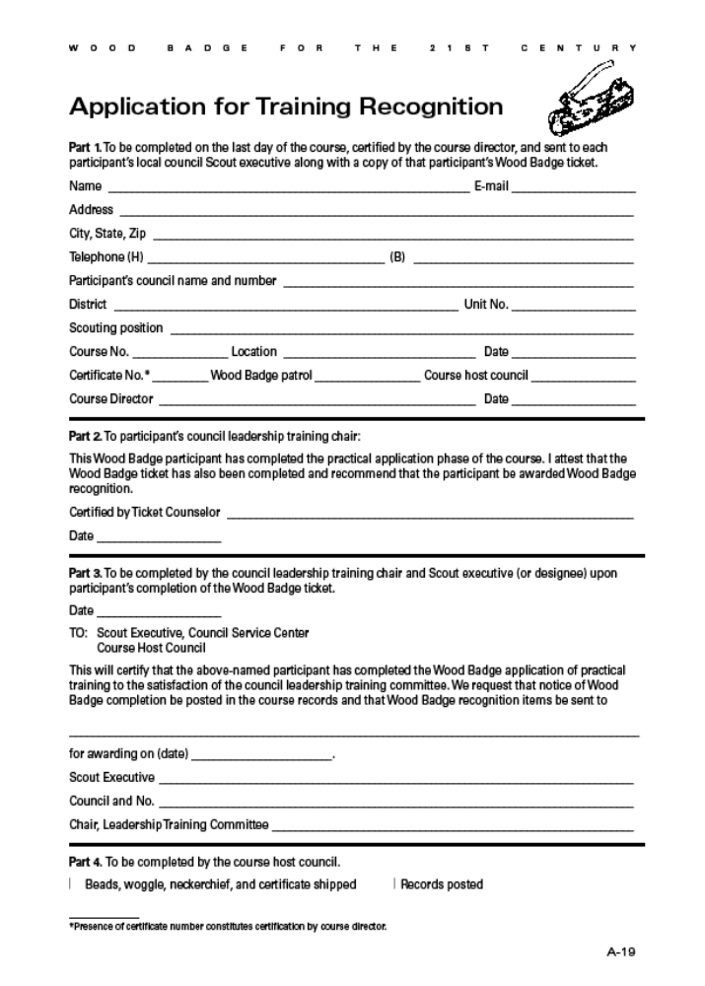

Wood Badge History

On the morning of September 8, 1919, a 61 year-old retired general of the British Army stepped out into the center of a clearing at Gilwell Park, in Epping Forest, outside London, England. He raised to his lips the horn of a Greater Kudu, one of the largest of African antelopes. He blew a long sharp blast. Nineteen men dressed in short pants and knee socks, their shirt-sleeves rolled up, assembled by patrols for the first Scoutmasters’ training camp held at Gilwell. The camp was designed and guided by Sir Robert Baden-Powell, the founder of the World Scouting Movement.
When they had finished their training together, Baden-Powell gave each man a simple wooden bead from a necklace he obtained from a Zulu chieftain when on campaign in South Africa in 1888. The Scoutmaster’s training course was a great success and continued to be held year-after-year. At the end of each course the wooden beads were used to recognize the completion of training. When the original beads ran out, new ones were whittled to maintain the tradition established by Baden-Powell. Because of these beads, the course came to be known as the Wood Badge Course. It continues to this day in England and around the world as the advanced training course for leaders in Scouting.
Wood Badge training was officially inaugurated in the United States in 1948. Since that time it has grown and developed and become a key motivating force in the training of volunteer leaders in the Boy Scouts of America.
For the next 10 years, Wood Badge courses were conducted by the Boy Scouts of America exclusively for the purpose of training representatives from councils in methods of training and how to help with the leadership training programs of their own councils. Scouters were required to subscribe to an agreement of service. This is the “Ticket.”
One of the great traditions of Wood Badge is the ticket. In Baden-Powell’s day, those in the military were expected to pay their own way back to England at the end of their service. In order to economize, soldiers nearing completion of their duties would seek assignments at posts increasingly close to home—a process known as “working your ticket.”
In the 1970’s two Wood Badge programs emerged. Cub Scout Trainer Wood Badge and Boy Scout Leader Wood Badge. The two courses share a common spirit and tradition, much of the symbolism is the same. The recognition for completion—the regalia is identical, and we are unified as we sing the same song, “Back to Gilwell”.
The fundamental difference between the two courses was in the audiences they serve. Both courses had a practical phase that is similar. It is a weeklong or several weekends long and is designed to help Scouters become more effective in their specific areas (Cub Scout Trainer, or Boy Scout Leadership). Successful completion of the practical course is based on evaluation by he staff members.
Both Wood Badge courses have an application phase—the Ticket. It could not be completed in less than 6 months and no more than 2 years.
The General purpose of Cub Scout Trainer Wood Badge training was to develop Council and District trainers to provide effective administration and implementation of Cub Scout leadership training, to improve the performance of Cub Scout leader trainers, thus ensuring a quality Cub Scout program.
Cub Scout Trainer Wood Badge was the advanced training program for trainers of Cub Scout leaders. This included members of District and Council Cub Scout leader training teams, as well as Cub Scout Roundtable Commissioners and their staffs. Other volunteer and professional Scouters with Cub Scout leader training responsibilities may also be invited to attend. Cub Scout Trainers are presented with 8 training techniques that will help them be better trainers. They were to identify 2 ways they can use each technique in their responsibilities in their District or Council. These commitments constituted their “ticket” and are given to and approved by the Den Counselor before the end of the course. Successful completion of the ticket was verified by the Den Counselor. Along with the ticket, Scouters also agree to participate in a minimum of 6 Cub Scout leader training sessions totaling 18 hours or more. . . verified by their district and sent to the Den Counselor, and complete a set of study questions which are returned to their Den Counselor for approval.
Each Region may conduct one or more Cub Scout Trainer Wood Badge courses each year. Scouters attend only by invitation from the Region, based on recommendations by their Council. Staff on a Cub Scout course contains Scouters from across the Region.
Boy Scout Leader Wood Badge offers a unique opportunity for learning and for leadership. It was designed to improve leadership in the Troop. Participants live and work together in a patrol with other Scouters. While they learn about the skills of leadership and the techniques of Scoutcraft, they have the opportunity to gain a deeper understanding of the values and the methods of Scouting. They experience the fun and adventure of Scouting at first hand, and in a very special way. With other Scouting leaders, and an experienced staff setting the example, they try to live Scouting at its best. 11 leadership skills are presented during the course. Scouters are to select 3 ways in each of the following areas that they can use these leadership skills. Service to others through the Troop, Goals for My Troop, and Personal Growth as a Unit Leader.
Boy Scout Leader Wood Badge is sponsored by Councils or groups of Councils known as “Clusters”. The staff is selected from within the area. The last Boy Scout Leader Wood Badge in our Council was held at Camp T. Brady Saunders in October 2000 – SR373.
Wood Badge is considered by many as a peak experience in their Scouting careers. It has served as a source of training and inspiration to thousands of Scouters. In their turn, these Scout Leaders have affected the lives of millions of America’s youth.
These two programs are now part of our Scouting history. It is time that we move on to 21st Century Wood Badge.

21st Century Wood Badge
There is now one Wood Badge for all Scouting leaders. What can you expect from this new course?
- To acquire a global view of Scouting as a family of interrelated values-based programs providing age appropriate activities for youth.
- Become familiar with contemporary team leadership concepts.
- Experience the stages of team development and practice leadership approaches appropriate for those stages.
- Have a great deal of fun in the company of interesting, like-minded individuals.
- Develop a renewed commitment to provide Scouting with the best possible leadership.
Wood Badge accomplishes these goals by building all the pieces of the course on a foundation of five central themes.
- Living the Values
- Bringing the Vision to Life
- Models for Success
- Tools of the Trade
- Leading to Make a Difference
But what about all the traditions that have made Wood Badge so special for so many of us? Most of them are still there—the regalia, the song, patrol names, and yes, the ticket. But now there is no minimum time to complete your ticket, but it must be completed within 18 months of your practical course. The Wood Badge ticket allows each participant to set out a personal vision and mission based on their own values. They will be envisioning an end result and figuring out the steps required to fulfill that vision.
The 21st Century Wood Badge course brings together leaders from all areas of Scouting - Cub Scouts, Boy Scouts, Varsity Scouts, Venturing, and all levels of BSA’s professional staff. Reflecting the best of nearly a century of Scouting experience 21st Century Wood Badge also draws upon the most current leadership models being used by corporate America, academic circles, and successful outdoor leadership organizations throughout the country.

Answers and Debriefing Material for “Have You Seen the Light?” Quiz
1. True. This sentence is quoted directly from the Charter and Bylaws of the Boy Scouts of America. The BSA believes that the recognition of God as the ruling and leading power in the universe is fundamental to the best type of citizenship and an important precept in the education of young people. No matter what the religious faith of the members may be, this fundamental need of good citizenship should be kept before them.
2. The correct answers are (a) personal religious obligations and (c) respect for the beliefs of others. The 12th point of the Scout Law reads, “Reverent. A Scout is reverent toward God. He is faithful in his religious duties. He respects the beliefs of others!’ In addition to being a quote from The Boy Scout Handbook, this statement is also a part of the Charter and Bylaws of the Boy Scouts of America.
The Boy Scout Handbook goes on to state: “The Constitution of the United States guarantees each of us the freedom to believe and worship as we wish without government interference. It is your duty to respect and defend others’ rights to their religious beliefs when they differ from your own.
“Duty to country” is an important component of the Scout Oath, of course, but it is not a part of the BSA’s religious principle. Just because something is patriotic doesn’t make it religious.
3. The correct answer is (c) not affiliated with any specific religion. This is a tricky one because not everyone uses these words correctly. A non-denominational service is, by definition, usually just for Protestants, although it can be developed so it is appropriate for all Christians—in which case it would also be ecumenical. An ecumenical service is one suitable for the whole Christian church. A nonsectarian service is one that is not affiliated with any specific religion.
The Charter and Bylaws of the Boy Scouts of America recognize the religious element in the training of the BSA’s members, but the BSA is absolutely nonsectarian in its attitude toward that religious training. Religious instruction is the responsibility of the home and the religious institution.
Being together to worship God in a Scout setting is an excellent way to “live” the 12th point of the Scout Law: A Scout is reverent. In planning and carrying out religious activities it is important to know, support, and respect all the faiths represented in the group.
A “truth in advertising” philosophy is important. Accurately name and promote the service. Nothing is more offensive than anticipating a service for everyone and then attending one that espouses the beliefs of one particular faith or religion.
4. The correct answers are (a), (b), (c), (d) and (e). Although the religions vary, all of these practices could be a violation of a religious belief. To become knowledgeable someone’s religious beliefs is to ask about them. Ignorance is not an acceptable excuse if you have the opportunity to become informed.
5. False. This is clearly stated in the Charter and Bylaws of the Boy Scouts of America: “In no case where a unit is connected with a church or other distinctively religious organization shall members of other denominations or faiths be required, because of their membership in the unit, to take part in or observe a religious ceremony distinctly unique to that organization or church.”
6. True. In planning an interfaith worship service, much attention must be paid to recognize the universality of beliefs in God and reverence. An interfaith worship service should be a nonsectarian service. Any scripture reading, prayers, hymns, and other parts of an interfaith worship service must be considerate of the beliefs of all those present.
7. True. The best way to know about a person’s religious beliefs is to inquire about them. The opportunity to share the various religious beliefs of members can be a great program feature and helps everyone understand and appreciate our religious diversity.
8. False. There are thousands of religions in the world, but only eight major religions. Although the BSA has an extensive religious emblems program, only five of the eight major religions currently have religious emblems for Scouts to earn. (Judaism, Hinduism, Buddhism, Islam, and Christianity have programs. Confucianism, Taoism, and Shintoism do not—perhaps because the number of adherents to those faiths in the United States is relatively small.)
Religious emblems are not Scouting awards. Each religious group develops and administers its own program, including the requirements.
9. The correct answers are (a), (c), (d), (e), and (f). All of them include religious components except the Law of the Pack.
10. False. A Scout does his duty to God by “following the wisdom of those teachings every day and by respecting and defending the rights of others to practice their own beliefs!’—Boy Scout Handbook. When in a nonsectarian group, Scouters should ensure that Scouts from a variety of religions have the opportunity to offer a prayer in the manner of their custom. Some Scouters choose to sidestep the issue by offering a nonsectarian grace.
Wood Badge Course Assessment

The purpose of this course assessment is to learn from your evaluation of the Wood Badge training program that you have recently experienced. We are interested in knowing how we can improve the communication and the delivery of the course, how what you learned will help you, and how we did in helping you increase your knowledge about each of Scouting’s programs.

Precourse Communication
Consider the communication you received before the course. How do you rate the information about where you were to be, when you were to be there, what to bring, and when you would leave?
□ Very Good, □ Good, □ Needs Improvement, □ Poor
If your rating was Needs Improvement or Poor, please let us know what we could have done to help you more.

Timing of the communications
How do you rate the timing of the information you received prior to the course?
□ Very Good, □ Good, □ Needs Improvement, □ Poor
If your rating was Needs Improvement or Poor, please let us know what we could have done to help you more.

Delivery of the Course
Consider the effectiveness of the staff. How effective was the staff in helping you to understand the schedule and material and to enjoy the Wood Badge experience?
□ Very Effective, □ Effective, □ Needs Improvement, □ Poor
If your rating was Needs Improvement or Poor, please let us know what we could have done to help you more.

Facilities and food
Please let us know how the facilities and food were.
□ Very Good, □ Good, □ Needs Improvement, □ Poor
If your rating was Needs Improvement or Poor, please let us know what we could have done to help you more.

What Did You Learn?
Please let us know how helpful you feel the material you learned will be in making real improvements to the Scouting program in your position back home.
□ Very Helpful, □ Helpful, □ Needs Improvement, □ Poor
If your rating was Needs Improvement or Poor, please let us know what we could have done to help you more.

About the Scouting Programs
We are interested in knowing how effective we were in helping you learn more about the different Scouting programs—Cub Scouting, Boy Scouting, Varsity Scouting, and Venturing.
□ Very Effective, □ Effective, □ Needs Improvement, □ Poor
If your rating was Needs Improvement or Poor, please let us know what we could have done to help you more.

Is there anything else we need to know?

Name (optional) ____________________________________ Patrol ___________

