Troop Guide: Beaver
Ed Hinds (434) 983-8830 edhinds@geico.com
1
59 Claybank Rd. Cumberland VA 23040
Districts: Weyanoke
Troop Guide: Bob White
Michael Lynch (804) 512-7194 mgtblynch@mindspring.com
2
10919 Rickey Court, Glen Allen, Virginia 23060
Cardinal
Troop Guide: Eagle
Kenny Jones (804) 741-0394 keepsakev@msn.com
3
204 Gunby Dr. Richmond Virginia 23229
Cardinal
Troop Guide: Fox
Pat Meadows (804) 745-7552 wsilgi@cs.com
4
Huguenot Trail
Troop Guide: Owl
Felicia Ferrigno (804) 360-3266 felicia@af-mail.net
5
Cardinal
Troop Guide: Bear
Joseph Oleksa (804) 741-9689 jcoleksa@yahoo.com
6
Cardinal
Troop Guide: Buffalo
Phil Victor (804) 353-7553 jprvictor@yahoo.com
7
Cardinal
Troop Guide: Antelope
Chip Hendricks (804) 861-0411 turf0213@aol.com
8
Petersburg
Crater
Sabine Allen
(804) 541-7690
4101 Montreal Ave, Prince George Va 23875-1716
ASM/ MC T / P 912 Crater
frieden4@verizon.net
4/5/1957
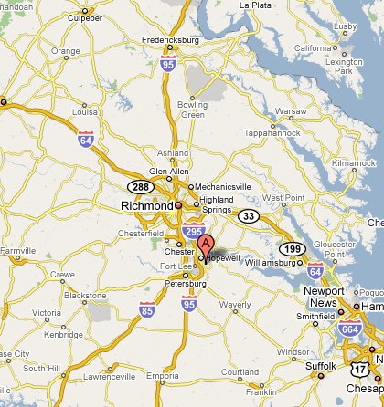
Julian Bailey
804.541.4164
6984 Hearthside Dr, Prince George Va 23875
DL P/T P902/T901 Crater
jbyjeff@aol.com
4/28/1964
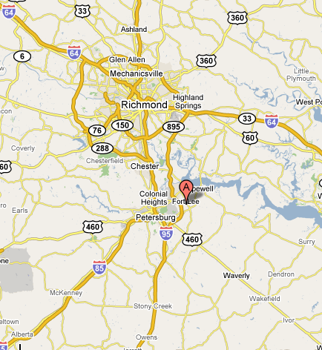
Dean Beuglass
804-539-3104
4020 Oxbridge Rd, Richmond Va 23236
dbeuglass@comcast.net
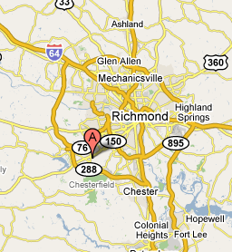
John Blackmore
804-539-9323
710 Maybeury Dr., Richmond Va 23229
jblackmore00@gmail.com
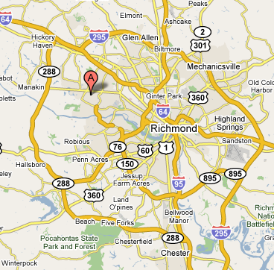
Rick Bragga
804-320-4973
3244 Center Ridge Dr, Richmond Va 23233
photoeagle@comcast.net
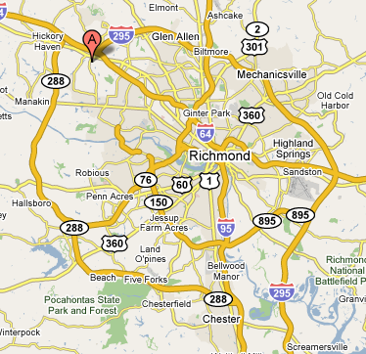
Assigned: 3 - Eagle

GREGORY BUTZ
434-392-5627
351 RIVER RD, FARMVILLE Va 23901
ASM Troop 6357
gdbutz@email.com
11/22/1966
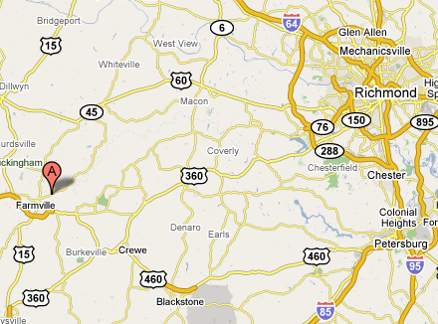
Gerard Coiley jr
804-378-4001
1736 bantry drive, Midlothian Va 23114
jerrycoiley@comcast.net
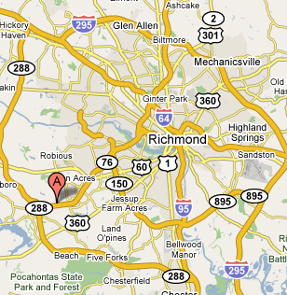
Kelly Cummings
434-983-7576
PO Box 1166, Dillwyn Va 23936
kcummings@bchs.k12.va.us
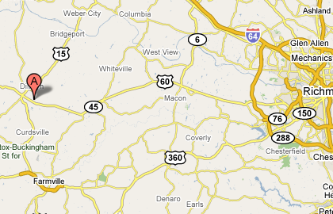
Jerry Daniels
8047397332
5209 Watercrest Rd, Midlothian Va 23112
h2okies@vt.edu
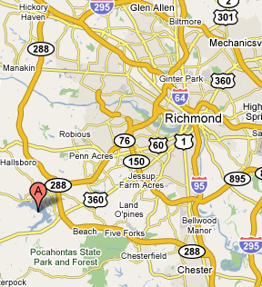
Dan Denmark
804.746-7464
9120 Agroe Dr, Mechanicsville Va 23116
ASM Troop 523 Battlefield
devdogdan@aol.com
7/11/1964
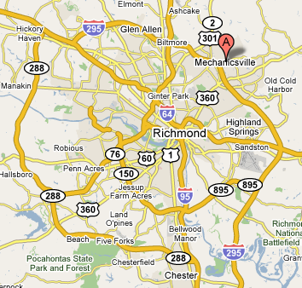
Donald Egan
757-621-7723
3804 Ronnie Ave., Richmond Va 23222
CM Pack 599 Battlefield
done082366@yahoo.com
8/23/1966
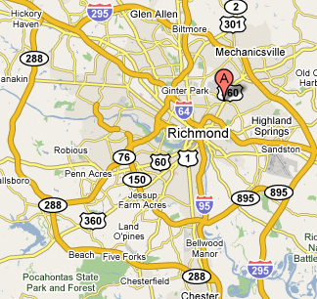
David Elliott
840-789-1964
8397 Windsor Dr, Mechanicsville Va 23111
ASM Troop 555 Battlefield
dbejr3@comcast.net
2/25/1963
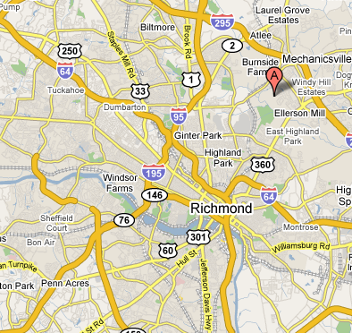
Patrick Gould
804.883.9410
16347 Goshen Rd, Montpelier Va 23192
ASM Troop 700 Cardinal
pat.gould@dom.com
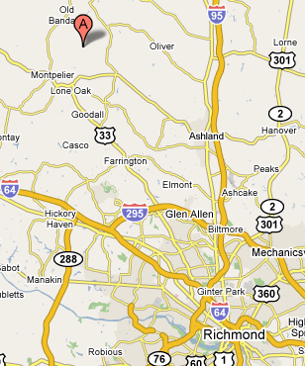
Paul Gross
804-272-0892
4008 Beechmont Rd., Richmond Va 23235
pgross@medivisuals.com
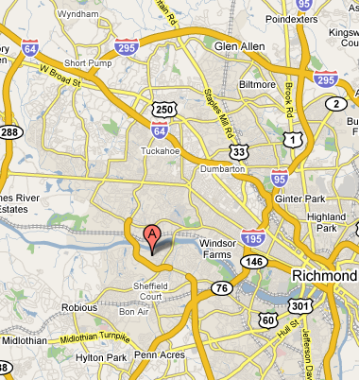
Chris Habenicht
288-5634
208 W. Hillcerst Ave, Richmond Va 23226
ExBrd Council
chablaw@aol.com
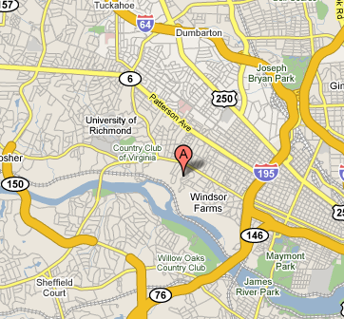
Matt Hadley
804-320-0949
2801 Williamswood Rd., Richmond Va 23235
mhadley@mediageneral.com
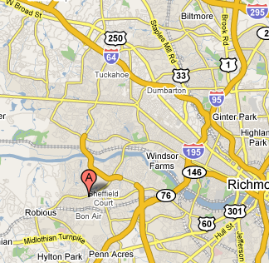
Iain Hall
804 314 5603
13205 Groveton Terrace, Midlothian Va 23114
iainhall@gmail.com
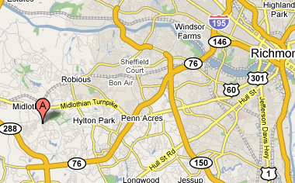
Leonard Holden
804 520-7679
5206 Thornwood Ct., Petersburg Va 23803
leholden@comcast.net
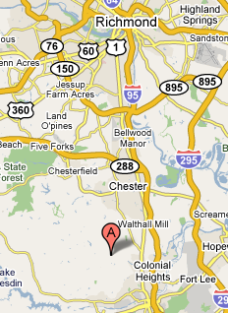
Charles Hooe
(804) 837-3425
6350 Tammy Lane, Mechanicsville Va 23111
landhooe@msn.com
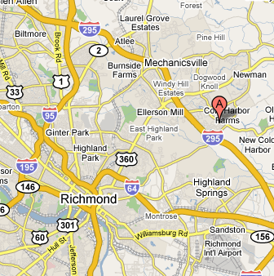
Scott Hooper
434-975-1665
1104 River Oaks Ln,Charlottesville Va 22901
Council Executive Board, Area 7 Camping Inspector
Monticello Stonewall Jackson Area Council
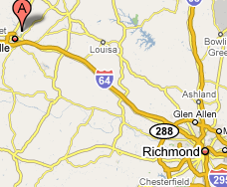
Robert (Bob) Hundley
804-550-9222
9195 harvey hollow drive, mechanicsville Va 23116
bhundley@resourceintl.com
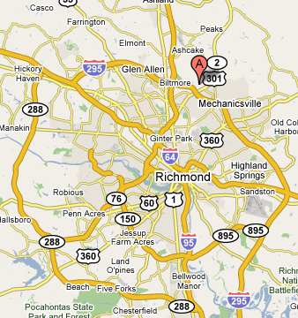
William Janis
804-698-1156
5005 Amberwood Dr., Glen Allen Va 23059
billjanis@comcast.net
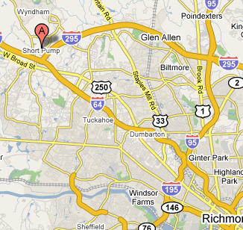
Bill Kelly
804-938-8948
4016 Poplar Grove Road, Midlothian Va 23112
Troop 876
bcwjt@clearwire.net
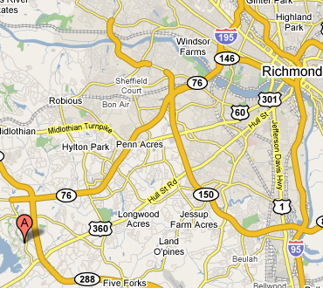
Steve Kraft
364-4220
12301 Lynwood Dr, Glen Allen Va 23059
ASM Troop 736 Cardinal
KRAFT5@comcast.net
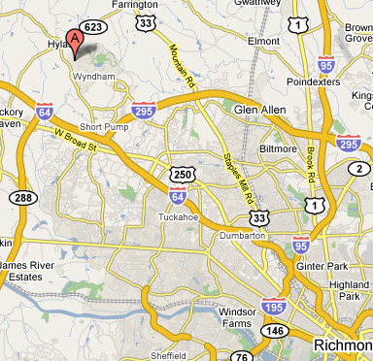
Brian Long
598-6989
3408 Sherwood Bluff Way, Powhatan Va 23139
CC Pack 1837 Hugeunot Trail
blongtrance@comcast.net
5/17/1967
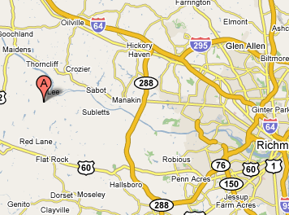
Gordon Mapes
804.754-1477
307 Smoketree Terr, Richmond Va 23236
SM Troop 810 Hugeunot Trail
gordon@brandermillchurch.org
1/18/1961
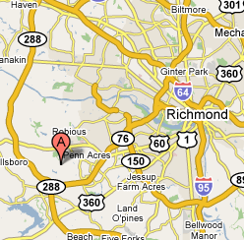
Terry McCann
804.730-3365
7963 Baneberry Dr, Mechanicsville Va 23111
DL Pack 544 Battlefield
mfd119@aol.com
2/1/1968
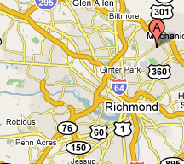
James McCoig
8043607282
5625 Belstead Lane, Glen Allen Va 23059
jlmccoig@comcast.net
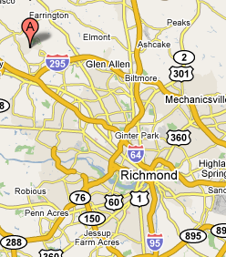
Robert McLemore
(804) 556-2757
1881 Wicker Woods Drive, Maidens Va 23102
grousek9@yahoo.com
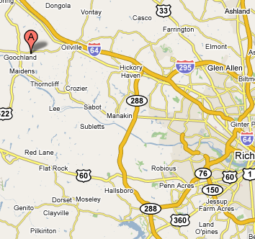
Frank McNeilly
804-748-3902
14105 Bridgetown Ct., Chester Va 23831
WL/CC Pack 2815 Arrohattoc
fmcneilly@comcast.net
9/29/1964
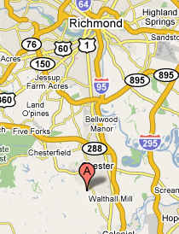
[something other than Eagle]
Martin Myers
804-261-3903
1234 Lorraine Ave, Richmond Va 23227
mmyers@horatio.us
Pack 740, CC and webelos
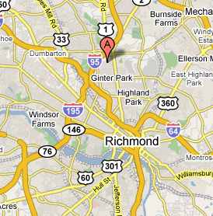
[something other than Eagle]
Sonja Myers
804-261-3903
1234 Lorraine Ave, Richmond Va 23227
goldsonja1@aol.com
Pack 740 Cubmaster
Alice Nelson
804-776-7445
P.O. Box 307, Hartfield Va 23071
SM Troop 341 Rappahannock
alinels8@aol.com
3/9/1965
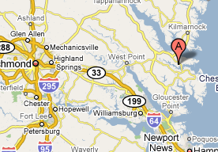
CP Norris
804.276.1916
1011 Robmont Dr., Richmond Va 23236
ASM Troop 1845 Hugeunot Trail
cpnva@yahoo.com
9/21/1958
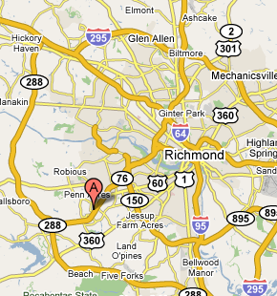
Tom O'Keefe
(804) 303-3938
11712 Shadow Run Lane, Glen Allen Va 23059-2528
DL, MC Pack 720 / Troop 763 Cardinal
Thomas.W.O'Keefe@dom.com
4/12/1961
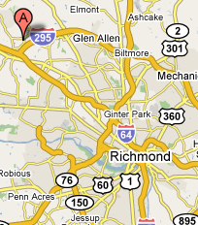
[probable no show]
Wray Palmore
804.356.2647
8180 Newman Dr., Mechanicsville Va 23116
DL Pack 544 Battlefield
gwpalmore@hotmail.com
4/7/1964
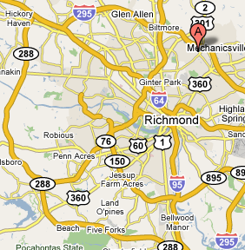
Steve Porter
804-378-1953
13731 Grove Pond Drive, Midlothian Va 23114
steveporter@plasti-cart.com
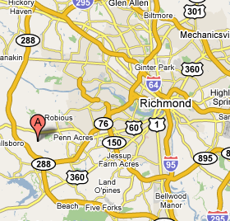
Joseph Rauguth
804 852 7807
6349 Little Sorrel Drive, Mechanicsville 23111
rauguthj@comcast.net
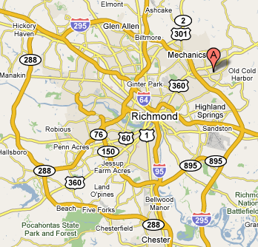
Matt Rigsby
804.569.1377
8266 Carneal Ln, Mechanicsville Va 23111
CM Pack 544 Battlefield
mrigsby@verizon.net
6/28/1968
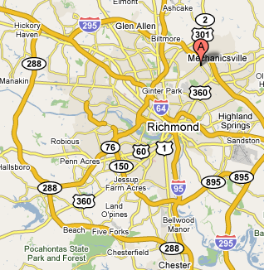
Robin Rush
804-204-2623
3205 Evergreen Ave, Hopewell Va 23860
Prof
RoRush@bsamail.org
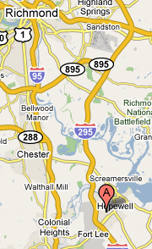
Dywana Saunders-Confroy
804-330-1346
10509 Saxony Rd, Richmond Va 23235
ibtwins@yahoo.com

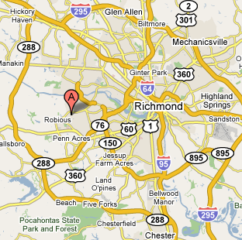
Ben Shaw
(804) 314-7193
swimming4fun7@yahoo.com
Troop 793

Judson JUD Shows
434-983-3272
1432 Rosney Rd, Dillwyn Va 23936
cowboyjud@embarqmail.net
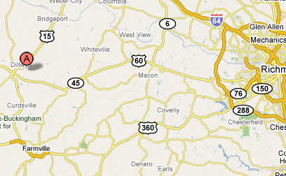
Ernie Smith
804.550-3525
9184 Bracey Mill Place, Mechanicsville Va 23116
ASM Troop 505 Battlefield
emaasmith@access4less.net
5/20/1957
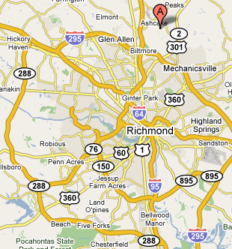
James Stallings
804-553-5876
PO 1769, Midlothian Va 23113-1769
CM Troop 2806 Arrohattoc
jdstallings@mcws.net
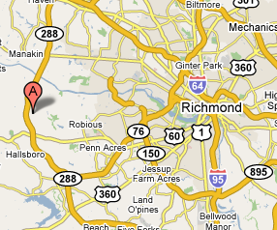
Charley Tinsley
804.204.2618
4902 Snowshoe Crt, Glen Allen Va 23060
ProfF
ctinsley@bsamail.org
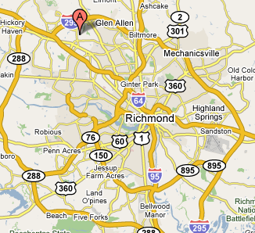
Randall Vaughan
804-270-7955
11209 Eastborough Ct, Richmond Va 23233 8
rvaughan@ubsh.com
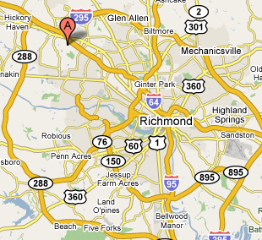
Ben Ward
690-2058
4380 Locust Green Ln, Mechanicsville Va 23116
ASM Troop 555 Battlefield
troop555eaglescout@yahoo.com
5/30/1981
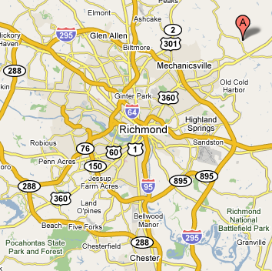
Darrell Wells
804-744-7760
12103 King Cotton Ct, Midlothian Va 23112 8
wells2835@comcast.net
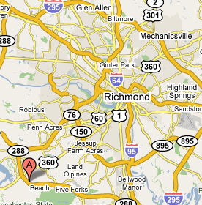
Carl Whitaker
804.449.1762
17127 Katy Ln, Beaverdam Va 23015
MC Troop 700 Cardinal
carl.a.whitaker@dom.com
7/15/1954
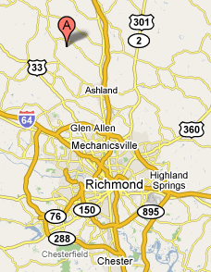
James White
932-8997
3411 Horseshoe Dr, Quinton Va 23141
ASM Troop 502 Battlefield
James.R.White@pmusa.com
12/6/1947
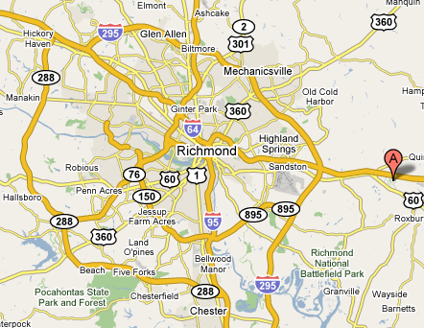
David Wild
804.382-2862
13700 Castleway Rd, Midlothian Va 23114
ASM Troop 1876 Hugeunot Trail
david.wild@dom.com
4/22/1963
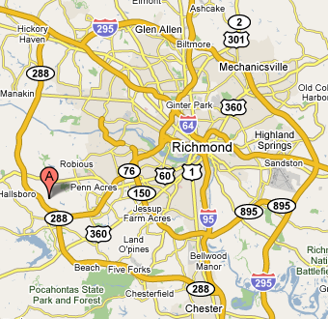

Jeffrey Wrobel
(804) 213-3669
9603 January Court, Richmond Va 23238
jwrobel@mutual-assurance.com


