Staff Positions SR917
Course Dates:
Sept (18), 19, 20, 21
Oct (17), 18, 19, 20

- Scoutmaster: Chuck Smith Bear 373
- ASM – Program: Al Best Bear SR267 BW SE-55
- ASM – Support: Tom Johnson SR267 Bobwhite
- ASM – Troop Guides: John McCulla Fox 501
- Senior Patrol Leader: Bill Eggleston Beaver 501
- Asst. Senior Patrol Leader:
- Troop Scribe: Chris Vernon Buffalo 501
- Asst Scribe/Technoscribe: Bennie Good Bear 501
- Asst Scribe/Historian: Norm Hipskind Eagle 604
- Asst Scribe: Carol Pilgrim Fox 604
- Friendly Quartermaster: Nancy Fonseca SE-CS-20 Eagle

- AFQM: Mike Smith Buffalo 677

AFQM: Jim Richards SR267
- AFQM: Sheila Newsome Antelope SR769

Committee Member: Randy Harris Bobwhite
Staff Advisor Geoffrey Angle SR809

Troop Guides

- Mike Lynch Bobwhite SR677
- Felicia Ferrigno Owl 769
- Pat Meadows Fox SR501
- Ed Hinds – Beaver SR769
- Chip Hendricks Eagle 769
- Kenny Jones Eagle 769
- Joe Oleska BEAR SR769
- Phil Victor Buffalo SR768

Consultants:
Religious Coordinator: <TBD>
Medical Resource: Felicia

Venture /Youth Advisors: Nancy Fonseca/ Mike Smith
Rocket Man John Turner
Baden Powell (Campfire/D6): Mike Oxford
Game of Life Erik Bodin / Craig Britt
Auxillay Staff: Mike Lynch (possible TG)
Everett Winn
Andy Curley

Returning Staff Members: 11
New Staff Members: 10
Male: 15
Female: 6
1. Scoutmaster: Chuck Smith Bear 373
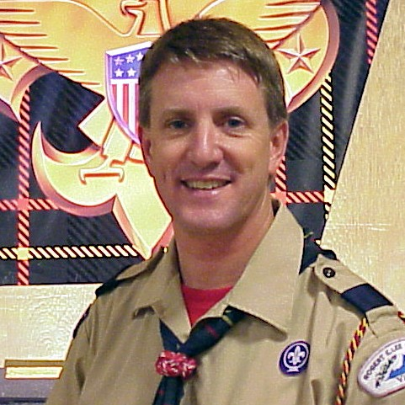
2. ASM – Program: Al Best Bear SR267 BW SE-55
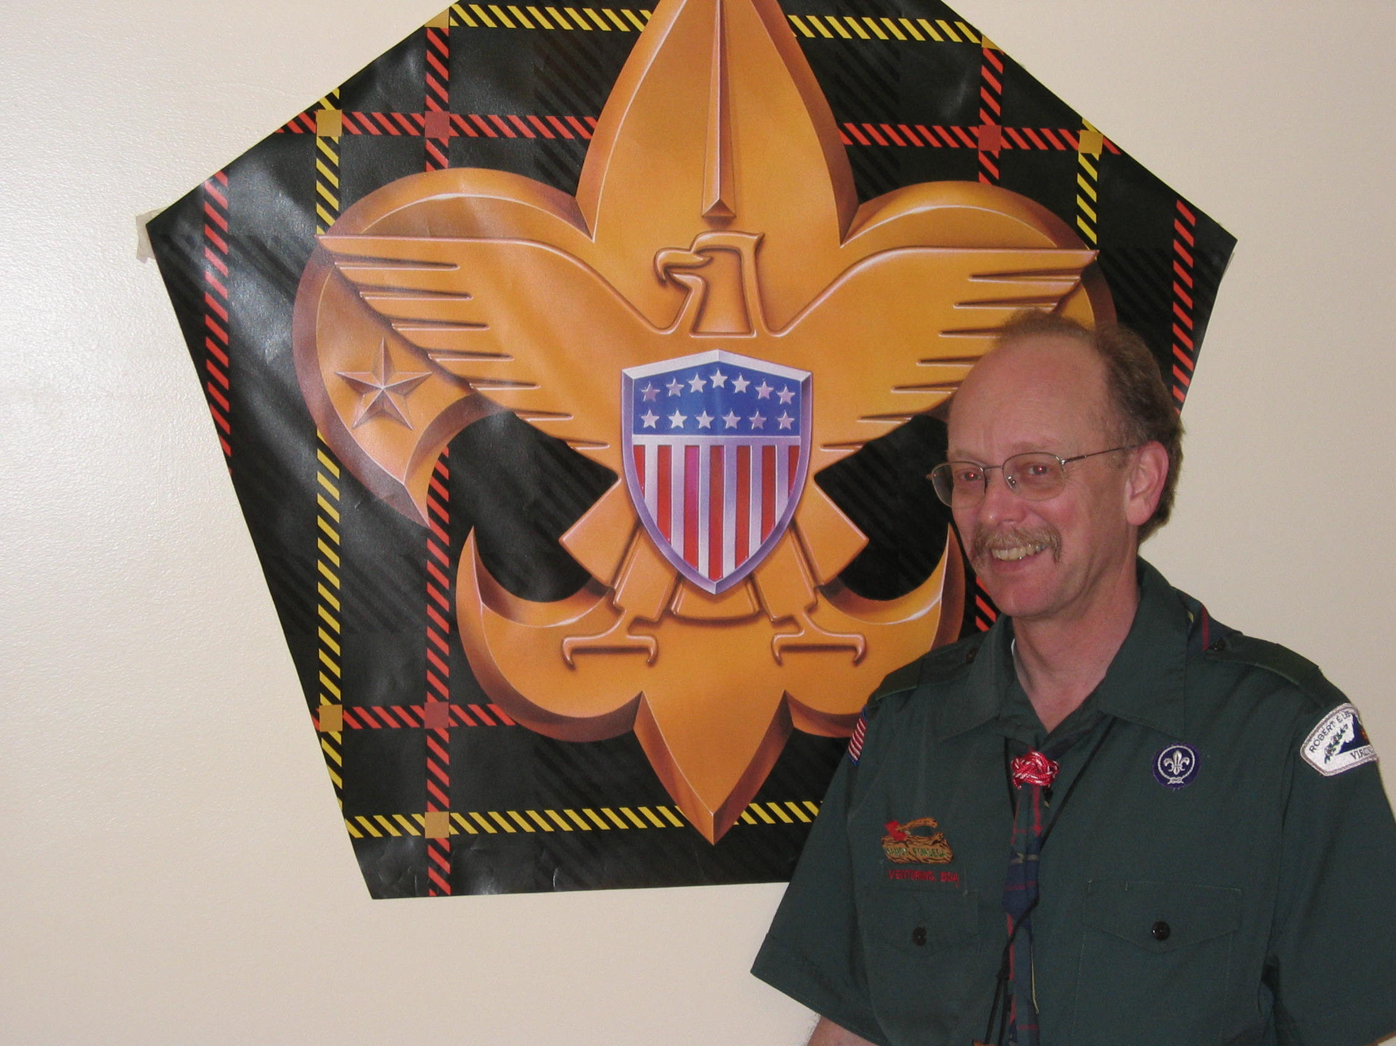
3. ASM – Support: Tom Johnson SR267 Bobwhite
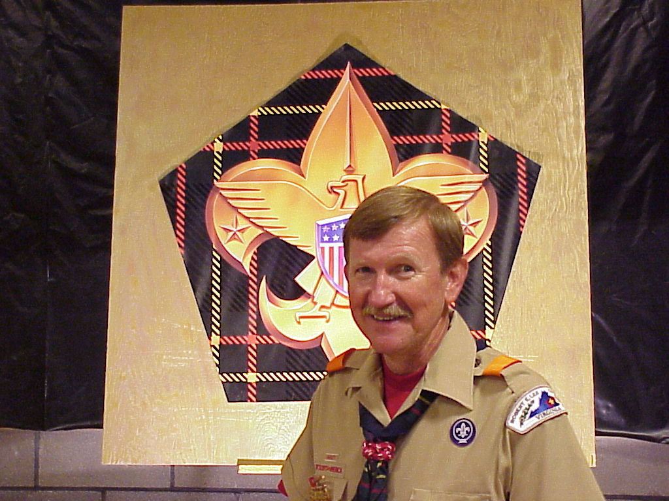
4. ASM – Troop Guides: John McCulla Fox 501
5. Senior Patrol Leader: Bill Eggleston Beaver 501
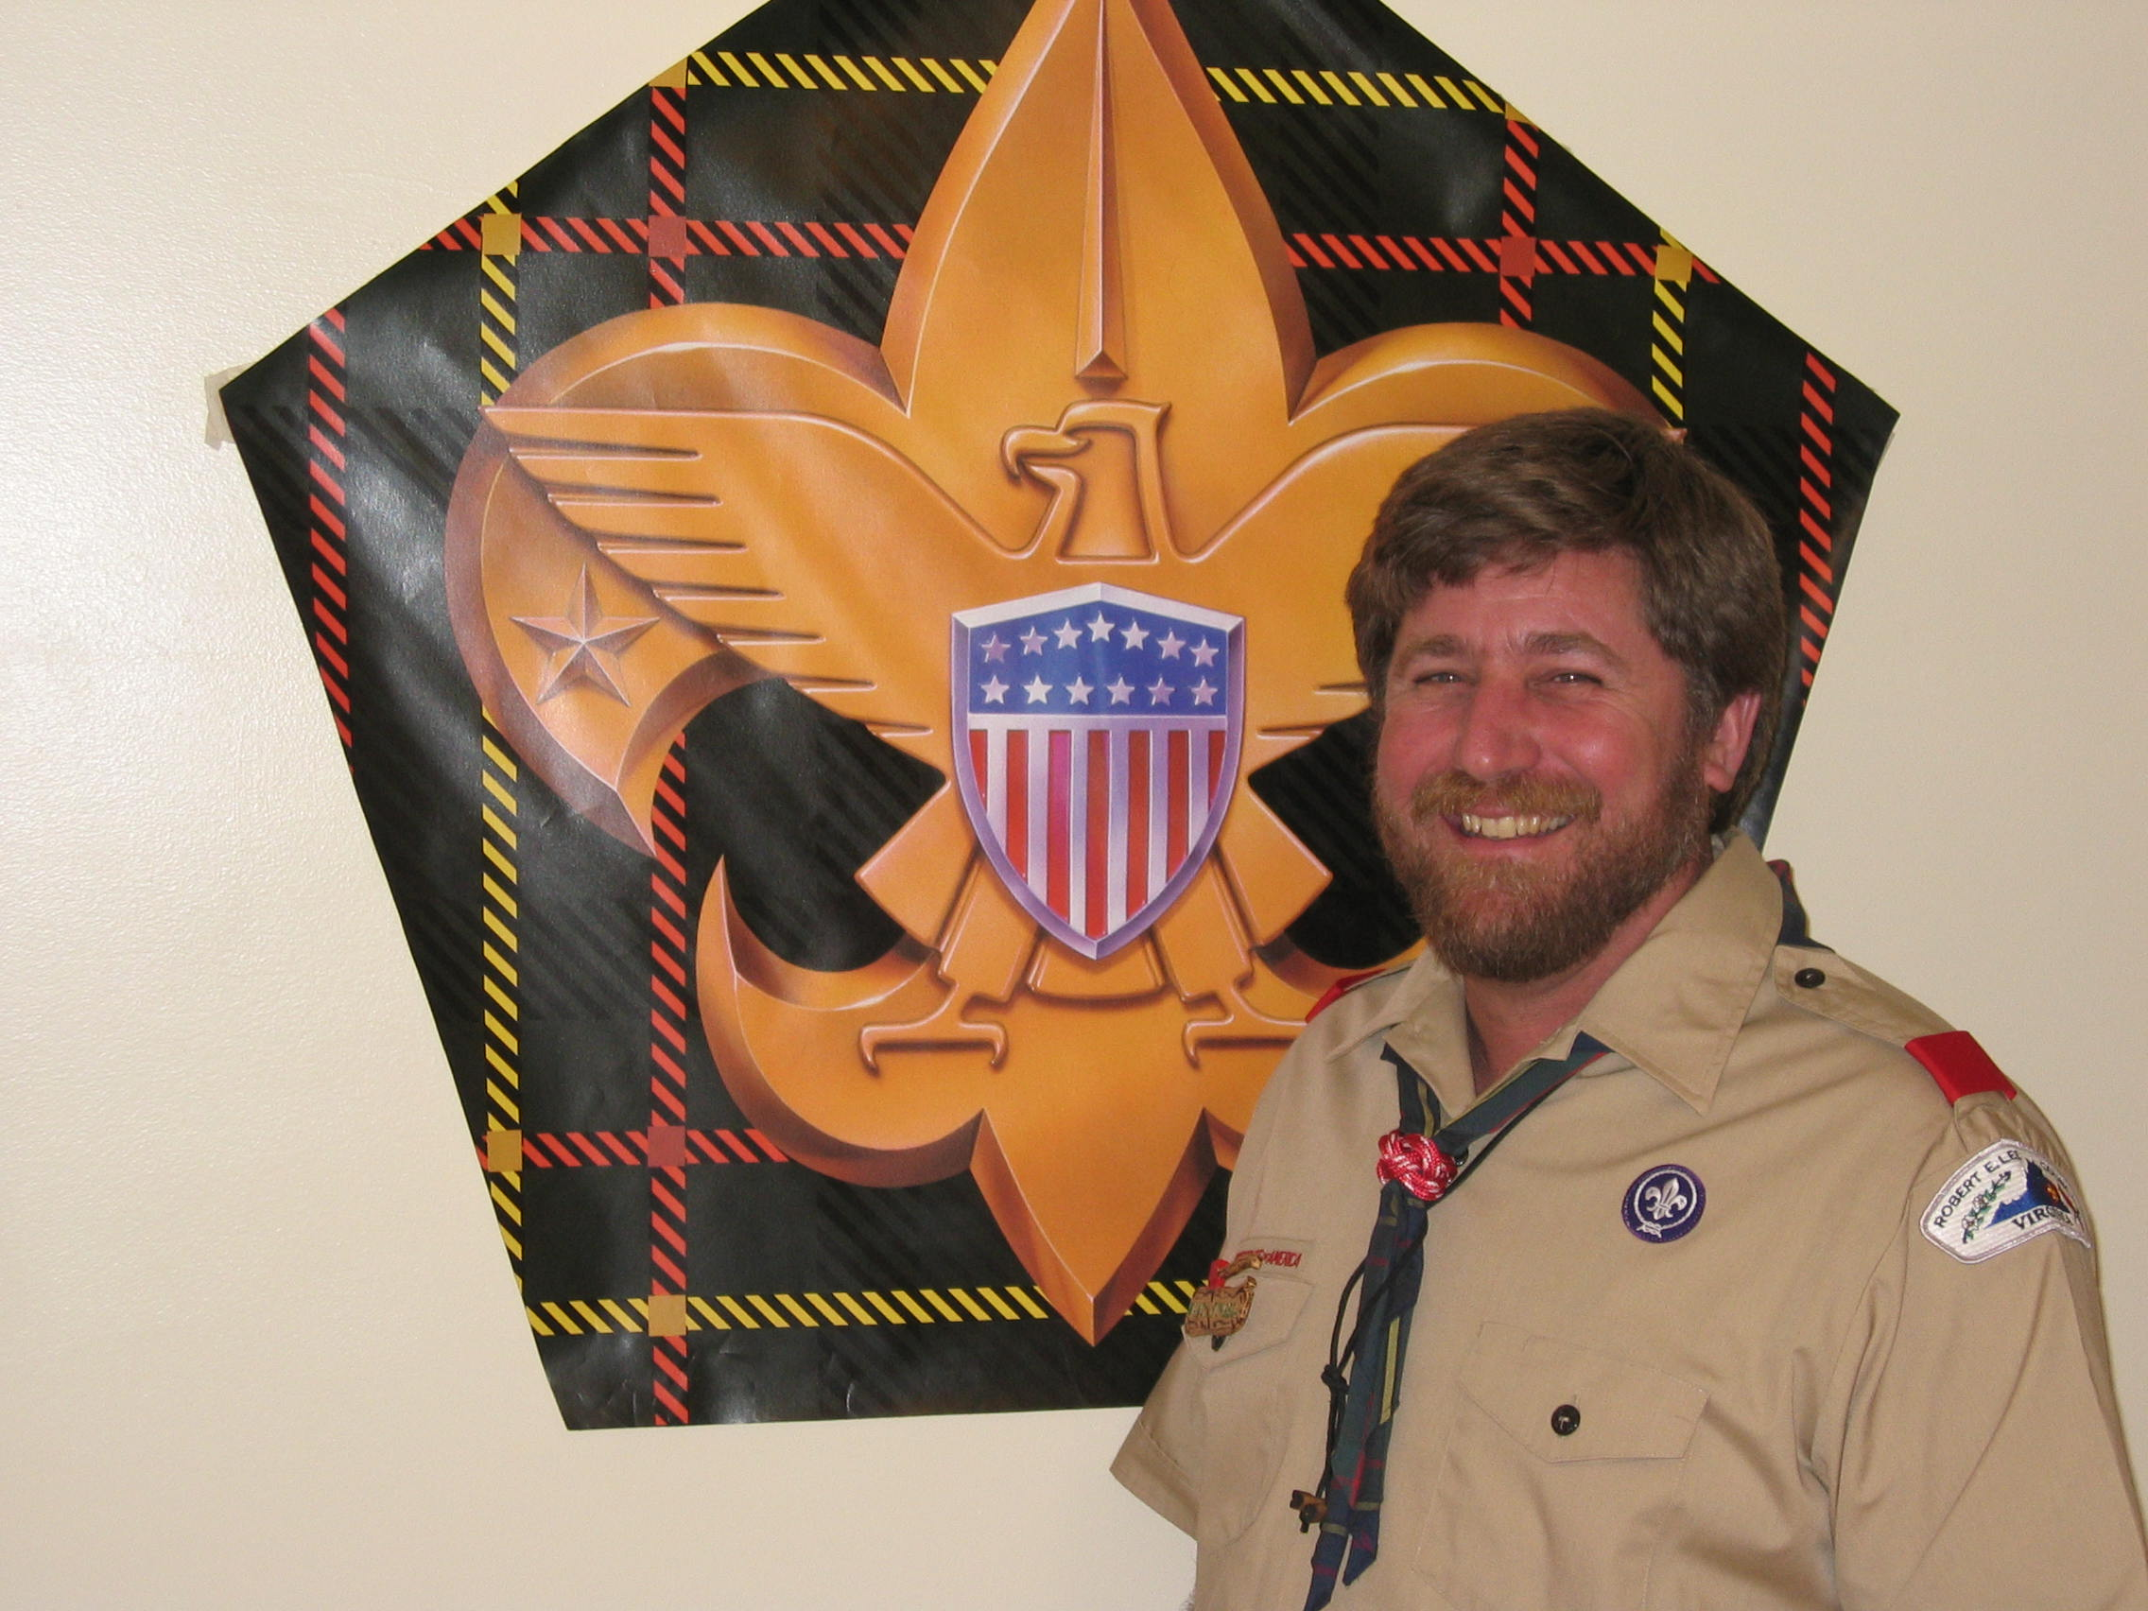
6. Asst. Senior Patrol Leader:
7. Troop Scribe: Chris Vernon Buffalo 501
8. Asst Scribe/Technoscribe: Bennie Good Bear 501
9. Asst Scribe/Historian: Norm Hipskind Eagle 604
10. Asst Scribe: Carol Pilgrim Fox 604
11. Friendly Quartermaster: Nancy Fonseca SE-CS-20 Eagle
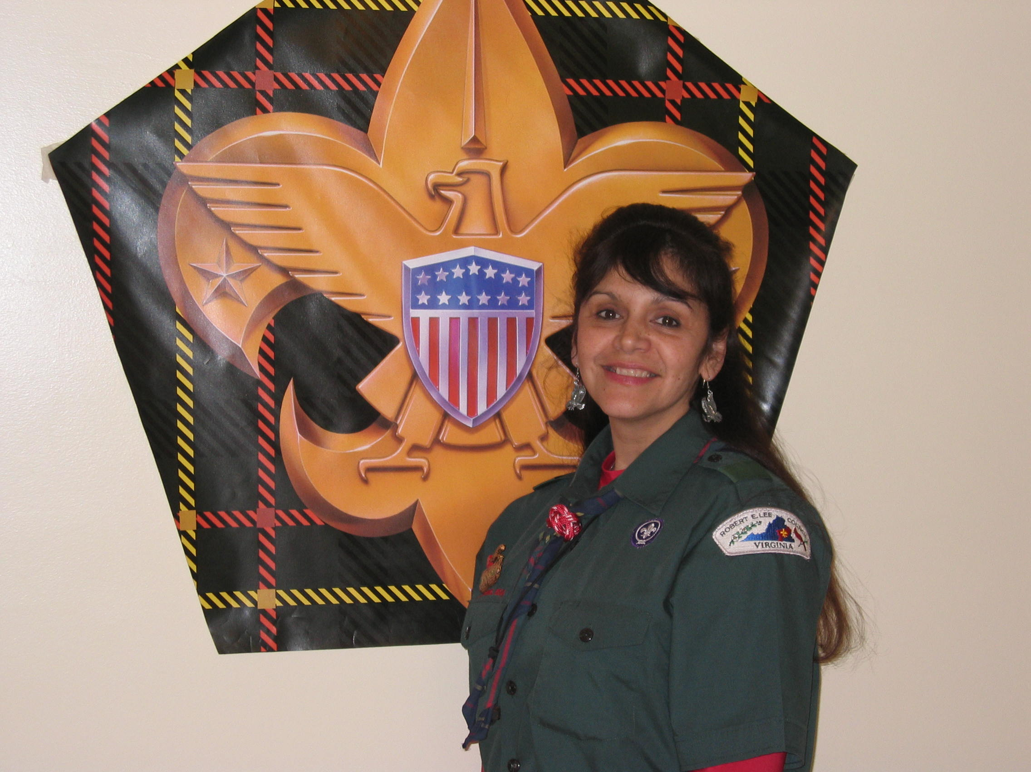
12. AFQM: Mike Smith Buffalo 677
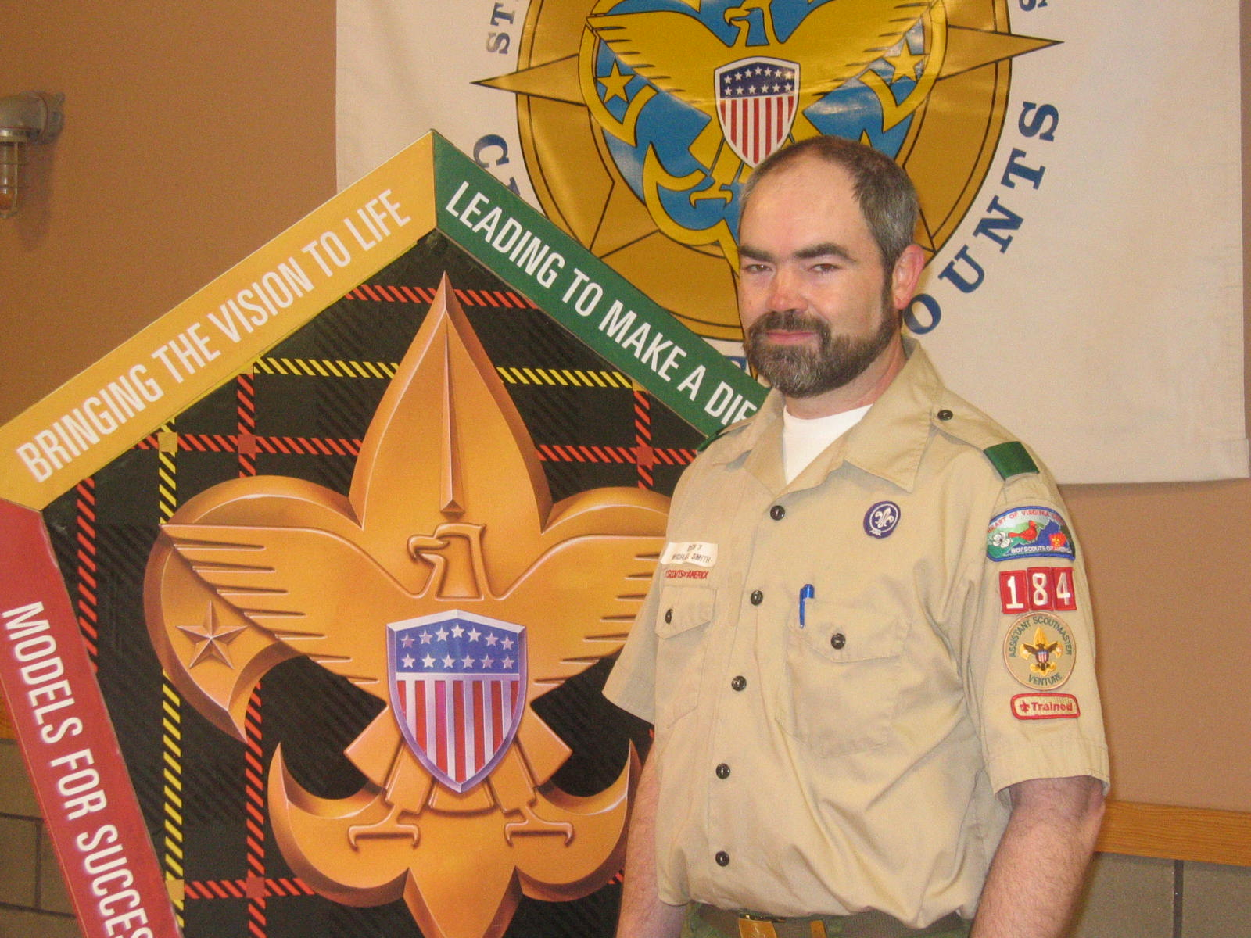
13. AFQM: Jim Richards SR267
14. AFQM: Sheila Newsome Antelope SR769

Committee Member: Randy Harris Bobwhite
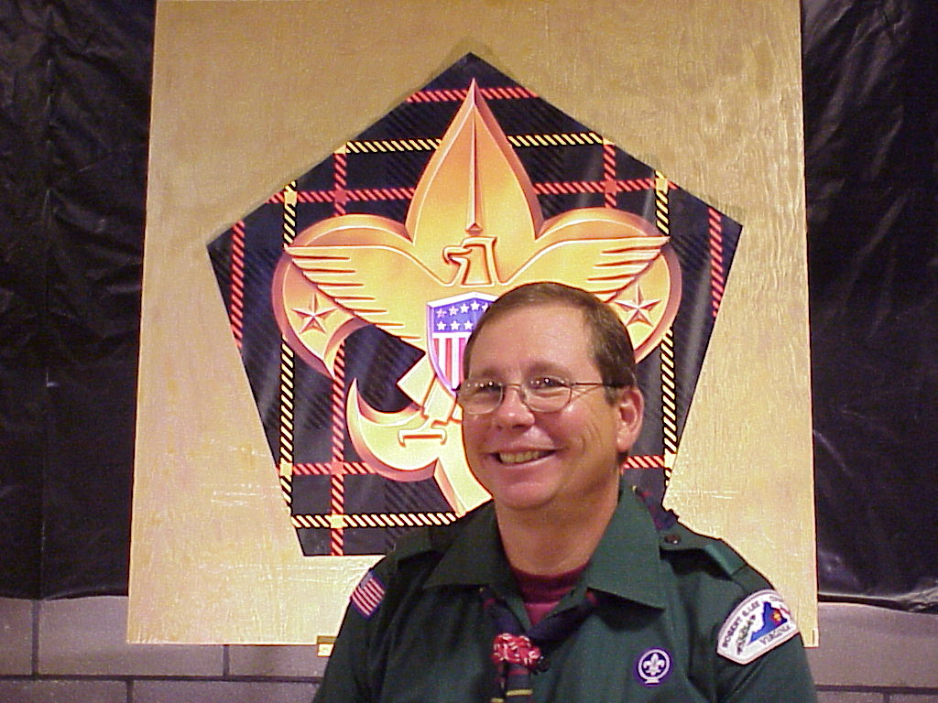
Staff Advisor Geoffrey Angle SR809

Troop Guides
15. Mike Lynch Bobwhite SR677
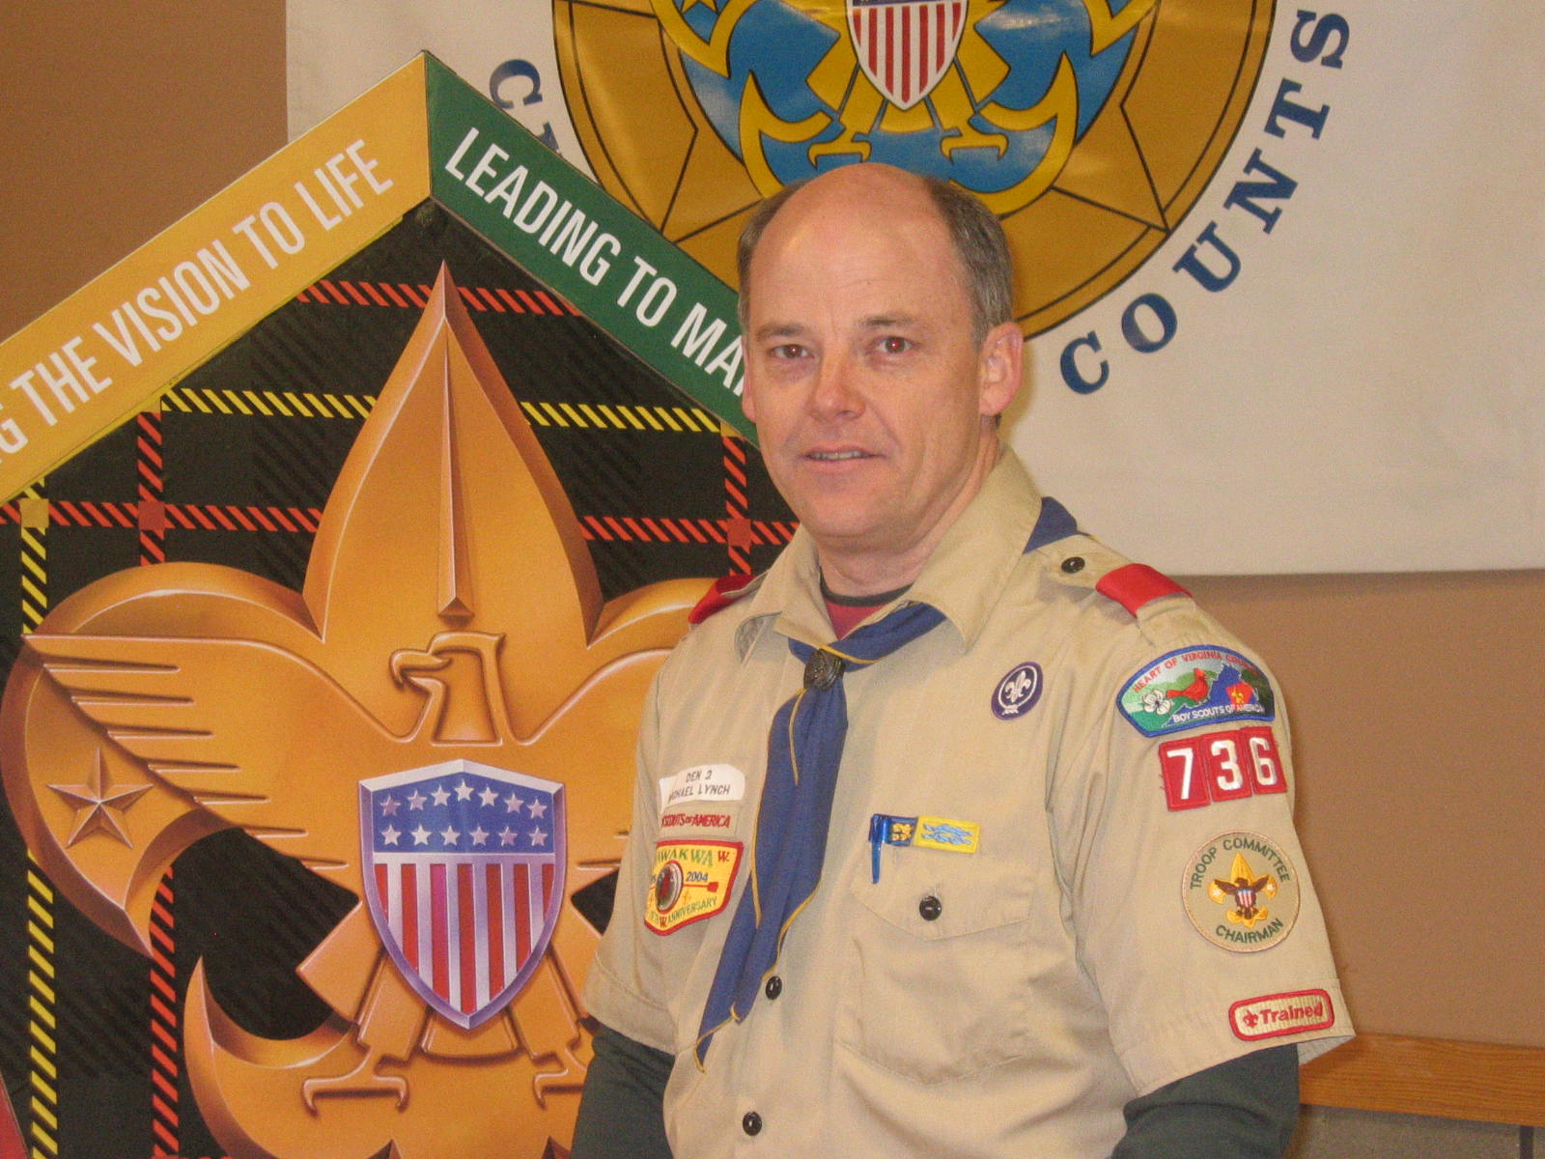
16. Felicia Ferrigno Owl 769
17. Pat Meadows Fox SR501
18. Ed Hinds – Beaver SR769
19. Chip Hendricks Eagle 769
20. Kenny Jones Eagle 769
21. Joe Oleska BEAR SR769
22. Phil Victor Buffalo SR768

