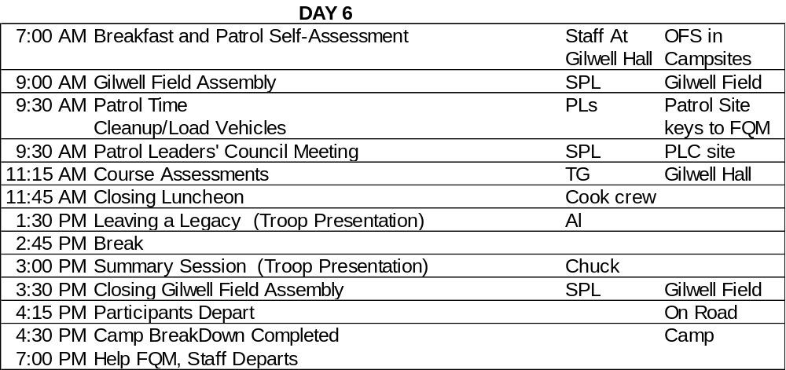

Breakfast (07:00)
- Patrols in campsites
- Staff in Dining Hall
- Gilwell Gazette for each

Day Six: Gilwell (09:00 -30 min)
- Staff in Field Uniform and Red Jac Shirt, Taupe Neckerchief and Leather Woggle, stave
- Songbook? On My Honor
- All staff stand behind the flag
- Sing Gilwell Song with Guide Patrol, Real Patrol and Staff

Patrol Time (09:30 - 1hr 45 min)
- Patrol Campsite
- On their own, packing
- One vehicle per Patrol allowed in camp to load equipment
- Concurrent – PLC at Dining Hall

Course Assessments (11:15 - 30 min)
- Dining Hall
- TGs
- Assessment forms

Closing Luncheon (11:45 - 1 hr 45 min)
- Dining Hall
Leaving a Legacy Troop Presentation (13:30 - 1 hr 15 min)
- Dining Hall
- Al

Break (14:45 - 15 min)

Summary Session Troop Presentation (15:00 - 30 min)
- Dining Hall
- Chuck

Closing Gilwell Field (15:30 - 45 min)
- Staff in order of height
- Field Uniform with Red Jac Shirt, Taupe Neckerchief and Leather Woggle?
- Have American Flags
- Follow Chuck, SHAKING hands then line road and salute with Flag in left hand

COURSE DIRECTOR:
“The moment has come for us to gather on Gilwell Field as Troop 1 for the last time in this Wood Badge course. We’ve had a tremendous experience together over these six days. We’ve worked together, learned together, achieved a great deal, and had a lot of fun.
“As you discovered during the troop’s outdoor experience, Gilwell Field exists wherever Wood Badge participants gather. The same is true of membership in Troop 1. Our association with one another, our support of each other, and our fellowship with one another does not cease simply because the course is over. You will always be a part of this group. The spirit of Gilwell Field, and of Wood Badge, will be with you wherever you go.
“I speak for all of the staff when I say this has been a very rewarding experience for those of us who have been privileged to accompany you through your Wood Badge experience. During the course, we have spoken often of the leadership skills that you can take with you to your home units, districts, and councils. You have already contributed greatly to the advancement of Scouting by what you have brought to this course. We thank you for that, and look forward to news of your future leadership successes.
“Baden-Powell always got a bit nostalgic and misty-eyed when he was saying goodbye to Scouts and Scouters with whom he had shared meaningful experiences. I’ll try not to do that now, though the temptation is great. Let me just say that each one of you has an important role to play in providing leadership for Scouting and leadership for America. Good luck to you all.
Participants Depart (16:15)

