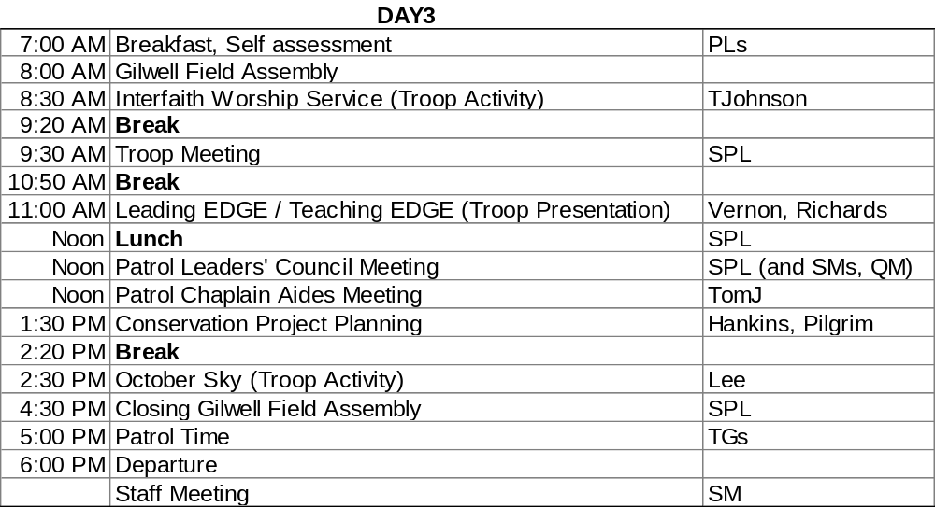
Breakfast
• Gazette, Start Stop Continue?
Dan: “Lord Baden Powell had many Scouts”
Day Three: Gilwell (08:00-30 min)
• Serapis, “Columbia the Gem of the Ocean”
• TG stand with patrol
• PL will do “patrol report”
Interfaith Worship instruction/service (08:30-50min)
• TG to sit with patrols
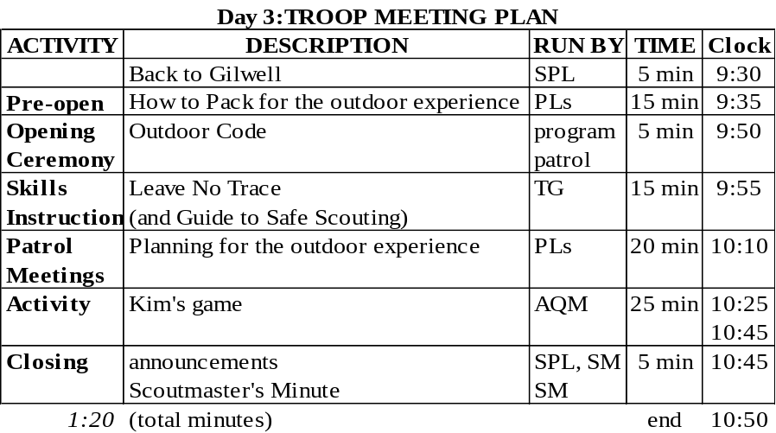
Troop Meeting (09:30-10:50)
• TG do not sit with patrol.

Things needed:
• Leave No Trace handout
• LNT cards
• Handbook
• Kim’s game stuff
Patrol Meeting—run by PL (20 min)
Patrol leaders should use the patrol meeting to begin planning the details of the upcoming outdoor experience. Among the topics to consider are these.

• Food
— Budget for meals — Shopping
— Menus — Food repackaging, transport, and storage
— Ingredient lists

• Group gear
— For camping — For cooking

