Patrol
Leader
Notebook
Table of Contents
Course Info 3
Cub Adventure Camp Map 4
Camp T. Brady Saunders Map 5
Traditional Order for Wood Badge Patrols 6
Responsibilities of the Program & Service Patrols 7
Start, Stop, Continue 8
Day One 10
Patrol Leaders’ Council Meeting Agenda 11
Day Two Flag Ceremony 13
Roles and Responsibilities 15
Patrol Leadership Positions 17
The Patrol Project 18
Troop Meeting Plan 20
Start, Stop, Continue 21
Day Two 23
Patrol Leaders’ Council Meeting Agenda 24
Patrol Meeting Plan 25
Day Three Flag Ceremony 26
The Campfire Program Planner 27
Troop Meeting – Day Two Pre-Opening Activity 29
Troop Photo Plan 30
Start, Stop, Continue 31
Day Three 33
Spring Open Burning Laws 34
Patrol Leaders’ Council Meeting Agenda 35
Outdoor Code 36
Troop Meeting Plan 37
Planning for the Outdoor Experience 38
Day Four Flag Ceremony 39
Patrol Leader Assignments for the Day Three Troop Meeting 40
Wood Badge Outdoor Experience 41
Wood Badge Cooking Guidelines 43
Cooking Checklist 44
Gear Lists 45
Start, Stop, Continue 47
Day Four 49
Patrol Leaders’ Council Meeting Agenda 50
Patrol Meeting Plan 51
Day Five Flag Ceremony 52
Start, Stop, Continue 53
Day Five 55
Patrol Leaders’ Council Meeting Agenda 56
Patrol Meeting Plan 57
Day Six Flag Ceremony 58
Wood Badge Patrol Project Discussion Guide 59
Start, Stop, Continue 61
Day Six 63
Patrol Leaders’ Council Meeting Agenda 64
Start, Stop, Continue 65

Course
Info

Cub Adventure Camp Map
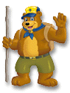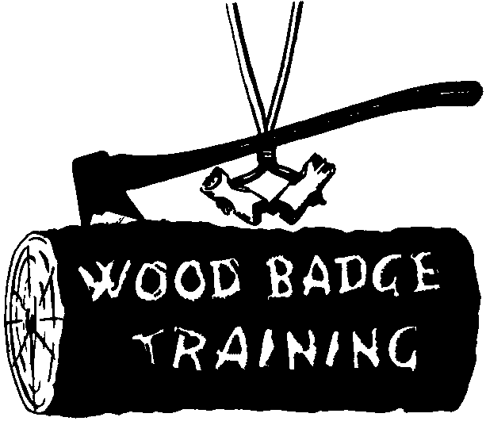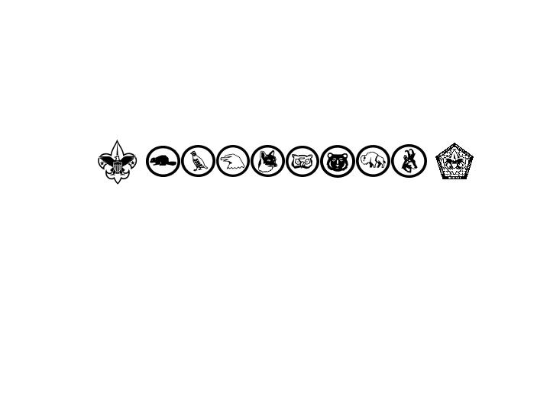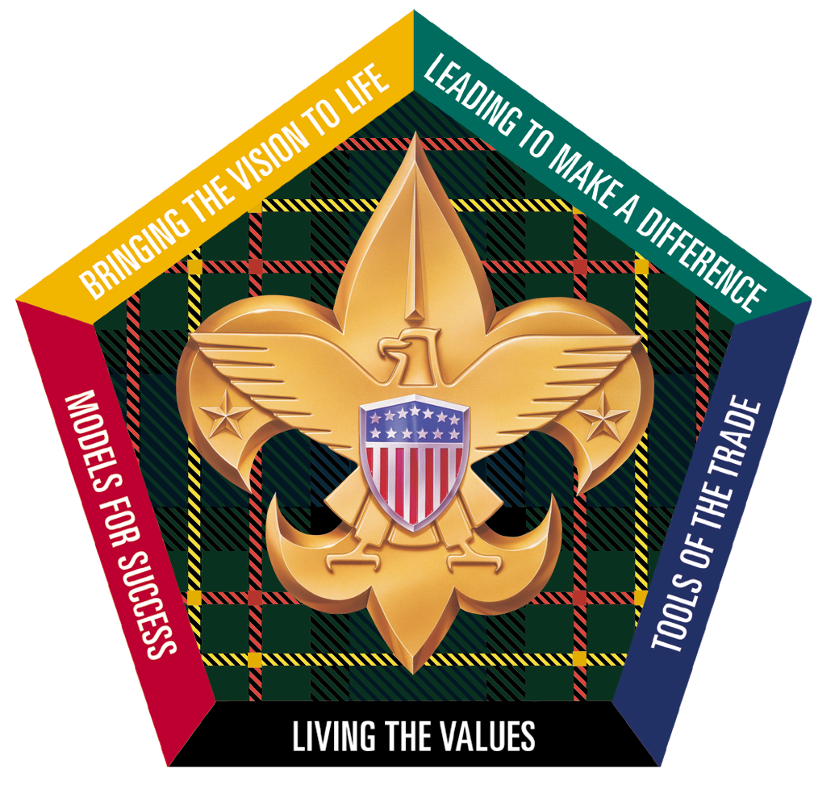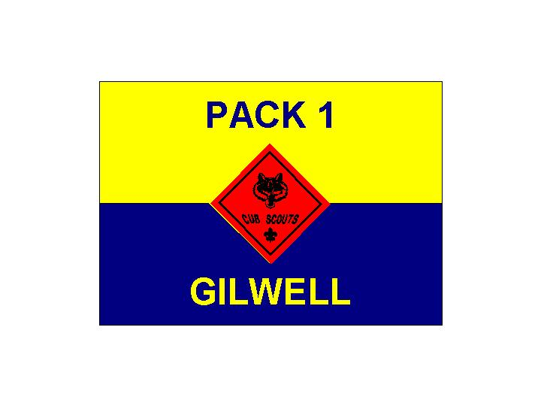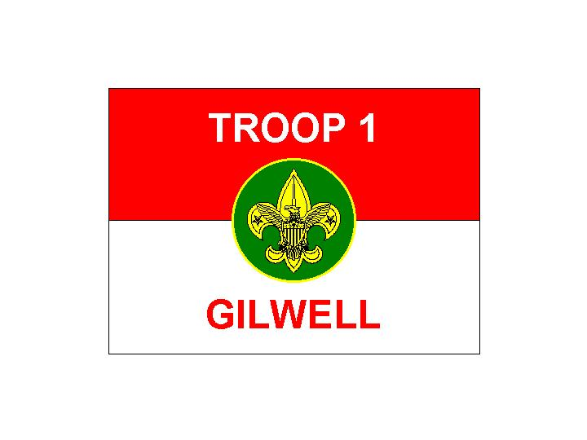
Gilwell Field
Cub and Webelos Adventure Camp
Heart of Virginia Council
Fort Ferguson
Our Fellow Scouters Quarters
TeePee Village
Mountain Cabins
Staff Quarters
Amphitheater
Patrol Cabins (PC)
Parking
To Route 6. – Maiden’s Road – To Route 632
Aspenwall House
Handicraft
To Boy Scout Camp T. Brady Saunders
Health Lodge
Staff Office
Gilwell Hall
Welcome Center
Castle
(Pool)
Private Residence
Welcome to
Wood Badge for the 21st Century
Private Residence
Emergency
Gathering
Location

Camp T. Brady Saunders Map
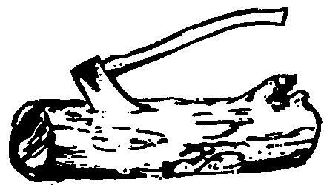
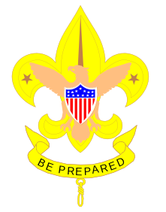
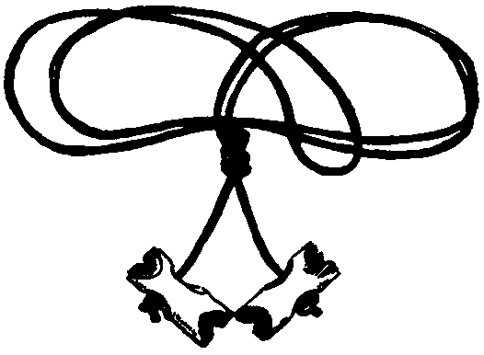
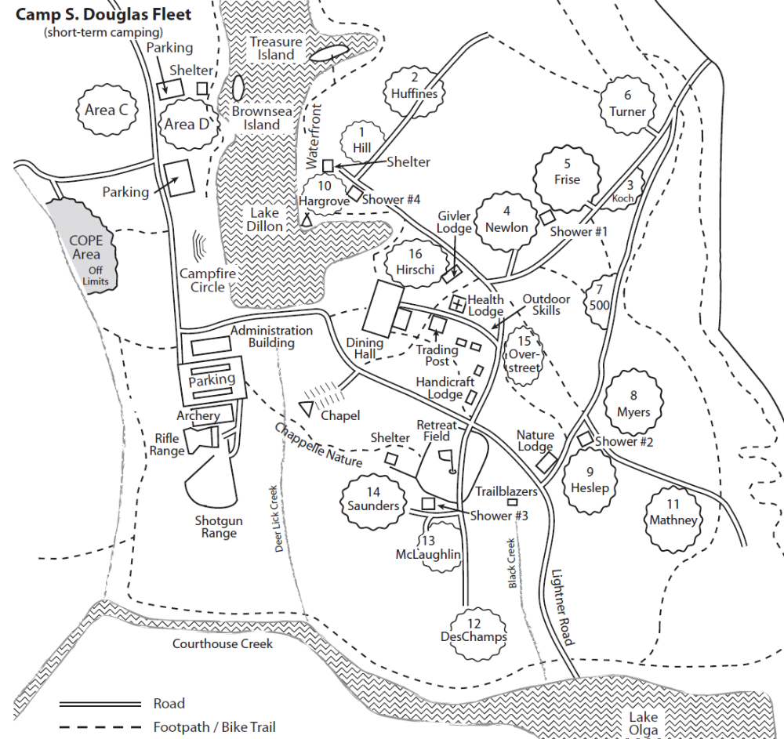
Emergency Gathering Location
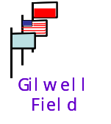
Gilwell Hall
Staff Camp
Patrol Camps
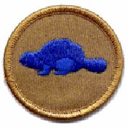 | 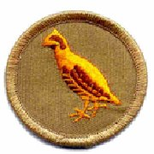 | 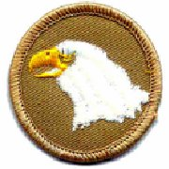 | 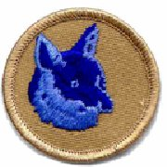 | 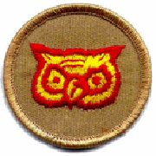 | 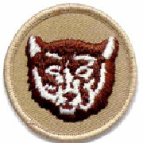 | 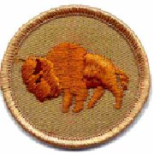 | 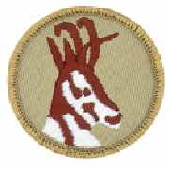

Traditional Order for Wood Badge Patrols

Beaver
Bobwhite
Eagle
Fox
Owl
Bear
Buffalo
Antelope

Responsibilities of the Program & Service Patrols
 | Program |  | Service
Day | Patrol | Responsibilities | Patrol | Responsibilities
One | Buffalo | Retire Flags at Dusk | Owl | Meal Condiments & Table Wipe down
 |  | Flag Ceremony Morning Day 2 |  | Monitor Restroom Supplies
 |  |  |  | Trash Disposal
Two | Antelope | Opening for Troop Meeting | Bear | Meal Condiments & Table Wipe down
 |  | Retire Flags at Dusk |  | Monitor Restroom Supplies
 |  | Flag Ceremony Morning Day 3 |  | Trash Disposal
Three | Beaver | Help as needed with Interfaith Service | Fox | Meal Condiments & Table Wipe down
 |  | Opening for Troop meeting |  | Monitor Restroom Supplies
 |  | Retire Flags at Afternoon Gilwell |  | Trash Disposal
 |  | Flag Ceremony Morning Day 4
Four | Bobwhite | Retire Flags at Dusk | Buffalo | Monitor Restroom Supplies
 |  | Host Participant Campfire |  | Trash Disposal
 |  | Flag Ceremony Morning Day 5 |  | Fire Building & Clean-up for Participant Campfire
Five | Eagle | Retire Flags at Dusk | Antelope | Monitor Restroom Supplies
 |  | Flag Ceremony Morning Day 6 |  | Table Condiments & Wipe down
 |  | Assist with Patrol Presentations Set-up |  | Assist with Troop Service Project
 |  |  |  | Trash Disposal
Six | Fox | Help as needed with Interfaith Service | Beaver | Assist Chaplain Aides w/ physical needs
 |  | Help as requested with Closing Lunch |  | Table Condiments & Wipe down
 |  |  |  | Monitor Restroom Supplies
 |  |  |  | Trash Disposal

Start, Stop, Continue
The Start, Stop, Continue (SSC) tool is used for a variety of purposes. In the process of developing your Patrol, it will be very helpful to assess team interaction and to modify actions and behaviors to move you towards a stronger performing team. Here is a brief outline of the steps to follow in using the Start, Stop, Continue worksheet.

- Think about your patrol’s activities for the day

Take some time to think about what you are doing as it pertains to actions within both your Patrol and in the Troop. Ask yourself these questions:

- In our patrol, what should we put in place to improve?
(Something we should START).
- In our patrol, what is not working?
(Something we should STOP).
- In our patrol, what is working well?
(Something we should CONTINUE).

- Record your Start, Stop, Continue assessment

Use the Start, Stop, Continue Worksheet to:
- List up to three (3) things that we should START doing that would improve our performance.
- List up to three (3) things we are currently doing that we should STOP.
- List up three (3) things we are currently doing that should CONTINUE.

- Consider using SSC any time
- Before, during, or after an activity you can always stop and check how it’s going by using the SSC tool.
- Start, Stop, Continue Worksheet

Patrol:

Category | Assessment
Start | In our patrol, what should we put in place to improve?  (Some things we should START)  1.  2.  3.
Stop | In our patrol, what is not working? (Some things we should STOP)  1.  2.  3.
Continue | In our patrol, what is working well? (Some things we should CONTINUE)  1.  2.  3.

Day
One

Patrol Leaders’ Council Meeting Agenda

Day One

- Welcome
- Introduction of attendees
- Purpose of the meeting – what we need to accomplish
- When the meeting will end
- Announcements
- Assessment of Day One Troop Meeting
- Assignments for the Day Two Troop Meeting
- Reminder of Service and Program patrol assignments
- Discussions – patrol projects & left and lost Items
- Morale – how each patrol and patrol leader is doing
- Close

Wood Badge Course Schedule

Day Two

 | DAY 2
7:00 AM | Breakfast & patrol self assessment, quick-peppy song
8:00 AM | Gilwell Field Assembly
8:30 AM | Troop Meeting
9:45 AM | Inter Patrol Activity & Debrief
10:15 AM | Break
10:30 AM | Leveraging Diversity Thru Inclusiveness (Troop Presentation)
11:00 AM | Stages of Team Development (Troop Presentation)
11:50 AM | Break
Noon | Lunch (+ Grace)
Noon | Patrol Leaders' Council Meeting
Noon | Patrol Chaplain Aides Meeting
1:10 PM | Photos
2:00 PM | Communication (Patrol Presentation)
3:00 PM | Project Planning (Troop Presentation)
3:30 PM | Rocket Competition (Inter-Patrol Activity)
4:50 PM | Rocket Project reflection
5:00 PM | Patrol Meeting
6:00 PM | Dinner
7:00 PM | Wood Badge Game Show (Troop Activity)
7:50 PM | Break
8:00 PM | Game of Life (Troop Activity)
8:50 PM | Debrief
9:00 PM | Flag Retirement
9:30 PM | Cracker Barrel
10:00 PM | Staff Meeting

OMHIWDMB

Patrol Meeting Plan

DAY ONE

- Program Patrol/Service Patrol
– Review the patrol’s assignments and responsibilities
- Patrol Project – Initial planning
- Patrol Totem – Initial planning
- Patrol Leader – Elect Patrol Leader and define Patrol Leader Schedule
- Introduce Start - Stop - Continue

Day Two Flag Ceremony

Program Patrol Day One: BUFFALO

Note: Retrieve 3 flags from the Friendly Quartermaster. They will be placed on the counter in the Administration Building.

SPL forms Troop and asks SM if can proceed

SPL asks program patrol to present the colors

Program patrol advances to the flag poles without moving across Gilwell Field

Color Guard hooks up the US Flag on Center pole

PL calls Troop to attention and for Scout salute

Color Guard hoists flag swiftly

PL leads the Pledge of Allegiance

Color Guard hoists Historic Flag (Betsy Ross Flag) on Left pole

PL calls Two! for Troop to lower salute

PL reads the paragraph below:

The Betsy Ross Flag (The Flag of 1777)

In June 1776, Betsy Ross was a widow struggling to run her own upholstery business. Upholsterers in colonial America not only worked on furniture but did all manner of sewing work, which for some included making flags. According to Betsy, General Washington showed her a rough design of the flag that included a six-pointed star. Betsy, a standout with the scissors, demonstrated how to cut a five-pointed star in one snip. Impressed, the committee entrusted Betsy with making our first flag. According to Betsy Ross's dates and sequence of events, in May the Congressional Committee called upon her at her shop. She finished the flag either in late May or early June 1776. In July, the Declaration of Independence was read aloud for the first time at Independence Hall. Amid celebration, the Liberty Bell tolled, heralding the birth of a new nation.

Day Two Flag Ceremony

With the signing of the Declaration of Independence, the new American nation needed a flag of its own. On June 14, 1777, the Continental Congress, passed this resolution: "Resolved: That the flag of the United States be thirteen stripes, alternate red and white; that the union be thirteen stars, white in a blue field, representing a new constellation." Each star and each stripe represented one of the colonies that would become the United States. The Flag of 1777 flew over the young nation for 18 years. George Washington was the only president to serve under this banner. To this day, June 14, the birthday of our flag, is celebrated as Flag Day.

Let us honor this Flag by singing a song that also honors America, America the Beautiful, which is on page ___3___ in Song Book.

PL leads troop in singing America the Beautiful.

Color Guard raises the Troop One Flag on the Right pole (no salute)

Patrol reforms and returns to place in line

Roles and Responsibilities

Role and Responsibilities of the Patrol Leader
- Take a leading role in planning and conducting patrol meetings and activities.
- Encourage patrol members to fully participate in the Wood Badge course and to achieve all they can.
- Represent the patrol as a member of the patrols leaders’ council (PLC).
- Set a good example by living up to the Scout Oath and Law.
- Practice using the leadership and team skills being presented during Wood Badge presentations.
- Ensure that daily patrol self-assessments are carried out in a timely, effective manner.
- Provide patrol members with all the resources and information they need to succeed.
- Empower the patrol to become a high-performance team.
- See that the patrol is prepared for all course presentations and activities.

Role and Responsibilities of the Assistant Patrol Leader
- Assume the responsibilities of the patrol leader whenever the patrol leader is unable to do so.
- Encourage patrol members to fully participate in the Wood Badge course and to achieve all they can.
- Assist the patrol leader in empowering the patrol to become a high-performance team.
- Set a good example by living up to the Scout Oath and Law.

Role and Responsibilities of the Patrol Chaplain Aide
- In concert with the chaplain aides of the other patrols and with the Staff Chaplain Aide assigned to coordinate their efforts, the patrol chaplain aide will:
- Learn what resources are available that can be used for religious observances during the course and make that information available to the rest of the patrol.
- Develop and help present the participants’ Scouts’ Own religious service.
- Assist in conducting any other religious observances that may arise during the Wood Badge course.
- Set a good example by living up to the Scout Oath and Law.

Role and Responsibilities of the Patrol Scribe
- Provide interesting and timely material about the patrol to the publisher of The Gilwell Gazette – the daily newspaper of the course. (The publisher of the Gazette may hand out guidelines to help scribes fulfill their duties, or may briefly meet with all the patrol scribes to discuss how best they can assist in making the Gazette a worthwhile publication.)
- Set a good example by living up to the Scout Oath and Law.

Roles and Responsibilities

Role and Responsibilities of a Patrol Member
- For a patrol to succeed as a team, each of its members must:
- Fully participate in the Wood Badge course and achieve all her or she can.
- Practice using the team development skills introduced during Wood Badge presentations.
- Help his or her patrol meet its obligations to fulfill assignments including the development and presentation of the patrol project.
- Set a good example by living up to the Scout Oath and Law.
- Have fun!

Service Patrol Responsibilities
- Be responsible for the general cleanliness of the camp, especially for the latrines, washing places, meeting areas, and the campfire circle.
- Assist the quartermaster with the evening cracker barrels.
- Lay campfires, when requested, and extinguish the fires when done.

Program Patrol Responsibilities
- Conduct the morning flag-raising ceremony.
- As part of the flag-raising ceremony, present a brief history of an historic flag, and lead the group in a song associated with that flag.
- Lower the flags in the evening no later than 6:50 PM.
- Ensure that necessary equipment is on hand before the start of each training session, as requested by the staff member in charge.
- Provide leadership for the Day Four participant campfire.

Patrol Leadership Positions

Daily Roster
Day | Patrol Leader | Assistant Patrol Leader | Scribe* | Chaplain Aide**
One
Two | someone other than the Chaplain Aide
Three | someone other than the Chaplain Aide
'tween
Four | someone other than the Chaplain Aide
Five
Six
* The positions of scribe and chaplain aide may be held by the same individuals throughout the course, or they may rotate among several or all members of the patrol.
**Because of their involvement with the chaplain aides meeting on Day Two and Day Three, the person or persons serving as chaplain aide should be patrol leader on days other than Day Two or Day Three.

Note: Each day a different member will serve as leader of your patrol, thus allowing each person to have at least one chance during a Wood Badge course to experience that leadership opportunity. The person assigned as Assistant Patrol Leader will become Patrol Leader on the following day.

The Patrol Project

The Patrol Project encourages Wood Badge course participants to focus their efforts on the production of a tangible product and to experience the satisfaction that results from participating as a member of a high-performing team.

During this morning’s orientation session, everyone saw the project developed and presented by members of the Wood Badge staff. Each Patrol is now assigned the challenge of creating a Patrol project of its own.

The projects will be presented to the entire Troop on Day Five.

- The project must illustrate a program element or theme of Scouting that is clearly a part of all four programs – Cub Scouting, Boy Scouting, Varsity Scouting, and Venturing – and must consist of both a self-explanatory display and an oral presentation.
- The project will focus on “best practice” solutions to share with the Troop.
- Possible topics include (but are not limited to) advancement, adventure, athletics, citizenship, codes of ethics, conservation, diversity, family involvement, finance, leadership training, learning, outdoor activities, public service, recognition, recruiting, safety, and uniforms.
- Elements of the project could be a game, role-play, demonstration, or narrative. There are no restrictions on creativity or method of presentation other than no electronics, electricity or videos may be incorporated. The project must be constructed in such a way that Patrol members can transport it to their backcountry campsite.
- Patrol members must reach a consensus regarding the topic of their project by the morning of Day Two. The Patrol Scribe will write a brief description of the topic to be presented by the Patrol Leader to the Senior Patrol Leader for approval. Approval must be gained no later than the Day Two Patrol Leaders’ Council meeting.
- Each Patrol will have a set amount of time to presents its project to the rest of the troop –15 minutes maximum. Patrol members must keep that time limit in mind as they prepare and rehearse their presentations.
- The quality of each project should meet or exceed the standard set by the staff exhibit observed on the morning of Day One.

THE PATROL PROJECT

- In keeping with the Leave No Trace standards of Wood Badge, Patrols may not use native materials found at the course sites.
- At Patrol Leaders’ Council meetings from Day Two through Day Five, Patrol Leaders will offer status reports on the progress of their Patrol projects.
- On the morning and afternoon of Day Five, the Patrol projects must be presented in a manner in which all Patrol members have substantial participation.
- At the Patrol Leaders’ Council meeting on the morning of Day Four, the Scoutmaster will assist Patrol Leaders in discussing and reaching a consensus regarding a plan for the presentation of the projects.
- All Wood Badge participants are expected to contribute to the success of their Patrols during the development and presentation of projects. The final product should clearly reflect the combined efforts of many individuals.
- After presenting their projects, Patrol members will complete a self-assessment to explore the process by which they developed their project and to reinforce their understanding of team development.
Whenever possible, the Patrol projects will not be discarded after the Wood Badge course, but should be used as permanent exhibits to promote the Scouting program within participants’ units, districts, and councils.

Troop Meeting Plan
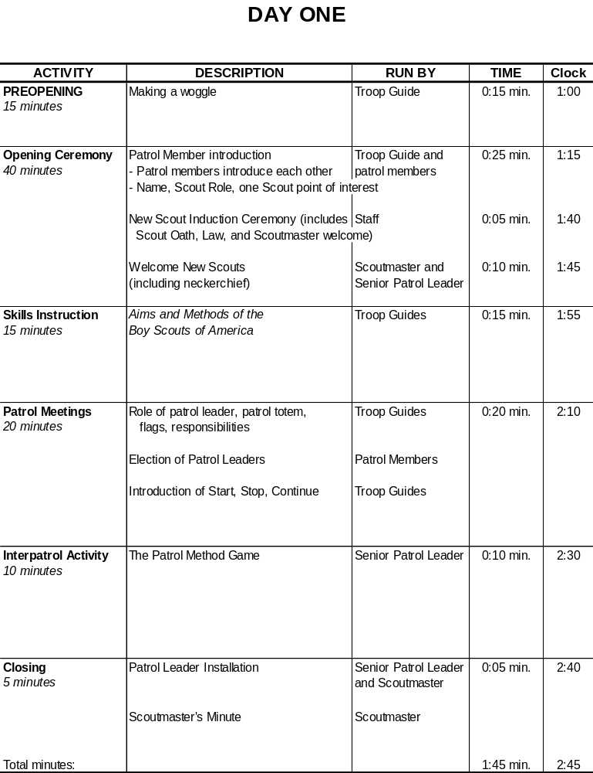

Start, Stop, Continue
The Start, Stop, Continue (SSC) tool is used for a variety of purposes. In the process of developing your Patrol, it will be very helpful to assess team interaction and to modify actions and behaviors to move you towards a stronger performing team. Here is a brief outline of the steps to follow in using the Start, Stop, Continue worksheet.

- Think about your patrol’s activities for the day

Take some time to think about what you are doing as it pertains to actions within both your Patrol and in the Troop. Ask yourself these questions:

- In our patrol, what should we put in place to improve?
(Something we should START).
- In our patrol, what is not working?
(Something we should STOP).
- In our patrol, what is working well?
(Something we should CONTINUE).

- Record your Start, Stop, Continue assessment

Use the Start, Stop, Continue Worksheet to:
- List up to three (3) things that we should START doing that would improve our performance.
- List up to three (3) things we are currently doing that we should STOP.
- List up three (3) things we are currently doing that should CONTINUE.

- Consider using SSC any time
- Before, during, or after an activity you can always stop and check how it’s going by using the SSC tool.
- Start, Stop, Continue Worksheet

Patrol:

Category | Assessment
Start | In our patrol, what should we put in place to improve?  (Some things we should START)  1.  2.  3.
Stop | In our patrol, what is not working? (Some things we should STOP)  1.  2.  3.
Continue | In our patrol, what is working well? (Some things we should CONTINUE)  1.  2.  3.

Day
Two

Patrol Leaders’ Council Meeting Agenda

Day Two

- Welcome
- Introductions
- Announcements
- Patrol leader reports on patrol progress
- Morale and productivity – How are we doing?
- Exhibits – Topic Approval
- Totems approved
- Assessment of the Day Two troop meeting
- Agenda and assignments for the Day Three troop meeting
- Distribution of patrol leaders’ copies Day Three course schedule
- Review of the assignments for program patrol and service patrol
- Assign the organization of the participants troop campfire
- Summarize the important points of the meeting and review assignments
- Adjourn

Wood Badge Course Schedule

Day Three

 | DAY3
7:00 AM | Breakfast, Self assessment
8:00 AM | Gilwell Field Assembly
8:30 AM | Interfaith Worship Service (Troop Activity)
9:20 AM | Break
9:30 AM | Troop Meeting
10:50 AM | Break
11:00 AM | Leading EDGE / Teaching EDGE (Troop Presentation)
Noon | Lunch
Noon | Patrol Leaders' Council Meeting
Noon | Patrol Chaplain Aides Meeting
1:30 PM | Conservation Project Planning
2:20 PM | Break
2:30 PM | October Sky (Troop Activity)
4:30 PM | Closing Gilwell Field Assembly
5:00 PM | Patrol Time
6:00 PM | Departure

Patrol Meeting Plan

DAY TWO

- Review any upcoming responsibilities as the Service Patrol or Program Patrol.
- Plan the pre-opening activity for the Day Three Troop meeting.
- Discuss the patrol meeting portion of the Day Three Troop meeting and determine any preparations that will be needed.
- Review progress on writing Wood Badge tickets.
- Review progress on the patrol project.
Devote remaining meeting time to working on the exhibit.

Day Three Flag Ceremony

Program Patrol Day Two – Antelope

Note: Flags need to be retrieved from the Friendly Quartermaster. They will be placed on at the counter at the Administration Building.

SPL will ask the program patrol to present the colors. Program patrol will advance to the flagpoles without moving across Gilwell field.

The Color Guard will hook up the US Flag
Call for attention and Scout salute
Hoisted swiftly
Two!
Lead the Pledge of Allegiance

Hoist the Historic Flag (Serapis Flag) command troop to salute)
Read the paragraph below
Lead the Troop in singing Columbian the Gem of the Ocean

The Serapis Flag

Designed with 13 stripes alternating red, white, and blue, this flag was raised by Captain John Paul Jones on the British frigate Serapis during the most famous Revolutionary War naval Battle.

In 1779, after conducting sea raids on the coast of Britain, Jones took command of a rebuilt French merchant ship that had been renamed the U.S.S. Bonhomme Richard in honor of Benjamin Franklin. In September of that year, Jones engaged the British Frigate Serapis in the North Sea, sailing in close, lashing his vessel to the British ship, and fighting the battle at point blank range. During the fight, two cannon burst on the Bonhomme Richard. The British Captain asked Jones if he was ready to surrender. Jones replied, ‘Sir, I have not yet begun to fight!’

Eventually it was the crew of the Serapis that surrendered, though the Bonhomme Richard was severely damaged. The American sailors boarded the Serapis and watched form the deck as the Bonhomme Richard sank beneath the waves.

The Campfire Program Planner
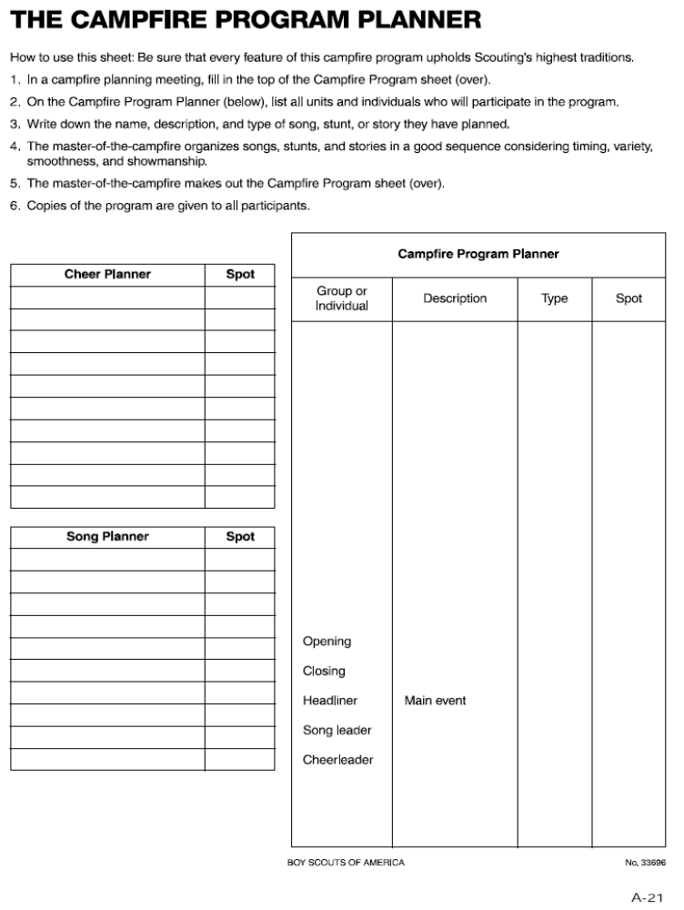

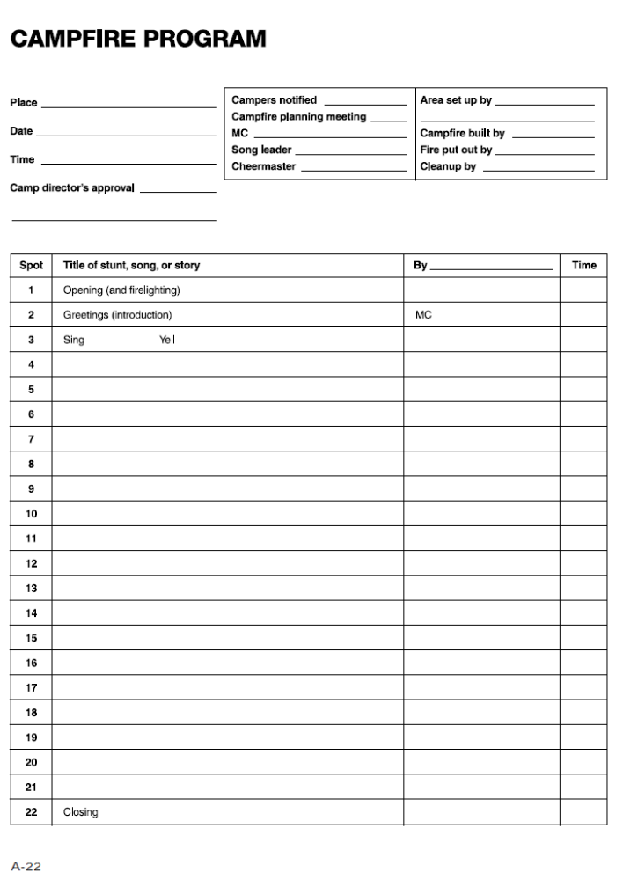

Troop Meeting – Day Two
Pre-Opening Activity

Zulu Toss Game

Materials
One tennis ball or other toss-able item (ball) per patrol member

Procedure
- Each patrol forms a circle. The Patrol Leader (participant A) tosses (sends) one ball to participant B, who receives it and then tosses (sends) it to participant C, etc., until the ball has been touched once by every individual. The last to touch it sends it back to the Patrol Leader.
- Toss the ball around the circle several more times until everyone is accustomed to receiving from and sending to the same individuals every time.
- The Patrol Leader tosses the ball to participant B again to start it on another trip around the circle. When that ball is midway through the participants, the Troop Guide hands the Patrol Leader a second ball, which he or she then tosses to participant B, participant B to participants C, and so on. There are now two balls being sent and received around the circle. As long as everyone receives from the same person and sends to the same participant each time, the balls will continue to move smoothly through the system.
- The Troop Guide gradually hands the Patrol Leader more balls, timing their introduction into the circle to keep the balls moving, until all balls are in play.

Troop Photo Plan
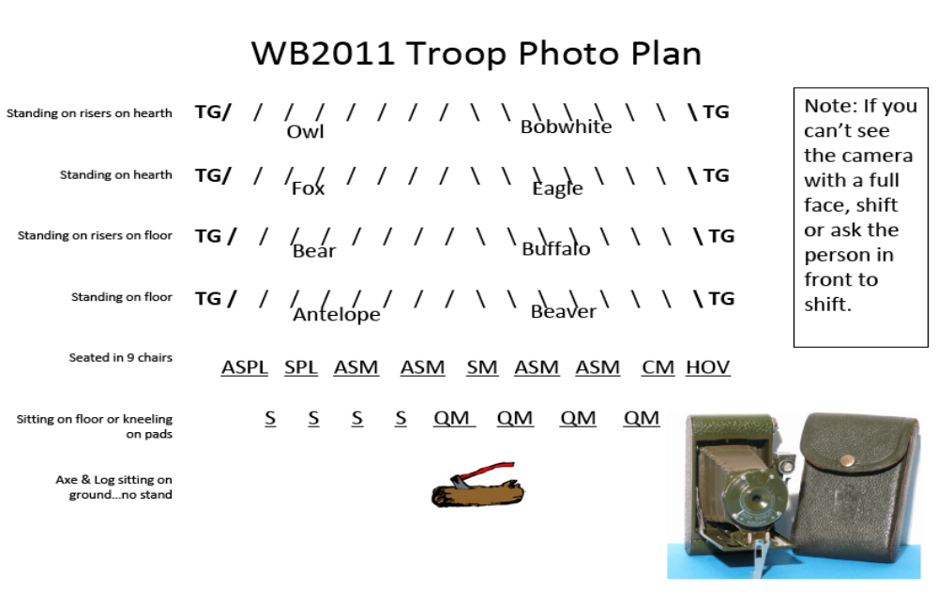

Start, Stop, Continue
The Start, Stop, Continue (SSC) tool is used for a variety of purposes. In the process of developing your Patrol, it will be very helpful to assess team interaction and to modify actions and behaviors to move you towards a stronger performing team. Here is a brief outline of the steps to follow in using the Start, Stop, Continue worksheet.

- Think about your patrol’s activities for the day

Take some time to think about what you are doing as it pertains to actions within both your Patrol and in the Troop. Ask yourself these questions:

- In our patrol, what should we put in place to improve?
(Something we should START).
- In our patrol, what is not working?
(Something we should STOP).
- In our patrol, what is working well?
(Something we should CONTINUE).

- Record your Start, Stop, Continue assessment

Use the Start, Stop, Continue Worksheet to:
- List up to three (3) things that we should START doing that would improve our performance.
- List up to three (3) things we are currently doing that we should STOP.
- List up three (3) things we are currently doing that should CONTINUE.

- Consider using SSC any time
- Before, during, or after an activity you can always stop and check how it’s going by using the SSC tool.
- Start, Stop, Continue Worksheet

Patrol:

Category | Assessment
Start | In our patrol, what should we put in place to improve?  (Some things we should START)  1.  2.  3.
Stop | In our patrol, what is not working? (Some things we should STOP)  1.  2.  3.
Continue | In our patrol, what is working well? (Some things we should CONTINUE)  1.  2.  3.

Day
Three

Spring Open Burning Laws

Effective from February 15 - April 30

The VA Department of Forestry burn laws went into effect on February 15th and remain in effect until midnight of April 30th. Also known as the “4 pm law”, open burning is permitted from 4pm until midnight and is required to be constantly attended at all times. The listed dates are typically the more dangerous of the fire season due to dry materials that have fallen over the winter and higher winds during the daytime hours. For more information, contact the local VA Department of Forestry at 556-4145.

What does this mean to the units camping at the Heart of Virginia Scout Reservation?
- No campfires may be ignited before 4 PM and
must be extinguished at Midnight.
- Propane stoves are allowed.

Friendly Quartermaster Note:
Each patrol site will be provided with one metal barrel (about 2 feet in diameter and less than a foot deep) to contain your patrol fire. The intent is that if you use charcoal or dutch ovens, here is where it goes.

Some answers to frequently asked questions – (These answers are from the Virginia Division of Forestry website)

Can I have a campfire if I put rocks around it?
NO. Campfires are considered an open air fire.

Can I use my charcoal or gas fire fired barbeque grill?
Yes, however you must take proper care and precaution by clearing all flammable material from around it and you must stay with it until it is completely extinguished or turned off.

What is the penalty for violating the 4 p.m. law?
Violation of the 4 p.m. law is a class 3 misdemeanor with a fine of not more than $500.
The Scout Reservation does not get an exemption from the law. We have an excellent working relationship with the local Forest Wardens and do not want to do anything to damage that relationship.

Patrol Leaders’ Council Meeting Agenda

Day Three
- Welcome
- Introductions
- Announcements
- Purpose of the meeting – what we need to accomplish
- Assessment of the Day Three troop meeting
- Distribution of patrol leaders’ copies of the Day Four course schedule
- Discussion of the upcoming Outdoor Experience
- Patrol leader reports on patrol progress
- Morale and productivity – How are we doing?
- Exhibits
- Daily Duties and Assessments
- Reports on the progress being made on the Participant Campfire
- Review of the assignments for program patrol and service patrol
- Summarize the important points of the meeting and review assignments
- Adjourn

Wood Badge Course Schedule

Day Four
 | DAY 4
6:30 A.M. | Working Staff Breakfast
7:00 A.M. | Participants Arrive
 | Gazette in Parking Lot
 | Outdoor Experience Model Campsite
 | Camp Set-up
 | Change into Field Uniform
9:30 AM | Gilwell Field Assembly
10:15 AM | Gilwell Song
10:30 AM | Leading Change
11:20 A.M. | Break
11:30 A.M. | Patrol Leaders' Council Meeting
11:30 A.M. | Chaplain's Aid Meeting
 | Change into Activity Uniform
Noon | Lunch
 | (aux staff lunch)
1:00 P.M. | Generations in Scouting (Troop Presentation)
2:00 P.M. | Break
2:15 P.M. | Problem Solving and Decision Making
2:45 P.M. | Problem Solving Round-Robin (Patrol Activity)
4:00 P.M. | Managing Conflict (Patrol Presentation)
5:00 P.M. | Patrol Meeting
 | Change into Field Uniform
6:00 P.M. | Dinner
7:30 P.M. | The Diversity Game (Patrol Activity)
8:30 P.M. | Participants' Troop Campfire
9:30 P.M. | Patrol Cracker Barrel

Outdoor Code

As an American, I will do my best to
Be clean in my outdoor manners,
Be careful with fire,
Be considerate in the outdoors, and
Be conservation-minded.
Patrol Meeting Plan

Troop Meeting Plan
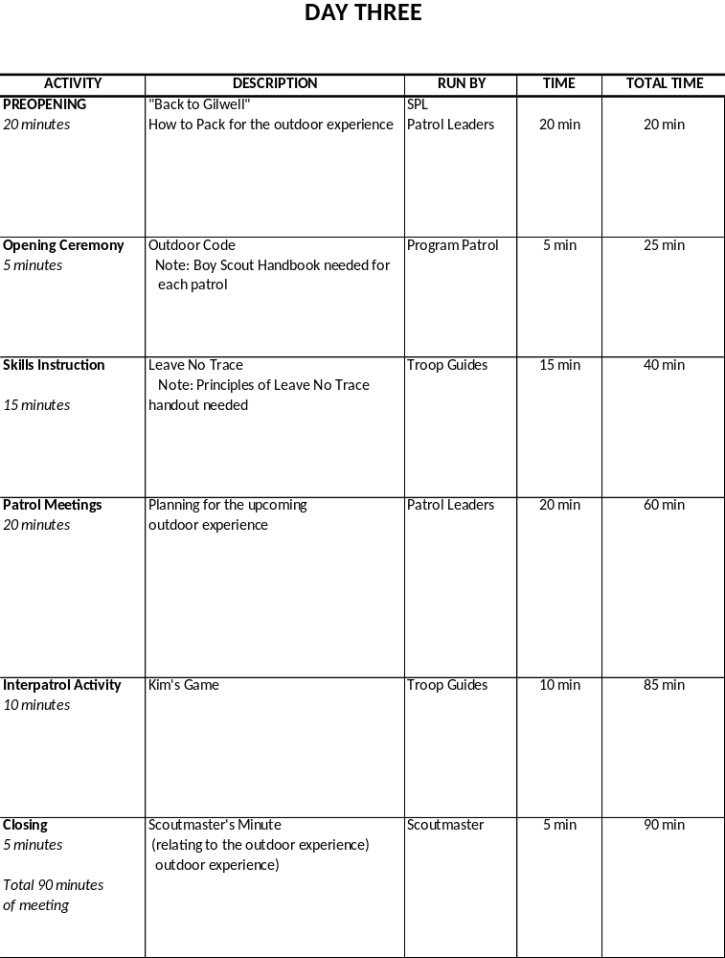

Planning for the Outdoor Experience

Patrol leaders can use the Patrol meeting portion of the Day Three troop meeting to begin planning the details of the upcoming Outdoor Experience. Among the topics to consider are the following:

- Food
  - Budget for meals
  - Menus
  - Food repackaging, transport, and storage
  - Ingredient lists
  - Shopping
- Group gear
  - For camping
  - For cooking

Day Four Flag Ceremony

Program Patrol Day Three: BEAVER

Note: Retrieve 3 flags from the Friendly Quartermaster. They will be in Gilwell Hall.

SPL forms Troop and asks SM if can proceed
SPL asks program patrol to present the colors

Program patrol advances to the flagpoles without moving across Gilwell field
The Color Guard hooks up the US flag on Center pole

PL calls Troop to attention and for Scout salute

Color Guard swiftly hoists the US flag
PL leads Pledge of Allegiance
Color Guard swiftly hoists Historic flag (Star-Spangled Banner) on Left pole

PL say “Two!” to lower salute
PL reads the paragraph below
THE STAR-SPANGLED BANNER
By 1795, Vermont and Kentucky had joined the union, bringing the number of states to 15. The new flag, featuring 15 stars and 15 stripes, flew over the nation for the next 23 years and the administrations of five presidents. It was this flag that flew over Fort McHenry the memorable night of its bombardment by British in 1814, inspiring Francis Scott Key to write the verses are national anthem.

The actual flag that flew over Fort McHenry that night is now preserved in the Smithsonian national Museum of American history.

Let us honor this flag by singing the first verse of the song it inspired, The Star-Spangled Banner, on page _____ in the Song Book.

PL leads the Troop in singing The Star-Spangled Banner.

Color Guard Raises the Troop One Flag on Right pole (no salute)

Patrol reforms and returns to place in line

(No Scout Oath or Law, as Gilwell Field Assembly continues into Venturing Induction including Venturing Oath and Code, led by SM).

Patrol Leader Assignments for the Day Three Troop Meeting

Pre-Opening Activity for the Day Three Troop Meeting

“How to Pack for the Outdoor Experience”

The Wood Badge Outdoor Experience is an opportunity for each patrol to travel together to a remote location, establish a camp, and take part in several days of outdoor activities. Patrol members will pack and carry their own gear and clothing, appropriate for the backcountry.

The members of each Wood Badge patrol represent a wide range of skills and backgrounds. The goal of the Day Three troop meeting pre-opening activity is for patrol members to share their knowledge with one another in order to ensure that each person has access to the necessary gear and clothing, and that everyone will be able to pack their equipment for traveling to the patrol’s campsite.

In addition to drawing upon their own experiences, patrol members may also refer to The Boy Scout Handbook, Fieldbook, Camping, Hiking, and Backpacking merit badge pamphlets; and Venturing publications highlighting camping and backpacking.

Wood Badge Outdoor Experience

One of the purposes of Wood Badge for the 21st Century is to simulate a month of a Boy Scout Troop. Days One, Two and Three simulate troop meetings and programs leading up to a campout. Days Four, Five and Six are intended to represent that outdoor experience. With that in mind, your patrol will also experience life as part of a Boy Scout patrol in an outdoor adventure. Weekend Two (days four, five and six) will be held in the out-of-doors at Camp T. Brady Saunders. The following information should help your patrol plan and prepare for that experience.
When we return for Weekend Two, you’ll arrive at the Administration Building parking lot for Camp T. Brady Saunders at 7:00am sharp on Saturday, April 9th. Please transport all necessary gear, food, and other articles into a pickup truck provided by your patrol. The Friendly Quartermaster can provide a truck if requested in advance. Once your entire patrol has arrived, one of the Friendly Quartermasters will drive the truck to your designated campsite.
All patrol members should be prepared to go on a short hike, simulating a backpacking outing, to their campsite carrying their personal gear. Further instructions about this hike will be given when you arrive on Day Four.
No vehicles will remain in camp—your truck will be parked in the parking lot for the weekend. A reverse procedure will be used on Day Six when it is time to break and leave camp. By 8:00am on Day Six, your truck will be brought to your patrol site to pack your camp equipment. The gear will be transported to the parking lot by one of the Friendly Quartermasters.

Personal Equipment
Each patrol member will be responsible for providing their own personal equipment, i.e. sleeping bags, pack, etc. that they will need for a three-day outdoor experience. For reference, a suggested personal equipment list is found in the Boy Scout Handbook (12th ed.) on pages 292-293.

Patrol Equipment
Each patrol will plan menus for several meals (see menus and food, below) and should determine the equipment necessary to prepare, cook, and clean up for these meals. You will also need to identify any equipment needed (such as a dining fly) or desired for camp life. The patrol will be responsible for acquiring all equipment needed for their weekend in the woods. Please note that while the Friendly Quartermaster will not provide any equipment for the patrol’s use, they, as well as other staff members, are always willing to help locate whatever the patrol cannot acquire for themselves.

Stewardship
When planning your outdoor experience, be sure to keep in mind the patrol will be responsible for following the Outdoor Code and for practicing the principles of Leave No Trace. All equipment for the patrol must be able to fit in the bed of a single pickup truck. All items “carried in” will be carried back out as well. The patrols are expected to leave the campsite “better than they found it.” A suggested gear checklist is found in the Boy Scout Handbook on pages 294-295. Please note that the summer-camp wall-tents will be pitched and will have cots; so, you do not need to bring your personal tents, though you may use them if desired.

Patrol Project
When your patrol arrives at the parking lot behind the Administration building, your patrol project will be placed in a separate truck to be taken directly to Gilwell Hall. That is, your patrol project does not go with you to your campsite. Your patrol project will be returned to the patrol on Day Six.

Menus and Food
See the Cooking section in the Boy Scout Handbook, beginning on page 314. Each patrol shall plan for and prepare the following meals:
Day Four Lunch (4-5 guests)
Day Four Dinner (3-4 guests)
Day Five Breakfast (3-4 guests)
Day Five Dinner (no guests)
Day Five Cracker Barrel (no guests)
Day Six Breakfast (no guests)
(Staff will provide Lunch on Days Five and Six)

Members of the staff will be eating with the patrols on a rotating basis. Meals should be planned so that preparation, serving, and cleanup can be accomplished within the constraints of the course schedule. Please note that guests will be evaluating the patrol’s performance and cooking for each meal. The coveted Golden Spoon will be awarded to the patrol which best demonstrates their abilities in outdoor cooking. Other awards may be given at the discretion of the staff. More information regarding patrol cooking during weekend two will be given at the PLC on Day 3, and/or at the closing Gilwell Assembly on the afternoon of Day Three.

When planning meals, each patrol shall keep in mind that the total expenditure for food should not exceed $200. Original store receipts for all purchases MUST be submitted by the Patrol Leader to the Senior Patrol Leader at the Day Four Patrol Leaders Council Meeting. Reimbursement for all costs up to the food limit will be made to the patrol before leaving camp on Day Six. A Scout is thrifty! Patrols should not exceed the food limit including the retail value of any donated food.

While it is the patrol’s responsibility to plan for their own outdoor experience, they are encouraged to use resources at hand within their unit. Troop Guides, the Friendly Quartermasters, and the rest of the staff are all prepared to assist should you request help with planning. It is the entire staff’s desire that your outdoor experience be safe, educational, fun, and a time in which your patrol truly performs as a high performance team!

Wood Badge Cooking Guidelines

- The patrol may spend only the monetary allotment set at the PLC.
- The retail value of donated food counts towards your allotment.
- You must make a full accounting to the SPL at the Day 4 PLC. Accounting to include original store receipts and written explanation of expenditures or gifts.
- Your patrol will have up to 4 guests at every meal. Guests will likely bring their own cup.
- Each meal will be eaten as a patrol. Food will be served when all guests and patrol members are present. The meals will be eaten with everyone sitting together at a table and be served family style or buffet style.
- The meals will be nutritionally well-balanced.
- Grace will be said at every meal.
- The cooking area will be clean and sanitary in appearance.
- The portions will be reasonable. Did everyone have enough to eat?
- The meal will be evaluated based on the following:
  - Served on time
  - Appropriateness for youth to prepare during a Scout outing
  - Taste and appearance
  - Nutritional balance
  - Creativity and fun
- Food will be stored in your campsite. Ice will be provided at your request.
- Since all patrol members must attend all presentations, the patrol must make appropriate plans for preparation and clean up.

The meals you will be cooking in your campsite include:
- Day 4 – Lunch and dinner (guests at both meals)
- Day 5 – Breakfast (guests) and dinner (no guests)
- Day 6 – Breakfast (no guests)

Cooking Checklist
Outdoor Cooking Experience Checklist
Patrol:
Meal: |  |  | Date:
Guests:
 |  | Yes |  | No
Were there accommodations for you?
Were all the Patrol Members Present?
Did the Patrol eat as a group?
Was the food served family style or buffet?
Was a blessing said before the meal?
Did everyone appear to have enough to eat?
Was the food served on time?
Was the food stored properly? Iced sufficiently?
 |  | Great | Good | Ok | Not Ok
Rate the presentation of the food (attractiveness)
Rate the taste of the food
Rate the nutritional balance of the meal
Rate the cleanliness and sanitation of the cooking area
Rate the appropriateness of the meal as camp cooking
Special Notes About the Meal:
Give to the SPL immediately after the meal, one per group.

Gear Lists
The following is a list of suggested gear for the patrol for camping trips:
» | Cookware (as needed for menu)
» | Coffee Pot
» | Cooking utensils (as needed for menu)
» | Can Opener
» | Measuring Cup/Spoons
» | Cooler
» | Water Cooler
» | Water jugs/ containers
» | Stove and fuel (Follow BSA policies)
» | Dutch Oven (if needed)
» | Tarp(s)
» | Rope and Twine
» | Axe, saw, and safety equipment
» | Lantern(s)
» | Shovel & Rake
» | Trash bags
» | Paper towels & napkins
» | Aluminum foil
» | Plates and utensils for patrol/guests
» | Dishwashing soap, pads, & bleach
» | Matches or lighter
» | Hand soap or sanitizer
» | Fire buckets

Gear Lists

The following is a list of personal gear that should be packed by scouts for camping trips:
» | Back pack with waist belt fitted to your back
» | Sleeping bag
» | Sleeping pad / air mattress
» | Tent and ground cloth
» | Camp Chair
» | Matches/lighter/fire starter
» | Compass
» | Notebook
» | Personal First Aid Kit
» | Jacket suitable for expected weather
» | Warm dry socks (wool and cotton)
» | Raincoat or poncho
» | Wash cloth/towel/small bar soap/zip-lock bag
» | Toothpaste and brush
» | Toiletries & Medications
» | Small mirror / comb
» | Pocket knife
» | Canteen or water bottle (one or more)
» | Flashlight with extra batteries & extra bulb
» | Lip balm
» | Large plastic bag
» | Mess kit with utensils
» | Sunglasses
» | Day-pack

Start, Stop, Continue
The Start, Stop, Continue (SSC) tool is used for a variety of purposes. In the process of developing your Patrol, it will be very helpful to assess team interaction and to modify actions and behaviors to move you towards a stronger performing team. Here is a brief outline of the steps to follow in using the Start, Stop, Continue worksheet.

- Think about your patrol’s activities for the day

Take some time to think about what you are doing as it pertains to actions within both your Patrol and in the Troop. Ask yourself these questions:

- In our patrol, what should we put in place to improve?
(Something we should START).
- In our patrol, what is not working?
(Something we should STOP).
- In our patrol, what is working well?
(Something we should CONTINUE).

- Record your Start, Stop, Continue assessment

Use the Start, Stop, Continue Worksheet to:
- List up to three (3) things that we should START doing that would improve our performance.
- List up to three (3) things we are currently doing that we should STOP.
- List up three (3) things we are currently doing that should CONTINUE.

- Consider using SSC any time
- Before, during, or after an activity you can always stop and check how it’s going by using the SSC tool.
- Start, Stop, Continue Worksheet

Patrol:

Category | Assessment
Start | In our patrol, what should we put in place to improve?  (Some things we should START)  1.  2.  3.
Stop | In our patrol, what is not working? (Some things we should STOP)  1.  2.  3.
Continue | In our patrol, what is working well? (Some things we should CONTINUE)  1.  2.  3.

Day
Four

Patrol Leaders’ Council Meeting Agenda

Day Four

- Welcome
- Introduction
- Announcements
- Patrol leaders report on patrol progress
- Distribute patrol leaders’ copies of the Day Five course schedule
- Discuss the Day Five patrol project presentations.
- Review the plans for the Day Five conservation project
- Review the Day Five staff departure
- Review the plans for the Day Four participant campfire
- Review program patrol and service patrol assignments
- Summarize the important points of the meeting and review assignments
- Adjourn

Wood Badge Course Schedule

Day Five

7:00 AM | Breakfast and Patrol Self-Assessment
8:00 AM | Gilwell Field Assembly
8:30 AM | Patrol Project Setup and Presentations
8:45 AM | Round One of Presentations
10:15 AM | Break
 | (change into grungies)
10:30 AM | Conservation Project (Troop Activity)
12:30 PM | Lunch
12:30 PM | Patrol Leaders' Council Meeting & Working Lunch
 | In activity uniform, please
1:30 PM | Gilwell Song
1:35 PM | Coaching and Mentoring (Troop Presentation)
2:45 PM | Assessments (Troop Presentation)
2:30 PM | Break
3:15 PM | Round Two of Presentations
4:30 PM | Ticket Review and Collection
6:00 PM | Patrols Depart to Patrol Sites
6:00 PM | Patrol Dinner
 | Staff: Field uniform, taupe neckerchief, beads
7:00 PM | SM Dinner Staff Dinner
7:30 PM | Patrol Meeting
8:00 PM | Patrol Campfires and Cracker Barrel
9:00 PM | Evening Ceremony (Troop Activity)

Patrol Meeting Plan

DAY FOUR

Troop Campfire
Review the patrol’s contributions for the troop campfire occurring on the evening of Day Four.

Conservation Project
Review the patrol’s involvement in the conservation project that will occur on Day Five.

Tickets
Review progress on writing Wood Badge tickets.

Program or Service Patrol
Review any upcoming responsibilities as the service patrol or program patrol.

Patrol Project
Review progress on the patrol project. Devote remaining meeting time to working on the project.

Day Five Flag Ceremony

Program Patrol Day Four: BOBWHITE
Note: Retrieve 3 flags from the Friendly Quartermaster. Flags will be available in Gilwell Hall.
SPL forms Troop and asks SM if can proceed
SPL asks program patrol to present the colors

Program patrol advances to the flagpoles without moving across Gilwell field
The Color Guard hooks up the US flag on Center pole
PL calls Troop to attention and for Scout salute
Color Guard swiftly hoists the US flag
PL leads Pledge of Allegiance
Color Guard swiftly hoists Historic flag (46-Star Flag) on Left pole
PL say “Two!” to lower salute

PL reads the paragraph below
THE 46-STAR FLAG
By 1908, the United States of America had grown to encompass states from the Atlantic to the Pacific. Nearly all the territory in between had also been recognized with statehood. When Oklahoma join the union, the US flag changed to include 46 stars, a design that would last for only four years and the administrations of two presidents, Theodore Roosevelt and William Taft.

For us, there is further significance. This is the flag that was flying over America in 1910 when the Boy Scouts of America had its beginnings.

Let's honor this flag with a song that also honors our nation. Please join me in singing , God Bless America, page ______ in the Song Book.

PL Leads Troop in singing God Bless America.

Color Guard Raises the Troop One Flag on Right pole (no salute)

PL commands Troop to display Boy Scout Sign and leads reciting the Boy Scout Oath and Law
Patrol reforms and returns to place in line

Start, Stop, Continue
The Start, Stop, Continue (SSC) tool is used for a variety of purposes. In the process of developing your Patrol, it will be very helpful to assess team interaction and to modify actions and behaviors to move you towards a stronger performing team. Here is a brief outline of the steps to follow in using the Start, Stop, Continue worksheet.

- Think about your patrol’s activities for the day

Take some time to think about what you are doing as it pertains to actions within both your Patrol and in the Troop. Ask yourself these questions:

- In our patrol, what should we put in place to improve?
(Something we should START).
- In our patrol, what is not working?
(Something we should STOP).
- In our patrol, what is working well?
(Something we should CONTINUE).

- Record your Start, Stop, Continue assessment

Use the Start, Stop, Continue Worksheet to:
- List up to three (3) things that we should START doing that would improve our performance.
- List up to three (3) things we are currently doing that we should STOP.
- List up three (3) things we are currently doing that should CONTINUE.

- Consider using SSC any time
- Before, during, or after an activity you can always stop and check how it’s going by using the SSC tool.
- Start, Stop, Continue Worksheet

Patrol:

Category | Assessment
Start | In our patrol, what should we put in place to improve?  (Some things we should START)  1.  2.  3.
Stop | In our patrol, what is not working? (Some things we should STOP)  1.  2.  3.
Continue | In our patrol, what is working well? (Some things we should CONTINUE)  1.  2.  3.

Day
Five

Patrol Leaders’ Council Meeting Agenda

Day Five
- Welcome
- Introductions
- Announcements
- Review the morning’s conservation project
- Patrol leaders report on patrol progress
- Patrol project presentation
- Distribute patrol leaders’ copies of the Day Six course schedule
- Discuss the Day Six departure from the site of the Outdoor Experience
- Review assignments for the program and service patrols
- Summarize the important points of the meeting and review assignments
- Adjourn

Wood Badge Course Schedule

Day Six

7:00 AM | Breakfast and Patrol Self-Assessment
8:00 AM | Patrol Time
 | Cleanup/Load Vehicles
9:00 AM | Patrol Leaders' Council Meeting
10:00 AM | Gilwell Field Assembly
11:00 AM | Interfaith Worship Service (Troop Activity)
11:45 AM | Closing Luncheon
1:00 PM | Leaving a Legacy (Troop Presentation)
2:15 PM | Break
2:30 PM | Summary Session (Troop Presentation)
3:00 PM | Course Assessments
3:30 PM | Closing Gilwell Field Assembly
4:15 PM | Participants Depart

Patrol Meeting Plan

DAY FIVE
- Determine how to handle any final patrol project issues such as returning materials, displaying significant display pieces in unit, district, or council settings, etc.
- Conduct the Patrol Project Self-Assessment, using the form distributed at the Patrol Leaders’ Council to focus the thoughts of patrol members and to guide the discussion facilitated by the patrol leader.

Day Six Flag Ceremony

Program Patrol Day Five: EAGLE
Note: Retrieve 3 flags from the Friendly Quartermaster. Flags will be available in Gilwell Hall.

SPL forms Troop and asks SM if can proceed

SPL asks program patrol to present the colors

Program patrol advances to the flagpoles without moving across Gilwell field

The Color Guard hooks up the US flag on Center pole

PL calls Troop to attention and for Scout salute
Color Guard swiftly hoists the US flag

PL leads Pledge of Allegiance

PL say “Two!” to lower salute
Color Guard swiftly hoists Historic flag (World Scout Flag) on Left pole (no salute)

PL reads the paragraph below:

The World Scout Flag
Scouting is world wide, serving 28 million individuals in over 150 countries. In the United States, Scouts and Scouters may wear the purple World Scout emblem above their left shirt pocket. The emblem includes a rope which encircles the fleur-de-lis and is tied by a square knot. The rope is there to symbolize the World Scout Movement and the rope represents unity. Royal purple is the color of leadership and service.

Let’s sing a song to remind us of why we are all here, On My Honor, which is on page _______ in the Song Book.

PL leads Troop in singing On My Honor.

Color Guard Raises the Troop One Flag on Right pole (no salute)

PL commands Troop to display Boy Scout Sign and leads reciting the Boy Scout Oath and Law

Patrol reforms and returns to place in line

Wood Badge Patrol Project Discussion Guide

Objectives
- In what ways did your patrol project describe a program element or theme that can be clearly identified as being associated with Cub Scouting, Boy Scouting, and Venturing?

- How did your patrol project relate this program element or theme to the aims and methods of Scouting?

- List the ways in which the presentation of your patrol project involved both a static display and an oral presentation.

- How did the presentation of your patrol project involve every member of your patrol?

- Did your patrol project represent your patrol’s best effort?

Processes
- During the development or your patrol project what decision-making processes did your patrol use to reach consensus regarding selection or a topic?

- During the development or your patrol project did a single member of your patrol assume leadership for the project? If so, on what basis was this patrol member selected?

- During the development or your patrol project did conflict ever arise? If so, how did your patrol manage the conflict?

- During the development of your patrol project, were the unique talents of the individual members of your patrol used to their fullest?

- As a consequence of developing your patrol project, did the members of your patrol learn about aspects of the Scouting program in areas other than those in which they are involved?

- As a consequence of developing your patrol project, did the members of your patrol develop a more global view of the Scouting movement?

Team Development
Below, graph your patrol’s enthusiasm (morale) and skill level (productivity) over the course of the first four days of Wood Badge. To what extent does your graph correspond to the Stages of Team Development?
Day One | Day Two | Day Three | Day Four
(+)
(–)

Start, Stop, Continue
The Start, Stop, Continue (SSC) tool is used for a variety of purposes. In the process of developing your Patrol, it will be very helpful to assess team interaction and to modify actions and behaviors to move you towards a stronger performing team. Here is a brief outline of the steps to follow in using the Start, Stop, Continue worksheet.

- Think about your patrol’s activities for the day

Take some time to think about what you are doing as it pertains to actions within both your Patrol and in the Troop. Ask yourself these questions:

- In our patrol, what should we put in place to improve?
(Something we should START).
- In our patrol, what is not working?
(Something we should STOP).
- In our patrol, what is working well?
(Something we should CONTINUE).

- Record your Start, Stop, Continue assessment

Use the Start, Stop, Continue Worksheet to:
- List up to three (3) things that we should START doing that would improve our performance.
- List up to three (3) things we are currently doing that we should STOP.
- List up three (3) things we are currently doing that should CONTINUE.

- Consider using SSC any time
- Before, during, or after an activity you can always stop and check how it’s going by using the SSC tool.
- Start, Stop, Continue Worksheet

Patrol:

Category | Assessment
Start | In our patrol, what should we put in place to improve?  (Some things we should START)  1.  2.  3.
Stop | In our patrol, what is not working? (Some things we should STOP)  1.  2.  3.
Continue | In our patrol, what is working well? (Some things we should CONTINUE)  1.  2.  3.

Day
Six

Patrol Leaders’ Council Meeting Agenda

Day Six

- Welcome
- Introductions
- Review the patrols’ return from the Outdoor Experience
- Distribute copies of the Day Six schedule to the patrol leaders and review the events for the remainder of the course
- Discuss what is expected of the patrols to make the camp breakdown as efficient as possible
- Discuss Closing Lunch
- Review assignments for the program and service patrols
- Summarize the important points of the meeting and review assignments
- Adjourn

Wood Badge Course Schedule

Day Six

7:00 AM | Breakfast and Patrol Self-Assessment
8:00 AM | Patrol Time
 | Cleanup/Load Vehicles
9:00 AM | Patrol Leaders' Council Meeting
10:00 AM | Gilwell Field Assembly
11:00 AM | Interfaith Worship Service (Troop Activity)
11:45 AM | Closing Luncheon
1:00 PM | Leaving a Legacy (Troop Presentation)
2:15 PM | Break
2:30 PM | Summary Session (Troop Presentation)
3:00 PM | Course Assessments
3:30 PM | Closing Gilwell Field Assembly
4:15 PM | Participants Depart
4:30 PM | Camp Breakdown to Start
7:00 PM | Help FQM, Staff Departs

Start, Stop, Continue
The Start, Stop, Continue (SSC) tool is used for a variety of purposes. In the process of developing your Patrol, it will be very helpful to assess team interaction and to modify actions and behaviors to move you towards a stronger performing team. Here is a brief outline of the steps to follow in using the Start, Stop, Continue worksheet.

- Think about your patrol’s activities for the day

Take some time to think about what you are doing as it pertains to actions within both your Patrol and in the Troop. Ask yourself these questions:

- In our patrol, what should we put in place to improve?
(Something we should START).
- In our patrol, what is not working?
(Something we should STOP).
- In our patrol, what is working well?
(Something we should CONTINUE).

- Record your Start, Stop, Continue assessment

Use the Start, Stop, Continue Worksheet to:
- List up to three (3) things that we should START doing that would improve our performance.
- List up to three (3) things we are currently doing that we should STOP.
- List up three (3) things we are currently doing that should CONTINUE.

- Consider using SSC any time
- Before, during, or after an activity you can always stop and check how it’s going by using the SSC tool.
- Start, Stop, Continue Worksheet

Patrol:

Category | Assessment
Start | In our patrol, what should we put in place to improve?  (Some things we should START)  1.  2.  3.
Stop | In our patrol, what is not working? (Some things we should STOP)  1.  2.  3.
Continue | In our patrol, what is working well? (Some things we should CONTINUE)  1.  2.  3.

