Patrol
Leader
Notebook
Table of Contents
Course Info 1
Camp Maps 2
Traditional Order for Wood Badge Patrols 4
Responsibilities of the Program & Service Patrols 5
Start, Stop, Continue 6
Day One 8
Patrol Leaders’ Council Meeting Agenda 10
Roles and Responsibilities 12
The Patrol Project 15
Troop Meeting Plan 17
Day Two 18
Wood Badge Course Schedule Day Two 19
Start, Stop, Continue 20
Day Two Flag Ceremony 21
Troop Meeting Plan, Day Two 23
Troop Meeting – Day Two Pre-Opening Activity 24
Patrol Leaders’ Council Meeting Agenda 25
Patrol Meeting Plan 26
The Campfire Program Planner 27
Day Three 29
Wood Badge Course Schedule 30
Start, Stop, Continue 31
Day Three Flag Ceremony 32
Spring Open Burning Laws 33
Patrol Leaders’ Council Meeting Agenda 34
Troop Meeting Plan Day Three 36
Patrol Leader Assignments for the Day Three Troop Meeting 37
Wood Badge Outdoor Experience 38
Wood Badge Cooking Guidelines 40
Between 44
Patrol Meeting Plans 45
Day Four 46
Wood Badge Course Schedule 47
Start, Stop, Continue 48
Day Four Flag Ceremony 49
Patrol Leaders’ Council Meeting Agenda 50
Patrol Meeting Plan 51
Day Five 52
Wood Badge Course Schedule 53
Start, Stop, Continue 54
Day Five Flag Ceremony 55
Patrol Leaders’ Council Meeting Agenda 56
Patrol Meeting Plan 57
Wood Badge Patrol Project Discussion Guide 58
Day Six 60
Wood Badge Course Schedule 61
Start, Stop, Continue 62
Day Six Flag Ceremony 63
Patrol Leaders’ Council Meeting Agenda 65

Course
Info

Cub Adventure Camp Map
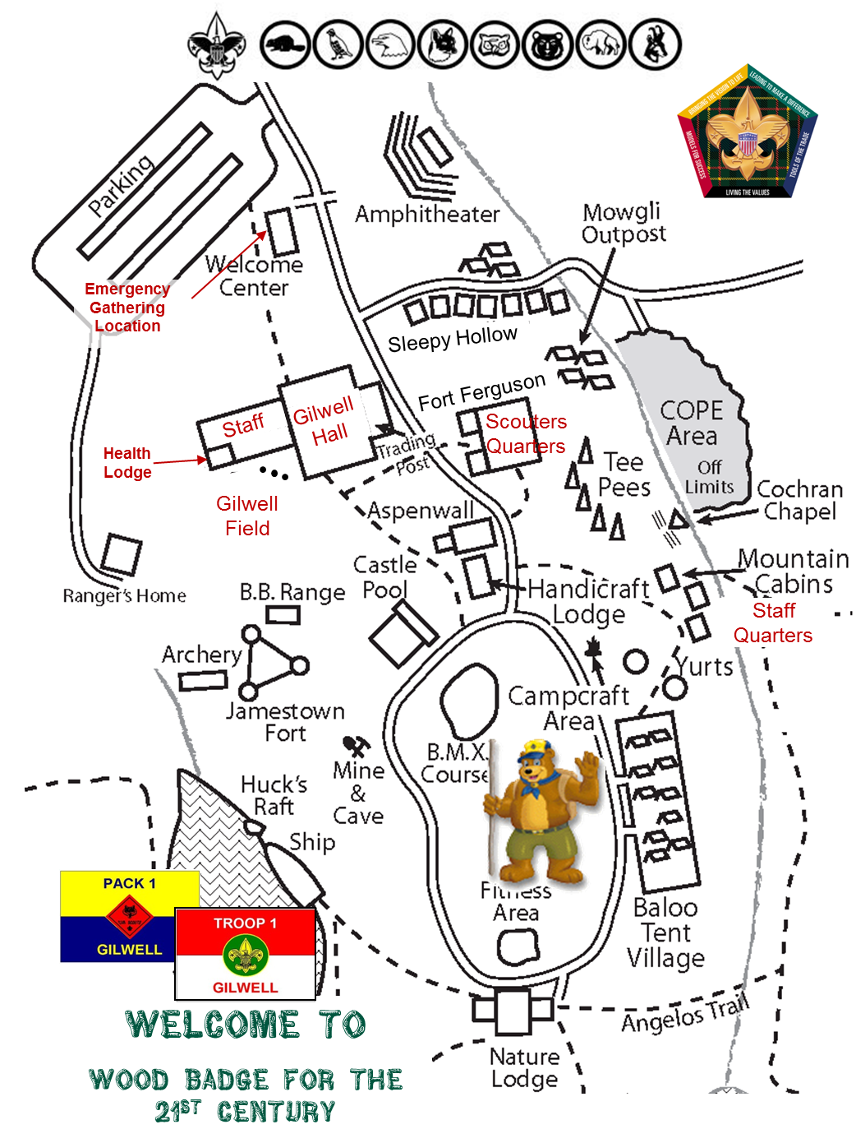

Camp T. Brady Saunders Map
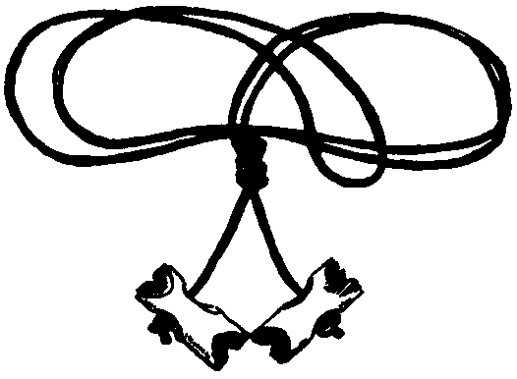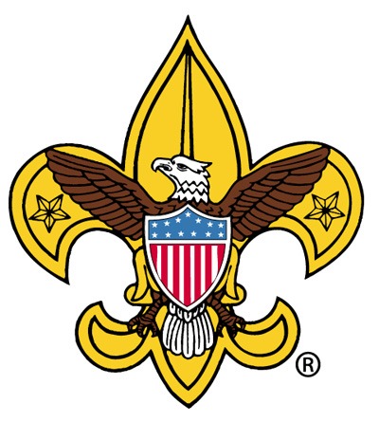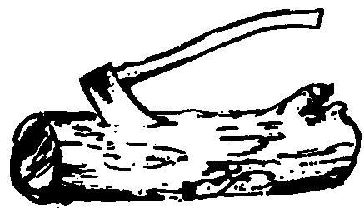
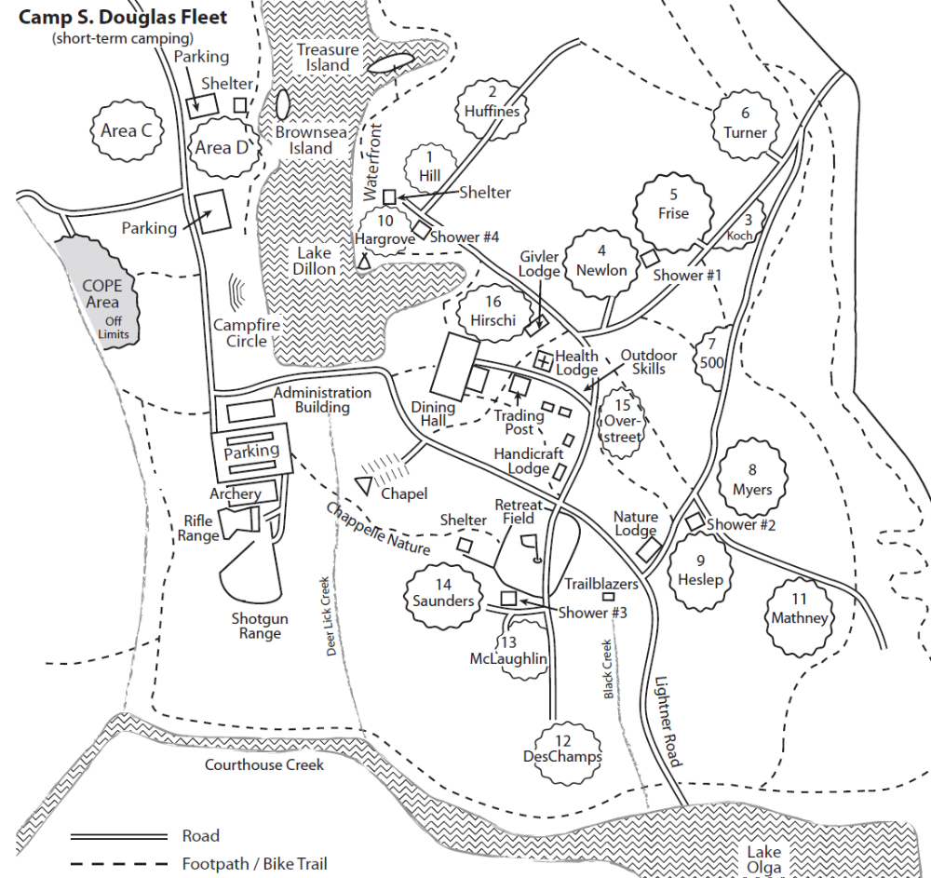
Emergency Gathering Location
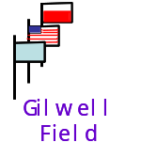
Gilwell Hall
Staff Camp
Patrol Camps
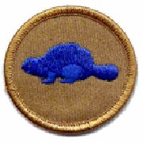 | 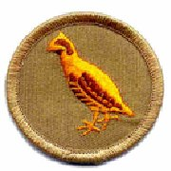 | 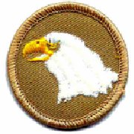 | 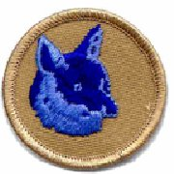 | 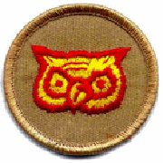 | 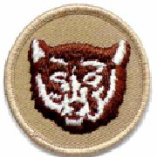 | 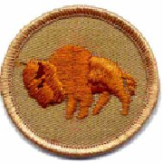 | 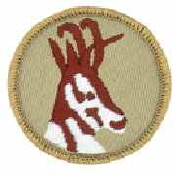
WOOD BADGE for the 21st Century

Traditional Order for Wood Badge Patrols

Beaver
Bobwhite
Eagle
Fox
Owl
Bear
Buffalo
Antelope

Responsibilities of the Program & Service Patrols
 | Program |  | Service
Day | Patrol | Responsibilities | Patrol | Responsibilities
One | Buffalo | Retire Flags at Dusk | Owl | Meal Condiments & Table Wipe down
 |  | Offer grace for Dinner Day 1 & Breakfast Day 2 |  | Monitor Restroom Supplies
 |  | Flag Ceremony Morning Day 2 |  | Trash Disposal
Two | Antelope | Opening for Troop Meeting | Bear | Meal Condiments & Table Wipe down
 |  | Retire Flags at Dusk |  | Monitor Restroom Supplies
 |  | Offer grace for Lunch & Dinner Day 2 and Breakfast Day 3 |  | Trash Disposal
 |  | Flag Ceremony Morning Day 3
Three | Beaver | Help as needed with Interfaith Service | Fox | Meal Condiments & Table Wipe down
 |  | Opening for Troop meeting |  | Monitor Restroom Supplies
 |  | Offer grace for Lunch |  | Trash Disposal
 |  | Retire Flags at Afternoon Gilwell
 |  | Flag Ceremony Morning Day 4
Four | Bobwhite | Retire Flags at Dusk | Buffalo | Monitor Restroom Supplies
 |  | Host Participant Campfire |  | Trash Disposal
 |  | Flag Ceremony Morning Day 5 |  | Fire Building & Clean-up for Campfire
Five | Eagle | Retire Flags at Dusk | Antelope | Monitor Restroom Supplies
 |  | Flag Ceremony Morning Day 6 |  | Table Condiments & Wipe down
 |  | Assist with Patrol Presentations Set-up |  | Lead Troop Service Project
 |  |  |  | Trash Disposal
Six | Fox | Help as needed with Interfaith Service | Beaver | Assist Chaplain Aides w/ physical needs
 |  | Help as requested with Closing Lunch including Grace |  | Table Condiments & Wipe down
 |  |  |  | Monitor Restroom Supplies
 |  |  |  | Trash Disposal

Start, Stop, Continue
The Start, Stop, Continue (SSC) tool is used for a variety of purposes. In the process of developing your Patrol, it will be very helpful to assess team interaction and to modify actions and behaviors to move you towards a stronger performing team. Here is a brief outline of the steps to follow in using the Start, Stop, Continue worksheet.

- Think about your patrol’s activities for the day

Take some time to think about what you are doing as it pertains to actions within both your patrol and in the troop. Ask yourself these questions:

- In our patrol, what should we put in place to improve?
(Something we should START).
- In our patrol, what is not working?
(Something we should STOP).
- In our patrol, what is working well?
(Something we should CONTINUE).

- Record your Start, Stop, Continue assessment

Use the Start, Stop, Continue Worksheet to:
- List up to three (3) things that we should START doing that would improve our performance.
- List up to three (3) things we are currently doing that we should STOP.
- List up three (3) things we are currently doing that should CONTINUE.

- Consider using SSC any time
- Before, during, or after an activity you can always stop and check how it’s going by using the SSC tool.
- Start, Stop, Continue Worksheet

Patrol:

Category | Assessment
Start | In our patrol, what should we put in place to improve?  (Some things we should START)  1.  2.  3.
Stop | In our patrol, what is not working? (Some things we should STOP)  1.  2.  3.
Continue | In our patrol, what is working well? (Some things we should CONTINUE)  1.  2.  3.

Day
One

OMHIWDMB

Patrol Leaders’ Council Meeting Agenda

Day One

- Welcome
- Introduction of attendees
- Purpose of the meeting – what we need to accomplish
- When the meeting will end
- Announcements
- Assessment of Day One Troop Meeting
- Assignments for the Day Two Troop Meeting
- Reminder of Service and Program patrol assignments
- Discussions – patrol projects & left and lost Items
- Morale – how each patrol and patrol leader is doing
- Close

Patrol Meeting Plan
DAY ONE

- Program Patrol/Service Patrol
– Review the patrol’s assignments and responsibilities
- Patrol Project – Initial planning
- Patrol Totem – Initial planning
- Patrol Leader – Elect patrol leader and define patrol leader schedule
- Introduce Start - Stop - Continue

Roles and Responsibilities

Role and Responsibilities of a Patrol Member
For a patrol to succeed as a team, each of its members must
- Fully participate in the Wood Badge course and achieve all he or she can.
- Practice using the team development skills introduced during Wood Badge presentations.
- Help his or her patrol meet its obligations to fulfill assignments including the development and presentation of the patrol project.
- Set a good example by living up to the Scout Oath and Law.
- Have fun!

Role and Responsibilities of the Patrol Leader
- Take a leading role in planning and conducting patrol meetings and activities.
- Encourage patrol members to fully participate in the Wood Badge course and to achieve all they can.
- Represent the patrol as a member of the patrol leaders’ council (PLC).
- Practice using the leadership and team skills being presented during Wood Badge presentations.
- Ensure that daily patrol self-assessments are carried out in a timely, effective manner.
- Provide patrol members with all the resources and information they need to succeed.
- Empower the patrol to become the best it can be.
- See that the patrol is prepared for all course presentations and activities.

Role and Responsibilities of the Assistant Patrol Leader
- Assume the responsibilities of the patrol leader whenever the patrol leader is unable to do so.
- Encourage patrol members to fully participate in the Wood Badge course and to achieve all they can.
- Assist the patrol leader in empowering the patrol to become the best it can be.

Role and Responsibilities of the Patrol Chaplain Aide
In concert with all the chaplain aides, the patrol chaplain aide will
- Learn what resources are available that can be used for religious observances during the course, and make that information available to the rest of the patrol.
- Develop and help present the participants’ interfaith worship service on Day Six.
- Assist in conducting any other religious observances that may arise during the Wood Badge course, including graces at patrol meals and troop meals when their patrol is the program patrol.

Role and Responsibilities of the Patrol Scribe
- Provide interesting and timely material about the patrol to the publisher of The Gilwell Gazette—the daily newspaper of the course.
The troop scribe will communicate guidelines to help scribes fulfill their duties and may briefly meet with all the patrol scribes to discuss how best they can assist in making the Gazette worthwhile.
- As needed, keep notes in the Patrol Leader’s Notebook.

Service Patrol
- Be responsible for the general cleanliness of the camp, especially for the latrines, washing places, campfire circle and meeting areas.
- Assist the quartermaster just prior to and after meals.
- Assist the quartermaster with the evening cracker barrels.
- Lay campfires, when requested, and extinguish the fires when done.
- Provide Leadership for the Day Five service project.

Program Patrol
- Conduct the morning flag-raising ceremony.
- As part of the flag-raising ceremony, present a brief history of the historic flag for the day and lead the group in a song associated with that flag.
- Lower the flags in the evening.
- Provide leadership for the Day Four participant campfire.
- When requested, provide grace at meals.

Patrol Leadership Positions

Daily Roster
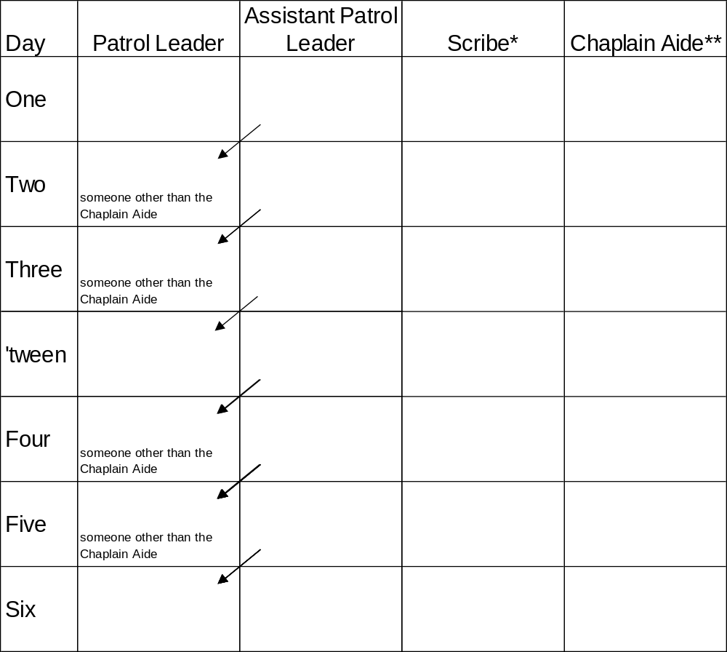
*The positions of scribe and chaplain aide may be held by the same individuals throughout the course, or they may rotate among several or all members of the patrol.
**Because of their involvement with the chaplain aides meeting on Days Two, Three, Four and Five, the person or persons serving as chaplain aide should be patrol leader on days other than Days Two or Three or Days Four or Five.

Between: If a patrol has 7 members, one will serve as patrol leader during the period between the two course weekends. If a patrol has 6 or fewer members, the patrol will choose which patrol member will lead during this ‘tween period.
Note: Each day a different member will serve as leader of your patrol, thus allowing each person to have at least one chance during a Wood Badge course to experience that leadership opportunity. The person assigned as assistant patrol leader will become patrol leader on the following day.

The Patrol Project

The patrol project encourages Wood Badge course participants to focus their efforts on the production of a tangible product and to experience the satisfaction that results from participating as a member of a high-performing team.

During this morning’s orientation session, everyone saw the project developed and presented by members of the Wood Badge staff. Each patrol is now assigned the challenge of creating a patrol project of its own.

The projects will be presented to the entire Troop on Day Five.

- The project must illustrate a program element or theme of Scouting that is clearly a part of all four programs – Cub Scouting, Boy Scouting, Varsity Scouting, and Venturing – and must consist of both a self-explanatory display and an oral presentation.
- The project will focus on “best practice” solutions to share with the troop.
- Possible topics include (but are not limited to) advancement, adventure, athletics, citizenship, codes of ethics, conservation, diversity, family involvement, finance, leadership training, learning, outdoor activities, public service, recognition, recruiting, safety, and uniforms.
- Elements of the project could be a game, role-play, demonstration, or narrative. There are no restrictions on creativity or method of presentation other than no electronics, electricity or videos may be incorporated. The project must be constructed in such a way that patrol members can transport it to their backcountry campsite.
- Patrol members must reach a consensus regarding the topic of their project by the morning of Day Two. The patrol scribe will write a brief description of the topic to be presented by the patrol leader to the senior patrol leader for approval. Approval must be gained no later than the Day Two patrol leaders’ council meeting.
- Each patrol will have a set amount of time to presents its project to the rest of the troop –15 minutes maximum. Patrol members must keep that time limit in mind as they prepare and rehearse their presentations.
- The quality of each project should meet or exceed the standard set by the staff exhibit observed on the morning of Day One.

The Patrol Project (continued)

- In keeping with the Leave No Trace standards of Wood Badge, patrols may not use native materials found at the course sites.
- At patrol leaders’ council meetings from Day Two through Day Five, patrol leaders will offer status reports on the progress of their patrol projects.
- On the morning and afternoon of Day Five, the patrol projects must be presented in a manner in which all patrol members have substantial participation.
- At the patrol leaders’ council meeting on the morning of Day Four, the SPL will assist patrol leaders in discussing and reaching a consensus regarding a plan for the presentation of the projects.
- All Wood Badge participants are expected to contribute to the success of their patrols during the development and presentation of projects. The final product should clearly reflect the combined efforts of many individuals.
- After presenting their projects, patrol members will complete a self-assessment to explore the process by which they developed their project and to reinforce their understanding of team development.
Whenever possible, the patrol projects will not be discarded after the Wood Badge course, but should be used as permanent exhibits to promote the Scouting program within participants’ units, districts, and councils.

Troop Meeting Plan
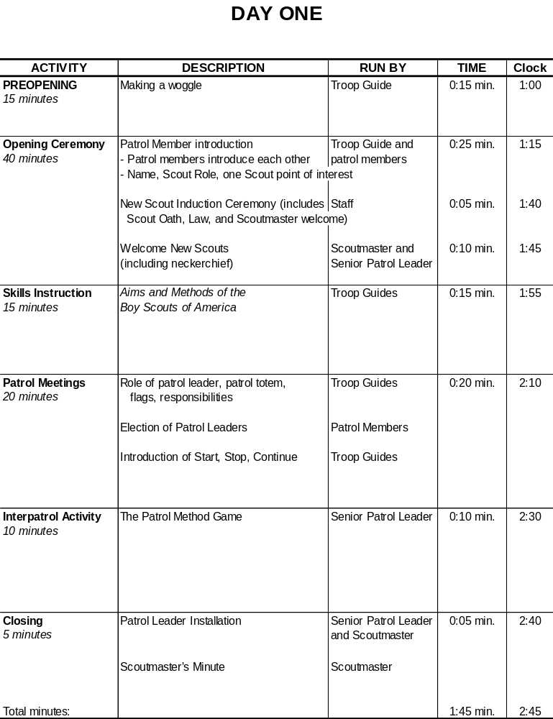

Day
Two

Wood Badge Course Schedule
Day Two

 | DAY 2
7:00 AM | Breakfast & patrol self-assessment, quick-peppy song
8:00 AM | Gilwell Field Assembly
8:30 AM | Troop Meeting
9:45 AM | Inter-patrol Activity & Debrief
10:15 AM | Break
10:30 AM | Leveraging Diversity Through Inclusiveness  (Troop Presentation)
11:00 AM | Stages of Team Development (Troop Presentation)
11:50 AM | Break
Noon | Lunch (+ Grace)
Noon | Patrol Leaders’ Council Meeting
Noon | Patrol Chaplain Aides’ Meeting
1:10 PM | Photos
2:00 PM | Communication (Patrol Presentation)
3:00 PM | Project Planning (Troop Presentation)
3:30 PM | Rocket Competition (Inter-patrol Activity)
4:50 PM | Rocket Project reflection
5:00 PM | Patrol Meeting
6:00 PM | Dinner
7:00 PM | Wood Badge Game Show (Troop Activity)
7:50 PM | Break
8:00 PM | Game of Life (Troop Activity)
8:50 PM | Debrief
9:00 PM | Flag Retirement
9:30 PM | Cracker Barrel
10:00 PM | Staff Meeting

Start, Stop, Continue Worksheet

Patrol:

Category | Assessment
Start | In our patrol, what should we put in place to improve?  (Some things we should START)  1.  2.  3.
Stop | In our patrol, what is not working? (Some things we should STOP)  1.  2.  3.
Continue | In our patrol, what is working well? (Some things we should CONTINUE)  1.  2.  3.

Day Two Flag Ceremony

Program Patrol Day One: BUFFALO

Recall that details regarding Flag Ceremony Guidelines are in the Wood Badge Handbook, and that all songs are in the songbook. Retrieve 3 flags from the Friendly Quartermaster. They will be placed on the counter in the Administration Building.

SPL forms troop and asks SM if can proceed

SPL calls troop to attention and asks program patrol to present the colors

Program patrol advances to the flag poles without moving across Gilwell Field.

Color Guard hooks up the US Flag on center pole, and the Troop Flag on the right pole.

PL calls for Scout salute

Color Guard hoists (only) US flag swiftly

PL leads the Pledge of Allegiance

PL calls Two! for Troop to lower salute

Color Guard hoists the Troop Flag (do not salute)

Color Guard displays the historic flag so the troop can see.

PL reads the paragraphs below:

The Serapis Flag
Designed with 13 stripes alternating red, white, and blue, this flag was raised by Captain John Paul Jones on the British frigate Serapis during the most famous Revolutionary War naval battle.
In 1779, after conducting sea raids on the coast of Britain, Jones took command of a rebuilt French merchant ship that had been renamed the U.S.S. Bonhomme Richard in honor of Benjamin Franklin. In September of that year, Jones engaged the British Frigate Serapis in the North Sea, sailing in close, lashing his vessel to the British ship, and fighting the battle at point blank range. During the fight, two cannon burst on the Bonhomme Richard. The British captain asked Jones if he was ready to surrender.
Jones replied, ‘Sir, I have not yet begun to fight!’ Eventually it was the crew of the Serapis that surrendered, though the Bonhomme Richard was severely damaged. The American sailors boarded the Serapis and watched from the deck as the Bonhomme Richard sank beneath the waves.

Color Guard hoists historic flag (The Serapis Flag) on left pole. (Do not salute.)

PL continues reading the paragraphs below:
Let us honor this flag with a song that also honors America. Today’s featured song is “Columbia, Gem of the Ocean” which is found on page 6 of your songbook. In our country’s early days, this song was at times considered to be our national anthem. The “Columbia” was a famous warship but the Columbia in this song likely refers to the United States as a ship of state—with a crew of citizens riding safely through a storm.

PL (or designate) leads troop in singing Columbia, The Gem of the Ocean.

Patrol reforms and returns to place in line.
The patrol leader (silently) salutes the senior patrol leader.
The SPL will signal taking control of the troop by returning the salute.

Troop Meeting Plan, Day Two
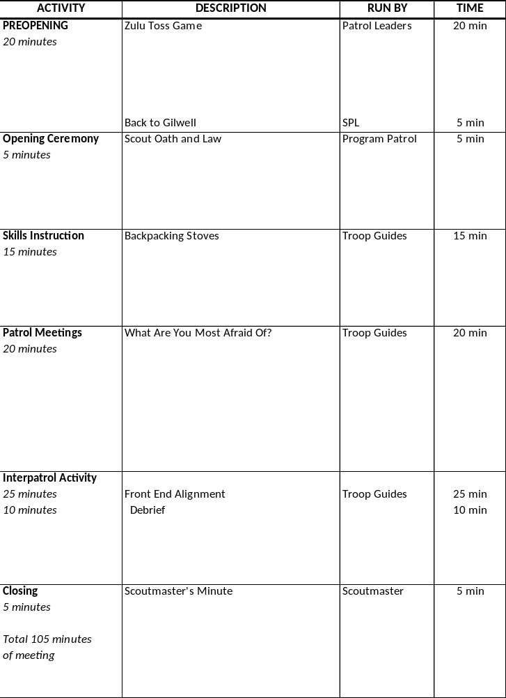

Troop Meeting – Day Two
Pre-Opening Activity

Zulu Toss Game

Materials
One tennis ball or other toss-able item (ball) per patrol member

Procedure
- Each patrol forms a circle. The patrol leader (participant A) tosses (sends) one ball to participant B, who receives it and then tosses (sends) it to participant C, etc., until the ball has been touched once by every individual. The last to touch it sends it back to the patrol leader.
- Toss the ball around the circle several more times until everyone is accustomed to receiving from and sending to the same individuals every time.
- The patrol leader tosses the ball to participant B again to start it on another trip around the circle. When that ball is midway through the participants, the troop guide hands the patrol leader a second ball, which he or she then tosses to participant B, participant B to participants C, and so on. There are now two balls being sent and received around the circle. As long as everyone receives from the same person and sends to the same participant each time, the balls will continue to move smoothly through the system.
- The troop guide gradually hands the patrol leader more balls, timing their introduction into the circle to keep the balls moving, until all balls are in play.

Debrief
- The troop guide will lead a reflection on the activity.

Patrol Leaders’ Council Meeting Agenda

Day Two

- Welcome
- Introductions
- Announcements
- Patrol leader reports on patrol progress
- Morale and productivity – How are we doing?
- Exhibits – Topic Approval
- Totems approved
- Assessment of the Day Two troop meeting
- Agenda and assignments for the Day Three troop meeting
- Distribution of patrol leaders’ copies Day Three course schedule
- Review of the assignments for program patrol and service patrol
- Assign the organization of the participants troop campfire
- Summarize the important points of the meeting and review assignments
- Adjourn

Patrol Meeting Plan

DAY TWO

- Review any upcoming responsibilities as the Service Patrol or Program Patrol.
- Plan the pre-opening activity for the Day Three Troop meeting.
- Discuss the patrol meeting portion of the Day Three Troop meeting and determine any preparations that will be needed.
- Review progress on writing Wood Badge tickets.
- Review progress on the patrol project.
Devote remaining meeting time to working on the exhibit.

The Campfire Program Planner
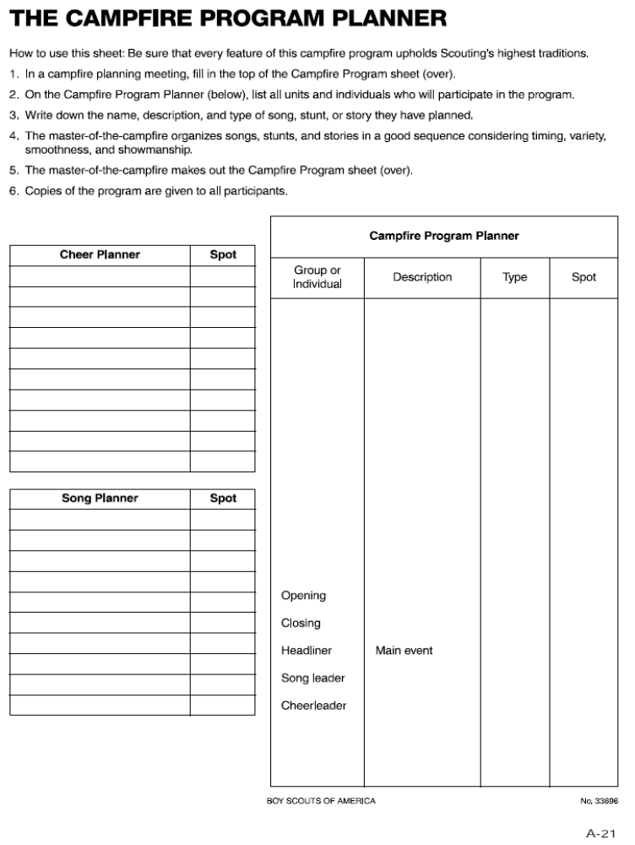

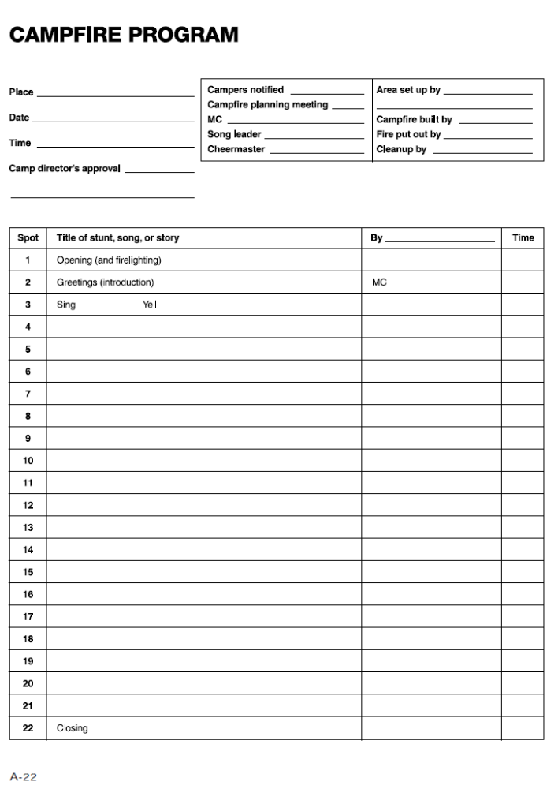

Day
Three

Wood Badge Course Schedule

Day Three

7:00 AM | Breakfast, Self-assessment
8:00 AM | Gilwell Field Assembly
8:30 AM | Interfaith Worship Service (Troop Activity)
9:20 AM | Break
9:30 AM | Troop Meeting
10:50 AM | Break
11:00 AM | Leading EDGE / Teaching EDGE  (Troop Presentation)
Noon | Lunch
Noon | Patrol Leaders’ Council Meeting
Noon | Patrol Chaplain Aides’ Meeting
1:30 PM | Conservation Project Planning
2:20 PM | Break
2:30 PM | October Sky (Troop Activity)
4:30 PM | Closing Gilwell Field Assembly
5:00 PM | Patrol Time
6:00 PM | Departure

Start, Stop, Continue

Patrol:

Category | Assessment
Start | In our patrol, what should we put in place to improve?  (Some things we should START)  1.  2.  3.
Stop | In our patrol, what is not working? (Some things we should STOP)  1.  2.  3.
Continue | In our patrol, what is working well? (Some things we should CONTINUE)  1.  2.  3.

Day Three Flag Ceremony

Program Patrol Day Two – Antelope

Recall that details regarding Flag Ceremony Guidelines are in the Wood Badge Handbook, and that all songs are in the songbook. Retrieve 3 flags from the Friendly Quartermaster. They will be placed on the counter in the Administration Building.

SPL forms troop and asks SM if can proceed

SPL calls troop to attention and asks program patrol to present the colors

Program patrol advances to the flag poles without moving across Gilwell Field.

Color Guard hooks up the US Flag on center pole, and the Troop Flag on the right pole.

PL calls for Scout salute
Color Guard hoists (only) US flag swiftly

PL leads the Pledge of Allegiance

PL calls Two! for Troop to lower salute

Color Guard hoists the Troop Flag (do not salute)

Color Guard displays the historic flag so the troop can see.

PL reads the paragraphs below:
By 1795, Vermont and Kentucky had joined the union, bringing the number of states to 15. The Stars and Stripes on the flag were increased from 13 to 15 on May 1, 1795. It was this flag of 15 stripes that flew over Fort McHenry in Baltimore on the memorable night of its bombardment in 1814 and inspired Francis Scott Key to write the verse of our National Anthem.
The actual flag that flew over Fort McHenry that night is now preserved in the Smithsonian National Museum of American History.
Color Guard affixes the flag to the halyard.

PL calls for Scout salute
Color Guard hoists The Star Spangled Banner on left pole.

PL calls Two! for Troop to lower salute

PL continues reading the paragraphs below:
The Star-Spangled Banner lyrics appear on page 7 of your songbook. Let us honor this flag by singing the first verse of the song it inspired.

PL (or designate) leads troop in singing The Star Spangled Banner.

Patrol reforms and returns to place in line.
The patrol leader (silently) salutes the senior patrol leader.
The SPL will signal taking control of the troop by returning the salute.

Spring Open Burning Laws

Effective from February 15 - April 30

The VA Department of Forestry burn laws went into effect on February 15th and remain in effect until midnight of April 30th. Also known as the “4 pm law”, open burning is permitted from 4pm until midnight and is required to be constantly attended at all times. The listed dates are typically the more dangerous of the fire season due to dry materials that have fallen over the winter and higher winds during the daytime hours. For more information, contact the local VA Department of Forestry at 556-4145.

What does this mean to the units camping at the Heart of Virginia Scout Reservation?
- No campfires may be ignited before 4 PM and
must be extinguished at Midnight.
- Propane stoves are allowed.

Friendly Quartermaster Note:
Each patrol site will be provided with one metal barrel (about 2 feet in diameter and less than a foot deep) to contain your patrol fire. The intent is that if you use charcoal or dutch ovens, here is where it goes.

Some answers to frequently asked questions – (These answers are from the Virginia Division of Forestry website)

Can I have a campfire if I put rocks around it?
NO. Campfires are considered an open air fire.

Can I use my charcoal or gas fire fired barbeque grill?
Yes, however you must take proper care and precaution by clearing all flammable material from around it and you must stay with it until it is completely extinguished or turned off.

What is the penalty for violating the 4 p.m. law?
Violation of the 4 p.m. law is a class 3 misdemeanor with a fine of not more than $500.
The Scout Reservation does not get an exemption from the law. We have an excellent working relationship with the local Forest Wardens and do not want to do anything to damage that relationship.

Patrol Leaders’ Council Meeting Agenda

Day Three
- Welcome
- Introductions
- Announcements
- Purpose of the meeting – what we need to accomplish
- Assessment of the Day Three troop meeting
- Distribution of patrol leaders’ copies of the Day Four course schedule
- Discussion of the upcoming Outdoor Experience
- Patrol leader reports on patrol progress
- Morale and productivity – How are we doing?
- Exhibits
- Daily Duties and Assessments
- Reports on the progress being made on the Participant Campfire
- Review of the assignments for program patrol and service patrol
- Summarize the important points of the meeting and review assignments
- Adjourn

Outdoor Code

As an American, I will do my best to
Be clean in my outdoor manners,
Be careful with fire,
Be considerate in the outdoors, and
Be conservation-minded.
Patrol Meeting Plan

Troop Meeting Plan
Day Three
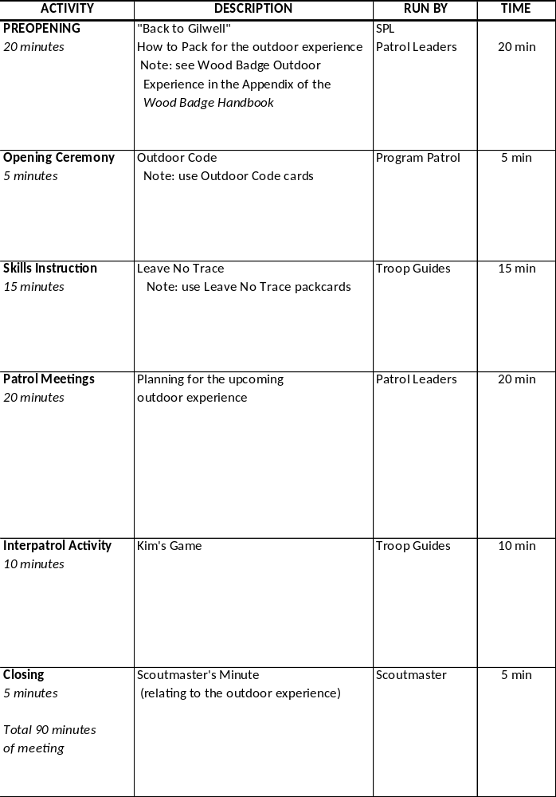

Patrol Leader Assignments for the Day Three Troop Meeting

Pre-Opening Activity for the Day Three Troop Meeting

“How to Pack for the Outdoor Experience”

The Wood Badge Outdoor Experience is an opportunity for each patrol to travel together to a remote location, establish a camp, and take part in several days of outdoor activities. Patrol members will pack and carry their own gear and clothing, appropriate for the backcountry.

The members of each Wood Badge patrol represent a wide range of skills and backgrounds. The goal of the Day Three troop meeting pre-opening activity is for patrol members to share their knowledge with one another in order to ensure that each person has access to the necessary gear and clothing, and that everyone will be able to pack their equipment for traveling to the patrol’s campsite.

In addition to drawing upon their own experiences, patrol members may also refer to The Boy Scout Handbook, Fieldbook, Camping, Hiking, and Backpacking merit badge pamphlets; and Venturing publications highlighting camping and backpacking.

Patrol Meeting
Patrol leaders can use the patrol meeting portion of the Day Three troop meeting to begin planning the details of the upcoming outdoor experience. Among the topics to consider are the following:

- Food
  - Budget for meals
  - Menus
  - Preparation time, cleanup time
  - Food repackaging, transport, and storage
  - Ingredient lists
  - Shopping
- Group gear
  - For camping
  - For cooking
Plan what to go over during the troop meeting, and what to defer to the patrol meetings you’ll be having between Day Three and Day Four of the course.

Wood Badge Outdoor Experience

One of the purposes of Wood Badge for the 21st Century is to simulate a month of a Boy Scout Troop. Days One, Two and Three simulate troop meetings and programs leading up to a campout. Days Four, Five and Six are intended to represent that outdoor experience. With that in mind, your patrol will also experience life as part of a Boy Scout patrol in an outdoor adventure. Weekend Two (days four, five and six) will be held in the out-of-doors at Camp T. Brady Saunders. The following information should help your patrol plan and prepare for that experience.
When we return for Weekend Two, you’ll arrive at the Administration Building parking lot for Camp T. Brady Saunders at 7:00am sharp. Once your entire patrol has arrived, you will pack all necessary gear, food, and other articles into a pickup truck provided by your patrol. The friendly quartermaster can provide a truck if specified in advance. Once packed, one of the friendly quartermasters will drive the truck to your designated campsite. All patrol members should be prepared to go on a short hike, simulating a backpacking outing, to their campsite carrying their personal gear. Further instructions about this hike will be given when you arrive on Day Four. No vehicles will remain in camp—the truck will be parked in the parking lot for the weekend. A reverse procedure will be used on Day Six when it is time to break and leave camp. At 8:00am on Day Six, one truck will be brought to each patrol site to pack your camp equipment. The gear will be transported to the parking lot by one of the friendly quartermasters.

Personal Equipment
Each patrol member will be responsible for providing their own personal equipment, i.e. sleeping bags, pack, etc. that they will need for a three-day outdoor experience. For reference, a suggested personal equipment list is found in the Boy Scout Handbook (12th ed.) on pages 292-293.

Patrol Equipment
Each patrol will plan menus for several meals (see menus and food, below) and should determine the equipment necessary to prepare, cook, and clean up for these meals. You will also need to identify any equipment needed (such as a dining fly) or desired for camp life. The patrol will be responsible for acquiring all equipment needed for their weekend in the woods. Please note that while the friendly quartermaster will not provide any equipment for the patrol’s use, they, as well as other staff members, are always willing to help locate whatever the patrol cannot acquire for themselves.

Stewardship
When planning your outdoor experience, be sure to keep in mind the patrol will be responsible for following the Outdoor Code and for practicing the principles of Leave No Trace. All equipment for the patrol must be able to fit in the bed of a single pickup truck. All items “carried in” will be carried back out as well. The patrols are expected to leave the campsite “better than they found it.” A suggested gear checklist is found in the Boy Scout Handbook on pages 294-295. Please note that the summer-camp wall-tents will be pitched and will have cots; So, you do not need to bring your personal tents.

Patrol Project
When your patrol arrives at the parking lot behind the Administration building, your patrol project will be placed in a separate truck to be taken directly to Gilwell Hall. That is, your patrol project does not go with you to your campsite. Your patrol project will be returned to the patrol on Day Six.

Menus and Food

See the Cooking section in the Boy Scout Handbook, beginning on page 314. Each patrol shall plan for and prepare the following meals:
Day Four Lunch (4-5 guests)
Day Four Dinner (3-4 guests)
Day Five Breakfast (3-4 guests)
Day Five Dinner (no guests)
Day Five Cracker Barrel (no guests)
Day Six Breakfast (no guests)
(Staff will provide Lunch on
Days Five and Six)

Members of the staff will be eating with the patrols on a rotating basis. Meals should be planned so that preparation, serving, and cleanup can be accomplished within the constraints of the course schedule. Please note that guests will be evaluating the patrol’s performance and cooking for each meal. The coveted Golden Spoon will be awarded to the patrol which best demonstrates their abilities in outdoor cooking. Other awards may be given at the discretion of the staff. More information regarding patrol cooking during weekend two will be given at the closing Gilwell Assembly on the afternoon of Day Three.
When planning meals, each patrol shall keep in mind that the total expenditure for food should not exceed the budget set at the PLC. Original store receipts for all purchases MUST be submitted by the patrol leader to the senior patrol leader at the Day Four patrol leaders council meeting. Reimbursement for all costs up to the food limit will be made to the patrol before leaving camp on Day Six. A Scout is thrifty! Patrols should not exceed the food limit including the retail value of any donated food.
While it is the patrol’s responsibility to plan for their own outdoor experience, they are encouraged to use resources at hand within their unit, troop guides, the friendly quartermasters, and the rest of the staff are all prepared to assist should you request help with planning. It is the entire staff’s desire that your outdoor experience be safe, educational, fun, and a time in which your patrol truly performs as a high performance team.

Wood Badge Cooking Guidelines

- The patrol may spend only the monetary allotment set at the PLC.
- The retail value of donated food counts towards your allotment.
- You must make a full accounting to the SPL at the Day 4 PLC. Accounting to include original store receipts and written explanation of expenditures or gifts.
- Your patrol will have up to 4 guests at every meal. Guests will likely bring their own cup.
- Each meal will be eaten as a patrol. Food will be served when all guests and patrol members are present. The meals will be eaten with everyone sitting together at a table and be served family style or buffet style.
- The meals will be nutritionally well-balanced.
- Grace will be said at every meal.
- The cooking area will be clean and sanitary in appearance.
- The portions will be reasonable. Did everyone have enough to eat?
- The meal will be evaluated based on the following:
  - Served on time
  - Appropriateness for youth to prepare during a Scout outing
  - Taste and appearance
  - Nutritional balance
  - Creativity and fun
- Food will be stored in your campsite. Ice will be provided at your request.
- Since all patrol members must attend all presentations, the patrol must make appropriate plans for preparation and clean up.

The meals you will be cooking in your campsite include:
- Day 4 – Lunch and dinner (guests at both meals)
- Day 5 – Breakfast (guests) and dinner (no guests)
- Day 6 – Breakfast (no guests)

Cooking Checklist
Outdoor Cooking Experience Checklist
Patrol:
Meal: |  |  | Date:
Guests:
 |  | Yes |  | No
Were there accommodations for you?
Were all the patrol members present?
Did the patrol eat as a group?
Was the food served family style or buffet?
Was a blessing said before the meal?
Did everyone appear to have enough to eat?
Was the food served on time?
Was the food stored properly? Iced sufficiently?
 |  | Great | Good | Ok | Not Ok
Rate the presentation of the food (attractiveness)
Rate the taste of the food
Rate the nutritional balance of the meal
Rate the cleanliness and sanitation of the cooking area
Rate the appropriateness of the meal as camp cooking
Special Notes About the Meal:
Give to the SPL immediately after the meal, one per patrol.

Gear Lists
The following is a list of suggested gear for the patrol for camping trips:
» | Cookware (as needed for menu)
» | Coffee Pot
» | Cooking utensils (as needed for menu)
» | Can Opener
» | Measuring Cup/Spoons
» | Cooler
» | Water Cooler
» | Water jugs/ containers
» | Stove and fuel (Follow BSA policies)
» | Dutch Oven (if needed)
» | Tarp(s)
» | Rope and Twine
» | Axe, saw, and safety equipment
» | Lantern(s)
» | Shovel & Rake
» | Trash bags
» | Paper towels & napkins
» | Aluminum foil
» | Plates and utensils for patrol/guests
» | Dishwashing soap, pads, & bleach
» | Matches or lighter
» | Hand soap or sanitizer
» | Fire buckets

Gear Lists

The following is a list of personal gear that should be packed by Scouts for camping trips:
» | Back pack with waist belt fitted to your back
» | Sleeping bag
» | Sleeping pad / air mattress
» | Tent and ground cloth
» | Camp Chair
» | Matches/lighter/fire starter
» | Compass
» | Notebook
» | Personal First Aid Kit
» | Jacket suitable for expected weather
 | Field & activities uniform (shirt, pants or shorts, belt, socks, hat)
 | Work pants & shirt
 | Sleeping clothes
» | Warm dry socks (wool and cotton)
» | Raincoat or poncho
» | Wash cloth/towel/small bar soap/zip-lock bag
» | Toothpaste and brush
» | Toiletries & Medications
» | Small mirror / comb
» | Pocket knife
» | Canteen or water bottle (one or more)
» | Flashlight with extra batteries & extra bulb
» | Lip balm
» | Large plastic bag
» | Mess kit with utensils
» | Sunglasses
» | Day-pack

Between

Patrol Meeting Plans
The patrol will want to successfully address all of the following:
- Progress on finalizing Wood Badge tickets
- Upcoming responsibilities as the service patrol or program patrol
- Planning for the Outdoor Experience
  - Gear
  - Food
  - Other…
- Finish and rehearse the presentation of the patrol project
- How, exactly, will every patrol member arrive on time during the early morning of Day Four?
- Patrol Flag, totems, etc.
- Morale. How’s everyone doing?

Day
Four

Wood Badge Course Schedule

Day Four
7:00 A.M. | Participants Arrive
 | Gazette in Parking Lot
 | Outdoor Experience Model Campsite
 | Camp Set-up
 | Change into Field Uniform
9:30 AM | Gilwell Field Assembly
10:15 AM | Gilwell Song
10:30 AM | Leading Change (Troop Presentation)
11:20 A.M. | Break
11:30 A.M. | Patrol Leaders’ Council Meeting
11:30 A.M. | Chaplain's Aid Meeting
 | Change into Activity Uniform
Noon | Lunch
1:00 P.M. | Generations in Scouting (Troop Presentation)
2:00 P.M. | Break
2:15 P.M. | Problem Solving and Decision Making  (Troop Presentation)
2:45 P.M. | Problem Solving Round-Robin (Patrol Activity)
4:00 P.M. | Managing Conflict (Patrol Presentation)
5:00 P.M. | Patrol Meeting
 | Change into Field Uniform
6:00 P.M. | Dinner
7:30 P.M. | The Diversity Game (Patrol Activity)
8:30 P.M. | Participants’ Troop Campfire
9:30 P.M. | Patrol Cracker Barrel

Start, Stop, Continue

Patrol:

Category | Assessment
Start | In our patrol, what should we put in place to improve?  (Some things we should START)  1.  2.  3.
Stop | In our patrol, what is not working? (Some things we should STOP)  1.  2.  3.
Continue | In our patrol, what is working well? (Some things we should CONTINUE)  1.  2.  3.

Day Four Flag Ceremony

Program Patrol Day Three: BEAVER

Recall that details regarding Flag Ceremony Guidelines are in the Wood Badge Handbook, and that all songs are in the songbook. Retrieve 3 flags from the Friendly Quartermaster. They will be placed on the counter in the Administration Building.

SPL forms troop and asks SM if can proceed
SPL calls troop to attention and asks program patrol to present the colors
Program patrol advances to the flag poles without moving across Gilwell Field.
Color Guard hooks up the US Flag on center pole, and the Troop Flag on the right pole.

PL calls for Scout salute
Color Guard hoists (only) US flag swiftly

PL leads the Pledge of Allegiance

PL calls Two! for Troop to lower salute

Color Guard hoists the Troop Flag (do not salute)

Color Guard displays the historic flag so the troop can see.

PL reads the paragraphs below:

By 1908, the United States of America had grown to encompass states from the Atlantic to the Pacific. Nearly all of the territory in between had also been recognized with state-hood. When Oklahoma joined the Union, the U.S. flag changed to include 46 stars, a design that would last for only four years and the administrations of two presidents, Theodore Roosevelt and William Taft.
Color Guard affixes the flag to the halyard.

PL calls for Scout salute
Color Guard hoists historic flag (The 46 star Flag) on left pole.

PL calls Two! for Troop to lower salute

PL continues reading the paragraphs below:
For us, there is further significance. This is the flag that was flying over America in 1910 when the Boy Scouts of America had its beginnings. God Bless America appears on page 7 of your songbook. Let us honor this flag with a song that also honors our land.

PL (or designate) leads troop in singing God Bless America.

Patrol reforms and returns to place in line.
The patrol leader (silently) salutes the senior patrol leader.
The SPL will signal taking control of the troop by returning the salute.

(No Scout Oath or Law, as Gilwell Field Assembly continues into Venturing Induction including Venturing Oath and Code, led by SM).

Patrol Leaders’ Council Meeting Agenda

Day Four

- Welcome
- Introduction
- Announcements
- Patrol leaders report on patrol progress
- Review patrol leaders’ copies of the Day Five course schedule
- Discuss the Day Five patrol project presentations.
- Review the plans for the Day Five conservation project
- Review the Day Five staff departure
- Review the plans for the Day Four participant campfire
- Review program patrol and service patrol assignments
- Summarize the important points of the meeting and review assignments
- Adjourn

Patrol Meeting Plan

DAY FOUR

Troop Campfire
Review the patrol’s contributions for the troop campfire occurring on the evening of Day Four.

Conservation Project
Review the patrol’s involvement in the conservation project that will occur on Day Five.

Tickets
Review progress on writing Wood Badge tickets.

Program or Service Patrol
Review any upcoming responsibilities as the service patrol or program patrol.

Patrol Project
Review progress on the patrol project. Devote remaining meeting time to working on the project.

Day
Five

Wood Badge Course Schedule

Day Five

7:00 AM | Breakfast and Patrol Self-Assessment
8:00 AM | Gilwell Field Assembly
8:30 AM | Patrol Project Setup and Presentations
8:50 AM | Round One of Presentations
10:15 AM | Break
 | (Grungies for Conservation Project)
10:30 AM | Conservation Project (Troop Activity)
12:30 PM | Lunch
12:30 PM | Patrol Leaders’ Council - Working Lunch
12:30 PM | Chaplain Aides’ - Working Lunch
 | In activity uniform, please
1:25 PM | Gilwell Song
1:30 PM | Coaching and Mentoring (Troop Presentation)
2:30 PM | Assessments (Troop Presentation)
2:20 PM | BREAK
3:00 PM | Round Two of Presentations
4:30 PM | Ticket Review and Collection
6:00 PM | Patrols Depart to Patrol Sites
6:00 PM | Patrol Dinner
 | Staff: Field uniform, taupe neckerchief, beads
7:00 PM | SM Dinner Staff Dinner
7:30 PM | Patrol Meeting
8:00 PM | Patrol Campfires and Cracker Barrel
9:00 PM | Evening Ceremony (Troop Activity)

Start, Stop, Continue

Patrol:

Category | Assessment
Start | In our patrol, what should we put in place to improve?  (Some things we should START)  1.  2.  3.
Stop | In our patrol, what is not working? (Some things we should STOP)  1.  2.  3.
Continue | In our patrol, what is working well? (Some things we should CONTINUE)  1.  2.  3.

Day Five Flag Ceremony

Program Patrol Day Four: BOBWHITE
Recall that details regarding Flag Ceremony Guidelines are in the Wood Badge Handbook, and that all songs are in the songbook. Retrieve 3 flags from the Friendly Quartermaster. They will be placed on the counter in the Administration Building.

SPL forms troop and asks SM if can proceed
SPL calls troop to attention and asks program patrol to present the colors

Program patrol advances to the flag poles without moving across Gilwell Field.
Color Guard hooks up the US Flag on center pole, and the Troop Flag on the right pole.

PL calls for Scout salute
Color Guard hoists (only) US flag swiftly

PL leads the Pledge of Allegiance

PL calls Two! for Troop to lower salute
Color Guard hoists the Troop Flag (do not salute)
Color Guard displays the historic flag so the troop can see.

PL reads the paragraph below:
The British Union flag, sometimes called the Union Jack, was carried by the Jamestown settlers in 1607 and by the pilgrims who arrived on the Mayflower in 1620. Today, it is the
official flag of the United Kingdom. Its design can be found in the Hawaii flag and several flags of other nations, including New Zealand and Australia.

Color Guard hoists historic flag on left pole. (Do not salute.)

PL continues reading the paragraphs below:
My Country Tis of Thee appears on page 6 of your songbook.
MY COUNTRY, ‘TIS OF THEE
My country, ‘Tis of Thee,
Sweet land of liberty,
Of Thee I sing;
Land where my fathers died,
Land of the pilgrims’ pride:
From every mountainside,
Let freedom ring.

PL (or designate) leads troop in singing My Country Tis of Thee.
Patrol reforms and returns to place in line.
The patrol leader (silently) salutes the senior patrol leader.
The SPL will signal taking control of the troop by returning the salute.

PL commands Troop to display Boy Scout Sign and leads reciting the Boy Scout Oath and Law
Patrol reforms and returns to place in line
PL (silently) salutes the SPL
SPL returns the salute.

Patrol Leaders’ Council Meeting Agenda

Day Five
- Welcome
- Introductions
- Announcements
- Review the morning’s conservation project
- Patrol leaders report on patrol progress
- Patrol project presentation
- Review patrol leaders’ copies of the Day Six course schedule
- Discuss the Day Six departure from the site of the Outdoor Experience
- Review assignments for the program and service patrols
- Summarize the important points of the meeting and review assignments
- Adjourn

Patrol Meeting Plan

DAY FIVE
- Determine how to handle any final patrol project issues such as returning materials, displaying significant display pieces in unit, district, or council settings, etc.
- Conduct the Patrol Project Self-Assessment, using the form distributed at the patrol leaders’ council to focus the thoughts of patrol members and to guide the discussion facilitated by the patrol leader.

Wood Badge Patrol Project Discussion Guide

Objectives
- In what ways did your patrol project describe a program element or theme that can be clearly identified as being associated with Cub Scouting, Boy Scouting, and Venturing?

- How did your patrol project relate this program element or theme to the aims and methods of Scouting?

- List the ways in which the presentation of your patrol project involved both a static display and an oral presentation.

- How did the presentation of your patrol project involve every member of your patrol?

- Did your patrol project represent your patrol’s best effort?

Processes
- During the development or your patrol project what decision-making processes did your patrol use to reach consensus regarding selection or a topic?

- During the development or your patrol project did a single member of your patrol assume leadership for the project? If so, on what basis was this patrol member selected?

- During the development or your patrol project did conflict ever arise? If so, how did your patrol manage the conflict?

- During the development of your patrol project, were the unique talents of the individual members of your patrol used to their fullest?

- As a consequence of developing your patrol project, did the members of your patrol learn about aspects of the Scouting program in areas other than those in which they are involved?

- As a consequence of developing your patrol project, did the members of your patrol develop a more global view of the Scouting movement?

Team Development
Below, graph your patrol’s enthusiasm (morale) and skill level (productivity) over the course of the first four days of Wood Badge. To what extent does your graph correspond to the Stages of Team Development?
Day One | Day Two | Day Three | Day Four
(+)
(–)

Day
Six

Wood Badge Course Schedule

Day Six

7:00 AM | Breakfast and Patrol Self-Assessment  In Field Uniform, please
8:00 AM | Patrol Time
9:00 AM | Patrol Leaders’ Council Meeting
10:00 AM | Gilwell Field Assembly
11:00 AM | Interfaith Worship Service (Troop Activity)
11:45 AM | Closing Luncheon
1:00 PM | Summary Session (Troop Presentation)
1:45 PM | Leaving a Legacy (Troop Presentation)
3:00 PM | Course Assessments
3:30 PM | Closing Gilwell Field Assembly
4:15 PM | Participants Depart

Start, Stop, Continue

Patrol:

Category | Assessment
Start | In our patrol, what should we put in place to improve?  (Some things we should START)  1.  2.  3.
Stop | In our patrol, what is not working? (Some things we should STOP)  1.  2.  3.
Continue | In our patrol, what is working well? (Some things we should CONTINUE)  1.  2.  3.

Day Six Flag Ceremony

Program Patrol Day Five: EAGLE
Recall that details regarding Flag Ceremony Guidelines are in the Wood Badge Handbook, and that all songs are in the songbook. Retrieve 3 flags from the Friendly Quartermaster. They will be placed on the counter in the Administration Building.

SPL forms troop and asks SM if can proceed

SPL calls troop to attention and asks program patrol to present the colors

Program patrol advances to the flag poles without moving across Gilwell Field.

Color Guard hooks up the US Flag on center pole, and the Troop Flag on the right pole.

PL calls for Scout salute

Color Guard hoists (only) US flag swiftly

PL leads the Pledge of Allegiance

PL calls Two! for Troop to lower salute

Color Guard hoists the Troop Flag (do not salute)

Color Guard displays the historic flag (the Virginia state flag) so the troop can see.

PL reads the paragraphs below:

On April 30, 1861, this flag was adopted when Ordinance No. 30 was embraced by the Virginia Convention of 1861.
“Be it ordained by the convention of the commonwealth of Virginia, that the flag of this commonwealth shall hereafter be made of bunting, which shall be a deep blue field with a circle of white in the centre, upon which shall be painted or embroidered, to show on both sides alike, the coat of arms of the state, as described by the convention of seventeen hundred and seventy-six, for one side of the seal of state, to wit:
Virtus, the genius of the commonwealth, dressed like an Amazon, resting on a spear with one hand, and holding a sword in other, and treading on tyranny, represented by a man prostrate, a crown fallen from his head, a broken chain in his left hand and a scourge in his right. In the exergon the word Virginia over the head of Virtus, and underneath the words ‘Sic Semper Tyrannis.’
This flag shall be known and respected as the flag of Virginia.”

Color Guard hoists historic flag on left pole. (Do not salute.)

PL continues reading the paragraphs below:
Today, we will be reading an excerpt from Baden-Powell’s final message to Scouters. It was found among his papers after his death in 1941. These words were written during his final years while living in Kenya. He was buried in Nyeri, within sight of Mt. Kenya and a simple stone marks his gravesite. On it are the symbols for Boy and Girl Scouting as well as a circle with a dot inside—the symbol for “gone home”.

“Dear Scouts, I have had a most happy life and I want each one of you to have as happy a life too. I believe that God put us in this jolly world to be happy and enjoy life. Happiness doesn’t come from being rich, nor merely from being successful in your career, nor by self-indulgence. One step towards happiness is to make yourself healthy and strong while you are young, so that you can be useful and so can enjoy life.
Nature study will show you how full of beautiful and wonderful things God has made the world for you to enjoy. Be contented with what you have got and make the best of it. Look on the bright side of things instead of the gloomy one.
But the real way to get happiness is by giving out happiness to other people. Try and leave this world a little better than you found it and when your turn comes to die, you can die happy in the feeling that at any rate you have not wasted your time but have done your best. “Be Prepared” in this way, to live happy and to die happy—stick to your Scout promise always… and God help you do it.
Signed, Baden-Powell”

PL commands Troop to display Boy Scout Sign and leads reciting the Boy Scout Oath and Law
Patrol reforms and returns to place in line.
The patrol leader (silently) salutes the senior patrol leader.
The SPL will signal taking control of the troop by returning the salute.

Patrol Leaders’ Council Meeting Agenda

Day Six

- Welcome
- Introductions
- Review the patrols’ return from the Outdoor Experience
- Review copies of the Day Six schedule to the patrol leaders and review the events for the remainder of the course
- Discuss what is expected of the patrols to make the camp breakdown as efficient as possible
- Discuss Closing Lunch
- Review assignments for the program and service patrols
- Summarize the important points of the meeting and review assignments
- Adjourn

Start, Stop, Continue

Patrol:

Category | Assessment
Start | In our patrol, what should we put in place to improve?  (Some things we should START)  1.  2.  3.
Stop | In our patrol, what is not working? (Some things we should STOP)  1.  2.  3.
Continue | In our patrol, what is working well? (Some things we should CONTINUE)  1.  2.  3.

SPL
Scripts

Patrol Leaders’ Council Meeting Agenda
Day One

Welcome
- Ask each patrol to turn to page 11 of the PLNB: OMHIWDMB
- This is all you need to do to be a successful patrol leader….but you can do no less
- Turn to page 12 for the agenda of this meeting. I suggest you take notes on page 13.

Introduction of attendees
- SPL, ASPL, patrol leaders, Quartermaster, Scribe, and other staff

Purpose of the meeting – what we need to accomplish
- What is a PLC? Who attends? How structured? How often?
- WHY do Troops use PLC’s?
- Explain why this meeting is “in-the-round” and different from other PLCs
- PLs to convey PLC information to patrol members AND vice versa.
- Effective method to use with Scouts, a committee meeting, or even a business team

When the meeting will end
- This meeting will take no more than 1 hour.

Announcements
- Patrol Totems designs need to be submitted to SPL no later than the PLC on D2
- Patrol Scribes provide items for Gilwell Gazette by 9:00pm in basket.
- Interfaith Worship Service on the morning of Day Three. There will an opportunity to participate in “Act of Friendship” offering at the service.
- There will be a Catholic Mass offered tomorrow at 6:00pm at the Welcome Center. Those that attend Mass will need to return quickly to the Dining Hall for a very quick dinner, as the program will continue at 7:00pm.
- D2 PLC will take place at 12:10 at the Welcome Center. Only patrol leaders and troop guides attend.
- A chaplains aide meeting at 12:10 on D2 in the Handicraft Building
- Troop and patrol pictures will be taken tomorrow at 1:10. Assemble in the Dining Hall. When your entire patrol and troop guide are gathered, please queue up for your patrol picture. You will need your patrol flag and be in your activity uniform.
- Announcements from ASMs, FQM, Scribe, SM.
- Uniforms: Activity vs. Field

Assessment of Day One Troop Meeting
- What was the purpose of the meeting?
- How was the purpose accomplished?
- How can we make future meetings more effective?

Assignments for the Day Two troop meeting
- Refer to Troop Meeting Plan for D2, under Day 2 Section page 28.
- Explain and run the Zulu Toss Game (Handout in PL Notebook, Day 2, page 29)
- Explain and Run the Inter-patrol Activity (Front End Alignment information will be given at the time of the activity)
- D2 Program Patrol (Antelope) will open Troop Meeting with the Scout Oath and Law (see page 5 for all the S/P patrol responsibilities)

Reminder of D2 Service and Program Patrol assignments
- D2 Service Patrol – (Bear) - D2 Trash and as requested by FQM (see page 5).
- D2 Program – (Antelope) - Retire flags at dusk tomorrow night and leave on counter in Admin Building. Fold if dry, hang if damp/wet. D3 Gilwell Flag ceremony (see page 38). Flags on counter in Admin Building. Your chaplain's aide should be prepared to offer graces at troop meals, if asked.
- D1 Program Patrol (Buffalo) - Retire flags at dusk tonight and leave on counter in Admin Building. Fold if dry, hang if damp/wet. D2 Gilwell Flag ceremony (page 26). Find flags on counter in Admin Building. Your chaplain's aide should be prepared to offer graces at troop meals, if asked.

Discussion – Patrol Projects
- See the handout in PL notebook beginning on page 18.
- Each patrol will develop and present (D5) a patrol project that meets or exceeds the level presented by the TG’s this morning.
- Patrols must reach consensus on the subject of their project and present this for approval at the D2 PLC. Have an alternate subject to present in case there is duplication.
- The presentation must cover aspects of Cub Scouts, Boy Scouts, Venturing, and Varsity Scouts, and must include the concept of best practices in Scouting.
- The project must stand alone and should not use electronics or computers.
- All patrol members must contribute and participate in the presentation.
- A report of the patrol’s progress on the project will be made at each PLC through Day 5.

Discussion – “Lost and Left” Items
- Patrol Tables, flags and sleeping areas are “safe”. Don’t bother them.
- Lost and Left patrol & staff items may be adorned, but not permanently modified. Please return them to their owner or leave them where you found them.

Morale & Productivity - how each patrol and patrol leader is doing?
- Patrol Cheers.
- Don’t forget to do patrol self-assessments, at the very least at every breakfast. In the PL Notebook, they are the first thing after the daily schedule—which should remind you.

Close
- Recap key points of the meeting
- Reminders of who is to do what, when it will be done
- Stress performing at high levels of quality and communication
- Final Questions?

Adjourn

Patrol Leaders’ Council Meeting Agenda
Day Two

Welcome
- Welcome to the D2 PLC
- This meeting must end by 1:10 PM. See page 30 for our agenda today.

Introductions
- Introduce staff at meeting
- Patrol leader introductions

Announcements
- Reminder of the photos after the meeting.
- There will be a Catholic Mass offered this evening at 6:00pm at the Welcome Center. Those that attend Mass will need to return quickly to the Dining Hall for a very quick dinner, as the program will continue at 7:00pm.
- Reminder of the D3 Interfaith Service; opportunity do make donation if desired to the World Friendship Fund.
- All orders from FQM by 2:30 Sunday.
- Be on time

Patrol Leader reports on Patrol progress
- Morale and productivity – How are we doing?
- Patrol Projects – topic approval at this meeting
- Totems – submit by now
- Table totems
- Reports and cheers
- Flags

Assessment of the D2 troop meeting
- What was the purpose?
- What was learned?
- How could we make it better?

Agenda and assignments for the D3 troop meeting
- See D3 Troop Meeting Plan (page 43).
- Discuss the upcoming outdoor experience; refer to resources in WBHB and beginning on page 45.
- Program Patrol (Beaver) to present “The Outdoor Code” as the Opening – in PL Notebook, Day 3, page 42. Note that we will have done the Oath and Law on Gilwell Field, so don’t do them again.

Discuss course schedule for D3
- See page 35 and comment on any changes.

Review of the D3 assignments for Program Patrol and Service Patrol
- See all the S/P Patrol responsibilities on page 5.
- D3 Program Patrol (Beaver) - Present the Outdoor Code, Assist with Interfaith Service if needed; Retire flags on Gilwell in the afternoon, D4 Gilwell Flag ceremony. Offer graces for troop meals, if requested.
- D3 Service Patrol (Fox) – Trash, latrines, etc. on D3.
- D2 Program Patrol (Antelope) – Retire flags at dusk tonight. Fold and leave on counter in administration building or hang if wet/damp. D3 Gilwell Flag ceremony. Offer graces for troop meals, if requested.

Assign the organization of the participants troop campfire
- Refer Campfire Planner Sheet, page 32.
- Bobwhite Patrol as Program Patrol on D4 is host and will need to get participation from all other patrols. Approval of all skits and songs prior to PLC on Day 4.
- Buffalo Patrol is Service Patrol and in charge of building, maintaining, and extinguishing fire

Summarize the important points of the meeting and review assignments
- Review Assignments
- Questions

Adjourn

Patrol Project Topics

Patrol | Topic
Beaver
Bobwhite
Eagle
Fox
Owl
Bear
Buffalo
Antelope

Patrol Leaders’ Council Meeting Agenda
Day Three

Welcome
- Welcome to the D3 PLC
- This meeting must end by 1:25 p.m. See page 41 for our agenda.

Introduction
- Staff
- Patrol leaders

Announcements
- Remember to leave Fort Ferguson clean and better than you found it.
- All Participants need to be away from camp by 6:00 PM tonight.
- Day 4 PLC will be at the Brady Saunders PLC Shelter Camp Savvy 11:30am
- Email Gilwell Gazette articles to Scribe by ______________. Email address is in D1 Gazette

Purpose of the meeting – what we need to accomplish
- Prepare for the second weekend.

Assessment of the Day Three troop meeting
- What was the purpose?
- What was learned?
- How could we make it better?

Review patrol leaders’ copies of the Day Four course schedule
- The schedule is on page 55.
- If required, highlight any changes to this.

Discussion of the upcoming Outdoor Experience
- All patrol members arrive by 7:00 am on Saturday April 9th in grungies, not Scout uniform. Camping the night before at Douglass Fleet is permitted.
- Park at the Brady Saunders Admin Building.
- You will arrive with all your gear in one pickup truck, except for personal gear you backpack in. If needed, the QM staff will provide truck to haul camp gear.
- FAQM’s will deliver the trucks to patrol campsites.
- Food cost and reimbursement.
- Up to 4 staff members will eat with each Patrol for Lunch D4, Dinner D4, & Breakfast D5.
- Outdoor meal guidelines (see page 48)
- Questions?

Patrol leader reports on patrol progress
- Morale and productivity – How are we doing? Each PL reports
- Patrol Projects?
- Daily Duties and Assessments

Reports on the progress being made on the Participant Campfire (Bobwhite/Buffalo)
- See page 5 for all the P&S Patrol responsibilities.
- Review of the assignments for D4 program patrol and service patrol
- D3 Program Patrol (Beavers) – D4 Gilwell Flag ceremony (page 58). Offer grace at troop meals if requested.
- Program Patrol – Bobwhite – Retire Flags D4, Campfire Host D4, Flag Ceremony on D5 (see page 66). Note that the song is not in the WBHB but it is in the songbook.
- Service Patrol – Buffalo – Build, light and put out Campfire, Latrines, Trash on D4

Summarize the important points of the meeting and review assignments
- Review Assignments
- Questions

Adjourn

Patrol Leaders’ Council Meeting Agenda
Day Four

Welcome
- Welcome to the D4 PLC
- This meeting must end by 11:55 a.m. See page 60 for our agenda today.

Introductions
- Staff
- Patrol Leaders

Announcements
- There will be a Catholic Mass offered this evening at 6:00pm at Camp Savvy. Those that attend Mass will need to return quickly to their Patrol Sites for a very quick dinner. Please let your Patrol members know if you plan to attend Mass.
- D6 instructions
- Activity uniform for lunch
- Field uniform for dinner and
- Activity Uniform for Campfire, if desired
- Receipts due at this PLC; get them in to FQM by 5:00 Today

Patrol leaders report on patrol progress
- Interim patrol meetings
- Making camp, settling into the outdoor experience.
- Working with Venturers
- Golden Spoon Cooking Awards
- Questions or concerns?

Review patrol leaders’ copies of the D5 course schedule
- See page 63
- If needed, highlight changes.

Discuss the Day Five patrol project presentations.
- (Patrol leaders should work together to determine the following)
- Location of presentations
- 15 minutes per patrol, one behind another-stay on time
- Pay attention to all presentations
- Order for patrol projects presentations (Group 1 – Morning, & Group 2 - Afternoon)
1.1 –
1.2 –
1.3 –
1.4 –
2.1 –
2.2 –
2.3 –
2.4 –

Review the plans for the D5 conservation project
- Meet at _____________ at 10:30 am
- Bring water & gloves, wear grungies
- D5 patrol leaders may depart early for PLC
- Troop will all have Lunch together at the Gilwell Hall at 12:30
- D5 PLC will be at 12:15 – grab your lunch first; go to PLC site (Camp Savvy?)
- D5 CA will be at 12:15 – grab your lunch first; go to the corner of Gilwell Hall.

Review the D5 staff departure
- Staff will depart camp at 6:00 pm
- In an emergency, someone will be at the Health Lodge
- Evening program at 9:00. Directions provided by SM earlier in evening

Review the plans for the Day Four participant campfire
- All skits and activities approved?
- Any special instructions from the Bobwhites
- Are the Buffalos ready for the fire (heat, starter, tinder, wood, water, shovel (see QM)
- Arrival Time?
- Bring chairs!

Review D5 program patrol and service patrol assignments patrol
- See page 5 for all P & S Patrol responsibilities.
- Program Patrol – Eagle –Retire Flags D5, Flag Ceremony on D6 (see page 77), assist with set up of patrol Projects
- Service Patrol – Antelope – Latrines and Trash on D5, assist with Troop Service Project as needed,
- D4 Program Patrol (Bobwhite) – Retire flags at dusk tonight. Fold and leave in Gilwell Hall or hang if wet/damp. D5 Gilwell Flag ceremony.

Summarize the important points of the meeting and review assignments
- Review Assignments
- Questions

Adjourn

Patrol Leaders’ Council Meeting Agenda
Day Five

Welcome
- Welcome to the D5 PLC
- This meeting must end by 1:25 pm latest. See page 68 for our agenda.

Introductions
- Staff
- Patrol Leaders

Announcements
- Reminder of Staff Departure at 6:00 p.m., please stay away from Dining hall side of camp
- Emergency procedures
- Evening ceremony, information provided by SM in evening when he drops by for a visit.
- PLC meeting at 9:00am on D6 for PL – 30 min.; PLC site.
- D6 break of camp – After Breakfast; Finished by 9:30 a.m.; Truck packed and ready to transport
- D6 @ 9:40 am, assemble on the road near the old super shower, line up by patrol. Wait for Kudu Horn signal and march as troop to Gilwell: March as a patrol at sound of Kudu Horn
- Remind of opportunity for contribution to the World Fellowship Fund at Interfaith Service
- Inform that the Course Assessment will be completed at 3:00 pm; PLs will ensure all are completed and left in stack on table.

Review the morning’s conservation project
- Reflection

Patrol leaders report on patrol progress
- Camping issues – questions or concerns
- Morale & Productivity

Patrol project presentation
- Review the presentation schedule for 2nd round start promptly at 3:00
- 2.1 -
- 2.2 -
- 2.3 -
- 2.4 -

- Discuss the Patrol Project Assessment used by each patrol (see page 70).

Review patrol leaders’ copies of the D6 course schedule
- See page 74.
- If necessary, highlight any changes.

Discuss the D6 departure from the site of the Outdoor Experience
- Start cleaning up camp at 8:00 am after breakfast, or sooner
- By 8:00, your vehicle will be brought by FQM to your campsite to transport gear
- Must clean latrines and campsites before leaving
- Place Troop gear by road for FQMs to pick up
- Take trash to the dumpsters behind Dining Hall
- Be ready to assemble on road by 9:40

Review D6 assignments for the program and service patrols
- See page 5 for all P & S Patrol responsibilities
- Program Patrol – (Fox) – Help as needed w/ Closing Lunch; assist as requested with Interfaith Service
- Service Patrol – (Beaver) – Latrines, Trash, Help w/ Lunch; assist as requested with physical setup needs for Interfaith Service
- D5 Program Patrol (Eagle) - Retire flags at dusk tonight. Fold and leave on counter in administration building or hang if wet/damp. D6 Gilwell Flag Ceremony (see page 77).

Summarize the important points of the meeting and review assignments
- Review Assignments
- Questions

Adjourn

Patrol Leaders’ Council Meeting Agenda
Day Six

Welcome
- Welcome
- This meeting must end by 9:30 am. See page 79 for our agenda.

Introductions
- Staff
- Patrol Leaders

Review the patrols’ return from the Outdoor Experience
- Did your patrol enjoy the outdoor experience?
- Was there anything learned that can be taken back to your unit?
- Is there anything we can do to make the experience better?
- How is morale in the patrol?
- Permanent Patrol Leader selected?

Review copies of the D6 schedule to the patrol leaders and review the events for the remainder of the course
- See page 74
- If necessary, highlight changes

Discuss what is expected of the patrols to make the camp breakdown as efficient as possible
- Camp breakdown should be happening now and complete by 9:30
- One vehicle will be brought to your camp to transport all gear out of camp
- Clean latrines and campsites before leaving
- Leave Troop gear by road
- Take trash to the dumpsters behind Dining Hall
- Be assembled on road near shower house by 9:40
- Turn in Symbols of Office, original Patrol Flags and Position Patches at lunch

Discuss Closing Luncheon
- Each patrol will be allowed two minutes to make any introductions, tributes, acknowledgements, or other presentations they wish. Patrol leaders should discuss this with patrol members before the luncheon to determine whether they wish to use their two minutes and, if so, in what manner. No grey areas allowed!
- These are meant to be presentations that would be understood and appreciated by the whole troop. The patrol will want to make patrol-specific presentations during a meeting of the patrol.

Review assignments for the program and service patrols
- See page 5 for all P & S Patrol responsibilities.
- Program Patrol – Fox– Help as needed w/ Closing Lunch as requested, including, but not limited to, offering grace; help with Interfaith Service as requested
- Service Patrol – Beaver – Latrines, Trash, Help w/ Lunch as requested; assist with Interfaith Service setup as requested

Summarize the important points of the meeting and review assignments
- Review Assignments
- Questions

Adjourn

