Wood Badge

Beaver Patrol
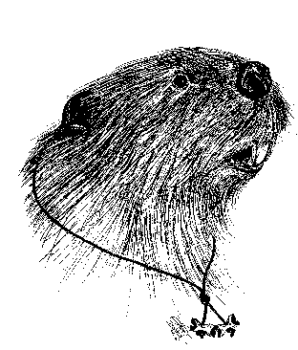

Patrol Leader
Notebook

Wood Badge

Bobwhite Patrol
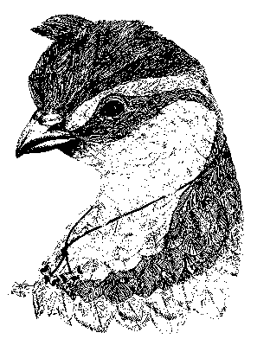

Patrol Leader
Notebook

Wood Badge

Eagle Patrol
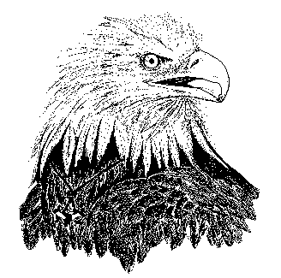

Patrol Leader
Notebook

Wood Badge

Fox Patrol
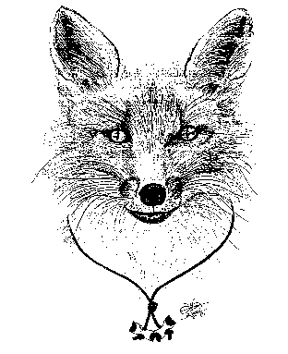

Patrol Leader
Notebook

Wood Badge

Owl Patrol
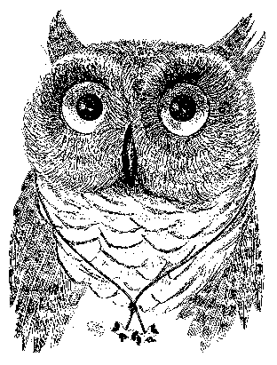

Patrol Leader
Notebook

Wood Badge

Bear Patrol
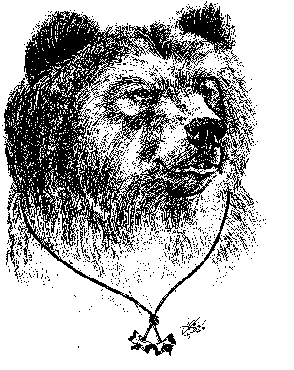

Patrol Leader
Notebook

Wood Badge

Buffalo Patrol
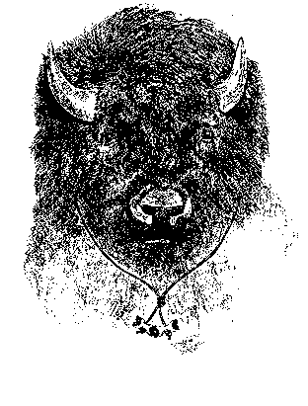

Patrol Leader
Notebook

Wood Badge

Antelope Patrol
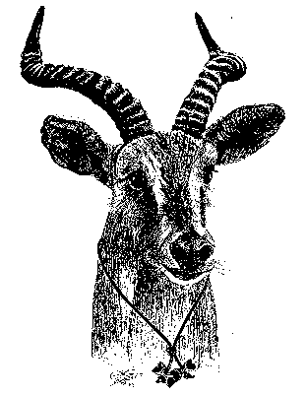

Patrol Leader
Notebook

