Al Best – SDM-Support
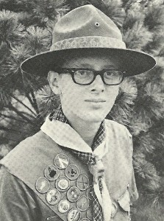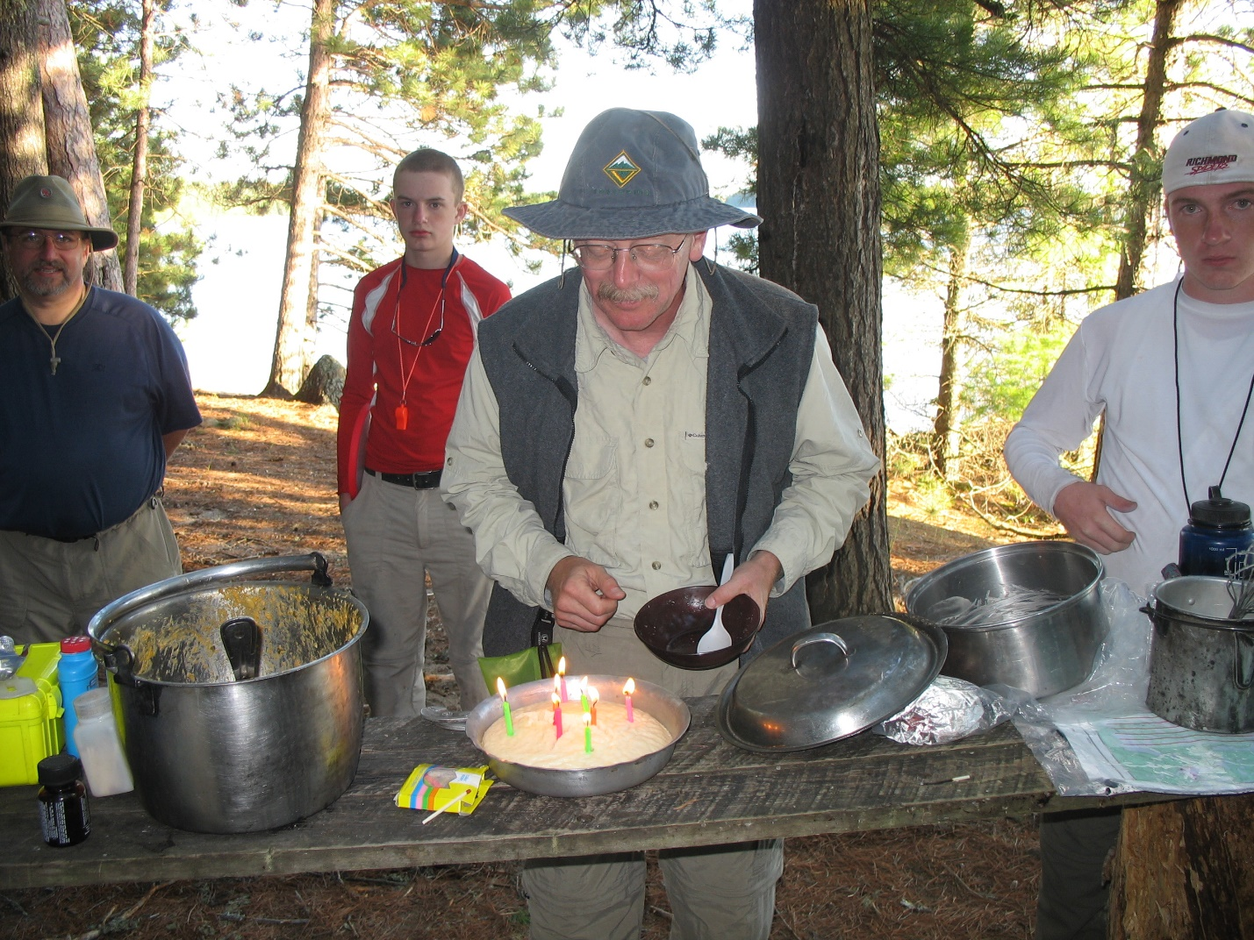
Al Best
Wood Badge Patrol / Critter: BobWhite SE-55 (1975), Bear SR-267 (1998)
Scout Unit: Troop 700
District: Cardinal
Years in Scouting: 45
Highest Rank: Eagle
Current Registered Position: Committee Member
Other Positions in Scouting and for how long? Assistant Scoutmaster 20+ years, Venturing Associate Advisor 5 yrs. Cadet and Senior Girl Scout leader 3 years.
Occupation? Biostatistician in the MCV Dental School
Who’s in your family? Barbara (wife), Ryan (son), Korinne (daughter in law), Anna (daughter)
What is your favorite Scouting event? Canoeing in Canada
What do you most enjoy doing? Snorkeling and canoeing
What is your best Scouting memory? My daughter earning Venturing Silver Award
If you had unlimited time and resources, what would you choose to do? Take Scouts Canoeing in Canada
What is your favorite food or meal? Rib-eye steak (medium rare), baked potato with cream cheese, fresh green beans, Cabernet Sauvignon
What is your proudest Scouting achievement? Leading crews to three BSA High Adventure Bases: Northern Tier, Seabase, Philmont.
What is your favorite childhood memory? Camping on the shore of Traverse Lake in Michigan with my family—every year until I was 14.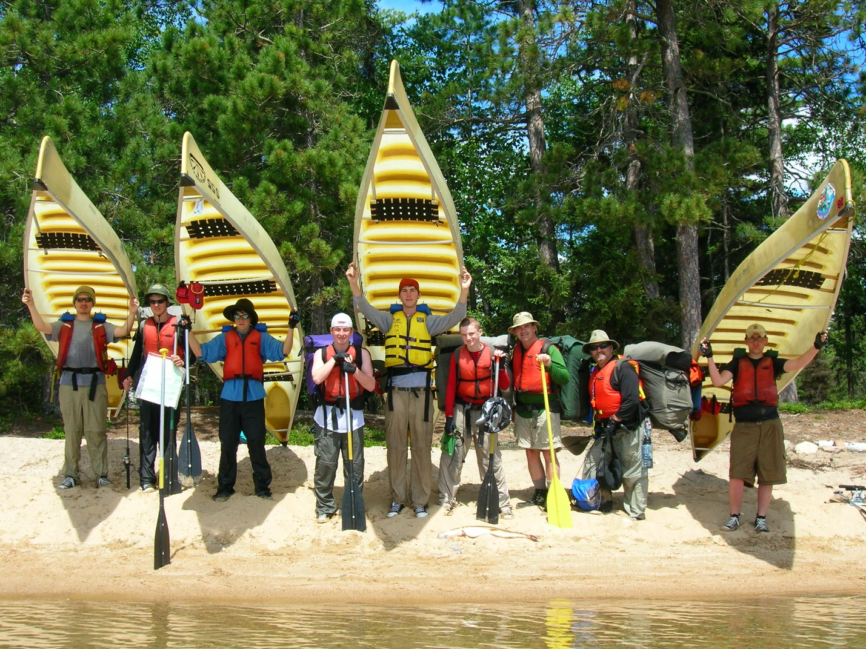
What is something about you that would surprise other people? I learned about first aid for arterial bleeding after sticking my Bowie knife through the hand of a fellow Scout.

