WOOD BADGE
Handbook
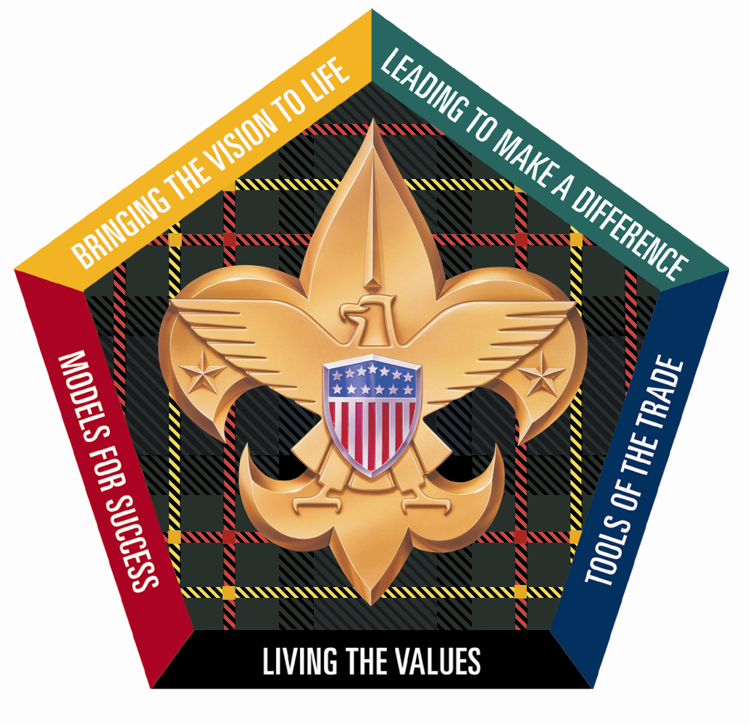
Heart of Virginia Council
S7-602-11-1


Welcome to the Heart of Virginia Council Wood Badge course S7-602-11-1. We hope that you will find this Wood Badge Handbook useful throughout the course and a valuable reference for you to use for years to come.
Table of Contents
Sharing Leadership 1
Troop Organization 2
Grace at Meals 3
Emergency Procedures 4
Program and Service Patrol Assignments 4
Cub Adventure Camp 5
Camp T. Brady Saunders Map 6
Flag Ceremonies 7
Roles and Responsibilities 8
Program and Service Patrol Responsibilities 9
DAY 1 10
Check in, Orientation, Team Formation 11
Gilwell Field Assembly 11
Course Overview 12
Values, Mission, and Vision 15
Guidelines for
Writing a Wood Badge Ticket 17
Listening to Learn 20
Blue and Gold Banquet 21
Wood Badge Traditions 22
Back to Gilwell 24
Notes and How to Keep ‘em 25
Turk’s Head or Woggle Neckerchief Slide 26
Aims of Scouting Worksheet 27
Daily Patrol Self-Assessment Form 28
Start, Stop, Continue Worksheet 29
Introduction to Campfires 31
The Campfire Program Planner 33
DAY 2 35
Gilwell Field Assembly 36
What Are You Most Afraid Of?” Worksheet 37
Leveraging Diversity through Inclusiveness 38
Stages of Team Development 40
Communication 42
Project Planning 43
Flag Retirement 45
DAY 3 47
Gilwell Field Assembly 48
Interfaith Worship Service 49
Have You Seen the Light? 52
The Leading EDGE™ /
The Teaching EDGE™ 54
A Good Conservation Project 58
Conservation Project Planning Checklist 60
October Sky—About the Movie 61
DAY 4 62
Gilwell Field Assembly 63
Venturing Induction Ceremony 63
Leading Change 64
Generations in Scouting 65
Problem Solving and Decision Making 69
Managing Conflict 71
DAY 5 75
Gilwell Field Assembly 76
Coaching and Mentoring 76
Self Assessment 78
DAY 6 82
Gilwell Field Assembly 83
Leaving a Legacy 84
Take Home Messages For 21st Century Wood Badge 86
Appendix 88
Aims of Scouting Worksheet (answers) 88
The Mission and Vision of the Boy Scouts
of America 88
Additional Goal-Setting Questions 89
Wood Badge Ticket Workbook 96
Application for Training Recognition 103
Wood Badge History 104
Answers and Debriefing Material for
“Have You Seen the Light?” Quiz 106
Staff Contacts 108
Outdoor Experience 109
Wood Badge Course Assessment 111
Patrol Roster 113
Patrol Leadership Positions 114


Letter to Our Fellow Scouters
Heart of Virginia Council
Boy Scouts of America

Fellow Scouters:

You hold in your hands the Wood Badge Handbook. It should be used during the course, and I hope you will continue to use it at home. This handbook contains many resources to support you during your Wood Badge experience. Included is course specific information such as duties and ceremonies, as well as information that may not be directly referenced in the course.
“Scouting is a game with a purpose” (B-P). Scouting should be FUN, yet instructional. Let us work together to find the fun in Scouting, both at Gilwell and at home in our units.
Wood Badge is an opportunity to develop lasting friendships, while improving leadership and personal skills. This course is challenging. It is full and demanding. We need to stay focused and work together. For most participants, Wood Badge stands tall as a highlight of their Scouting careers. Some have described it as a life changing experience.
The staff of S7-602-11-1 began preparing almost two years ago for the events you will participate in during these two weekends in March and April. After completing this part of your training, staff members will continue to follow up with you for the next 18 months. I tell you this to let you know how seriously we all take the charge to “Deliver the Promise” to our youth. At the end of the course you will have an opportunity to share your thoughts with the staff—let us know how the course worked for you, and how you see it helping others. Please take time to do this; it will help those preparing for next year’s course improve their program.
This team is an outstanding group of Scouters, who have worked hard over the past year to make the course a “mountain top” experience for you. Now it is up to you; work with each other and the staff, have fun, and make this course a stepping stone to the betterment of Scouting in your units, districts, and councils. Thank you for participating, as that step alone distinguishes you as someone who cares and wants to make Scouting the best experience possible for our youth.

Yours in Scouting,

Al Best, Course Director

Troop Organization

Wood Badge is a Troop of Scouters. There are up to eight Patrols in the Troop and approximately 6-8 Scouters per Patrol. Each Patrol is led by a Patrol Leader. This responsibility changes daily. A staff member is associated with each Patrol and serves in the position as Troop Guide, much in the same way that the Troop Guide serves to help a new Patrol in the standard Scout Troop.
The Troop is led by a Senior Patrol Leader. The Troop Guides and the Patrol Leaders report to the Senior Patrol Leader. The Senior Patrol Leader reports to the Scoutmaster. The Senior Patrol Leader is in charge of the Troop when we meet at assemblies.
The staff is divided based on the functional areas. The Course Director/ Scoutmaster is responsible for the overall operation of Wood Badge. Assisting the Course Director are Assistant Scoutmasters—for Program, for Support, for Communication, and for Troop Guides—in addition to the Quartermaster and Troop Scribe.
Each staff member has been working diligently for many months in preparation for Wood Badge. Some have been working for more than a year. We have assembled over 400 years of Scouting experience to serve you.

S7-602-11-1 Wood Badge Staff
Scoutmaster, Course Director Al Best
Assistant Scoutmaster (ASM)-Program John McCulla
ASM-Support Bob Efird
ASM-Troop Guides Ron Alexander
ASM-Communication Bennie Good
Senior Patrol Leader (SPL) Tom Johnson
Assistant Senior Patrol Leader (ASPL) AJ Kendrick
Course Mentor Chuck Smith
Scribe Carol Pilgrim
Assistant Scribe Kenny Jones
Assistant Scribe Chris Habenicht
Assistant Scribe Dean Beuglass
Friendly Quartermaster (FQM), Chaplain Aide Nancy Fonseca
Assistant FQM HC Davis
Assistant FQM Alice Nelson
Assistant SPL Jim Stallings
Staff Advisor Marcus Ragland
Troop Guide Jim McCoig
Troop Guide Carl Whitaker
Troop Guide Frank McNeilly
Troop Guide Jon Vaughan
Troop Guide Sonja Myers
Troop Guide Lisa Wright
Troop Guide Rick Bragga
Troop Guide Robert McLemore

Grace at Meals

The 12th point of the Scout Law is:
A Scout is reverent. In place of the command “Let us pray,” more inclusive, nonsectarian ways to invite participation in a blessing include the following statements and invitations: “A Scout is reverent” “Would you join me in prayer?” or “Will you all assume an attitude of prayer?”

Webelos grace
- For Woods, for Earth, and Blessings,
For Enjoyment and Life,
For Outdoors and Scouting,
We thank Thee, O Lord. Amen

Morning Graces
- Gracious Giver of all good, Thee we thank for rest and food. Grant that all we do or say this day will serve others and honor Your name. Amen.
- Our God, we thank You for the dawn of a new day and for our loving care. Help us to be mindful of You as we begin this new day. Amen.
- Oh God, we thank Thee for thy care through the night and for this new day. Help us to be faithful to You in our thoughts, our words, and our deeds this day and always. Amen.

Noon Graces
- Mighty God, for this noonday meal we would speak the praise we feel. Health and strength we have from Thee; help us, Lord, to faithful be. Amen.
- Dear God, help us to see the beautiful things in earth and sky, which are tokens of Your love. Walk with us in the days we spend together here. May the food we eat and all Your blessings help us to better serve You and each other. Amen.
- Oh God, as this day continues let us not forget to honor and serve You. We thank You for these gifts of Your love. Bless them to our use, and our lives to Your service. Amen.

Evening Graces
- Tireless Guardian on our way, Thou hast kept us well this day. While we thank thee, we ask for your continued care, for forgiveness of our sins, and for rest at the close of a busy day. Amen.
- Dear God, we thank You for this day and for Your presence in it. Forgive us if we have not made it a better day and help us to be tomorrow what we have failed to be today. Amen.
- Our God, we thank You for this evening meal. As You have been mindful of us, so help us to be mindful of You, that we may know and do your will. Amen.
- Oh God, You have given us all things to enjoy. We bring our thanks to You at this evening meal. Bless us as we eat this food, and keep us mindful of the needs of others. Amen.

Graces for Any Meal
- For health and strength and daily food, we give Thee thanks, Oh Lord. Amen.
- For this and all Your mercies, Lord, make us grateful. Amen.
- We thank You, God, for this food. Bless us as we eat this meal that it may strengthen us for Your service. Amen.
- Be present at our table, Lord. Be here and everywhere adored; these mercies bless and grant that we may love, and serve, and honor Thee. Amen.
- Praised are You, 0 Lord, who provided all with food. Amen.
- For food, for raiment, for life, for opportunity, for friendship and fellowship we thank Thee, Oh Lord. (Philmont Scout Ranch Blessing)
- For food, for raiment, for life, for opportunity, for sun and rain, for lakes and portage trails, for friendship and fellowship, we thank Thee, Oh Lord.
(Northern Tier Blessing)
- Bless the creatures of the sea,
Bless the person I call me.
Bless the Keys You made so grand,
Bless the sun that warms the land.
Bless the Fellowship that we feel,
As we gather for this meal. Amen.
(Florida Sea Base Blessing)

Emergency Procedures

Medical Emergency
In case of a life-threatening injury, administer first aid immediately and send for help.
For other medical conditions, illness or injury, report to the Course Health Officer. Anyone with special medical condition (back problem, severe allergies, etc) or on prescribed medication must inform the Course Health Officer.

Fire Emergency
Fire is a real and ever present danger. The camp is on a high fire alert status. Open fires are prohibited. Extreme care must be taken when cooking. In the event of a fire that cannot be extinguished easily and safely, sound the alarm and send for help.
All vehicles are backed into parking spaces. They should be ready to leave promptly in case of fire or other emergency.
If you hear sirens, bells, or horns in sets of three, evacuate the area and DO NOT return to your campsite for belongings. Report immediately to the emergency gathering area and form as patrols. Patrol leaders report missing members to staff. DO NOT send anyone to look for missing patrol members.

Safety
Safety is the utmost concern in camp.
All campsites must have fire fighting tools and ample water. Use sun screen and insect repellent, as needed. Stay on trails and roads and within the reservation.

Emergency contact phone numbers
Al Best, Course Director: 399-9847
Camp Office: 556-3633
Dickie Coffey: 248-0224
Tim Streagle: 467-1897
John Hankins: 467-1986

Program and Service Patrol Assignments

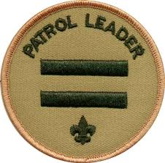 | Wood Badge Day
 | 1 | 2 | 3 | 4 | 5 | 6
Respon- | Fri | Sat | Sun | Sat | Sun | Mon
sibility | 11-Mar | 12-Mar | 13-Mar | 9-Apr | 10-Apr | 11-Apr
Program
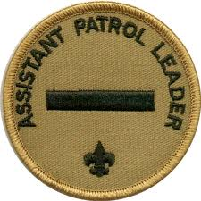  Patrol | Buffalo | Antelope | Beaver | Bobwhite | Eagle | Fox
Service | Owl | Bear | Fox | Buffalo | Antelope | Beaver
Patrol

Cub Adventure Camp
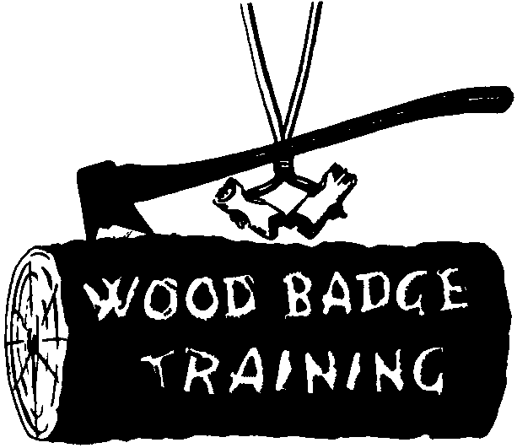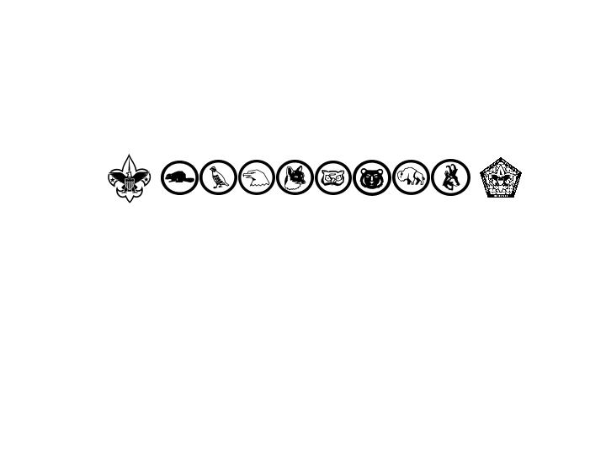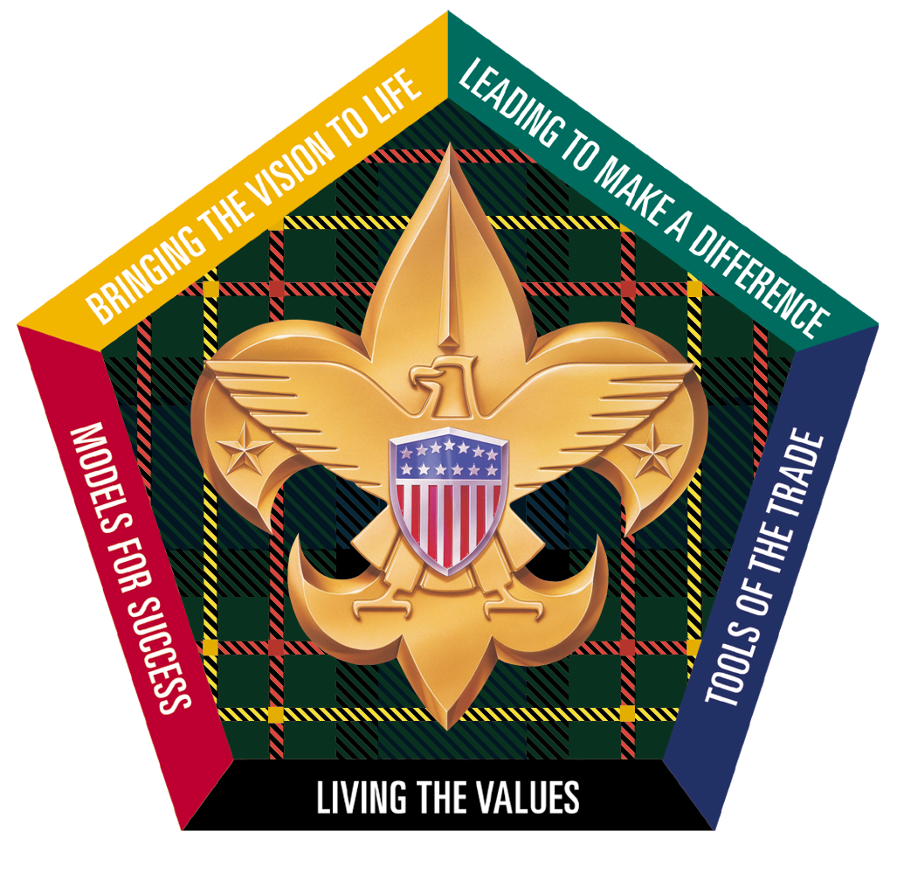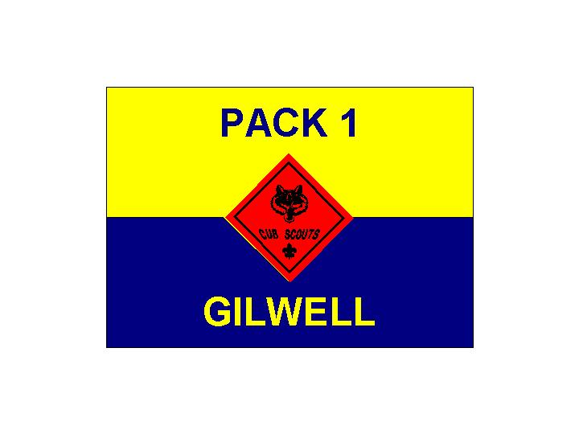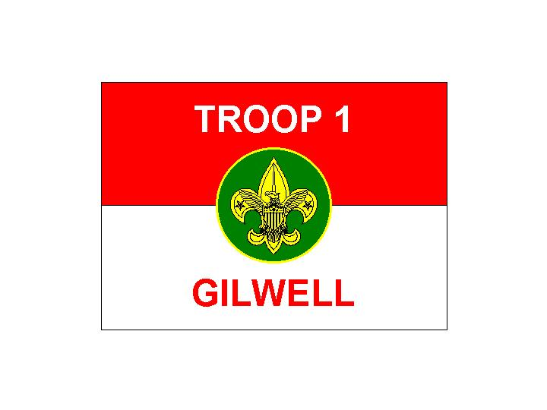
Gilwell Field
Cub and Webelos Adventure Camp
Heart of Virginia Council
Fort Ferguson
Our Fellow Scouters Quarters
TeePee Village
Mountain Cabins
Staff Quarters
Amphitheater
Patrol Cabins (PC)
Parking
To Route 6. – Maiden’s Road – To Route 632
Aspenwall House
Handicraft
To Boy Scout Camp T. Brady Saunders
Health Lodge
Staff Office
Gilwell Hall
Welcome Center
Castle
(Pool)
Private Residence
Welcome to
S7-602-11-1
Wood Badge for the 21st Century
Private Residence
Emergency
Gathering
Location

Camp T. Brady Saunders Map
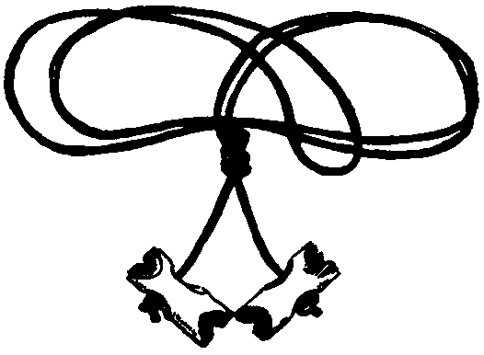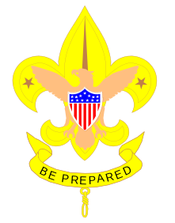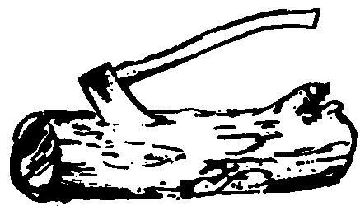
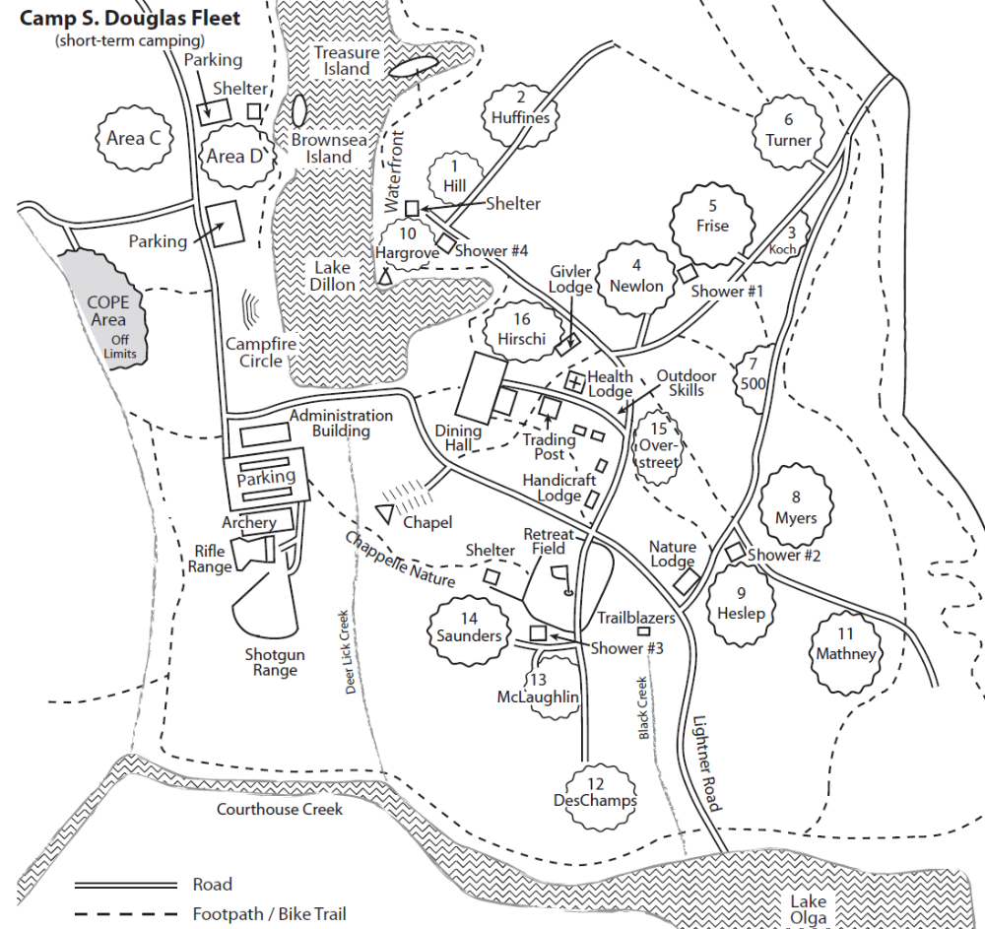
Emergency Gathering Location
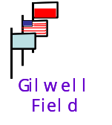
Gilwell Hall
Staff Camp
Patrol Camps
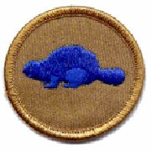 | 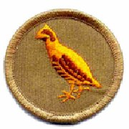 | 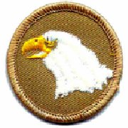 | 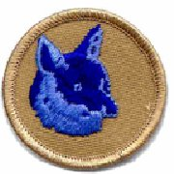 | 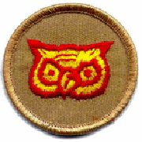 | 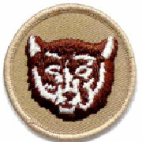 | 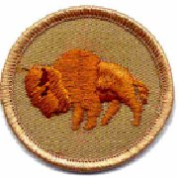 | 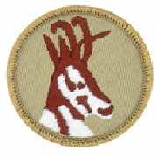
WOOD BADGE S7-602-11-1
“In every country the aim of Scout’s training is identical,
namely, efficiency for service toward others;
and with such an object in common, we can, as an international brotherhood of service, go forward and do a far-reaching work.”
—Baden Powell

Within My Power
I am not a Very Important Man, as importance is commonly rated.
I do not have great wealth, control a big business,
or occupy a position of great honor or authority.
Yet I may someday mould destiny.
For it is within my power to become the most important man
in the world in the life of a boy.
And every boy is a potential atom bomb in human history.
A humble citizen like myself might have been the Scoutmaster of a Troop
in which an undersized unhappy Austrian lad by the name of Adolph
might have found a joyous boyhood,
full of the ideals of brotherhood, goodwill, and kindness.
And the world would have been different.
A humble citizen like myself might have been the organizer of a Scout Troop
in which a Russian boy called Joe
might have learned the lessons of democratic cooperation.
These men would never have known that they had averted world tragedy, yet actually they would have been
among the most important men who ever lived.
All about me are boys.
They are the makers of history, the builders of tomorrow.
If I can have some part in guiding them up the trails of Scouting,
on to the high road of noble character and constructive citizenship,
I may prove to be the most important man in their lives,
the most important man in my community.
A hundred years from now it will not matter what my bank account was,
the sort of house I lived in, or the kind of car I drove.
But the world may be different, because I was important in the life of a boy.
—Forest E. Witcraft. Scouting magazine, October 1950.

Flag Ceremonies

Guidelines for Conducting Flag Ceremonies, Days One through Six

Preparations
At the Day One Gilwell Field Assembly, a staff color guard conducts the flag-raising ceremony, setting the tone and providing an appropriate model for subsequent flag ceremonies.
During the remainder of the Wood Badge course, the PROGRAM PATROL takes responsibility for the flag ceremony. That patrol will have had program responsibilities since the previous day’s Gilwell Field Assembly; that should give them time to plan and practice the ceremony, and to obtain the appropriate historic flag from the Friendly QM.
Lyrics of the songs associated with historic flags can be found in your course songbook.

Flag Raising Ceremony
After the senior patrol leader reports to the Scoutmaster, “The troop is formed,” the Scoutmaster replies, “Proceed with the flag ceremony.”
The senior patrol leader directs, “Program patrol, raise the colors.”
The patrol leader of the program patrol takes charge, calling “Troop atten -tion”. The color guard approaches the flagpoles and attaches the flags for raising. The patrol leader asks the troop members to make the “Scout salute” [color guard members holding a flag or rope do not salute], then instructs the color guard to “Raise the colors.” The U.S. flag should be hoisted rapidly. As soon as it is at the top of the flagpole, the patrol leader commands “Two.” The historic flag and flags of the Boy Scouts of America are also raised quickly.
The patrol then makes its presentation of the historic flag. Upon completion of the presentation, the historic flag and the Gilwell troop flag are raised rapidly to the tops of their flagpoles. Note that The Star-Spangled Banner and the Flag of 1818 are saluted, as they are still recognized as official flags of the United States of America. Official U.S. flags are saluted and other flags are not saluted.
The program patrol leads the group in singing a song associated with the historic flag [in the songbook], then returns to its position in the troop assembly.

Roles and Responsibilities

Role and Responsibilities of the Patrol Leader
- Take a leading role in planning and conducting patrol meetings and activities.
- Encourage patrol members to fully participate in the Wood Badge course and to achieve all they can.
- Represent the patrol as a member of the patrol leaders’ council (PLC).
- Set a good example by living up to the Scout Oath and Law.
- Practice using the leadership and team skills being presented during Wood Badge presentations.
- Ensure that daily patrol self-assessments are carried out in a timely, effective manner.
- Provide patrol members with all the resources and information they need to succeed.
- Empower the patrol to become the best it can be.
- See that the patrol is prepared for all course presentations and activities.

Role and Responsibilities of the Assistant Patrol Leader
- Assume the responsibilities of the patrol leader whenever the patrol leader is unable to do so.
- Encourage patrol members to fully participate in the Wood Badge course and to achieve all they can.
- Assist the patrol leader in empowering the patrol to become the best it can be.
- Set a good example by living up to the Scout Oath and Law.

Role and Responsibilities of the Patrol Chaplain Aide
In concert with all the chaplain aides, the patrol chaplain aide will
- Learn what resources are available that can be used for religious observances during the course, and make that information available to the rest of the patrol.
- Develop and help present the participants’ interfaith worship service.
- Assist in conducting any other religious observances that may arise during the Wood Badge course, including the interfaith worship service on Day Six of the course.
- Set a good example by living up to the Scout Oath and Law.

Role and Responsibilities of the
Patrol Scribe
- Provide interesting and timely material about the patrol to the publisher of The Gilwell Gazette—the daily newspaper of the course.
The Troop Scribe will hand out guidelines to help scribes fulfill their duties and may briefly meet with all the patrol scribes to discuss how best they can assist in making the Gazette worthwhile.
- Set a good example by living up to the Scout Oath and Law.

Role and Responsibilities of a Patrol Member
For a patrol to succeed as a team, each of its members must
- Fully participate in the Wood Badge course and achieve all he or she can.
- Practice using the team development skills introduced during Wood Badge presentations.
- Help his or her patrol meet its obligations to fulfill assignments including the development and presentation of the patrol project.
- Set a good example by living up to the Scout Oath and Law.
- Have fun!

Program and Service Patrol Responsibilities

Service Patrol
- Be responsible for the general cleanliness of the camp, especially for washing places, and meeting areas.
- Assist the quartermaster just prior to and after meals.
- Assist the quartermaster with the evening cracker barrels.
- Lay campfires, when requested, and extinguish the fires when done.
- Provide Leadership for the Day Five service project.

Program Patrol
- Conduct the flag-raising ceremony.
- As part of the flag-raising ceremony, present a brief history of the historic flag for the day and lead the group in a song associated with that flag.
- Lower the flags in the evening.
- Ensure that necessary equipment is on hand before the start of each training session, as requested by the staff member in charge.
- Provide leadership for the Day Four participant campfire.

DAY 1

Cub Adventure Camp

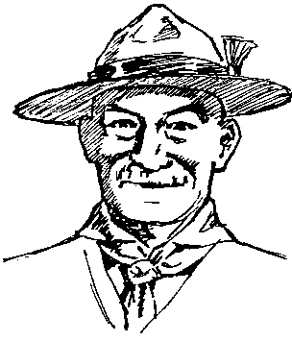

Wood Badge Course Schedule
Notes: We will be in the Field Uniform (normal Scout uniform) all day.
See the Gilwell Gazette for times and locations.
Day One
Participant Check In
Orientation, Team Formation
Opening Gilwell
Break
Course Overview (Pack Presentation)
Listening to Learn (Den Presentation)
Break
Opening Luncheon (Blue and Gold banquet)
Troop Meeting
Break
Patrol Leaders' Council Meeting
Values, Mission and Vision (and WB Ticket)
Patrol Meeting
Dinner
Who Me Game (Patrol Activity)
Instructional Campfire (Troop Presentation)
Cracker Barrel

Check in, Orientation, Team Formation

We gather together for the first time to:
- Form teams that will stay together throughout the course.
- Meet the staff member assigned to your team.
- Enjoy several brief and entertaining get-acquainted activities.
- Locate the course facilities, meeting places, and other relevant landmarks.
- Understand emergency procedures.
- View the staff exhibit, both to gain from the material being presented and to see a model presentation of the sorts of exhibits you will later prepare yourselves.
- Have FUN!

Cub Pack
We gather as a Cub Pack to review Cub- and Webelos-related information. However, you’ll be involved much like a new Cub would be. That is, you’ll be thrown into a (well planned) mêlée that that includes fun activities.

Staff Exhibit
The staff exhibit illustrates the various programs that make up the family of Scouting. This exhibit is a model of the exhibits that patrols will be creating later in the program. It sets a high standard for what is acceptable in the development and presentation of an exhibit.

Gilwell Field Assembly

Everyone (even staff) are excited to be here! Where is ‘here’? Gilwell Field! It is one of the many key traditions that we uphold to link our modern traditions to the long and rich heritage of Wood Badge. Gilwell Field was the home of the very first Wood Badge course, and that it serves as a symbol linking all Wood Badge courses through the years and throughout the world. We’ll also see a model flag ceremony—a serious ceremony that you will want to participate in yourself. We model the best ‘duty to country’ that Scouting can offer.
This morning’s assembly is suited to Cub Scouts, for that is what you are. We use the Cub Scout salute, and, with the Cub Scout sign, recite the Cub Scout Promise and the Law of the Pack.


Historic Flag Presentation

The Continental Flag
When the Revolutionary War broke out, the colonists felt the need for a new flag.
And so, on the first day of January 1776, what was called the Grand Union Flag was raised over George Washington’s headquarters in Massachusetts. The Union was the same as that of the Queen Anne Flag, but six stripes broke the red field into seven red stripes. Now the proper name for the flag is the Continental Flag.
Let us honor it by singing about the men over whom it was first hoisted.
AMERICA
My country ‘tis of thee
Sweet land of liberty
Of thee I sing;
Land where my fathers died,
Land of the pilgrims’ pride,
From every mountainside,
Let freedom ring.

Course Overview

Learning Objectives
We aim to:
- Understand the progression of BSA training opportunities and the place Wood Badge holds in that framework.
- Get an overview of the practical and application phases of Wood Badge.
- Understand why the Patrol Method in a Boy Scout troop is used during Wood Badge as the model for training and team building.
- Discard any misconceptions or anxiety regarding the course purpose, content, and methods of presentation.

Scouting and Leadership Training
The quality of the Scouting experience for Cub Scouts, Boy Scouts, Varsity Scouts, and Venturers depends upon the quality of those leading the units and those working in the districts and councils throughout the nation. The BSA offers leaders a progression of training opportunities to give them the skills they need to provide leadership for Scouting and leadership for America.
Here’s how it works.
- Fast Start, Youth Protection. Provides an online introduction to the Scouting organization and safety.
- New Leader Essentials. This is an overview of the mission, vision, and values of the BSA, and an introduction to each of the Scouting programs.
- Leader-Specific Training. Contained in this training are the nuts and bolts of specific positions in Scouting. Adult leaders can learn how best to fulfill their particular leadership roles in Cub Scouting, Boy Scouting, Varsity Scouting, or Venturing, or as district or council Scouters involved with multiple Scouting program areas.
- Appropriate Outdoor Skills Training. Training opportunities are targeted to enhance the outdoor skills needed by leaders in Scouting’s various programs.
- Wood Badge. The BSA’s ultimate leadership training for adults, Wood Badge offers a six-day immersion in the theory, practice, and experience of appropriate skills for leading others within Scouting and in many environments beyond the BSA.
- Lifelong Learning. There are numerous opportunities for continuous learning and supplemental training within the Scouting organization—roundtables, pow wows, COPE courses, Scouting’s publications, special courses tailored to specific program areas of emphasis, etc. Lifelong learning is further enhanced when adults accept the challenge of teaching skills to others.
The front end of this, the progression of BSA training, is skills-oriented. In the middle, the emphasis is on leadership. After that, the focus is on advanced skills that require leadership.

What Can You Expect From a
Wood Badge Course?
As a result of attending Wood Badge, the participants will:
- Acquire a global view of Scouting as a family of interrelated, values-based programs providing age-appropriate activities for youth.
- Become familiar with contemporary team leadership concepts.
- Experience the stages of team development and practice leadership approaches appropriate for those stages.
- Have great deal of fun in the company of interesting, like-minded individuals.
- Develop a renewed commitment to provide Scouting with the best possible leadership.
Note: The five central themes of Wood Badge are represented in the Wood Badge icon. The icon is in the shape of a pentagon around the BSA fleur-de-lis. Each side of the icon represents one of the five central themes of Wood Badge. Likewise, each of those themes is represented on the icon and throughout the course by one of the five colors of the MacLaren tartan. The themes are the threads of a course which, when woven together, form the pattern of the tartan and the full measure of Wood Badge.
Wood Badge accomplishes these goals by building all the pieces of the course on a foundation of five central themes. Those themes, and the presentations that directly support them, are as follows:
- Living the Values. Values, Mission, and Vision; Joyful stewardship and gratitude.
- Bringing the Vision to Life. Listening to Learn; Communication; Leveraging Diversity through Inclusiveness; Coaching and Mentoring; Generations in Scouting.
- Models for Success. Stages of Team Development; The Leading EDGE ™; The Teaching EDGE™.
- Tools of the Trade. Project Planning; Leading Change; Problem Solving and Decision Making, Managing Conflict, Self Assessment
- Leading to Make a Difference. Leaving a Legacy

Using the Troop Format
Wood Badge is designed to be as valuable to leaders involved with Cub Scouting, Varsity Scouting, and Venturing as it is to those primarily involved with the Boy Scout program.
Participants begin a Wood Badge course as Cub Scouts. The pack format is used initially, with the Cubmaster doing the leading and den chiefs assisting with the learning and activities. When participants bridge over at the blue and gold luncheon today, the troop format will be incorporated, with the Scoutmaster mentoring the senior patrol leader while the senior patrol leader takes over management of the troop. The troop guides will aid with instruction and the ticket. Later on in the course, as the patrols advance in rank and no longer need a troop guide, the troop guides will become part of the Venturing program. But for the bulk of the course, participants and staff will consider themselves to be members of Gilwell Troop 1.
A troop setting provides a good framework to practice the leadership skills introduced during the course. Be assured, though, that the course content and leadership principles will be applicable to Scouters working throughout the movement and will provide a common foundation of leadership skills to be used in all program areas.
There will be three troop meetings during this course, one on each of the first three days. These represent three weeks in the life of a Scout unit. The final portion of the course—the outdoor experience—parallels the sort of activity a Scout troop, a Cub Scout pack, a Varsity Scout team, or a Venturing crew would build toward for the final week of a month long program.

The Gilwell Gazette and the Wood Badge Handbook
As the Wood Badge course progresses, participants will find that they are being provided with a great deal of information, both through presentations and through resource material explaining what is happening and why.
Teams can develop most efficiently when they have full access to resources.
The Gilwell Gazette is the newspaper of the Wood Badge course. It is distributed each morning, with the intent of letting participants know as much as possible about the inner workings of the course. In it participants will find the schedule of events for the day, interesting stories about people and activities, articles submitted by patrol scribes, and lots of material that relates to the operation of the course.
The Wood Badge Handbook is the detailed information behind all the sessions. It’s meant to also be resource you will want to go back to, including after the course.

Patrol Project
Earlier in the day, everyone saw the exhibit developed by the course staff. At the patrol leaders’ council meeting after lunch, each patrol will be tasked to plan and produce a project of its own.
The project must illustrate “best practice solutions” to an issue relevant to all four program areas: Cub Scouting, Boy Scouting, Varsity Scouting, and Venturing. It must consist of a self-explanatory display and an oral presentation. Patrols will present their projects to the rest of the troop on the fifth day of the course.

Wood Badge Ticket
One of the great traditions of Wood Badge is the ticket. In Baden-Powell’s day, those in the military were expected to pay their own way back to England at the end of their service. To economize, soldiers nearing completion of their duties would seek assignments at posts increasingly close to home—a process known as working your ticket.
During this course, participants will be asked to develop a ticket—a list of goals that will allow them to use their new leadership skills in ways that strengthen Scouting in their home units, districts, and councils. Details of the ticket process will be discussed today at the patrol leaders’ council meeting and during the Values, Mission, amid Vision session.
Wood Badge Ticket is
- A commitment to complete goals relating to your Scouting position.
- An opportunity to practice and demonstrate a working knowledge of the leadership skills presented during Wood Badge.
- A chance to strengthen Scouting in your unit, district, and council.
- An opportunity for personal growth.

Summary
BSA training opportunities enhances leadership for Scouting and for America.
A Wood Badge course is the pinnacle of leadership training for Scouting’s adult leaders. The curriculum of a Wood Badge course is built around five central themes:
— Living the Values
— Bringing the Vision to Life
— Models for Success
— Tools of the Trade
— Leading to Make a Difference
- Wood Badge is appropriate training for adults involved with Cub Scouting, Boy Scouting, Varsity Scouting, or Venturing. The Boy Scout troop format provides a practical framework for much of a Wood Badge course.
- An essential requirement of every Wood Badge course is for participants to have fun.

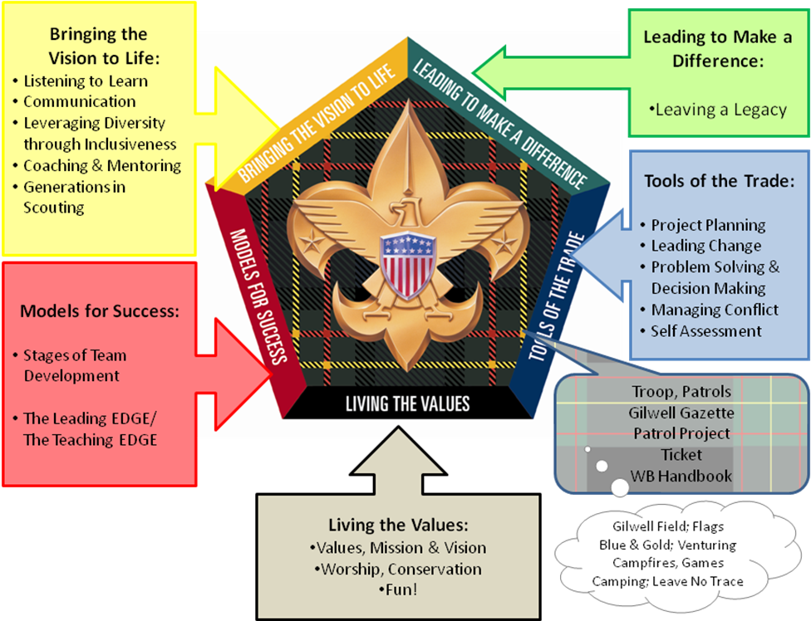

Values, Mission, and Vision

Values are core beliefs or desires that guide or motivate our attitudes and actions. Values can take a variety of forms. For example:
- Principles or Standards
- Personal Qualities
- Character Traits
- Codes of Ethics
Scouting’s Values:
The Scout Oath and Law
A mission is a brief statement that reflects the core values of an organization and communicates the organization’s long-term objectives—why the organization exists. Routinely, an organization’s mission is formalized in a mission statement.
A mission statement
- Serves as a communication tool inside and outside the organization.
- Aligns people with a purpose and fosters commitment and unity.
- Defines directions for change and growth.
- Acts as an evaluation tool to help measure decisions, activities, and programs.
The mission of the Boy Scouts of America is to prepare young people to make ethical and moral choices over their lifetimes by instilling in them the values of the Scout Oath and Law!
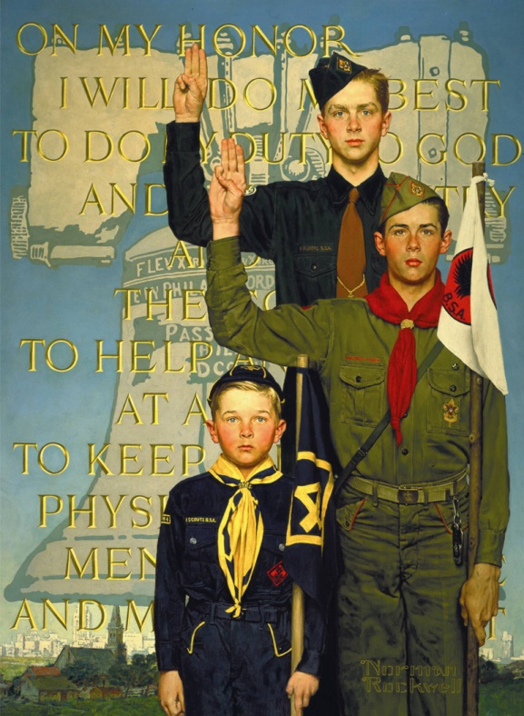
A vision is a picture of future success.
A vision forms when we think far enough ahead to realize there will be important challenges that we can prepare for now, perhaps by doing something as simple as planting a few acorns.

“Nothing happens unless first a dream!”
—Carl Sandburg

Criteria for a meaningful Vision:
- A vision engages the heart and spirit.
- A vision leads toward a worthwhile goal.
- A vision gives meaning to an effort.
- A vision inspires action.
- A vision is simple.
- A vision is attainable.
- A vision can change across time.
Effective leaders have the capability to create compelling vision, but they must also be able to translate that vision into reality. This is not easy. It requires effort, including self examination.
Vision statement:
The Boy Scouts of America will prepare every eligible youth in America
to become a responsible, participating citizen and leader
who is guided by the Scout Oath and Law.

Values: What we believe in and
how we will behave
Mission: Why we exist
Vision: What success looks like
Goals: How we will get there

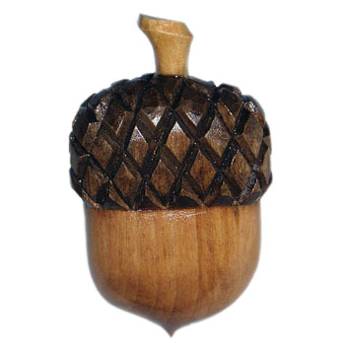

Guidelines for Writing a Wood Badge Ticket

A primary purpose of the Wood Badge experience is to provide leadership for Scouting and leadership for America. Your ticket is a commitment to complete a set of goals that will significantly strengthen the BSA program in which you are involved. Additionally, the ticket provides an opportunity for you to practice leadership skills that will be of value in many areas of your life, both within and beyond Scouting.

Three parts of a ticket
A ticket consists of three parts:
- A description of your Scouting role
- A statement of your vision of success
- A plan of action composed of five significant goals that can be attained within 18 months.
- At least one goal must incorporate some aspect of diversity.
The goals will be written in support of your current Scouting responsibilities and should be designed to provide maximum positive impact for youth membership.

Specifying your role
If you have more than one position in Scouting, initially write down all your current Scouting positions. Consider the whole picture. Then, you’ll need to specify the one position on which you want to write your Wood Badge ticket. When deciding which position to use, think about the positions in which you can most affect the lives of youth. Consider your training or training you may need. It may be helpful to confer with your group leader to review your role so that you understand what responsibilities you have. Write down the one group that you are going to work with as you work your ticket. This group may be your pack, troop, crew, district, council, roundtable, etc.
Bottom line:
Chose one position in Scouting and specify the group who will benefit from your leadership.

Formulating a meaningful vision
Read over your answers to the “Twenty Questions” that you were sent prior to the course. Then do the following: Write down some words that describe your values—the things that are important to you, the things that help set your priorities in life. Now, think about why you are in Scouting, what motivates you to remain involved in Scouting, and why you are at Wood Badge. Write down a long-term image that you have for yourself in Scouting—What does success look like? It may also help to refer back to Values, Mission, and Vision section of the Wood Badge Handbook, including Scouting’s Mission Statement.
Bottom line:
Your ticket will we guided by your values,
the organization’s mission, and your vision
of success in your role.

Realization of your vision
Taking steps in the right direction is what’s important. You should not expect that you will realize your vision immediately upon completion of the five goals; reaching your goals is an initial part of a long-term work in progress.

Using Skills to achieve goals
The key to making the skills you’ve learned a part of your leadership style is to practice using them. It is assumed that you will use many of the skills you learned during the Wood Badge course. In writing your ticket it will help if you list the skills you can use to accomplish your goals. It is not required that you incorporate all of the skills presented during the course into your goals.

Diversity
There are many ways to incorporate some aspect of diversity. Possibilities include goals that promote diversity in units, districts, and/or councils; that encourage a more diverse BSA membership; of that help young people better understand the nature and importance of diversity in Scouting and in America. See the section on “Leveraging Diversity through Inclusiveness.”
If you wish, one of the five goals may involve developing and applying a self-assessment tool to measure your progress and effectiveness in relation to the other goals on your ticket. See the section on“Self-Assessment”.

Goals must be SMART
Describe each ticket goal in enough detail so that you and your ticket counselor know specifically what is to be done; how it will impact those you lead; any why it fits in with your vision. You’ll want it to be challenging and do-able within 18 months.
Specifically, the goals written for your ticket should be SMART:
Specific - Describe this goal in enough detail so that you and your ticket counselor know specifically what is to be done; how it will impact the program. Is it challenging?
Measurable - Describe how this ticket goal is measurable. How will you know when the goal has been accomplished?
Attainable - Describe how this Ticket Goal is Attainable. Can it be accomplished?
Relevant - Describe how this Ticket Goal is Relevant. How is this ticket goal relevant to your vision of success in your primary Scouting position?
Timely - Describe how this Ticket Goal is Timely. Can it be accomplished in a reasonable amount of time?
“A Goal Without a Deadline
is Only a Dream!”
An effective way of defining your ticket goals is to use the Who, What, Where, When, and Why steps. By describing each step for each goal, you can be assured that you will have a well-defined ticket goal. Then, after you have completed your ticket goal, perform a self-assessment to evaluate your goals. This is a good time to review your goal with your troop guide or ticket counselor.
- For each goal, you will also indicate
Who - Who is involved?
What - What, specifically, will you do to help realize your vision through this goal?
Where - Where will you work on the goal?
When - When will you work on the goal?
Why - Why is this goal important to realizing your vision?
How measured - How do you measure the completion of your goal?
How verified - How do you verify whether your goal helped to achieve your vision?
Think WWWWWHH
so each is a SMART goal

Support
The troop guide assigned to your patrol will help you prepare your ticket and will approve it when it is completed. You will be assigned a Ticket Counselor to help you in the completion of your ticket.
Upon returning home after your Wood Badge course, you will work with your ticket counselor. You will meet with your counselor to finalize your ticket and establish a review plan for completion.
The five goals of the ticket must be completed within 18 months of the end of the Wood Badge course.

Success!
When you and your ticket counselor have agreed that you have fulfilled all the items on your ticket, the following course of action should take place:
Your ticket counselor will:
- Submit your Wood Badge completion form to your council.
- Verify with your council that the form has been received and that your regalia is available.
- Arrange with you when you would like to have your “Beading Ceremony”.
It is appropriate to hold this ceremony is the area where your ticket was worked. For example; if you are a Cub Scout leader a pack meeting, Cub Scout Roundtable, or a ceremony where you invite family, friends, and fellow Scouters would be appropriate. A similar format would hold true for all others working at the unit level. For District or Council positions, a District or Council Dinner or recognition event (with approval of the appropriate executive) would be appropriate for you.
Your ticket counselor can help you arrange your ceremony and can enlist staffers to present your regalia to you. If you have specific people in mind to participate in your ceremony, let your troop guide know. A sample Wood Badge Ticket Ceremony is available.

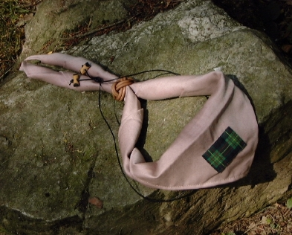

Listening to Learn

Patrol, welcome home to your own private space! Let’s settle in and do the following:
- Become aware of how we listen
- See how good listening works as a communication skill
- Practice active and empathetic listening
- Get some tips on how to receive and give feedback

Listening is…
- An essential part of communication
- Not taught in school
- A skill that can be learned

Why is Listening a Key Skill
of Leadership?
- Connecting
- Decision Making
- Problem Solving
“Seek first to understand,
then to be understood.”
—Stephen Covey

Two Parts of Effective Listening
- Active Listening
- Empathetic Listening

Active Listening Requires…
- Rephrasing and Confirming
- Nonjudgmental Attitude

Empathetic Listening Requires…
- Putting oneself in the speaker’s place
- Imagining the speaker’s viewpoint
- Understanding the speaker’s feelings

Monitoring Our Listening Level
- Awareness
- Adjustments
- Powerful Tools

Listening in Adversarial Situations
- Nonjudgmental
- Productive Framework
- Positive Conversation
Listeners should always strive to create a positive present
as opposed to a negative past.

Giving and Receiving Feedback
- Can be difficult
- Basic part of team development, leadership, and friendship
- Both parties must use effective listening

Tips on Giving Feedback
- Is it helpful?
- Do others want it?
- Can it change a behavior?
- Is it specific?
- Does it describe behavior?
- How does it impact you?
- Does it contain an “I” statement?
- Did the recipient understand what you said?
You can give caring feedback without a good technique,
but the slickest technique
in the world will
not hide a lack of caring.

Tips on Receiving Feedback
- Seek out feedback.
- Listen carefully.
- Listen actively.
- Listen empathetically.
- Monitor your emotions.
Consider feedback to be a gift.
It truly is one.

Effective Listening
- A learned skill
- Important to relationships and problem solving
- Active and empathetic
- Turns a negative situation into a positive one
- Give and receive feedback

Blue and Gold Banquet

Most Cub Scouts celebrate Scouting Anniversary Week in February with a “birthday party” called the blue and gold banquet. In nearly all packs, the blue and gold banquet is the highlight of the year. It brings families together for an evening of fun.
The purpose of the blue and gold banquet is to celebrate the pack's anniversary, thank pack leaders and other adults who have helped the pack, and inspire the leaders, Scouts, and parents. Packs often like to invite former members and other Scouting or community leaders to take part in their blue and gold banquet.
The banquet can be like a regular pack meeting, with songs, skits, stunts, and awards. Or it can be something different and a little more special.
Aside from that, why are we here?
- Experience a blue and gold banquet
- Become more acquainted with other Scouters, course staff, and visitors
- Learn about the traditions of Wood Badge
- Cross over into Boy Scouts and become patrols
- Understand the responsibilities of the service and program patrols

Webelos-to-Scout Bridging Ceremony
Scouters will make the transition using a brief and simple ceremony. The ceremony could include four candles but certainly includes a footbridge. It might go something like this:
Cubmaster: Today you are taking a giant step—from Cub Scouting to Boy Scouting.
Today we will be talking about the colors of the four winds and the meaning they have for us. Remember what is said today, and let the winds continue to guide you along the Scouting trail.
(Lights the blue candle.)
Blue stands for the Cub Scout spirit and the north wind. You are a true-blue Cub Scout and live up to the Law of the Pack. It brings you only the warmest of winds.
(Light its time yellow candle.)
Yellow stands for the south wind that carries the story of your achievements far and wide. As a Cub Scout you have been eager, fair, and a credit to your den and pack.
(Lights the white candle.)
White stands for the east wind and the spirit of Scouting. The east wind carries the story of fun and happiness to your Scout troop and tells others how you live up to the Cub Scout Promise.
(Light the red candle.)
Red stands for the west wind and represents your family. In Cub Scouting, your family helped guide you along the trail. They will go with you into Boy Scouting, but now it is you who will lead the way.
Scoutmaster: Hello, Webelos Scouts of Akela, what do you desire?
Cubmaster: Your answer is,
“We want to be Boy Scouts.”
Scouts: We want to be Boy Scouts.
Scoutmaster: Then prepare to cross the bridge.
Cubmaster: Congratulations! We have been proud to have you as a member of this Cub Scout Pack and we wish you well in Boy Scouting. As you cross the bridge, we’ll give you the Cub Scout handshake one last time. Your Scoutmaster and senior patrol leader await you on the other side. Please cross over by dens.
Scoutmaster: (After each den has crossed over the bridge)
Welcome to Boy Scouting. You are now members of the __________________ Patrol. May I present you with your temporary patrol flag.
(After all the dens in the group have crossed over)
Later today each of you will be inducted into membership in Gilwell Troop 1 and presented with your troop neckerchief. Wear it with pride as many have done before you. Your senior patrol leader now wishes to express the troop’s pleasure in having you as a member.
Senior patrol leader leads the troop in a cheer for the new Scouts.
Scoutmaster: Cubmaster ___, would you be willing to join Troop 1 as an Assistant Scoutmaster?
Cubmaster: Thank you, I would love to be a part of Troop 1. Scoutmaster,
I turn the program over to you.

Wood Badge Traditions

There are many traditions that unite our course with all other Wood Badge courses—past, present, and future—all around the world. Chief among these are:
Gilwell Field. Baden-Powell held the first Wood Badge course at Gilwell Park near London. To this day, Gilwell is considered the international home of Wood Badge. Wherever on the globe a course takes place, the main assembly area is known as Gilwell Field.
Ax and log. The ax and log is the totem of Gilwell Park. The ax is the symbol of the English freeman. Whereas serfs could only gather wood from the forest floor, a freeman was given the right of loppage. Earned as a right by service, a freeman could cut limbs from the nobleman’s forest as high as they could reach with an ax. The ax became the badge of a freeman.

MacLaren tartan. In 1919, a Scotsman named W. F. de Bois MacLaren, a district commissioner for Scouting in Scotland, purchased Gilwell Park and presented it to the British Boy Scout Association. He explained that one of his purposes in doing so was “to provide a training ground for the officers of the Scouting movement.” In perpetual appreciation for his generosity to Scouting, Wood Badge adopted the tartan of the MacLaren clan. It is this tartan that appears on the Wood Badge neckerchief.

Wood Badge beads. In 1888 during a military campaign in Africa, Baden Powell acquired a necklace of wooden beads from the hut of a warrior chief named Dinizulu. Years later at the conclusion of the first Wood Badge course, Baden-Powell gave each course graduate a bead from the necklace. The “Wood Badge” program takes its name from those beads. Since then, more than 100,000 Scouters worldwide have completed Wood Badge courses and can wear replicas of the original wooden beads.
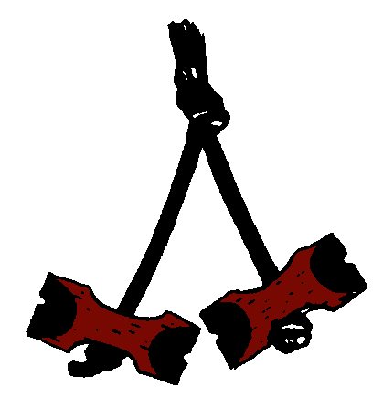
Neckerchief and woggle. Held in place by a leather woggle, the Wood Badge neckerchief—tan with a patch of MacLaren tartan—may be worn by course graduates. Wood Badge beads, neckerchief, and woggle may be worn only with the official field uniform of the BSA.
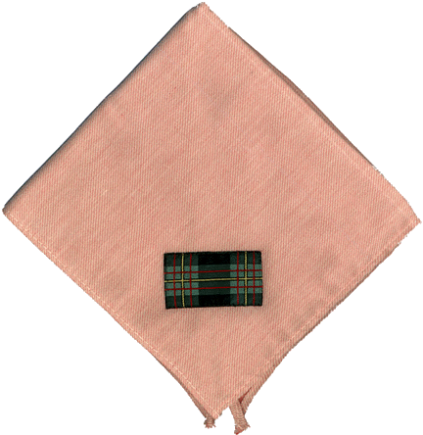
Kudu horn. During his military service in Africa, Baden-Powell observed members of the Matabele tribe blowing on the horn of a kudu to signal to one another. He brought a kudu horn back to England with him, and in the summer of 1907 when he held his first experimental camp on Brownsea Island, Baden Powell sounded the horn to assemble his campers. The same horn was entrusted to Gilwell Park in 1920 for use in Scout training courses. Since that time, the kudu horn has been a symbol of Wood Badge courses throughout the world.
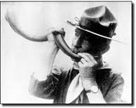

Service Patrol and Program Patrol Responsibilities
Each day, one patrol will act as the service patrol and one patrol will be the program patrol. These duties are Wood Badge traditions and not necessarily part of a typical Troop’s operation. The period of service will extend from the morning’s troop assembly on Gilwell Field until the following morning’s assembly. (The exception will be Day One, when the service and program patrols assume their duties during this lunchtime presentation.)
The patrol leader notebook contains information on what is expected of the service and program patrols, and a roster listing the patrols assigned to be the service patrol and program patrol for each day of the Wood Badge course.
Service and Program Patrol Symbols
The senior patrol leader will ask a member of the Day One service and program patrols to come forward to receive the symbols of office for those patrols.
• Service patrol symbol—a small shovel
• Program patrol symbol—a large set of beads
Encourage patrols to decorate the symbols in their keeping. Before they relinquish the symbols to the next day’s service and program patrols, they may wish to attach some version of their totems, although they are free to devise any decoration of their own choosing.
And, the final tradition of Wood Badge:
Gilwell Song. The Gilwell Song has been sung by generations of Wood Badge Scouters—always energetically, but with wildly varying degrees of harmonic success.

Back to Gilwell
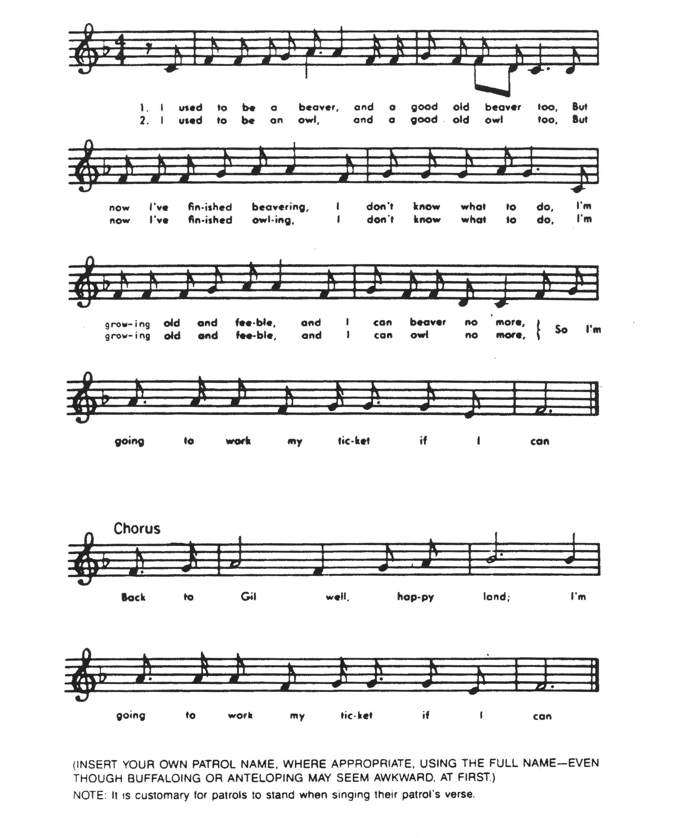
Beaver | Bobwhite | Eagle | Fox | Owl | Bear | Buffalo | Antelope

Notes and How to Keep ‘em

Did you ever hear a really great idea that you wanted to use with your Patrol or troop—and then discovered that when you needed it you couldn’t remember the details? It happens to all of us! So, taking notes of good ideas is important.
There is nothing hard or complicated about taking notes. Remember that they are for your personal use and you’ll soon work out your own way of doing it. Here are some ideas that may help.
- Don’t try to write everything down. Just note the key words with enough detail so you’ll be able to recall what you saw or heard.
- Do write down enough information. It’s frustrating to read the words “paper plate gimmick” in your notes and you can’t remember what the wonderful gimmick was.
- Use the outline form. It’s a good way to organize your notes. This sheet is written in a simple type of outline form—numbered items. A more detailed system starts with major topics, then the details are filled in. Numbers and letters keep things sorted out. Here’s how this sheet would look in outline form.
I. Notes and how to keep ‘em
A. Notes help you remember details.
B. Taking notes of good ideas is important
C. Note-taking isn’t complicated
1. They’re for your own use
2. Work out your own system.
D. Helpful hints
1. Don’t write everything down.
a. Note key words
b. Add details to aid recall.
II. Write down enough information
III. Use the outline form.
A. Good way to organize notes
B. List of numbered items is simplest
C. Outline starts with major topics
D. Details are then filled in.
E. Numbers and letters are used.
Get the idea?
IV. Finally, go over your notes before they get “cold” and be sure you got everything. Fill in more detail if needed. When you go over them ask yourself, “Will I be able to remember the main points that I want to remember in a week or a month by reading the notes over again?” Then keep ‘em handy and use ‘em often. They’ll be your most valuable resource.

V. Use sketches. You don’t have to be an artist. Here are some simple examples:

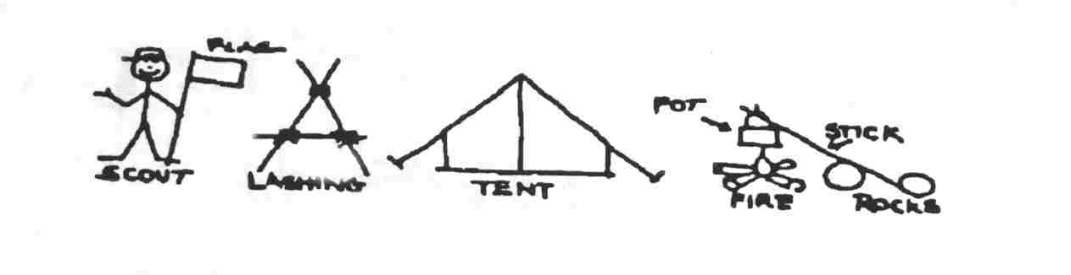

Turk’s Head or Woggle Neckerchief Slide
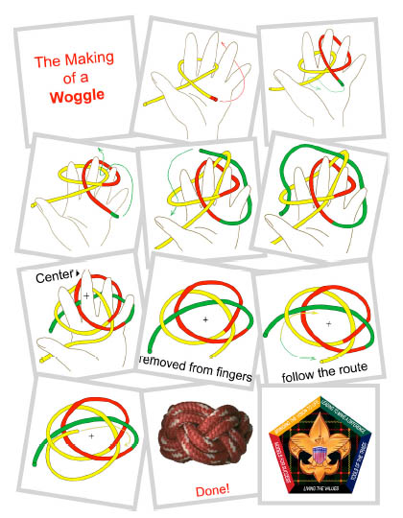
2 Strand x 4 Bight Turkshead Woggle

Aims of Scouting Worksheet
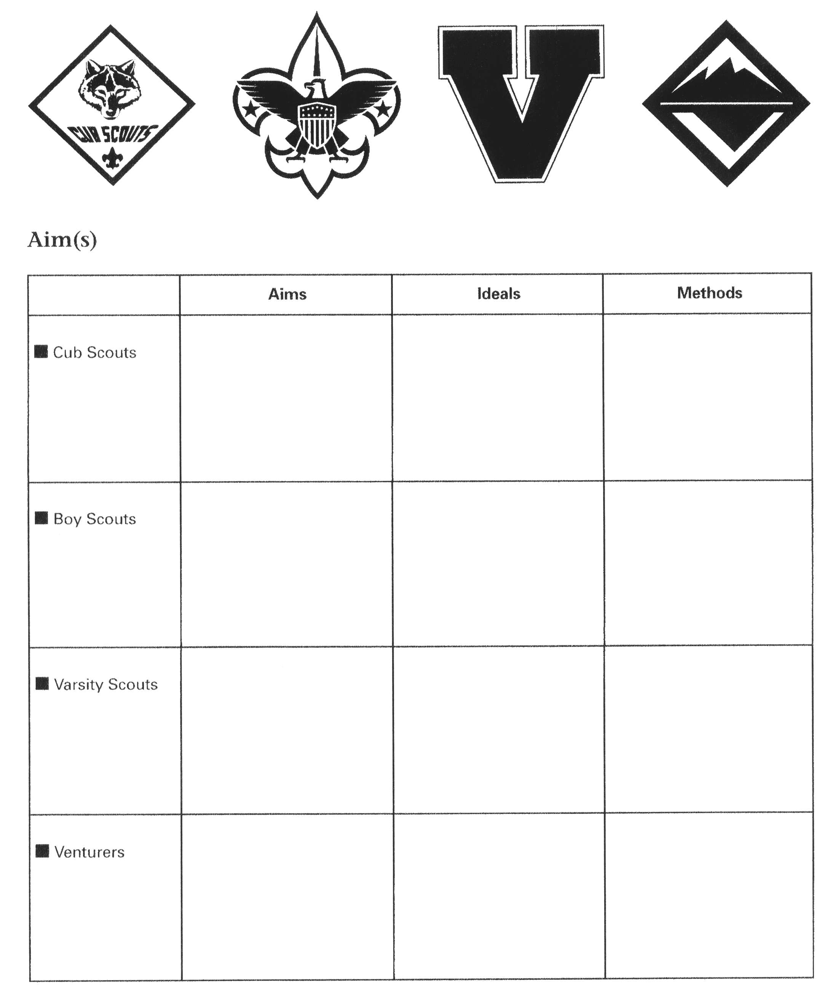

Daily Patrol Self-Assessment Form

The assessment process is meant to provide members with hands-on experience in making assessments. It may also give you fresh insights into ways that the patrol can more effectively develop into a high-performance team. An effective way to evaluate performance is to use the Start, Stop Continue evaluation tool for the daily patrol self assessment.
The Start, Stop, Continue (SSC) tool is used for a variety of purposes. In the process of developing your Patrol, it will be very helpful to assess team interaction and to modify actions and behaviors to move you towards a stronger performing team. Here is a brief outline of the steps to follow in using the Start, Stop, Continue worksheet.
Think about your patrol’s activities for the day. Think about what you are doing as it pertains to actions within both your Patrol and in the Troop. Ask yourself these questions:
- In our patrol, what should we put in place to improve?
(Something we should START.)
- In our patrol, what is not working?
(Something we should STOP.)
- In our patrol, what is working well?
(Something we should CONTINUE.)
Before, during, or after an activity you can always stop and check how it’s going by using the SSC tool. (Perhaps you know this tool by another name: Thorns, Roses, and Rosebuds.)
A key to effective team development is self assessment—regularly measuring the enthusiasm and skill level of the group. The daily self–assessment encourages course Scouters to do just that.
The Daily Patrol Self-Assessment takes place each morning during or just after breakfast. Members use the following discussion points to assess their patrol’s activities of the previous 24 hours.
The evaluation is discussed only within the patrol. It is not shared with the patrol leaders’ council or the rest of the troop.
A copy of each day’s assessment form should be kept in the Patrol Leaders Notebook for future reference.

Fact: Your Boy Scouts learn to use Start, Stop, Continue in Buckskin Leader Training!
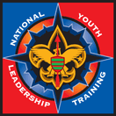

Start, Stop, Continue Worksheet
Category | Assessment
Start | In our patrol, what should we put in place to improve? (Some things we should START)  1.  2.  3.
Stop | In our patrol, what is not working? (Some things we should STOP)  1.  2.  3.
Continue | In our patrol, what is working well? (Some things we should CONTINUE)  1.  2.  3.

The Art and Skill of Creating a Totem

Creating a totem is a method by which members of a Wood Badge patrol can have a distinguishing symbol for themselves and their patrol. The totem becomes a life long identifying characteristic of the patrol that all members can use as a reminder of their time at Wood Badge Troop 1.
A totem is unique to a particular patrol. It is unlike any other totem, even those for patrols with the same name. For example, not all Beaver totems are the same, but they all have symbols that reference a Beaver while differing in design.
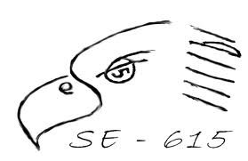
The totem is to be one which all members of the patrol can easily reproduce on their own from memory It should not require any special artistic talent or equipment Simplicity and creativity in design are important elements to keep in mind when designing a totem. The totem design incorporates the Wood Badge course number, and represents the patrol animal or bird. Some totems also include a part that is unique to each individual patrol member. The totem for your patrol should be presented to your Troop Guide for review and guidance.
When the practical phase of your Wood Badge training is completed the totem will be with you for the remainder of your Scouting career. It is not something that is changed or modified after the course. Your fellow patrol members will expect you to maintain the totem you created as a patrol in its original form.
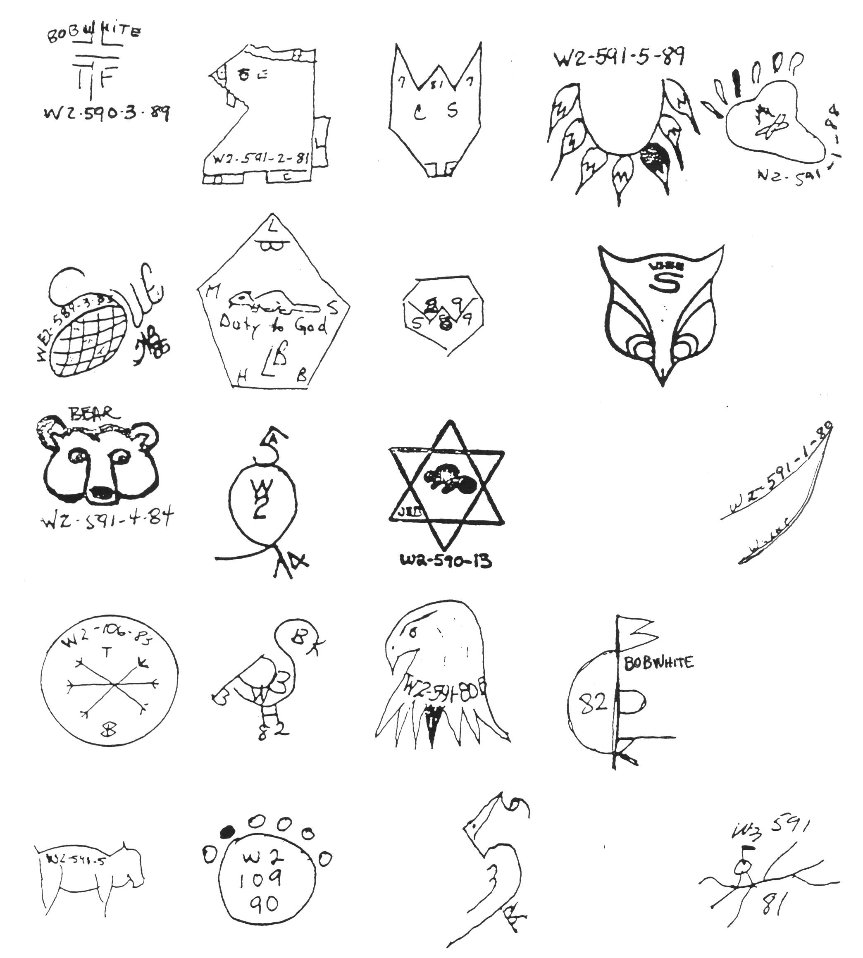

Introduction to Campfires

Campfire programs are a part of the great game of Scouting. Planning and directing a campfire develops leadership skills, performing with fellow scouts fosters friendship, understanding, and team skills, and the content can inspire positive character traits and citizenship in participants and audience members alike.
To win this part of the game of Scouting, there are some very basic “do’s” when planning a campfire program with youth.

Plan
This is the key to a successful campfire. Everyone knows their part and the material can be vetted if the program is laid out in advance. An easy way to schedule the entertainment is to “follow the flames”: in the early part of the evening when the flames are big and bright, the performances should be too. As the fire dies down, the program should calm and become more meaningful as the embers glow. Use interfaith openings and closings – unless your group consists of adherents to one faith, choose prayers that have a universal message, not a specific doctrine.
Sandwich this program between a ceremonial lighting of the fire and a BSA approved extinguishing and get ready to have an evening your scouts will be talking about until the next amazing campfire!
A campfire program planner like the one at the end of this section can help the director of your campfire put all the pieces together.
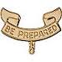

Use
A successful campfire is built on the four S’s:
- Showmanship – the presentation of the program, especially the enthusiastic attitudes of the performers, the location and the atmosphere make the campfire shine.
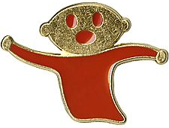
- Stunts – aka “skits”, will mostly be funny but can also teach or inspire.
- Songs – action, audience participation, Scout, inspirational, and silly; songs can set the tone of that portion of a program.
- Stories – Ghost stories are a traditional favorite, but must be considered carefully for gory descriptions and excessive fright value. Adventure, humor and heroic stories are better options to consider.
Including these elements in your campfire provide the fun and entertainment your Scouts are looking for.

Guidelines
The Scout Law, especially the points friendly, courteous and kind. If the material your Scouts want to perform doesn’t meet those criteria, ask for an alternate. In general, topics of religion, politics, and mental or physical abilities should be avoided. There’s nothing humorous or entertaining about these issues. Additionally, for the target there’s rarely anything funny about being doused in water or any other kind of even pretend bullying behavior. Inside jokes can be funny, but only to the few people who were there and can leave the rest of the audience feeling left out and bored. Material about bodily functions, toilet humor, and the use of drugs, alcohol, and tobacco are simply inappropriate as are cross gender impersonations for the sake of lampooning members of the opposite sex.

Prepare
Make sure the performers rehearse their parts. Public speaking and performing are stressful situations which can be eased by simply following the Scout motto: Be Prepared. Not only will this benefit the performers but it creates a better experience for the audience as well.
Have a backup plan in case issues arise that prevent the building of an actual fire. Be ready to recognize guests and new campers by including them in an opening or lighting ceremony to symbolize their joining the group.
Sometimes, even when we plan our campfire, building it to include a variety of positive entertainments, using the Scout Law as our test of appropriateness, and preparing carefully, offensive or un-Scout-like material makes it to the stage. What’s a Scout Leader to do?


Stop:
Don’t hesitate to stop the action and get the campfire back on the Scout track. The Master of Ceremonies, who may be an adult leader, the Senior Patrol Leader (if you work with a Boy Scout Troop), or the Venture Crew President, has the responsibility to step in. Performers and audience alike should be reminded of Scouting’s ideals and values and then presented more appropriate material. If the campfire is abruptly ended, disappointment will be the lingering memory of the evening, so it’s important to simply redirect the focus and continue the show.
Not only do the performers have a responsibility to provide a positive experience for the audience, the audience has a responsibility to provide a positive experience for the performers. A word to the assembly about etiquette before the campfire can set the standard for behavior for the evening’s entertainment. Any razzing or booing that does occur must be immediately halted. If a polite request for friendliness and courteousness doesn’t work, make the heckler part of the program. Moving the source of the disturbance out of the audience and into the show provides the attention they’re craving, and allows the participants and audience to enjoy the rest of the evening.
When campfire time comes, make sure your Scouts see the adult leadership participating enthusiastically in the proceedings and abiding by the same criteria for our contributions of the campfire.
“We do not have a choice
in whether we are
setting the example;
we only have a choice of the kind of example we set.”

The Campfire Program Planner

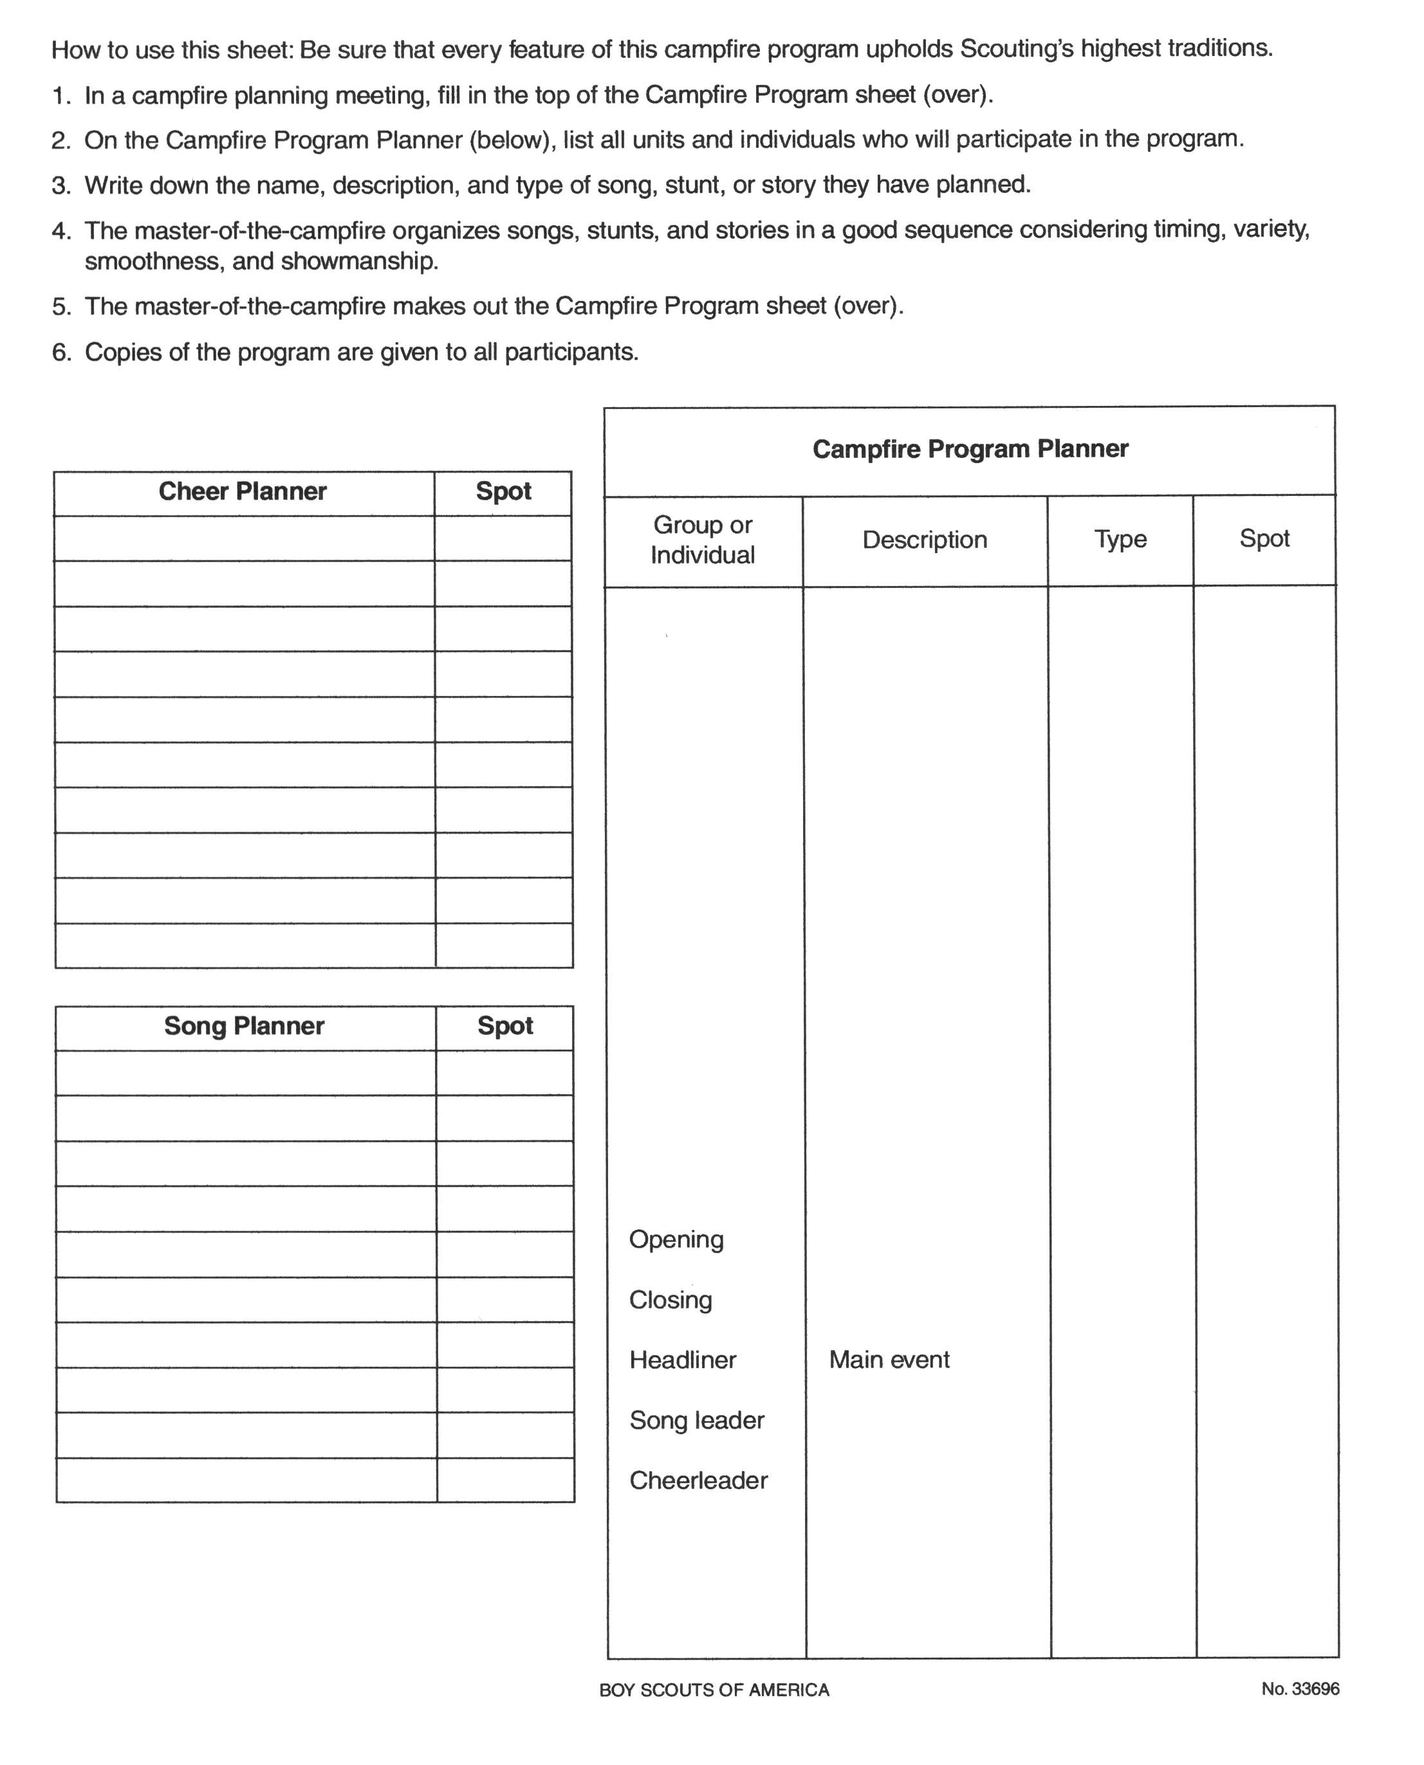

Campfire Program
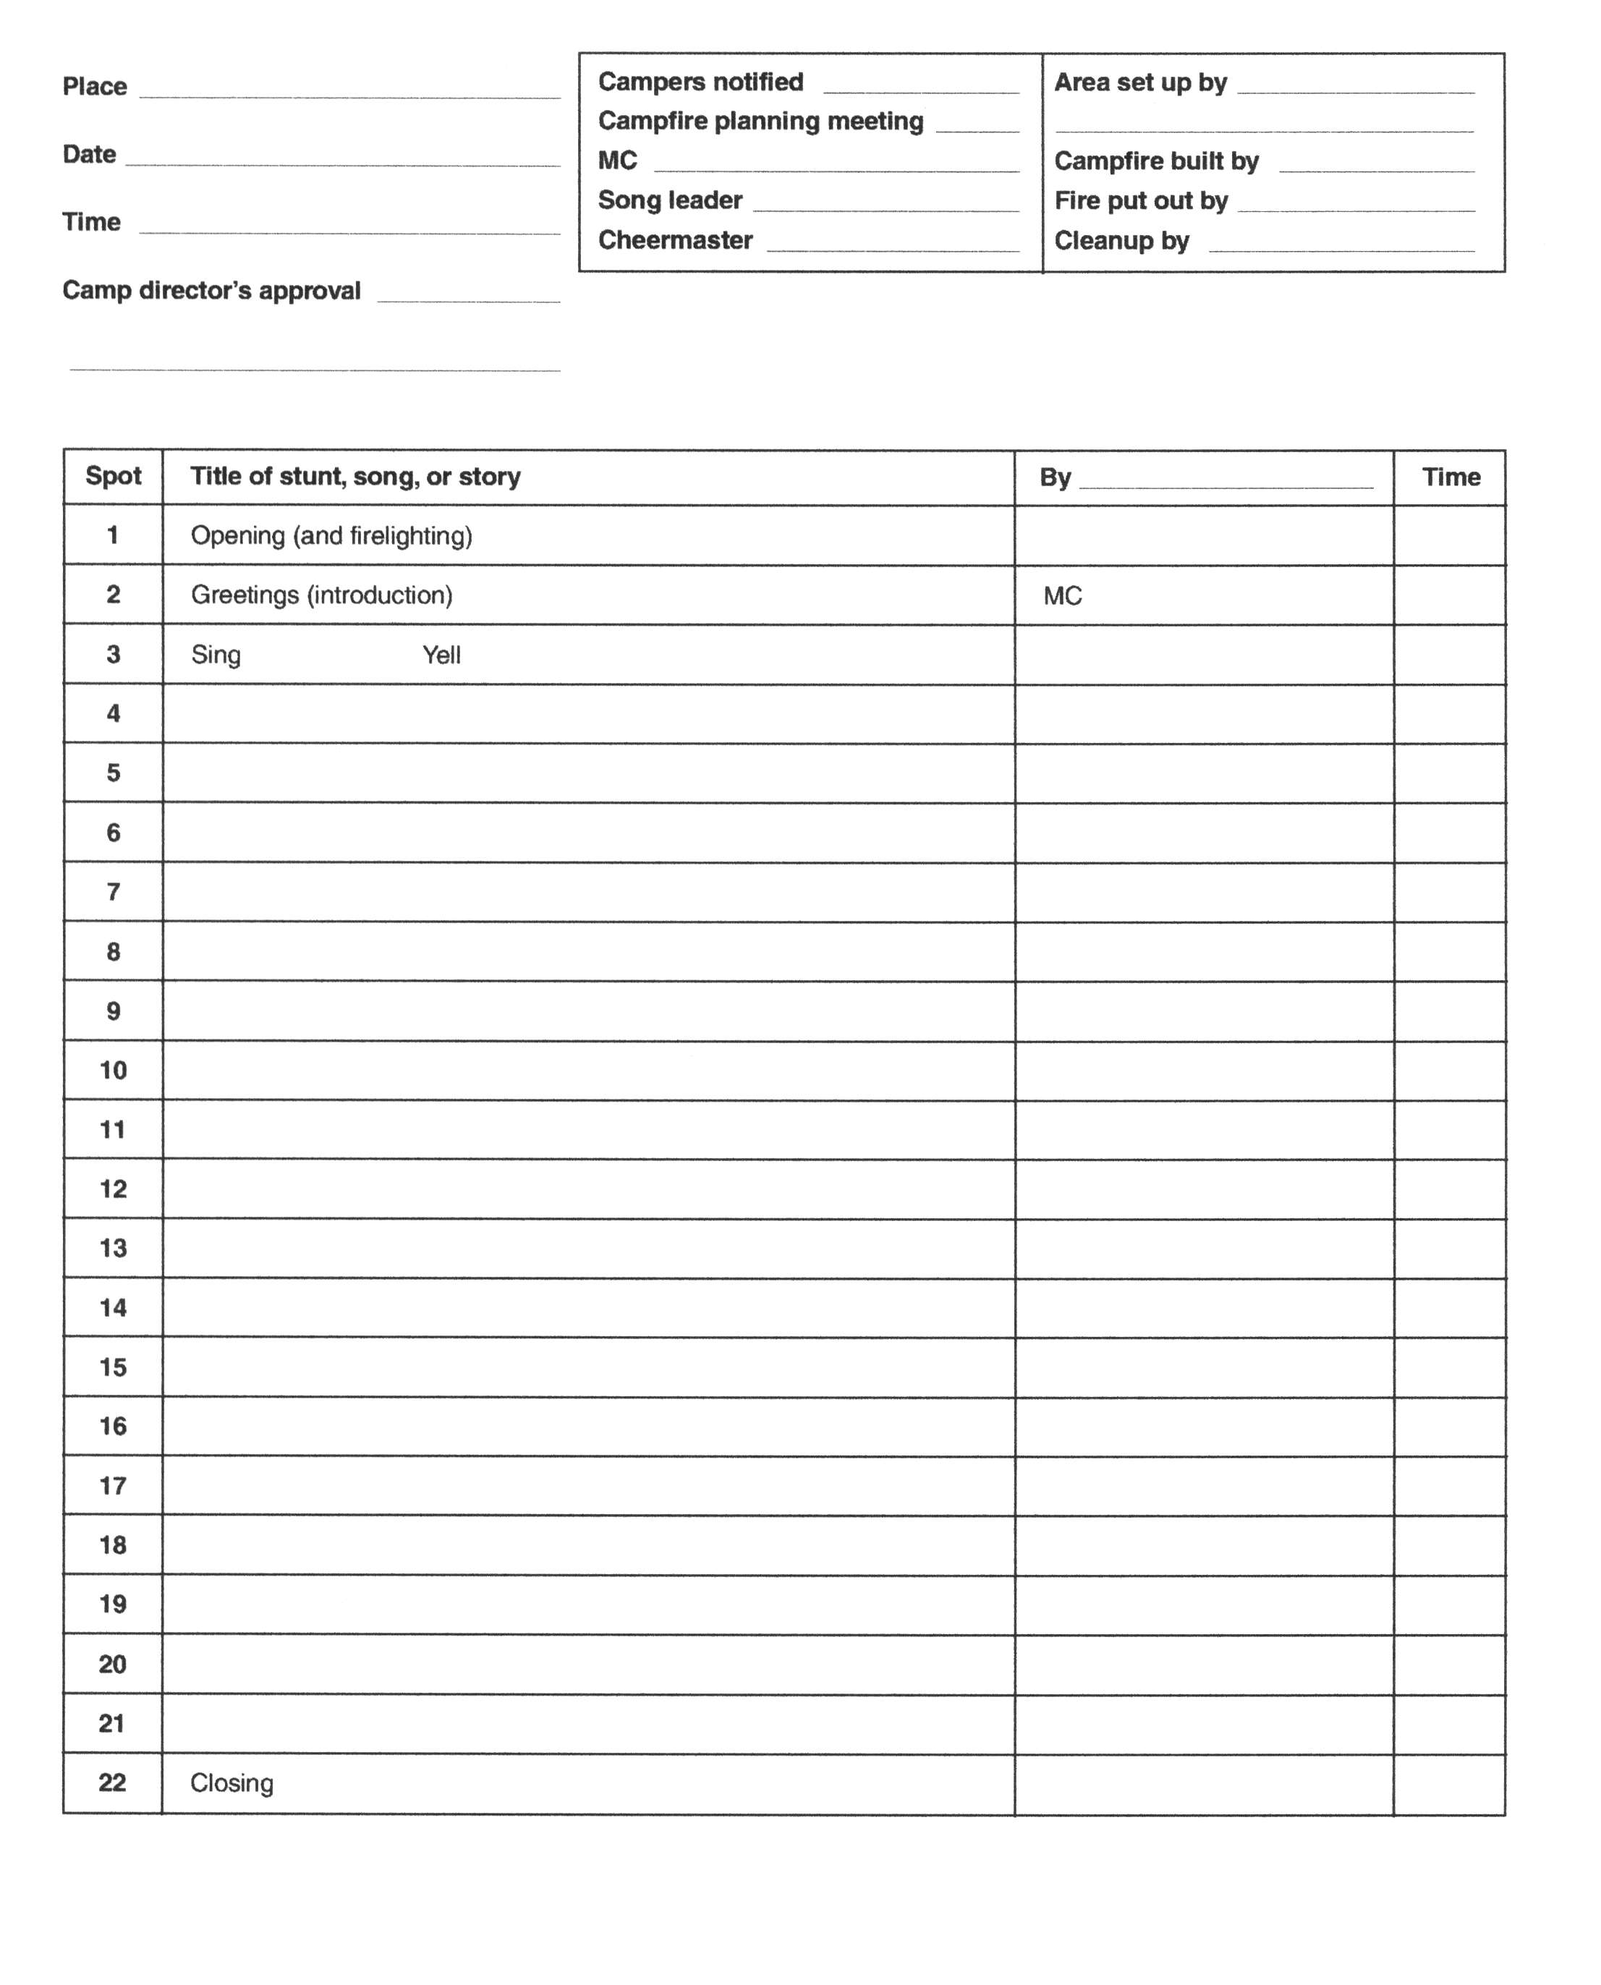

DAY 2
Cub Adventure Camp

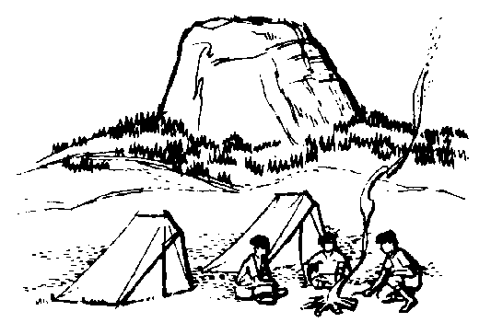

Wood Badge Course Schedule
See the Gilwell Gazette for times and locations
in Field Uniform, please
Breakfast & patrol self assessment (SSC)
Gilwell Field Assembly
Troop Meeting
Inter Patrol Activity & Debrief
Break
Leveraging Diversity Thru Inclusiveness (Troop Presentation)
Stages of Team Development (Troop Presentation)
Break
change into Activity Uniform before Photos
Lunch
Patrol Leaders' Council Meeting
Patrol Chaplain Aides Meeting
Photos
Communication (Patrol Presentation)
Break
Project Planning (Troop Presentation)
Rocket Competition (Inter-Patrol Activity)
Patrol Meeting
change into Field Uniform for the evening
Dinner
Wood Badge Game Show (Troop Activity)
Break
Game of Life (Troop Activity)
Debrief
Cracker Barrel

Gilwell Field Assembly

We assemble at Gilwell Field to begin our day. As you’ll see, we look forward to a day filled with team building games. B-P said “Scouting is a game with a purpose.” So, Scouting is meant to be “hands on.” Join in! (But, please try to not bloody yourself.)

Historic Flag Presentation

The Flag of 1777 (Betsy Ross Flag)

With the signing of the Declaration of Independence, the new American nation needed a flag of its own. On June 14, 1777, Congress passed this resolution:
“Resolved: That the flag of the thirteen United States be thirteen stripes alternate red and white; that the union be thirteen stars, white in a blue field, representing a new constellation.”
Each star and each stripe represented one of the colonies that would become the United States. The Flag of 1777 flew over the young nation for 18 years. George Washington was the only president to serve under this banner. To this day, June 14, the birthday of our flag, is celebrated each year as Flag Day.
Let us honor this flag with a song that also honors America:

America the Beautiful
O beautiful for spacious skies,
For amber waves of grain,
For purple mountain majesties
Above the fruited plain!

America! America!
God shed his grace on thee
And crown thy good with brotherhood
From sea to shining sea!

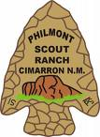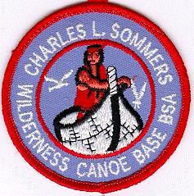

What Are You Most Afraid Of?” Worksheet
Below is a list, in alphabetical order, of 14 common fears. You have two tasks:
- Working on your own, rank all 14 items in the order in which you think a survey of respondents from throughout the United States ranked them.
Rank them from “1” (most feared) to “14” (least feared).
- Once everyone has completed the individual ranking, work together as a patrol to come up with a group ranking of the items, again using “1” for most feared, up to “14” for least feared.

Fear | Individual Ranking | Team Ranking
Darkness | ______________ | _____________
Death | ______________ | _____________
Deep water | ______________ | _____________
Dogs | ______________ | _____________
Driving/riding in a car | ______________ | _____________
Elevators | ______________ | _____________
Escalators | ______________ | _____________
Financial problems | ______________ | _____________
Flying | ______________ | _____________
Heights | ______________ | _____________
Insects and bugs | ______________ | _____________
Loneliness | ______________ | _____________
Sickness | ______________ | _____________
Speaking before a group | ______________ | _____________

Leveraging Diversity through Inclusiveness

Learning Objectives
- Understand a basic definition of diversity.
- Recognize the importance of Inclusiveness to a team.
- Understand what simple behaviors that can make inclusiveness work for you.

The Usual Suspects
Think for a minute about the people in your unit at home. Think about the people you work with. Are there people you count on all the time? When it really needs to get done do you turn to “the usual suspects” to make it happen? Why?
- Do they work as you do?
- Are you alike in many ways?
- Do you know them better than others?
- What about the other folks? How are they different?

Diversity, Inclusiveness
For our purposes, diversity is any dimension that can be used to differentiate groups and people from one another. Inclusiveness is our actions to help someone become part of a group.

Three Categories of Diversity
Human Diversity
Gender
Race
Age
Physical Appearance
Health
Generation
Disability
Cultural Diversity
Language
Lifestyle
Heritage
Belief Systems
Religious Beliefs
Traditions
Organizational Diversity
Teamwork
Roles
Relationships
Leadership Empowerment
Education and Training
Affiliations

How can we Use Diversity?
- Aggressively recruit diverse membership
- Immediately identify and challenge unacceptable behavior
- Encourage all members to contribute their talents and stregths regardless of backgrounds
- Serve as a role model

Barriers to Diversity
- Comfort in sameness
- Learning the differences
- Naturally resist change when change is positive
- How We Respond
As leaders and role models we have the responsibility to young people to help them understand those values that may differ from our own

What can I do?
- When you lead, make sure everyone has challenging opportunities to contribute and learn.
- Consider how your leadership behavior affects the team environment.
- Take time to show you care.
- Recognize individual and team achievements.
- Reach out and learn something from everyone.
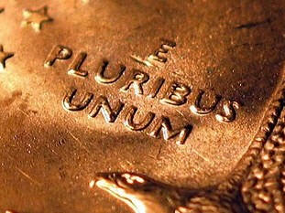

Patrol = People
- Successful patrols put differences to work.
- Successful patrols will function as a team.
- Members of a team are responsible for the whole group.
How do you make diversity work in a patrol? Include everyone on the team!

Food for Thought
What does success look like for your Wood Badge Patrol?
- Do you sense how other team members are doing?
- Are you teaching each other skills so all can participate?
- Do you support each other?
  - Even in conflict?
- Do you listen to each other?
- Does the team work to ensure everyone is performing?

Powerful Concepts, Simple Behaviors
- Diversity and inclusiveness are powerful concepts.
- Make them work and the team will grow!
- Make them work and you will grow.
How will you include a diversity/ inclusiveness goal in your ticket? In addition to your unit, consider other areas such as your district or council.
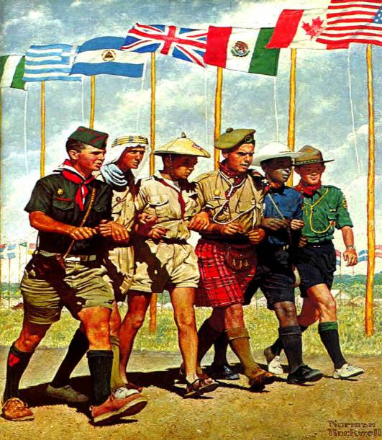

Review – Why is inclusiveness so important?
- Makes us better leaders
- Recognize the advantages of diversity
- Know how to pull diverse groups together
Lord Robert Baden-Powell said it best in an excerpt from his speech at the
1920 World Jamboree:
“Brother scouts, I ask you to make a solemn choice. Differences exist between the peoples of the world in thought and sentiment, just as they do in language and physique. The war has taught us that if one nation tries to impose its particular will upon others, cruel reaction is bound to follow. The jamboree has taught us that if we exercise forbearance and give and take, then there is sympathy and harmony. If it be your will, let us go from here determined that we will develop among ourselves and our boys that comradeship, through the world wide spirit of the scout brotherhood, so that we may help to develop peace and happiness in the world and good will among men. Brother scouts, answer me – will you join me in this endeavor?”

Stages of Team Development

Objectives
- Recognize the stage of development associated with a team.
- Understand the characteristics of each of the four stages of team development.
- Understand how enthusiasm and skill level relates to the four stages.
There are a variety of ways to illustrate team development. We’ll use the following:
Stages of Team Development
“Pickup Sticks”  Forming | “At Odds”  Storming | “Coming Around”  Norming | “As One”  Performing
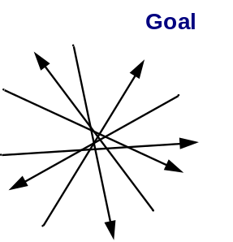 | 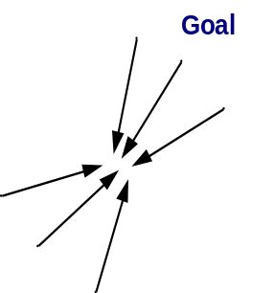 | 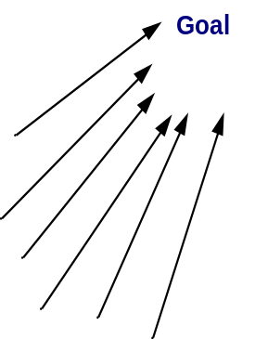 | 

- The first stage in a team’s development is the Forming stage
(“Pickup Sticks”).
Most team members are fairly eager to be on the team. However, they often come with high, unrealistic expectations. These expectations are accompanied by some anxiety about how they will fit in, how much they can trust others, and what demands will be placed on them. Team members are also unclear about norms, roles, goals, and timelines. In this stage, there is high dependence on the leadership figure for purpose and direction. Behavior is usually tentative and polite. The major issues are personal well being, acceptance, and trust.
- The second stage in a team’s development is the Storming stage
(“At Odds”).
As the team gets some experience under its belt, there is a dip in enthusiasm as team members experience a discrepancy between their initial expectations and reality. The difficulties in accomplishing the task and in working together lead to confusion and frustration, as well as a growing dissatisfaction with dependence upon the leadership figure. Negative reactions to each other develop, and subgroups form, which polarize the team. The breakdown of communication and the inability to problem-solve results in lowered trust. The primary issues in this stage concern power, sharing control, and avoiding conflict.
- The third stage in a team’s development is the Norming stage
(“Coming Around”).
As the issues encountered in the second stage are addressed and resolved, enthusiasm begins to rise. Task accomplishment and technical skills increase, which contributes to a positive, even euphoric feeling. There is increased clarity and commitment to purpose, values, norms, roles, and goals. Trust and cohesion grow as communication becomes more open and task-oriented. There is a willingness to share responsibility and control. Team members value the differences among themselves. The team starts thinking in terms of “we” rather than “I.” Because the newly developed feelings of trust and cohesion are fragile, team members tend to avoid conflict for fear of losing the positive climate. This reluctance to deal with conflict can slow progress and lead to less effective decisions. Issues at this stage concern the sharing of control and avoidance of conflict.
- The fourth stage in a team’s development is the Performing stage
(“As One”).
At this stage, both skill level and enthusiasm are high, and they reinforce one another. There is a sense of pride and excitement in being part of a high-performing team. The primary focus is on performance. Purpose, roles, and goals are clear. Standards are high, and there is a commitment to not only meeting standards, but to continuous improvement. Team members are confident in their ability to perform and overcome obstacles. They are proud of their work and enjoy working together. Communication is open and leadership is shared. Mutual respect and trust are the norms. Issues include continued refinements and growth.

There are two important variables that are woven through the four stages of team development: Enthusiasm and Skill Level. Unlike skill level, enthusiasm starts out high in the Forming stage. Then realizing the teams low skill level and inability to meet expectations enthusiasm takes a sudden dip as the team moves into the Storming stage. As differences are explored, expectations are aligned with reality, and the team achieves results with increasing skill levels, enthusiasm begins to rise in the Norming stage. Ultimately, both enthusiasm and skill level are high as the team becomes a high-performing team in the Performing stage.
Understanding the stages enable us to anticipate what a team is likely to go through. This will prevent team members from being surprised or depressed by various events such as disagreements during the “Storming” stage.
The stages enable us to use appropriate strategies to smooth the progress of a team as it evolves. For example, we can suggest a procedure for establishing ground rules for a team in the “Norming” stage.
Different teams may proceed through different stages at different speeds, a process that can be affected by the fact that team members may also have varying rates of progress. Members should avoid making self fulfilling prophecies about how long each stage will last.
A team may sometimes regress to an earlier stage. For example, team members may return to a previous stage if they discover that a team’s mission or membership has changed, such as when a significant number of new boys are added to a patrol.
It is possible for a team to be in different stages with respect to different aspects of its mission. For example, it may still be in the “Storming” stage with respect to implementing its final plan, even while it is in the “Performing” stage with respect to efficiently generating ideas for the plan.

Communication

Learning Objectives:
- Use listening skills learned in our previous session
- Develop strategies to overcome communication barriers
- Practice effective instruction skills
- Look for feedback

Communication can be in various forms, verbal and non-verbal
- Visually & Auditory i.e., spoken word, performance (dance/theatre/song), symbols (icons), written (stories, and many more).

What makes communication really effective?
- Importance of the message
- Presenting ideas with relevance to the listeners
- Establish authority on the subject
- Have conviction and passion for the subject
- Use the skills of voice, tone, body language
President John F. Kennedy and Dr. Martin Luther King Jr. speeches grip the listener
to this day—

Basic Blueprint of Communication
- A sender
- A message
- A receiver

Effective Communication…
- Good listening on the part of both speaker and the audience
- Engage the audience
- Two-way process

Engaging the audience…
- Presentation should not be one way
- Consider the listener’s perspective
- Understanding the speaker’s feelings

From the audience point of view, “What do you want?”
- Knowledge
- Skill
- Understanding

Barriers to Effective Communication
- Lack of common ground
- Lack of sincerity
- Lack of authority
- Lack of skill
- Lack of clarity
- Lack of receptiveness
- Poor environment
Consider how to overcome each barrier

Ways to assure Good Communications
- Know your audience
- Truly show sincerity
- Know the subject
- Be receptive and willing to learn something while teaching
- Be clear and concise
- Pace your presentation to the audience
- Physical environment has a impact

Summary
- Communications is a tool of leadership
- Communication is essential to effective teams
- Communications happens on common ground
- Communication should be clear and concise
- Sender and receiver consider each other
- Communication is written, verbal, and nonverbal
- Feedback is a gift. It truly is one!
Great leaders are
great communicators
- Be generous in support and praise!

Project Planning

Objectives
- Know what a project is.
- Identify and understand the five stages of team-based project planning.
- Learn some of the pitfalls of project planning.
- Understand what SMART objectives and activities are.

“Project” Defined
A temporary piece of work with a finite end date undertaken to create a unique product or service.

Why Project Planning is important
Projects are ubiquitous! They are everywhere…from home to work to scouts.
Wood Badge is no exception! There are explanations, demonstrations (Patrol Project, Conservation Project) and opportunities for guiding and enabling (your own Patrol’s project and carrying out your role in scouting and your Wood Badge ticket).

Will vs. Knowledge & Resources
Every project is completed because there is the “will” and the “knowledge and resources to accomplish it.”
If the sum of these two is 100%, what percentage of these two would you say it takes to be successful?
_____________%will
+ _____________%knowledge & resources
100 %

Five Stages of Team-Based Project Planning
1. Project overview
2. Activity list
3. Activity assignments
4. Putting the plan into action
5. Project closeout

Stage One: Project Overview
The most important step and one that is most often curtailed or skipped. The project overview is a document that
- Identifies the problem or opportunity
- Establishes project goals
- States the scope of the project
- States the projects budget and other constraints
- Explains how success is measured
- Determines the approach or methodology
- Identifies assumptions and risks.

Project Overview Benefits

Goals and Objectives
This captures the basic essence of your project. What are you planning to do? It has several benefits:
- Gets everyone on the same page.
- Creates a shared vision of success.

SMART
Establish project goals and objectives that pass the “SMART” test:
Specific: Is it specific in targeting an objective?
Measurable: What are the measurable indicators of success?
Attainable: Is it attainable by someone on the team?
Relevant: Can it be achieved within the resources and time allowed?
If not, then the goal is irrelevant to project success.
Time-based: When will the project be completed?

Cost & Constraints
- What is your budget?
- When do you need to finish?
- How many resources do you have to draw from?
These questions help to put “boundaries” around your project.

History
- Talk to someone who has done this project before.
- Look at their notes. There “lessons learned” or “start-stop-continue” could be useful to you.

Approach or Method
- What are the different ways in which the project may be carried out.
- Consider cost/benefit ratios.
- Challenge assumptions regarding usual approaches….just because we’ve always done it that way, doesn’t mean you have to.

Assumptions and Risks
To help identify the project’s assumptions and risks, answer these questions.
- What resources are required?
- What risks are associated with obtaining these resources in a timely manner?
- What problems or delays could we have?

Measures of Success
What quantitative measures might you use to measure your success?
- Popcorn sold
- Scouts participating in an event
- Number of leaders trained
- Survey of participants
- Percentage of scouts advancing or earning a particular award
- Frequency of events, such as outings
Avoid the use of goals with intangible measures, like “make it better”. Avoid the use of superlatives like “all” or “never” … because they can be impossible to achieve

Activity Trap & Scope Creep
An “activity trap” occurs when activities begin before a complete project overview has been completed and agreed to.
“Scope creep” a changes in the projects scope while you are in project execution.

Stage Two: Activity List
The activity list helps keep the team focused and helps prioritize tasks.
- Following the network of high-level objectives, break down each objective into separate activities that will be necessary to accomplish it.
- Order the activities by what must be done and when.
Project activities should
- Pass the “SMART” test.
- Have clear start and stop events.
- Be assignable and manageable.

Stage Three: Activity Assignments
When assigning activities, be sure participants have
- Clarity regarding their assignment
- Clarity about the project’s purpose
- Clarity about resources and deadlines
- A good match to their skills
- Established milestones and reporting procedures

Stage Four: Executing the Plan
The implementation and tracking leader should
- Provide leadership to the team.
- Assist with decision making and problem solving.
- Monitor the project’s progress and each team member’s performance. Provide feedback & support as needed

Stage Five: Project Closeout
When closing out the project:
- Recognize team members.
- Write a closing report.
-Were goals and objectives achieved?
-Was the project completed on time?
-What lessons were learned? Start-Stop-Continue might serve well as a method of collecting “lessons learned”.
- What ideas and recommendations do you have for next time?
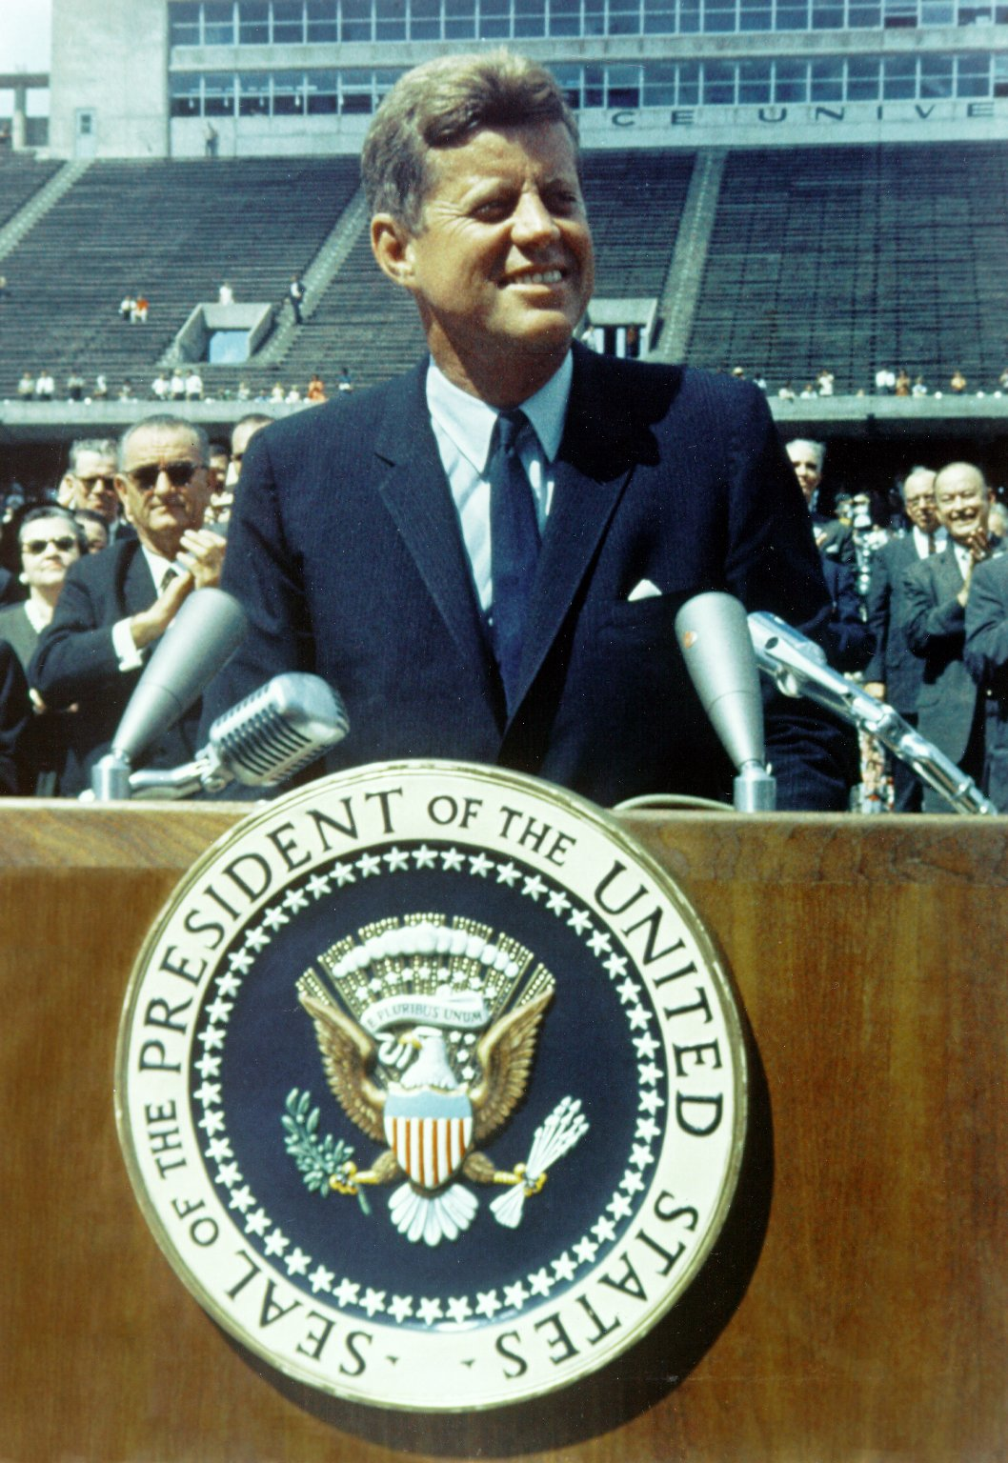
“We choose to go to the Moon!”
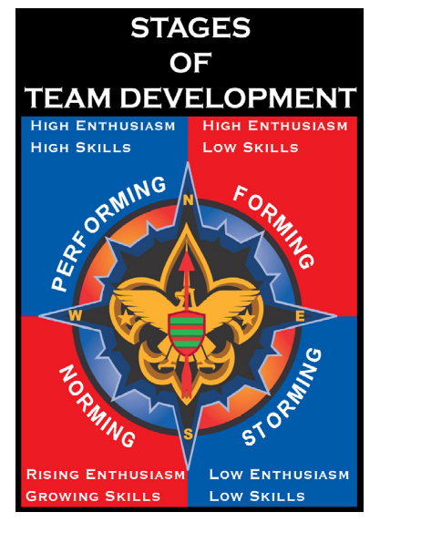

Flag Retirement


Flag retirement is the final ceremony conducted when the flag is to be disposed of. Usually there will be several flags to be disposed of that have been stored for retirement by the organization conducting the ceremony. See the the US Flag Code in the ceremony, below.
Flag disposal is the process that begins after the flag has been removed from service because it is no longer a fitting emblem for display. There usually is a period of time for storage. Flag disposal includes getting the flag to the flag disposal site, preparing the flag, and ends when the flag is destroyed by fire in a proper retirement ceremony. Depending upon the tradition of the of flag disposing organization the flag ashes are buried and sometimes scattered.
The American Legion has a useful brochure Flag of the United States, How to Display It, How to Respect It. One excellent source of information is the web site flagkeepers.org. An abbreviated version of their retirement ceremony appears below:
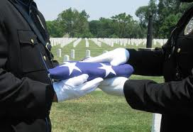
CEREMONY LEADER
(Include a chaplain/prayer per your tradition)
“We are gathered here to destroy these flags that have been deemed no longer serviceable. It is proclaimed that each of these flags has served well.
These flags have inspired those who desired the taste of freedom and have represented hope to those oppressed by tyranny and terror. These flags have welcomed any and all in the name of liberty.
The American flag flies free to the wind. The American flag flies above residential porches, camp sites, small businesses, corporate offices, hospitals, schools, military and naval bases, government buildings and nonprofit organizations. The American flag is the most displayed and recognized banner in the world.
These flags serve as constant reminders to all of us that we live in a country where our freedom has been deeply purchased by blood, sweat, tears and ultimate sacrifice. We must not forsake what those in the service to this flag, and their families, have forfeited.
To all who shall see these presents, greeting. Know ye that these flags have served well and honorably. Their stars and stripes have been loosed to the winds of freedom and have basked in the light of liberty."
CALL ATTENTION/ALL RISE (Those that Can)
“Please join me to recite the Pledge of Allegiance”: (PAUSE) “I pledge allegiance to the flag of the United States of America. And to the Republic for which it stands, one nation under God, indivisible with liberty and justice for all”.
STAND AT EASE
Read, “The U.S. Flag Code states”, (PAUSE) “The flag, when it is in such condition that it is no longer a fitting emblem for display, should be destroyed in a dignified way, preferably by burning”.
(OPTIONAL) Dedicate this ceremony to an individual American who loved the Flag (Read previously obtained info about the honoree)
CALL ATTENTION/ALL RISE
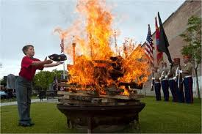
Staff member inserts one properly folded flag into the incinerator/fire.
Sing or recite the first stanza of God Bless America.
Read
“While the storm clouds gather far across the sea,
Let us swear allegiance to a land that's free,
Let us all be grateful for a land so fair,
As we raise our voices in a solemn prayer.”
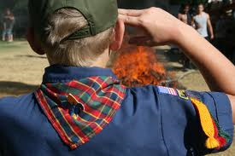
STAND AT EASE
“Ladies and gentlemen, this concludes the ceremony. God bless America.”
When guests have departed, staff members and volunteers burn the remaining flags.

DAY 3

Cub Adventure Camp
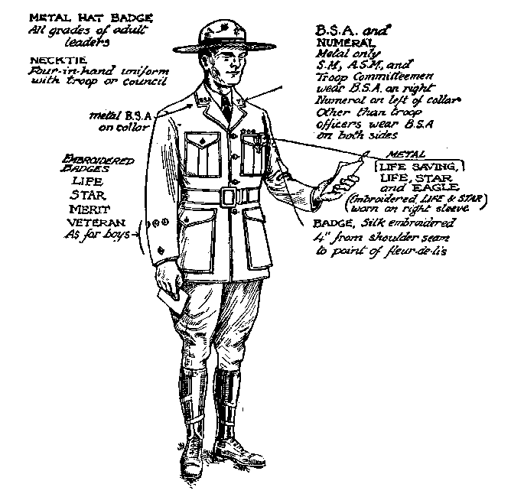

Wood Badge Course Schedule
See the Gilwell Gazette for times and locations.
in Field Uniform, please
Breakfast, Self assessment
Gilwell Field Assembly
Interfaith Worship Service (Troop Activity)
Break
Troop Meeting
Break
Leading EDGE / Teaching EDGE (Troop Presentation)
change into Activity Uniform before PLC
Lunch
Patrol Leaders' Council Meeting
Patrol Chaplain Aides Meeting
Conservation Project Planning
Break
October Sky (Troop Activity)
Closing Gilwell Field Assembly
Patrol Time
Departure

Gilwell Field Assembly

Have we come a long way in just two days! Today we give thanks, through our spiritual practice and through practical service. We’re also leading our Patrols toward our outdoor adventure during the second weekend of Wood Badge.

Historic Flag Presentation

The Serapis Flag

Designed with 13 stripes alternating red, white, and blue, this flag was raised by Captain John Paul Jones on the British frigate Serapis during the most famous Revolutionary War naval Battle.
In 1779, after conducting sea raids on the coast of Britain, Jones took command of a rebuilt French merchant ship that had been renamed the U.S.S Bonhomme Richard in honor of Benjamin Franklin. In September of that year, Jones engaged the British Frigate Serapis in the North Sea, sailing in close, lashing his vessel to the British ship, and fighting the battle at point blank range. During the fight, two cannon burst on the Bonhomme Richard. The British Captain asked Jones if he was ready to surrender.
Jones replied, ‘Sir, I have not yet begun to fight!’ Eventually it was the crew of the Serapis that surrendered, though the Bonhomme Richard was severely damageed. The American sailors boarded the Serapis and watched form the deck as the Bonhomme Richard sank beneath the waves.
Let us honor this flag with a song that also honors America.

Columbia, The Gem of the Ocean
O Columbia, the gem of the ocean
The home of the brave and the free
The shrine of each patriot’s devotion,
A world offers homage to thee.

Thy mandates make heroes assemble,
When Liberty’s form stands in view,
Thy banners make tyranny tremble,
When borne by the red, white, and blue!

When borne by the red, white, and blue!
When borne by the red, white, and blue!
Thy banners make tyranny tremble,
When borne by the red, white, and blue!

Interfaith Worship Service (Instructional Portion)

Objectives
- Explore issues that can affect the content and presentation of an interfaith worship service.
- Involve staff members in the presentation.
- Draw upon a diversity of resources.
- Be a model for conducting an interfaith worship service. (The second service, on Day Five, is prepared and presented by the patrol chaplain aides.)

Why Include Religious Services in Scouting?
The Charter and Bylaws of the Boy Scouts of America recognize the religious element in the training of the BSA’s members, but the BSA is absolutely nonsectarian in its attitude toward that religious training. Religious instruction is ultimately the responsibility of the home and the religious institution.
From the BSA’s Charter and Bylaws:
The Boy Scouts of America maintains
that no member can grow into the best kind of citizen
without recognizing an obligation to God.

From the Boy Scout Handbook, 11th edition:
A Scout is reverent.
A Scout is reverent toward God.
He is faithful in his religious duties.
He respects the beliefs of others.
Wonders all around us remind us of our faith in God.
We find it in the tiny secrets of creation
and the great mysteries of the universe.
It exists in the kindness of people and
in the teachings of our families and religious leaders.
We show our reverence by living our lives
according to the ideals of our beliefs.

Throughout your life
you will encounter people expressing their reverence in many different ways.
The Constitution of the United States guarantees each of us
complete freedom to believe and worship
as we wish without fear of punishment
.
It is your duty to respect and defend the rights of others to their religious beliefs even when they differ from your own.

What is an Interfaith Worship Service?
The explanation provided by Baden-Powell is as valid today as when he wrote it:
Some Ideas on Interfaith Worship Service
For an open Troop, or for Troops in camp,
I think the interfaith worship service should be open to all denominations,
and carried on in such manner as to offend none.
There should not be any special form,
but it should abound in the right spirit,
and should be conducted not from any ecclesiastical point of view,
but from that of the boy.
Everything likely to make an artificial atmosphere should be avoided.
We do not want a kind of imposed church parade,
but a voluntary uplifting of their hearts by the boys
in thanksgiving’ for the joys of life,
and a desire on their part to seek inspiration
and strength for greater love and service for others.
An interfaith worship service should have as big an effect on the boys
as any service in church,
if in conducting the interfaith worship service
we remember that boys are not grown men,
and if we go by the pace of the youngest and most uneducated of those present. Boredom is not reverence, nor will it breed religion.
To interest the boys,
the interfaith worship service must be a cheery and varied function.
Short hymns (three verses are as a rule quite enough-never more than four); understandable prayers; a good address from a man who really understands boys (a homely “talk” rather than an address), which grips the boys,
and in which they may laugh or applaud as the spirit moves them,
so that they take a real interest in what is said.
If a man cannot make his point to keen boys in ten minutes
he ought to be shot!
If he has not got them keen,
it would be better not to hold an interfaith worship service at all.
-Baden-Powell
Printed in The Scouter, November 1928

Basic Concepts for Planning an Interfaith Worship Service
- Choose a setting that lends itself to the occasion and promotes reverence, a grove of trees, a site with a view of a lake, pond, brook, etc. For small groups, sitting in a circle can be a very effective arrangement.
- Everything must be in good taste.
- The service should be planned, timed, and rehearsed. (Generally 30 minutes maximum.)
- It should go without saying that those attending an interfaith worship service will be courteous, kind, and reverent. They should respect the rights and feelings of others even if their beliefs and religious practices differ from their own.
- Everyone in attendance should have opportunities to participate, if they wish, through responsive readings, silent and group prayer, singing, etc.

Recognizing Diversity in a Interfaith Worship Service
Scouts practice many faiths and many units are composed of Scouts from a variety of faiths. When this is the case during a Scout outing, ask them to suggest materials, to participate in the planning, and to assist in leading the service. If the group represents a mixture of religions, you may choose to use inspirational passages instead of particular religious materials.
Because different faiths observe different religious practices and have a variety of holy days, it is not always possible to conduct an interfaith service in a time frame that fully recognizes individual religious obligations. This should be acknowledged and explained. Other time may need to be built into the schedule to allow individuals to meet their obligations.
“Interfaith” means a service that all Scouts and Scouters may attend. Therefore, much attention must be paid to recognize the universality of beliefs in God and reverence.
Encourage Scouts and Scouters to participate in religious services. Let them know ahead of time the nature of a service so that those anticipating a interfaith experience do not find themselves surprised by a service that espouses the beliefs of a particular faith or religious tradition.

Summary
Whenever possible, BSA outings and activities should include opportunities for members to meet their religious obligations. Encourage Scouts and Scouters to participate. Even the opportunity to share the uniqueness of various faiths, beliefs, and philosophies with other members may be educational and meaningful. Planning and carrying out religious activities can be as simple or complex as the planners choose to make them.
Care must be taken to support and respect all the faiths represented in the group. If services for each faith are not possible, then an interfaith, nonsectarian service is recommended. Scout leaders can be positive in their religious influence without being sectarian.

Interfaith worship service (Example)
- Call to worship
- Hymns or songs
- Scripture(s) or readings from a variety of religious or inspirational sources
- Responsive reading
- Personal prayer
- Group prayer
- Inspirational reading or message
- Offering (World Friendship Fund)
- An act of friendship
- Benediction or closing

The World Friendship Fund
World Friendship Fund donations are sent to the International Division of the BSA.


Have You Seen the Light?
How enlightened are you when it comes to knowing and applying the religious principles of the Boy Scouts of America? It is a little more involved than simply understanding the 12th point of the Scout Law. Take a few minutes to complete this quiz.

1. True or False—Circle one
The Boy Scouts of America maintains that no member can grow into the best kind of citizen without recognizing an obligation to God.

2. Multiple Choice— Circle the correct answer(s)
The 12th point of the Scout Law includes the following responsibilities:
a. personal religious obligations
b. duty to country
c. respect for the beliefs of others
d. all of the above

3. Multiple Choice— Circle the correct answer(s)
The word “nonsectarian” means
a. nondenominational
b. ecumenical
c. not affiliated with any specific religion
d. all of the above

4. Multiple Choice— Circle the correct answer(s)
Which of the following could be a violation of a religious belief?
a. recitation of the Pledge of Allegiance to the United States of America
b. removing one’s hat when indoors and/or during a meal
c. expecting everyone to taste a particular food
d. attending a program event or activity on a Saturday
e. drinking coffee, tea, or cola
f. asking for a financial donation at a worship service
5. True or False— Circle one
In accordance with their agreement with the Boy Scouts of America, some churches sponsoring Cub Scout, Boy Scout, Varsity, or Venturing units can require members of their units to participate in religious ceremonies and services distinctive to that church.
6. True or False—Circle one
An interfaith worship service is one that all Scouts and Scouters may attend. It requires careful planning to ensure that it does not violate the beliefs of any religion.

7. True or False—Circle one
Some religions have specific requirements that cannot be fulfilled through an interfaith worship service. Other arrangements might be necessary for Scouts of those faiths to fulfill such commitments.

8. True or False— Circle one
Of the eight major religions in the world, all are represented in the BSA’s religious emblems program.

9. Multiple Choice— Circle the correct answer(s)
“Duty to God” and “religious duties” are important components of
a. The Cub Scout Promise
b. The Law of the Pack
c. The Scout Oath
d. The Scout Law
e. The Venturing Oath
f. The Venturing Code
g. All of the above

Principles of Leave No Trace 

1. Plan Ahead and Prepare
Proper trip planning and preparation helps hikers and campers accomplish trip goals safely and enjoy-ably while minimizing damage to natural and cultural resources. Campers who plan ahead can avoid unexpected situations, and minimize their impact by complying with area regulations such as observing limitations on group size.

2. Travel and Camp on Durable Surfaces
Damage to land occurs when visitors trample vegetation or communities of organisms beyond recovery. The resulting barren areas develop into undesirable trails, campsites, and soil erosion.

3. Dispose of Waste Properly (Pack It In, Pack It Out)
This simple yet effective saying motivates backcountry visitors to take their trash home with them. It makes sense to carry out of the backcountry the extra materials taken there by your group or others. Inspect your campsite for trash or spilled foods. Accept the challenge of packing out all trash, leftover food, and litter.
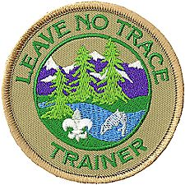

4. Leave What You Find
Allow others a sense of discovery, and preserve the past. Leave rocks, plants, animals, archaeological artifacts, and other objects as you find them. Examine but do not touch cultural or historical structures and artifacts. It may be illegal to remove artifacts.

5. Minimize Campfire Impacts
Some people would not think of camping without a campfire. Yet the naturalness of many areas has been degraded by overuse of fires and increasing demand for firewood.

6. Respect Wildlife
Quick movements and loud noises are stressful to animals. Considerate campers observe wildlife from afar, give animals a wide berth, store food securely, and keep garbage and food scraps away from animals. Help keep wildlife wild.

7. Be Considerate of Other Visitors
Thoughtful campers travel and camp in small groups, keep the noise down, select campsites away from other groups, always travel and camp quietly, wear clothing and use gear that blend with the environment, respect private property, and leave gates (open or closed) as found. Be considerate of other campers and respect their privacy.

Go to www.lnt.org for a variety of program resources.

The Leading EDGE™ / The Teaching EDGE™
The primary function of team leadership is to help the team move through the stages of development.

Objectives
- Describe the four leadership behaviors included in the Leading EDGE™, and explain which behavior is most appropriate for each stage of team development.
- Describe the four skills instruction behaviors included in the Teaching EDGE, and explain which behavior is most appropriate for each stage of skills development.
Effective leaders usually have more than one leadership style. A key to good leadership is to match the style of leadership to the people and the situation. A powerful tool for choosing the right leadership style is the Leading EDGE.
The letters EDGE stand for
- Explain
- Demonstrate
- Guide
- Enable

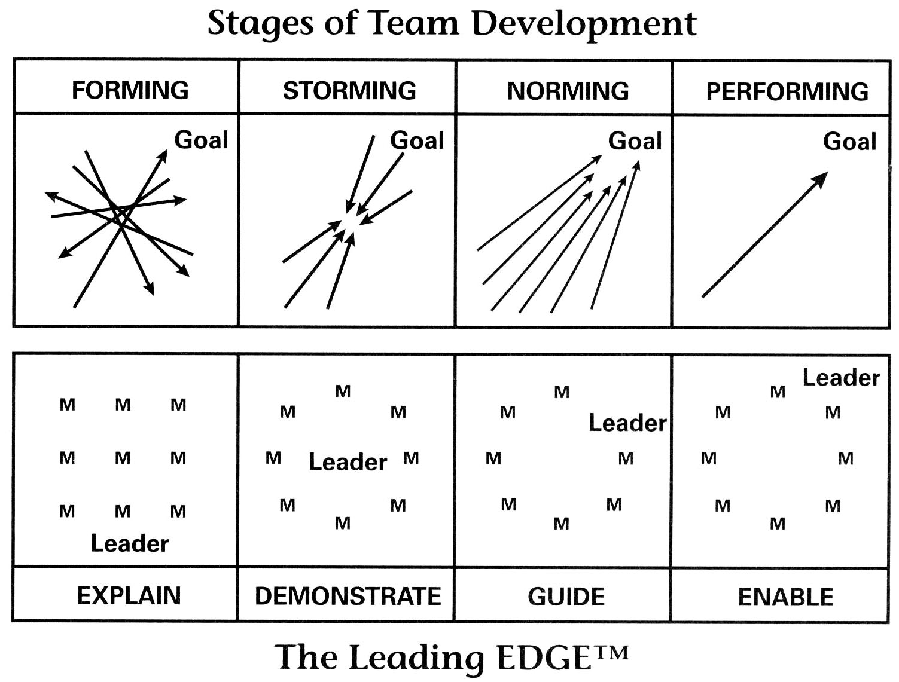

Review
Recall from the Stages of Team Development discussion yesterday:

Forming (High Enthusiasm, Low Skills) (Pick-up Sticks)
An effective leader of a team that is Forming will do lots of careful explaining to help the team understand exactly what the leader expects them to do. There is high dependence on the leader, some anxiety about fitting in norms, roles, timelines, etc.

Storming (Low Enthusiasm, Low Skills) (At Odds)
In the Storming stage an effective leader will continue to make things clear by demonstrating to the team how to succeed. There is some discrepancy between initial expectations and reality. Negative subgroups form, with confusion & frustration.

Norming (Rising Enthusiasm, Growing Skills) (Coming Around)
Leaders of teams in the Norming stage can find success by giving team members lots of freedom to act on their own, but being ready to provide guidance (coaching) when a little help is needed. Trust and cohesion grow as communications become more task oriented. Start to think of team as “we”. They avoid conflict fearing losing positive climate.

Performing (High Enthusiasm, High Skills) (As One)
During the Performing stage a leader will enable team members to make decisions on their own and to keep progressing toward completion of the task. Focus is on performance, pride/excitement in being part of high performance team. Roles, goals and purpose are clear.
To enable a team to make decisions and move ahead on their own, the leader must provide access to relevant information and necessary resources.

Regression (Going Backwards)
Regression, or moving back a stage or two, can take place when there are changes in leadership, task, roadblocks or membership. Teams and/or individuals can ‘regress’.

The Relationship between Stages of Team Development and the Leading EDGE™
Together the stages of team development and The Leading EDGE™ provide a framework for matching each stage of team development with an appropriate leadership behavior.
Remember, when serving as a team leader, identify the current stage of team development by accessing the team’s level of enthusiasm and skill, and select an appropriate leadership style to use.

The Teaching EDGE™
The ability of a team to succeed at a particular task often depends upon the need for the members to individually or collectively learn new skills.
It is the leader’s responsibility to provide skills instruction when the need is recognized. The leader may serve as instructor if he or she has mastered the requisite skills, or arrange for an instructor.
A learner responds best to skills instruction tailored to the stage of skills development the individual is experiencing at the moment. To provide a appropriate style of skills instruction. The instructor must access the level of enthusiasm and skill demonstrated by the learner.
A powerful tool for choosing the right instruction style is the “Teaching EDGE; again, Explain, Demonstrate, Guide, or Enable?
Skill Development Stages
Forming
(High Enthusiasm, Low Skills)
A person is enthused about something new and motivated to learn, but has a low level of skill during the Forming stage. An instructor will need to do lots of careful explaining - telling the learner exactly what to do and how to do it.

Storming
(Low Enthusiasm, Low Skills)
A person has been at it long enough to realize that mastering a skill may not be easy and that lots of work remains to be done. As a result, his enthusiasm and motivation are low. Skills are still low, too. An instructor must demonstrate the new skill to the learner, clearly showing him what to do and how to do it.

Norming
(Rising Enthusiasm, Growing Skills)
As a learner keeps at it, his level of skill will rise. He realizes he is making progress, and so motivation and enthusiasm will rise, too. An instructor will need to guide the person – giving him more freedom to figure out things on his own, supporting him with encouragement, and helping him move closer to the goal.

Performing
(High Enthusiasm, High Skills)
Skills are high and so is enthusiasm and motivation. A learner has reached the point where he can act independently and be very productive. An instructor will need to enable the person—offer the learner plenty of freedom to make decisions on their own and to keep moving ahead.

Teaching- or Leading EDGE?
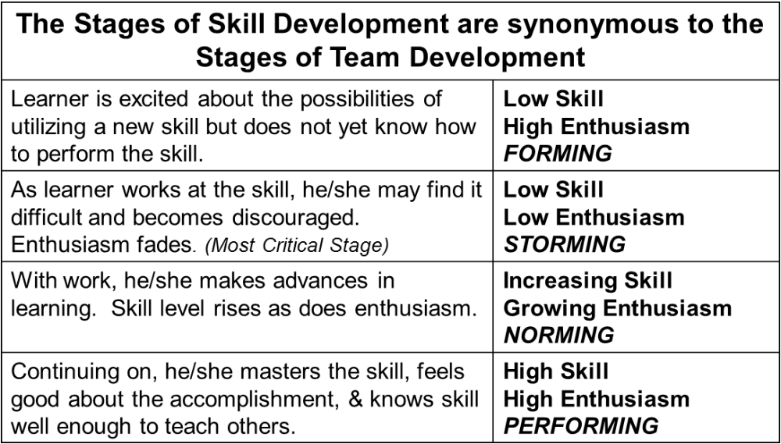

Explain, Demonstrate, Guide, or Enable?
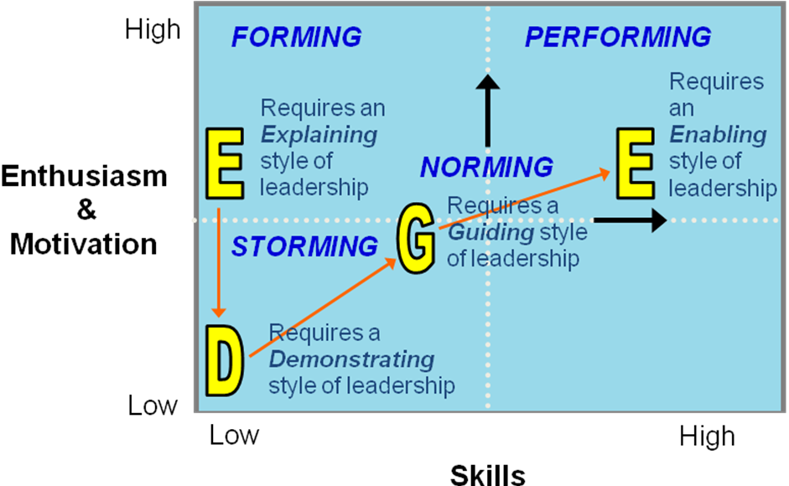
Skill Development Stage | Enthusiasm (Morale) | Skill Level (Productivity) | Teaching EDGE Behavior
Forming Storming Norming Performing | High  Low  Increasing  High | Low  Low  Increasing  High | Explain  Demonstrate  Guide  Enable
A team responds best to leadership tailored to the stage of the team at the moment.
A learner responds best to skill instruction tailored to the stage of skill development of the moment.
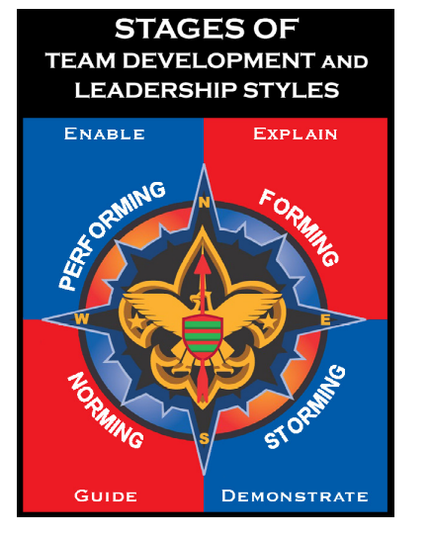

What Makes a Good Conservation Project?

Cub Scouts, Boy Scouts, Varsity Scouts, and Venturers undertaking conservation work are volunteering their time and energy for the good of the environment.
A worthwhile project allows them to feel pride in what they are doing. It gives them a chance to experience something new. Though the work may be hard, it should also be satisfying.
The following guidelines will help Scout leaders and agency personnel plan conservation work that serves the needs of Scouts, of agencies, and of the environment.

Involve Scouts in All Aspects of a Project
A sense of project ownership is important to young people. Scouts should understand the purpose of a conservation project. Increase their commitment to conservation by involving them in planning as well as in carrying out the work.

Make Projects Fun
Whenever possible, combine conservation efforts with other Scout activities such as a hike, a campout, a swim, or a nature walk with someone who can discuss the area’s ecology. That will enrich the experience for everyone and also reinforce the idea that caring for the environment is a fundamental part of the Scouting program.

Choose Reasonable First Projects
The first projects undertaken by a Scouting unit should be limited in scope and last no more than a few hours or an afternoon. As the young people gain experience and confidence, projects can become more lengthy and complex.

Consider Skill Levels
A good project is within the skill levels of the young people doing it and is age-appropriate. Work that is too demanding sets up young people to fail and to lose interest. On the other hand, the best opportunities challenge Scouts to push a little beyond their current abilities and master new skills.

Set Reasonable Goals
Everyone likes a sense of completion to their work. Some conservation efforts can be finished in a few hours, an afternoon, or a day. Longer-term projects may be broken into intermediate goals achievable in shorter amounts of time ~ planting a certain number of trees, for example, or repairing the sites in just one area of a campground.

Make a Difference
Appropriate projects allow young people to see that their efforts have a positive effect on the quality of their environment. They learn about the importance of conservation and gain a sense of pride in having done a Good Turn for the environment and for those who will enjoy the outdoors in the future.


Sample Conservation Projects
Conservation projects come in all shape and sizes. Among those that have been successfully completed by Scouts are the following:
HABITAT AND WILDLIFE
- Improve fish and wildlife habitat, riparian areas, streams, and shorelines.
- Stabilized threatened stream banks.
- Collect discarded Christmas trees and install them as revetments to protect stream banks, or submerge them to provide shelter for fish.
- Re-vegetate damaged meadows and hillsides.
- Plant trees, shrubs, and grasses to control erosion, produce shade, and provide wildlife with sources of food and shelter.
- Remove exotic plant species and restore native vegetation.
- Establish and care for urban greenbelts, neighborhood parks, or other open spaces.
- Clean up urban waterways, paint DUMP NO WASTE / DRAINS TO STREAM on storm drains, and distribute fliers that outline appropriate ways of disposing of oil, chemicals, and other toxic wastes.
- Construct and set up nesting boxes and feeders for waterfowl and other wild birds.
- Help officials stock lakes and streams.
- Build structures in arid regions to hold water for wild animals.
TRAILS AND CAMPSITES
- Return unwanted and abandoned campsites and trails to their natural conditions.
- Increase accessibility of resource area facilities for handicapped visitors.
- Upgrade, maintain and help construct trails for hikers, horseback riders, bicyclists, and other users.
MONITOR
- Monitor the quality of streams.
- Conduct an ongoing census of selected wild animals.
- Conduct measurements of snow depth at backcountry monitoring locations and forward the information to meteorological stations.
STRUCTURES
- Maintain picnic pavilions, lifeguard towers, boat docks, playground equipment, and other outdoor recreational facilities.
- Build fences to prevent the overgrazing of riparian areas.
- Construct observation decks and blinds in wildlife refuges.
- Prepare and install educational signs along nature trails.
EDUCATIONAL
- Develop and maintain outdoor classroom sites.
- Teach environmental awareness to young people visiting resource areas.
- Provide training in appropriate camping, hiking, and other recreational skills that are easy on the land.
- Offer conservation-oriented presentations and slide shows to youth organizations and civic groups.
- Prepare informational brochures to be distributed at agency visitor centers.
- Develop interpretive demonstrations, tours, and living history exhibits, and help present them to visitors of resource areas.
HISTORICAL
- Clean and repair statues, gravestones, and other historic monuments.
- Restore historic buildings.
- Prepare and present research about the people and events important to the heritage of an area.
- Assist archaeologists in protecting and studying archaeological sites.

Conservation Project Planning Checklist
Scouting leaders and agency personnel can use the following checklist to assist them in planning conservation projects.
What is the task to be done?
Why is it important?
How many Scouts and Scouters can take part in the work?
What is the time frame for completing the project
What tools and materials will be needed, if any, and who will provide them?
What leadership skills are required to oversee the work?
Who will provide project leadership? (List youth and adult Scouting leaders and any agency personnel.)
How will youth reach the work area?
What safety factors are involved and how will they be addressed?

October Sky—About the Movie

Opening comments
Why watch a movie about a bunch of boys building rockets during a training course for Scout Leaders?
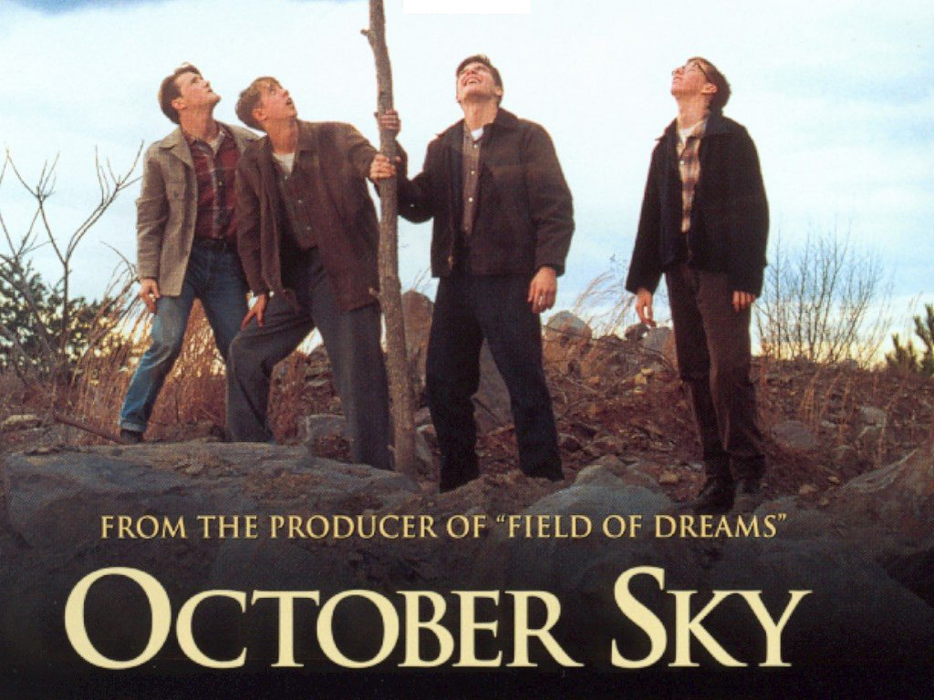
Over the last three days you have been introduced to many important aspects of leadership and team development. You have learned about listening, inclusiveness, and communication. No matter if you are in a scout setting, work setting, or just spending time with your family, you will experience forming, storming, norming, and performing at different times.
Now you might wonder why would we be watching a movie at Wood Badge. October Sky is a wonderful movie on many levels. But for our purposes, it is a dynamic example of what you have learned about over the last three days.
As you watch the movie, pay particular attention to the relationships between Homer and his father. Watch the team development between the Rocket Boys themselves. Look for how Miss Riley acts as a mentor and coach as well as a teacher to Homer. What are the characters’ values, missions, and visions? You’ll see examples of people giving and receiving feedback. What are the different leadership styles? How do the characters listen and communicate?
The staff has shared so much with you. October Sky helps to bring it all together. Help yourself to some popcorn and drink. Grab a tissue—you may need it. And enjoy the movie. But don’t lose sight of why we are watching this movie—as students of leadership, we want to use this opportunity to become better leaders ourselves.

Post Movie analysis/discussion
What was the driving force of this entire story? (a dream and vision of accomplishing something)
Did you witness examples of LISTENING, COMMUNICATING? What examples of listening and communication can you give?
How do the Rocket Boys exemplify INCLUSIVENESS and DIVERSITY?
What types of leadership did we see? Authoritarian (John Hickman); Participative (Homer Hickman). What are the strengths and weaknesses of their different styles?
Miss Riley was more than just Homer’s teacher. What impact did she have on Homer? (mentor & coach)
Quite often we can see ourselves more clearly when we stand back and watch others. Think about what kind of leader you are. Are you like John or Homer or Miss Riley? Do you encourage, motivate and support those around you?

DAY 4

Camp T. Brady Saunders
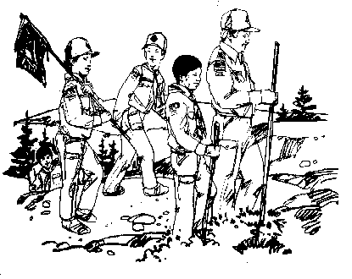

Wood Badge Course Schedule
See the Gilwell Gazette for times and locations.
Arrive in 'grungies' please
Participants Arrive
Gazette in Parking Lot
Camp Set-up
Change into Activity Uniform, please
Gilwell Field Assembly
Leading Change
Break
Patrol Leaders' Council, and Chaplain’s Aides Meetings
Lunch
Generations in Scouting (Troop Presentation)
Break
Problem Solving and Decision Making
Problem Solving Round-Robin (Patrol Activity)
Youth Staff departs for home
Managing Conflict (Patrol Presentation)
Patrol Meeting
Change into Field Uniform, please
Dinner
The Diversity Game (Patrol Activity)
Troop Campfire
Patrol Cracker Barrel

Gilwell Field Assembly

Back again so soon? The Patrols have been off preparing themselves for a great weekend. The staff has been doing likewise—and we can’t wait to see what you’ll be cooking for us! Although we’ve all done our best to “Be Prepared,” who knows what surprises are in store during our campout.

Historic Flag Presentation

The Star-Spangled Banner

By 1795, Vermont and Kentucky had joined the Union, bringing the number of states to 15. The Stars and Stripes on the flag were increased from 13 to 15 on May 1, 1795. It was this flag of 15 stripes that flew over Fort McHenry in Baltimore the memorable night of its bombardment in 1814 and inspired Francis Scott Key to write the verse of our National Anthem.
The actual flag that flew over fort McHenry that night is now preserved in the Smithsonian National Museum of American History.

Let us honor it by singing the first verse of the song it inspired.

The Star-spangled Banner
O say, can you see, by the dawn’s early light,
Who so proudly we hailed at the twilight’s last gleaming?
Whose broad stripes and bright stars, through the perilous fight,
O’er the ramparts we watched, were so gallantly streaming?
And the rockets red glare, the bombs bursting in air,
Gave proof through the night that our flag was still there!
O say, does that star-spangled banner yet wave
O’er the land of the free and the home of the brave?

Venturing Induction Ceremony
Scouting is diverse by design. Volunteers work in Cub Scouting, Boy Scouting, Venturing, and Varsity Scouting (there is one in our council). Additionally, volunteers also work at the district, council, and regional levels of scouting.
This morning, the Troop Guides will move up into a Venture Crew. Venturing is for young men and women between 14-20 years old. Crews can be co-ed, all men, or all women. Although many crews focus on high-adventure, others focus on religious and community life. HOV council even has a few “Ships”—Sea Scouts! There is even a possible focus on arts and hobbies. The result is a great program of exciting and meaningful activities that help youth pursue their special interests, grow, develop leadership skills, and become good citizens.
All use the Venturing Code and Oath. If you are interested in more information, contact anyone with a dark-green shirt.
Venturing Code
As a Venturer,
I promise to do my duty to God
and help strengthen America;
To help others,
and to seek truth, fairness,
and adventure in our world.

Venturing Oath
As a Venturer, I believe that America’s strength lies in our trust in God and in the courage, strength, and traditions of our people.
I will, therefore, be faithful in my religious duties and will maintain a personal sense of honor in my own life.
I will treasure my American heritage and will do all I can to preserve and enrich it.
I will recognize the dignity and worth of all humanity and will use fair play and goodwill in my daily life.
I will acquire the Venturing attitude that seeks truth in all things and adventure on the frontiers of our changing world.

Leading Change

Change is a fact of life.
Change is inevitable
but progress is not.
You must lead the way.
Change Happens: It is inevitable! What choices do we have in how we react to change?
- We can be fearful of change and resistant to it, but that allows change to control us.
- We can accept changes and try to make the most of them. That’s better, but it causes us to adapt to changes that are already occurring.
- We can lead change by taking responsibility for steering changes in the best possible directions. That approach not only accepts the inevitability of change, but also does something about determining the outcome of change.

Objective of Leading Change
When change is needed, leading change can make it happen.
When change is inevitable, leading change can make it positive.

How to Lead Change:

Step 1 – Recognize That Change Happens
Anticipate change. Change happens. And once change happens, change will happen again.

Step 2 – Empower Others to Help You Lead Change
Change is much easier to lead when others buy into new ideas and become supporting players in developing a positive future.

Step 3 – Lead Change Based on Values, Mission, and Vision
To lead change, we need to know where we are headed. The tools for finding that direction and staying on course are vision and mission based on a clear sense of personal and organizational values.
VALUES are core beliefs or desires that guide and motivate our attitudes and actions.
MISSION is made up of the steps that lead to the realization of a vision.
VISION is a picture of future success.

Step 4 – Establish Urgency
People need a compelling reason to change. Without urgency, great ideas may sit on the shelf for years.

Step 5 – Move Ahead, Regardless
Some people are so resistant to change that you may not be able to bring them along on the journey to effective change. They may not be able to accept changes that are necessary or inevitable. They may find it impossible to embrace change and to enjoy what it has to offer.
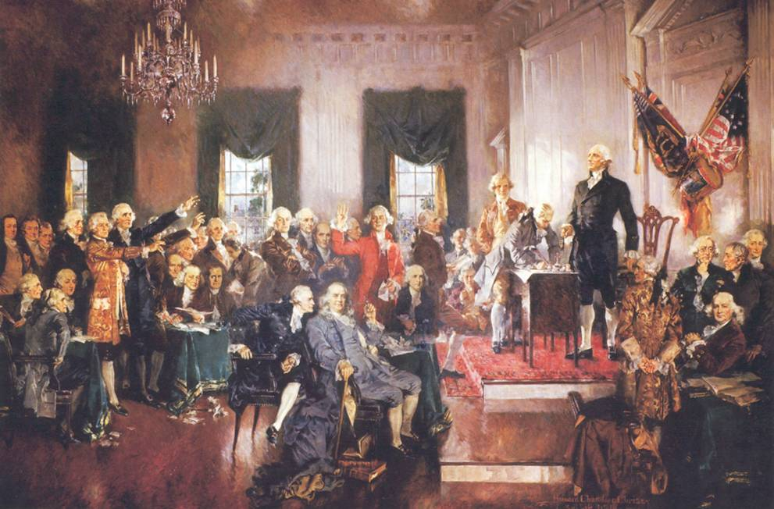

Step 6 – Create a Culture That Embraces Change
An important goal of leading change is to create a culture that embraces the need for change and that seeks it out willingly, effectively, and with a sense of eagerness and anticipation. That can happen within a small team of people, a Scouting unit, a business, or an entire organization.

Three Characteristics of a Good Incremental Goal
- It’s visible (people see for themselves it’s not just hype)
- It’s unambiguous
(a real win-no doubt)
- It’s clearly related to the change effort
Small Steps Can Lead Toward Remarkable Goals
We cannot become what we need to be
by remaining what we are.

The Ultimate Step - Lead Change Through Lifelong Learning
Leaders are educators. They don’t just educate others, though. They are also responsible for seeing to their own continuing education.

Mental Habits That Support Lifelong Learning
- Risk Taking
- Humble self-reflection
- Solicitation of opinions
- Careful listening
- Openness to new ideas
If we have
a clear vision of what can be,
then leading change
can help make it so.

Generations in Scouting

In the Wood Badge segment on Leveraging Diversity thru Inclusiveness we learned:
- Diversity embraces the qualities of other people that are different from our own.
- The different types of diversity: human, cultural and organizational.
- How we can use diversity.
The Generations in Scouting segment is intended to help you:
- Understand generational differences as another aspect of diversity.
- Consider how those differences impact each generational group.
- Understand the “adult led, youth run” aspects of a unit.
- Learn ways to work together across generations for a better future.

Definition of a Generation
A group of people born in the same time frame with common cultures and attitudes.

Why is this Important
Understanding generational differences is important because those in different generations have different experiences, core values, work ethics, attitudes, behaviors, leadership styles, and learning methods.

Five Generations in Scouting
- Silent Generation (Traditional), born 1928 to 1945, now age 66 to 83
- Baby Boom Generation, born 1946 to 1964, now age 47 to 65
- Generation X, born 1965-1980, now age 31 to 46
- Millennials (Generation Y), born 1981 to 2000, now 11 to 31
- The Next Generation (as yet unnamed), born in the 21st century, now at least 10
The fifth generation in Scouting is, of course, The Greatest Generation. Although some are still around, these 80+ year-olds are not discussed here.

What Events and Experiences Shaped Each Generation
Silent Generation—The Great Depression, Roosevelt’s New Deal, World War II, GI Bill, radio and television
Baby Boomers—The struggle for Civil Rights, Cold War, Vietnam War, space travel, television
Generation X—Fall of the Berlin Wall, latchkey kids, divorce, Watergate, energy crisis, video games and MTV
Millennials—Columbine, Oklahoma City bombing, Clinton/Lewinsky, technology, social networking
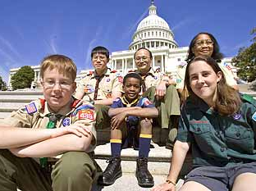
See Table Following for Personal and Lifestyle Characteristics by Generation

Working with the Silent Generation
- Capture and apply their wisdom
- Help them adapt to and embrace new technologies
- Provide flexible ways for them to be involved in scouting as they grow older
- Recognize and applaud their contributions

Working with Baby Boomers
- Take advantage of their willingness to make commitments and assume leadership roles
- Respect their experience
- Offer them opportunities
- Motivate them on their terms
- Make them mentors

Working with Gen Xers
- Challenge them
- Vary their experiences
- Give structure and direction
- Support their lifestyles
- Give them feedback and individual recognition

Working with Millennials
- Take advantage of their motivation and willingness to volunteer
- Provide variety of experience
- Be specific about expectations
- Foster collaborative effort
- Offer coaching and guidance
- Recognize and make use of their technological orientation and knowledge
- Give feedback often
- Make it fun

Scouting never has been more diverse in gender, ethnicity or age of volunteers. Scouting also is reaching out for more opportunities to serve communities in new and diverse ways. The challenge is to create a cohesive team to address the specific needs and challenges of the units, districts, councils – and most of all, the Scouts.
Scouting tomorrow will be as different from today as it is from 30 years ago. Together we can create the greatest change in Scouting history and equip the next generation of leaders to build upon our legacy.

Sources and Suggested Reading
Millennials Rising, The Next Generation, Neil Howe and William Strauss, Vintage Books 2000.
Generations, Inc., From Boomers to Linksters-Managing the Friction Between Generations at Work, Meagan Johnson and Larry Johnson, AMACOM 2010.
Millennials, A Portrait of Generation Next, Pew Research Center, February 2010.
Forty Years After Woodstock, A Gentler Generation Gap, Pew Research Center, August 12, 2009.
How Generational Theory Can Improve Teaching: Strategies for Working with the “Millennials”, Currents in Teaching and Learning, Vol. 1, No. 1, Fall 2008.
Managing the Millennials, Discover the Core Competencies for Managing
Today’s Workforce, Chip Espinoza, Mick Ukleja and Craig Rusch, Wiley, 2010.

Situations
Consider the following questions in your Patrol:
What generational conflicts does the Situation present?
How can the team work together to overcome the generational conflicts?

Situation One: Your Unit is approaching its 50th Anniversary.
It has been a tradition to hold a potluck dinner to celebrate every 10-year anniversary. The Scoutmaster is a Gen Xer. He wants to do something new and exciting that might engage a wider audience in the community.
The Committee Chair is a member of the Silent Generation and values tradition. Most of the Assistant Scoutmasters and Committee Members are Baby Boomers.

Situation Two: The Unit’s leadership (Scoutmaster and Committee Chair), as well as most of the Assistant Scoutmasters and Committee Members, are Baby Boomers. They have held their positions for five to seven years. Several parents, who are Gen Xers or Millennials, have wanted to participate and contribute but have been discouraged with the lack of opportunities.

Personal and Lifestyle Characteristics by Generation
Characteristic | Silent Generation  (Traditional)  Born 1928-1945 | Baby Boom Generation  Born 1946-1964 | Generation X  Born 1965-1980 | Millennials  (Gen Y)  1981-2000
Current Ages | 66 to 83 | 47 to 65 | 31 to 46 | 11 to 31
Size of Generation | 52 Million | 78 Million | 46 Million | 75 Million +
Core Values | Respect for Authority  Conformity  Loyalty  Discipline | “Me” Generation  Internally Driven  Competitive | Independent  Self-Confident  Skeptical | Confident and Ambitious  Optimistic  Open to Change  Sense of Entitlement
Motivated By | Loyalty | Team Development | Love to Fly Solo | Fellowship
Work/Family Life Balance | Duty Before Fun | No Balance  Live to Work | Work to Live  Demand a Work/Life Balance | Work Hard, Play Hard  Family Comes First  Value Free Time
Work Ethic | Hard Work  Sacrifice  Play-by-the-Rules | Hard Working  Results-Driven | Want Structure and Direction | Team Players
View of Authority | Respectful | Accepting of Authority, But Question | Challenge Authority  Not Intimidated | Accepting  Deferential
Leadership Style | Hierarchy  Seniority  Command and Control | Collegial  Participative  Consensus | Straightforward  Based on Competence | Inclusive  Averse to Conflict
Feedback Preference | No News  is Good News | Annually with Documentation | Interrupts and asks, "How am I doing?" | Wants constant feedback
Communication Skills and Styles | Prefer Face-to-Face | Prefer Meetings and Telephone Calls | Favors Email and Voicemail | Prefers Texting and Social Media
What They Want | To Be Respected and Contribute in a Meaningful Way | Respect for Their Experience and Coming Together to Solve Problems | Independence and Recognition for Individual Achievement | Structure and Watchful Interest

Problem Solving and Decision Making

In Scouting, there will be numerous occasions when effective planning is necessary. On Day Two, we saw the five steps of team based project planning. These steps were a project overview, work breakdown structure, activity assignments, action on the plan and a closeout report. By following these five steps, the individual or team increases the chances of a successful outcome.
However, within the scope of the entire project, problems will arise that require immediate attention. Like in project planning, the steps that you take in resolving a problem play a big role in achieving the desired and best outcome for the team or individual. Let’s use a real scouting example and walk through the steps of effective problem solving and decision making.
Camping trips represent the major activity of most units. A big part of each camping trip is cooking. Prior to each camping trip, the patrol develops a patrol menu and a duty roster outlining each scouts cooking and cleaning responsibilities for the various meals. The goal for the patrol is to have good meals that satisfy each patrol member. For our example, the Eagle Patrol has developed a good menu for their camping trip, however once they are in the woods things are not going as planned. As a result, the meals are not good and some members of the patrol are frustrated.
Finger pointing and blame is being spread around various members of the patrol. How do we resolve this?
There are five steps to systematic and effective problem solving. Let’s apply them to our example.

- Describe the problem. Do this as accurately and completely as possible. The better you understand the problem, the more efficiently you can solve it.
For the Eagle Patrol, the problem is the meals are not good, the cleaning is not getting done and everyone is frustrated.
- Gather information. Consider quantitative information (facts that can be measured) and qualitative information (how people feel about the situation).
For the Eagle Patrol, there are six members of the patrol and four separate meals to cook and clean (quantitative). Three of the patrol members have been doing all the work, while the other three members are not helping. The three patrol members doing all the work are frustrated at having to do all the work and mad at the other three (qualitative). As a result, all of the meals are not prepared properly or completely and the cleanup does not get done at all.
- Determine the most important factors that contribute to the problem. Figure out what is causing the problem. Factors may include timing, personality, the setting, a combination of all three or something completely unforeseen.
For the Eagle Patrol, the initial cause may appear to be laziness on the part of three members. However, the cause could also be lack of knowledge about cooking and cleaning, lack of understanding of each member’s role, lack of understanding about the duty roster or a weak patrol leader unable to properly lead the patrol. For the Eagle Patrol, the cause turned out to be a lack of knowledge on how to cook and clean.
- Visualize what success looks like. Describe how things will be when the problem is solved and everything is working well.
For the Eagle Patrol, success is having each patrol member knowledgeable about cooking and cleaning and fulfilling their responsibilities on the camping trip.
- Create action steps that will lead to that success. Action steps close the gap between the current situation and your visualization of success.
For the Eagle Patrol, the action steps include the patrol leader instructing members of the patrol on cooking and cleaning and then supervising them while they prepare a meal and cleanup.

For problem solving, the solution is not always obvious. A systematic approach as outlined above can solve problems quicker, more efficiently and increase the odds for success.
When an individual or team is working on a project or addressing a problem, decisions have to be made. The nature of the team, its experience together and the situation it finds itself in can all contribute to the way a team makes a decision. There are many ways that teams can reach decisions:

- Brainstorming allows for the free flow of ideas. When the Eagle Patrol was preparing their menu for the camping trip, each member was encouraged to give their input. Everyone’s ideas are valuable.
- Consensus occurs when a discussion leads to an agreement without resorting to a vote. For the Eagle Patrol, everyone verbally agreed to orange juice for breakfast, so a vote was not necessary.
- Multivoting When there are many acceptable options and no consensus, multivoting allows team members to cut a list down to a manageable size. For example, the Eagle Patrol could not reach a consensus on bacon, sausage or ham for breakfast, so they took a vote among members to choose. It may take several votes, so if necessary, repeat the voting process.
- Parking Lot This involves tabling part of a discussion that is not immediately relevant or is not directly related to finding a solution to the problem at hand. For the Eagle Patrol, the problem was a lack of knowledge about cooking and cleaning. The immediate solution was for the patrol leader to instruct and supervise members on the current camping trip. A good idea put forward was to have a cooking class and demonstration at an upcoming troop meeting. This was tabled until the next troop meeting.
Scouting presents many opportunities for scouts and scout leaders to organize projects and events. A systematic approach to planning, problem solving and decision making will increase the chances of achieving the desired results.

Advantages of Systematic
Problem Solving
The problem-solving process is a time-saver. With an organized approach to a problem, issues can be dealt with in an orderly and timely fashion.
As teams become accustomed to using a systematic approach, they can solve problems more quickly and efficiently. A systematic approach increases the odds of success.

Managing Conflict

We’d all like to:
- Better understand conflict from a leadership point of view.
- Acquire new tools for successfully managing conflict situations.
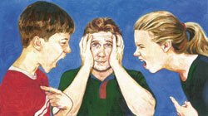
Leadership is easy when everything is going well—or when everybody is sound asleep. Much of the rest of the time, leadership involves managing conflict by finding common ground among individuals, providing tools for people to settle their own disputes, and on rare occasions stepping in to make unilateral decisions.
Specifically we want to:
- Consider the fact that we can’t make people do what they don’t want to do.
- You can encourage others to act in a specific way.
- Be aware of the boundaries of your authority.
- Get some tips on how to receive and give feedback
Ultimately, you can only empower yourself. Then, within boundaries, you can encourage others to act in certain ways.

Be Aware of Yourself
The first thing to do in any relationship, but especially one that may involve conflict, is to look at yourself.
- Why is this issue important to you?
- How important is the issue?
- Should you really intervene?
You may stumble upon a the self-resolving conflict—a situation that, if given time, will work itself out without confrontation or argument.

Be Aware of Others
Aside from when there is a safety risk, look around and see if there are others working thru the situation. Perhaps you do not really need to intervene.
However, if there is a problem and no one is moving to solve it then leadership is called for. However, when are people most likely to do what you ask them to do, especially if it is something they are less than excited about?
- When they trust you
- When they have experience with you and have found you to be a reliable leader and ally
- When they understand that you are making decisions for the good of the group
- Most of all, when they sense that you care about them
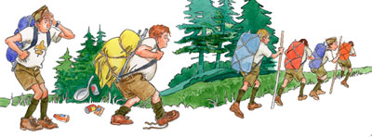

Active and Empathetic Listening
Early in this Wood Badge course, we discussed the importance of Listening to Learn. Listening is the most important skill in resolving any conflict, whether the conflict involves you as a participant or as a moderator. Unless you make a conscious effort to listen, you will miss vital facts and beliefs that could lead to a satisfactory resolution.

Set the Scene for Cooperative Resolutions
Think back to the Who-Me Game we did earlier in this course. Think of how you and others in your patrol have shared information about yourselves with one another. Remember the experiences you have shared in the last few days. Those are all points of contact, connections that provide a foundation of trust, understanding, and familiarity for further communication and, if necessary, for resolving conflicts.
In real estate, the rule is “Location, location, location!” In leadership, and especially when dealing with conflict, the bottom line is “Involvement, involvement, involvement!”
As a leader, the more you have shared with those you lead, the greater your chances of finding cooperative resolutions for conflicts. Developing that kind of connection cannot happen overnight, though. It is one of the ongoing challenges and rewards of good leadership.

Questions for Conflict Resolution
Whenever you work with people, the most important question to ask them is,
“What do you want?”
Think about that. When was the last time somebody asked you that? When was the last time somebody really listened to your answer?

Once you’ve gotten the answer to “What do you want?” there are three follow-up questions.
• “What are you willing to do to get what you want?”
• “Is what you are doing working?”
• “Do you want to figure out another way?”
Think about the power of these questions when asked in this order. The first one focuses people’s attention on what their real needs are and helps you see more clearly other people’s points of view. The subsequent questions put responsibility on other people to be a party in examining where they are and then in finding pathways to reach where they want to be.
Questions 2 and 3 are vital. Don’t skip them. They are questions that empower people. Give people the time and encouragement to figure out the answers, to understand their own path. Too often we as leaders skip questions 2 and 3. We ask, “What do you want?” and then jump immediately to a variation of question 4, telling someone what we think they should do.
Questions 2 and 3 help people figure things out on their own and discover their own path. Question 4 gives them a way to invite you to help them explore other approaches to a problem. It encourages a cooperative effort—working together to help everyone get what they want.

Remember, you can’t control another person. But you can persuade. You can join forces with him or her in a mutual search. You can encourage him or her to become an active seeker after meaningful answers.

Effective Communication in Conflict Situations
In the Wood Badge session on Communication, we talked about the fact that there is much more to conveying a message than simply repeating the words. Body language sends powerful messages, as does tone of voice.
If anger or frustration or some other emotion is clouding your ability to see an issue as objectively as possible, it’s probably wise to step back for a minute or an hour, or even a day or more. Allow time to collect yourself before going forward. Remember the parenting trick of counting to 10 before reacting to a child’s confrontational actions? The same principle holds true when you are engaged in difficult interactions with teenagers or adults.
Work on issues in the present and the future, not in the past. Rather than looking for blame and recrimination, steer conversations toward seeking solutions.
Any time you feel that you aren’t making progress or that you don’t know what to do next, return to the basic four questions.

A Directive Approach
Sometimes cooperation fails. Leaders sometimes must make the decision that certain behavior will not be tolerated. Perhaps the most dramatic instances are when safety is being compromised and someone must take action immediately.
Within the context of making such decisions—that is, proscribing behavior and then demanding that it happen that way—it is still possible to act in a manner that is effective for you and understandable to those you are leading.
Rather than four questions, directive conflict resolution is built on four statements:
- This is what I want.
- This is what I understand you are doing.
- This is why that isn’t working for me.
- Here’s what I need for you to do.
While the end result is an immediate change in behavior, this approach gives leaders tools to explain themselves and provide a basis for a decision. It allows a leader and group members to interact on a healthy level, and it provides the opportunity for directive decisions to evolve into arrangements developed through a more cooperative approach.
As with any sort of leadership, being able to step in, if necessary, and set certain boundaries is easier to do if leaders have already established a relationship of trust and understanding with those they are leading. Leaders who have taken the time to listen and learn and care for people in their groups will have a much easier time negotiating with group members and individuals to establish the needs and solutions of everyone, leaders included.
After the directive approach is used make time to explain the action so learning can be incorporated. This reinforces their trust in you.
You can be open with people in your group about your understanding of your responsibilities and what you expect from them. At its most basic, the contract between leaders and those who are led is as follows.
My Job Is Your Job Is
To do all I can to ensure your safety. To tell me when you don’t feel safe.
To help you get the most out of this To help me ensure your safety.
experience. To be honest with you To be honest with me and treat
and treat you with respect. me with respect

Ideas we don’t share often enough with others include these:
- “If I’m doing something that bothers you, I’d like you to tell me in a respectful way.”
- “How will it be if we really get along? What will that be like?”
- “If I see you’re having a problem, what do you want me to do?”

Conclusion
The right words will change things for the better, but it takes awareness and understanding to discover what those words are. It is well worth the time and the effort.
The ultimate goal of conflict resolution—to build on common ground, to listen, to find solutions to situations that allow us to grow closer to one another rather than farther apart.


DAY 5

Camp T. Brady Saunders
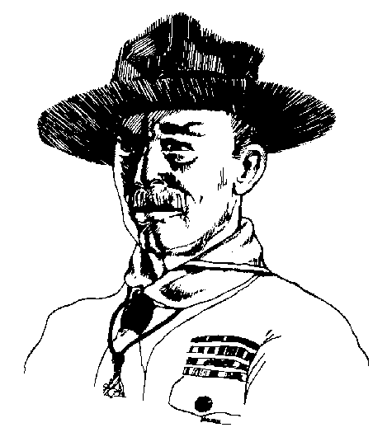

Wood Badge Course Schedule
See the Gilwell Gazette for times and locations
Breakfast and Patrol Self-Assessment
In Activity shirt over grungies, please
Gilwell Field Assembly
Patrol Project Setup and Presentations
Round One of Presentations
Break
Conservation Project (Troop Activity)
Lunch
Patrol Leaders' Council Meeting & Working Lunch
Gilwell Song
Coaching and Mentoring (Troop Presentation)
Assessments (Troop Presentation)
Break
Round Two of Presentations
Ticket Review and Collection
Staff Departs
Suggest Field Uniform
Patrol Dinner
Patrol Meeting
Patrol Campfires and Cracker Barrel
Rededication ceremony

Gilwell Field Assembly

Patrols, you’ve done extraordinarily well. Just like in a Scout Troop, the staff is confident in your abilities—what seasoned campers you are! A Tenderfoot no longer; good work.

Historic Flag Presentation

46-Star Flag
 By 1908, the United States of American had grown to encompass States from the Atlantic to the Pacific. Nearly all of the territory in between had also been recognized with state- hood. When Oklahoma joined the Union, the U.S. flag changed to include 46 stars, a design that would last for only four years and the administrations of two presidents, Theodore Roosevelt and William Taft.
For us, there is further significance. This is the flag that was flying over American in 1910 when the Boy Scouts of America had its beginnings.
Let us honor this flag with a song that also honors our land.

GOD BLESS AMERICA
God Bless America, land that I love
Stand beside her and guide her
Through the night with the light from above.
From the mountains to the prairies,
To the oceans white with foam,
God bless America, my home, sweet home.
God bless America, my home, sweet home.

Coaching and Mentoring

Responsibilities of Mentors and Coaches
- First, we must realize that when we accept positions of leadership, people will be looking up to us. We have a responsibility to listen to them, to pay attention to them, and to attempt to understand what they want and need.
- We also have a responsibility to convey our values through our actions. We must be willing to live by the standards that we are expecting others to uphold.

Coach
A coach is an individual who develops skills and capabilities in another person or in a group of people (a team).

Mentor
A mentor is an experienced Scout or adult leader who becomes a trusted guide and counselor of a less experienced individual.

What Coaches DO
- Provide task direction and vision
- Provide skill instruction
- Build team and individual capabilities
- Provide resources
- Facilitate external relationships for individuals and teams
- Transfer responsibility for success to the team
- Support the growth and progress of individuals in the program

Tips on Being a Good Coach
- Listen
- Supply energy
- Provide focus
- Provide information
- Influence, don’t control
- Recognize team and individual success
- Recognize what’s right versus what’s wrong
- Value differences
- Evolve and grow with the team’s life cycle


What Mentors DO
- Advise, support, and/or provide guidance on subjects that a young person may find difficult to discuss with other leaders or peers.
- Help a mentored person develop an understanding of the unit environment and “culture” and the practicalities of life in the unit.
- Instill attitudes, social intelligence, and values embraced by Scouting
- Aid in retention of the mentored individuals in our program.
- Provide trusted counsel and a broader perspective on Scouting and personal issues.

Tips on Being a Good Mentor
- Provide a safe, non-threatening environment in which a person can ask difficult or sensitive questions. Keep confidences.
- Build trust early
- Be a good listener
- Share personal experiences that address the issue a mentored person is facing
- Make suggestions on specific Scouting problems
- Make suggestions on what it takes to get things accomplished

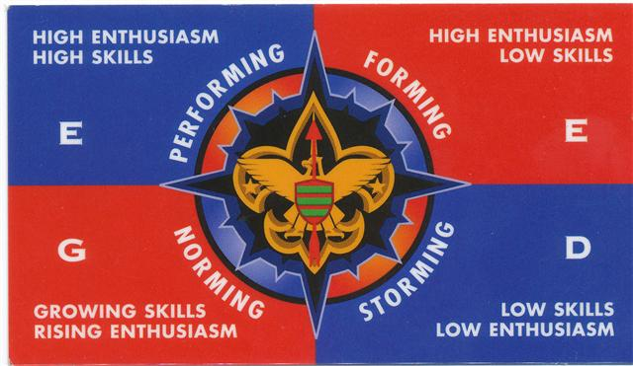
Differences
Consider the EDGE model.
Coaching is often used during the Norming stages when teams need Guidance.
Mentoring is often used during the Performing stages when individuals need Enabling.
 | Coaching | Mentoring
Goals | To correct inappropriate behavior, improve performance, and impart skills as an individual accepts a new responsibility | To support and guide the personal growth of the mentee
Initiative | The coach directs the learning and instruction. | The mentee is in charge of his or her learning.
Focus | Immediate problems and learning opportunities | Long-term personal development
Roles | Heavy on telling with appropriate feedback | Heavy on listening, providing a role model, and making suggestions and connections

Self Assessment

During this course, a lot has been talked about on assessing team performance; measuring team progress, working on projects, personal interaction and how they have progressed through various stages of development: forming, storming, norming and performing.
- Each Troop meeting was assessed during the Patrol Leader’s Council. Each member of the council was given the opportunity to answer the questions... “How are you feeling?” “How are we doing?”
- After the presentations of the patrol projects you will be given the opportunity to assess your project and presentation.
- Near the end of the course, on day 6, you will also be asked to assess this Wood Badge course.
Assessment can help a team and its leaders to understand from where they have come; where they are; and can help more effectively chart a course to where they wish to go.
This session take a few moments to consider the importance of another type of assessment; self-assessment.
In many ways, we assess ourselves all the time. We measure ourselves against each other and against all kind of social standards.
We set goals for ourselves and have a fairly good sense of where we are in fulfilling those goals and objectives.
But there are limitations to listening only to ourselves. We all see the world from our own particular perspectives, based on our unique histories and backgrounds. All of that is further shaded by the way we want to see things rather than the way things really are.
A much more complete picture of our progress comes through receiving feedback from others.

On day one, during the “Listening to Learn” session we discussed the gift of feedback.

Tips on Giving Feedback
1. Consider your motives. Feedback should always be helpful; otherwise, there is no reason to offer it.
2. Find out if the other people involved are open to receiving feedback. Listen carefully, and then rephrase what they say to be sure you understand them.
3. Deal only with behavior that can be changed.
4. Deal with specifics, not generalities.
5. Describe the behavior and do not evaluate it.
6. Let the other person know the impact the behavior has on you.
7. Use an “I” statement to accept responsibility for your own perceptions and emotions.
8. To make sure the recipients of feedback have understood your message in the way you intended it, ask them to rephrase what they heard you say.

You can give caring feedback without a good technique,
but the slickest technique in the world will not hide
a lack of caring.

Tips on Receiving Feedback
1. Seek out feedback. It will nearly always provide you with information that will in some way help you improve your performance.
2. Listen carefully. Receiving feedback requires a heightened awareness of yourself and the person offering the feedback.
3. Listen actively. Restate the feedback in your own words so that the speaker knows that the message you are receiving is the same as the one the speaker intended to send.
4. Listen empathetically. Put feedback in its proper context by observing the speaker’s body language, tone of voice, and emotions. Consider the speaker’s reasons for offering feedback.
5. Notice how you are feeling when someone offers you feedback. Becoming angry or defensive can cloud your ability to listen effectively.

Consider feedback to be a gift. It truly is.

One of the best ways for leaders to encourage effective feedback is by developing and using a 360-degree assessment.
A 360-degree assessment is based on the idea that feedback comes from all directions and depends on people considered “stakeholders”; ones that have a stake or interest in the outcome of your success or failure. Each stakeholder is viewing all aspects of your success or failure through their own perspective and can provide valuable feedback and productive opinions about your progress in reaching your goals.
As you embark on the mission of completing the goals set out in your Wood Badge tickets, each of you will discover that you have stakeholders.
In Scouting, your stakeholders may be fellow unit leaders, parents of Scouts, your district executive, roundtable chair, Cubmaster, commissioners, representatives of your chartered organization, and other Scouters who have direct knowledge of your leadership.
Each of these stakeholders represents a different perspective. Each has seen you in different circumstances and from a unique point of view. Through a 360-degree assessment, these stakeholders can provide you with valuable feedback.
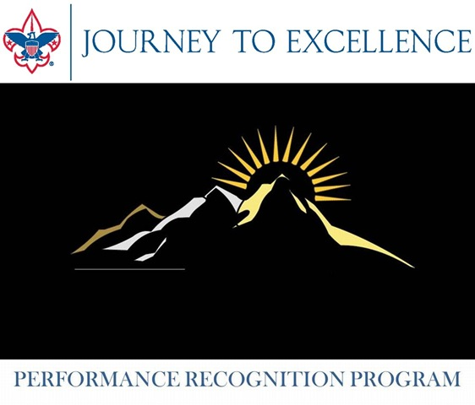
Instructions: Here are step-by-step instructions for developing and using a 360-degree assessment.
1. Determine the goals for which you wish to be assessed. The goals you are writing for your Wood Badge ticket are a good example. Ideally, the goals need to be clear, attainable, measurable, and challenging.
2. Join with a facilitator to help with the assessment process. This person should understand how a 360-degree assessment works. If your assessment is to be of your Wood Badge ticket goals, an appropriate facilitator may be your Wood Badge ticket counselor.
3. Develop an assessment survey that will provide the kind of feedback that will help you more effectively move toward your goals.
4. Identify 5 to 10 of your stakeholders who can offer a wide range of perceptions about your progress. Provide each with a copy of the survey and a stamped envelope addressed to your facilitator. Assure each stakeholder that only the facilitator will see the surveys.
5. Upon receiving the completed surveys, your facilitator will compile the results, and then meet with you to discuss the assessment and to talk about ways that you can use the results to more effectively progress toward your goals.
6. Finally, make assessment an ongoing part of your Scouting responsibilities and, where appropriate, in other areas of your life. Self-assessment should not be a one-time event, but rather a constant tool for gaining a clearer perception of your strengths and the areas where you can improve.
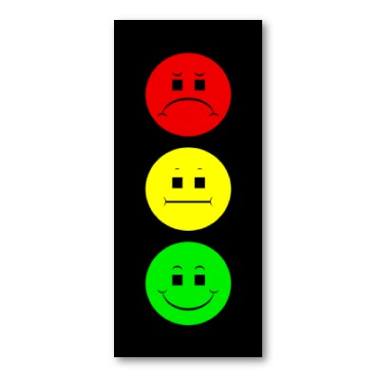

Pointers on developing a 360-Degree Assessment Survey
1. Instructions to the stakeholders should be clear and unambiguous. Stakeholders should understand why they are taking part in the assessment, how it will be used, and that only the facilitator will see their answers.
2. Questions must be developed based on the goals you are striving to reach. The feedback the questions generate should lead to real changes that will bring you closer to your goals.
3. Feedback comes from what those completing the form have actually observed and can measure. There is nothing to be gained in asking them to assess what they have not seen or cannot in some way quantify.
4. Answers to the questions can be simple and straightforward. Offer stakeholders two or three options such as the following:
• Green Light (This is good. Keep Going.)
• Yellow Light (This could be better)
• Red Light (Some serious concerns here.)
Or
• Way to go
• Ways to grow
Or
• Start
• Stop
• Continue
The survey should also encourage stakeholders to add any comments and suggestions they feel would be helpful. This kind of feedback can be extremely helpful.
Use assessment as a tool for Leading Change.
Good 360-degree assessments help people discover differences between how they perceive themselves and how others perceive them.

Sample 360-Degree Assessment Survey
I am seeking productive feedback on my progress toward reaching these four goals that have to do with my leadership in Scouting:
1. ________________________________________________________________________________

2. ________________________________________________________________________________

3. ________________________________________________________________________________

4. ________________________________________________________________________________

With those goals in mind, please provide an assessment of how I am doing. Of the following questions, answer those for which you have personal knowledge. Your answers may be either “Way to Go!” or "Ways to Grow." If an answer is “Ways to Grow,” please feel free to suggest how I can do better in that area.
When you have finished the survey, please mail it in the enclosed envelope to my assessment facilitator. The facilitator will provide me with a summary of all the surveys. No one but the facilitator will see your answers.

 | Way to Go! | Ways to Grow
1. Produces work on time
2. Communicates well with others
3. Encourages diversity in Scouting
4. Develops creative solutions to problems
5. Demonstrates a good knowledge of Scouting
6. Treats Scouts and Scouters in a respectful, considerate manner
7. Creates an environment that makes progress possible for all
8. Serves as a good role model
9. Shares knowledge with others
10. Takes active steps to ensure lifelong learning

DAY 6

Camp T. Brady Saunders
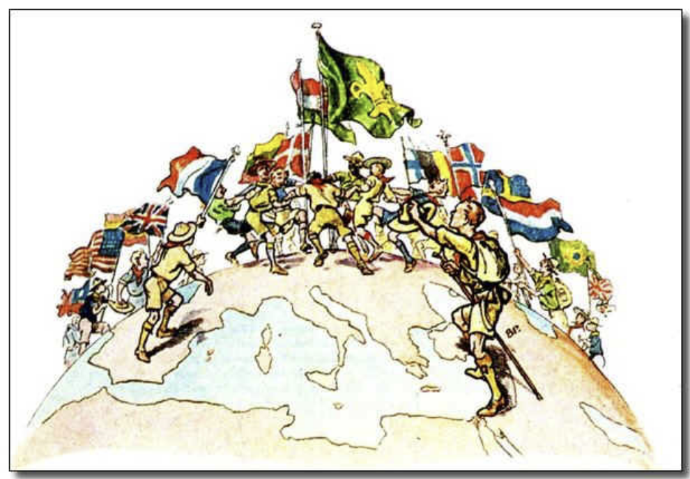
Flags (left to right). China, U.S.A., Spain, Great Britain, France, Lithuania, Denmark,
Hungary, World Scout Flag, Finland, Belgium, Norway, Sweden, Netherlands, Brazil, Japan

Wood Badge Course Schedule
See the Gilwell Gazette for times and locations.

Breakfast and Patrol Self-Assessment
In Field Uniform, please
Patrol Time
Patrol Leaders' Council Meeting
Gilwell Field Assembly
Interfaith Worship Service (Troop Activity)
Closing Luncheon
Leaving a Legacy (Troop Presentation)
Break
Summary Session (Troop Presentation)
Course Assessments
Closing Gilwell Field Assembly
Departure

Gilwell Field Assembly

Today the Troop has work to do before return from the back country. We look back on our time together as we renew our commitment to servant leadership.

Historic Flag Presentation

The World Scout Flag

Scouting is world wide, serving 28 million individuals in over 150 countries. In the United States, Scouts and Scouters may wear the purple World Scout emblem above their left shirt pocket. The emblem includes a rope which encircles the fleur-de-lis and is tied by a square knot. The rope is there to symbolize the World Scout Movement and the rope represents unity. Royal purple is the color of leadership and service.
Let’s sing a song to remind us of why we are all here.

On My Honor
On my honor I'll do my best
To do my duty to God.
On my honor I'll do my best
To serve my country as I may.
On my honor I'll do my best
To do a good turn each day.
To keep my body strengthened.
To keep my mind awakened.
To follow paths of righteousness..
On my honor, I'll do my best.

Reading
Today, we will be reading an excerpt from Baden-Powell’s final message to Scouters. It was found among his papers after his death in 1941. These words were written during his final years while living in Kenya. He was buried in Nyeri, within sight of Mt. Kenya and a simple stone marks his gravesite. On it are the symbols for boy and girl scouting as well as a circle with a dot inside—the symbol for “gone home”.
Dear Scouts, … I have had a most happy life and I want each one of you to have as happy a life too. I believe that God put us in this jolly world to be happy and enjoy life. Happiness doesn’t come from being rich, nor merely from being successful in your career, nor by self-indulgence. One step towards happiness is to make yourself healthy and strong while you are young, so that you can be useful and so can enjoy life.
Nature study will show you how full of beautiful and wonderful things God has made the world for you to enjoy. Be contented with what you have got and make the best of it. Look on the bright side of things instead of the gloomy one.
But the real way to get happiness is by giving out happiness to other people. Try and leave this world a little better than you found it and when your turn comes to die, you can die happy in the feeling that at any rate you have not wasted your time but have done your best. “Be Prepared” in this way, to live happy and to die happy—stick to your Scout promise always… and God help you do it.


Leaving a Legacy

We’re about to wrap up this Wood Badge course and conclude our six-day study of leadership. You’re probably thinking that there isn’t much more that can be said about leadership, but there is one thing left that we want to share with you: The Greatest Leadership Secret

1. It’s a Palindrome—Sort Of
A palindrome is a word, phrase, line, or verse that reads the same backward as it does

2. Lead From the Inside Out
If you don’t put the big rocks in first, you’ll never get them in at all. What are the big rocks in your life? The best leaders lead from the inside out. Lead yourself first before you lead others. Accept responsibility for your own growth and progress—your own rocks—and take care of them first.
Realize, too, that after you have taken care of your big rocks, there will still be room for more. There will still be space in your life for you to lead and serve others. And you’ll be better at leading others because you’ve practiced leading yourself first.

3. Great Leaders Are Great Teachers
The third clue to the Greatest Leadership Secret is also another quality of great leaders—that’s the fact that great leaders are also great teachers.
A key ability of a great Scout leader is to create an atmosphere in which young people can learn to lead their own Scout units. Good leaders help others learn to think, to judge, to act, and to motivate. If you are not teaching while you are leading, you are not doing your whole job as a leader.
There are a couple of other dimensions to this that are important to talk about as well.
- Great leaders are great students, too. They realize that learning is a lifelong process. They never stop learning—they have a passion for it.
- Great leaders learn from what they do. They assess, analyze, try new things. Through lifelong learning, they continually grow and improve.
Business sometimes refers to this process of lifelong learning as “continuous quality improvement” or “total quality management.” Use whatever works for you, but know that with continuous, careful analysis, everything can always be improved, just about everything we can do, individually or as a team, we can learn to do better.

4. Build Heart Connections
Building heart connections is about communicating genuine care and respect for our fellow human beings—those we lead and those we don’t. It’s about reaching out and touching people, connecting with them at a very simple human level.
Respect, like love, has value only when it is given freely and is genuine. People can see through counterfeit respect, caring, and love.
It’s the same way with leadership. We nurture, we encourage, we care for others.

5. It’s in Every One of Us
Taking charge of your own life—self-leadership—is the first step toward the kind of personal empowerment that will allow you to lead others. Accept responsibility for your own growth and progress. Realize your own personal power.
As you give yourself the direction and support you need, turn outward and begin empowering those you lead. Empower everyone you can. Authority is 20 percent given and 80 percent taken. Free those you lead to realize and utilize their own abilities. Help them develop self-confidence.
All people have untapped leadership potential, just as all people have untapped athletic ability. With coaching and practice, they can all get much better at it.
It’s in every one of us. As a leader you must find it in yourself, and you must help other people find it in themselves. The most effective leaders empower themselves and others, bringing out the best in everyone.

6. Leave a Legacy
The great thing about leadership is that it can be studied and practiced. We can all get better. We can all win at this game of life, and we can all leave legacies that bring us satisfaction and pride.
What will your legacy be? What impact will you have upon others? How will you bring leadership to Scouting and to America?

Conclusion
So what is the Greatest Leadership Secret?
- You lead from the inside out.
- Great leaders are great teachers.
- Build heart connections.
- It’s in every one of us.
- Leave a legacy.
The Greatest Leadership Secret is infused through human history, its message worded a little differently by different traditions.
“What you do not want done to yourself, do not do unto others.”
—Confucius, 551-479 B.C.

“What you hate,
do not do to anyone.”
—Judaism

“Hurt not others
that which pains thyself.”
—Buddhism

“The real way
to get happiness
is by giving out happiness
to other people.”
—Baden-Powell,
The Founder’s Last Message

In the form most familiar to us, the Greatest Leadership Secret is this:
“Do unto others as you would have them do unto you.”
—The Golden Rule

The importance of its meaning flows both directions, as does that of a palindrome. Its few words encompass the five important attributes of leaders, and plenty of lesser qualities as well.
“Do unto others as you would have them do unto you.” Simple, isn’t it? Obvious, too, but the Greatest Leadership Secret presents each of us with all we need to know. As leaders, as Scouters, as human beings, we can all strive to meet this challenge of a lifetime, and in doing so will find our lifetimes enriched with the knowledge that we are doing our best.
All of you have the knowledge to be great leaders. All of you will find opportunities to change lives. Each of you can leave a legacy, but none of that will happen unless you take action. What will your legacy be?
It’s your move.

Take Home Messages For 21st Century Wood Badge

Living the Values

Values, Vision, Mission
- Effective leaders create a compelling vision and inspire others to bring the vision to reality.
- Your ticket will help you turn your personal vision into reality.

Bringing the Vision to Life

Listening to Learn
- Listening is a skill that can be improved.
- Listening is critical to successfully communicate, learn, and lead.
- Feedback is a gift.

Communicating
- Communication is essential to effective leadership and high-performing teams.

Coaching and Mentoring
- Our actions and behaviors as a coach or mentor will have big consequences.

Leveraging Diversity by Inclusiveness
- We are stronger when we make diversity work for us.
- Inclusive behaviors will help us achieve diversity.
- Leading change to become more inclusive is critical for Scouting to remain relevant.


Generations
- Scouts and Scouters span multiple generations, working with and learning together.
- We must equip our next generation to build on the legacy we have created.
- Our shared vision for Scouting will bridge our generations.

Models for Success

Stages of Team Development
- The role of the leader is to move the team through the stages of development to become an empowered high-performance team.

Leading/Teaching EDGE
- Leaders are more successful when they adapt their instruction to the development stage of the team
- The EDGE acronym describes the leader’s behavior: Explain, Demonstrate, Guide, Enable.

Tools of the Trade

Project Planning
- A five-step approach to planning will enable teams to achieve greater success.

Leading Change
- Change is inevitable, yet should be a positive experience.
- Leading others through change takes planning and a shared vision.

Managing Conflict
- Conflicts will occur, and can be objectively approached by asking four key questions – What Do You Want …

Problem Solving and
Decision Making
- Teams using a structured approach to problem solving achieve better results and become higher performing.

Self-Assessment
- Self-assessment helps each of us to realize our full potential as a leader.
- Seek feedback – it is a gift, as we know from Listening to Learn.
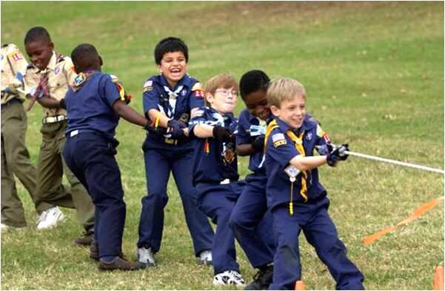

Leading to Make a Difference

Leaving a Legacy
- What is the key take-home message of “Leading to Make a Difference”?
- That’s for you to determine in your own life.
- It’s for you to make the most of the opportunities and challenges you find along the way.
- You will write you own legacy.
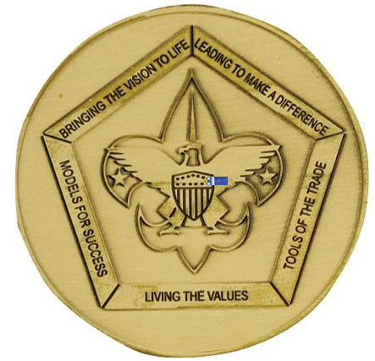

Key messages to consider:
- Values, vision and mission can change the world.
- The choice of how you will lead to make a difference in Scouting is up to you.
- Ask yourself, “What will my legacy be?”
Then act to make it real.



Appendix

Aims of Scouting Worksheet (answers)

The Aims of Scouting
Character development, citizenship training, and mental and physical fitness

The Methods of Scouting
Cub Scouting | Boy Scouting | Venturing
Boys grades 1-5 | Boys ages 11-18 | Young men and women
 |  | ages 14-20
 | 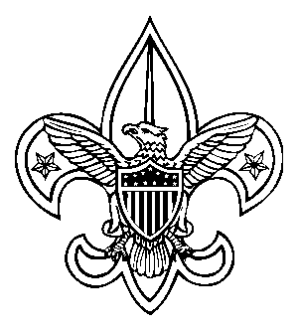 | 
The ideals | The ideals | The ideals
Den | Patrol | Group activities
Advancement | Advancement | Recognition
Family Involvement | Adult association | Adult association
Activities | Outdoors | High adventure
Home- and neighborhood-  centered | Personal growth | Teaching others
Uniform | Uniform
 | Leadership | Leadership

The Mission Statement of the Boy Scouts of America
The mission of the Boy Scouts of America is to prepare young people to make ethical choices over their lifetimes by instilling in them the values of the Scout Oath and Law.

Vision statement
The Boy Scouts of America will prepare every eligible youth in America to become a responsible, participating citizen and leader who is guided by the Scout Oath and Law.
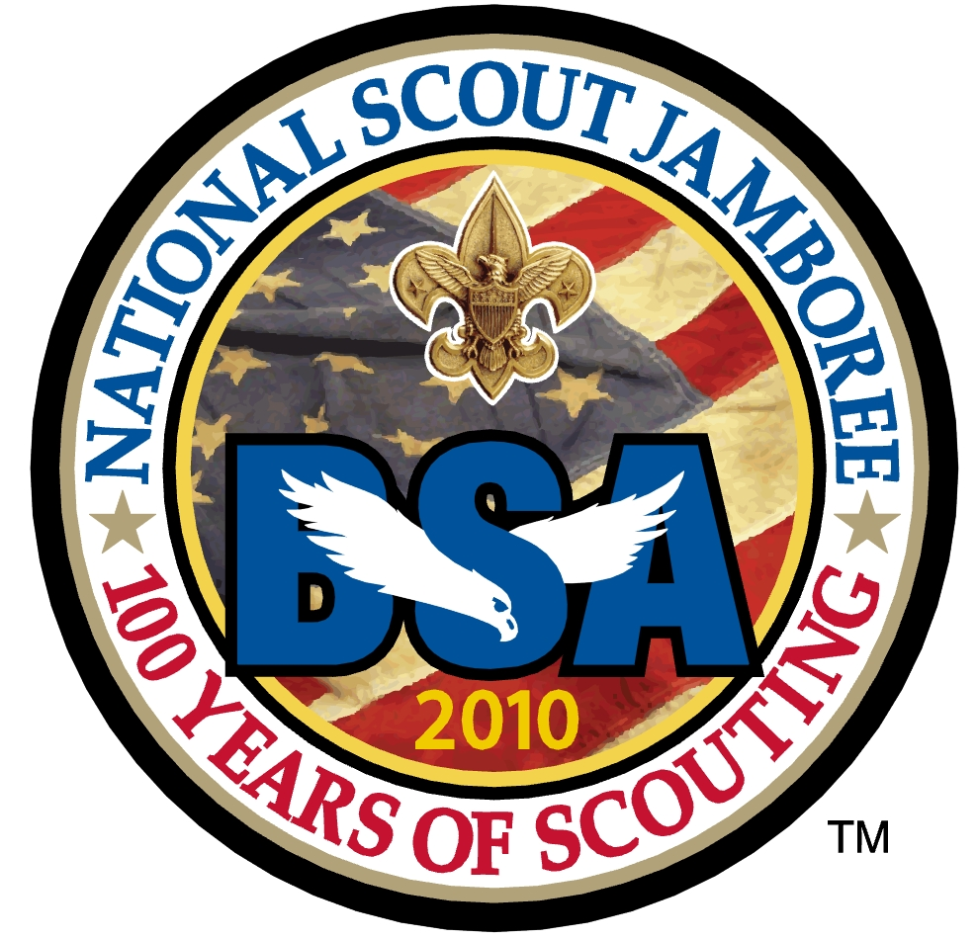

Additional Goal-Setting Questions
The Twenty Questions precourse assignment was intended to help you lay the groundwork for the course by developing a clearer understanding of your personal interests, values, and sense of the future. Now it’s time to begin developing a vision and considering the mission that will allow you to make that vision a reality. That’s at the heart of the Wood Badge ticket. Along the way, you are very likely to discover that the values of Scouting form the foundation for your vision and mission.
The following list of questions may help you formulate some of your 5 ticket goals.
- Set aside time to think seriously about the following questions.
- Some may apply, others won't, you may think of more on your own.
- You may find them to be a helpful reference.
- Don’t worry about what the “right” answers are or about satisfying someone else’s idea of how you should respond.

Consider
What aspect of the scout program that you are involved in do youth seem to enjoy most? … enjoy least?
How often are activities repeated?
What new programs / activities should be considered / provided?
What new skills need to be developed?
What new equipment is needed?
How can programs / activities be changed to challenge youth / adults to improve their skills?
What aspect of the program do Adults seem to enjoy most?… enjoy least?
What aspect of the scout program do you enjoy most?
What areas frustrate you?
Does your Troop follow the Troop Meeting Plan?
Is your troop Adult Led or Youth-Led?
Who really runs Patrol Leaders Council?
Who Plans the Unit Annual Activity Plan?
Does your Unit participate in the Religious Awards Program?
How does your unit recruit new members?
How well does your unit retain members?
Why do youth leave your program?
How do Registered Adults support the unit leader?
How do Parents support the unit leaders?
How does your Charter Organization support your unit?
How does District support your unit?
How does Council support your unit?
How does your unit support your Charter Organization?
How does your unit support District?
How does your unit support Council?
What service projects does your unit perform?
Are all of your adults trained?
Are your youth leaders trained?
What Leadership opportunities are available for your youth?

Overwhelmed? Too much information?
Yes we all want world peace, justice, and the perfect scout unit. But that’s not required for a Ticket. Just five simple things that you can do in 18 months is all that's required. Plus, these are not set in stone—if things change in the next year or so, you’ll work with your Ticket Counselor and change some of your Goals. It's OK; it will all work out.
Ticket => just 5 things you can do for your guys
JTECub1
JTECub2
JTEScouts1
JTEScouts2
JTECrew1
JTECrew2

Wood Badge Ticket Workbook
See “Guidelines for a Wood Badge Ticket” in the Day One section.

Purpose
The purpose of a Wood Badge Ticket is to help you realize your personal vision of your role in Scouting. Ideally, you will write your ticket around your primary job in Scouting.

Three parts of a ticket
A ticket consists of three parts:
- A description of your Scouting role
- A statement of your vision of success
- A plan of action composed of five significant goals that can be attained within 18 months. At least one will incorporate an aspect of diversity.

Realization of your vision
You should not expect that you will realize your vision immediately upon completion of the five goals; reaching your goals is an initial part of a long-term work in progress.

Use of Skills
It is assumed that you will use most or all of the skills you learned during the Wood Badge course. In writing your ticket it will help if you list the skills you can use to accomplish your goals. It is not required that you incorporate all of the skills presented during the course into your goals.

Diversity
At least one goal must address increasing diversity within the Boy Scouts of America.
Notes for Part 1:
Describe your job in Scouting; the role that you fulfill. It may be helpful to confer with your group leader to review your role so that you understand what responsibilities you have.

Notes for Part 2:
Vision Statement
A vision is a picture of future success. Our vision is formed when we think far enough ahead to realize that there will be challenges for which we can prepare.

Notes for Part 3: Five SMART* Goals
The remainder of the Wood Badge ticket focuses on your goals. There should be a minimum of 5 goals that can be attained in less than 18 months. One of the goals must address increasing diversity in the Boy Scouts of America.
Brainstorm some ideas below:

All Ticket Goals should be “SMART” : Specific–Describe this Ticket Goal in enough detail so that you and your ticket counselor know specifically what is to be done; how it is important, or how it will have an impact on the program. Is it challenging? Measurable–Describe how this Ticket Goal is Measurable. How will you know when the goal has been accomplished? Attainable–Describe how this Ticket Goal is Attainable. Can it be accomplished? Relevant–Describe how this Ticket Goal is Relevant to your Vision of Success in your primary Scouting position? Timely–Describe how this Ticket Goal is Timely. What is the time frame to completion?
Wood Badge Ticket Goal Sheet Goal #____
Step 1: Name Patrol: __________________________
My Scouting position:
For this goal, who will benefit from my leadership:
Step 2: My Vision of future success is:
Step 3: Describe your SMART* goal:

Complete the development of your goal by defining the following elements.
Who:
What:
Where:
When:
Why:
Self-Assessment:
How Measured:
How Verified:

Troop Guide Goal Approval: _________________________________ Date: ________________
* Specific, Measurable, Attainable, Relevant, and Timely; That’s SMART.
Wood Badge Ticket Goal Sheet Goal #____
Step 1: Name Patrol: __________________________
My Scouting position:
For this goal, who will benefit from my leadership:
Step 2: My Vision of future success is:
Step 3: Describe your SMART* goal:

Complete the development of your goal by defining the following elements.
Who:
What:
Where:
When:
Why:
Self-Assessment:
How Measured:
How Verified:

Troop Guide Goal Approval: _________________________________ Date: ________________
* Specific, Measurable, Attainable, Relevant, and Timely; That’s SMART.
Wood Badge Ticket Goal Sheet Goal #____
Step 1: Name Patrol: __________________________
My Scouting position:
For this goal, who will benefit from my leadership:
Step 2: My Vision of future success is:
Step 3: Describe your SMART* goal:

Complete the development of your goal by defining the following elements.
Who:
What:
Where:
When:
Why:
Self-Assessment:
How Measured:
How Verified:

Troop Guide Goal Approval: _________________________________ Date: ________________
* Specific, Measurable, Attainable, Relevant, and Timely; That’s SMART.
Wood Badge Ticket Goal Sheet Goal #____
Step 1: Name Patrol: __________________________
My Scouting position:
For this goal, who will benefit from my leadership:
Step 2: My Vision of future success is:
Step 3: Describe your SMART* goal:

Complete the development of your goal by defining the following elements.
Who:
What:
Where:
When:
Why:
Self-Assessment:
How Measured:
How Verified:

Troop Guide Goal Approval: _________________________________ Date: ________________
* Specific, Measurable, Attainable, Relevant, and Timely; That’s SMART.
Wood Badge Ticket Goal Sheet Goal #____
Step 1: Name Patrol: __________________________
My Scouting position:
For this goal, who will benefit from my leadership:
Step 2: My Vision of future success is:
Step 3: Describe your SMART* goal:

Complete the development of your goal by defining the following elements.
Who:
What:
Where:
When:
Why:
Self-Assessment:
How Measured:
How Verified:

Troop Guide Goal Approval: _________________________________ Date: ________________
* Specific, Measurable, Attainable, Relevant, and Timely; That’s SMART.

Application for Training Recognition
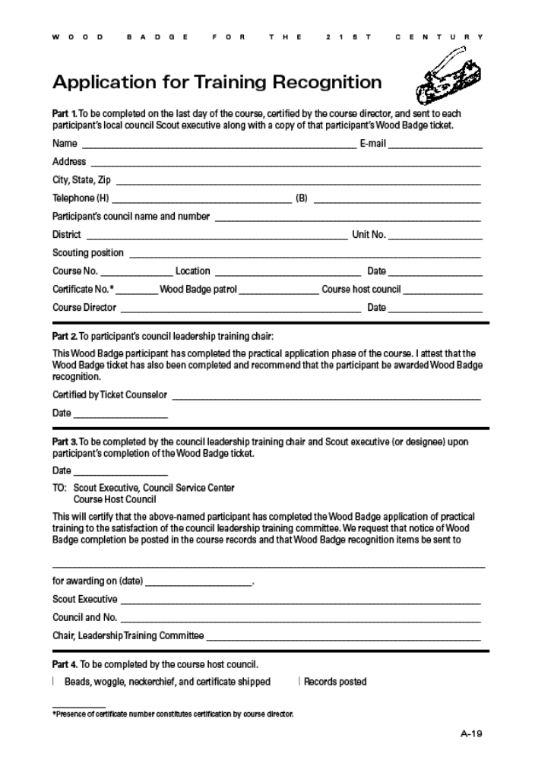

Wood Badge History

On the morning of September 8, 1919, a 61 year-old retired general of the British Army stepped out into the center of a clearing at Gilwell Park, in Epping Forest, outside London, England. He raised to his lips the horn of a Greater Kudu, one of the largest of African antelopes. He blew a long sharp blast. Nineteen men dressed in short pants and knee socks, their shirt-sleeves rolled up, assembled by patrols for the first Scoutmasters’ training camp held at Gilwell. The camp was designed and guided by Sir Robert Baden-Powell, the founder of the World Scouting Movement.
When they had finished their training together, Baden-Powell gave each man a simple wooden bead from a necklace he obtained from a Zulu chieftain when on campaign in South Africa in 1888. The Scoutmaster’s training course was a great success and continued to be held year-after-year. At the end of each course the wooden beads were used to recognize the completion of training. When the original beads ran out, new ones were whittled to maintain the tradition established by Baden-Powell. Because of these beads, the course came to be known as the Wood Badge Course. It continues to this day in England and around the world as the advanced training course for leaders in Scouting.
Wood Badge training was officially inaugurated in the United States in 1948. Since that time it has grown and developed and become a key motivating force in the training of volunteer leaders in the Boy Scouts of America.
For the next 10 years, Wood Badge courses were conducted by the Boy Scouts of America exclusively for the purpose of training representatives from councils in methods of training and how to help with the leadership training programs of their own councils. Scouters were required to subscribe to an agreement of service. This is the “Ticket.”
One of the great traditions of Wood Badge is the ticket. In Baden-Powell’s day, those in the military were expected to pay their own way back to England at the end of their service. In order to economize, soldiers nearing completion of their duties would seek assignments at posts increasingly close to home—a process known as “working your ticket.”
In the 1970’s two Wood Badge programs emerged. Cub Scout Trainer Wood Badge and Boy Scout Leader Wood Badge. The two courses share a common spirit and tradition, much of the symbolism is the same. The recognition for completion—the regalia is identical, and we are unified as we sing the same song, “Back to Gilwell”.
The fundamental difference between the two courses was in the audiences they serve. Both courses had a practical phase that is similar. It is a weeklong or several weekends long and is designed to help Scouters become more effective in their specific areas (Cub Scout Trainer, or Boy Scout Leadership). Successful completion of the practical course is based on evaluation by he staff members.
Both Wood Badge courses have an application phase—the Ticket. It could not be completed in less than 6 months and no more than 2 years.
The General purpose of Cub Scout Trainer Wood Badge training was to develop Council and District trainers to provide effective administration and implementation of Cub Scout leadership training, to improve the performance of Cub Scout leader trainers, thus ensuring a quality Cub Scout program.
Cub Scout Trainer Wood Badge was the advanced training program for trainers of Cub Scout leaders. This included members of District and Council Cub Scout leader training teams, as well as Cub Scout Roundtable Commissioners and their staffs. Other volunteer and professional Scouters with Cub Scout leader training responsibilities may also be invited to attend. Cub Scout Trainers are presented with 8 training techniques that will help them be better trainers. They were to identify 2 ways they can use each technique in their responsibilities in their District or Council. These commitments constituted their “ticket” and are given to and approved by the Den Counselor before the end of the course. Successful completion of the ticket was verified by the Den Counselor. Along with the ticket, Scouters also agree to participate in a minimum of 6 Cub Scout leader training sessions totaling 18 hours or more. . . verified by their district and sent to the Den Counselor, and complete a set of study questions which are returned to their Den Counselor for approval.
Each Region may conduct one or more Cub Scout Trainer Wood Badge courses each year. Scouters attend only by invitation from the Region, based on recommendations by their Council. Staff on a Cub Scout course contains Scouters from across the Region.
Boy Scout Leader Wood Badge offers a unique opportunity for learning and for leadership. It was designed to improve leadership in the Troop. Participants live and work together in a patrol with other Scouters. While they learn about the skills of leadership and the techniques of Scoutcraft, they have the opportunity to gain a deeper understanding of the values and the methods of Scouting. They experience the fun and adventure of Scouting at first hand, and in a very special way. With other Scouting leaders, and an experienced staff setting the example, they try to live Scouting at its best. 11 leadership skills are presented during the course. Scouters are to select 3 ways in each of the following areas that they can use these leadership skills. Service to others through the Troop, Goals for My Troop, and Personal Growth as a Unit Leader.
Boy Scout Leader Wood Badge is sponsored by Councils or groups of Councils known as “Clusters”. The staff is selected from within the area. The last Boy Scout Leader Wood Badge in our Council was held at Camp T. Brady Saunders in October 2000 – SR373.
Wood Badge is considered by many as a peak experience in their Scouting careers. It has served as a source of training and inspiration to thousands of Scouters. In their turn, these Scout Leaders have affected the lives of millions of America’s youth.
These two programs are now part of our Scouting history. It is time that we move on to 21st Century Wood Badge.

21st Century Wood Badge
There is now one Wood Badge for all Scouting leaders. What can you expect from this new course?
- To acquire a global view of Scouting as a family of interrelated values-based programs providing age appropriate activities for youth.
- Become familiar with contemporary team leadership concepts.
- Experience the stages of team development and practice leadership approaches appropriate for those stages.
- Have a great deal of fun in the company of interesting, like-minded individuals.
- Develop a renewed commitment to provide Scouting with the best possible leadership.
Wood Badge accomplishes these goals by building all the pieces of the course on a foundation of five central themes.
- Living the Values
- Bringing the Vision to Life
- Models for Success
- Tools of the Trade
- Leading to Make a Difference
But what about all the traditions that have made Wood Badge so special for so many of us? Most of them are still there—the regalia, the song, patrol names, and yes, the ticket. But now there is no minimum time to complete your ticket, but it must be completed within 18 months of your practical course. The Wood Badge ticket allows each participant to set out a personal vision and mission based on their own values. They will be envisioning an end result and figuring out the steps required to fulfill that vision.
The 21st Century Wood Badge course brings together leaders from all areas of Scouting - Cub Scouts, Boy Scouts, Varsity Scouts, Venturing, and all levels of BSA’s professional staff. Reflecting the best of nearly a century of Scouting experience 21st Century Wood Badge also draws upon the most current leadership models being used by corporate America, academic circles, and successful outdoor leadership organizations throughout the country.

Answers and Debriefing Material for “Have You Seen the Light?” Quiz

1. True. This sentence is quoted directly from the Charter and Bylaws of the Boy Scouts of America. The BSA believes that the recognition of God as the ruling and leading power in the universe is fundamental to the best type of citizenship and an important precept in the education of young people. No matter what the religious faith of the members may be, this fundamental need of good citizenship should be kept before them.
2. The correct answers are (a) personal religious obligations and (c) respect for the beliefs of others. The 12th point of the Scout Law reads, “Reverent. A Scout is reverent toward God. He is faithful in his religious duties. He respects the beliefs of others!’ In addition to being a quote from The Boy Scout Handbook, this statement is also a part of the Charter and Bylaws of the Boy Scouts of America.
The Boy Scout Handbook goes on to state: “The Constitution of the United States guarantees each of us the freedom to believe and worship as we wish without government interference. It is your duty to respect and defend others’ rights to their religious beliefs when they differ from your own.
“Duty to country” is an important component of the Scout Oath, of course, but it is not a part of the BSA’s religious principle. Just because something is patriotic doesn’t make it religious.
3. The correct answer is (c) not affiliated with any specific religion. This is a tricky one because not everyone uses these words correctly. A non-denominational service is, by definition, usually just for Protestants, although it can be developed so it is appropriate for all Christians—in which case it would also be ecumenical. An ecumenical service is one suitable for the whole Christian church. A nonsectarian service is one that is not affiliated with any specific religion.
The Charter and Bylaws of the Boy Scouts of America recognize the religious element in the training of the BSA’s members, but the BSA is absolutely nonsectarian in its attitude toward that religious training. Religious instruction is the responsibility of the home and the religious institution.
Being together to worship God in a Scout setting is an excellent way to “live” the 12th point of the Scout Law: A Scout is reverent. In planning and carrying out religious activities it is important to know, support, and respect all the faiths represented in the group.
A “truth in advertising” philosophy is important. Accurately name and promote the service. Nothing is more offensive than anticipating a service for everyone and then attending one that espouses the beliefs of one particular faith or religion.
4. The correct answers are (a), (b), (c), (d), (e), (f). Although the religions vary, all of these practices could be a violation of a religious belief. To become knowledgeable someone’s religious beliefs is to ask about them. Ignorance is not an acceptable excuse if you have the opportunity to become informed.
5. False. This is clearly stated in the Charter and Bylaws of the Boy Scouts of America: “In no case where a unit is connected with a church or other distinctively religious organization shall members of other denominations or faiths be required, because of their membership in the unit, to take part in or observe a religious ceremony distinctly unique to that organization or church.”
6. True. In planning an interfaith worship service, much attention must be paid to recognize the universality of beliefs in God and reverence. An interfaith worship service should be a nonsectarian service. Any scripture reading, prayers, hymns, and other parts of an interfaith worship service must be considerate of the beliefs of all those present.
7. True. The best way to know about a person’s religious beliefs is to inquire about them. The opportunity to share the various religious beliefs of members can be a great program feature and helps everyone understand and appreciate our religious diversity.
8. False. There are thousands of religions in the world, but only eight major religions. Although the BSA has an extensive religious emblems program, only five of the eight major religions currently have religious emblems for Scouts to earn. (Judaism, Hinduism, Buddhism, Islam, and Christianity have programs. Confucianism, Taoism, and Shintoism do not—perhaps because the number of adherents to those faiths in the United States is relatively small.)
Religious emblems are not Scouting awards. Each religious group develops and administers its own program, including the requirements.
9. The correct answers are (a), (c), (d), (e), and (f). All of them include religious components except the Law of the Pack.

Staff Contacts
What can we do to help?
Scoutmaster | Al Best | 399-8947 | al.best3@gmail.com
ASM-P | John McCulla | 306-2488 | jkmcculla@comcast.net
ASM-S | Bob Efird | 441-4893 | befird28@aol.com
ASM-TG | Ron Alexander | 399-9152 | ralexanderwb2011@gmail.com
ASM-C | Bennie Good | 601-0272 | benniegood@gmail.com
SPL | Tom Johnson | 677-5454 | bsacomtom@hotmail.com
Course Mentor | Chuck Smith | 691-1505 | cws3.smith@usa.net
Staff Advisor | Marcus Ragland | 938-2634 | marcus.ragland@scouting.org
Scribe | Carol Pilgrim | 387-4936 | pilgrim1410@verizon.net
Ascribe - Photo | Kenny Jones | 937-5248 | keepsakev@msn.com
Ascribe | Chris Habenicht | 387-4101 | chabenicht@hophabcave.com
Ascribe - Tech | Dean Beuglass | 306-0267 | dbeuglass@verizon.net
FQM | Nancy Fonseca | 338-9029 | nfons@comcast.net
AFQM | Jim Stallings | 553-5876 | jdstallings@mcws.net
AFQM | Alice Nelson | 695-4833 | alinels8@va.metrocast.net
AFQM | HC Davis | 239-4105 | Herman.Davis@vsp.virginia.gov
ASPL | AJ Kendrick | 721-5618 | kendrick.fam@comcast.net
TG - Beaver | Jim McCoig | 212-6069 | jim.mccoig@capitalone.com
TG - Bob White | Carl Whitaker | 449-1762 | carl.a.whitaker@dom.com
TG - Eagle | Frank McNeilly | 350-5170 | fmcneilly@comcast.net
TG - Fox | Jon Vaughan | 931-2439 | vaughan4bsa@yahoo.com
TG - Owl | Sonja Myers | 334-1925 | goldsonja1@aol.com
TG - Bear | Lisa Wright | 334-1726 | wrightrealestate@hotmail.com
TG - Buffalo | Rick Bragga | 615-0470 | photoeagle@comcast.net
TG - Antelope | Robert McLemore | 387-2975 | grousek9@yahoo.com

Yours in Scouting

Wood Badge Outdoor Experience

One of the purposes of Wood Badge for the 21st Century is to simulate a month of a Boy Scout Troop. Days One, Two and Three simulate troop meetings and programs leading up to a campout. Days Four, Five and Six are intended to represent that outdoor experience. With that in mind, your patrol will also experience life as part of a Boy Scout patrol in an outdoor adventure. Weekend Two (days four, five and six) will be held in the out-of-doors at Camp T. Brady Saunders. The following information should help your patrol plan and prepare for that experience.
When we return for Weekend Two, you’ll arrive at the Administration Building parking lot for Camp TBrady Saunders at 7:00am sharp on Saturday, April 9th. Once your entire patrol has arrived, you will pack all necessary gear, food, and other articles into a pickup truck provided by your patrol. The Friendly Quartermaster can provide a truck if specified in advance. Once packed, one of the Friendly Quartermasters will drive the truck to your designated campsite. All patrol members should be prepared to go on a short hike, simulating a backpacking outing, to their campsite carrying their personal gear. Further instructions about this hike will be given when you arrive on Day Four. No vehicles will remain in camp—the truck will be parked in the parking lot for the weekend. A reverse procedure will be used on Day Six when it is time to break and leave camp. At 8:00am on Day Six, one truck will be brought to each patrol site to pack your camp equipment. The gear will be transported to the parking lot by one of the Friendly Quartermasters.

Personal Equipment
Each patrol member will be responsible for providing their own personal equipment, i.e. sleeping bags, pack, etc. that they will need for a three-day outdoor experience. For reference, a suggested personal equipment list is found in the Boy Scout Handbook (12th ed.) on pages 292-293.

Patrol Equipment
Each patrol will plan menus for several meals (see menus and food, below) and should determine the equipment necessary to prepare, cook, and clean up for these meals. You will also need to identify any equipment needed (such as a dining fly) or desired for camp life. The patrol will be responsible for acquiring all equipment needed for their weekend in the woods. Please note that while the Friendly Quartermaster will not provide any equipment for the patrol’s use, they, as well as other staff members, are always willing to help locate whatever the patrol cannot acquire for themselves.

Stewardship
When planning your outdoor experience, be sure to keep in mind the patrol will be responsible for following the Outdoor Code and for practicing the principles of Leave No Trace. All equipment for the patrol must be able to fit in the bed of a single pickup truck. All items “carried in” will be carried back out as well. The patrols are expected to leave the campsite “better than they found it.” A suggested gear checklist is found in the Boy Scout Handbook on pages 294-295. Please note that the summer-camp wall-tents will be pitched and will have cots; So, you do not need to bring your personal tents.

Patrol Project
When your patrol arrives at the parking lot behind the Administration building, your patrol project will be placed in a separate truck to be taken directly to Gilwell Hall. That is, your patrol project does not go with you to your campsite. Your patrol project will be returned to the patrol on Day Six.

Menus and Food
See the Cooking section in the Boy Scout Handbook, beginning on page 314. Each patrol shall plan for and prepare the following meals:
Day Four Lunch (4-5 guests)
Day Four Dinner (3-4 guests)
Day Five Breakfast (3-4 guests)
Day Five Dinner (no guests)
Day Five Cracker Barrel (no guests)
Day Six Breakfast (no guests)
(Staff will provide Lunch on
Days Five and Six)

Members of the staff will be eating with the patrols on a rotating basis. Meals should be planned so that preparation, serving, and cleanup can be accomplished within the constraints of the course schedule. Please note that guests will be evaluating the patrol’s performance and cooking for each meal. The coveted Golden Spoon will be awarded to the patrol which best demonstrates their abilities in outdoor cooking. Other awards may be given at the discretion of the staff. More information regarding patrol cooking during weekend two will be given at the closing Gilwell Assembly on the afternoon of Day Three.
When planning meals, each patrol shall keep in mind that the total expenditure for food should not exceed $200. Original store receipts for all purchases MUST be submitted by the Patrol Leader to the Senior Patrol Leader at the Day Four Patrol Leaders Council Meeting. Reimbursement for all costs up to the food limit will be made to the patrol before leaving camp on Day Six. A Scout is thrifty! Patrols should not exceed the food limit including the retail value of any donated food.
While it is the patrol’s responsibility to plan for their own outdoor experience, they are encouraged to use resources at hand within their unit. Troop Guides, the Friendly Quartermasters, and the rest of the staff are all prepared to assist should you request help with planning. It is the entire staff’s desire that your outdoor experience be safe, educational, fun, and a time in which your patrol truly performs as a high performance team.



Wood Badge Course Assessment
The purpose of this course assessment is to learn from your evaluation of the Wood Badge training program that you have recently experienced. We are interested in knowing how we can improve the communication and the delivery of the course, how what you learned will help you, and how we did in helping you increase your knowledge about each of Scouting’s programs.

Precourse Communication
Consider the communication you received before the course. How do you rate the information about where you were to be, when you were to be there, what to bring, and when you would leave?
□ Very Good, □ Good, □ Needs Improvement, □ Poor
If your rating was Needs Improvement or Poor, please let us know what we could have done to help you more.

Timing of the communications
How do you rate the timing of the information you received prior to the course?
□ Very Good, □ Good, □ Needs Improvement, □ Poor
If your rating was Needs Improvement or Poor, please let us know what we could have done to help you more.

Delivery of the Course
Consider the effectiveness of the staff. How effective was the staff in helping you to understand the schedule and material and to enjoy the Wood Badge experience?
□ Very Effective, □ Effective, □ Needs Improvement, □ Poor
If your rating was Needs Improvement or Poor, please let us know what we could have done to help you more.

Facilities and food
Please let us know how the facilities and food were.
□ Very Good, □ Good, □ Needs Improvement, □ Poor
If your rating was Needs Improvement or Poor, please let us know what we could have done to help you more.

What Did You Learn?
Please let us know how helpful you feel the material you learned will be in making real improvements to the Scouting program in your position back home.
□ Very Helpful, □ Helpful, □ Needs Improvement, □ Poor
If your rating was Needs Improvement or Poor, please let us know what we could have done to help you more.

About the Scouting Programs
We are interested in knowing how effective we were in helping you learn more about the different Scouting programs—Cub Scouting, Boy Scouting, Varsity Scouting, and Venturing.
□ Very Effective, □ Effective, □ Needs Improvement, □ Poor
If your rating was Needs Improvement or Poor, please let us know what we could have done to help you more.

Is there anything else we need to know?

Name (optional) ____________________________________ Patrol _________________________

Patrol Roster
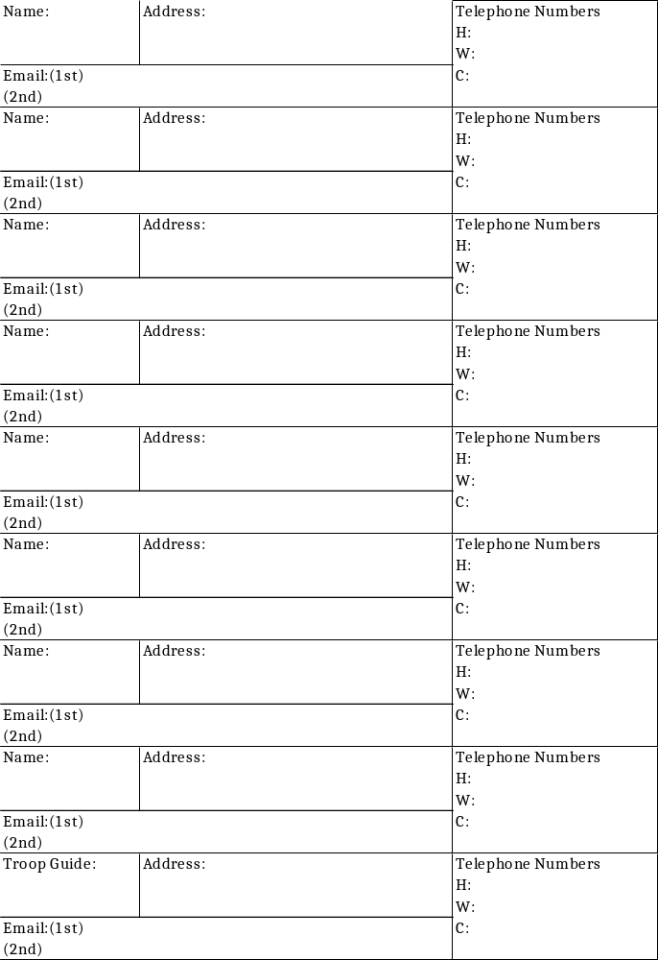

Patrol Leadership Positions

Daily Roster
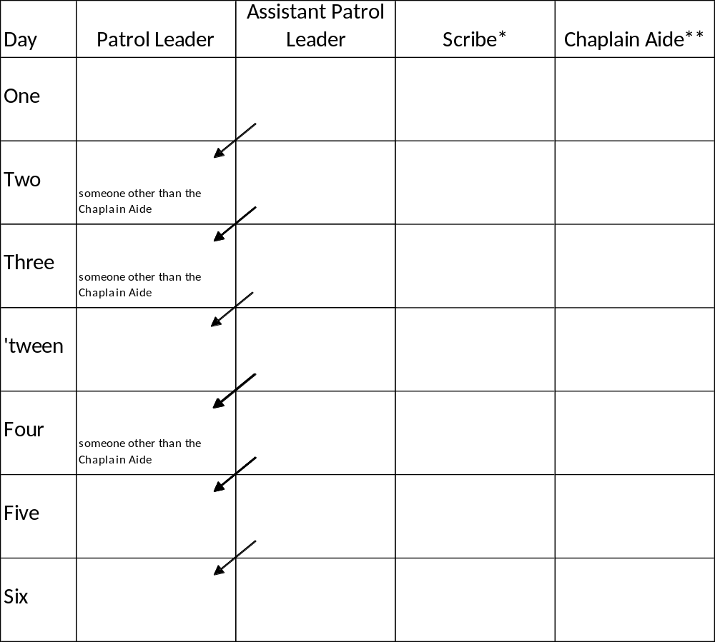
*The positions of scribe and chaplain aide may be held by the same individuals throughout the course, or they may rotate among several or all members of the patrol.
**Because of their involvement with the chaplain aides meeting on Days Two, Day Three and Day Four, the person or persons serving as chaplain aide should be patrol leader on days other than Day Two or Day Three or Day Four.
Note: Each day a different member will serve as leader of your patrol, thus allowing each person to have at least one chance during a Wood Badge course to experience that leadership opportunity. The person assigned as Assistant Patrol Leader will become Patrol Leader on the following day.

