CORE VALUES
Cub Scout Roundtable Leaders’ Guide
The core value highlighted this month is:
- Respect: Showing regard for the worth of someone or something. Respect is something we should all practice every day. We should strive to be respectful of others, of our surroundings, in what we say and do, and most of all we should have respect for ourselves. Cub Scouts will learn that if they are respectful of others, others will respect them.

COMMISSIONER’S CORNER
Knowledge will give you power,
but character respect.
Bruce Lee
And this brings me to the end of a wild two months – two Wood Badge weekends, a trip to Philmont Training Center, A Pack Family Camping Trip and a Webelos Weekend. Now next weekend is Baltimore Area Council's Pow Wow and a Northeast Region, Area 6, leadership conference. And I have a presentation at each of them!!
Plus work is busy - I am on project teams for engineering changes at several nuclear power plants. And as we know every Project Manager thinks his project is the most important.
And right now we are waiting out Hurricane Sandy. As I type I keep praying my house will not lose power until I am done. Pray with me for safety of all of us on the East Coast. By the map, the eye could cross right over my roof!!!
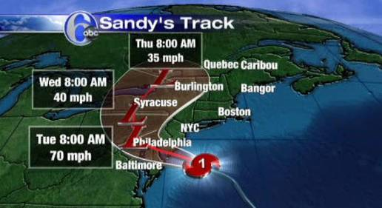
Why "Holiday Lights"?
www.scouting.org,
Many of our holiday traditions this month involve lights—the star of Bethlehem, miracle of the lamps, the morning star that enlightened Buddha, the bonfires at Yule. We show respect for the customs of others by sharing our holiday traditions with the pack and den: lights on a Christmas tree, candles on a menorah for Hanukkah, or on a Kwanzaa kinara. Boys can light the way this month by brightening someone’s holiday season while learning more about how others celebrate this season.
As a pack or den, visit a nursing home, preschool, or children’s ward, and sing holiday favorites. Conclude your outing by sharing cookies decorated by the boys. Help those less fortunate with a service project or toy drive. How about a holiday dessert pot luck? Each family can bring a traditional dessert to share at the pack meeting.
This might be a perfect time to ask pack families to donate to the World Friendship Fund of the Boy Scouts of America, which assists developing nations in providing Scouting to their youth (search “World Friendship Fund BSA” on the Internet). This is also an appropriate month to work on the Language and Culture belt loop and pin, or the Heritages belt loop and pin.


TABLE OF CONTENTS
In many of the sections you will find subdivisions for the various topics covered in the den meetings
CORE VALUES 1
COMMISSIONER’S CORNER 1
TABLE OF CONTENTS 2
Dag Hammarskjöld 3
THOUGHTFUL ITEMS FOR SCOUTERS 5
Roundtable Prayer 5
Stars Light From Above 5
Quotations 5
Edward Hibberd Johnson and the First Electrically Lit Christmas Tree 6
TRAINING TOPICS 7
Character Connections Part 2 7
ROUNDTABLES 8
Publicity and Promotion 8
November RT = December Pack Program 8
Roundtable Name Change Error! Bookmark not defined.
Pack Meeting Themes 8
Cubcast 11
DEN MEETING TOPICS 11
PACK ADMIN HELPS – 12
Youth Leadership In The Pack 12
Den Discipline 13
Den Discipline with Positive Attitude 14
CUBMASTER'S CORNER 15
It’s December!!! 15
Stage Displays: 16
SPECIAL OPPORTUNITIES 17
Heritages Loop and Pin 17
Hockey Loop and Pin 17
Recruiter Strip 18
Boys’ Life Reading Contest for 2012 18
Knot of the Month 19
Unit Leader’s Award of Merit 19
GATHERING ACTIVITIES 19
Respect Ideas 19
Holiday Lights Ideas 20
Other Ideas 22
OPENING CEREMONIES 24
Respect Ideas 24
Holiday Lights Ideas 24
AUDIENCE PARTICIPATIONS & STORIES 27
LEADER RECOGNITION & INSTALLATION 28
The Light of Scouting 28
ADVANCEMENT CEREMONIES 29
SONGS 32
Respect Songs 32
Holiday Lights Songs 33
Cub Scout Songs 34
STUNTS AND APPLAUSES 34
APPLAUSES & CHEERS 34
RUN-ONS 35
JOKES & RIDDLES 35
SKITS 36
GAMES 38
Respect Games 38
Holiday Lights Games 38
CLOSING CEREMONIES 40
CUBMASTER’S MINUTE 41
CORE VALUE RELATED STUFF 42
Connecting RESPECT with Outdoor Activities 42
The Character Connection Process 42
Respect Character Connection 42
December – A Month for Respect 44
Festivals of Light Around the World 45
Fun Facts about the Holidays 48
Crazy Holidays 49
PACK & DEN ACTIVITIES 50
DEN MEETINGS 57
TIGERS 57
WOLF 61
BEAR 67
Bear Ideas by Felicia 67
WEBELOS DENS 73
Core Value for December 73
Book Corner 74
Roundtable Webelos Break Out 75
Denner Installation Ceremony 75
Meeting Planner 75
Flag Ceremony 76
December Flag Ceremony 76
Den Meeting Helpers 77
Webelos Den 77
CITIZEN 77
ARTIST 80
Arrow of Light Den 81
ADDITIONAL ADVANCEMENT IDEAS 83
Tiger Achievements 83
Tiger Electives 83
Wolf Achievements 84
Wolf Electives 84
Bear Achievements 84
Bear Electives 85
Webelos Den 85
Arrow of Light Den 86
MORE GAMES AND ACTIVITIES 86
CUB GRUB 86
WEB SITES 90
ONE LAST THING 91
Christmas Spirit & the Gimme Pig 92

Please let me know about Pow Wow's
and send me Pow Wow Books!!
I cannot do this job without your help!!!


Dag Hammarskjöld
UN Secretary-General 1953-1961
In 2011 The Financial Times reported that Hammarskjöld is still the benchmark against which all UN Secretary-Generals are judged. He is a truly well respected man.
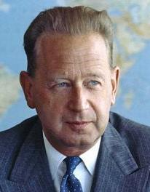
“I realize now that in comparison to him,
I am a small man. He was the greatest statesman of our century.”
John F. Kennedy after Dag Hammarskjöld's death
Dag Hjalmar Agne Carl Hammarskjöld was a Swedish diplomat, economist, and author. The second Secretary-General of the United Nations, he served from April 1953 until his death in a plane crash in September 1961. When Trygve Lie resigned from his post as UN Secretary-General in 1953, the United Nations Security Council recommended Hammarskjöld for the post. It came as a surprise to him. Seen as a competent technocrat without political views, he was selected on 31 March by a majority of 10 out of 11 Security Council members. The UN General Assembly elected him with 57 votes out of 60. In 1957, he was re-elected.
He was the youngest of four sons of Agnes (Almquist) Hammarskjöld and Hjalmar Hammarskjöld, prime minister of Sweden. Dag Hammarskjöld said of the influence of his parents: "From generations of soldiers and government officials on my father's side I inherited a belief that no life was more satisfactory than one of selfless service to your country - or humanity. This service required a sacrifice of all personal interests, but likewise the courage to stand up unflinchingly for your convictions. From scholars and clergymen on my mother's side, I inherited a belief that, in the very radical sense of the Gospels, all men were equals as children of God, and should be met and treated by us as our masters in God."
Dag Hammarskjöld was, by common consent, the outstanding student of his day at Uppsala University where he took his degree in 1925 in the humanities, with emphasis on linguistics, literature, and history.
Hammarskjöld began by establishing his own secretariat and defining their responsibilities. He planned and supervised every detail in the creation of a "meditation room" in the UN headquarters. The room is dedicated to silence where people can withdraw into themselves, regardless of their faith, creed, or religion.

During his term, Dag Hammarskjöld
- Tried to smooth relations between Israel and the Arab states.
- Made a 1955 visit to China and successfully negotiated the release of 15 captured US pilots who had served in the Korean War. Mr. Hammarskjold also traveled to many countries of Africa, Asia, Europe, the Americas and the Middle East, either on specific assignments or to further his acquaintance with officials of member governments and the problems of various areas.
- Intervened in the 1956 Suez Crisis. During the crisis, he exercised his own personal diplomacy with the nations involved; worked with many others in the UN to nullify the use of force by Israel, France, and Great Britain following Nasser's commandeering of the Canal; and under the UN's mandate, commissioned the United Nations Emergency Force (UNEF) - the first ever mobilized by an international organization.
- Allowed participation of the Holy See (The Pope) within the United Nations in 1956.
- Came to the aid of the newly independent Congo in 1960 in defusing the Congo Crisis. Hammarskjöld made four trips to the Congo. His efforts towards the decolonization of Africa were considered insufficient by the Soviet Union; in September 1960, the Soviet government denounced his decision to send a UN emergency force to keep the peace. They demanded his resignation and the replacement of the office of Secretary-General by a three-man directorate with a built-in veto, the "troika". The objective was to, citing the memoirs of Soviet leader Nikita Khrushchev, “equally represent interests of three groups of countries: capitalist, socialist and recently independent.” Hammarskjöld denied Patrice Lumumba's request to help force the Katanga Province to rejoin the Congo despite being good friends, since Dag saw the UN as a neutral force meant to avoid human rights violations in conflict areas and looked to diplomacy as a solution rather than military action.
- Organized the first and second UN international conferences on the peaceful uses of atomic energy in Geneva, and planned a UN conference on the application of science and technology for the benefit of the less developed areas of the world held in 1962.
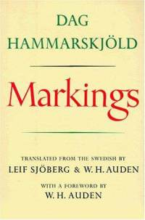
Legacy -
- Hammarskjöld posthumously received the Nobel Peace Prize in 1961, having been nominated before his death.
- He is commemorated as a peacemaker in the Calendar of Saints of the Evangelical Lutheran Church in America on September 18th of each year.
- He held honorary degrees from Carleton University, Oxford University, Harvard, Yale, Princeton, Columbia, the University of Pennsylvania, Amherst, Johns Hopkins, the University of California, and Ohio University; Uppsala University; and McGill University.
- He refused to resign: One of Hammarskjöld's greatest moments was refusing to give in to Soviet pressure to resign. Dag Hammarskjöld: "It is very easy to bow to the wish of a big power. It is another matter to resist it. If it is the wish of those nations who see the organization their best protection in the present world, I shall do so again."
- Historian Paul Kennedy hailed Hammarskjöld in his book The Parliament of Man as perhaps the greatest UN Secretary-General because of his ability to shape events, in contrast with his successors.
- The Dag Hammarskjöld Library, a part of the United Nations headquarters, was dedicated on 16 November 1961 in honour of the late Secretary-General.
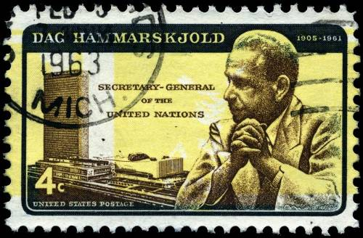
I remember well when the stamp came out with the error and the USPS issued more with the error.
I have both stamps. CD
Dag Hammarskjöld Quotes
- Life only demands from you the strength you possess. Only one feat is possible — not to have run away.
- Never, "for the sake of peace and quiet," deny your own experience or convictions.
- The longest journey of any person is the journey inward.
- Friendship needs no words..
- I am the vessel. The draft is God's. And God is the thirsty one.
- Constant attention by a good nurse may be just as important as a major operation by a surgeon.
- To forgive oneself? No, that doesn't work: we have to be forgiven. But we can only believe this is possible if we ourselves can forgive.
- It is when we all play safe that we create a world of utmost insecurity.
- The pursuit of peace and progress cannot end in a few years in either victory or defeat. The pursuit of peace and progress, with its trials and its errors, its successes and its setbacks, can never be relaxed and never abandoned.
- The more we do, the more we can do; the more busy we are, the more leisure we have.
- Never measure the height of a mountain until you have reached the top. Then you will see how low it was.
- Forgiveness is the answer to the child's dream of a miracle by which what is broken is made whole again, what is soiled is made clean again.
- A mature man is his own judge. In the end, his only form of support is being faithful to his own convictions. The advice of others may be welcome and valuable, but it does not free him from responsibility. Therefore, he may become very lonely.

The quote on the picture is "I have no doubt that 40 years from now we shall be engaged in the same pursuit. How could we expect otherwise? World organization is still a new adventure in human history."

THOUGHTFUL ITEMS FOR SCOUTERS
Thanks to Scouter Jim from Bountiful, Utah, who prepares this section of Baloo for us each month. You can reach him at bobwhitejonz@juno.com. CD
“I have just three things to teach: simplicity, patience, compassion. These three are your greatest treasures.”
Lao Tzu

Roundtable Prayer
Scouter Jim, Bountiful UT
Oh great beloved Father, by whose hands were created the heavens and the earth, we thank thee for the lights that lead us in the night. Both those that shine in the sky, and those that shine from a generous heart. Bless us to let our lights shine and lead others out of the paths of darkness and despair. Let us impart of Thy love to those we meet, and be a shining light to the world. Teach us to respect the earth as well as our fellow men, and honor the light and talents of others. Amen.

Stars Light From Above
Scouter Jim, Bountiful UT
Every good gift and every perfect gift is from above, and cometh down from the father of lights, with whom is no variableness, neither shadow of turning.
(New Testament | James 1:17)
When I was a young man, Webelos age, our family moved to a small town in rural Utah, where my father lived his dream of being Ranch Foreman, for a large private ranch. I was enrolled in the local two room school. One class was kindergarten, first and second grade. The other class was third, fifth and sixth grade. There were no fourth graders. To understand the size of the school, the Principal that taught the older classes sent me to the company Store with a five dollar bill to by a can of soda pop for every student and teacher in the school. I bought the soda and brought back the change. Okay, pop was only ten cents a can; way back them, but there were only thirty-two students in the whole school. My daughter teaches more than that in each of her classes.
One of the ranch hands, Chet Smith, born before World War I, spent his whole life on the range. In my mind, I can still see him on the desert range, with his horse and cat, looking at the sky full of stars. There were no city lights for miles and miles to mar the night sky. In the winter Chet lived in a cave, blasted into a red desert rock on the winter range. He lived without electricity or indoor plumbing. The only holiday lights for Chet was the moon and the sky full of stars. The first holiday light was a Star in the sky and shepherds were called to visit the new born King.
Chet had great respect for nature and his fellowmen. As deer would cross the range, often they would get caught up in the fences. The local wildlife ranger had an agreement with Chet, that if he found a deer with its hind legs hung up in the barbed wire, he would butcher eat, and use the meat, but leave the hoof in the fence so the ranger could account for the deer. Chet never took more than he needed, but also never left and animal to suffer and die a slow painful death. Chet also had as much respect for the Bask sheepherders as he did the millionaire owner of the ranch. Every man had value and was to be respected.
This month would be a good day to teach boys to respect nature and leave not trace. It would also be a good month to teach respect for others. Respect for peers and to not tolerate bulling or improper teasing of others because of differences. Cub Scout should also learn respect for women, and what it means to be a gentleman. Each boy can become a light in the community, and light the way of respect.

Quotations
Quotations contain the wisdom of the ages, and are a great source of inspiration for Cubmaster’s minutes, material for an advancement ceremony or an insightful addition to a Pack Meeting program cover
I'm not concerned with your liking or disliking me... All I ask is that you respect me as a human being. Jack Roosevelt "Jackie" Robinson
To be one, to be united is a great thing. But to respect the right to be different is maybe even greater. Bono
I speak to everyone in the same way, whether he is the garbage man or the president of the university.
Albert Einstein
I have spoken of a thousand points of light, of all the community organizations that are spread like stars throughout the Nation, doing good. George Bush,
Inaugural Address ,Friday, January 20, 1989
Darkness cannot drive out darkness: only light can do that. Hate cannot drive out hate: only love can do that.
Martin Luther King Jr., A Testament of Hope:
The Essential Writings and Speeches
Part of our essential humanity is paying respect to what God gave us and what will be here a long time after we're gone. William J. Clinton
When it is dark enough, you can see the stars.
Ralph Waldo Emerson (1803 - 1882)
So let us then try to climb the mountain, not by stepping on what is below us, but to pull us up at what is above us, for my part at the stars; amen. M.C. Escher
I am fond of pigs. Dogs look up to us. Cats look down on us. Pigs treat us as equals. Winston Churchill
Friendship- my definition- is built on two things. Respect and trust. Both elements have to be there. And it has to be mutual. You can have respect for someone, but if you don't have trust, the friendship will crumble. (Mikael Blomkvist) Stieg Larsson, The Girl With the Dragon Tattoo
How would your life be different if…You stopped making negative judgmental assumptions about people you encounter? Let today be the day…You look for the good in everyone you meet and respect their journey.
Steve Maraboli, Life, the Truth, and Being Free
Respect yourself and others will respect you.
Confucius, Sayings of Confucius
Without feelings of respect, what is there to distinguish men from beasts? Confucius
Love is honesty. Love is a mutual respect for one another.
Simone Elkeles, Leaving Paradise
I cannot conceive of a greater loss than the loss of one's self-respect. Mahatma Gandhi, Fools, Martyrs, Traitors:
The Story of Martyrdom in the Western World
I can win an argument on any topic, against any opponent. People know this, and steer clear of me at parties. Often, as a sign of their great respect, they don't even invite me.
Dave Barry
“Respect for ourselves guides our morals; respect for others guides our manners. Laurence Sterne
The earth does not belong to us. We belong to the earth.
Chief Seattle, The Chief Seattle's Speech
Show respect to all people, but grovel to none. Tecumseh
“When we treat people merely as they are, they will remain as they are. When we treat them as if they were what they should be, they will become what they should be.
Thomas S. Monson, Pathways To Perfection:
Discourses Of Thomas S. Monson
Friendship is selfless love, care, respect, and honor not a profitable opportunity. Santosh Kalwar
If we would build on a sure foundation in friendship, we must love our friends for their sakes rather than for our own. Charlotte Brontë, The Life of Charlotte Brontë
It’s not so much the journey that’s important; as is the way that we treat those we encounter and those around us, along the way. Jeremy Aldana
Anyone who teaches me deserves my respect, honoring and attention. Sonia Rumzi
Football is like life - it requires perseverance, self-denial, hard work, sacrifice, dedication and respect for authority.
Vince Lombardi
The bond that links your true family is not one of blood, but of respect and joy in each other's life. Richard Bach
Every individual has a place to fill in the world and is important in some respect whether he chooses to be so or not. Nathaniel Hawthorne
Respect yourself if you would have others respect you. Baltasar Gracian

Edward Hibberd Johnson and
the First Electrically Lit Christmas Tree
Scouter Jim, Bountiful Utah
In 1867 retired 30 year-old Union Army General William Jackson Palmer headed west with his young assistant Edward Hibbert Johnson from their home in Philadelphia, mapping routes for the Kansas Pacific Railroad through New Mexico and Arizona to the Pacific Coast. In 1871 Edward H. Johnson, was sent back east to manage the Automatic Telegraph Company and he hired a young 24-year-old Thomas A Edison. Thus began a partnership that would last two lifetimes, Johnson’s and Edison’s. Johnson wrote of Edison: "He ate at his desk, slept in a chair. In six weeks he had gone through the books, written a volume of abstracts, and made two thousand experiments … and produced a solution."
Edward H. Johnson became Edison’s partner and trusted executive in his Menlo Park, New Jersey Company. On December 22, 1882, just three years after Edison successful experiment with the light bulb, Edward Johnson invited some friend, and some newspaper reporters to his home to see 80 walnut sized red, white, and blue light bulbs twinkling off and on the electrically rotating tree. This was the very first electrically lighted Christmas tree.
Though those first Christmas lights would be considered dangerous in our modern world, it was far safer than the lighted candles on a dead tree which had been used for centuries. From that first string of lights, the Holiday Lights we now enjoy today originated.



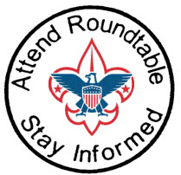

TRAINING TOPICS

Character Connections Part 2
Carol E. Little, Black Swamp Council
In the earlier column, we learned about the history behind Character Connections (CC). We discussed the three different components – Know –become familiar with all 12 core character connections (head), be able to Commit (heart) to doing the CC values and put them into practice in their daily life (hand) on their own initiative.
For part of this column, I’d like to use a piece that I ran into from the special needs section from Heart of America Council Pow Wow book for 2005. I think that by using some of these activities we can use the Character Connections values and give our scouts a way to connect to others who have special needs.
- Wear glasses that have been smeared with Vaseline to simulate impaired vision. What did you experience while wearing the glasses? What did you learn from about yourself? What was the purpose of trying the glasses?
- Use a balance board with a circular board with an “x” below also circular, to simulate inner ear problems. (see teeterboard jousting in the How-To Book) What did you like about this exercise? How did you feel while standing on the board? What did you learn?
- Set up a blind man’s maze, using wooden timbers to layout the maze. Each Cub was blindfolded, given a stick to tap out his way, and turned loose in the maze. Wow! Was that a site to see! What would you do differently in this exercise? How did you feel when you started to get around? What did you learn?
- Type out the Cub Scout Promise and the Law of the Pack on computer then use a font to change the words to symbols such as MT Extra, Mobile, Cairo, Webdings, Symbols, Zapf Dingbats. Have the boys figure out what they say. What was the best part of this activity? Why do you think this activity was a good idea to do?
- This exercise simulates vision challenges. Fill a bowl with pony beads and add 1 or 2 slightly larger different colored beads. The object is to pick out the larger bead of a specific color. The boys will always pick up one of the larger beads, but not necessarily the right color. What was the purpose of this game? What did you learn about yourself?
These are activities that are designed to give the boys the chance to experience the frustrations faced daily by people with disabilities. Unless a person has experienced a disability we really have no idea what others face day to day. Treat the disabled Scout with all the respect and consideration that you do with other Scouts. If the game being played requires a blindfold, the blind or visually impaired Scout should be given one as well. If the Scout is in a wheelchair, don’t stand over him to talk to him bend down to communicate face to face. If a hearing impaired scout has a signer, respond to the Scout not the signer. Our scouts look to us to set the example.
Games from Woods Wisdom 1996
Foggy Harbor Object: The group must maneuver an “oil tanker” (one member of the group) without bumping into the other “ships” (the remaining members). The oil tanker must be blindfolded. He is not to touch any of the other ships. These ships are distributed throughout the area. They remain stationary. As the oil tanker approaches on hands and knees, the nearest ship starts giving a warning signal, like a foghorn. The oil tanker then approaches slowly and attempts to maneuver across the harbor without colliding. What was the purpose of this game? What would you do differently? What was the best part of this game?
Everybody Up This exercise is a useful way to introduce the idea of group cooperation. Ask 2 scouts of about the same size to sit on the ground or floor facing each other with soles of their feet touching, knees bent, and hands tightly grasped. From this position they try to pull themselves into a standing position. If they succeed, ask another scout to join them and try standing with 3 scouts, then 4, etc. As the group grows, each player must grasp the hand of another person and must maintain foot contact with the group. An expanding group will find that thinking is required to come up with a solution that allows large numbers to get Everyone Up. What got you all going in the right direction? What would you try differently to get everyone up?
Bell Tag Equipment: Neckerchiefs or blindfolds and a hand bell. Method: Blindfold all scouts except the one who has the bell. Have blindfolded scouts mill around the room. The scout with the bell moves among the others, ringing his bell constantly. The blindfolded scouts try to tag the bell ringer. The scout who succeeds changes places with the bell ringer. What did you feel while playing this game? What did you learn from this game? What was the best part of the game?
I hope that you all had fun learning how to use Character Connections in your den and pack activities.
To learn more check out Character Connections
The Purposes of Cub Scouting and Character Connections
How Character Connections are used as part of the requirements.
Character Connections Chart #13-323A Chart explaining Character Connections
2005 Character Connections Packet Examples of the different areas covered by Character Connections from past Program Helps (from 2002 to this year's 2005 - 2006), Roundtable Resource sheets, and the 2003 Cub Scout Books.
Character Connections Data Some history behind the program.
Character Connections Overview of all ranks on a chart.
Character Connections Outdoor Grid This is used for outdoor activities that connect with the 12 CC core values.
What are YOU going to do now?
The best gift for a Cub Scout.......
......get his parents involved!
The greatest gift you can give your child
..... good self respect!

ROUNDTABLES

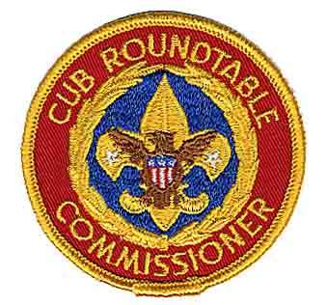

Publicity and Promotion
Barbara J. Hicklin,
ACC - Roundtables, DelMarVa Council
Contact me at: bjhicklin57@hotmail.com
Promotion is more than just letting Cub Scouting leaders know when and where the roundtable is happening. Your goal is to make them want to come. You should include the following information in any of your roundtable promotional materials:
- Purpose—Let leaders know how roundtable meetings will help them in their leadership positions.
- Involvement—Roundtables are interactive, hands-on meetings in which participants are actively involved.
- Contact— Include the name and phone number of a contact person to answer leaders’ questions about roundtables.
Remember to send monthly reminders to leaders 5-7 days before the roundtable with information about what is planned for the meeting.
Potential promotion methods: Fliers, Invitations, Mailed Announcements, District or Council Newsletters,
District or Council Websites, Local News Media, Social Media, Telephone Trees, Email Messages, Road Shows.
For additional information on the above promotion methods check out the Cub Scout Roundtable Planning Guide 2012-2013: http://www.scouting.org/filestore/training/pdf/511-410_WB.pdf

BE PREPARED for Next Month:
December Roundtable for January Pack Program
Core Value: POSITIVE ATTITUDE
Cub Scout Leader Specific Breakouts:
Cub Scout Den Leaders – Blue and Gold Preparations
Webelos Den Leaders- Arrow of Light Ceremonies
Cubmasters - Planning Special Ceremonies
Pack Leaders - Unit Leadership Enhancements

November RT = December Pack Program
Core Value: Respect
Suggested Roundtable Agenda:
Red - New for ‘2012-2013 Green – CS RT Planning Guide
Preopening
Displays:
- Parking Lot: Make it easy for participants to ask questions
- Highlighted Resources - was Book of the Month
- Other Displays - Give pack leaders ideas for their meetings
- Supplies - Forms and literature
Registration: Sign-in Sheets - Greet and welcome everyone
Preopening Activity: Get-acquainted game
General Opening (All Scouting Programs)
Welcome - Enthusiastic and friendly call to order
Prayer- Pre-select someone comfortable
Opening Ceremony - Flag ceremony / focus on Core Value
Introductions & Instructions - Introduce first time attendees
Combined Cub Scout Leader Session
Icebreaker, Song & Cheers – I Love the Word Hello
Tips for Pack Activity – Ice Skating Outing
Safe Scouting - New, materials available in the Guide
Sample Ceremony – World Globe Ceremony
Resource Highlight – Book of the month
Leader Specific Breakouts:
- Cub Scout Den Leaders – Youth Leadership
- Webelos Den Leaders – Youth Leadership
- Cubmasters - Maintaining Discipline in Pack Mtg.
- Pack Leaders – Blue and Gold Preparations
Membership & Retention- New, available in the Guide
Open Forum (Q & A) - Include answers to questions left in parking lot.
General Closing (All Scouting Programs)
Announcements:
- Invite contact responsible for upcoming events to make announcement. Limit to a short introductory statement and where to find more information
- Promote - date, theme, special topics for next roundtable
- Recognize Attendance - Cubbie, Totem, or Scout Bucks
Commissioners Minute – Scouting Legacy
Closing Ceremony - Retire colors
After the meeting
Fellowship / Refreshments or “Cracker Barrel”
Staff Meeting
Promotion gets them there the first time.
Good program gets them to return.

Pack Meeting Themes
Commissioner Dave (with help from Kim)
All 35 Supplemental Pack Meeting plans have been posted on National's site at: http://www.scouting.org/scoutsource/CubScouts/Leaders/DenLeaderResources/DenandPackMeetingResourceGuide/PackMeetingPlans.aspx
And plans are underway to add 12 more!!
The 2012-2013 Cub Scout Roundtable Planning Guide (CS RT PG) includes the supplemental theme pack meeting agendas from Set A. And has the CS Roundtable Staff make use of them during Roundtable.
Here are the 12 in the current CS RT PG -
All twelve of the Pack Meeting Plans are on the web. (September - Aug). If you are reading this on-line the Theme Name is hyperlinked to file at National.
Month Core Value Supplemental Theme
- September Cooperation Hometown Heroes
- October Responsibility Jungle of Fun
- November Citizenship 50 Great States
- December Respect Holiday Lights
- January Positive Attitude Abracadabra
- February Resourcefulness Turn Back the Clock
- March Compassion Planting Seeds of Kindness
- April Faith Cub Scouts Give Thanks
- May Health and Fitness Cub Cafe
- June Perseverance Head West Young Man
- July Courage Cubs in Shining Armor
- August Honesty Kids Against Crime
Kim, the chair of the task force creating the plans and a friend of mine from two Philmont Training Center courses, said to me "I do want to stress that the focus is still the Core Value and the theme is just there as an enhancement." The theme pack meeting plans are specifically crafted to bring out the important points of the Core Value in a fun way. Eventually, there will be 36 alternate pack meetings posted, three for each Core Value, and with the existing Core Value based meeting you will have four total pack meetings for each Core Value from which to choose, thus providing variety so Cubs will not have to see the same thing every year. Also, it is planned that Roundtables will continue to provide new ideas for Pack Meetings each year that are based on the Core Values.
And don’t forget to use
YOUR IMAGINATION, too!!!
Here is the complete list of all 36 Supplemental Themes. Kim's Team has delivered all the Pack Meeting agendas to National. Any Pack/Cubmaster can use any theme any month. The year designation is to show you which themes will be featured at Roundtables each year. So, the 2012 - 2013 RT year kicked off in August with Cooperation and Hometown Heroes. Then Responsibility and Jungle of Fun. Then ...
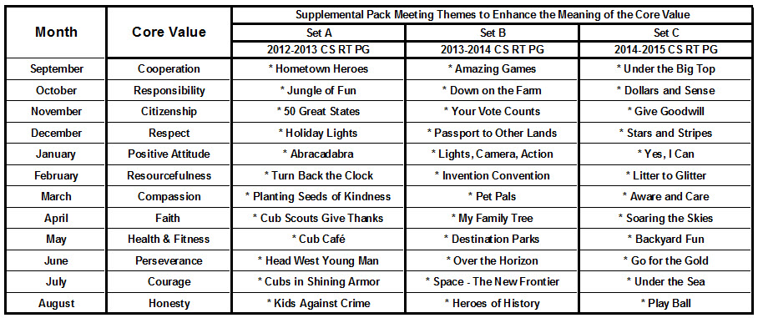
Upcoming:
- December's Core Value, Respect, will use "Holiday Lights."
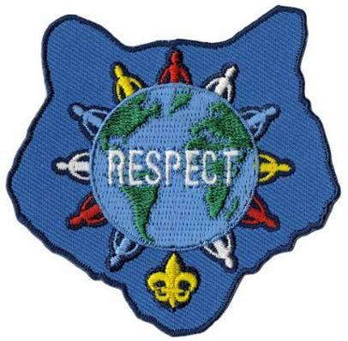
Month's that have themes that might help you with , Respect and "Holiday Lights" are:
Month | Year | Theme
Holiday Lights
December | 1939 | Pack Christmas Party
December | 1946 | Cub Scout Santa Claus
December | 1952 | An Old-Fashioned Christmas
December | 1956 | Christmas In The Americas
December | 1957 | Happy Holiday
December | 1960 | Guiding Stars
December | 1962 | The Magic of Christmas
December | 1963 | Old-Fashioned Christmas
December | 1966 | Yuletide Everywhere
December | 1974 | Old Fashion Christmas
December | 1980 | Happy Holidays
December | 1983 | Giving Gifts
December | 1987 | Happy Holidays
December | 1988 | Holiday Magic
December | 1990 | Giving Gifts
December | 1993 | Holiday Magic
December | 1999 | Holiday Magic
December | 2000 | What do You do at Holiday Time?
December | 2001 | Works of Art
December | 2007 | Celebrations Around the World
December | 2008 | Holiday Lights
December | 2009 | Works of Art
Respect
December | 2010 | Respect
December | 2011 | Respect
December | 2012 | Respect

- January's Core Value, Positive Attitude, will use "Abracadabra."
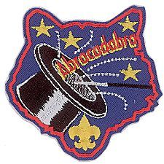
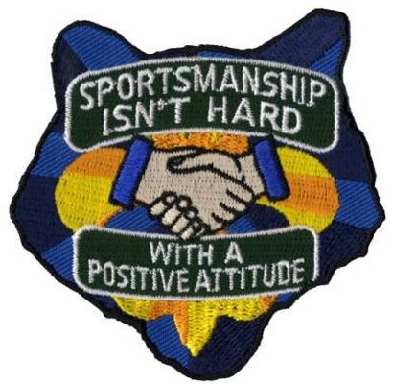
Month's that have themes that might help you with , Positive Attitude and "Abracadabra" are:
Month | Year | Theme
Abracadabra
September | 1941 | Cub Magicians
January | 1948 | Magic Tricks & Puzzles
June | 1951 | Lost on an Island
November | 1961 | Cub Scout Magic
October | 1965 | Magic Words
October | 1970 | Cub Scout Magicians
March | 1979 | Making Magic
August | 1991 | Cub Scout Magic
April | 1995 | Cub Scout Magic
May | 2002 | Abracadabra
May | 2008 | Abracadabra
Positive Attitude
January | 2011 | Positive Attitude
January | 2012 | Positive Attitude
January | 2013 | Positive Attitude

Cubcast
Note - National had not yet updated CUBCAST from Citizenship to Positive Attitude at the time of Baloo's publication but maybe by the time you see this, it will be Positive Attitude!!
Cubcast is an audio podcast featuring how-to and information topics for Cub Scouting leaders and parents. There is an RSS icon on the page where you can subscribe to ensure you do not miss an episode/edition. Old Cubcast broadcasts are archived and may be downloaded from the site. If reading on-line, click the picture to go to Cubcast –
UPDATE
There is a note at Cubcast that says, "Enjoy this vintage Cubcast while we're working on the new and improved Cubcast.
Come back in November for its debut!
Looking forward to hearing it!!
It is not necessary to own an iPod in order to view or listen to a podcast; the name is merely a holdover from the device on which they were introduced.
Likewise it is not required that you have iTunes on your computer to listen to podcasts. Other applications can manage your podcast subscriptions.
The current podcast can be found here – or use link below
http://www.scouting.org/scoutcast.aspx
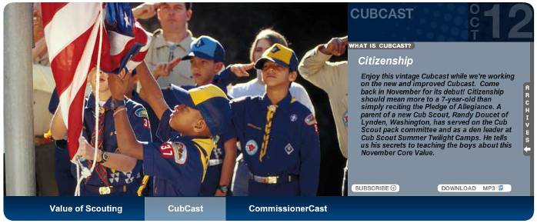
This is a link to the previous 12 months of Cubcast -
http://www.scouting.org/RSS%20Feeds/CubCast.aspx
Lots of good stuff!!

Click on Cubcast and enjoy!!!

Please let me know about Pow Wow's
and Pow Wow Books!!
I cannot do this job without your help!!!

DEN MEETING TOPICS
When a Den Meeting occurs depends on when you start your year and how often you meet. A Den that starts in August will be doing meetings 1 & 2 then, and 3& 4 in September. A den that meets three times a month will do 1, 2, and 3 in September. The pace is up to you!!
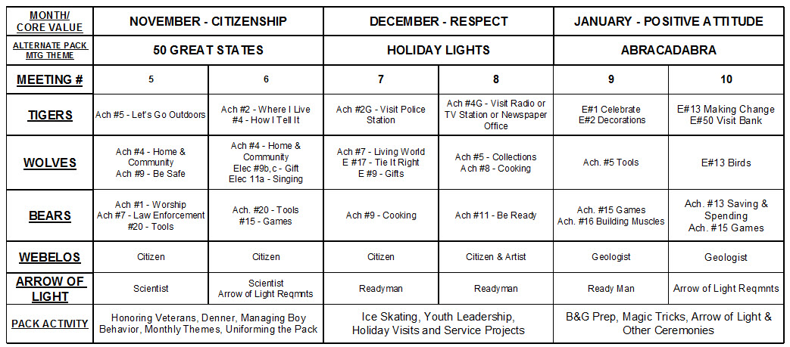

PACK ADMIN HELPS –

Youth Leadership In The Pack
Developing Leadership in Boys
is what it is all about!! !!
The Denner and Assistant Denner
Scouter Jim, Bountiful, Utah
The Denner and Assistant Denner are the most important youth leadership positions in Cub Scouts. A Denner is a Cub Scout or Webelos Scout who is elected to be the temporary youth leader of his den. All Tiger Cub, Wolf, Bear, as well as Webelos Dens should elect a Denner. A den may elect a new Denner every few weeks, monthly, or other term. The Denner wears the gold double-strand Denner shoulder cord No. 00368 over his left shoulder.
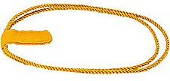
Importance
The Denner position provides many important benefits to the boy and to the den:
- Each boy serving as a Denner earns parts of various rank requirements. Dens should rotate the position so that all members serve as a Denner at least once.
- Denners learn about leadership and responsibility first-hand.
- The Denner program helps give every boy a fair chance to lead.
- Each family shares equally in helping the den leader.
- The Denner position is preparing boys to be Patrol Leaders in Boy Scouts.
- Scouts and parents who are allowed to help are more like to stay in Scouts.
- Denners are recognized by being allowed to wear the Denner's gold cords.
Rotation
Certain ranks require that every boy serve as Denner. Also, the Denner leads the flag and opening ceremony as required for various ranks. However a popular boy who is re-elected may deny others the opportunity to learn and advance. For this reason, the Den Leader may decide that boys who have already served as Denner may not be elected again until every other boy has had a turn. Alternately, a single Denner election may be held at the beginning of the year to determine the Denner schedule for the year, with new den leaders rotating monthly or of every few weeks.
In the lower Cub Scout ranks, Denner elections may not be the best approach, as you commonly end up with each boy voting for himself, or boys getting very upset when they do not win the election. Some possibly approaches are to appoint them in alphabetical order, or by drawing names from a hat.
By Webelos age, the boys should be able to handle elections, and this will be a good lead-in for Patrol Leader elections within Boy Scouts.
Responsibilities
The Denner (typically along with his parent or adult partner) have many important duties as assigned by the Tiger Cub Den Leader, Cub Scout Den Leader or Webelos Den Leader that may include:
- Help with den meeting setup.
- Lead the opening ceremony (flag, oath, law).
- Take the Den Attendance and dues meetings.
- Help with the meeting activities.
- Provide simple refreshments such as cookies and cups of juice.
- Lead the closing ceremony.
- Help with den meeting cleanup.
- Help with other responsibilities as assigned by the Den Leader.
Assistant Denner
The Assistant Denner assists the Denner at den meetings and fills in for the Denner when the Denner is not available. The Den Leader may establish a practice of the Assistant Denner becoming the Denner in the next term. This way the Assistant Denner can watch and learn from the Denner so that he will be ready for the next term. Using this approach, the Assistant Denner is elected each month to become the Denner the next month.
The Assistant Denner wears the gold single-strand Assistant Denner shoulder cord No. 00385 over his left shoulder.
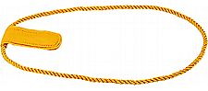
For information on Den Chiefs
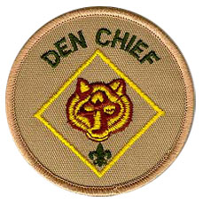
Click on the patch or
go to the July 2012 issue for August 2012 Activities -
http://usscouts.org/usscouts/bbugle2011-2012.asp

Den Discipline
Utah National Parks Council
Does the idea of a six highly energetic boys jumping on your couch, bouncing off your walls, painting the cat and causing all kinds of mayhem just make you want to pull your hair out? Don’t worry – every Cub Scout leader has felt like that at one time or another.
For the sake of your sanity, not to mention your house or your cat, you will need to come up with some guidelines of behavior for the den. This is known as den discipline. It is important to remember that discipline is not punishment. Discipline is making the Cub Scout responsible for his own behavior – telling him that if he chooses a certain course of action, what the specific consequences of that action will be. Discipline is training given to a child to mold or correct his behavior. As a den leader, you need to spell out for the boys what is acceptable behavior and what is not. Also, let them know the consequences for acceptable and unacceptable behavior.
A den code of conduct (or den rules) should be established in an open discussion with the boys. Some of their ideas may be silly to you, but don’t judge too harshly. Many of their ideas that relate to safety, respect for property and relationships with others will be along the same lines as yours. You may need to make suggestions for things the boys don’t bring up. And they’ll be delighted if you decide to throw out a rule or two. You should also discuss the consequences of breaking the den code of conduct. What should be in your den code? Things that are important to you and your boys. Since every den is different, every den code will be different. Here are some suggestions to help you get started.
- No put-downs, name calling, or crude language.
- No physical aggression.
- You are a guest in this house, please act like one. (Try to be on your best behavior.)
- Be on time.
- Wear your uniform.
- Bring your book.
- One person speaks at a time and everyone listens.
- No running inside.
- Share, take turns.
- Leave the cat (or dog or hamster or fish) alone.
A few rules are enough to start, but more may need to be added as you go along. Cub Scouts may want to write out their den rules and sign on a line at the end of the list. This is a way of sharing with parents the expectations of their sons. A large poster can also be placed at the den meeting site to remind boys of the code.
Now that the rules have been established, stick to them. Be fair. Don’t let one boy get away with doing something you would discipline another boy for doing. Be consistent. Don’t warn and threaten but take action quickly. Don’t send a boy home unless he oversteps the disciplinary bounds you have drawn. If you do send a boy home, call his parents immediately and tell them why.
Here are a few ideas to keep your den meetings
running smoothly.
- Use the Cub Scout SIGN as a signal for quiet. When boys see this symbol, they should stop what they’re doing, be quiet and raise their own arm in the sign.
- Keep den meetings going at a FAST PACE, with lots of variety and fun things to do. Plan more than you think you will need. Get assistants and den chiefs involved.
- Treat boys IMPARTIALLY. Boys expect fair treatment and your example becomes their model. If you make promises, keep them.
- DON’T CRITICIZE a boy in front of the den. Wait until you can talk to him alone.
- Give boys opportunities to make CHOICES as often as possible. Involve them in planning.
- Take some time to EVALUATE your den meetings. What went well? What didn’t go so well? How can I do this differently next time?
- Focus on the POSITIVE. Catch boys being good, helping others, keeping the den code of conduct. Baden-Powell said “A pat on the back is a stronger stimulus than a prick with a pin Expect a great deal of your boys and you will generally get it.”
When asked what tricks, programs or guidelines were used in their den to promote discipline, one leader said “Well, we have our good days and our bad days. Sometimes we just have to remember they are little boys that need to use their bodies. So, we always try to have at least one activity each den meeting that gets them moving! Normally, den meetings are full of various activities, so the boys have a good chance to work off that energy.
“Most of the years we have taught, the boys got along fine. But we had one year when that was not so. The first time we had two boys collide physically, we let them know it would
not be tolerated. We told them we are like brother wolves in a den and we support each other. I said if it ever happened again the parents would be informed and they would possibly attend our future meetings. No more problems!”
Some den leaders use little “pats on the back” to help with den discipline and reward boys who are doing good. Here are a few things that have worked.
Print up “SCOUT BUCKS.” These can be anything from a fancy piece of paper with cool graphics that looks like money to a slip of paper that says “Scout Bucks” on it. Distribute these to the boys when you catch them doing something good. You can also give them out for being on time, wearing their uniform and bringing their book. At the end of den meeting (or the end of the month or another time you designate), boys can go to the den store and buy something. This store can be a box that you have filled with small toys, candies, gift certificates or coupons for free goodies, scout paraphernalia, etc.
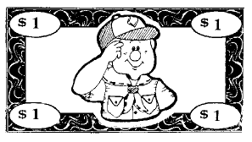
“BEAR STUMPS” Each boy is given a block of wood that doubles as a stool at den meeting. He earns nails that will be hammered into the stump if he meets the following requirements:
- Red: He must attend den meeting.
- Blue: He must wear his Scout uniform.
- Green: He must bring his book to den meeting.
- Yellow: He must be represented by at least one member of his family at pack meeting.
- White: He must meet the requirements of a “Bear Necessities.” challenge. This challenge, a charge to do something to make the world just a little bit better, is written down and sent home with the boy.
- Silver: He must do three good deeds for the week, without being asked. (Chores do not count.)
- Gold: He must have done one good deed, that includes a sacrifice of at least one hour, with no expectation of reward.
The den leader hands out the nails before the meeting begins, and the Bear Cubs can only hammer before the meeting and after the closing prayer. If hammer or nails are misused, the Bear loses his nails for that week. The boys are challenged to see how creatively they can decorate their stump. This can be adapted for Wolf dens and Webelos dens too.
Give each boy a whole piece of shoestring LICORICE at the beginning of the meeting. Every time you need to discipline the boy, cut off two inches. He gets whatever is left at the end of meeting time for a treat. A variation of this method would be to give each boy a small cup and three or four M&M’s when he arrives. When you catch him doing good (waiting his turn, helping someone else, volunteering to do something, etc.) reward him with a few more M&Ms to keep in his cup. When the meeting is over, he gets to keep the goodies in the cup.
The GOOD CONDUCT CANDLE is an oldie but goodie. A candle is lit as the meeting begins. If the boys misbehave, the candle is extinguished. Use your den code of conduct as a basis of when to keep the candle lit and when to blow it out. You determine if the behavior is suitably changed so that the candle can be lit again. When the candle is burned down to a certain level, a reward is given. It can be a pizza party, a day at the park or pool, or a day of games. Help the boys decide what the reward will be, then they will work for it. This method has several disadvantages. Most schools and some churches do not allow open flames. Open flame is dangerous around any group of young kids. Then, what do you do for discipline once the candle is blown out?

Use a MARBLE JAR. Give each boy three marbles at the beginning of the meeting. When he breaks a rule, he gives up a marble. The marbles left at the end of the meeting go into a jar with a line drawn around it at a height determined by the leader. When the marbles go over the line, the den gets a special treat. Adjust the size of the jar to make this happen every two months or so.
Use carnival or homemade TICKETS. Give each boy three tickets at the beginning of the meeting. Have him sign his name on the ticket. When he breaks a rule, he has to give up a ticket. Tickets left at the end of the meeting can be placed in a bank. At the end of the month, add up who has the most tickets, and he gets a special treat.
Use a POINT SYSTEM. Award points for every part of the uniform worn by the boy (shirt, neckerchief, slide, belt, pants, socks, tucking in shirt), a point for coming, bringing their book and anything they passed off at home. Additional points can be awarded as you see fit (pack meeting attendance, helping without being asked, performing a service project etc.). When the boy earns a set amount of points, he can choose a gift from the Scout bag. The bag contains different items from the Scout Shop, Wal-Mart, Harbor Freight, dollar store, etc. When a boy earns his Arrow of Light, he is allowed to pick his own party (within reason - no Disneyland!)
An Indian COUP and beads can be used in conjunction with any of the above methods. The boys can make their own coups out of leather or vinyl. They can be worn on their belts, around their necks, or displayed on a board. he boys can earn beads for:
- Attending den meeting
- Passing off achievements and electives
- Advancement
- Denner service
- Coming in uniform
- Bringing his book
- Attending pack meeting
- Bringing a snack
- Almost anything else – beads are cheap!
The real keys to your discipline system are:
- HAVE ONE. Don’t wait to see if you need one, you do! If you wait until you need it, it’s too late!
- Make sure everyone (Cubs and parents) KNOWS what it is. Explain it at the parents’ meeting, in a note sent home with the boys, and at your first den meeting. Remind when necessary.
- STICK TO IT. Plan on the boys (and maybe the parents) testing you to see if you mean it. Be ready for it. They expect you to do what you say you will do. You lose all credibility if you don’t.

Den Discipline with Positive Attitude
Alice, Golden Empire Council
Focus on the POSITIVE. “Catch” the boys being good, helping others, keeping the den code of conduct. Baden-Powell said “A pat on the back is a stronger stimulus than a prick with a pin. Expect a great deal of your boys and you will generally get it.” Set a goal to say at least one good thing about each boy at every den meeting. But don’t give undeserved compliments – boys know when the praise is genuine! Remember,
“It’s better to build boys than repair men.”
DON’T CRITICIZE a boy in front of the den. Wait until you can talk to him alone. You might want to have a signal so that your assistant can ask a boy to come with her – make sure this is done without sounding angry or as if punishment is in store. Often, removing a boy from the action will defuse the situation. The other adult can simply take the boy to another location and have him help set up for another activity or discuss what happened in the den meeting.
USE POSITIVE WORDS –
- Be specific about what a boy does right – “Thank you for remembering to pick up your mess!” rather than just “Good Job”
- Be sincere and don’t exaggerate – “I really like the colors you used in that drawing” rather than “That’s the best drawing I’ve ever seen”
- Be Immediate with praise so you can reinforce good behavior.
- Share the Praise – while criticism should be done in private, praise is GREAT to SHARE. Share it by saying “I like the way John is putting the cap back on his markers”
You can also Share Praise by adding stickers or beads to a Den Doodle or Individual Boy’s Coup Stick.
And don’t forget to Share with Parents – send an email to let them know when their son is doing a good job or being a good example!
COUPONS – Enlarge and photocopy the coupons below, consisting of a front and back cover and six pages of various coupons. Use as an award for the Cub Scouts. As a boy achieves goals of good behavior, he is awarded “coupons,” which are compiled by the Den Leader. At the end of the month, (or whatever time you have decided) he receives the assembled coupon book. Coupons can be redeemed for treats, tokens to “purchase” incentive items, special privileges, such as helping make a den treat. Assemble the cut out pages, fastening with a staple and threading yarn through punched holes.
Note from Alice: I think a really good way to use these coupons would be to fill them in as a note to send home to parents – Parents need to know when their son has shown a Positive Attitude!
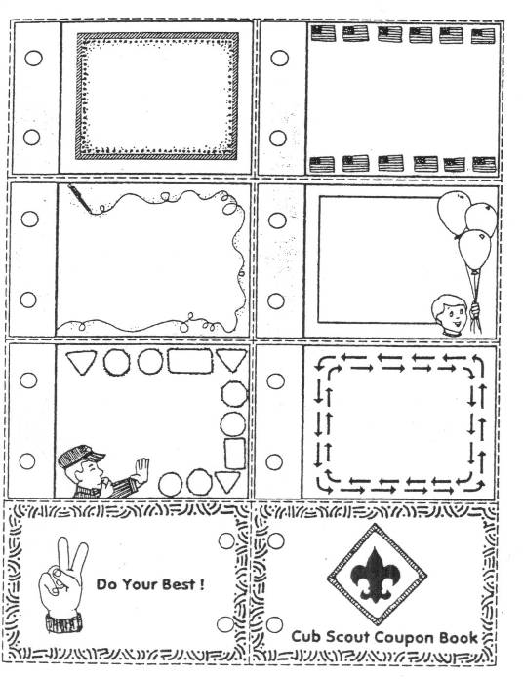

CUBMASTER'S CORNER
Pamela, North Florida Council
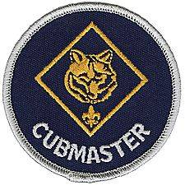
It’s December!!! There are bazillion things you and your Scouts can be doing at this time of year to make Scouting rewarding and fun! As they used to say on an old show I used to watch:”Choose wisely” and as all my Scout Friends say: And KEEP IT SIMPLE! This month's theme is respect!
(Did you know there is a Thai celebration of Respect?)
There are many directions your Packs can go. You can go for the religious ceremonies or celebrations that all your Scouts celebrate and there is of course the BSA Theme Respect. They can even be tied together. We respect each other’s faith in God, we respect our leaders, teachers and family members. Even though this is a great time to celebrate the season try to remind Scouts to remember why we celebrate at this time of year and not just toss candy or gifts but remind them that the best gift is the ones we give to others. Encourage Scouts in understanding that encouraging, helping, and giving of their time to better another’s life and the response of gratitude for all our efforts big and especially small is what real happiness is like.
Usually November is my council’s month for food drives but this is something that can be done any time of the year. Check with your local charter organization to see if they have a food pantry or check your local community food pantry to see how your unit can help out. Some units set up a display at a local grocery outside asking for donations. If your food pantry has a wish list you can hand this to people as they go in and they can deposit on the way out. Some units go door to door and the usual answer is very rewarding. Always remind Scouts to say thank you even if the answer is no. Also be mindful of Scouts in your unit that may benefit from this. Use discretion and as leaders possibly leave on those families’ door steps to help them save face.
Other opportunities to share and show respect? Rest home visits, orphan home visits, food kitchens, the Veterans Homes are all looking for people to visit. Take something with each Scout even if is a homemade card as they always appreciate it and allows Scouts something to say when visiting. Remember most of those in these homes do not have families and do appreciate a friendly face. Practice with your Scouts before going. Talk to the facility in advance as to the needs and how to help your Scouts to know what to expect.
Coat drives at this time of year is a great cause! Mitten drives as well! It’s cold in most parts of the USA this time of year. Shelters are always looking for coats, mittens, or blankets. Ask what your Scouts can do to help out!
Warning! Do NOT get burned out at the holiday season. Do NOT burn out your leaders either. There is no rule that says you can only do service for others on the holidays! If you need to stretch the events out to other months (and you know everyone wants your pack to participate in events.) then that is what you do. I would try and keep it to one thing or event. Remind all those groups that last minute asking makes it hard to change your calendars and need a few months head notice. Let them know when you do your annual planning and ask you again next year but in at the same time if you do not think your Pack can do this I would still pass the information to the dens incase their den would like to or a family would like to participate or help. Parents and Scouts are busy this time of year too with concerts, parades, relatives visiting, events with their religious affiliations, and commitments. So do not burn your pack out! This is why it's important you have an active committee. So you and they can plan ahead, and parents know what is going to happen all year long not month to month. It’s not fair to you, and it’s not fair to them or the Scouts. Den leaders plan 3 months ahead packs should plan even farther out. If you can’t do a food drive till March that’s great! Do not over tax your leaders ever or you will see them dropping like flies!
I was asked at my last Round Table, “How do I keep Scouts in Scouting the rest of the year? We had Cuborees, belt loop fairs, Halloween, Christmas and etc. but what is it that can keep Scouts and adults active in the Spring? Now is the time to plan ahead for those months if you have not already. Whatever it is make sure to have fliers, make it exciting and Fun!
The Blue and Gold’s held in February and March are fun Birthday Parties of Scouting. Remember to keep up dated on the planning of your Blue and Gold Committee and find out where they are in the planning. They should have a location by now, times, and menus drawn up. Work on your theme and ask Den Leaders how their planning is going. Remind yourself and the committee the plan is to keep it as close to 90 minutes as possible from start to finish. (not including set up and break down… and yes the meal or dessert time is included in that 90 minutes!)
Other things? Pine Wood Derbies are in Spring in this part of the woods but if they aren’t in yours why not Kite Derbies? Have your Webelos design the contests or bring in some professional Kite makers and have a kite building seminar at your pack meeting before your Kite Derby on another day! Remember to have extras already made at the event for Scouts who do not have anyone at home to help them! Catapult contests are fun too! There are plenty of plans for those from as small as a clothes pen to something that can shoot water balloons! (We usually do these at the Pack camp outs. More space to shoot them. I have seen Webelos sitting in camping chairs have score cards after shots much like the Olympics.)
Pack camp outs in Spring are great too. Make sure your Pack Activity Chair is looking and working on sites your pack can go as a group. Not every district has a spring Cuboree but your pack can have its own Camporee and just as much fun!
Carnivals and bike rodeos are all things that can be done almost any time of the year but if you space these large events out through the year you can keep your boys excited and active all year long! Remember the key is recognizing their efforts of not only awards they earned but participation of them AND your adult volunteers! Have you heard this all before? Maybe but there are a million ideas out there for pack events! Look around and you would be amazed!
Stage Displays: I know many of you have tables for different dens to show what they did the month before but it’s always great to have a stage area set up with your pack theme. For those of us that never see snow (Anyone wanting a bag of sand just ask) but to make a snow like appearance there is always quilt batting and you can stuff white trash bags with paper and cover with the batting to make snow men. I know some of you would love to send me your driveways full of snow and I would welcome it (I miss the snow!) but for those out there wondering how to make a snow scene this would be the easiest. Do not set Christmas lights on the snow… as depending on the heat you would end up with a bon fire on stage. If you use Christmas lights make sure they do not touch the batting. Poly batting is better than the cotton batting. Trust me the poly batting looks closer to what snow looks like than the cotton. A large mirror could also be used to make the reflection of a pond and surround with blue lights. This gives the appearance of a moon lit night. Of course an artificial tree would complete the setting and color lights are always a nice touch. Have Scouts make the ornaments or string popcorn. At the end the ornaments can be sent home or taken to a rest home or shelter.


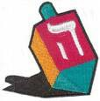

SPECIAL OPPORTUNITIES
Pat Hamilton, Baltimore Area Council
Our Core Value this month is Respect and the Supplemental Theme is Holiday Lights. This is a good time to focus on some of the holiday decorating traditions we pass down through our families and also to learn about the traditions of others that might be different than our own. The Heritages Belt Loop and Academic Pin is a good tie-in for this. As the days turn cooler (at least for some of us!), I’m going to focus on the winter sports Belt Loops and Pins. These are about the only ones we haven’t spotlighted yet. Hockey is the Belt Loop and Sports Pin I have chosen for this month.

Heritages Loop and Pin
from usscouts.org
The requirements listed below are taken from the Cub Scout Academics and Sports Program Guide (34299) 2009 Printing. Webelos Scouts that earn the Heritages Belt Loop while a Webelos Scout also satisfy requirement 12 for the Family Member Activity Badge.
Tiger Cubs, Cub Scouts, and Webelos Scouts may complete requirements in a family, den, pack, school, or community environment. Tiger Cubs must work with their parents or adult partners. Parents and partners do not earn loops or pins.
Heritages Belt Loop
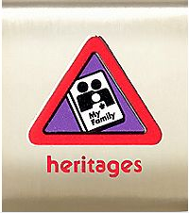
Complete these three requirements:
- Talk with members of your family about your family heritage: its history, traditions, and culture.
- Make a poster that shows the origins of your ancestors. Share it with your den or other group.
- Draw a family tree showing members of your family for three generations.
Heritages Academics Pin
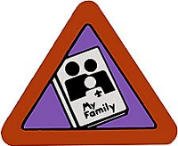
Earn the Heritages belt loop, and complete five of the following requirements:
- Participate in a pack heritage celebration in which Cub Scouts give presentations about their family heritage.
- Attend a family reunion.
- With your parent's or adult partner's permission, find and correspond with a pen pal from another country. Find out how his or her heritage is different from yours.
- Learn 20 words in a language other than your native language.
- Interview a grandparent or other family elder about what it was like when he or she was growing up.
- Work with a parent or adult partner to organize family photographs in a photo album.
- Visit a genealogy library and talk with the librarian about how to trace family records. Variation: Access a genealogy Web site and learn how to use it to find out information about ancestors.
- Make an article of clothing, a toy, or a tool that your ancestors used. Show it to your den.
- Help your parent or adult partner prepare one of your family's traditional food dishes.
- Learn about the origin of your first, middle, or last name. Tell your den or an adult family member about what you learned.
For worksheets to help with earning these awards go to http://usscouts.org/advance/cubscout/academics/heritages.asp

Hockey Loop and Pin
from usscouts.org
The requirements listed below are taken from the
Cub Scout Academics and Sports Program Guide (34299) 2009 Printing. The Hockey belt loop and pin include roller hockey and ice hockey. You may complete requirements in either or both activities.
Tiger Cubs, Cub Scouts, and Webelos Scouts may complete requirements in a family, den, pack, school, or community environment. Tiger Cubs must work with their parents or adult partners. Parents and partners do not earn loops or pins.
Hockey Belt Loop
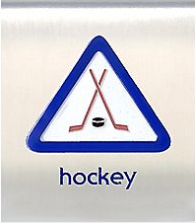
Complete these three requirements:
- Explain ways to protect yourself while skating. Demonstrate how to put on all necessary safety equipment. Explain why proper safety equipment is important.
- Spend 30 minutes practicing the skills of hockey: skating, stick handling, passing, shooting, and checking. This may be over two different practice periods.
- Play a game of hockey while on roller skates or hockey skates.
Hockey Sports Pin
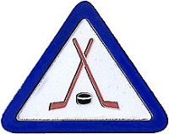
Earn the Hockey belt loop, and complete five of the following requirements:
- Participate in a pack, school, or community hockey tournament or in a supervised hockey league.
- Participate in a hockey skills development clinic.
- Spend at least 30 minutes practicing the skills of hockey: skating, stick handling, passing, shooting, and checking. This may be over two different practice periods.
- Draw the layout of the playing surface for a hockey game including the starting positions of the goalie, three forwards (two wings and a center), and two defenders.
- Demonstrate foul signals. Explain to your den or team why players should avoid fouls.
- Attend a high school, college, or professional hockey game.
- Demonstrate hockey terms (for example, assist, breakaway, deke, draw, pulling the goalie, and so on.) to another team member or adult.
- Learn about a U.S. Olympic hockey team and report what you learn to your den or family.
- Watch an ice resurfacing machine at an ice rink. Report to your den or family about the history of the machine commonly known as the Zamboni and how it is used.
For worksheets to help with earning these awards go to http://usscouts.org/advance/cubscout/sports/hockey.asp

Recruiter Strip
from usscouts.org
As the end of the calendar year approaches, many units are going through their annual recharter process. This is a good time to add boys to your roster. The boys themselves are a great recruitment tool among their friends. One incentive that is available to you is to make the boys aware of the Recruiting Strip patch that they can earn.
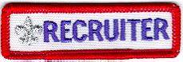
Cub Scouts and Boy Scouts may be awarded, and wear, below the right pocket on their uniforms, the Recruiter Strip shown above
There are NO formal requirements for these strips. Each Unit establishes the procedure for awarding the strip. Usually, a Recruiter Strip is awarded to a Cub Scout or Boy Scout the first time he is successful in getting a friend, relative, classmate, or other acquaintance to join his unit.
Typically, only ONE strip is awarded to a boy while he is a Cub Scout, and another may be awarded while he is a Boy Scout.
Scouts that recruit a new member during special national recruiting drives, can be awarded a special collectible "Scout Recruiter" patch. The design varies from time to time. Some examples are shown below.
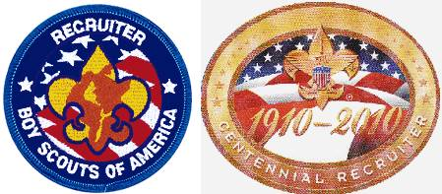
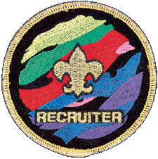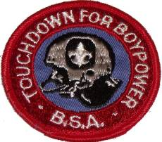

Boys’ Life Reading Contest for 2012
http://boyslife.org/
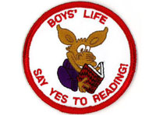
SAY ‘YES’ TO READING
Enter the 2012 Boys’ Life Reading Contest
Write a one-page report titled “The Best Book I Read This Year” and enter it in the Boys’ Life 2012 “Say Yes to Reading!” contest.
The book can be fiction or nonfiction. But the report has to be in your own words — 500 words tops. Enter in one of these three age categories:
- 8 years old and younger
- 9 and 10 years old
- 11 years old and older
First-place winners in each age category will receive a $100 gift certificate good for any product in the Boy Scouts official retail catalog. Second-place winners will receive a $75 gift certificate, and third-place winners a $50 certificate.
Everyone who enters will get a free patch like the one on this page. (And, yes, the patch is a temporary insignia, so it can be worn on the Boy Scout uniform shirt, on the right pocket. Proudly display it there or anywhere!) In coming years, you’ll have the opportunity to earn different patches.
The contest is open to all Boys’ Life readers. Be sure to include your name, address, age and grade in school on the entry.
Send your report, along with a business-size, self-addressed, stamped envelope, to:
Boys’ Life Reading Contest
S306
P.O. Box 152079
Irving, TX 75015-2079
Entries must be postmarked by Dec. 31, 2012 and must include entry information and a self-addressed, stamped envelope.
For more details go to http://boyslife.org/

Knot of the Month

Unit Leader’s Award of Merit
from usscouts.org
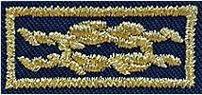  Award of Merit Knot | 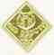  Cubmaster Device
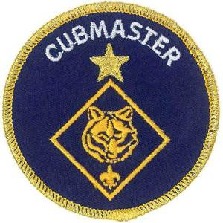
Special Unit Leader Patch
Background
Quality unit leadership is the key to a quality unit program—and it leads to better Scout retention. Statistics show that if young people stay engaged in the program for at least five years, the BSA’s influence likely will stay with them for the rest of their lives. A quality Scouting experience will help keep Scouts in the program, and the Boy Scouts of America created the Unit Leader Award of Merit to recognize the quality unit leaders who make that happen.
The Unit Leader Award of Merit replaces the Scoutmaster Award of Merit, the Varsity Team Coach Award of Merit, and the Venturing Crew Advisor's Award of Merit programs. This new recognition has revised requirements and may be earned by Cubmasters as well.
Requirements
The nominee must:
- Be a currently registered Cubmaster, Scoutmaster, Coach, or Advisor who has served in that position at least 18 continuous months.
- Meet the training requirements for the registered position.
- Distribute a printed or electronic annual unit program plan and calendar to each family in the unit.
- Have a leader succession plan in place.
- Effectively use the advancement method so that at least 60 percent of the unit’s youth have advanced at least once during the last 12 months.
- Cultivate a positive relationship with the chartered organization.
- Project a positive image of Scouting in the community.
Nomination Procedure
- The unit committee chair completes the Unit Leader Award of Merit Nomination Form on behalf of the unit committee. For Boy Scout troops, Varsity Scout teams, and Venture crews, the nomination must include endorsement by the senior patrol leader, team captain, or crew president, respectively.
- The unit or district commissioner certifies that the form is complete.
- The unit submits the nomination form to the council for approval by the Scout executive and council commissioner or president.
The Award
Upon receipt of the approved nomination form, the council may present the Unit Leader Award of Merit, which includes a certificate, square knot with the appropriate device, and a special unit leader emblem. Recognition of this achievement may be presented at appropriate district or council events, such as district or council leader recognition dinners, training events, and board meetings.
The award may be presented for each program, Cub Scouts, Boy Scouts, Varsity, and Venturing, if the individual meets the requirements in each program. Only one knot is worn with the devices of each program that the award was earned in.
The application form for the Unit Leader Award of Merit (512-003.pdf) may be downloaded from http://www.scouting.org/filestore/pdf/512-003_WB.pdf

GATHERING ACTIVITIES
Note on Word Searches, Word Games, Mazes and such –
In order to make these items fit in the two column format of Baloo’s Bugle they are shrunk to a width of about 3 inches. Your Cubs probably need bigger pictures. You can get these by copying and pasting the picture from the Word version or clipping the picture in the Adobe (.pdf) version and then enlarging to page width. CD

Respect Ideas
Meet and Greet
2011-2012 CS RT Planning Guide
As families arrive, ask each person to find two other people to form groups of three. They greet one another, introduce themselves, and find out at least two things that the three of them have in common other than things related to Scouting. Then they part after thanking one another politely. Each of them goes around the room again and repeats the process. Emphasize good manners.
Respect for People:
Alice, Golden Empire Council
Honor Rosa Parks for her simple act of self respect - Make a display of pictures or drawings of her experience on the bus in Montgomery, and what happened next. Note: More info under VALUE RELATED – A Month for Respect.
Make a Talking Stick
Alice, Golden Empire Council
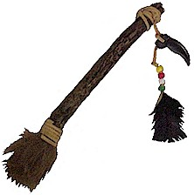Set up a table with supplies to let each family make a “Talking Stick” – They can use it when having family meetings and working on the Cub Scout Family Award. Provide sticks, pieces of fur and leather, lacing, feathers, beads, natural items like shells, permanent markers – have a glue gun ready for applying materials. You could even have a contest and give an award for each family’s creation – “Best use of Natural Materials, Most colorful, Best Representation of Family, Best Use of Feathers – or Fur, or Leather – you get the idea (Tandy Leather has scrap bags of fur and leather materials that would work)
Say What? Gathering Game
Alice, Golden Empire Council
Before the meeting, make several copies of some quotations about respect – enough so that you will have several teams. (See Quotations in "Thoughtful Stuff") Make sure the person doesn’t see the quotation. They must walk around and check the quotation that other people have on their back, asking “yes” or “no” questions about the quotation on their own back. When they find the group they belong to, they should talk about the quotation and decide how to explain it.
When the meeting opens, give each group time to share their phrase and what they think it means. If they know anything about the person who said the phrase, they should share that as well. Here are some phrases you could choose from:
Gift of Respect Exchange
Utah National Parks Council

Ask each family to bring in various items that could be used to put together kits for homeless children – toothpaste and brushes, soap, deodorant – items that help maintain self-respect. Assemble the gift bags during the Gathering Time.
Belt Loop Display
Utah National Parks Council
Have a display about the different Belt Loops and Pins that might be used to encourage RESPECT. Many times, parents are not aware of the many different belt loops and pins available!
Some ideas are: Citizenship, Communicating, Disabilities Awareness, Family Travel, and Good Manners.
Respect Secret Message
Utah National Parks Council
Each word in the puzzle has something to do with RESPECT. Unscramble them and decipher what the secret words are.
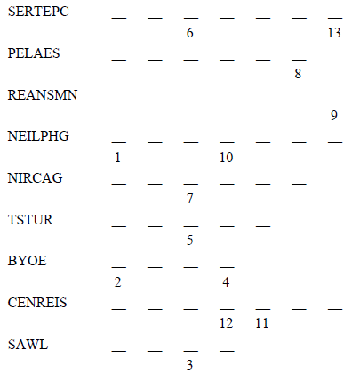
Answers: RESPECT, MANNERS, PLEASE,
HONESTY, SHARING, TRUST, HELPING,
OBEY, CARING, SINCERE, LAWS
Respect Word Search
Utah National Parks Council
Find all the words dealing with RESPECT listed below -
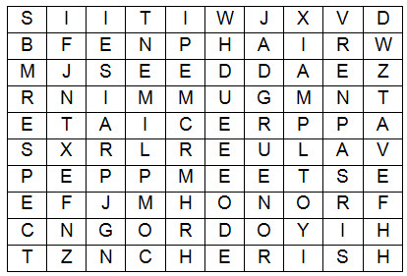
ADMIRE CHERISH ESTEEM
PRAISE RESPECT APPRECIATE
COMPLIMENT HONOR REGARD
VALUE
It’s All About Respect Word Search
Utah National Parks Council
The words below can be found in any direction. Each word either describes an aspect of respect or names something a person should have respect for.
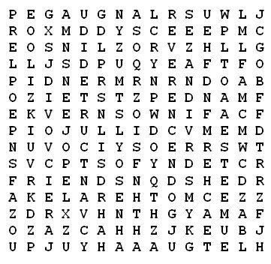
AKELA COUNTRY COURTEOUS
ELDERLY ESTEEM FATHER
FRIENDS KINDLY LANGUAGE
MANNER MOTHER PEOPLE
POLITE POSSESSIONS REVERENCE
SELF TEACHER

Holiday Lights Ideas
December Number Rhyme
Baltimore Area Council
Fill in the right number at the end of each line. After you have completed one through six, add up the numbers to get the answer for number seven.
- Take the number of letters in SANTA ______
- Count a half dozen candy canes. ______
- Check the number of ears on a panda bear. ______
- Count the wings on two shiny toy planes. ______
- Count the points on a treetop star. ______
- Count the number of kings in a favorite
Christmas carol ______
- They add up to a date in December- -
It’s our merriest day, by far! ______
Backward and Forward
Baltimore Area Council
Can you fill these blanks with words that are spelled the same backward as forward?
- The night before Christmas. __ __ __
- What you do with a whistle. __ __ __ __
- A little child __ __ __
- Father __ __ __
- Twelve o’clock __ __ __ __
- A chin apron __ __ __
- A live Christmas gift __ __ __
- Silent __ __ __
- A good thing you did __ __ __ __
- What a noisemaker does __ __ __
Holiday Theme:
Alice, Golden Empire Council
Assign dens or families to choose a Holiday of Lights to demonstrate and explain. See some ideas under CORE VALUE RELATED: December – A Time for Respect; Also see the Holiday Around the World skit idea for some suggestions.
Invite every family to dress as they would to celebrate “their” holiday, bring a favorite holiday treat to share and display pictures and examples of how they celebrate the Holiday Season. This can be a really interesting Pack meeting, especially if you live in an area with people from many different cultures, religions and parts of the world – not everyone celebrates Christmas. Here’s a chance to learn about other holiday celebrations.
Decorate a Christmas Tree
Utah National Parks Council
Materials: Small Christmas Tree, paper, stickers, markers, glitter, etc. to make decorations
Directions:
As they arrive have the boys and their families make decorations to place on the Christmas Tree to be given to a family in need.
During the Pack Meeting announce and talk about the purpose of the tree. That it is to be donated to a family in need with all your lovely, handmade ornaments adorning it.
Christmas Cheer Song Match
Utah National Parks Council
Directions: Match the phrase with the song title.
Lyrical Phrase
- Was a happy jolly soul
- Are you listening?
- In a one horse open sleigh
- No crib for his bed
- Let Earth receive her King
- As they shouted out with glee
- The lights are brightly shining
- Now you say there’s no such thing as Santa
- Like the ones I used to know
- Bring us some figgie pudding
- Sing, choirs of angels
- All is bright
- She didn’t see me creep
- He knows when you’re awake
- Dancing and prancing in Jingle Bell Square
Song Title
- I saw Mommy Kissing Santa Claus
- Grandma Got Run Over by a Reindeer
- Frosty the Snowman
- Joy to the World
- Jingle Bell Rock
- Santa Claus Is Coming to Town
- Oh Come, All Ye Faithful
- Away in a Manger
- Silent Night
- Jingle Bells
- O Holy Night
- We Wish You a Merry Christmas
- White Christmas
- Winter Wonderland
- Rudolph
Answers: 1-C, 2-N, 3-J, 4-H, 5-D, 6-O, 7-K,
8-B, 9-M, 10-L, 11-G, 12-I, 13-A, 15-F, 15-E
Christmas Carol Scramble
Utah National Parks Council
Materials: Choose several well-known Christmas carols. For each selected song, write each line on a separate piece of paper.
Directions: Give a slip of paper to everyone as they come in. Tell them to find the people who have the other lines to their song and arrange them in order. The first song team to find all the right people and sing the song is the winning team.

Other Ideas
What Am I?
Pamela, North Florida Council
Materials: Index cards with the names of objects related to the beach written on them, tape.
As Cub Scouts and families arrive, tape a card on each person's back. Make sure the people don't see their own cards. They walk around the room and ask others questions that will help them guess the name of the object. They may ask each person only one question at a time.
Questions must require a "yes" or "no" answer.

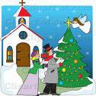

Holiday Maze
Baltimore Area Council
Can you find the way from the bedroom to the Christmas tree?

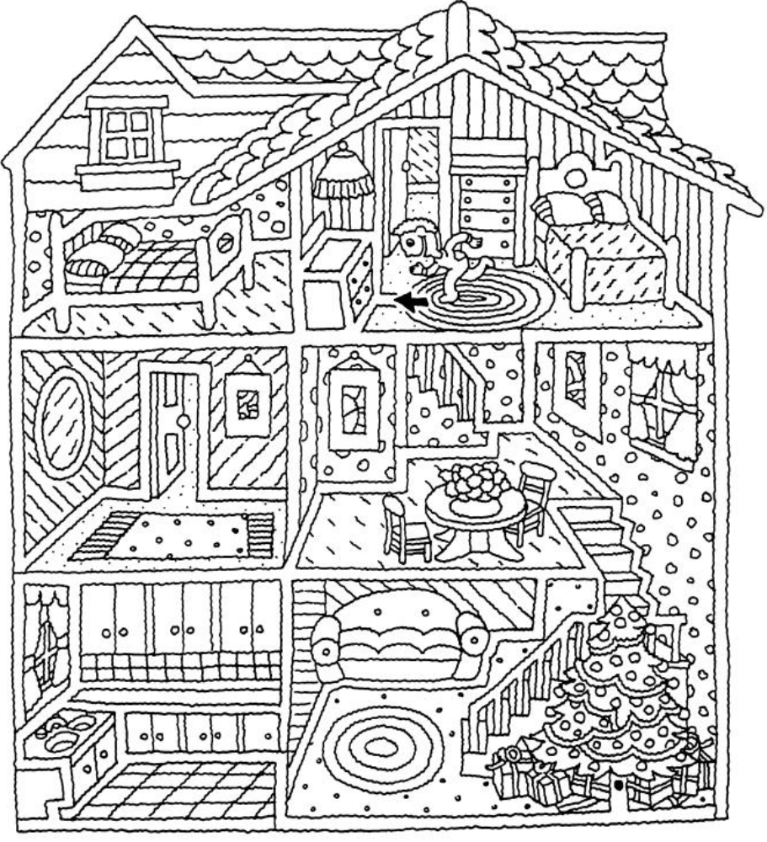

Answers to gathering Activity Things -
December Number Rhyme: (1) 5, (2) 6, (3) 2, (4) 4, (5) 5, (6) 3, (7) 25
Backward and Forward: (1) eve, (2) toot, (3) tot, (4) dad, (5) noon, (6) bib, (7) pup, (8) mum, (9) deed, (10) pop

OPENING CEREMONIES

Respect Ideas
Respect
2011-2012 CS RT Planning Guide
Materials: Seven large cards with the letters to spell out “RESPECT” on one side and script on the other
Personnel: Eight Cub Scouts, seven of whom are holding the letter cards
- R stands for rules. Cub Scouts obey the rules.
- E stands for environment. Cub Scouts treat the environment with care.
- S stands for speech. Cub Scouts use good speech and good manners.
- P stands for personal appearance. Cub Scouts keep themselves neat, clean, and physically fit.
- E stands for example. Cub Scouts set an example by treating others as they would like to be treated.
- C stands for courtesy. Cub Scouts are kind and courteous to others.
- T stands for things. Cub Scouts take care of the things that belong to others.
- Let us show our respect for our country’s flag by repeating the Pledge of Allegiance.
Respect the Earth
Utah National Parks Council
Materials: (Items or Pictures) aluminum can, book, basketball, flower, car.
- (Holds up aluminum can) “I respect the earth by recycling”
- (Holds up book) “I respect my parents by doing my homework when told”
- (Holds up basketball) “I respect my teammates by passing them the ball.”
- (Holds up flower) “I respect nature by planting”
- (Holds up car) “I respect the air by riding with friends”
- Please show your respect to the flag by giving it the proper salute.
Respect Means ...
Utah National Parks Council
CM: There are many ways that we can show respect.
- Respect means using good manners.
- Respect means to disagree, without being disagreeable.
- Respect to the flag means we hang it correctly, and do not let it touch the ground.
- Respect for our country means obeying the law.
- Respect for our belongings means taking good care of them.
- Respect for ourselves means to dress neatly.
- Respect for ourselves also means taking care of our bodies—exercising, eating healthful foods, and getting enough sleep.
- Respect for our parents and leaders means we listen and follow directions.
- Respect for our environment means we use resources wisely, and do not litter.
- Respect for God means not swearing, and following His commandments.
If a closing -
CM: Each of you have been provided a copy of this ceremony in tonight's program.. I challenge you do your best to live this way until we meet again and then tell me what you noticed. (or something similar)
If an Opening -
CM: These are just a few of the ways we can show respect. Please join me now as we show respect to our flag and country by saying the Pledge of Allegiance.

Holiday Lights Ideas
Holidays Lights Around The World
Alice, Golden Empire Council
- In India and Thailand, they celebrate the Festival of Lights, With little lamps or lotus boats that float into the night. [Boy carries a Lotus Boat of foil]
- In Sweden, too, they honor Santa Lucia, Queen of Light, The oldest girl will wear a crown with candles warm and bright. [St. Lucia crown or candle and greens.]
- In Mexico, the children gather goodies from the floor, For they’ve broken the piñata filled with candy treats galore! [Piñata]
- In Poland, on the table, under dishes they put straw, And they leave a chair that’s empty for the Holiest child of all. [Hand full of straw or a small chair.]
- In Ireland, each window holds a very special light, A candle that will welcome all who wander in the night, Just as Mary came with Joseph seeking shelter long ago, The candle still will welcome those who wander to and fro. [Artificial battery candle]
- In Holland, children fill their shoes with carrots and with straw ~ In hopes “Black Pete” will substitute a gift for one and all. [Wooden shoes and/or carrots]
- In Israel, the children play with a special top for a special day. [Dreidel]
- In England, children hang a sock - one that doesn’t have a hole! They hope it will hold presents and not a lump of coal! [Christmas stocking]
- Let’s Celebrate! Let’s Celebrate! and learn of special ways that people all around the world celebrate their holidays! [Globe]
A December Gift Opening Ceremony
Alice, Golden Empire Council
Props: Box wrapped with holiday paper and tied with a bow. In the box are a menorah, small Christmas tree, invitation, Kwanzaa candelabra, and other symbols of December Holidays appropriate for your unit, Instant Recognition patch and beads, small wrapped gift, small felt stocking, and card saying "Do Your Best."
Cubmaster: (Opens box and looks inside.) December is one of the most exciting months of the year, and certainly one of the busiest. This month we have: Christmas (Takes out tree.); Hanukkah (Removes menorah.); Kwanzaa (Removes candle holder.), (Does other symbols), and Holiday parties (Takes out invitation.).
What a great time for all of us! Our pack has had lots of fun this month working on advancements (Takes patch and beads from box.).
One of the best things was our special service project/Good Turn (Takes stocking (or other symbol for the project) from box.)
We've been busy, and all the time we have followed the Cub Scout Motto: (takes paper out of box and shows it while saying motto) "Do Your Best". And we have learned to Respect the traditions of other people from around the world. We are also learning to show Respect for our flag.
Now den ___ will present the colors.
Tree Opening
Utah National Parks Council
HINT: Use tree decorating as a Gathering Activity
Directions: Cubmaster uses Cub Scout sign to get everyone's attention, then Assistant Cubmaster lights the Christmas tree.
Cubmaster: “Cub Scouts, isn’t that a beautiful tree? It’s full of Holiday Lights making it bright and colorful, like the joyous seasons we celebrate this month.” (Name seasons celebrated by Pack members, such as Christmas, Hanukkah, Kwanzaa, and any others.)
Assistant Cubmaster: “And we all had a part in making it so beautiful. When all Cub Scouts work together and do their best, the result is always something fine like this tree. Let’s remember that as we repeat the Cub Scout Promise.” (Leads Promise)
Cubmaster: "Now let us repeat the Pledge of Allegiance"
Holiday Pledge of Allegiance
2011-2012 CS RT Planning Guide
Personnel: A Cub Scout (or several Cub Scouts) , den chief, or adult leader reads the lines for narrator (NAR) and the audience (AUD) reads the other lines together. Either print the lines in the Program or Distribute the ceremony beforehand.
NAR: I pledge allegiance
AUD: At this joyous time of the year
NAR: To the flag
AUD: A symbol of unity
NAR: Of the United States of America
AUD: Where we join together in peace
NAR: And to the republic for which it stands
AUD: Where people do their best to help each other
NAR: One nation under God
AUD: Where we have freedom to worship in our own way
NAR: Indivisible
AUD: We will stand strong, giving respect to others.
NAR: With liberty and justice for all.
AUD: Where people of all races and faiths can experience true fairness
NAR: Let us remember all our blessings as we pledge our allegiance to the flag.
Christmas Flag
Baltimore Area Council
A beautiful opening but be sure of your audience before using it, please. CD
Personnel 6 Cub Scouts
Equipment taped music, American Flag
Setting Play "Joy to the World" softly in the background as Cub Scouts recite lines.
- I pledge Allegiance, at this joyous time of year.
- To the flag, a symbol of unity as Christ is a symbol of peace.
- Of the United States of America, a land chosen above all others.
- And to the republic, to the people who care and share for which it stands.
- One nation under God, who shared His Son with us.
- Indivisible, a nation united through love with liberty and justice for all.
- Please stand and repeat the Pledge of Allegiance.
Cub Scout Spirit
Baltimore Area Council
Personnel: 5 Cub Scouts, Den Chief (DC), Den Leader (DL) or Cubmaster (CM)
Equipment: 5 index card with script written on each, US flag, Pack flag
Setting: Flags are already in place in the front and each Cub Scout enters from the side one at a time and reads his script.
- December is a fun time of the year. It is a time for giving and sharing.
- As we gather for the last pack meeting of 2012 let us remember the good times.
- Let us end this year with new determination to keep the Cub Scout Spirit going.
- As we begin our program tonight, let us keep in mind the true holiday spirit.
- Remember, to give of yourself is more important than any gift you can buy.
DC: Please stand for the Pledge of Allegiance.
Holiday Lights
Utah National Parks Council
Personnel: 5 Cubs, Den Leader (DL) and Cubmaster (CM)
(I inserted the DL because of the large amount of text
to be read. DL could stand at podium or elsewhere and
read. If you have a Webelos Den and they are all good
readers, let them do the reading. Or maybe use your
Den Chief. Or have a parent for each boy up front with
them to help with the reading. CD)
Materials: Log candle holder with 3 candles (12")
Multipurpose lighter

- The theme of this month is “Holiday Lights” and we have been busy getting ready for the Holiday season.
- This month there are three major holidays celebrated by a different Religions, Hanukkah, Christmas and Kwanzaa. And each uses light in a special way.
- Hanukkah is the Jewish Feast of Lights or Feast of Dedication. The Hebrew word Hanukkah means dedication. It is a celebration of God's deliverance of the Jews in 165 BC.
DL: The Hanukkah holiday begins on the eve of the 25th day of the Hebrew month of Kislev, and lasts eight days. It usually falls in the month of December and is celebrated by lighting of candles in a special Hanukkah menorah. I light the first candle for Hanukkah. [Lights the first candle]
- Christmas is the celebration of the birth of Jesus Christ. Advent is the season of preparation for Christmas.
DL: In preparing for Christmas, Christians use an Advent wreath with four candles in the wreath and one in the center. They light one candle in the wreath each week and the center, or Christ, candle on Christmas, for Jesus is the Light of the World. The word Christmas is taken from old English, Christes maesse or Christ's Mass. I light the second candle for Christmas. [Lights the second candle]
- Kwanzaa is an African American holiday based on the traditional African festival of the first harvest crops.
DL: The word Kwanzaa comes from the phrase Matunda ya Kwanzaa, which means “first fruits” in Swahili. The holiday was developed in the United States in 1966 by M. Ron Karenga, a professor of Pan African studies and a black cultural leader. It begins on December 26th and lasts for seven days. Each day of Kwanzaa, another candle is lit on the Kinara. The candles stand for the seven principles of black culture developed by Karenga. The principles are: Unity, Self-determination, Collective Work and Responsibility, Cooperative Economics, Purpose, Creativity, and Faith. I light the third candle for Kwanzaa. [Lights the third candle]
- With the spirit of the holiday candles now burning, let us begin our own celebration of our accomplishments this month.
CM: All rise for the Pledge of Allegiance. [Perform proper flag protocols.]
Flag and Candle Ceremony
Utah National Parks Council
Note - The Three Candles closing extinguishes these
candles to close the meeting
Material: American flag, Pack Flag (optional), white candle, blue candle, red candle, white 5-pointed star, and five Cub Scouts.
Set Up: The flags have been posted in their stands before the beginning of the Pack Meeting.
The Cub Scouts walk to the front of the room carrying their unlit candles. (Candle-shaped lamps with batteries may be used in place of wax candles.)
- Practically from the beginning of time, man has used symbols to express hope, ideals, and love of his own nation. Our Flag represents the ideals of science, commerce, and agriculture. It symbolizes the sacrifices made by men and women for the future of America. It stands for your home and everything and everyone you hold dear. I light the red candle, which represents the red in our flag, and stands for hardiness and valor. It reminds us of the lifeblood of brave men and women shed in our defense.
- I light the white candle, which is the symbol of purity and innocence, and which represents the white of our Flag.
- I light the blue candle which symbolizes perseverance and justice. The blue in our Flag directs our view toward the heavens. It reminds us of a power greater than our own.
- The stars in our Flag represent the individual states. They indicate that the height of achievement for our nation is as limitless as the heavens above us.
Each Cub Scout places his candle on a table in the
center of the meeting room, situated between the
American Flag and the Pack Flag. The candles remain
lit until the end of Pack Meeting.
- Will the audience please stand and join me as we pledge our allegiance to the Flag.

AUDIENCE PARTICIPATIONS
& STORIES
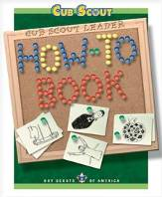
The How To Book contains the greatest Audience Participation ever written -
The House Where Santa Claus Lives
on Page 5-6
Manners Matter
Alice, Golden Empire Council
Divide the group into four smaller groups and assign each group one of the words listed below. Practice as you make assignments. Read the story.
After each of the words is read pause for the group to make the appropriate response.
SNEEZE or COUGH raise your arm
and “sneeze or cough” into your elbow
GIFT Thank you – it’s great!
PLATE Let me help you
DOOR Thanks for coming
Johnny Cub Scout was having a birthday party. He couldn’t wait to see his GIFTS! He hoped he would get something he really wanted.
Just then, he heard someone at the DOOR. He ran to open the DOOR and see if someone brought him a GIFT. But when he opened the DOOR, something in the air made him SNEEZE. In fact, he SNEEZED three times! He shut the DOOR quickly. His friend had brought him a GIFT – He hoped it was something he really wanted! He offered his friend a snack from the PLATE his Mom brought in. His friend looked really happy to see the treats on that PLATE! Then they heard someone else at the DOOR. Both of them went to see who it was, and if there was another GIFT. It was a really small box – they wondered what kind of GIFT it was. All three boys headed back for a treat from the PLATE.
In the background, Johnny’s mother COUGHED. Several more times, they had to answer the DOOR – and each time, Johnny started to SNEEZE. And each time, there was a GIFT for Johnny Cub Scout. He could hardly wait to open his GIFTS. But first they all played some games and then his Mom brought in a PLATE with a huge birthday cake on it. Everyone had a PLATE with cake and ice cream.
Finally, it was time to open the GIFTS. Johnny Cub Scout was very happy with his GIFTS, and he ate a huge PLATE of cake and ice cream. In fact, his mother COUGHED and raised her eyebrow when she saw what was on his PLATE! When the party was over, he went to the DOOR with each of his friends to thank them for coming and also for their GIFT. And each time he opened the DOOR, Johnny would SNEEZE – in fact, he SNEEZED three times each time he opened the DOOR. And best of all, there was even some cake left on the PLATE!
Camping in the Woods on Christmas Eve
Pamela, North Florida Council
T'was the night before Christmas
And all through the woods,
Not a scout was stirring, they were all being good.
Their sneakers were hung by the camp fire with care.
In hopes the delivery guy, soon would be there…
And I in my Neckerchief,
And Mr._______ in his Cub-Cap,
Had just settled down for a short camping nap,
When deep in the woods there arose such a clatter,
I sprang from my sleeping bag,
To see what was the matter.
Away to the tent, I flew, I was scared,
I grabbed a hammer and shovel,
In case it was a bear.
Then what to my wondering eyes should appear,
But Scouter Clause, with some pizza and root beer.
He was a little old scout, so lively and quick,
I knew in a moment, He was scared of ticks.
More rapid than an Eagle Scout the pizzas they came,
and he whistled and shouted and called them by name,
Now sausage, now peppers, now onions and pepperoni,
On meatball, on, ham. On, hold the anchovies.
To the top of the tents, to the top of the trees,
Dash away, Dash away, with extra cheese.
As I got to my feet and was turning around,
Into the campsite, he came with a bound.
He was dressed all in uniform from his head to this toes.
His shirt was garnished with badges and bows.
A bundle of pizzas he had flung on his back,
And he looked like a new scout,
doing the opening ceremony, for his pack,
His eyes, how they twinkled, His dimples so merry,
His cheeks were like roses, his nose like a berry.
He had a broad face and a little round belly,
That shook when he laughed like a bowl full of jelly.
He was chubby and plump, a right jolly old scout,
And I laughed when I saw him, in spite of myself.
He spoke not a word, but went straight to work,
Gave out the pizza and then turned with a jerk,
And laying a finger onside of his nose,
and checking his compass, Down the trail he goes,
I sprang to my feet, to the boys gave a whistle
And up they all flew, like the down of a thistle.
We ate all the pizza and drank all the soda,
Our stomachs, all felt like they would explode.
And we heard him exclaim, as he drove out of sight,
Merry Christmas Pack ____, & to all a good night!
A Wintry Mix-Up
Utah National Parks Council
Directions: Print the following phrases, one per card. Number the cards. Distribute to the audience. The Narrator reads the story aloud, pausing at each blank space. The person with the next card fills in the blank. You might want to number the cards and your script in case someone is not paying attention. Make sure order is random for maximum fun.
Cards Needed -
A quart of eggnog A Little Lamb A Snowman
A pound of butter A broken TV A pair of dirty socks
A fluffy pillow A dog' s bone Chicken feathers
A snow shovel A Stocking cap An old innertube
14 cookies Lipstick Frozen fingers
Snow boots Furniture Polish Bubble Gum
It was a cold winter night. The icicles on the eaves of the cozy house hung down like _____, and the snowflakes were falling as fast as ______. Inside, Mrs. Woolley sat in her old rocker that creaked like _____. She was knitting a pair of mittens the color of ______.
Story -
"Where can my husband be?" she wondered as she went to the stove. She lifted up the lid and stirred a bubbling pan of stew. The stew smelled delicious, just like ______. Just then, two little children burst into the room. Their frightened faces were the color of ______.
"Mommy, come with us!" they cried. "Something is happening in the garage." Mrs. Woolley tossed her knitting into______ and ran out the door so fast that she almost tripped over ______. With a noise like ______, the three quietly crept to the garage. In the frosty sky overhead, the stars twinkled like ______, and the snow lay on the ground as deep as ______. Through the window of the garage, they could see a figure pulling tools off the shelf and stuffing them into a sack that was as lumpy as ______.
"A robber," Mrs. Woolley whispered to the children. "You grab ______, and you grab ______, and I'll make a noise like______ to scare him away."
But just then, the door opened, and the person inside quietly crept out. "Stop, thief", Mrs. Woolley tried to shout, but she was so frightened, her voice sounded like ______. The figure with the sack stopped short. Then there was a jolly laugh, and a voice said, "What are you doing out here so late?"
It was daddy, himself! He said he was just gathering some tools to fix the broken sled, which had lost ______. Daddy had the day off tomorrow, and wanted the whole family to go sledding. He took each child by the hand. "Your hands are so cold, they feel like ______," he said.
They all hurried into the house for a bowl of stew, which tasted better than ______on that cold night. Then he gathered the family around the fire, which was crackling like ______, and read them all a story about ______. How wonderful it was to be together again.

LEADER RECOGNITION & INSTALLATION

The Light of Scouting
Baltimore Area Council
Setting – You will need candles for every person in the pack. Wrap each candle in foil to create a drip plate.
Scene – Dim the lights in the room. There should be two candles on a table in the front of the room. The pack committee should be near the front with the Cubmaster and the Assistant Cubmaster. The den leaders line up on each side of the room after the pack committee, and the Scouts line up next to their den leaders. Make sure the Cubmaster has a lighter.
(Cubmaster lights one of the candles on the table
and turns to speak to the group.)
This candle represents the spirit of Scouting. All by itself in this big room, it doesn’t seem like much. But then, the spirit of Scouting finds me, as your Cubmaster
(Lights the 2nd candle from the 1st, and continues.)
While this is a little better, it is not nearly enough light. Fortunately, the spirit of Scouting continues to spread from me to the Assistant Cubmaster and to our wonderful Pack Committee
(Cubmaster lights candle of Assistant Cubmaster,
and then they each light one candle of the pack
committee members. Lighting continues from one
candle to another until all the pack committee
candles are lit.)
The spirit of Scouting doesn’t stop there! It continues to spread as more and more folks learn about the riches and treasures found in our program.
(Den leader candles are lit from pack committee members.)
Are you starting to see a pattern? Don’t you think having even more spirit would be better? How do the den leaders spread their Spirit? That’s right! They spread the spirit of Scouting with their dens and all the Tigers, Wolves, Bears, and Webelos Scouts can experience this spirit.
(Den leader lights one candle of the den and
Scouts light one candle from a previous candle
until all Scout candles are lit.)
Wow! Isn’t this better? Let’s consider that this is just one pack. We’re a small part of one district in one council in the United States. The spirit of Scouting burns all over the world! So, when our light combines with all the other lights in all the other packs all over the world, the spirit of Scouting becomes a tremendous beacon to guide Scouts on their journey through life. I hope you carry this spirit of Scouting with you all your life!
Here’s to the Scouters’ Spouses
Utah National Parks Council
Obtain Scouter's Husband awards (#33765) and Scouter's Wife Awards (33766) from National Supply (www.scoutstuff.org) or your local National Shop.
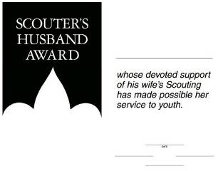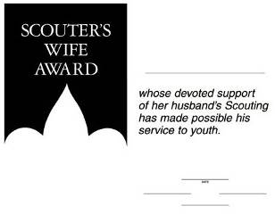
Fill In the information and sign them.
Then at a Pack Meeting (Blue & Gold?) call them forward, read Here’s to the Scouters’ Spouses and present the certificates.
Here’s to the Scouters’ Spouses
By Carol Shaw Lord
You quietly sit
While we threaten to quit
And encourage us to keep on a tryin’.
Without you being strong
We wouldn’t last long
You’re the one’s we always rely on.
You listen (without squawks)
While we practice our talks
While we’re gone you pick up the slack.
You do our share of chores,
And butler the doors,
And help keep us on the right track.
Here’s to our spouses
Who care for our houses,
That’s great help we could never hire.
Why, you hardly even mutter
While the house fills with clutter
As the Scouting stuff piles ever higher.
For all your warm greetings,
When we come from our meetings,
And helping us out in a crunch,
For manning the phone,
And your struggles alone,
We say to you all, thanks a bunch!
Christmas Wreath
Utah National Parks Council
- Have each Scout trace their hand on green construction paper.
- Cut out all the hands and place them together in a circle with the fingers pointing outward, forming a wreath.
- Decorate with red berries using markers or crayons.
- Give to the head of their Chartered Organization as a ‘Thank You' and Christmas Card. (Or Cubmaster. Or each Den for their Den Leader. Or one for each Committee Member. Or ...)

ADVANCEMENT CEREMONIES
Magic Words
2011-2012 CS RT Planning Guide
Materials: Large signs with “thank you,” “please,” “pardon me,” “how nice you are,” and “you’re welcome” written on them.
Cubmaster (CM) leads the ceremony. If desired Cubmaster part may be split among several leaders.
CM: We have many values in Cub Scouting. Respect is one of them. To be respectful to others, you need to be courteous, appreciative, kind, and thoughtful. There are important words that tell someone that you are respectful. I call them magic words. I’m sure the Cub Scouts in this room know these words already. I would like to ask the Cub Scouts who have earned special awards to come up and help me review some of these magic words.
First, we have boys who have earned the Bobcat badge. Will the following boys come forward with their parents? (Name each boy and have the parent present him the Bobcat badge.) Now boys, please show the first sign to the audience. (Boys show the sign with “thank you” on it.) New Bobcats and parents, thank you for joining our pack. I’m really glad to get to know all of you. (Lead a Cheer)
We have Tiger Cubs who have earned some awards. Will the following Tiger Cubs come forward with their parents? (Say each boy’s name and what he has earned. Ask the parents to present the awards to their sons.) Tiger Cubs, please show the next sign to the audience. (Boys show the sign with “please” on it.) Thank you, boys. And please accept my congratulations on your awards. (Lead a Cheer)
Some of our Wolf Cub Scouts have earned awards. The following boys, please come forward with your parents. (Say each boy’s name and what he has earned. Ask the parents to present the awards to their sons.) Wolf Cub Scouts, please show the next sign to the audience. (Boys show the sign with “pardon me” on it.) Pardon me, boys, but could you please hold up the sign so everyone can see it? Thank you! (Lead a Cheer)
Now we have Bear Cub Scouts who have earned some awards. Will the following boys please come forward with their parents? (Say each boy’s name and what he has earned. Ask the parents to present the awards to their sons.) Congratulations, boys. Now could you show the next sign to the audience? (Boys show the sign with “how nice you are” on it.) How nice you are to do that. Thank you. (Lead a Cheer)
We also have Webelos Scouts who have earned some awards. Will the following boys please come forward with their parents? (Say each boy’s name and what he has earned. Ask the parents to present the awards to their sons.) Good job, boys. Now could you look at the remaining sign and show it to the audience? (Boys show the sign with “you’re welcome” on it.) Thank you, Webelos Scouts. (Boys will say, “You’re welcome.”) (Lead a Cheer)
(Draw attention to the signs.) These are simple words but they are important because they tell someone else that you are appreciative, courteous, kind, and thoughtful. But these words do not mean much if actions do not go with them. Cub Scouts, do your best and add kind deeds to these magic words. Congratulations on your awards and thank you for your help.
The Many Roles of Respect
Utah National Parks Council
Note: This could also be altered to be an Opening Ceremony. If so, boys can bring up the letters one by one – and you can finish with the optional ending. Have large individual letters prepared, spelling out R-E-S-P-E-C-T. During the Ceremony, each letter can be mounted on the wall or a board where they can be seen by everyone.
NARRATOR: The boys in our pack have been learning about the many ways to show RESPECT this month. Let’s take a closer look:
(Letter R is put up) – One of the first ways a Cub Scout learns to use RESPECT is by following Akela and showing RESPECT to his leaders – and by using good manners at all times. We have some good examples here tonight.
(Call up boys earning Bobcat, or those who have earned the Good Manners Belt Loop and/or pin. Parents of Bobcats should be called up and handed the badge to present to their sons. Bobcat boys should present the parents’ pins.)
NARRATOR: (Letter E is put up) – Since Scouts have always spent much of their time outdoors, RESPECT for the Environment is one of our main goals.
(Boys who have earned their Tiger Cub Award have shown this respect in Achievement 5, Let's Go Outdoors which is part of the Leave No Trace Award. If you have no Tigers that month, use it for Leave No Trace or World Conservation awards, or to give out special patches for a service project involving the environment)
NARRATOR: (Letter S is put up) – One important lesson we each need to learn is that without having Self-RESPECT, we will not be able to RESPECT others. Self-RESPECT is shown by how we act, how we talk, even how we dress. Wolf Scouts have learned how important it is to wear the scout uniform proudly – it’s a symbol of Self-RESPECT!
(Boys earning Wolf badges and their parents can be called up.)NOTE: If you have boys who have earned the Disability Awareness Belt Loop or Pin, they could also be given at this time – make the connection that Self-RESPECT means you can RESPECT others, including those who are different from you.
NARRATOR: (Letter P is put up) – RESPECT for Parents is an important way for all scouts to show they value those who love and guide them.
(If you have Sports Belt Loops or pins to give out, they could be given out now, with a connection made to how parents demonstrate good sportsmanship and encourage boys to follow safety rules in sports.) Parents are often the best example of good sportsmanship for their sons, and urge boys to follow the safety rules so they will be safe.
NARRATOR: (Letter E is put up) – In completing the Character Connection for RESPECT, Bear scouts learn to have greater RESPECT for their elders as they learn what Cub Scouting was like for them, and learn more about their own family and community history.
(Boys and parents are called up to receive their Bear badges ) NOTE: If you have boys getting the Belt Loop or pin for Heritages, they could also be given now.
NARRATOR: (Letter C is put up) – Webelos Scouts have a world that is becoming larger and wider – as they learn about other people, they come to value and RESPECT Cultures, Customs and languages that are different from their own.
(Webelos Scouts receiving their badge, compass emblem and points can be called up with their parents) NOTE: If you have boys getting the Languages &Cultures Belt Loop or pin, they could be given now, or you could refer to the diverse ways in which people celebrate the Holidays.
NARRATOR: (Put up letter T) – RESPECT isn’t just about people, it’s also about Things. We need to have RESPECT for our possessions and those of other people, whether it’s our clothes, a bike, a piece of furniture, or your scout book. Boys who are working toward the Arrow of Light award have learned to keep good records and take care of them and will value the only badge that can be worn on the Boy Scout uniform.
(If you have anyone getting the Arrow of Light, they could be called up now and you can move into a special Arrow of Light ceremony.)NOTE: If not, close with this:
NARRATOR: You’ve seen how many different ways the scouts in our pack have been learning about and practicing RESPECT this past month – Let’s all commit to showing RESPECT for everyone and everything!
OPTIONAL ENDING IF USED AS AN OPENING CEREMONY:
NARRATOR: One important thing that every Scout should always RESPECT is our Country’s Flag. (Transition into the Flag Ceremony)
Climbing the Tree
Capital Area Council, Utah National Parks Council
Baltimore Area Council
Materials: Have a Christmas tree with various colored lights. (This can be a cardboard tree with holes for the lights.) The bulbs should be unscrewed slightly so that they can be easily turned on at the proper time. You may wish to use yellow lights for the bottom row (BOBCAT), orange lights for the next row (TIGERS), red lights next (WOLF), green lights on the fourth row (BEAR), and blue lights for the top row as well as the top of the tree (WEBELOS).
Personnel: Cubmaster (CM) and Assistant Cubmaster (CA)
CM: As we look at our tree this evening, we see that it is dark, with only one light on. [Screw in top light.] This is the light which represents the Webelos Arrow of Light Award.
Let us see if there are boys here tonight who can help light the way to the top of the tree, to the highest rank in Cub Scouting.
The first step along the Cub Scout trail is the BOBCAT. [Turn on light at the bottom. If there are any Bobcats to be inducted do it here. Call boys and parents forward, present badges to parents to award to sons. Lead cheer.]
Once a boy has achieved this honor, he is ready to climb.
CA: There are 5 achievements to complete for the Tiger rank. They are Making My Family Special, Where I Live, Keeping Myself Healthy and Safe, How I Tell It, and Let’s Go Outdoors. Each achievement has three parts: a den activity, a family activity, and a Go See It. The following boys have completed these requirements: [Call boys and parents forward and any boys who have earned any Tiger Track beads, too. Present badges to parents to award to sons. Lead cheer.]
Thank you, boys. We are now able to turn on the light representing the Tiger rank. [Turn on next light.]
CM: There are 12 achievements to complete for the rank of Wolf. Some of these require knowledge of the United States flag, keeping strong, safety, and being useful to the family. The following boys have completed these requirements: [Call boys and parents forward and any boys who have earned arrow points, present badges to parents to award to sons. Lead cheer.]
Thank you, boys. We are now able to turn on the light representing the Wolf rank. [Turn on next light.]
CA: As the boy grows older and stronger, he is able to climb higher. But just as it is a little more difficult to climb the upper branches of a tree, so the achievements are a little more difficult for the Bear rank. [Call boys and parents forward and any boys who have earned arrow points. Present badges to parents to award to sons. Lead cheer.]
Thank you, boys. We are now able to turn on the light representing the Bear rank. [Turn on next light.]
CM: These boys have helped us light our tree, but it is still not quite as bright as it might be. Since they have received help from their parents and leaders, let us turn on a light for the parents, too. [Turn on another light.]
Now the boys have reached 4th grade or 5th grade and have more climbing to do. This last climb will bring them to the top of the tree and the coveted Arrow of Light. To reach it they must first attain the Webelos Award. In order to reach the Webelos Award they must earn three activity badges. [Call boys and parents forward, present activity awards to parents to award to sons. Lead cheer.]
Thank you, boys. As you have learned throughout Cub Scouting, you have helped to make the world brighter. [Turn on another light.]
CA: And now the boys who have earned their Webelos badge and have begun to learn what Scouting really is. [Call boys and parents forward, present Webelos badges to parents to award to sons. Lead cheer.]
We are now able to turn on the light representing the Webelos rank. [Turn on next light.]
CM: Now our tree is complete. As you have seen, it has taken boys plus parents and leaders to complete it. With the same effort you have shown before, keep working for the highest rank in Cub Scouting. Congratulations to you and your parents for the fine work you have done.
Some FUN Holiday Advancement Ceremonies Ideas
Alice, Golden Empire Council
- Have a stack of wrapped gifts, all different shapes and sizes – put a gift tag on each one and as boys are called up, they have to find their “gift” – which is the award(s) they have earned, all wrapped up.
- Have all the boys take a turn at breaking open a piñata, in which, besides wrapped candies and small toys, there are envelopes addressed to the boys and containing their awards. But be sure to bring each boy forward with parents to announce what they have earned.
- Take a page from the fun-loving Dutch – wrap each boy’s award in tissue, then tie with yarn and before the Pack Meeting begins, string the yarn all over the room , under and over other yarns leading to other boy’s awards, between the rungs of chairs – when the boy’s name is called he is given the end of his yarn string and must follow it all the way to the end. You could use a different colored yarn for each boy, or make it even harder and use the same color yarn! If it seems too difficult for a boy, invite his parents to come up and join the fun!
- Along the same lines, the Dutch like to plant notes with riddles leading to the final prize, in this case, a box or envelope with the boy’s awards inside. This will take some extra time before the meeting – either use rhymes or riddles – again, the boy can get help from his den, his parents, or the whole audience.
Recognition Ceremony: Webelos Activity Badges
2011-2012 CS RT Planning Guide
Materials: One candle for each activity badge to be presented
Cubmaster (CM) and Webelos Den Leader (WL) lead the ceremony. If desired CM and WL parts may be split among several leaders.
CM: Tonight, we have the honor of presenting awards to the Webelos Scouts who have earned Webelos activity badges. Will the Webelos den leader of [den’s name] please bring forward the members of your den who have earned activity badges and their parents?
WL: [Names], you have worked hard and earned the [name of an activity badge]. To do that you [name some activities that the boys did]. I congratulate you on your new [skill or knowledge, depending on the badge earned]. (Hand the badge to the parents as the Cubmaster lights one of the candles. Ask the Webelos denner or den chief to lead the den in the den yell.)
CM: (Lead a Cheer)
(Repeat the above for each Webelos den.)
CM: (Point to the lit candles) Each of these candles represents an activity badge. Some of you have already earned one or more activity badges. The candles for those badges are burning brightly in your memory. These and the ones burning in your memory are steps along your Cub Scouting trail toward the Arrow of Light Award and toward becoming loyal Scouts.
Congratulations. (Lead a Cheer)
The Lights are Beautiful
Utah National Parks Council
Set Up: Have enough appropriately-sized light bulbs so that each Scout receiving an award (or each Scout in attendance) will receive a light bulb to give to his parents to screw into a socket on the string of lights.
Materials: Long string of large outdoor Christmas lights (C7 or C9 style) where each light screws into the base and is not dependent upon other lights in the string.
The string of lights should:
- Be UNPLUGGED
- Have no lights screwed into it (or as many sockets empty as there are Scouts receiving awards or as there are Scouts in the pack – could have more than one string... depending on how you want to do it)
Scene: Cubmaster (CM) leads the ceremony. Ask two or more adult leaders (depends on the length of your string of lights) to come to the front of the room to hold the string up... OR you could lay the string of lights across a large table or tables.
CM: This month we’ve really talked about all the lights around us at the holidays. I want you to know that you Cub Scouts that are a part of our pack are bright lights to me at all times. Your shining faces and examples help me and the other adults all year round – but we seem to notice that more as we watch your excitement during the holidays.
Your lights have been really shining this month in the work that you’ve done toward ranks, arrow points, and activity badges.
Cubmaster announces and distributes Bobcat, Tiger, Wolf/Arrow Points, Bear/Arrow Points, Webelos/Activity Badges and Arrow of Light.
As awards are distributed, give each Scout a light bulb. Make sure to include Scouts who might not be on your list of awards this month. Ask each Scout to give the light bulb to his parents then go up with him and put the bulb into the string of lights...
OR have other adult leaders assist them in adding their “lights” as well.
CM: All of our lights are now part of this long string, and when we add the Cub Scout program [plug in the lights] we are beautiful to see! [Replace non-working bulbs at this point... ☺] Thanks for all of you this month for being a great part of our pack! Lead Cheer
Christmas Awards
Baltimore Area Council
Characters:
SANTA - with long list & empty sack,
Helper X with green cap,
6 Helpers with red caps, working tools & toys.
Setting: Santa's workshop, with all 7 helpers busy working on toys & whistling or singing "Jingle Bells". As curtain opens, Santa enters, puzzled, despaired, checking list in hand.
SANTA: Ho, Ho, Ho! This is an unusual list from the Cub Scouts of Pack _____. We're running out of time! Good grief! Sakes alive! (Sits down with sack opened, looking very sad.)
Helper #1 I've worked on trains, have they run out of brains?
Helper #2 It's clear to see - they don't want trucks from me!
Helper #3 Surely Santa, you know the score! That's no Ho,Ho! Please tell us more.
Helper #4 I know, great red & white one ... they need a change. (Rattles change in pocket.) They have been good and have been working hard on their Cub Scout requirements.
Helper #5 That's right, wise leader. They are not looking for gifts and presents tonight!
Helper #6 Shazaam! Me thinks the Cubs are tired of toys. They have worked hard and earned their awards. How about Arrow points and Webelos Activity Awards for these hard working Cub Scouts?
Comment from CD - Be sure to really stress this point. The boys earned the awards. They are not gifts. It is too easy to let boys and parents think we just give out badges without meaning.
Helper X (Running across stage, carrying a cardboard shield on large sack - Christmas type - with arrow points glued on.) Sock it to 'em Santa! (He places shield in Santa's sack.) Santa can then proceed to distribute awards (Hidden either in the "empty" sack, or in bag attached to shield) and comment about how hard the Cubs worked, how they earned these, that these are not just gifts and presents but that the boys worked to earn them. (Please make sure no one thinks your pack just gives awards away.

SONGS

Respect Songs
Honesty’s a policy that helps you to be True,
When you always tell the truth
Your friends can count on You
If you’re always steadfast,
You can stand up for the Right
All your words will stand alone,
And in the brightest light
Golden Rule
Utah National Parks Council
Tune: She’ll Be Coming Round the Mountain
Oh, we’ll all be sure to use the Golden Rule,
Playing sports, at home, at church, or when at school.
We’ll all treat one another
Like a sister, friend or brother,
We will always choose to use the Golden Rule.
Respect
Utah National Parks Council
TUNE: We Wish You a Merry Christmas
I listen to my elders, I give to the needy,
I respect everyone’s color, creed, religion and views.
I shovel neighbor’s walks, whenever it snows.
I respect the air and water, plants and animals too.
I help my little sister, I honor my older brother,
As a family, we’re together — we respect one and all.
R-E-S-P-E-C-T
Utah National Parks Council
Tune: Twinkle, Twinkle Little Star
R-E-S-P-E-C-T,
What's it mean for you and me?
Honor, care, civility,
Even when we disagree.
Those that fight are bound to fall,
United we can do it all.
R-E-S-P-E-C-T,
We are Cubs and we agree:
Keep the promise, Do our best,
Give good will and all the rest.
I'll do for you, you do for me,
That's how we build community.
Manners
Tune of “Bring Back My Bonnie”
We always say “Please” and then “Thank You”
We don’t interrupt if you please,
We never make someone unhappy,
Cause we never taunt them or tease.
Chorus:
Manners, Kindness,
They both leave a smile on your face, your face
Manners, Kindness,
They both leave a smile on your face!
We always try hard not to argue,
We always try hard not to fuss,
We always try hard to be honest,
And listen when folks talk to us!
Chorus
We know how to play well with others,
We share and we take just one turn,
We’re careful with toys that we borrow,
Good manners are easy to learn!
Chorus

Holiday Lights Songs
Lights in the Window
Sam Houston Area &Utah National Parks Councils
Tune: Clementine
We see lights outside of houses
Candles in the windows bright
But the thing that make our hearts glow
Is the fire at our campsite.
We like hiking, and adventure
Helping others is our quest.
And we always share Scout spirit
When we try to do our best.
As the lights glow at this time of year
We pause to say a grand thank you
To the leaders who spend time with us
Now and all the whole year through.
I'm Playing In The Snow
Baltimore Area Council
(Tune: I’m singing in the Rain)
I’m playing in the snow.
I’m playing in the snow.
What a glorious feeling
It’s snowing again.
Making snowman tonight
For the whole world to see
I’m happy just playing
In the snow
Christmas Song
Baltimore Area Council
(tune: Rudolph the Red Nosed Reindeer)
Here's to the Cubs in our den,
As they follow, help and give;
All of the boys in our den,
Know just how a Cub should live.
Now it's time for Christmas,
We've been very helpful boys,
We've gathered lots of old things,
Fixed them up like brand new toys.
Saved our pennies every meeting,
Bought a lovely Christmas Tree;
Trimmed it up to take to
Our Den's adopted family.
Bright and early Christmas morning
When they see our shiny toys;
We'll be happy that we shared our
Christmas joys with other boys.
S-A-N-T-A
Utah National Parks Council
Tune: BINGO
There was a chubby merry man
And Santa was his name-o
S-A-N-T-A, S-A-N-T-A, S-A-N-T-A
And Santa was his name-o
Repeat verse substituting a clap for the letter S,
then S-A, Then S-A-N, ...
The Winter Pokey
Utah National Parks Council
Tune: The Hokey Pokey
You put your right mitten in,
You take your right mitten out
You put your right mitten in,
And you shake it all about.
You do the winter pokey (shiver)
And you turn yourself around.
That's what it's all about!
Continue adding additional verses:
left mitten, right boot, left boot, long scarf, warm cap, snowsuit, etc.
Santa’s Coming ‘Round the World
Tune: “Are. You Sleeping”
Chorus:
Santa’s coming, Santa’s coming,
Round the world, round the world;
He has many faces;
Seen in many places;
Santa Claus, Santa Claus.
Chorus
In France he’s Father Christmas
Who fills’ the children’s wishes;
Santa Claus, Santa Claus.
Chorus
In Hungary Kris Kringle
Brings gifts to make tots tingle;
Santa Claus, Santa Claus.
Chorus
In Belgium they leave carrots bunched
St. Nicholas’ horse will surely munch;
Santa Claus, Santa Claus.
Chorus
No matter what his face or name
Good will and peace are just the same;
Santa Claus, Santa Claus.

Cub Scout Songs
I Heard the Cubs
Utah National Parks Council
Tune: I Heard The Bells
I heard the call of cubs one day,
Their old familiar laughter play
And wild and sweet the boys repeat
Oh come with us to Scouts today!
The Law of the Pack
Utah National Parks Council
Tune: Blowin’ in the Wind By Bob Dylan
The Cub Scout follows Akela.
The Cub Scout helps the pack go.
The Pack helps the Cub Scout grow.
The Cub Scout gives good will.
The Answer my friend,
Is growing from within.
The Answer is growing from within.
Pack Meet
Utah National Parks Council
Tune: Take Me Out to the Ball Game
Let’s all go to the pack meet,
Let’s all join in the fun.
Songs, and games and lots of joys,
We’ll have fun with all the boys.
So, come on let’s work together,
And make Cub Scouting a treat.
For it’s Wolves, Bears, Webelos Scouts
At our old pack meet.

STUNTS AND APPLAUSES

APPLAUSES & CHEERS
2010 - 2011 CS RT Planning Guide
Cheerful Respect
(While clapping in unison, spell out and repeat the words.)
R-E-S-P-E-C-T
This we learn and must never forget
R-E-S-P-E-C-T
The more you give, the more you get
(Shout together) RESPECT!.
Christmas Bells Applause:
- The leader pretends to hold a bell rope,
- Have the left side of the audience to say "DING" on the down stroke and
- Have the right side of the audience to say "DONG" on the upstroke.
- Repeat three times.
Snowball Applause:
- Reach down and pick up some imaginary snow, and
- Pack it into a ball.
- Pull arm back, throw, and yell, "Splaaaatttt!"
Alice, Golden Empire Council
Good Manners Cheer - Please. Thank You. You’re Welcome! (repeat three times)
Respect Cheer:
Have audience make the appropriate motion while you call out the words
- Respect for Self (point to self)
- Respect for Others (point to someone else)
- Respect for Country (Hand over heart or Salute)
Call out the respects several times in different orders.
To end the cheer - throw your hands in the air and have everyone shout “It’s All About Respect!”
Scout Cheers
Utah National Parks Council
Genius Quiet Clap - Clap hands together four times and then loudly say, “How great I am, how great I am, Genius! Genius!”
Light Globe - Pretend to screw in a light bulb, while saying, “Bright, bright, bright!”
Idea - Put finger on side of face and close eyes as if thinking hard, suddenly jump up, open eyes real wide and yell, “That’s the best idea yet!”
Stamp of Approval - Pound right balled up fist in open palm of left hand.
Nutty - Say, “This is a nutty applause. Everyone yell ‘Cashew’, three times.” After they do that, you reply, “God, bless you!”
Okay - Divide into two groups. One group yells, “O!” the other “Kay!”
Tony the Tiger - Yell, “Greeaaaatttt!”
Dancer - Have all stand up, link arms, and do the Can-Can.
Jack in the Box - Squat down and then jump as high as you can and say, “Boing!”
Banana Cheer
Utah National Parks Council
Bananas of the world unite
(place hands together above head),
Peel to the left
(lower left hand to your side)
Peel to the right
(lower right hand to your side)
Peel down the center
(place both hands above head again and lower simultaneously)
And umph take a bite!
(Snap arms back together above head in a giant bite)
GO BANANAS! GO, GO BANANAS!
(while dancing around)
Holiday Lights Cheers
Utah National Parks Council
Snowglobe - Pretend to hold a ball in your hand, shake it up and down and say, “Oooo! Aaah! Oohh!”
Santa - “Ho, ho, ho!” Hold stomach as you laugh
(Optional) Pull on reins & say, "Where's Rudolph?"
Rudolph - Put thumbs to head with fingers pointing up and form antlers; wrinkle nose and say, “Blink, blink, blink.”
Silent Night - Stand up, cup hands around mouth (as if yelling) and silently mouth the words “Great Job!”
Merry Happy - One side yells “Merry Christmas” and the other side answers “Happy New Year.” Repeat three times.
Jingle Bells - Stand and wiggle all over while saying ‘jingle, jingle, jingle.”
Dad’s Gift - Act as if opening a gift and when open say, “Oh, a new tie! Just what I needed.”
Christmas Stocking - Pretend to empty your stocking and then put it on your right foot.
Dasher - Slide hands against each other, making loud swishing noises.
Frosty the Snowman - “Thumpity, thump, thump!” twice.
Mistletoe - Pretend to hold mistletoe over your head and make kissing sounds.

RUN-ONS
Christmas Flowers
Utah National Parks Council
#1: This year we are going to have lots of Christmas flowers.
#2: Why is that?
#1: Last year I planted all the Christmas Bulbs.

Ho, Ho, Ho
Utah National Parks Council
Q: How does Santa Claus water his garden?
A: With his ho, ho, hose
Q: How does Santa Claus keep his legs warm?
A: With his ho, ho, hose
Q: How does Santa Claus weed his garden?
A: With his hoe, hoe, hoe
Q: What does Santa Claus eat for breakfast?
A: His Cheerios, hos, hos
Q: What is Santa Claus’s favorite dessert?
A: Ho Hos
Baltimore Area Council
So what are you getting mom and dad for Christmas?
A list of what I want.
Why did the silly boy take the Christmas tree to a barber?
Because his mother said that it needed to be trimmed.
Knock, Knock
Who’s There?
Canada
Canada Who?
Canada dog come in the house, it’s cold outside.
Knock, Knock
Who’s There?
Murray
Murray Who?
Murray Christmas to all and to all a Good Night.
Knock Knock
Who’s There?
Pizza
Pizza Who?
Pizza on Earth, Good Will to Man.
Knock, Knock.
Who’s There?
Lettuce.
Lettuce Who?
Lettuce in, it’s freezing out here.
Knock, Knock
Who’s there?
Snow
Snow who?
Snow business like show business!
Knock Knock
Who’s there?
Donut
Donut who?
Donut open till Christmas!
Knock, Knock
Who’s there?
Avery
Avery who?
Avery Merry Christmas!

JOKES & RIDDLES
Utah National Parks Council
Q: What does a Christmas tree eat with?
A: U-tinsels.
Q: What do you get when you cross a shark and a snowman?
A: Frostbite.
Q: Who is two feet tall and sings “Blue Christmas?”
A: Santa’s Elvis.
Q: What do you get when you cross Frosty the Snowman with a baker?
A: Frosty the Doughman.
Q: Why is Santa like a light switch?
A: He goes up and down a lot during the night.
Q: Why did Comet stay home on Christmas Eve?
A: She was cleaning the kitchen sink.
Q: What do snowmen eat for lunch?
A: Iceburgers.
Q: What did the walrus say to the polar bear?
A: Have an ice day!
Q: What does Santa have for a snack on Christmas Eve?
A: Peanut butter and jolly!
Q: What’s in December that isn’t in any other month?
A: The letter “D”!
Q: How many pieces of candy can you put into an empty stocking?
A: One! After that, it’s not empty!
Q: Which Holiday candles burn longer, reds or greens?
A: Neither all candles always burn shorter!

More of these in the Felicia's Bear Section!!!



SKITS
Respect is Where You Find It!
Utah National Parks Council
Directions: Assign each boy to find one way that respect can be demonstrated in the activities in his Scout book. This can be done at home or in the den. Each boy picks an example, and could either draw a picture or just be assigned an item to bring. At the Pack Meeting, boys come forward and one by one, show their picture or item, and tell how respect is shown. (Following are examples from the Wolf Book, but any of the books would work as well):
DL: All of us went looking for examples of RESPECT this month.
- (show sign or picture) I learned to show respect by listening to Akela when I worked on the Bobcat badge.
- (show toothbrush & toothpaste or picture) I learned to have respect for my body and take care of my teeth.
- (Show an item used to do a chore around the house, or a picture) I learned to show my respect for my home by helping take care of it.
- (Show a two-liter bottle or a picture of recycling) I learned to show respect for the earth by recycling.
- (Show a game, the BSA Fun for the Family Book, or a picture of the family) I learned that I show my respect for my family when I help and cooperate at home.
- (Show a book of Scripture or a picture of his church) I learned to show respect for my God and my church by following my beliefs.
- (Show a picture of himself) I learned to have respect for myself and stand up for what is right.
DL: And guess where we found these examples of Respect? (hold up a copy of the Cub Scout handbook) They were right in our Wolf book, as we worked on the requirements.
If using as an Opening -
And we all learned about showing respect to our country and Flag. Please join us in honoring our Flag. (Transition to Opening Flag Ceremony)
If using as a Closing
Call the Cubmaster forward to close the meeting
If using as a skit
Expect a thunderous applause and rousing cheer from the Cubmaster or your pack's Baloo (Cheermaster)
Solving a Christmas Problem
Baltimore Area Council
Personnel: 8 Cub Scouts
Equipment: Christmas tree, chair
Setting: As the scene begins, a Cub Scout (#6) is seated, head in hands by a Christmas tree.
The other Cub Scouts enter and speak to him
- What is really wrong with you, we’ve got a lot of work to do.
- Come on don’t be so down. Your face looks terrible with that frown.
- Tell us why you are so sad. At Christmas time you should be glad.
- Maybe with Christmas so near, he’s worrying about what he’s getting this year.
- Come on and let me help you out. Because helping others is part of being a Cub Scout.
- (Jumps up and with a big smile on his fact and shakes hands and slaps on back on Cub #5)
That’s it! That’s it! Thanks old Buddy, my thinking sure was pretty muddy!
- (All look puzzled at each other) What did he do that made things right? I guess I’m just not too bright.
Cub #6: (speaking with lots of expression) I don’t have money to buy my Mom a gift you see, but now I know I’ll give her just helpful me!
- Boy I’m glad you’ve helped us all remember, the important part of that holiday in December
(All put their arms around each other and
walk off stage in a happy group)
Meetings
Utah National Parks Council
Directions: Five boys walk in with props and repeat the following script
- (Holding pillow to head) I don’t want our meeting to be boring. What can we contribute to help change that?
- (Holding paper Fan) I have brought a Fan, I want our meeting to be Cool.
- (Holding one weight from a set) I brought some weights, I want our meeting to be uplifting.
- (Holding a light bulb) I brought a light bulb, I want our meeting to be Inspirational.
- (Holding a ball) I brought a ball, I just want our meeting to be Fun!
Cub #1: (With his pillow) I brought a pillow for our leader (Insert Name) to kneel on to. It should make our announcements short.

Trimming the Christmas Tree
Baltimore Area Council
Cast: Group of Cubs, Den Leader (DL),
Materials: Scout staff with sprig of evergreen lashed to the top;
Materials to make snipping and sawing sounds (You can prerecord these on a cassette tape.)
Setting: Den Leader (DL) is on stage;
The Cubs are off to the side.
Two Cubs enter.
- Go ask the den leader how this tree is supposed to look.
- Goes to leader, acts out asking question. Leader acts out response. The Cubs run off stage, and audience can hear the sounds of sawing, snipping etc.)
- (Enters, goes to leader.) Like this?
DL: (Looks over at the Cubs who are positioned to let the leader see, but not the audience.) More off of this side. (Gestures Cub runs off stage.) More sawing sounds are heard.
Repeat this several times, with leader pointing and gesturing about different sides of the tree. Everyone is getting more and more tired. Finally after many sounds of sawing and snipping the Cubs all march over to the leader, carrying the staff with the sprig attached to the top, and show it to the leader and the audience. Leader groans and all leave.


GAMES

Respect Games
“Show Me Some Respect” Relay Game
Alice, Golden Empire Council
I (Alice) made up this game one month when I had some boys who needed this Character Connection Value, others who needed some of Wolf Achievement #1 or to review or finish Achievement #2 (Flag), so I combined it all into a game. But you could use it for a fun way to remind everyone of what respect really means. Feel free to change the format.
Materials:
- At least 7 cones (2-liter bottles or even water bottles weighted so they will stay standing)
- Labels to tape on your cones: Respect for Flag, Respect for the Environment, Respect for Parents, Respect for Teachers, Respect for someone different, Respect for Self
- Basketball or any large ball
Directions:
- Divide the boys into two teams, lined up at the starting line with some space between the teams.
- Your finish line could be a basketball hoop, or just a marker.
- Cones are laid out, with signs attached, between the two lines of boys and with plenty of space between each cone.
- Explain the game first, then demonstrate with one boy.
- Now, pass the ball to the first boy in each team in turn (If you have a Wolf den, you can use the chest pass, overhead pass and bounce pass, and sign off part of Achievement #1 as well)
- After getting the ball, the boy must name some way to show respect for…. If he comes up with a correct idea, he moves to the first cone.
- Ideas cannot be repeated, but if a boy is stuck, his teammates can help him.
- The idea is to get the whole team to the last cone, one boy at a time.
- After you have passed the ball to each boy on both teams, start the next category with the other team, so the advantage of first response changes from team to team.
- When every team member has made it through the course, give everyone a “High Five” for “You Showed Me Some Respect!”
- And of course, talk a little more about Respect.

Holiday Lights Games
After You
2011-2012 CS RT Planning Guide
Materials: Dishes of yogurt or dry cereal, spoons, string
- Divide players into pairs. Partners sit facing each other with a small table, chair, lapboard, etc., between them.
- Give each pair two spoons joined together with a length of string so spoons are only six inches apart.
- Place a dish of yogurt or dry cereal in front of each person.
- On signal, everyone starts to eat.
- Each person must eat only from his or her own dish and must not lift the dish off the table.
- The pair finishing their dishes first wins.
- Encourage the players to use good table manners.
Snowball Race
Baltimore Area Council
Materials:
- A container of small marshmallows per team
- A plastic spoon
- An empty container per team
Set Up:
- Players set in lines of equal length; 6 players per line.
- A container of marshmallows is placed in front of each line and an empty container is placed beside the player at the end of the line.
- Each player is given a small plastic spoon.
Action:
- On signal, the first player takes one marshmallow in his spoon and transfers it to his neighbor's spoon and so on down the line.
- The player at the end of the line receives the marshmallow and places it in the empty container and yells "It's a hit!"
- This is the signal for the first player to start the next marshmallow down the line.
- Any marshmallow that is dropped must be replaced on the spoon by the person who dropped it before it can be passed along.
- The team getting all their marshmallows into the container first, wins.
Dreidel Games
Alice, Golden Empire Council
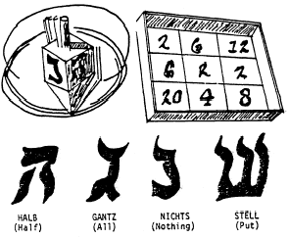
The Dreidel Game is played by making a game board from a large box top which has been squared off with appropriate numbers in each square. Each player spins the dreidel and adds or subtracts his or her score depending upon which side of the dreidel faces up and on which number it rests.
For example, if the dreidel faces up Stell on 20, the player loses 20. First player to accumulate 25 points is the winner.
The Put-Take-Nothing Game begins with each player receiving an equal amount of small candy, raisins or nuts. Each player puts one item into a "pot", or "kitty", and the players spin the dreidel in turn. Scoring is the same as in the Dreidel Game. When a player gets "Gantz", or all, each player puts in another item to make a new "pot". The game ends when one player has accumulated all of the items.
Hide the Dreidle (Hanukkah top) one Cub leaves the room. The others hide the dreidle. The Cub returns. The others yell "hot" and "cold" depending on whether he is near or far. You can use real or paper dreidle.
Pass the Dreidel Cubs sit in circle, start music. Pass the top around the circle. When the music stops, the Cub holding the dreidel drops out. Last Cub is the winner.
Pin The Hanukkah Candle
Baltimore Area Council
What you’ll need:
- A poster-size menorah
- A cardboard candle for each player
Set Up:
- Draw a menorah on a large sheet of cardboard and tape it to the wall.
- From lightweight cardboard, cut out a candle for each player.
- The candle represents the shammes or candle used to light the eight Hanukkah candles.
- Put a pin through the flame of each candle.
Action:
- Blindfold a Cub Scout and turn him around three times.
- He then tries to pin his shammes on any of the menorah's candles.
- The one who comes closest, wins.
Filling Santa's Pack
Baltimore Area Council
What you’ll need:
- A balloon for each player, color-coded for each team
- A large barrel or trash can
Set Up:
- Form two den size groups and line them up on the opposite sides of the room.
- Give one team balloons of one color; give the other team a contrasting color.
- Ask them to blow up their balloons and tie them.
- In the center of the room, have a large container - but not one large enough to hold all the inflated balloons.
Action:
- On signal, have all the boys try to tap their balloons into the barrel with one hand behind their back.
- When the container is full, stop the game.
- The team with the most balloons in the container wins.
Unscramble the String Lights
(AKA Tangle Knot)
Utah National Parks Council
Directions: Everyone stands in a circle. Each Cub Scout reaches in with his right hand and joins hands with someone NOT standing next to him. The repeat with left hands. Do not join both hands with the same person. Working as a group, try to untie the string of lights without breaking any grips. Hands may be rotated but should never lose contact. This can test the flexibility of the players/string. If the group is hopelessly tangled, the leader may break apart one set of hands and join somewhere else. If successful, the group will end up in an untangled circle.
Snow Clothes Relay
Utah National Parks Council
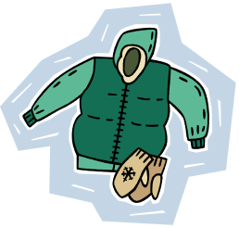
Materials: Two outfits of outside clothing (i.e. coats, mittens, boots, snow pants, scarf, hat, etc.), two paper bags. (Adult sized clothing makes this really funny)
Directions: Place the clothing in two bags. One team member must run across the room put the clothes on in order of receiving them out of the bag. Then run across the room and take it all off, for the next player to put on. First team to have all players finish, wins the game.
Ice Cube Race
Utah National Parks Council
Materials: A bag of ice, two spatulas, four containers
Directions: Place ice in two of the containers. Place the other two containers a fair distance away. Object of the game is to move the ice from one container to the other, by using the spatula. Boys must pick up an ice cube with the spatula and run to the other container and deposit the ice cube. First team to have all the ice in the opposite container wins.
Fumble Fingers Relay
Materials: 2 jars with screw on lids, 10 toothpicks, 2 pair of large mittens
Directions: Each team has a pair of large mittens. At a goal line is a jar, one for each team containing five toothpicks. On signal, the first person from each team races to the goal line, puts on the mittens, removes the lid, empties the jar, picks up the toothpicks and puts them back in the jar and screws on the lid. He takes off the mittens and races back to hand them to the next player, who repeats the action.
Santa Nods
- Santa is in the center of a circle made by the other players.
- Santa points at any player and says, "Santa says yes" or Santa says no".
- That player must quickly nod "yes" or shake his head "no".
- If Santa says only "yes' or "no" without first saying "Santa says", the player must not respond. If he does, he is out of the game.
- Santa should give commands quickly.
- The last person still in the game becomes the new Santa.
What Does The Snowman Say? Nothing
What you’ll need:
A hat, preferably a bowler hat and a scarf
Set Up:
One cub, the Snowman, dressed up in the hat and scarf, stands stiffly facing the group. He must not respond in any way - by giggling, moving or speaking.
Action:
- The object of the game is for the other boys to get a reply to their questions, such as "What's your middle name? Who's your best friend? Do you like ice cream?" or to make the Snowman laugh by making faces. No touching is allowed.
- Establish a short time limit and play several times. Any boy who gets a response from the Snowman becomes the next one.
- Finish up with SNOWMELT: everyone turns into a snowman and at the signal "the sun comes out," the snowmen begin to "melt down" to the floor - the last one to melt completely (stretch out on the floor) is the winner.
- Rule: keep moving at the same time.

CLOSING CEREMONIES
Our Land Deserves Respect
Utah National Parks Council
Materials: Eight Cub Scouts and a U.S. flag (or 6 Cubs and a Leader for Cub #1 and #8)
- This is the land of the Great Spirit.
- Using our eyes, we will observe its great beauty.
- We will walk softly so it won’t be disturbed.
- Using our ears, we will hear its magical sounds.
- Our minds will concentrate on those things we can do to make it more beautiful and productive.
- Using our hands, we will care for it.
- And, with our hearts, we will honor it.
- This is our country. Pledge with me to give our land the respect it deserves.
(Ask audience to stand and say the Outdoor Code
or sing a Patriotic song)
My Pledge
2011-2012 CS RT Planning Guide
Arrangement:
- Hand out a copy of the following pledge to everyone.
- Cubmaster leads the audience in reading the pledge.
As a Cub Scout, I pledge to always have respect for my leaders, for others, and for myself.
As a Cub Scout, I pledge to always show respect in thought, word, and deed.
As a Cub Scout, I pledge to be careful in what I say and not speak angry words that hurt others.
As a Cub Scout, I pledge to always say “thank you” when others help me.
As a Cub Scout, I pledge to always do my best to obey the Cub Scout Promise and the Law of the Pack.
Christmas Spelling
Baltimore Area Council
Arrangement: Nine Cub Scouts come onstage, one by one. Each carrying a large cardboard letter. As he speaks his lines, he holds up his letter, each ultimately spell out the word Christmas. Words are n back of Letters in LARGE PRINT.
- C is for candles, we burn on Christmas night. To gladden weary travelers with their light so bright.
- H is for happiest; the happiest time of year. It's jolly, gay old Christmas tunes with all its mirth & cheer.
- R is for ring; we ring the Christmas bell. All the Christmas gladness, the world to tell.
- I is for the infant who lay in a manger. Little Lord Jesus, a dear little stranger.
- S is for shepherds who kept their flocks by night; And heard the angels singing, and saw a wondrous light.
- T is for tree, all green and gold and red. We see it Christmas morning when we jump out of bed.
- M is for the mistletoe we hang at Christmas time. In merry wreaths, when candles burn and Christmas bells chime.
- A is for all; to all men we wish cheer. Joy and gladness, love and hope, for Christmas time is here.
- S is for the star that shone on Christmas night, Star and candle, bell and wreath, all make our Christmas bright.
Three Candles
Utah National Parks Council
NOTE - This closing extinguishes the candles lit for
the Flag and Candle Ceremony Opening
Directions: Three Cub Scouts, either the ones from the opening ceremony or new ones, may take part. They walk to the front of the room to extinguish the candles.
- As I put out this white candle, which represents purity, may we be mindful that a Cub Scout is clean. He is clean in body and thought. He stands for clean speech, clean sports, and clean habits. He travels with a clean crowd.
- As I put out this blue candle, which represents loyalty, may we as Cub Scouts be ever mindful to be loyal to whom loyalty is due. We are loyal to our den leader, our home, our parents, our country, and our God.
- As I put out this red candle, which represents courage and sacrifice, may we be mindful of the sacrifices that have been made for us by many others that we may continue to enjoy freedom, liberty and justice in the great nation of the United States of America.

CUBMASTER’S MINUTE
Individuality
2011-2012 CS RT Planning Guide
Please take a moment and look around the room. You see many people. Do you see two people who are exactly alike? No. None of us are the same, not even twins. We are all unique individuals, each different from others. By recognizing our own individual talents, tastes, and gifts, we can try to have a better understanding of other people and our surroundings and be more respectful of the world we live in.”
December Lights Closing Ceremony
(Or Opening)
Baltimore Area Council
This is the season of decorations and lights. It is a time when the days are shorter and the nights are long. But, somehow, things seem brighter. Shopping centers are bright with holiday decorations and lights. Thousands of homes have single candles to light the way for the Christ Child. Other thousands have candles burning to commemorate the miracle of the oils of Hanukkah. Even the stars in the winter sky seem brighter. The most brilliant glow comes from the spirit of goodwill that you live all year round in the Cub Scout Promise and Law of the Pack. Let us all stand and repeat them together.
A Cub Scout Prayer
Utah National Parks Council
Dear Lord, from your judgment seat on high,
Help me to work with others and be kind.
Look down on a Cub Scout such as I.
Be helpful with my hands and mind.
Search me through and find me whole,
Keep me Lord, both well and strong,
Then help me Lord to reach my goal.
To help Thy growing boys along.
Help me Lord to work for Thee,
Control my thoughts, keep them right,
Guard my homeland—Keep it free.
Sound, clean weapons for life’s fight.
Protect my morals, keep them high,
Grant this to a Cub Scout such as I.
Holiday Lights
Utah National Parks Council
During this pack meeting, we celebrated the many ways lights are used during this time of year. Whether we are decorating our homes, celebrating our faith, or lighting a path for our Cub Scouts, lights bring a special glow of warmth to our hearts. The Cub Scout spirit held by each of our Cub Scouts brings that same special glow because the spirit of Cub Scouting lights up their path with its ideals and purposes. All Cub Scouts everywhere share special lights of character, citizenship, and fitness. It is these lights that challenge them to consistently do their best.
A String of Lights
Utah National Parks Council
When I see a string of lights on a tree, I am amazed at how bright the small lights can be. They are like our Cub Scouts. One light by itself may not be very bright, but it certainly does its best. One Cub Scout by himself is certainly doing his best, too, but think of how much better all the Cub Scouts do when they can work together on achievements and Activity Badges. Look at the lights on a string of lights. When one fades, they all fade until the one light is fixed. Our Cub Scouts help each other, too, in this way – when one needs some extra support, they all pitch in and help their friend. Just as lights shine their brightest when they all work together, it is keeping our program working together for our Cub Scouts that allow them to shine their brightest.
The Season of Lights
Utah National Parks Council
This is the season of lights. It is a time when the days are shorter so the nights are longer, yet somehow things are brighter. Stores and homes are bright with holiday lights. Thousands of homes have a single light to show the way for the Christ child, others have candles burning to commemorate the miracle of Hanukkah, and some light candles to honor the heritage of Kwanzaa. Even the stars in the winter sky seem brighter at this time of year. But the most important glow is from the spirit of goodwill that WE live with year-round in the Cub Scout Promise and the Law of the Pack. Before we all leave to get on with our holiday celebrations, let's stand and repeat the Cub Scout Promise and Law of the Pack together. Happy Holidays!
I’ll Walk With You
Alice, Golden Empire Council
In a recent program, some children sang a song called “I’ll Walk With You” – it’s a song of promise. The promise is that even if “you don’t walk” or “talk” as most people do, “I’ll walk with you.” Another promise is that even though “some people walk away from you” or “laugh at you” – that “I won’t!” Each of us should show respect for ourselves (and for others) by the way we talk and how we act! Remember - A Good Scout is Helpful, Friendly, Courteous, Kind and Brave.
Potential
Utah National Parks Council
The boy you love and teach today,
Could be the man who saves your life one day.
A Lawyer or Fireman, Mechanic or Doc,
Who knows the potential these boys have got.
Well, he’s in a wheelchair or this one can’t read.
Hey, that doesn’t mean these boys don’t have speed!
The sky is the limit and the sky has no end.
We know not the limits of how far they can bend.
Just give them the power and the love then you’ll see,
What these sweet boys can grow up to be.
Respect
Utah National Parks Council
- To respect others means that you consider them of great worth. This includes yourself. You are of great worth.
- A simple rule to follow: "If it is not yours, leave it alone."
- The best rule of all: "Do unto others as you would like them to do unto you."
Happy Thoughts
Utah National Parks Council
- “Some think that happiness comes from getting. Others know it comes from giving.” Lord Baden-Powell, founder of Scouting
- You can be grouchy and grumpy, or you can be happy and cheerful. It is up to you. We have a choice. We can be pleasant or unpleasant. Which do you chose?

CORE VALUE RELATED STUFF

Connecting RESPECT
with Outdoor Activities
(Adapted from B.A.L.O.O. Appendix E)
- HIKES - Show respect for the history of your area. Hike to a museum or historical building and learn about the history of your community. Take a historical hike.
- NATURE ACTIVITIES - Show respect for the environment. Clean up trash in a designated area. Observe a certain species of animals to see how they live together and what nature laws they obey.
- SERVICE PROJECTS - Show respect for the flag. Raise the flag at the local school every morning for a specific period of time. Lead a flag salute at Sunday School. Do some community cleanup projects. Offer to lead a flag ceremony at a community event or recreational league game.
- GAMES & SPORTS - Show respect for your competition. Play a team sport and demonstrate good sportsmanship. Refrain from calling the opposition names.
- CEREMONIES - Show respect for your leaders, both youth and adult. Hold a ceremony to inaugurate the Denner or to graduate Wolfs to Bears or Bears to Webelos, complete with “tux”, “top hat”, and “judge”. Conduct a ceremony to honor your den leaders.
- CAMPFIRES - Show respect for our Founding Fathers. Re-enact an historical event, (e.g. the signing of the Declaration of Independence). The boys could even be in costume with a huge feather pen.
- DEN TRIPS - Show respect for the government. Visit a local governing body, city council, county commission, or school board- to see government in action. Have lunch with the mayor or chief of police.
- PACK OVERNIGHTER - Show respect for authority. Have the Cubs make up “laws” (e.g. a Den Code of Conduct) to govern their den or tent city on a camping trip. Discuss why it’s important to understand how good law benefits all citizens.
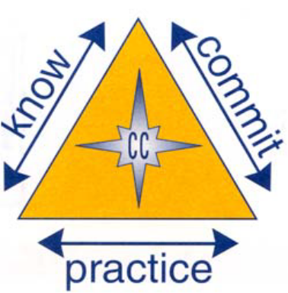

The Character Connection Process

Respect Character Connection
www.cubroundtable.com
Tiger Book
Character Connection - Respect (Page 57)
- Practice- When talking with other family members, how do you show respect? How do you listen respectful? How can you interrupt people and still be respectful?
- Know- Participate in a family conversation. After the conversation, discuss how you and others showed respect.
- Commit- How does it feel when people listen to you with respect? List 3 things to remember that will help you talk respectfully with others in the future.
Wolf Book
Character Connection - Respect (page 74)
- Know- Discuss these questions with your family: What things have people do to show a lack of respect to our world? Why is it important to respect your environment and natural resources? How can you show respect for your environment?
- Commit- Discuss with your family how you feel when you see places in your neighborhood that have lots of litter. Name one thing you can do to help the environment.
- Practice- Practice being respectful while doing the requirements for “Your Living World.”
Bear Book
Character Connection - Respect (Page 72)
- Know- As you learn about how Cub Scout age life was like for adults you know, does what you learn change what you think about them? Tell how it might help you respect or value them more.
- Commit- Can you think of reasons others might be disrespectful to people or things you value? Name one new way you will show respect for a person or thing someone else values.
- Practice- List some ways you can show respect for people and events in the past.
Webelos Book
Character Connection - Respect (Page 318)
- Know - Tell what interested you most when completing the requirements for this activity badge. Tell what you learned about how you can show appreciation and respect for wildlife.
- Commit - Tell things some people have done that show a lack of respect for wildlife. Name ways you will show respect for and protect wildlife.
- Practice- Explain how completing the requirements for this activity badge gives you the opportunity to show respect.
Character Connection Activities
Cub Scout Program Helps, 2002-2003, Page10 MAY
Movie Review Poster
On a piece of posterboard, write, “Upcoming feature: [name of the Scout] – A New Webelos Scout.” Each boy draws a self- portrait under his name or glues on a photo. Den members write compliments about him and glue them on the poster like a movie review. Place 5 stars by each comment. Display these posters at the pack meeting.
- What do you think it means to show?
Have the scouts draw a self-portrait and have the Den members write compliments about him and glue them onto a poster. Who was showing respect in making these posters?
- How did you feel about showing your respect for others by saying nice things?
How did you feel when others said nice things about you?
- Can you think of ways you show respect for people?
What can you do to other people you meet, or your family, to show your respect for them?
Character Connection: Respect
2011-2012 CS RT Planning Guide
- What does it mean to be respectful?
- Why is it important to show respect for people who look or act different from others you know?
- Is it always easy to be respectful?
- How would you feel if adults ignore you just because you are a kid? How would you feel if nobody paid attention to you?
- What can you do to show respect to others? Think of some ways that you can show respect to people
See Fun for the Family, No. 33012, for family activities related to this month’s core value, respect.
Family Mobile
Cub Scout Program Helps, 2004-2005, page 6 February
Spray-paint a small tree branch ahead of time. Place the base in a small pan of clay and mold the clay up to hold the branch upright. Add objects to the branch that represent the boy’s family members of the present and the past – include their countries of origin, what they did for work, different places they may have lived, etc.
Lead a discussion on Respect after completing the family mobiles.
- What you show respect for someone you say that you support them in things they do and like to do. When you were adding times to the branches, what did you think about?
- Did you choose items that represented positive things about family members?
- Is it important to show respect for others? How do you sow respect for people in the den? For your family?
- How can your den show respect for each other? How can you show respect for people at school or in your church? How about if everyone tries to show respect for others at least once a day during the next week.
Talking Stick
Cub Scout Program Helps, 2007-2008, Page6 November
Materials:
Stick or dowel rod approximately ½ by 24 in.,
Yarn,
Small scrap of fur or felt,
Jingle bells,
Leather or suede cord,
Pony beads,
Feathers,
Shells,
Craft glue,
Scissors.
Directions:
- Cut a piece of fur 1 by 2 in. Wrap it around the end of the stick and glue it.
- Spread a little glue at the end of the dowel or stick near the fur.
- Wrap yarn tightly around the stick, adding more glue as needed. Cover about 5 in. of the stick, changing the color, if desired.
- Tie suede lace near the bottom of the yarn wrap. Thread the lace through bells, beads, feathers, and shells – however boys want to decorate it – and knot again.
Talking Stick Legend
Whoever holds the talking stick has within his hands the sacred power of words. Only he can speak while he holds the stick; the others must remain silent. Feathers tied to the talking stick give him the courage and wisdom to speak truthfully and wisely. Rabbit fur on the end of the stick reminds him that his words must come from his heart and that they must be soft and warm. The speaker should not forget that he carries within him a sacred spark of the Great Spirit, and therefore he is also sacred.
If he feels he cannot honor the talking stick with his words, he should refrain from speaking so he will not dishonor himself. When he is again in control of his words, the stick will be returned to him.
Discussing the Talking Stick
We just made a talking stick and learned how it is used.
- What is a word that you might know that means taking runs or allowing someone to have your attention when he or she is talking? Do we all know what means?
- How does the use the talking stick show respect?
- Can you think of a time you have had for other Cub Scouts?
Thank you all for your respect for each other --it makes this a really great den
For more RESPECT Character Connection Activities go to ·
http://www.cubroundtable.com/assets/pdf-documents/2002-2010%20Character-Connections-Packet.pdf

December – A Month for Respect
Alice, Golden Empire Council
December 1 – Rosa Parks Day 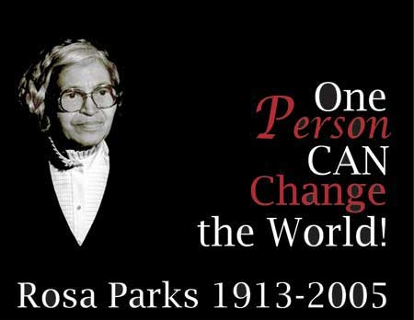
On this day in 1955, Rosa Parks, an African American tailor’s assistant at a department store in Montgomery, Alabama refused to give up her seat on the bus to a white man. She was arrested and fined. That simple action of demanding personal respect led to a boycott of the bus system by other African Americans. Her action was a major one in the fight for civil rights, including a Supreme Court ruling against segregation.
Martin Luther King, Jr. helped organize the bus boycott – and many people walked miles every day to get to and from work, rather than take the buses that only allowed them to sit in the back or stand, leaving the whole front of the bus available only to white people. Car pools were also organized, but many black families depended on the bus – some white people took a great personal risk to pick up black workers and drive them to work. The boycott lasted for 381 days!
On November 13, 1956, with future Supreme Court Justice Thurgood Marshall representing the boycotters, the US Supreme Court ruled that segregation on city buses is unconstitutional. On December 20, 1956, the bus system was finally desegregated.
In 1957, after numerous death threats, Mrs. Parks and her husband moved to Detroit and founded the Rosa & Raymond Parks Institute for Self Development, which helps young African-Americans develop leadership skills. Her autobiography, “Quiet Strength,” was published in 1994, and she received the Congressional Gold Medal in 1999.
After her death, on October 24, 2005, Mrs. Rosa Parks lay in state in the US Capitol Rotunda in Washington, D.C., to honor her pivotal role in US history. She was the first woman and the second African-American to be given that honor.
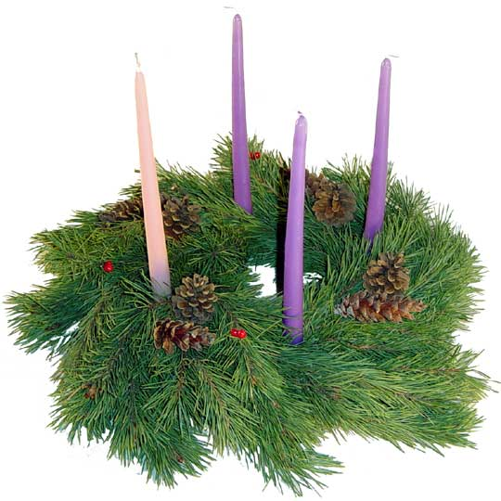December 2 – Advent Begins
Christians in Poland and around the world celebrate Advent during the first four Sundays of December – with a horizontal evergreen wreath that has four candles. The first Sunday, a purple candle representing Prophecy is lit; the second Sunday, a purple candle representing love or the manger is lit; the third Sunday, the pink candle representing joy, called the Shepherd’s Candle, is lit. The fourth and last purple candle is lit the next Sunday, representing peace and called the Angel’s Candle. Sometimes, there is a white center candle called the Christ Candle, and representing the sinless, spotless Savior coming into the world. This tradition is also a strong Lutheran tradition, accompanied by a Bible reading and special prayers each time a candle is lit.
December 4 – National Cookie Day
Make some cookies – you can make some to share with family and friends, too! If there are some special family cookie recipes from a relative, this could also be a way to show your respect for family. This is also a Bear advancement item and to do at Den Meeting #7.
December 5 – Walt Disney’s Birthday
Walt Disney not only created Mickey Mouse, Disneyland and Disney World – in every project he showed respect. He insisted on the very best quality even in his cartoons. In Disneyland, he insisted that animals and even the plantings be as true to life as possible – even when creating a miniature world, or when a character was behind and only partially viewed. He also expected his employees to be treated with respect and to treat those who came to the park with respect. He insisted on very high standards of cleanliness, dress, language and authenticity for his employees.
December 8 – Hanukkah Begins
Hanukkah is the Jewish Festival of Lights, an eight day holiday that commemorates rededication of the Temple, after the Macabees discovered that almost all the ritual olive oil had been polluted. They found only enough to light the menorah (a special candle holder) for a single day – but it burned for eight days, till new oil could be pressed and ready. It is considered a miracle, and is celebrated by Jews around the world. Special foods are also eaten and a special game with a dreidel, or spinner, is played. Check out WEB SITES to find more information and directions for making your own dreidel game.
December 8 - La Purisma celebrated in Nicaragua -
People go from house to house singing songs that are like Christmas carols during Christmas, and people give them fruits, candy, toys, etc. Images in honor of Virgin Mary are put up all over and lights are put up around them. People also have praying ceremonies in houses, then a party where the host gives out mugs of hot "pinolillo", a traditional drink, and toys, candy, fruits, fudge, and most important of all, a single firecracker. At midnight, thousands of firecrackers go up at the same time and make a display in the sky.
December 13 – Saint Lucia Day-Sweden
This celebration comes from stories that were told by Monks who first brought Christianity to Sweden, and honors a young Christian girl who secretly brought food to Christians hiding from persecution. She wore candles on her head so she had both hands free to carry the food – and Lucy also means “light.” Today, the oldest daughter, dressed in a white dress with a red sash and a crown of candles on her head brings special saffron buns to her parents for breakfast. Younger boys are “star” children, wearing cone-shaped hats with stars - and younger sisters wear white without the crown. There is also a St. Lucia named in each town or village, and even for the whole country. St. Lucia also visits elderly people and hands out ginger snap cookies. By the way, today electric “candles” are used, but the crown is still made of lingonberry branches, an evergreen symbolizing new life.
December 14 – Winter Bird Count
On a single day during the 16 day Christmas Count, small groups all over North, South and Central America identify and count as many birds as they can within a certain area.
December 15 – Native American Winter Count
Some Plains Indian Tribes showed their respect for their own personal and tribal history by keeping an ongoing record on a buffalo skin, in the form of pictures that represented the most important events of each year. See Den & Pack Activities for directions to make your own Winter Count.
December 23 – Roots Day
Early in the month, challenge the boys to work with family members to gather enough information to make a chart showing family roots. Some people have a special interest in learning about their family history, culture and genealogy – see an idea under Den & Pack Activities.
December 24 - Artist Joseph Cornell born in 1903 in New York City - Yes, I KNOW it’s Christmas Eve – so do this a little earlier - Cornell used all kinds of everyday “found items” from nature or purchased at thrift shops, then transformed them into works of art by mounting them in a box. He gave them a place of honor so they could be enjoyed for their shape, form or importance. He added glass to protect the items while they could still be seen – but just arranging items in a box gives them importance. So celebrate and show respect for the every day items in our lives by making an art construction. Directions in Den & Pack Activities
Also Check Out the Holiday Lights ideas from Around the World under DEN & PACK ACTIVITIES.
December 26 – Kwanzaa Begins 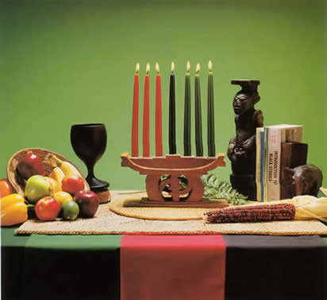
Kwanzaa is a weeklong celebration held in the United States to honor African-American heritage and culture, and values that are cherished in the family. It starts on December 26 and goes to January 1 each year. There are special activities each night, including lighting a candle holder with seven candles. A special feast and gift giving are held on the last night. The holiday was created by Maulana Karenga and was first celebrated in 1966–1967.
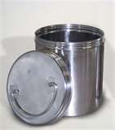 December 29 – Look to the Future Day - Make and bury a “Time Capsule” – Could be for yourself, the den and/or pack, or for the family. Your time capsule could be a metal container, or as simple as a 2 liter bottle cut in half, then pushed together and sealed with duck tape. Include items that represent the time period, then bury your capsule and mark a calendar for when you will dig it up – for a den, it could be at the end of the Cub years, just before the boys become Webelos or earn their Arrow of Light. A family might wait 5 years – and make sure that every family member is included!
December 31 – New Year’s Eve
In the Philippines, people wear polka dots, keep coins in their pockets and make sure they have round foods, such as grapes on their table – according to folklore, circles symbolize future good luck!
In Ireland, a candle is lit, and at the last stroke of midnight, people throw open their doors to welcome the New Year – they hope a dark-haired man will be the first to cross the threshold, a good luck omen.
In Spain, people eat one grape for each stroke of the clock, in hopes of having good luck in the new year.
In Japan, people eat Toshikoshi soba, or “sending out the old year noodles” – extra long buckwheat noodles. Whoever can swallow one strand without chewing will have good luck!
In Ecuador, families stuff old clothing with straw to make “Ano Viejo” or “Old Year.” Some children pretend to be his widow and beg for money. At midnight, the family reads a last will and testament, which is really a list of family shortcomings. Then both Ano Viejo and the will are set on fire in hopes that the family faults will disappear with the smoke.

Festivals of Light Around the World
Judie Haynes, Utah National Parks Council
The diversity in many [packs] provides a starting point for children to begin to understand and value the many distinct cultures of the world. What better way to do that than to feature a winter unit on light festivals from around the world. Teach your [Cub Scouts] about the cultural traditions in France, Sweden, Thailand, Philippines, India, Egypt, Holland, and Mexico.
When English language learners see their home cultures and languages being studied [at Cub Scouts], they feel their culture has been validated. This helps to develop positive self-esteem in culturally and linguistically diverse children.
Festival of Light: St. Lucia’s Day in Sweden
 | According to folk tradition, December 13th follows the longest night of the year in Sweden. During the winter there are only a few hours of sunlight each day. St. Lucia is honored this day with her wreath of candles.
- The oldest girl in the family is declared St. Lucia on December 13th. On this day she dresses up wearing a white robe with a red sash and a wreath with candles on her head.
- The "St. Lucia" of the family serves everyone a special bun called Lussekatter.
- Schools have a celebration with a St. Lucia choir. All the girls dress up as St. Lucia and the boys are "Star Boys."
- Make a St. Lucia wreath by cutting a hole in the center of a paper plate so that a child's head will fit in it. Cut out leaves from green construction paper and glue them to the paper plate. Make 7 paper candles stand up around the inside rim of the plate.
- Have boys dress as Star Boys. Cut an 18 inch wand from cardboard. Cover it with construction paper. Make a white star on the end of it. To make the hat roll a piece of construction paper so that it has a point on the end and staple it in place.
Traditions of Light: Christmas in France
The Christian tradition of light during the Christmas season is demonstrated by the Advent Candles which are lit each of four consecutive Sundays before Christmas Day. Additionally some families burn a yule log. This tradition goes back pre-Christian celebrations during Winter Solstice.

- French children put their shoes by the fireplace on Christmas Eve in hopes that "Pere Noel" (Santa Claus) will bring them some toys. They leave a snack and a glass of wine for Pere Noel and beet greens for the donkey that travels with him. Pere Noel is tall and thin. He has a long red robe trimmed with fur.
- Pere Noel brings toys to children in a sack. As he comes, he calls out “tralala, tralala, bouli, bouli, boulah.”
- Families go to church at midnight on Christmas Eve. After church everyone eats a huge dinner called Le Reveillon. After this large dinner of goose, turkey, chicken, or beef; a fish dish, cheese, bread, wine, and fruit, many families serve a Buche de Noel. The Buche de Noel is a sponge cake decorated like a yule log. Some families burn a real log in the fireplace.
[Dens] can make a replica of a Buche de Noel.
- French families think that mistletoe is also lucky and hang it everywhere. Your Cub Scouts could write a wish for the New Year on an index card and attach it to a picture of mistletoe.
- Have your Cubs]learn “Joyeux Noel” (Merry Christmas) and “Bonne Annee” (Happy New Year) to each other. Happy Hanukkah is “Joyeux Hanukkah.” Practice these and other languages.
- Teach the Cub Scouts to sing "Jingle Bells" in French.
Tintez Cloches, Tintez Cloches (Jingle Bells X2)
Tintez dans la nuit (Ring in the night)
Pere Noel et ses grand daims
(Santa Claus and his big reindeer)
Arrivent toute de suite...ite (Are coming soon)
Information for Christmas in France was contributed by Christine Gorman.
Traditions of Light: Hanukkah
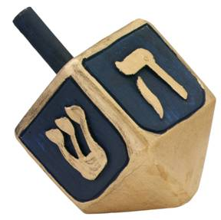
Hanukkah is the Jewish Festival of Lights celebrated in countries all over the world. In 165 B.C. there was a great battle between the Maccabees and the Syrians. The Jews won the battle and when they went to their temple, they found that the Syrians had allowed their sacred light to go out. They only had oil for one day. The miracle of Hanukkah is that the oil lasted 8 days until a messenger could return with more. There are nine candles in the menorah. One of the is used to light the other candles and the other eight stand for the eight days that the oil kept burning
- Children play a game with a spinning top called a dreidl. Play this game can be played online http://torahtots.com/holidays/chanuka/dreidel.htm
- Make special foods such as potato pancakes.
- On Hanukkah it is traditional for parents to give their children money or "gelt." This tradition can be replicated in the classroom by distributing small bags of chocolate "gelt" which is wrapped in foil to look like money.
- The Cubs can make and send Hanukkah cards
Festival of Light: St. Martin’s Day (Sint Maarten) in Holland
Saint Martin's Day is on November 11th and is celebrated in Holland. Children carry lanterns and go from house to house singing songs. People give them candy and other treats. Here is a song they sing to the tune of “My Bonnie Lies Over the Ocean:”
Saint Martin once saw a beggar
Who needed some food and some clothes
So he ripped his cape in two pieces
And eased some of the beggar’s woes.
Martin, Martin
He always helped those in need, in need
Martin, Martin
He was a saint, yes indeed!
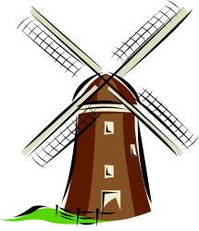
Martin was a good and kind man. On a winter night he was returning home during a snowstorm. He was wearing a cloak. A homeless man appeared in the darkness. Martin felt sorry for the man and gave him half of his cloak. Now he is called St. Martin and is known for his kindness to strangers. That is why Saint Martin's Day is celebrated in Holland.
Festival of Light: Loi Krathong (loy-kruh-thong) Festival in Thailand
This holiday is celebrated in Thailand in November each year. "Loy" means "to float" and a "Krathong" is a lotus-shaped vessel made of banana leaves. The Krathong usually contains a candle, three joss-sticks, some flowers and coins.
The festival starts at night when there is a full moon in the sky. People carry their Krathongs to the nearby rivers. After lighting candles and making a wish, they place the Krathongs on the water and let them drift away. People are offering thanks to the Goddess of water.
It is believed that the Krathongs carry away bad luck. The wishes that people make for the new year will start. It is the time to be joyful and happy as the sufferings are floated away.
- Make a paper boat that Cubs can launch. Boats in Thailand have flowers and candles on them.
- Do a reflection with the Cubs about what bad feelings or happenings they would like to put on the boat to send away. Explain how children in Thailand come to school dressed in special costumes on this day to launch their boats.
- To look at pictures of this festival on the internet go to Holidays of Thailand. http://sunsite.au.ac.th/thailand/special_event/loykratong/index.html .
Festival of Light: Diwali in India
Diwali, meaning array of lights, is a Hindu light festival. It symbolizes the triumph of light over darkness. It is one of the most important celebrations in India.
- Although it was originally a Hindu celebration, Diwali is now enjoyed by people of every religion in India. It is a family celebration which takes place in October or November and lasts for five days. This festival of lights celebrates the victory of good over evil and the glory of light.
- Commemorating Lord Rama's return to his kingdom Ayodhya after completing a 14-year exile, people decorate their homes, light thousands of lamps and give out sweets. There are fireworks in the streets.
- Diwali is a time for fun and rejoicing. However, before the celebration begins there is a lot preparation.
- The house must be thoroughly cleaned and windows opened in order to welcome the Laxmi, the goddess of wealth. People light up their homes using thousands of clay oil lamps to welcome the Goddess.
- During Dawali, Indians buy puffed rice to offer to Lakshmi, the Goddess of Prosperity. Have the Cubs put one cup of puffed rice in small squares of plastic wrap. Tell them to hand the rice out to friends.
- New clothing is also purchased to be worn during the celebration.
- In India a design using rice flour is made on the floor in front of the family's shrine. Cubs can make their own Rangoli. Use white chalk to draw a design on black construction paper. Have them color in the design with colored chalk. Be sure to spray the finished designs with a fixative. You can find a pattern at http://www.theholidayspot.com/diwali/rangoli.htm.
Festival of Light: Christmas in Egypt
Many Christians in Egypt belong to the Coptic Orthodox Church. Christmas is celebrated on January 6th and 7th. The churches have always been decorated with special lamps and candles. Copts also give candles to the poor. They represent the candles Joseph used to protect Mary with when Jesus was born.
On the night of the 6th, the Coptic Christians go to the church for mass and at midnight they eat dinner. On the morning of the 7th gifts are exchanged and people visit each other.
There are four weeks of Advent during which a candle is lit each week. In Egypt, Advent lasts for forty-five days and people fast. They do not eat any meat, poultry or dairy products.
Everyone buys new clothes to wear to the Christmas Eve church service.
Before Christmas, Christian homes are decorated with lights, Christmas trees and small mangers.
On Christmas morning people people visit friends and neighbors. They bring a gift of shortbread which is called "Kaik."
Festival of Light: Christmas in the Philippines
The Philippines is the only country in Asia that is predominately Christian. This festival of light is marked by the sight of "parols" or star lanterns.
- Nine days before Christmas a special mass is celebrated where the story of the birth of Jesus in reenacted.
- Parols are displayed and fireworks heard over the next nine days.
- On Christmas Eve a procession is held and Mary and Joseph's search of shelter is reenacted. Members of the procession carry "parols" to light their way.
- Paroles of all sizes can be found decorating the homes of people in the Philippines. There are contests to pick the most beautiful parols.
- Families may pass down their expertise in parol making from one generation to another.
- Strolling musicians play handmade banjos in the streets. This is an important feature in the celebration of Christmas in the Philippines.
- Have Cubs make lanterns to decorate their homes.
Festival of Light: Christmas in China
Christians in China celebrate Christmas by lighting their houses with paper lanterns.
They also have Christmas trees called "Trees of Light," with paper chains, flowers, and lanterns.
Chinese Children hang muslin stockings and await a visit from Santa Claus, whom they call "Dun Che Lao Ren" (dwyn-chuh-lau-oh-run) which means "Christmas Old Man."
Most Chinese people are not Christian so the main winter festival in China is the Chinese New Year which takes place toward the end of January. This is when children receive new clothing, eat fancy meals, get new toys, and enjoy fireworks.
Festival of Light: Christmas in Mexico
During the nine days prior to Christmas, Mexican families march from house to house with candles looking for a room at the inn. They are replicating Joseph and Mary's search in Jerusalem.
- Have Cubs who come from Hispanic families share their holiday customs with the Den.
- Point out Mexico on the map and ask questions about the location of Mexico such as "What continent is Mexico on? Is it north or south of the U.S.? What language is spoken there?"
- Explain that most Mexicans are Catholic and celebrate Christmas. In Mexico Christmas holidays start on December 16th and last 9 nights. Each night families act out the journey that Mary and Joseph made to Bethlehem. They knock at doors asking for shelter.
- With the Den look at information about Christmas in Mexico on the internet. Brainstorm a list of the different events of the Mexican celebration.
- Families gather together. They march around the house singing a special prayer and carrying candles. They pretend they are Mary and Joseph looking for a room in an inn. This procession is called the “posada.”
- Have a piñata. Ask Cubs to talk about their experiences with a piñata. Explain that they come from Mexico and are made of paper-mache.
- Families go to midnight church services on Christmas Eve.
- On January 5th the children put out their shoes for a visit from the Three Wise Men who leave gifts.

- Discuss the legend of the poinsettia. Have students color the poinsettia and explain how it got its name.

Fun Facts about the Holidays
Alice, Golden Empire Council
- Many people disapprove of the Xmas – but the original use was not disrespectful – it was based on X being the first letter of Xristos, the Greek name for Christ.
- King Richard II of England served 28 oxen and 30 hundred sheep at his 1377 Christmas feast!
- Rudolph the Red-Nosed Reindeer was written by Robert L. May as a promotion for Montgomery Ward. They distributed six million copies of the story between 1939 and 1946 alone. The song, written by Johnny Marks, came along in 1949.
- According to The Macaulay Institute in Aberdeen, Scotland, reindeer can haul up to twice their weight at speeds up to 15 miles an hour, making them great sleigh pullers.
- Over 70 million Americans give their dog or cat Christmas presents, according to an American Pet Association poll.
- “Jingle Bells,” one of the most popular holiday songs in America, was the first song ever broadcast in space, thanks to the crew of 1965’s Gemini 6 spacecraft.
- Frigg is the name of the Scandinavian love goddess who removed poison from mistletoe, bringing her son, Baldur, back to life. She was so happy, she made mistletoe a sign of love – so now people make “Kissing Balls” of mistletoe.

Crazy Holidays
Jodi, SNJC Webelos Resident Camp Director Emeritus,
2006-2011
December is:
- Write a Friend Month
- Hi Neighbor Month,
- National Stress Free Family Holiday Month,
- Awareness Month of Awareness Months Month
- World Aids Month
- Bingo's Birthday Month
- National Drunk & Drugged Driving (3D) Prevention Month
- National Write A Business Plan Month
- National Tie Month
- Operation Santa Paws (1-24)
- Quince and Watermelon Month
- Root Vegetables and Exotic Fruits Month
- Safe Toys and Gifts Month
- Spiritual Literacy Month
- Take a New Year's Resolution to Stop Smoking (TANYRSS) (1217 - 2/5)
- Tomato and Winter Squash Month
- Universal Human Rights Month
- Worldwide Food Service Safety Month
Weekly Celebrations:
- Cookie Cutter Week: December 1-7
- Tolerance Week: December 1-7
- Recipe Greetings For The Holidays Week: December 2-8
- Clerc-Gallaudet Week: December 2-8
- National Hand Washing Awareness Week: December 2-8
- Human Rights Week: December 10-17
- Halcyon Days: December 14-18 (Always 7 days before and 7 days after the Winter Solstice)
- Christmas Bird Count Week: December 16- January 5
- Gluten-free Baking Week: December 16-22
(Week Before Christmas)
- It's About Time Week: December 25-31
- Kwanzaa: December 26 - January 1
Each Day of December 2012 has a holiday:
1 Rosa Parks Day
1 Eat a Red Apple Day
1 World Aids Awareness Day
1 Earmuff Day or Chester Greenwood Day:
2 National Fritters Day
3 National Roof over Your Head Day
4 Santas' List Day - we hope you are on the "Nice" list
4 Wear Brown Shoes Day
5 Bathtub Party Day
5 Repeal Day - The 21st Amendment ends Prohibition
6 St. Nicholas Day
6 Mitten Tree Day
6 Put on your own Shoes Day
7 International Civil Aviation Day
7 Letter Writing Day
7 National Cotton Candy Day -
Would you like some fairy floss?
7 Pearl Harbor Day
8 National Brownie Day
8 Take it in the Ear Day
9 Christmas Card Day
9 International Children's Day
9 National Pastry Day
10 Human Rights Day
11 National Noodle Ring Day
12 National Ding-a-Ling Day
12 Poinsettia Day
13 Ice Cream Day
13 Violin Day
14 National Bouillabaisse Day
15 Bill of Rights Day
15 National Lemon Cupcake Day
16 National Chocolate Covered Anything Day
17 National Maple Syrup Day
18 Bake Cookies Day
18 National Roast Suckling Pig Day
19 Look for an Evergreen Day
19 Oatmeal Muffin Day
20 Go Caroling Day
21 Mayan Calendar Ends - is it the end of Humanity!?
21 Forefather's Day
21 Humbug Day
21 National Flashlight Day
21 Look on the Bright Side Day
22 National Date Nut Bread Day - or September 8!?
23 Festivus - for the rest of us
23 Roots Day
24 National Chocolate Day
24 National Egg Nog Day
25 Christmas Day
25 National Pumpkin Pie Day for recipes see Pumpkin Nook 's Cookbook
26 Boxing Day
27 Make Cut Out Snowflakes Day
27 National Fruitcake Day
28 Card Playing Day
29 Pepper Pot Day
30 National Bicarbonate of Soda Day
31 Make Up Your Mind Day
31 New Year's Eve
31 Unlucky Day

PACK & DEN ACTIVITIES
Slides of the Month
Christmas Light Bulb Slide
Inspired from 2008-2009 CS Program Helps
Betsy O Northwest Texas Council
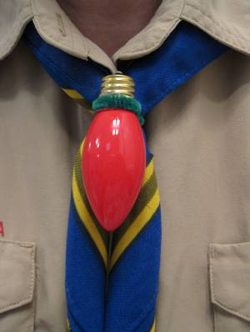
Materials:
8 inches of green chenille stem
1 C9 replacement bulb for Christmas lights
Tools:
Loaded hot glue gun
Sharpie marker
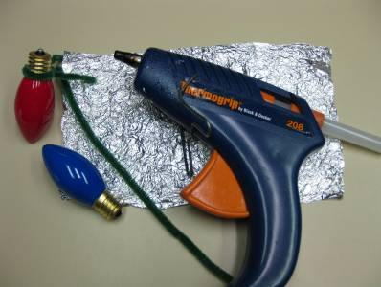
To make the Christmas Light Bulb Slide:
- Make a loop in the middle of the 8 inch chenille stem and form it tightly around the base of the light bulb where the glass meets the metal.
- Remove the stem and apply hot glue around the base of the bulb and quickly replace chenille stem. Be careful! The glue is hot!
- After the glue cools, give the chenille stem a hard twist tight against the bulb and add another drop of glue to the twist to hold it.
- Add your name and date and you are ready to go!
Flickering Candle Slide
Betsy O, Northwest Texas Council
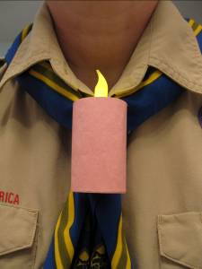
Materials:
Battery operated L.E.D. flickering candle tea light
Paper towel or toilet paper roll cardboard tube
Construction paper- white for a Menorah candle, red, black or green for a Kwanzaa candle or pink or yellow for a birthday candle
1/2 of a chenille stem, preferably the color of your “candle”
Tools:
Scissors
Ruler
Pencil
Exacto Knife or awl
Loaded hot glue gun
White glue
Rubber band
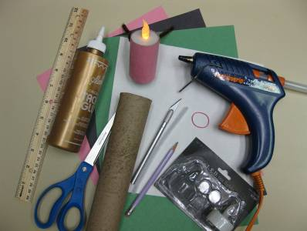
To make the Flickering Candle Slide:
- Mark and cut the cardboard tube 2 ½ inches long. Be careful not to squish your tube. (Any longer and you can’t reach in and turn on your flame)
- Slit the tube lengthwise, from top to bottom. You need to do this so that you can tightly wrap one end of the tube around the base of the candle tea light.
- Run a thin line of hot glue along the inside rim of the cardboard tube at one end and quickly roll tightly around the candle base. Hold until the glue has set. Add more glue to the overlapped cardboard to hold the side together.
- Measure and cut construction paper to wrap around “candle”. Glue and use a rubber band to hold until the glue sets.
- Form the ½ chenille stem into a square bottomed “U” shape. The base should be about 1 inch wide. Glue perpendicular to the back seam of the candle about 1 inch down from the top. Add your name and the date, turn on your candle and voilà!
Rudolph Tie Slide
Baltimore Area Council
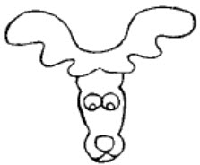
- Use a regular size flat clothespin.
- Cut legs" of clothespin off with coping saw. These will not be used.
- Sand & stain or paint the clothespin head light brown.
- Turn clothespin upside down (cut off part becomes top of his head) and glue on 7mm wiggle eyes.
- Trace antler pattern onto brown felt.

Adjust to a size you like with the clothespin.
My source of the pattern had been
copied many times.
- Cut out & glue on the clothespin piece.
- Use a 6mm red faceted plastic bead for-nose.
- Draw mouth with fine line black felt tip marker or paint pen.
- Glue plastic drapery ring or 3/4 inch PVC pipe on back for tie slide.
Respect Ideas
Respect for People & Ideas:
Alice, Golden Empire Council
Make a Family Tree to show respect for your heritage - You could make it in the common shape of a tree, with each person being represented by a leaf, with their name and birth information. Start at the bottom of the tree with your grandparents, or the furthest descendants from you, then go up till your own leaf is on the top. You could even use rubbings of real leaves, then cut them out and add the information. This would sign off for the Tiger Cubs – and this would also be a great family gift!
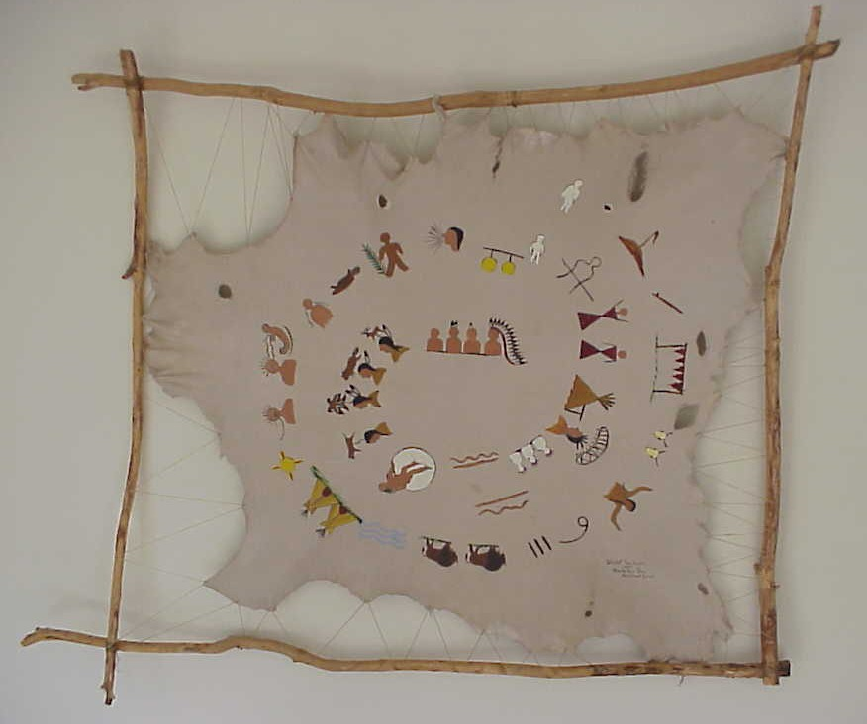
Make a Personal Story as Native Americans on the Plains did – with a “Winter Count” – The Crow and Blackfoot Tribes used a buffalo robe which they decorated with painted symbols and drawings to represent important events in their own lives – a kind of personal history. Each year, a new image or images were added, traditionally at the end of the year, so it was called a Winter Count. Look at the picture and you can see that the images were also added starting in the center and going in a circle.
Today, scouts can use a brown grocery bag, cut or torn in the shape of a buffalo skin. Use markers to draw pictures representing important events in your life, or people and things that are important to you. Crumple up the “skin” when you are done. Then spread it out and put a thin layer of vegetable oil on the surface as you smooth out the paper. (use a napkin with oil on it) Then using another napkin or paper towel, remove any excess oil. The brown paper will take on the appearance of leather. Display your work at the Pack Meeting.
Make an Art Construction in a Box to show respect for nature, your family or heritage, or some other subject – This could become a gift to display, using an ordinary box such as a cigar box or even a box you make yourself – Joseph Cornell, a famous artist, made boxes like this that are still considered valuable works of art.
Materials:
- A box to hold your items(shoebox or cigar box)
- Old magazines, greeting cards, maps, and catalogs (to cut up) Or photos and pictures
- Scissors
- Glue stick or white glue
- Hot glue
- Markers or paint and brushes
- Various small, inexpensive objects or found objects that would otherwise be discarded (like empty spools, tiny plastic toys, bottle tops, used stamps, small plastic bottles, film canisters, corks, broken toys, twigs, driftwood, dried leaves, seashells, nut shells, acorns, buttons, marbles, beads, feathers, or bits of plastic, fabric or wood)
- Paint (Optional)
- String or yarn (If you want to hang items)
Directions:
If you want to paint your box, do that first. Decide on the theme for your box, choose items, and try different arrangements – you will be turning the box on its side when you are done – but when you arrange the items, lay the box with the open end up. Use glue stick, hot glue, or string to arrange the items. Make sure every item is secure and dry before you turn your box up for display. If you have access to plastic or heavy plastic, it would be great to cover the open end.
Be sure to make a Title and Name Label
for your box, just as any artist would!
Make a “Talking Stick” to remind everyone to take turns talking and to give respect to everyone’s opinion. The idea is that a boy can only speak when he is holding the “talking stick” – and everyone must take turns with it. Native Americans in the Northwest used a talking stick, or speaker’s staff, to guarantee that each member of their tribal councils could be heard, even if they were shy. Only the person holding the stick could speak, but no one was allowed to hold it for too long, and the person holding the stick could allow someone else to interject a comment. There is often an Eagle feather, which gives the speaker courage to say what he thinks, and some rabbit fur, which reminds the speaker to use soft, not harsh words. Some tribes used a talking feather or a sacred shell instead of a talking stick. Whatever the object, it carries respect for free speech and assures the speaker he has the freedom and power to say what is in his heart.
Role Play Good Manners on the phone - Using phones (not plugged in or turned on), let boys role play how to use the phone, how to ask for a friend, how to politely handle a wrong number, how to answer the phone.
Manners Role Play @ the Door
Role play answering the door – if you know who is there and you have been asked to answer it. How do you greet a friend? How do you greet an adult? How do you let a parent or family member know someone is there to see them? And after a friend’s visit, role play the right kind of comment: Say “Thanks for coming.” And if you are the friend who came to visit, say something like, "Thanks for having me."
Manners Role Play with a Gift
Talk about how we can make someone feel good by accepting a gift graciously. Role play some ways to show your appreciation. Even if you aren’t thrilled with the gift, you can say something like “Thank you for thinking of me.” You could also send a thank you card. Ask each boy to think of something he has been given or something that has been done for him – then each boy can use construction paper, markers, stickers, etc. to make a Thank You card.
Help clean up, improve landscaping and repair gravestones in a local cemetery. You could also help to document names on historic grave sites.
Respect for the Earth Ideas:
Alice, Golden Empire Council
Have each boy, den or family choose a different subject or area to learn about do a display or activity – or have everyone celebrate the preservation or restoration of a particular area, such as a local creek. (Two examples to help you get started: A local area where a pair of beavers have become community icons – so celebrate all things “beaver.” Or celebrate Dec.
Participate in the annual winter bird count – On a single day during the 16 day Christmas Count, small groups all over North, South and Central America identify and count as many birds as they can within a certain area. Even if you don’t participate in the formal event, connect with a birding enthusiast in your pack or at a National Audubon Society club – ask them to show the boys how to identify and count birds in your own neighborhood or at nearby nature area.
Holiday Lights and
Other Ideas for December
Field Trips
Utah National Parks Council
Check out the local festivities
- See if there is an activity that your den can attend and fulfill some of the requirements needed for an achievement.
Example: Gardner Village in West Jordan, Utah, has ethnic Christmas elves all over the village and activities you can attend.
Visit special holiday light displays
- Most community or local papers put out lists of the best light displays. Find some near you.
- As a den or pack, spend an evening taking in the sights,
- End with a reflection over cookies and milk.
Service Project Ideas for December
Utah National Parks Council
- Collect food and clothing for your local food bank.
- Collect toys for children in the hospital.
- Litter Collection (Wolf Achievement #7d)
- Take part in a project with your family, den, or pack to make your neighborhood or community more beautiful. (Bear El. #14c).
- Rake leaves & clean gutters for elderly people.
- Visit an assisted living facility: sing holiday songs, bring decorations and holiday cards.
- Make cookies & holiday cards for police officers & fire fighters.
- Write letters/holiday cards to service personnel.
Service Ideas for Christmas
Utah National Parks Council
- It is a great opportunity in Cub Scouts to teach children about service. The first idea is to let the boys bake some cookies and pass them out to the widows and widowers in the neighborhood. You can use different treats.
- The second idea can be treated as a game. You have each of the boys pick out a driveway. Give them each a snow shovel and at the word ‘go’ have them begin to shovel the driveway.
Paper Bag Luminary
Utah National Parks Council
Materials:
Brown paper lunch bag (for each Scout)
Simple patterns
Pencils
Punches
Tea lights or votive candles
Sand
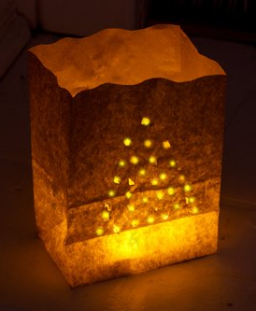
Directions:
- Take a brown paper lunch bag and trace a simple pattern in pencil on one side.
- Punch out your design with a hole punch
- Fill each luminary with about 2 inches of sand
- Sink a votive candle or tea light in the center
- Place the luminaries along a walk, patio, or deck
- Have an adult light them and then bask in the glow
Milk Jug Luminary
Utah National Parks Council
These are very unusual luminaries. They don't blow over or get snuffed out if it's wet and windy. They give a lovely white light. They are a very inexpensive way to decorate the outdoors at Christmas and other times of the year. Care must be taken to place the tea light near the center of the container but not directly under the spout.
Materials:
Sand
Empty plastic gallon milk containers
Tea or votive lights
Scissors
Directions
- Clean gallon milk containers and remove all labels
- On the side nearest the handle, cut a slit one inch tall and three inches long about one inch up from the bottom
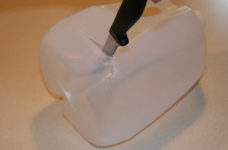
- Pour about one inch of sand into the container and shake to distribute sand evenly
- Push tea or votive light into the middle of the sand
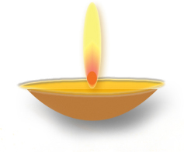
Holiday Lights Theme Ideas:
Celebrate all the different ways that Holiday Lights are used throughout the world – Kwanza candles, Diwali lanterns, Hanukkah menorah – invite parents, teachers or special guests to come and share their customs with your den, one each week - or have a Pack presentation with each den or family showing one custom of Holiday Lights – almost every culture has some celebration at the end of the year or to celebrate the New Year – many with lights.
One that fell on November 13 this year is Diwali, a Hindu festival honoring the once banished mythic hero Rama and his wife Sita – Lakshima, goddess of prosperity, is welcomed into homes decorated at the entrance with patterns made in rice flour, called rangoli. Candles and rows of oil lamps are lit all five nights of the festival, giving thanks for blessings of the past year, and lighting the way for good fortune in the next. One fun custom is drawing small footprints with rice flour and vermilion powder all over the house, indicating that Lakshima is coming. Diwali is celebrated all over India – in some places, the fourth day is Annokoot, meaning Mountain of Food – statues of deities are given milk baths and offered huge trays of delicious sweets.
In Sweden, candles are worn by St. Lucia as part of a crown of evergreen – See Dec. 13 under December-A Month for Respect.
In Ireland, a candle in each window welcomes travelers – and symbolizes welcoming Mary and Joseph. In the days when it was illegal to practice the Catholic faith in Ireland, a candle in the window of an Irish home signaled traveling priests that they would be welcome and could conduct the traditional Christmas Mass.
 In the Philippines, Christmas begins as early as September, when the first Parols appear. These are lighted star lanterns made from bamboo strips and paper and hung from a bamboo pole. Today many other materials are also used, and the star may be lit with electric lights. The parol is the most important and popular Christmas symbol, and the lanterns traditionally are not removed till January 6, the Three Kings Day. Many communities compete to make huge parols that can be as large as 40 feet wide! A famous event is the Giant Lantern Festival in Pampanga.
Visit special holiday light displays (every community or local paper usually puts out such a list) – as a den or pack, spend an evening taking in the sights, and then end with Christmas cookies and milk.

Have a "Pretend" Night Before Christmas celebration – everyone comes in sweats or p.j.s, have hot chocolate and cookies, and bring a present – the present could be one to be passed on to a local charity, or something on the Pack Wish List, or just a fun “white elephant” gift to trade with another family. Of course, I would plan this for a night other than the real night before Christmas!
Make some Art to Share – After talking about different ways to show respect for people or things, each boy chooses a topic and creates a piece of art that shows Respect for someone or something. Let each boy explain his version of Respect – you could also create labels and display at the Pack Meeting. Possible topics: Respect for: Self, Others, Those who are different, Parents and Leaders, Other Cultures, the Elderly, the Environment, the Flag, the Law, or even Possessions and their care.
Share some gift ideas your pack parents to help their sons “Do Your Best” in scouting – they could get a binder filled with plastic sleeves and baseball card sleeves and start a photo/award card album for their scout – a great way to keep a photo and memorabilia record, and great practice for saving those cards he will need to have to work on his Eagle!
Attend a Holiday play or performance as a den or pack – check your local newspaper or TV suggestions, and look for special group rates.
Make some ornaments to give to grandparents and other friends or family. (My favorite is the cinnamon dough ornaments - See recipe at the end of this section)
Make cookie dough up one den meeting, then bake and decorate at the next meeting. Or ask families to bring cookies ready to decorate to the pack meeting, and have frosting and decorations ready – each family decorates some cookies, then all can enjoy them with cocoa as the treat for the night.
Have a workshop to make gifts for family or to give to a local charity. Some ideas would be: making play clay or a wooden toy for young children, bath salts for women, pencil holders and/or desk sets for men. You can get lots of ideas in the How To Book – or check to see what suggestions the charity might have. Boys can also make Holiday cards and wrapping paper.
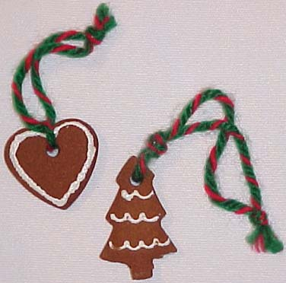Cinnamon Ornament Dough
This is a really simple way to make ornaments, even with younger children – and the scent lasts for years! (There is a recipe that adds applesauce, but that makes the ornaments more fragile, and could attract critters. This one won’t cause any problems- Alice)
- 1 cup ground cinnamon (available cheaply in bulk at Costco type stores, or at your grocery store in the Mexican food section – usually hanging in plastic bags.
- 4 tablespoons white glue
- 3/4 to 1 cup water
Mix cinnamon and glue. Gradually add the water. Stir until a ball of dough forms. Roll out with rolling pin 1/4 inch thick and cut with cookie cutters. Poke a hole with a straw and let dry at room temperature for 1 to 2 days, turning over every 6-8 hours.
Decorate with acrylic paint – my personal favorite is white! It’s really easy to outline your gingerbread man or personal handprint: Pour a thin layer of white acrylic paint in a small paper plate – then use the “wrong” end of a brush, dip it in the paint, and make dots all along the edges of your ornament. Looks great hanging from red ribbon or even red & white checkered ribbon. Hang and enjoy the fragrance! The scent will literally last for years! But don’t try eating them.
P.S. A great project is to make a handprint ornament to give to grandparents – they’ll LOVE it!
All that Glitters (Reflections of Light)
Window Ornament
Reflect your family’s holiday spirit.
Baltimore Area Council
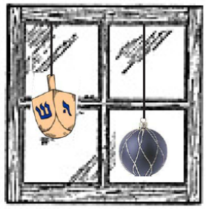
What you’ll need:
Newspaper
Stiff Paper or Cardstock
Scissors
Hole Punch
White Glue
Glitter
Waxed Paper
String
Directions
- Cover your work surface with newspaper.
- Cut your favorite shapes out of cardstock or stiff paper.
- Punch a hole in the top of each window ornament.
- Cover one side of the shape with a fine layer of glue.
- Sprinkle glitter over the shape.
- Place on waxed paper to dry.
- Shake the loose glitter onto a sheet of wax paper.
- Flip the shape over and repeat the process for the other side of the shape.
- Once the glue is dry, thread string through the holes, and
- Then hang your ornament in a sunny window.
Candle Shield
Baltimore Area Council
A candle shield is an ideal holiday project.
Since you can’t see the candle behind your shield,
it will seem as if your picture is glowing all by itself.
What you’ll need:
Heavy-duty Aluminum Foil
Blunt Scissors
Ruler
Permanent Marker
Push pin
Directions
- Cut three 8” squares from heavy-duty aluminum foil.
- Place the 3 foil squares on top of each other.
- Fold each edge over about 1” on each side.
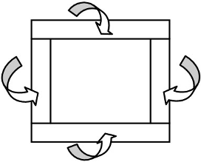
- Use the permanent marker to draw your design on the foil.
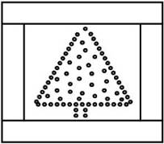
- Place the foil on a soft surface (piece of foam, a rug or a towel).
- Following the lines of the drawing on the foil, use the push pin to punch the design.
- Curve the foil so that it stands up about 3” in the front of a candle.
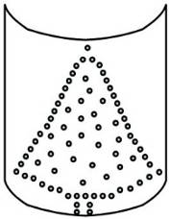
Kinara
Baltimore Area Council
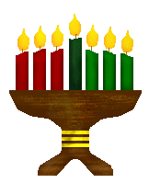
Picture does not illustrate the project
What you’ll need:
Flat piece of wood 12" long
One black candle
Seven bottle caps
Three red candles
Aluminum foil
Three green candles
Glue
Directions
- Cut seven six inch squares of aluminum foil.
- Put bottle caps on each square of foil, and mold each to look like a cup to hold a candle.
- Decorate the piece of wood, then place each foiled cup on the piece of wood, evenly spaced, then glue each.
- Allow time to dry, then place one black candle in the center holder, with three red candles to the left of the black candle, and three green candles to the right of the black candle.
- Press the aluminum tight to hold the candles in place.
Hanukkah Menorah
Baltimore Area Council
Directions
- Put 3 cups of uncooked white rice in a metal bowl.
- Drop food coloring on the rice.
- Stir the rice with a metal spoon to distribute the color evenly throughout the rice.
- Clean and dry eight baby food jars (or jars of about the same size) and one taller jar and their lids.
- Fill each jar to within 3/4" of the top of the jars.
- Push a menorah candle into the rice in each jar.
- Arrange the candles on the table with the taller jar in the middle.
Toilet Paper Roll Ornaments
Baltimore Area Council
What you’ll need:
Empty toilet paper rolls,
Lace,
Ribbon,
Batting,
Fiberfill.
Directions
- Stuff fiberfill into the toilet paper roll to keep the roll from collapsing.
- Wrap a thin layer of batting around the roll.
- Cover the batting with lace.
- Tie each end with ribbon.
- If the ends of the lace are raw edges trim with pinking shears to stop fraying, or use fray-check.
Snow Globe

What you’ll need:
Small jar with screw lid,
White glitter flakes,
Waterproof glue,
Small holiday object(s),
Water.
Directions
- Clean out the jar. A baby food jar is a good size.
- Glue the object(s) to the lid.
- Let the glue dry.
- Put some white glitter flakes into the jar.
- Add water to the jar leaving some room for air.
- Put glue around the rim and screw on the lid.
- Make sure the lid is on tight.
- Shake the globe to spread the flakes and create a snow scene.
Picture Frames
Baltimore Area Council
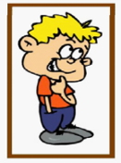
Materials Needed:
Foam sheets or sticks,
Magnets or paper clips, and
Glue.
For the foam sheets
- Cut one solid rectangle and one rectangle with the center cut out.
- Glue the top, bottom and one side together. Leave the other side unglued for inserting the picture.
- Glue magnets or an unbent paper clip to the back for hanging.
For the sticks
- Create a flat box with the sticks for the front.
- For the back put two sticks across the top and bottom and then glue the other sticks side to side until the back is filled.
- Glue the front and back together as before.
- Glue magnets or an unbent paper clip to the back for hanging.
Picture Ornaments
Baltimore Area Council
What you’ll need:
Foam sheets,
Clay
Juice or plastic lids,
Paper,
Paints, and
Ribbon,
Clay ingredients (listed below).
Directions
For the juice or plastic lids
- Cut out two pieces of paper. One is for the background and the other piece is for the backside of the lid.
- Glue the picture inside the lid.
- Wrap and glue the ribbon around the edge of the lid.
- Remember to add a loop for hanging.
- Write the date of the picture on the back of the ornament for a remembrance.
For the foam sheets
- Either use pre-made shapes, or trace the desired shape onto the foam and cut out.
- On the front cut out the picture hole as well.
- Glue around the edges leaving an opening for inserting the photo.
For clay ornaments,
- Use a recipe that needs cooking (e.g. 4 cups flour, 1 cup salt, 1½ cups warm water. Knead 10 min. Keep in airtight container until ready to use. Bake 350° for 30 min.).
- Use cookie cutters or make freehand shapes.
- Leave a spot on the front for the picture, or glue the picture to the back of the ornament.
- Poke a hole in the ornament with a nail or paper clip before cooking for hanging later.
- Make sure the hole is big enough because it will shrink slightly when baked.
- Paint with acrylic paints after cooling and
- Finish with a clear coat sealant.
Clear Ornament
Baltimore Area Council

What you’ll need:
See-through ornaments,
Metallic wrapping paper,
Puff paints,
Scissors.
Directions
- Cut the metallic wrap into thin strips.
- Take off the top of the ornament and place the strips inside.
- Replace the cap.
- Decorate the outside with puff paints or glitter.
- Write the boy’s name on the ornament with puff paints.
Quick and Easy Christmas Ornaments
Utah National Parks Council

Materials:
Old CD’s
Glitter glue, sequins, beads, etc.
Picture of each boy
Scrapbooking scissors
Decorative string for hanging
Instructions:
- Using glitter glue, make festive designs on the shiny side of the CDs.
- Slide decorative string through the hole of the CD and tie a knot to make a loop, long enough to hang from a Christmas tree.
- Take and print a small picture of each boy (preferably in his full uniform!). (Utah NP CD said "Polaroid Picture." Wow! I have a camera but no film - CD)
- Use fancy edger scissors to cut around the pictures and paste on the center of the decorated CD. If there is a label on the backside of the CD, you could cover it with wrapping paper or construction paper and decorate with glitter glue, sequins, beads, or whatever!
- Make sure to include the date in the decoration so everyone remembers when the picture was taken.

DEN MEETINGS
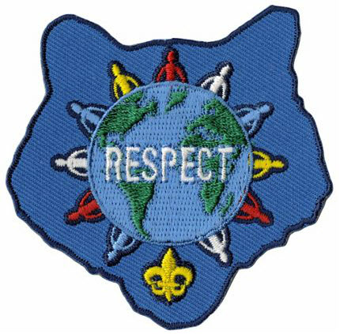

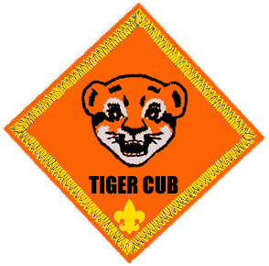

TIGERS
Wendy, Chief Seattle Council
Tigers are working on Ach. #2 and Ach. #4 this month.
Meeting #7
Do: Ach. #4F Respect Character Connection
Ach. #2G Police or Fire Station Field Trip
Verify Ach. #4F Meal Conversation
Meeting #8
Do: Ach. #4G Field trip to newspaper, radio,
or TV station
Media/Communication Ideas
Activities:
El. 20 Public Service Announcement. Have the boys write and perform a public service announcement at pack night.
Videotape a skit or demonstration for pack night.
How To Make Your Own Newspaper
Baloo's Bugle, December 2004
Get started: Think of a name for your newspaper and decide which stories to include.
Gather the Facts: Interview people who have information. Visit the location where the story is taking place.
Write the story: Make an outline or rough draft first--all news reporters do that. Put the basics of WHO, WHAT, WHERE, WHEN, WHY, and HOW at the beginning. Write a headline that tells the story in a few words. (Don't insist too much on correct writing style. If the boys enjoy writing, encourage them!)
Set up Pages: Set the words in columns, if you wish. Most papers use a column format.
Put it together: Begin to paste up the paper with articles and illustrations. Use glue stick or clear tape to hold in place.
Print your newspaper: Make one photocopy. If it looks good, make as many copies as needed. If dark lines show, use liquid correction fluid to cover. Make photocopies from corrected version. Deliver the newspaper to readers. (Have enough copies made for each boy in the pack. Some copying companies will give Scouters a discount. Others will give you a discount if you make at least 1000 copies, which is not difficult to do with the pack bulletin.
DEN NEWSLETTER
Baloo's Bugle, December 2004
The den’s newsletter can be whatever the boys want to make it. Ask each boy to write at least one story for the paper. Here are a few possible topics:
  - A report on a recent den field trip.
  - Brief impression of a recent den or pack event.
  - Directions for playing the writer’s favorite game.
  - A report on an interview with the den leader.
  - A one- or two-paragraph description of each den member written by himself.
  - An interview with the den chief, who tells why he likes Boy Scouting.
  - A story on what the den plans to do for the Blue and Gold Banquet.
If you have an artist in the den, he may want to draw a cartoon or some other illustration. A boy interested in photography might choose to take photos of den activities.
Recruit boys and parents who have access to a computer to help produce some or all of the newsletter electronically using graphics and word processing programs.
Printing
Southern NJ Council
You can make designs and use them over and over to make greeting cards, gift wrapping, banquet programs and menus and stationary. Cover the table where you are working with newspapers because you must press down hard when printing to make a clear print. Design will print the reverse of what is seen on the block so if there is lettering or a design that has a right or left, it should be glued to the block backwards. Here are some ideas -
Potato Printing
Potatoes make good block prints, if used right away. They are easily carved, but last only a day or two. One potato makes at least two designs.
- Cut potato in half with one straight cut
- Blot the surface to remove as much moisture as possible.
- With an orange stick or pencil, trace design on potato.
- Cut away all parts without any design on them. Cut outline at least 1/3" deep to provide a good printing surface.
- Again remove additional moisture.
- Place paper to be printed on a pad of newspaper or a water-soluble printer's ink on design.
- Transfer potato design onto paper. Press had but do not move the potato or the design will smudge.
Potato Stamp Tip
Baloo's Bugle, December 2004
You can make the potato stamp in a couple of ways. One way is to cut the potato in half and carve a design on one-half. This should be a raised design, so you cut away what you do not want to see. There is a safety issue here of using knives. Plastic ones work if the potato is a softer variety.
Another way to potato stamp is to use cookie cutters. You push the cookie cutter all the way into the potato and cut off the excess with a butter knife. This can make better shapes and is a lot safer for the Cubs.
Leaf Printing
Trees shrubs, flowering plants and weeks offer an infinite source of leaf designs for printing. Use an inked stamp pad, place leaf, veins side down on pad. Lay a piece of newspaper over leaf and rub fingers over it. Remove leaf and place it on surface to be printed. Pace clean newspaper on tap and rub.
Crayon Rubbing
Place leaves veins side up on paper or textured surface, such as burlap, wood or leatherette. Cover with sheet of plain paper and rub crayon held sideways. Outlines and veining of leaves will stand out.
Printing With Sponges
On a dry plastic sponge draw or trace your design. Cut cleanly along the lines. Place poster paint in a dish, brush the paint onto the flat part of the sponge and stamp it on your paper.
Printing With Odds And Ends
Interesting and easy prints can be made with odds and ends from around the house. You will be surprised with the patterns you can make by pressing the bottom of a spice can or a bottle on an ink pad and then stamping your paper. Other things such as:
Matchbox Half an Onion Your hand
Buttons Coins Kitchen Utensils
Fork Toothbrush
Crafts:
MEMO HOLDERS
Southern NJ Council
Craft Stick –

Materials: One large craft stick (tongue depressor); 1 spring-type clothes pin; Markers; Glue; Strip magnet.
Directions:
- Glue a clothespin near the end of the craft stick.
- Decorate with markers.
- Attach magnet on back.
Paint Stick
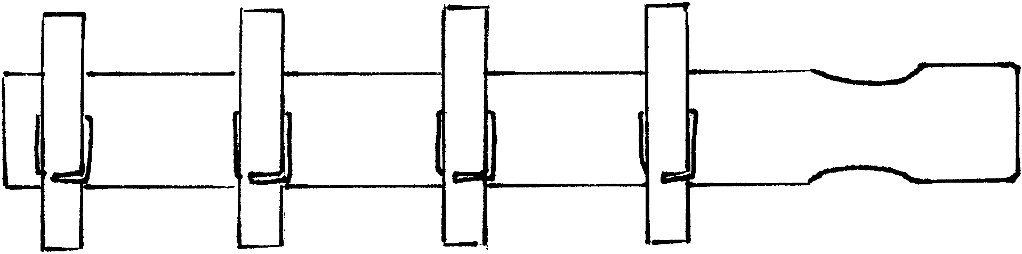
Materials: One paint stick (for quart or gallon can, about 14” long); Several spring-type clothes pins, Paint; Permanent markers; Glue; Strip magnet.
Directions:
- Paint the paint stick. Use any wood or acrylic paint.
- Attach clothespins. If desired, paint or decorate the clothespins before you glue them on the paint stick.
- Decorate with markers
- Attach magnet strips on the back of the paint stick.
Paper cup Telephones
National Capital Area Council
Make a small hole in the base of each cup. Insert one string from the outside to the inside of each set of cups and secure it with a piece of tape. Let the Cub and his partner talk to each other. Be sure to keep the string taut but don't pull so hard that the string comes untaped. Suggest they have a code word to indicate they are done talking, so each knows when to change from listening mode to speaking mode.
Family Communications Center
Baltimore Area Council
Create a message center using a wooden coat hanger and metal cup hooks.
Screw the cup hooks into the bottom of the wooden coat hanger, spacing them equal distances and using one for each member of the family.
Decorate the hanger any way you want, using Feathers, ribbon, seeds, dried flowers, material, etc.
Old Fashion Telegraph Set
Baltimore Area Council
Supplies: 2 wood blocks 2 nails
3 screws 1 dry cell battery 2 wires
2 metal tin can strips (Note: These cannot be from an aluminum can. Test it with a magnet first.)
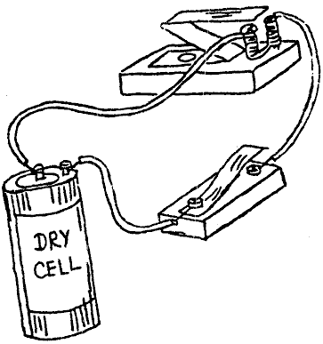
- Using supplies, assemble, as illustrated.
- Bend the metal “Z” (sounder) so that it attaches itself to the nails when the key is pressed.
- After the boys have completed their old fashion telegraph set, they can have fun sending messages to each other using the Morse Code chart below.
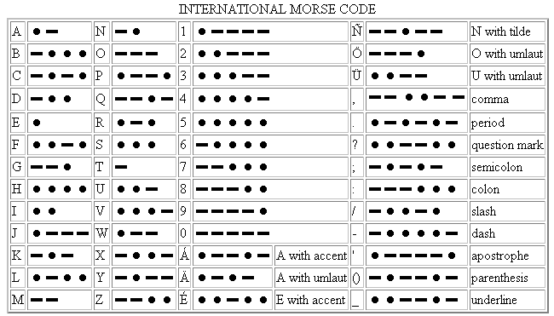
Historical Note: Samuel Morse became interested in telegraphy in 1832, and worked out the basics of a relay system in 1835. The equipment was gradually improved and was demonstrated in 1837. Morse developed “lightning wires” and “Morse code”, and applied for a patent in 1840. A line was constructed between Baltimore and Washington and the first message, sent on May 24, 1844, was “What hath God wrought!”
On May 24 2004, the 160th anniversary of the first telegraphic transmission, the International Telecommunications Union added the “@” (the “commercial at” or “comma at”) character to the Morse character set and is the digraph “AC” (probably to represent the letter a inside the swirl appearing to be a C).
It is notable since this is the first addition to the Morse set of characters since World War I probably, due to its popularity in e-mail addresses.
Games:
Here are two that go with the Police Station visit:
Detectives
Two boys are Detectives and are sent out of the room. The others choose an object that the Detectives will try to discover, such as a piece of furniture, a book, or a button on someone’s clothing. The Detectives are called back in and try to solve the mystery by asking questions. They can ask each of the other players only three questions. Suggest that they try to find the location first and then identify the object.
Look Sharp
Divide the group into two teams that stand in lines facing each other. Boys have one minute to observe their partners on the opposite team. On a signal, they turn their backs to each other, and each player makes three changes in his attire. He may undo a button, alter the position of an activity badge, exchange neckerchief slides with a neighbor, etc. At the next signal, all turn to face their partners again and try to determine what changes have been made. Each change correctly identified counts one point.
And here’s one that goes with the How I Tell It fieldtrip:
Rhyming Words
Boys sit in a circle. The first player says a one- or two-syllable word. The next boy must say a word that rhymes, and so on around the group.
Example: Pan, can, tan, man, fan. When a boy can’t think of a rhyming word, one point is scored against him, but he starts the game over with a new word. Player with the fewest points wins.
Noodlegrams
Simon Kenton Council
In a saucer place a tablespoonful or more of uncooked noodles. Each person must try to compose a ten word message out of the alphabet noodles. This could be done in couples or singly as gathering time activity.
Jigsaw Puzzle Ads and Comics
National Capital Area Council
Cut up full page color pictures from magazines. Have at least one puzzle per scout. As each scout arrives, hand him one to put together. If time permits, let the scouts exchange puzzles.
Save one week of comics from the local paper. Cut up each comic strip, panel by panel and mix them up. Give each person a panel as they arrive. Each participant must find the other panels and place them in the correct order. Have the comic strip panels ready for inspection, or place the panels at a designated place before the meeting. The order of each comic strip may be peculiar. Lots of surprises await you.
Newspaper Boy
Baltimore Area Council
This is played with at least eight players and folded newspaper. One player is designated “It” and gets the newspaper. The other players form a circle holding hands. “It” walks slowly around the outside of the circle, chanting: “Extra! Extra! Read all about it!”
While chanting, "It" drops the newspaper behind a player in the circle. That player then picks up the paper as quickly as possible and chases “It” around the circle. “It” tries to get back to the empty spot in the circle left by the chaser before being tagged. If “It” succeeds, the chasing player then becomes “It.”
Songs (Tiger E6):
Commercial Mix-Up
York Adams Area Council
Tune: Farmer in the Dell
Last night I watched TV, I saw my favorite show
I heard this strange commercial, and I can't believe it's so
Feed your dog Chiffon. Comet cures the cold
Use S-O-S pads on your face to keep from looking old.
Mop your floors with Crest. Use Crisco on your tile
Clean your teeth with Borateem, it leaves a shining smile
For headaches take some Certs. Use Tide to clean your face
And do shampoo with Elmer's Glue, it holds your hair in place
Perhaps I am confused, I might not have it right
But one thing that I'm certain of, I'll watch TV tonight!
THE MORE WE COMMUNICATE
Southern NJ Council
Tune: The More We Get Together
The more that we communicate,
Communicate, communicate,
The more that we communicate,
The happier we’ll be.
Then you know what I know,
And I’ll know what you know.
The more that we communicate,
The happier we’ll be.
By telephone or e-mail,
By signal code or snail mail,
The more that we communicate,
The happier we’ll be.
Communication
Baltimore Area Council
(Tune: You Are My Sunshine
Communication gets information,
Across to people both far and near.
May be letter, a TV program,
Or a radio that you hear.
Communication is conversation
Between two people or maybe more.
By telephone or walkie-talkie, or a
Neighbor standing at your door.
Communication can cross the nation,
Or cross the ocean by satellite.
The world seems smaller, news travels
Quicker than we ever dreamed it might.
Smoke Chant
If you don't want to choke
Crawl under the smoke.
Get down on the floor
And head for the door
Stop, Drop, and Roll!
Tune: Farmer in the Dell
Stop, Drop, and Roll
Stop, Drop, and Roll
If your clothes should catch on fire,
Stop, Drop, and Roll
Get out!
Sung to: "Bingo"
What happens if there is a fire ?
Do you know what to do ? Oh !
GET OUT ! QUICK , GET OUT !
get out ! Quick ,get out !
get out ! QUICK, get out !
Stay very low and go. GO !
What happens if there is a fire ?
Do you know what to do ? Oh!
STAY OUT ! DON'T GO BACK !
stay out ! Don't go back !
stay out ! Don't go back !
Don't go back in the house. No !
What happens if there is a fire?
Do you know what to do ? Oh !
GET HELP ! CALL FOR HELP !
get help ! call for help !
get help ! call for help !
call 911 for help ! oh!
Treats:
Edible messages:
Wendy, Chief Seattle Council
- Use letter-shaped cereal to make words and sentences, then you can eat them.
- Spread peanut butter or frosting on graham crackers, top with words made from letter cereal, and eat.
Fire Safety Ideas:
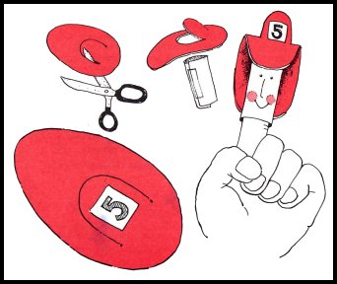
Fire Fighter Finger Puppet
Materials:
white paper, scissors, glue or tape, red construction paper or felt, black and red markers
Directions:
- Cut a rectangle measuring 2 1/2" x 3 1/2" out of white paper.
- To form cylinder, wind the rectangle around your finger.
- Remove from finger and glue or tape the cylinder together.
- Reproduce the hat pattern below.
- Cut out and trace on red construction paper or felt. This will be the firefighter's hat.
- Put scissors through the paper or felt; cut out the arc shape.
- Glue the front of the hat and the back onto the cylinder, the arc extending out. (see illustration)
- Add firefighter's features on the cylinder using a black marker and shade the cheeks with a red marker.
- Write the fire squad number on a small white square and glue it to the arc.
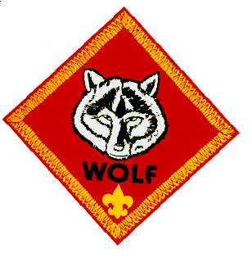

WOLF
Wolves are working on Ach. #6, Ach. #7, Ach. #8,
and Electives #9 and #17 this month.
Meeting #7
Do: Ach. #7a Respect Character Connection
Ach. #7b Discuss how land, water, and air get dirty with your family.
Ach. #7c Recycling.
Ach. #7d Litter collection.
Ach. #7e Conservation stories.
Ach. #7f Saving energy.
El. #9b,c Finish picture frame.
El. #17b,c Wrap the frame, and tie a string or ribbon around it.
El. #17a Overhand and Square Knot.
Verify Ach. #4e Chore Chart, and
Ach. #7e Conservation Stories.
HA: Ach. #4e. Chore chart (if not completed).
Ach. #6b Start a collection.
Ach. #8c-e Cooking.
Note: The only way the boys can complete Ach. #7a and #7b is if their parents attend a den meeting. These achievements should be discussed with the boys’ families.
Meeting #8
Do: Ach. #8a Food Pyramid.
Ach. #8b Meal Planning.
Ach. #6a Positive Attitude Character Connection.
Ach. #6c Collection show & tell.
Verify Ach. #4e Chore Chart and Ach. #8c-e Cooking.
Note: The only way the boys can complete Ach. #6a is if their parents attend den meeting. This achievement should be discussed with the families.
Conservation Ideas
Science Articles (conservation stories for Ach. #7e):
Here are two sources of stories:
http://www.sciencenewsforkids.org/pages/search.asp?catid=7
http://kids.nationalgeographic.com/kids/

Litter Sweep Relay
Baltimore Area Council
Object: To be the first team to make a clean sweep of all the litter.
Materials: A broom for each team and a small pile of dry trash: soda cans, paper, small plastic bottles, etc.
How to play: Divide into two teams and give each team a broom and a small pile of dry trash - soda cans, paper, small plastic bottles, etc. At the start signal, the first boy on each team sweeps the trash to a certain point and back. The next team member then takes over, and so on until all have run. The first team finished wins. If a boy loses any trash he must sweep back and pick it up.
Above and Below
Longhorn Council
The Idea of the Game: After some discussion about pollution and what are ways we have polluted out environment, you can play this game where you come up with ways we have polluted our environment and ways we are trying to save our environment and are they above or below (meaning is it visible to us).
Examples:
- Pollution: litter on highways - above,
- Garbage on the floor of the sea - below,
- Saving our environment: Planting a tree – above
Equipment: None
Formation: Circle
Directions:
- Arrange the players in a circle.
- Call out ways we pollute the environment or save our environment that are found above or below.
- When you call something that signifies above, the players stand; if below, they sit down.
- Failure to do this eliminates the players who miss.
- The list of things to be named should be carefully worked out in advance to keep the game going smoothly.
Earth, Water, Air and Fire
Longhorn Council
Equipment: 1 bean bag
Formation: circle
- The Pack or Den members sit in a circle with one Cub in the center holding the beanbag.
- The Cub in the center throws the bag at someone and shouts 'Earth!’ 'Water!’ 'Air!' or 'Fire!’
- If it is 'Earth', the chosen Cub must reply with the name of an animal, before the center Cub counts to ten.
- If it is 'Water!’ he must think of a fish,
- If 'Air!' - a bird and
- If 'Fire' - He whistles for the Fire Engine.
- Can be done with Paper, Plastic, and Metal (or Aluminum). Boy names something made from that material that can be recycled. Use Rock as the ringer, boy can say, "Thud" or some other sound he thinks a rock makes when it lands.
Note: Once a creature has been named, it may not be called again. If the Cub cannot reply in time, he changes places with the thrower.
QUIET RECYCLE ACTIVITY
Circle Ten Council
Unscramble our recycling world. Have the boys unscramble the word in the highlighted box below to spell how our state will look if we all recycle our waste.
Litter Reduce Cardboard Compost Reuse
Landfill Recycle Ecology Resources Glass
Aluminum Newspaper
1. ecreyle ___ ___ ___ ___ ___ ___ ___
2. tltrei ___ ___ ___ ___ ___ ___
3. locyoge ___ ___ ___ ___ ___ ___ ___
4. drecue ___ ___ ___ ___ ___ ___
5. erruosecs ___ ___ ___ ___ ___ ___ ___ ___ ___
6. bocadrdra ___ ___ ___ ___ ___ ___ ___ ___ ___
7. lsgsa ___ ___ ___ ___ ___
8. pcmoots ___ ___ ___ ___ ___ ___ ___
9. umualimn ___ ___ ___ ___ ___ ___ ___ ___
10. uesre ___ ___ ___ ___ ___
11. apwreesnp ___ ___ ___ ___ ___ ___ ___ ___ ___
12. fladlinl ___ ___ ___ ___ ___ ___ ___ ___

BONUS word _____ _____ _____ _____ _____
Bonus word answer: CLEAN
Other sources -
- 1999 Santa Clara Pow Wow Book “Pollution Solution” p. 6-7; 16-17. http://www.macscouter.com/CubScouts/PowWow99/SCCC/April99.pdf
- ’01 Baloo’s Bugle “Save it for Us” p. 13-15. http://usscouts.org/usscouts/bbugle/bb0103.pdf
- ’01 Santa Clara Pow Wow Book “Save it for Us” p. 6; 11; 16-17. http://www.macscouter.com/CubScouts/PowWow01/April01.pdf
Crafts & Activities
Conserve Energy Door Hanger
Great Salt Lake Council
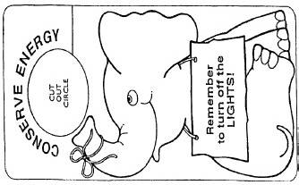
Enlarge the elephant and copy it on card stock, color and hang on doorknobs to remind people to turn off the lights.
Encourage boys to come up with their own ideas for pictures for the door hangers. CD
Other sources -
- ’04 Baloo’s Bugle “Cubservation” p. 10. http://usscouts.org/usscouts/bbugle/bb0403.pdf
- 1999 Santa Clara Pow Wow Book “Pollution Solution” p. 19-26. http://www.macscouter.com/CubScouts/PowWow99/SCCC/April99.pdf
- ’01 Baloo’s Bugle “Save it for Us” p. 6-10. http://usscouts.org/usscouts/bbugle/bb0103.pdf
- ’01 Santa Clara Pow Wow Book “Save it for Us” p. 21-25.. http://www.macscouter.com/CubScouts/PowWow01/April01.pdf
Snacks
Incredible Edible Landfill
Our Special Thanks to:
Maurita Hudson, Educator
Dearborn County Solid Waste Management District
Aurora, IN
You should copy this picture and enlarge to full page.
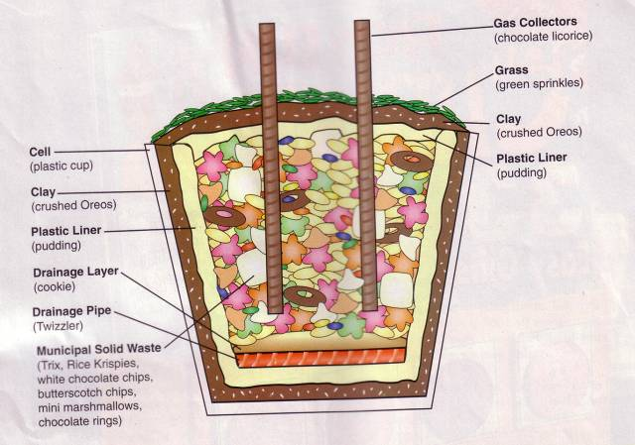
Materials
Base layer
Plastic cup or container"
1 tsp. Oreo cookie crumbs
2 tsp. vanilla pudding
Two 4" Twizzlers®
One shortbread cookie
Municipal waste (middle layer)
1 tsp. Trix® cereal
2 tsp. Rice Krispies® cereal
1 tsp. white chocolate chips
l tsp. butterscotch chips
Six mini marshmallows
Four chocolate rings
1 tsp. mini M&M's®
Chocolate syrup
Final Cap (top layer)
2 tsp. vanilla pudding
1 tsp. Oreo cookie crumbs
1 tsp. green sprinkles
Two 4" chocolate licorice pieces
*Designer used clear Solo® cups.
Instructions
Add each ingredient in order listed to plastic cup.
The layers of a landfill are described below.
Base layer
Layer 1 (cell): Landfills range in size from four to six acres of land. The area, or cell, must be free of debris and able to hold the weight of the landfill mass. This is represented by the plastic cup.
Layer 2: This layer is three feet of clay which prevent fluids from seeping out of the landfill. This is represented by pressing 1 tsp. of Oreo cookie crumbs firmly into bottom of cup.
Layer 3: This layer is a thin liner of plastic which is designed to prevent leaks in the ground beneath the landfill. This is represented by adding 2 tsp. of pudding.
Layer 4: These are pipes that make the leachate collection system. They collect leachate which is a liquid that is squeezed out of the garbage leachate then travels to a treatment pond. This is represented by laying two Twizzlers across pudding.
Layer 5: This is a drainage layer that protects the pipes from being damaged. This is represented by laying the shortbread cookie on top of the Twizzlers. (Note: No trash has been added yet. Layers 1-5 are designed to protect the environment by disposing of garbage safely.)
Municipal waste (middle layer)
Municipal solid waste is all of the garbage from peoples' homes and businesses.
Layer 6: This layer is composed of the following:
- Organic waste (Trix) is yard waste and food scraps.
- Paper (Rice Krispies) consists of cardboard, newspaper, and, packaging products.
- Plastics (white chocolate chips) include milk and soda bottles and food containers.
- Glass (butterscotch chips) range from bottles to old building windows.
- Metals (mini marshmallows) include tin and aluminum cans and appliances or sheet metal.
- Tires (chocolate rings) include those from cars and trucks.
- Other garbage (mini M&M's) contains old toys, shoes, and clothing.
This is represented by adding 1 tsp. Trix, 2 tsp. Rice Krispies, 1 tsp. white chocolate chips, l tsp. butterscotch chips, six mini marshmallows, four chocolate rings, and 1 tsp. mini M&M's. Spread evenly.
Layer 7: This layer is the leachate that forms. It seeps through all of the layers to the pipes which filter the liquid out of the landfill. This is represented by squirting chocolate syrup around the edge of the cup.
Final Cap (top layer)
This outermost layer prevents rainwater from entering the landfill and keeps gases from leaving and polluting our air.
Layer 8: This layer is the top plastic barrier that seals the landfill. This is represented by adding 2 tsp. of pudding.
Layer 9: This layer is five to seven feet of soil. This is represented by sprinkling 1 tsp. of Oreo cookie crumbs onto pudding.
Layer 10: This layer is grass which prevents soil erosion. This is represented by adding 1 tsp. of green sprinkles.
Gas collectors. These pipes are placed in the closed cell and act as methane gas collectors. They prevent fires by collecting the gas produced from decaying trash. This is represented by inserting two chocolate licorice pieces vertically into the cup.
Maurita was kind enough to share some secrets:
- The Solo cups she uses are 9 or 10 oz ones with hard plastic side. Very wide at the top.
- She, also, told me to keep talking during the assembly. Ask boys what impermeable, leachate, organic, perforated mean Start a discussion about what can become leachate. She says these usually get to be fun Ask them what some of the items represent before you tell them (e.g. ask what the chocolate cereal rings look like (tires))
DIRT PIE
Circle Ten Council
Ingredients
1.25# package Oreo's
1/2 stick margarine
8 oz cream cheese
1 cup powdered sugar
3.5 cups milk
2 sm. boxes instant vanilla pudding
12 oz Cool Whip
Directions
- Crush Oreo's until fine.
- Cream margarine, cream cheese and powdered sugar together.
- Mix milk and pudding and combine with margarine mixture.
- Mix well, and then add Cool Whip.
- Thoroughly clean out a new plastic flowerpot with soap and hot water.
- Alternate layers of Oreo crumbs and pudding mixture in the containers
- Have Oreo's on both the bottom and top layers.
This cake looks especially good if you add gummy worms for special effect.
Food Ideas
Taco Tie Slide:
Wendy, Chief Seattle Council
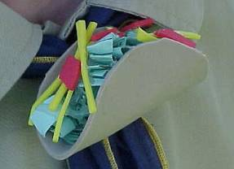
Materials
4" Tan Craft Foam
Red Craft Foam
Yellow Craft Foam Green Paper
PVC ring
Hot Glue
Scissors
Directions
- Cut 4" diameter circle from tan craft foam for taco shell.
- Cut thin strips of yellow craft foam for shredded cheese.
- Cut irregular shapes of red craft foam for tomato.
- Tear green paper into irregular shapes and wad up for lettuce.
- Fold taco shell in "U" shape.
- Using hot glue, attach cheese to bottom, then tomato, and finally lettuce on top.
- Make sure sides of taco are held in place, if not put on more hot glue.
- Hot glue a PVC ring to the back.
Bacon & Eggs Tie Slide:
Wendy, Chief Seattle Council
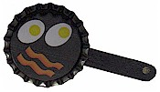
Materials
Bottle Caps
Can't find classic bottle caps??
Go to MakingFriends.com and you can buy them for less than 10 cents apiece. Unbelievable!! Of course, I never thought about buying crickets either until my daughter adopted an Anole CD
Bacon & Eggs
Scissors
Paint & Brush
Tacky Glue
1/2 Mini Craft Stick
3/4" PVC pipe about 1/2" long (for loop)
Low Temp Hot Glue Gun and Glue Sticks
Instructions:
- Have the boys draw bacon & eggs (or pancakes or ... ) on piece paper that will fit in the cap.
- You can cheat here a little. Click this link
- Glue the picture to inside of bottle cap.
- Break mini craft stick in half.
- Paint black to look like a pot handle.
- Glue to back of bottle cap.
- Glue on a PVC pipe
Collection Ideas
Collecting
Denver Area Council
All kinds of collections can be found in boys' pockets! Collecting is a very big part of every boy's life!
Sports cards
Rocks
Star Wars items
Patches
Stamps
Coins
The list could go on and on. The Cub Scout program encourages collecting: Wolf trail: Achievement. 6. ‘Start a Collection’ Bear trail: Elective. 22. ‘Collecting Things’ Webelos: wood samples, insects, rocks and minerals. You could take your den on field trips to special places to obtain information about collecting.
- Rock quarry: rocks, gems, minerals
- Butterfly Pavilion: insects, butterflies
- Sports groups: sports cards
- Scout Service Center: patches
- Post Office: stamps
- Federal Mint: coins
Other ideas for collecting: Take a hike with a purpose. If you can’t collect the actual items, then bring along a camera to take pictures of the items. The pictures could be labeled and put inside an album. Check your Boys’ Life magazine – there are lots of suggestions for collections.
- Internet – surf the net for suggestions on collections.
- Collector’s exhibits – family members – check out your attic or basement.
- Have fun with collections – you never know when it might turn into a lifelong hobby or occupation.
Games
Kim’s Game
Baloo's Archives
Modeled after the tests of Kim in the Rudyard Kipling book, this game has many variations, each of which helps hone boys’ memory and powers of observation.
Materials:
Tray,
cloth cover or trash bag,
10 to 20 different common objects, (For working with collections, make the items all part of a collection - e.g. different matchbox cars, computer items, shells and beach items, travel souvenirs, baseball memorabilia.)
Scorecard and pencil for each player
To Play:
Arrange the objects in an orderly fashion on a tray or table.
Keep the objects covered until the game begins, and
Then have the players study the objects silently for one minute. NO WRITING AT THIS TIME.
Cover the objects again, and
Each boy now writes down the names of as many objects as he can remember. Boys can compete individually or work as teams. Set a time limit.
Hidden Treasures
Sam Houston Area Council
Before the pack meeting or den meeting, place several small items in a cloth bag or a box with a hole in the side for a hand to reach in and feel the items. Items could be marbles, keys, paper clips, comb, etc… (Difficulty should depend on Scout’s age.) You could have several different “collections” if you have a large pack. As the Scouts arrive, direct them to the different stations and tell them the items inside the bags/box are items you might find in a Cub Scout’s pockets. Can he guess them without seeing them? A small pad of paper and a pen next to the bag/box would help them write down their guesses.
Who Collects What?
Catalina Council
1. Rock Hound A. Stamps
2. Folk Singer B. Recipes
3. Numismatist C. Times Table
4. Ham Radio Operator D. Coins
5. Cook E. Old Furniture
6. Lexicographer F. Call Numbers
7. Philatelist G. First Editions
8. Antique Collector H. Ballads
9. Railroad Buff I. Obsidian
10. Book lover J. Words
Answers: 1-I, 2-H, 3-D, 4-F, 5-B, 6-J, 7-A, 8-E, 9-C, 10-G

More Ideas:
- ’09 Baloo’s Bugle Pockets p.12-13; 37-39. http://usscouts.org/usscouts/bbugle/bb0908.doc
- ’00 Santa Clara Pow Wow Book “Getting to Know You” p.1;4. http://www.macscouter.com/CubScouts/PowWow00/Sept00.pdf
- ’04 Baloo’s Bugle “Cub Scout Collectors” p.15-16. http://usscouts.org/usscouts/bbugle/bb0410.pdf
- Marble Roll Relay: http://familyfun.go.com/games/indoor-outdoor-games/game/ff1107-roll-out-the-marble/
Activities
Show-n-Tell
Southern NJ Council
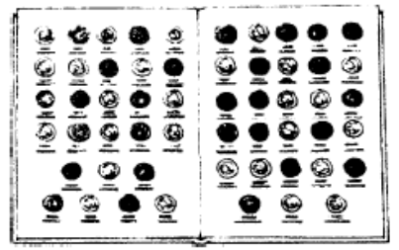
Yeah, I know. It sounds like something for a group of kindergartners. But really, this works too. We've talked before about how difficult it is for people to speak in front of others so you know this helps them warm to the idea. And, believe it or not, this is also a fun thing to do. (I know, because I sat through just the same thing when my son was in Cub Scouts. The boys really enjoyed doing it and the parents and families that "came out to the program" thought it was really neat too. And as I recall, the parents had to bring in and talk about their collections, too.
PACK FAMILY HOBBY DISPLAY
Southern NJ Council
Have a family hobby corner at the pack meeting. Ask each family to bring a sample of what they collect as a family or things that represent their hobby. Families who like baseball can bring baseball equipment, uniform, baseball cards, photos and maybe some trophies. Families who like movies can bring movie posters and movie paraphernalia including popcorn! Families who collect seashells can bring some in a box. It doesn't have to be a "formal" hobby - it's something a family does together. How about a family who buys T-shirts where they go? Set a time during the meeting for families to go around and admire each other's hobby. Family members can take turns staying at the "booth" to explain about the hobby
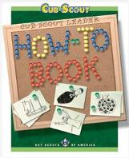
Commissioner Dave
The How To Book has lots of information on collections -
Leaf Collections, p. 4-11
Collecting Rocks and Minerals, p. 4-14
Collecting Seeds, p. 4-6
Collecting Shells, p. 4-16
Collecting Insects, p. 4-17
And an Insect House - p. 4-18
More Ideas:
’09 Baloo’s Bugle Pockets p. 30-36. http://usscouts.org/usscouts/bbugle/bb0908.pdf
’00 Baloo’s Bugle Pockets p. 9-11. http://usscouts.org/usscouts/bbugle/bb0008.pdf
’04 Baloo’s Bugle “Cub Scout Collectors” p.11-13. http://usscouts.org/usscouts/bbugle/bb0410.pdf
Crafts
Collection Box:
Paint an egg carton. Decorate with ribbon, stickers, and markers if desired. Store tie slides, seashells, rocks, etc. in the box.
Leaf Collection Book:
Using an iron, press fall leaves between 2 sheets of wax paper. (Protect iron by putting clean paper beneath and on top of the wax paper sheets.) Assemble into a book.
Felt Patch Holder:
Tacky glue ribbon to the two long edges, and one short edge of a felt rectangle. Wrap the un-ribboned edge around a hanger, and hot glue. Pin patches onto the felt. (Variation of design under Ach. #6b in the Wolf Book.) The beauty of this patch holder is that it can hang in a closet.
Snacks
Chocolate-Peanut Butter S’mores Fondue
Sam Houston Area Council
What are S'Mores but a collection of some of our
very favorite things to eat?? CD
Ingredients –
½ cup milk
1 2/3 cup (11 oz pkg) peanut butter and milk chocolate morsels
1 jar (7 oz) marshmallow crème
1 cup graham cracker crumbs
8 Granny Smith apples, cored and sliced
Directions –
- Heat milk in medium, heavy-duty saucepan over medium-high heat until hot (do not boil).
- Reduce heat to low.
- Add morsels; stir until smooth.
- Whisk in marshmallow crème until smooth.
- Remove from heat.
- Pour chocolate mixture into fondue pot or serving bowl.
- Place graham cracker crumbs in a separate serving bowl.
- Dip apple slices in to warm chocolate mixture, and then into graham cracker crumbs.

Conservation Ideas
Science Articles (conservation stories for Ach. #7e):
http://www.sciencenewsforkids.org/pages/search.asp?catid=7
http://kids.nationalgeographic.com/kids/

Games
’04 Baloo’s Bugle “Cubservation” p. 16-17. http://usscouts.org/usscouts/bbugle/bb0403.pdf
1999 Santa Clara Pow Wow Book “Pollution Solution” p. 6-7; 16-17. http://www.macscouter.com/CubScouts/PowWow99/SCCC/April99.pdf
’01 Baloo’s Bugle “Save it for Us” p. 13-15. http://usscouts.org/usscouts/bbugle/bb0103.pdf
’01 Santa Clara Pow Wow Book “Save it for Us” p. 6; 11; 16-17. http://www.macscouter.com/CubScouts/PowWow01/April01.pdf
A fun and painless way to accomplish Ach. #7c is to divide the boys into teams, and give them a pile of household garbage to sort into trash, recycling , and compost bins. Award points for correct answers. Team with the most points wins.
Crafts & Activities
’04 Baloo’s Bugle “Cubservation” p. 10. http://usscouts.org/usscouts/bbugle/bb0403.pdf
1999 Santa Clara Pow Wow Book “Pollution Solution” p. 19-26. http://www.macscouter.com/CubScouts/PowWow99/SCCC/April99.pdf
’01 Baloo’s Bugle “Save it for Us” p. 6-10. http://usscouts.org/usscouts/bbugle/bb0103.pdf
’01 Santa Clara Pow Wow Book “Save it for Us” p. 21-25.. http://www.macscouter.com/CubScouts/PowWow01/April01.pdf
Snacks
’04 Baloo’s Bugle “Cubservation” p. 19-21. http://usscouts.org/usscouts/bbugle/bb0403.pdf
’01 Baloo’s Bugle “Save it for Us” p. 17.
’01 Santa Clara “Save it for Us” p. 26.
Hamburger Tie Slide
Wendy, Chief Seattle Council
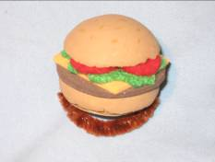
Cut a 2” Styrofoam ball in half. Cut the half Styrofoam ball in half again, to make the bun. Paint the top and sides of the bun light brown, using 2-3 coats of paint. Dabbing the paint on works better than using a stroking motion. To make the hamburger patty, cut a circle out of dark brown craft foam or felt that is a little bigger than the bottom half of the bun. To make the cheese slice, cut a square out of orange craft foam that is the same diagonal width as the hamburger patty. For the lettuce, cut a circular shape out of light green felt. Cut a wavy edge around the circle so that it will expose the corners of the cheese underneath. To make the tomatoes, cut small circles out of red felt.
Assembly: Stack the hamburger fixings on top of each other, gluing down each layer using tacky glue, and making sure that the top layers are positioned so that they expose the bottom layers. Suggested order: bottom hamburger bun, cheese, lettuce, tomatoes, top hamburger bun.
Cut a circle out of corrugated cardboard that is a little smaller than the hamburger. Push a bamboo skewer through one of the center ribs of the cardboard circle to enlarge the hole. Push 1/3 of a chenille stem (pipe cleaner) through the enlarged rib. Glue the cardboard circle to the back of the hamburger. Make sure the ribs run horizontally. Wrap the ends of the chenille stem around each other to make a ring. Use pliers to flatten any protruding wire ends.
Collection Ideas
Games
’09 Baloo’s Bugle Pockets p.12-13; 37-39. http://usscouts.org/usscouts/bbugle/bb0008.pdf
’00 Santa Clara Pow Wow Book “Getting to Know You” p.1;4. http://www.macscouter.com/CubScouts/PowWow00/Sept00.pdf
’04 Baloo’s Bugle “Cub Scout Collectors” p.15-16. http://usscouts.org/usscouts/bbugle/bb0410.pdf
Marble Roll Relay: http://familyfun.go.com/games/indoor-outdoor-games/game/ff1107-roll-out-the-marble/
Activities
’09 Baloo’s Bugle Pockets p.30-36. http://usscouts.org/usscouts/bbugle/bb0008.pdf
’00 Baloo’s Bugle Pockets p. 9-11. http://usscouts.org/usscouts/bbugle/bb0008.pdf
’04 Baloo’s Bugle “Cub Scout Collectors” p.11-13. http://usscouts.org/usscouts/bbugle/bb0410.pdf
Crafts
Collection Box: Paint an egg carton. Decorate with ribbon, stickers, and markers if desired. Store tie slides, seashells, rocks, etc. in the box.
Leaf Collection Book: Using an iron, press fall leaves between 2 sheets of wax paper. (Protect iron by putting clean paper beneath and on top of the wax paper sheets.) Assemble into a book.
Felt Patch Holder: Tacky glue ribbon to the two long edges, and one short edge of a felt rectangle. Wrap the un-ribboned edge around a hanger, and hot glue. Pin patches onto the felt. (Variation of design under Ach. #6b in the Wolf Book.) The beauty of this patch holder is that it can hang in a closet.
’09 Baloo’s Bugle Pockets p. 39-41.
Aluminum Foil Picture Frames
Cut a picture frame out of corrugated cardboard. Draw simple shapes on a thin cardboard box (like a cereal box), and cut out. Glue the shapes to the frame. Draw designs on the frame using a thick bead of white glue. (Boys might want to draw designs first using a pencil, then go over the design with white glue.) You can also experiment with adding more texture by cutting shapes out of corrugated cardboard and removing the paper from one side; punching holes in the thin cardboard shapes; or gluing mesh cut from vegetable/fruit bags to the shapes.
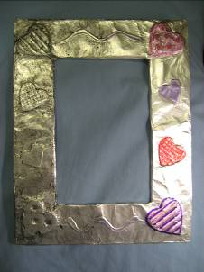
When the glue is completely dry, cover the frame with aluminum foil. (White glue designs will take several hours to dry completely.) Using your fingers, push the foil tightly around the shapes. Rub the foil covering the textured shapes with your fingers to create an embossed metal look.
To decorate the frames, choose one of the following methods: 1. Using a paper towel, dab black acrylic paint on the foil, and let it sit for a few minutes. Then lightly wipe some of the paint off to create an antique silver look. 2. Color the frame using permanent markers.
Glue a triangle cut from a thin card board box to the back of the picture frame so the frame will stand up.
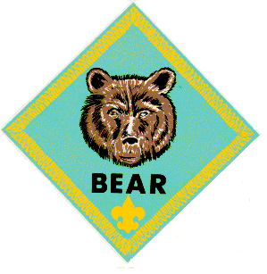

BEAR

Bear Ideas by Felicia
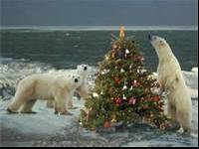

Core Value - Respect
Theme – Holiday Lights

Bear Achievements:
HA = Home Assignment
Meeting Plan #10
Verify: Achievement 13a–g (any four)
Do: Achievement 15a–c
HA: Achievement 6a
Meeting # 11
Verify: Achievement 6a
Do: Achievements 8a, 17b, and 17c
HA: Achievement 17a and 17d if not completed
Meeting # 12
Verify: Achievement 17a and 17d if not completed
Do: Achievement 5a–c and 5e and
Wildlife Conservation belt loop (optional)
HA: Achievements 5d and 6d–f
Den Meeting Plan 10
Achievement 13 Saving well Spending Well
Ach. #13a go grocery shopping 
Take in sales ads & compare prices.

13c keep a spending record. Here is a chart you can give the boys, it can be found at: http://www.sparkpeople.com/resource/wellness_articles.asp?id=1130
Date | Place | What did I buy? | Category/Reason | Amount $



13d shop for a car. Take in car sales flyers and have the boys pretend to shop for vehicles. If you have small toy cars: take them in for the boys to look for the larger versions in the flyers. You can let the boys race the cars after you’re done.
13f play a board game with toy money. Take in: Life, Monopoly, Monopoly Jr., Payday, Money Wise Kids, Money bags, easy Money, Budget, or any other money game you have at home, can borrow from a friend, or can find. Or better yet – see if one of your scouts has a money game to bring in & share to get credit for Achievement 15c.
13g figure out how much it costs for 1 person to eat a meal at home. Take in grocery ads, have the boys select a reasonable meal from the products shown. Add up the prices for those items. Try to determine how many it would feed. Divide your total costs of the meal by the # it feeds to get your cost per person.
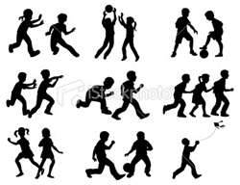
Achievement 15 – Games, Games, Games!
15a play 2 outdoor games. Do you have access to a gym – where you can play indoors? If not, can you go outdoors? Before this meeting; make sure your den knows to dress appropriately for the weather. If the weather is safe to go out – try to figure out which games you can play. If it is snowy – Is there a park or a yard where the kids could play these games? Remember many of these boys would enjoy stomping the snow down to make their play area.
Here is a plan for making a mini-golf course in the snow. http://familyfun.go.com/crafts/crafts-by-type/dolls-toys/outdoor-crafts/snowgusta-mini-golf-665565/
If all you have are muddy messy areas or wet nasty weather – & you do not want to put this assignment off until Mother Nature cooperates. Another option is to adapt the Backyard Games to be done in Indoor spaces. Here are some suggestions from Wendy, Chief Seattle Council
Balloon Badminton: (Bear Ach. #15a, Ach. #23b, c)
- Cut a piece of corrugated cardboard into a rectangle 6” by 1 ½’, making sure the ribs of the cardboard run the long way.
- Roll up the cardboard width wise to create the 1 ½’ long handle for the racquet.
- Duct tape, hot glue, or tacky glue the edge of the cardboard. (You may need to use rubber bands to keep the cardboard from unrolling while the glue dries.)
- Decorate a paper plate.
- Tacky glue the decorated plate to a 2nd paper plate, with the decorated plate on top.
- Using a nail, punch holes in the paper plate, & enlarge the holes with a pencil. (The holes reduce wind drag.)
- Tacky glue the plates to the cardboard handle.
- find a way to fasten a long string across the middle of the playing area, a little above the boys’ heads for a net. (Or have 2 leaders hold the string.)
- Use a balloon for the shuttlecock.

The boys play badminton, batting the balloon back & forth over the string.

Scout Volleyball
Materials: Beach ball, net
Divide the den into 2 teams. This game is played with standard volleyball rules, but with a beach ball. Instead of scoring points, the teams are awarded with letters spelling out SCOUT. The first team to spell SCOUT wins.
Backyard Golf
Materials: Make 9 holes from stiff cardboard (see directions below)
Hole 1. Place several cans, weighted with sand, in precarious positions midway between the tee position & the hole.
Hole 2. Arrange 2 arches of folded cardboard through which the ball must pass.
Hole 3. Make a ramp across a water filled pan for the ball to travel across. If the ball goes in the water, the golfer must place the ball in front of the ramp and try again. Each stroke counts toward the total score.
Hole 4. With string, suspend a hoop from a low branch of a tree. The hoop should just be touching the ground. As a player tees off, spin the hoop. The ball must go through the hoop.
Hole 5. Remove both ends of 3 large cans. Tie or tape them together. The ball must go through one of the cans.
Hole 6. Lay 1-in. wooden strips across the course at 2- to 3-ft. intervals. The ball must leap all three strips.
Hole 7. Make 9 arches from coat hangers. Set up in groups of 3. The ball must go through 2 arches.
Hole 8. To form a right angle turn in the course, nail 2 lengths of wood together. Place a piece of rubber hose or similar object in front of the hole. Ball must follow the course.
Hole 9. Cut an opening on 2 sides of large cardboard box. Add a shoebox ramp over which the ball must go.

Den Meeting Plan 11
Achievement 17 Information Please.
Achievement #8a & #17c Visit a newspaper office & you can satisfy both of these.
Den Meeting Plan 12
Achievement 5 Sharing your world with wildlife.
5b bird feeders
Bird's Miracle Meal from the Heart of America Council

This mixture will attract all the suet-eating birds - woodpeckers, chickadees, titmice.
Place in a large mixing bowl:
1 C. flour
3 C. yellow cornmeal Add:
2 C. melted suet (or lard, but not shortening or fat)
1 C. melted peanut butter
Optional - chopped raisins or nuts.
Mix well.
Chill the mixture until it is thick enough to handle.
The leftover mixture will keep in the freezer until you are ready to use it.
Miracle Meal Birdfeeders:
A. 1. Spread the mixture into pans until it is about 1" thick.
2. Chill until hard.
3. Cut into pieces.
4. Place a piece inside a net bag (such as oranges or onions come in), tie it closed & mount it against a tree trunk.
B. 1. Cut a 6 to 12" piece from a small log.
2. Drill some shallow holes in the log & set a screw eye in the top.
3. Press the soft mixture into the holes & hang the log from a tree branch.
C. Force the soft mixture into existing holes or forks on a tree.
Hang it up high enough, because the smell of the peanut butter will be attractive to your dog as well!

Easy Birdhouse to Make
Materials:
Empty paper half-gallon mild carton
Stapler
Sharp pencil
Wire coat hanger
Acrylic paint
Instructions:
- Get an empty cardboard half-gallon milk carton. Open up the top of the carton, wash & rinse it thoroughly. Let it dry.
- Re-close the milk carton & staple it shut.
- Decide what type of bird you want to use the birdhouse. Look at birdhouse specs, & determine how large a hole to cut, as well as how far from the floor the hole should be. Cut the entrance hole in the birdhouse.
- Using a pencil, make several holes in the bottom of the carton for any rain to drain out. Also make several holes in the top of the carton to let heat & condensation escape.
- Paint birdhouse & allow to dry
- Make a hole through the top of the house near the staples. Put a short piece of wire (perhaps from a clothes hanger?) through the hole to make a loop.
- Hang the birdhouse on a shepherd's hook or a tree branch.
½ gallon Milk Carton Dimensions: 3 3/4" x 3 3/4" x 9 1/2"
Bird House Specifications
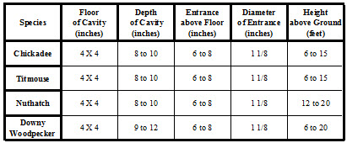
Find bird house Specifications here:
http://www.npwrc.usgs.gov/resource/birds/birdhous/specs.htm
http://www.littlechickadee.com/BIRDHOUSE-SPECS.HTM
http://www.sialis.org/nestboxguide.htm
Information on birds & their nesting preferences can be found at http://birdhouses101.com/
Keep it up:
Individuals or group blow on a feather. The object is to keep it up in the air as long as possible. For more of a challenge, use 2 or more feathers.
More info:
http://www.nbc.com/minute-to-win-it/how-to/keep-it-up/
http://www.nbc.com/minute-to-win-it/how-to/
Achievement 5e
Extinct animals no longer exist & are no longer living.

Lists extinct animals can be found at: http://en.wikipedia.org/wiki/List_of_extinct_animals
http://extinctanimal.com/
http://www.buzzle.com/articles/extinct-animals-list.html

Endangered species are at risk of extinction. They are near no longer existing on this planet.
Lists of endangered species can be found at:
http://earthsendangered.com/
http://en.wikipedia.org/wiki/List_of_endangered_animal_species
http://www.fws.gov/endangered/
Food Chain
A food chain is the sequence of what eats what in a biological community (an ecosystem).
Information on food chains can be found at the following web sites:
http://www.enchantedlearning.com/subjects/foodchain/
http://www.brainpopjr.com/science/animals/foodchain/grownups.weml
http://www.scribd.com/doc/19051800/All-About-Food-Chains-for-Kids
http://www.playlearnschool.com/Science/1/Food-Chain/Food-Chain.aspx
A short video on Food Chains http://magma.nationalgeographic.com/ngexplorer/0309/quickflicks/
Wildlife Conservation Belt Loop
- Explain what natural resources are & why it's important to protect & conserve them.
- Make a poster that shows and explains the food chain. Describe to your den what happens if the food chain becomes broken or damaged.
- Learn about an endangered species. Make a report to your den that includes a picture, how the species came to be endangered, and what is being done to save it.
Natural resources occur naturally within environments that exist relatively undisturbed by mankind, in a natural form. More information can be found at
http://www.epa.gov/students/
http://www.neok12.com/Natural-Resources.htm
http://dnr.wi.gov/
http://www.earthrangers.com/
http://en.wikipedia.org/wiki/Natural_resource
http://www.nrcs.usda.gov/wps/portal/nrcs/main/national/home

Jokes:

What money do you use under the sea?
Sand Dollars.
Why did the man put his money in the freezer?
He wanted cold hard cash!
Where do snowmen keep their money?
In snow banks!
Why do the Irish keep their money in banks?
Because it’s Dublin!
When does it rain money?
When there’s a change in the weather!
Why is money called dough?
Because we all knead it!
Why did the coach go to the bank?
To get his quarter back.
Why was the computer good at golf?
Because of its hard drive.
Which sport is always in trouble?
Bad-minton.
What’s harder to catch the faster you run?
You’re breath.
What’s a golfer’s favorite letter?
Tee.
Why did the golfer wear 2 pairs of pants?
In case he got a whole in one.
What’s black ,white, and read all over?
The newspaper.
John: I lost my pet.
Ron: Why don't you put an ad in the newspaper?
John: What good would that do, she can't read!
When is the best time to buy budgies ?
When they're going cheap
What do you call a very rude bird ?
A mockingbird
What did the bird say to the sugar cube?
Sweet sweet!
What do you get when dinosaurs crash their cars ?
Tyrannosaurus wrecks!
Why did the dinosaurs go extinct?
Because they wouldn't take a bath !
What kind of dinosaur can you ride in a rodeo?
A Bronco-saurus!
What do you get when you cross a dinosaur with fireworks?
DINOMITE!
What do you call a dinosaur who is elected to Congress?
Rep. Tile! (That is short Representative not a political party)
How does the gingerbread man make his bed?
With cookie sheets!
What do elves do after school?
Gnomework!
What do elves learn in school?
The elfabet!
What is the best Christmas present in the world?
A broken drum….. u can’t beat it!
Songs
If I Were Not a Boy Scout
Tune: This is the Music Concert
If I were not a Boy Scout, I wonder what I'd be
If I were not a Boy Scout, a ......

A bird watcher I'd be
Hark a lark, flying through the park, SPLAT!
A plumber I would be
Plunge it, flush it, look out below!
A teacher I would be
Sit down, shut up, throw away your gum!
An electrician I would be
Positive, negative bbzzzzt zap
A politician I would be
Raise the taxes, lower the pay, vote for me on election day!
Superman I would be
It's a bird, it's a plane, where is Lois Lane?
A Lawyer I would be,
Honest. I swear, My client wasn't there
A Ranger I would be,
Get eaten by a bear, see if I care.
A Scoutmaster I would be ,
Do this, do that, I'm gonna take a nap.
Finally: A Girl Scout I would be!

To hear this song:
http://www.youtube.com/watch?v=in5VyDj_H2w&feature=related
http://www.youtube.com/watch?v=gSD7pOmkMYo&feature=related
http://www.youtube.com/watch?v=OJSD9qulbuo&feature=related

The Green Grass Grew All Around
There was a hole,
There was a hole,
In the middle of the ground,
In the middle of the ground,
Prettiest little hole,
Prettiest little hole,
That you ever did see,
That you ever did see,
OOOOOH
The holes in the ground and the green grass grew all around all around and the green grass grew all around

2. and in that hole...there was some dirt
3. and in that dirt...there were some roots
4. and on those roots...there was a tree
5. and on that tree...there was a limb
6. and on that limb...there was a branch
7. and on that branch...there was a nest
8. and in that nest...there was an egg
9. and in that egg...there was a bird
10. and on that bird...there was a wing
11. and on that wing...there was a feather
12. and on that feather...there was a flea
13. and on that flea...there was a mite

To hear this song:
http://www.youtube.com/watch?v=AkAOeIMypg8&feature=related
http://www.youtube.com/watch?v=izsFt76fNfw

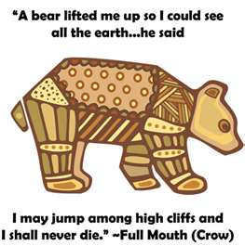

WEBELOS DENS

Joe Trovato,
WEBELOS RT Break Out Coordinator
Westchester-Putnam Council
Have a question or comment for Joe??
Write him at
madyson54@hotmail.com

Since its origin, the Scouting program has been an educational experience concerned with values. In 1910, the first activities for Scouts were designed to build character, physical fitness, practical skills, and service. These elements were part of the original Cub Scout program and continue to be part of Cub Scouting today
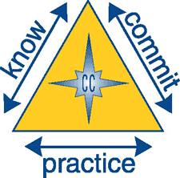

Core Value for December
Respect
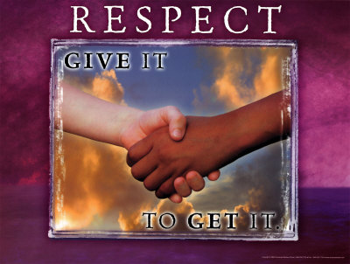
RESPECT is something that you show towards others regarding their feelings. You RESPECT others when you show them you care, you listen to what they have to say, and use manners when you deal with them.
“Respect for ourselves guides our morals; respect for others guides our manners.”
― Laurence Stern
Laurence Sterne was an Irish-born English novelist and an Anglican clergyman. He is best known for his novels The Life and Opinions of Tristram Shandy, Gentleman, and A Sentimental Journey Through France and Italy; but he also published many sermons, wrote memoirs, and was involved in local politics. Sterne died in London after years of fighting consumption.
See also http://en.wikipedia.org/wiki/Laurence_Sterne
Earning the Respect of Others?
Excerpt from a larger piece written by Tracy O Connor at www.pickthebrain.com
While it’s true that every human being is born inherently worthy of being treated with respect, there are some who stand out from the crowd and earn an extra portion. It could be because of their accomplishments, natural abilities, heroism or beauty.
You don’t have to be world renowned to gain increased respect. In our smaller circles there are those that others look up to more. It is within your power to become one of those people that others regard with an extra portion of respect. Here are some ways:
- Carry yourself with confidence. It’s true, we often teach people how to treat us and when we project an air of confidence, people see us as successful.
- Treat everyone with kindness and dignity.
- However, set boundaries and don’t let others see you as a pushover.
- Act with integrity.
- Learn to cope with stress in a cool, calm manner.
- Laugh and smile often.
- Be generous.
- Step up to the plate when things need to be done.
- Speak your mind.
- Look out for those who are helpless.
- Be firm but fair.
- Accept criticism with grace and an open mind.
- Resist the urge to be defensive.
- Admit your weaknesses.
- Take pride in your accomplishments.
- Put your heart into all that you do.
Human beings crave the respect of others; it’s coded into our DNA. When we feel like nobody respects us, it’s difficult for us to be positive and productive. When we don’t respect ourselves, we act in ways that our counter to our interests in an attempt to make ourselves feel better.
Cultivating self-respect and earning the respect of others goes a long way toward leading a balanced, healthy, happy life.
Complete the Character Connection for Respect.
- Know- Tell what interested you most when completing the requirements for this activity badge. Tell what you learned about how you can show appreciation and respect for wildlife.
- Commit- Tell things some people have done that show a lack of respect for wildlife. Name ways you will show respect for and protect wildlife.
- Practice- Explain how completing the requirements for this activity badge give you the opportunity to show respect.
Respect Games

Say Something Nice
Get all group members to sit in a large circle, and give each one a sheet of paper. Have each person write his name at the top of the page, and pass the sheet around the group. At the bottom of the paper, each person writes one thing he values about the person, whose name is on the sheet, folds it so the next person cannot see what he has written, and passes it on. This continues until everyone receives back the sheet with their name on it. Have each person silently read what others have written, and encourage them to preserve this list and look at it any time they feel their self-respect or confidence go down.
Different, Yet Same
Create groups of five people and give each group two sheets of paper. On one sheet, ask the group to list something the entire group has in common, other than traits that they can see, such as all having hair. On the other sheet of paper, ask the group to list at least two unique qualities of each person in the group. Again, it should not be something which is obvious or that everyone can see, but a characteristic. This activity serves to create respect as people realize their commonalities, learn something new about each other, and focus on their uniqueness.
Read more: Group Games That Teach Respect | eHow.com http://www.ehow.com/info_8142941_group-games-teach-respect.html#ixzz29hpHrVo4

Book Corner
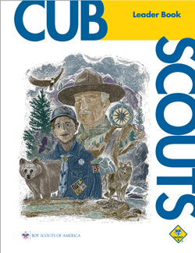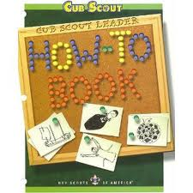
From the Cub Scout Leader Book:
How to Show Respect
- Treat other people as you would like to be treated.
- Don’t insult or bully people who are different from you.
- Be courteous; use good manners and good language.
- Take care of school and public property.
- Honor the country’s flag, laws, and public officials.
- Appreciate the religions of other people.
- Obey the rules and instructions of adults.
- Use dangerous objects (e.g. knives, fire) with care.
- Respect others without necessarily agreeing with all of their ideas.
- Treat the environment (trees, rives, land, air) with care.
- Have confidence in your abilities.
- Keep yourself neat and clean.
- Stay in shape.
(CS How To Book, Page 4-5)
You can find a copy of the
Cub Scout Leader Book at
http://www.scouting.org/filestore/hispanic/english/33221_WEB.pdf
From the How-To Book
Showing respect extends not only to people we deal with, but also to nature. The following ceremony can be used to focus on respecting the world around us.
Outdoor Code
Responsive Reading Ceremony
Equipment: U.S. flag, copy of the Outdoor Code for each participant
The Cubmaster(CM) speaks briefly about the importance to our nation of taking good care of our natural resources and then uses the Outdoor Code as a responsive reading, with boys (and parents, if present, and everyone in the audience) reading the responses.
CM: As an American, I will do my best to be clean in my outdoor manners—
BOYS: I will treat the outdoors as a heritage. I will take care of it for myself and others. I will keep my trash and garbage out of lakes, streams, fields, woods, and roadways.
CM: Be careful with fire—
BOYS: I will prevent wildfire. I will build my fires only where they are appropriate. When I have finished using fire, I will make sure it is cold-out. I will leave a clean fire ring or remove all evidence of my fire.
CM: Be considerate in the outdoors—
BOYS I will treat public and private property with respect. I will use low-impact methods of hiking and camping.
CM: Be conservation-minded—
BOYS: I will learn how to practice good conservation of soil, waters, forests, minerals, grasslands, wildlife, and energy. I will urge others to do the same.
CM: Let us close by singing
“God Bless America.”
(CS How To Book, page 6-13)
You can find a copy of the How-To Book at
http://www.scouting.org/filestore/hispanic/english/33832_WEB.pdf

Roundtable Webelos Break Out
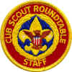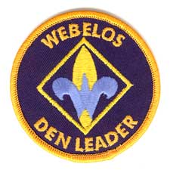
Youth Leadership
Webelos Scouts have reached the top rung of cub scouting. They are old hands and want to do more. Leadership skills are something that should be taught and practices, which will help them when they cross over to Boy Scouts. Make sure you use the Denner and Assistant Denner positions to help them learn to lead others.
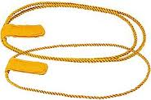
The Webelos Denner is a role that is intended to teach leadership skills. The responsibility is given to a den member as assigned by the Den Leader. Each month, a new Denner is selected. The Denner is easily recognized as he will be wearing a special Denner shoulder cord. (Left Shoulder)
His responsibilities are determined by the Den and Pack leader and will include:
Den Meetings:
- Lead Flag and Pledge of Allegiance ceremony
- Assist Den Leader with Den activities
- Hold the Flag
Pack Meetings:
- Assist with gathering activity
- Lead Den in skit (if part of meeting)
- Assist Cubmaster to pass out achievements to Den
Go See It/Pack Events:
- Set a good example for scouting behavior
- Inform other scouts of what they should be doing and where they should be going.
In General, the purpose of this role is to build leaders so Den Leaders should encourage and promote this role.
The Assistant Denner assists the Denner at den meetings and fills in for the Denner when the Denner is not available. The Den Leader may establish a practice of the Assistant Denner becoming the Denner in the next term. This way the Assistant Denner can watch and learn from the Denner so that he will be ready for the next term. Using this approach, the Assistant Denner is elected each month to become the Denner the next month.
The Assistant Denner wears the gold single-strand Assistant Denner shoulder cord over his left shoulder.

Denner Installation Ceremony
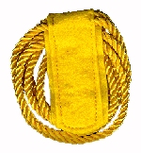

Leader (to Outgoing Denners): Thank you for your leadership and service to our den. Please remove your denner cords.
Leader to New Denners: You have been chosen to be leaders in our den. As Denner and Assistant Denner you will be responsible for tasks such as assisting in ceremonies and activities, leading songs and cheers, and helping with set-up and clean-up. During this month you will set a good example for the other members of our den by being honest, fair, polite, helpful, responsible, and loyal to the Cub Scout pledge.
Do you accept these responsibilities?
Denners: I will do my best.
Leader (to New Denners): I am happy to present to you the denner and assistant denner cords, which are to be worn on your left sleeve during your term of office. Wear it proudly and with honor.
Congratulations.
Leader shakes hands with new denner, using the Cub Sscout handshake. Denner passes handshake to assistant denner, who passes it to another cub … (continue down the line).

Meeting Planner

This month’s meeting plans for the Webelos Den (Webelos I, First Year Webelos) calls for them to work on the Citizen and Artist activity badges, and complete the Webelos Badge (subject to three month membership requirement).
Meeting 7:
- Do: Citizen 2–7 & 9
- HA: Webelos Requirement 8. Review Artist chapter
For the recommended agenda for Webelos Den Meeting #7
go to:
http://www.scouting.org/filestore/CubScoutMeetingGuide/webelos/WebelosMeeting7.pdf
Meeting 8:
- Verify: Citizen 8 (Citizenship belt loop 3),
Webelos 1–8
- Do: Citizen (make up) Webelos Review (make up) Artist 1, 4, 7, 9
- HA: Review Geologist chapter.
For the recommended agenda for Webelos Den Meeting #8
go to:
http://www.scouting.org/filestore/CubScoutMeetingGuide/webelos/WebelosMeeting8.pdf
This month’s meeting plans for the Arrow of Light Den (Second Year Webelos, Webelos II) work on Readyman
Meeting 7:
- Do: Readyman 1–3, 11, 13
- HA: Review Readyman chapter. Readyman 3, 11
For the recommended agenda for the Arrow of Light Den Meeting #7 go to:
http://www.scouting.org/filestore/CubScoutMeetingGuide/ArrowofLight/ArrowofLightMeeting7.pdf
Meeting 8:
- Verify: Readyman 3, 11
- Do: Readyman 4–7
- HA: Review Readyman chapter
For the recommended agenda for the Arrow of Light Den Meeting #8 go to:
http://www.scouting.org/filestore/CubScoutMeetingGuide/ArrowofLight/ArrowofLightMeeting8.pdf

Flag Ceremony
National Bill of Rights Day
December 15, 2012
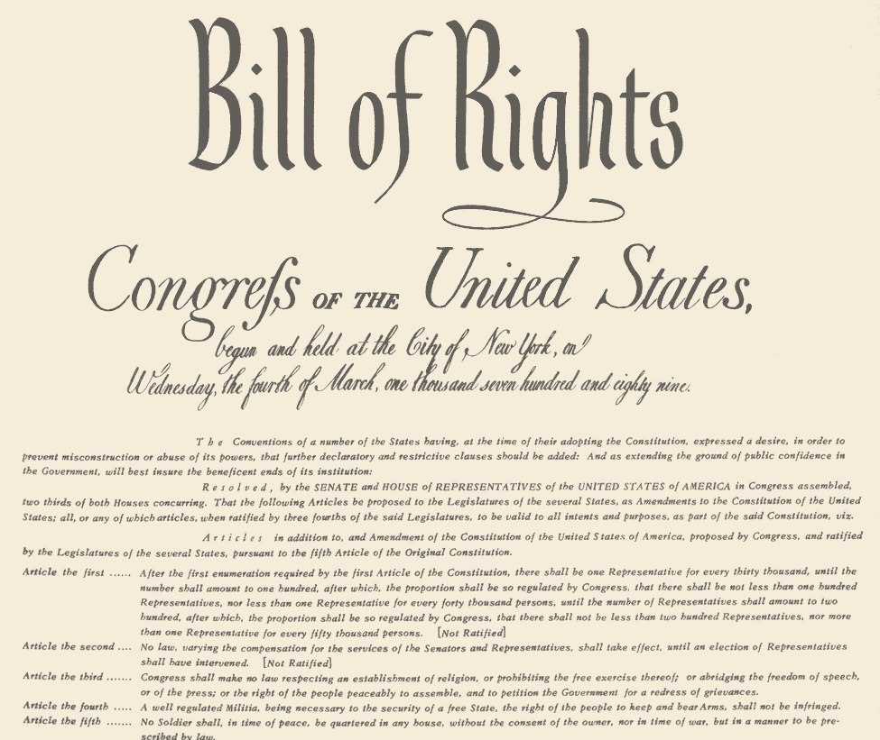
On December 15th, 1791, the Bill of Rights was ratified by three-quarters of the States, giving us the first 10 amendments of the U.S. Constitution. This is a day to honor those certain inalienable rights like freedom of press and a speedy trial by jury

December Flag Ceremony
http://www.wvsd.uscourts.gov/outreach/Pledge.htm

Follow your standard Color Guard process (see prior Baloo’s Bugles for samples). After the Cub Scout Promise (or Boy Scout Law, and Oath, if this is a Webelos Den meeting) and before posting the U.S. Flag you may insert the following:
Reader 1: December 15 is the national Bill of Rights Day. On this day, we remember and renew our appreciation for the liberties given to us by the first 10 amendments to the Constitution.
Reader 2: The Constitution did not mention these liberties, because they were thought to be inherent – which means they were rights everyone has. People were concerned and wanted them written so that there was no doubt. Its principles emanated from the experience and expectations of the broad majority of the public. James Madison pledged to work in the new Congress to pass a Bill of Rights.
Reader 3: When the first Congress met in 1789, Madison kept his promise, introducing 17 amendments in the House, The ten that the states approved became the Bill of Rights.
Reader 4: Freedom of Speech, Freedom of Religion and other freedoms we enjoy today, we owe to the Bill of Rights.
Reader 5: Let us all recite the Pledge of Allegiance.

Den Meeting Helpers
These activities can be used for the gathering or to reinforce/satisfy badge requirements.

Webelos Den


CITIZEN
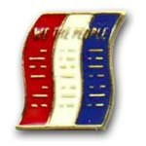
Objectives
- To foster citizenship in WEBELOS Scouts.
- To teach boys to recognize the qualities of a good citizen.
- To introduce boys to the structure of the U.S. government.
- To familiarize boys with basics of American history.
- To convince boys that laws are beneficial.
- To encourage WEBELOS Scouts to become community volunteers.
Ideas for Den Activities
- Pretend that your den is starting a new government.
- Have the boys make their own flag.
- Learn more about your community.
- Teach the Wolf and Bear dens how to do a flag ceremony.
- Plan and make a display on citizenship for Pack meeting.
- Invite a highway patrolman or policeman to come to your den and talk about being good citizens.
- Invite a new American citizen to come and talk to the den about his or her experiences in becoming a United States’ citizen.
More on the Bill of Rights
http://bensguide.gpo.gov/9-2/citizenship/rights.html

When the Constitution was ratified in 1787, many people were concerned that it did not protect certain freedoms. They thought that the Constitution should be changed or amended to protect these freedoms. On December 15, 1791, ten amendments were added to the Constitution. The first eight amendments set out or enumerate the substantive and procedural individual rights associated with that description. The 9th and 10th amendments are general rules of interpretation of the relationship among the people, the State governments, and the Federal Government. These amendments guarantee certain freedoms and rights, so they are known as the Bill of Rights.
Early History of the U.S. Flag
Santa Clara Council
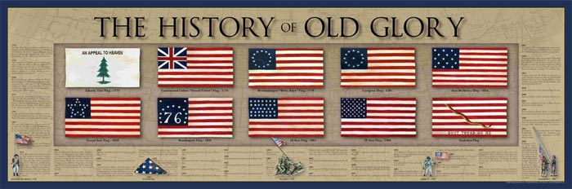
Many different flags have represented the United States at one time or another. But all the flags and what they represent led up to the current flag, which was adopted in 1960 with the addition of a star representing the state of Hawaii, the nation’s 50th state.
The Grand Union Flag (also known as the Continental flag) was the first flag chosen by George Washington to be flown at the commemoration of the Continental Army on New Year’s Day, 1776. It is a combination of the British King’s Colors and the thirteen stripes signifying colonial unity.
Betsy Ross, a seamstress from Pennsylvania, has been credited with creating the first Stars and Bars, though some people question whether she did or not. As the legend goes, George Washington appeared on Mrs. Ross’ doorstep in June of 1776 with two representatives of Congress.
They asked that she make a flag according to a rough drawing they carried with them. At Mrs. Ross’ suggestion, Washington redrew the flag design in pencil in her back parlor to employ the stars of five points instead of six points.
Since there was no official flag during the first year of the United States, there were a great number of designs. The Betsy Ross Flag is the most well-known of those, but the United States did not choose its first official flag until June 14, 1777 with the passing of the first Flag Act.
This 13-Star flag became the Official United States Flag on June 14, 1777 – which is why we celebrate Flag Day as June 14th every year. The only president to serve under this flag was George Washington. It was our official flag for 18 years.
Each star and stripe represented the 13 Colonies, which were united in 1776 by the Declaration of Independence.
When Vermont (the 14th State in 1791) and Kentucky (the 15th State in 1792) joined the United States, a new flag was needed. Two stars and two stripes were added and the Star Spangled Banner became the new Official United States Flag in 1795. It had 15 stars and 15 stripes – the only flag to have more than 15 stripes. It was flying in 1814 over Fort McHenry when Francis Scott Key wrote our National Anthem.
In 1818, Congress decided that it wasn’t practical to add a new stripe for each new State, and so they passed the Flag Act of 1818 that made the flag have 13 stripes and they specified that a new star would be added for each state. This is the standard that is still used today.
Citizenship Games
Newspaper Study Game

Equipment: One current newspaper per team of two Scouts
Teams gather in groups, each with the same day's issue of a newspaper. On signal, teams start a search for news items that definitely illustrate the Bill of Rights. Items are cut out and numbered according to the amendment. Team with the most clippings in a given time wins.
Strategy Tip: Team leaders should distribute pages among his team members instead of everyone grabbing for papers.
Citizen Scavenger Hunt

Most government buildings offer a tour of some sort and you might be able to combine the tour with the following scavenger hunt. Divide the den into two or three teams and give the boys a reasonable time limit. Have them locate answers to questions like these:
- What is the mayor's middle initial and what does the initial stand for?
- Bring back a piece of stationery showing our town's logo or crest.
- Draw a picture of our state flag.
- On what floor of City Hall can you find _______________?
- Who runs the Water Works Department and what does that department do?
- Where does the City Council meet?
- What's on the top floor of the City Hall building?
- What is the full name of the governor of the state?
- Get a brochure about trash pick up service.
- Who takes care of snow removal/tree removal from city streets and what is their budget?
Build a Flag

Materials needed:
For each team,
1 set of the five US flags shown in Citizen Section of the Webelos handbook. Each flag is to be on a standard letter size sheet of cover stock or paper. This can be done with a color printer, copier or by hand drawing a set of the flags for each team.
When the copies are ready, cut each flag picture into 2 pieces, the stripes and the field of stars. Prepare cards with the name of each flag and year of each flag. A corkboard and pushpins are needed.
Action:
Divide Webelos into two teams.
First boy from each team runs to his team’s pile of pieces, grabs a stripe piece and a push pin and pins it to the corkboard.
He runs back and touches off the second boy, who pins up the star field piece that matches the striping.
Next team member matches appropriate flag name and fourth member pins up the year of the flag. Continue to rotate until all five flags have been properly constructed, named, and dated.
The President, Vice President and Governor

Requirement # 2: - Know the names of the President and Vice-President of the United States. Know the names of the Governor of your state and the head of your local government.
Consider using the web to get information on the President, Vice-President and Governor of your state. It helps provide the Scouts with biographies and additional information on current issues facing these government executives.
The President’s website may be found at http://www.whitehouse.gov/administration/president-obama/
The Vice-President’s website may be found at http://www.whitehouse.gov/administration/vice-president-biden.
There are links to members of the President’s cabinet as well as other agencies of the government. You may find a link to the website of your State’s Governor at http://www.justlawlinks.com/STATE/all-states/acsgovs.htm.
Write A Short Story About A Great American
Requirement #11: - Write a short story of not less than 50 words about a former U.S. president or some other great American. Give a report on this to your Webelos den.
There is a great government website that provides back up information about Americans. “Meet Amazing Americans” provides information on U.S. Presidents, explorers, musicians, inventors and others. It includes a time line and historical events. Check out “America’s Story from America’s Library” at http://www.americaslibrary.gov/index.html.

A Few Great Americans
Thurgood Marshall
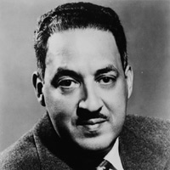
Thurgood Marshall was the first African-American member of the U.S. Supreme Court. He served on the court from 1967 until he retired in 1991. Earlier in his career, Marshall worked as a lawyer for the National Association for the Advancement of Colored People (NAACP) and helped win the 1954 landmark desegregation case, Brown v. Board of Education of Topeka, Kansas. Throughout his life, Marshall used the law to promote civil rights and social justice.
John Adams
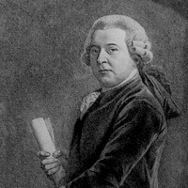
John Adams worked as a teacher and lawyer before dedicating himself to a life of patriotism and politics. He was America's second president. Adams was well known for his extreme political independence, brilliant mind and passionate patriotism. He was a leader in the Continental Congress and an important diplomatic figure, before becoming America's first vice president. Adams then served one term as president but lost the election of 1800 to Thomas Jefferson, his longtime friend and political rival.
Thomas Alva Edison
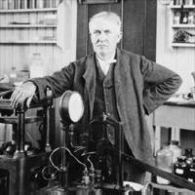
The phonograph and the motion-picture projector were only a few of Thomas Alva Edison's more than 1,000 inventions. One of the most famous inventors in the history of technology, Edison also created the first industrial research laboratory, in Menlo Park, New Jersey, in 1876.
Rights and Duties
Santa Clara Council
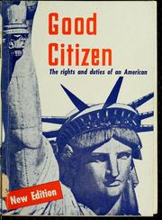
Your Rights As A Citizen:
- The right to equal protection under the law and equal justice in court.
- The right to be free from arbitrary arrest or search.
- The right to equal education and economic opportunity.
- The right to select public offices in free elections.
- The right to own property.
- The right to free speech, press, and assembly.
- The right of religious freedom.
- The right to have a lawyer and a speedy court trial if accused of a crime.
Your Duties As A Citizen:
If you are going to have rights as a citizen and you want to keep them, then you also have certain duties that you must take care of. Your duties as a citizen are:
- Obey the laws.
- Respect the rights of others.
- Keep informed on issues of National and local government.
- To vote in elections.
- To serve and defend your country.
- To assist the agencies of law enforcement.
- To practice and teach good citizenship in your home.

ARTIST

Artist Ideas
Santa Clara Council
Artists have all kinds of talent – and some they don’t even realize. They’ve used paints, crayons, pencils, and clay – all tools of the artist. They mix colors, make designs and make mobiles and sculptures. Webelos Scouts can learn to be artists and have fun while they do it.
- Let the Webelos Scouts realize that they are artists most of the time. Let them try some new things that perhaps they haven’t tried before.
- Invite a local artist or an illustrator to come speak at your den meeting to talk about their career as an artist or illustrator.
- Visit an art museum.
- Have the boys sculpt with a material they may have never used before.
- Have the boys study a color wheel and let them mix some colors.
Snack Food Sculptures
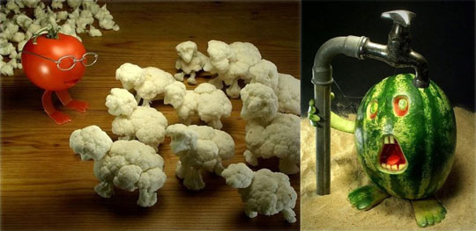
Sculpture materials: Bread sticks, pretzels, potato chips, corn chips, popcorn, crackers, cheese curls, etc.
Paste: Mix three 8-oz packages of softened cream cheese with 8-oz sour cream. Blend in a package of dried onion soup mix.
Each player should have a paper plate and a plastic knife. First lay out a framework for the sculpture. Bread sticks, pretzels, crackers and rippled potato chips are great for this.
You may want to stand bread sticks as a skeleton and add lighter food to it. When you finish your snack-food sculpture, give it a title and display it (briefly). Then the snack food sculptures can be eaten – artfully nibbled into nothingness.
Aluminum Foil Sculptures
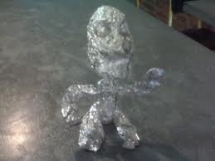
Materials: Plenty of aluminum foil, clear tape, wire, long straight pins, acrylic paint and brushes or permanent markers, scraps of fabric, paper, yarn, glue, etc.
- Crumple aluminum foil to form shapes of objects or creatures, or shape the foil around a wire frame.
- Fasten clumps together with pins, wire or tape.
- Use paint or markers to add color.
- Glue on scraps of fabric, paper, etc to add details.
Colored Concoctions

Let the Webelos Scouts practice mixing colors using different flavors of Kool-Aid in primary colors (add a drop or two of food coloring as needed). Have them make up names for their different “formulas,” design a menu, and serve their concoctions at the pack meeting.
Desired  Color | Drops of Food Coloring
Desired  Color | Red | Yellow | Green | Blue
Orange | 1 | 3
Coral | 3 | 1
Lime green |  | 3 | 1
Chartreuse | 12 | 12 | 1
Aqua |  |  | 2 | 4
Turquoise |  |  | 1 | 3
Orchid | 5 |  |  | 1
Purple | 3 |  |  | 1
Violet | 1 |  |  | 2
Toast | 3 | 4 | 1
Modeling Clay
Santa Clara Council
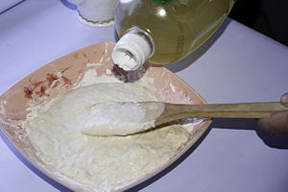
Recipe 1
Mix together:
2 1/2 cups flour
1-cup salt
1-cup water
Food coloring is optional.
Store in refrigerator.
Recipe 2
Mix and cook over low heat until mixture thickens:
1-cup salt
1-cup flour
1-cup water
Food coloring is optional.
Cool before using

Match the answers on the right to the clues on the left.
- A primary paint color a. Violet
- Genius Kit b. Design
- Arrangement of shapes or lines c. White
- A secondary paint color d. Blue
- Mixture of blue and yellow e. Construction
- Hanging shape f. Green
- Mixture of blue and red g. Orange
- Add this color to make a lighter hue h. Mobile

Arrow of Light Den

Readyman

Readyman Activities
The Boy Scout motto is “Be Prepared”.
In earning the Readyman Activity Badge, Webelos will get a head start on being prepared as a Boy Scout.
The Scout is always ready in mind and body to do his duty and to face danger, if necessary, to help other people. He learns first aid. He learns how to swim safely and how to ride his bicycle without danger to himself or others. He also learns how to make his home safer and the safety rules for passengers in the car.
Core Values
Compassion, Cooperation & Courage
Activities
- Ask a First Aid Merit Badge Counselor from a Scout Troop in your area to attend the meeting and explain the items in a first aid kit, or have him shoe what to do for “hurry cases.”
- Invite a Scout Troop to your meeting to show first aid for cuts and scratches, burns and scalds, and choking.
- Invite a police officer to speak on bicycle safety.
- Have a swim instructor go over the safe swim defense plan.
- Visit a fire station with an E.M.S. Unit.
- Visit a hospital E.R. or an Emergency Clinic.
Make Your Own First Aid Kit
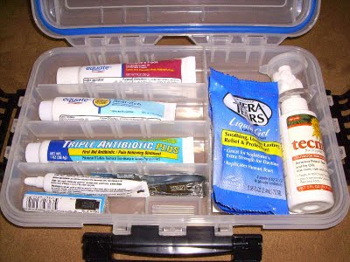
What to Include:
For open wounds, cuts, skinned knees, and scratches
- 1 box 12 adhesive compresses
- 3 sizes sterile bandages
- 3 sterile gauze squares
- A small bottle antiseptic
For blisters
- Adhesive compresses or gauze squares
- Narrow adhesive
For sprains
- 1 triangular bandage
- Small scissors
For burns, sunburn
- Tube burn ointment - 5%
For splinters
- Small tweezers
- Needle
- Matches to sterilize
For fainting
- Small bottle aromatic spirits of ammonia
For bites or stings
- Small box bicarbonate of soda
For toothache
- Small bottle oil of cloves
For plant poisoning
- Small bar yellow soap
Ideas for containers to use:
- A cigar box, a tin cracker or candy box - paint and decorate. Put a list of what-to-do inside the lid.
- Make a cloth case with a strap.
- A cloth kit with pockets. Fold over the top, roll up, and tie.
Kitchen Fire Extinguisher
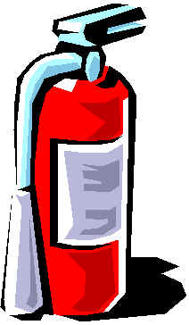
Materials:
- Glass bottle
- Red and black construction paper
- Funnel (optional)
- Baking soda
- Black marker, scissors, glue
Directions:
- Wash and dry the bottle.
- Cover the outside with red paper; glue ends.
- Draw extinguisher shape on front of bottle.
- Write the words with black marker.
- Fill the jar with baking soda (a funnel helps, if you have one).
- Place next to kitchen stove.
- If there should ever be a stove fire, pour the baking soda on the flames to put them out.
Home Fire Escape Plan
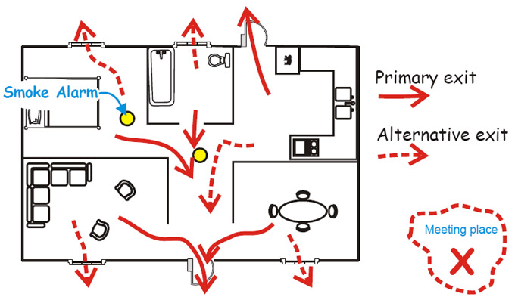
Copy and enlarge the following grid on a separate sheet of paper.

Use the grid above (or similar one you found or drew) to prepare your fire escape plan. Draw a floor plan of your home, including all windows and doors, and label each sleeping area. Indicate all working smoke alarms, which should be located on every floor of your home and outside of sleeping areas. Plan two routes of escape from every room and mark your family meeting spot, located safely away from your home. Post the escape plans on each level of your home and in locations where overnight guests and others can easily see it. Most importantly, practice your fire escape plan regularly, at least twice a year.
Games
Douse That Fire
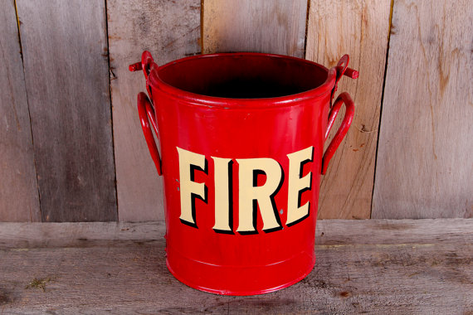
Each team has a pail with a candle stub in a holder on the bottom. Fill the bucket to two inches below the candle wick and light the candle. Divide the den into two teams and give each team a cp and a jar of water. On signal, the first player on each team fills his cup, runs to the bucket, and empties the water into it. He then runs back with his cup and the next player repeats the action. Continue until one team has doused its fire by filling the bucket to candlewick level. A team is disqualified if a player pours water on the candle flame.
Fire Hazard Hunt
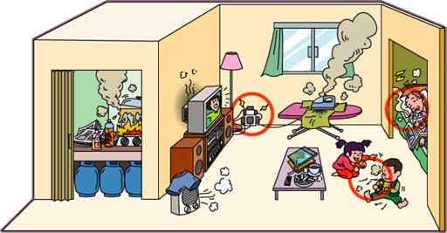
Prepare for this game by creating some fire hazards in and around your meeting place -- matches left carelessly within reach of children; outside door blocked by a chair, oily rags in a pile in the garage; grease spilled near stove burner, newspaper piled near furnace; fireplace screen away from fireplace; frayed electric cord, etc. Ask boys to find and list on paper as many hazards as they can find. At the end of the game, check findings and explain the hazards. Urge Webelos to check their own home.
Pressure Pad Relay
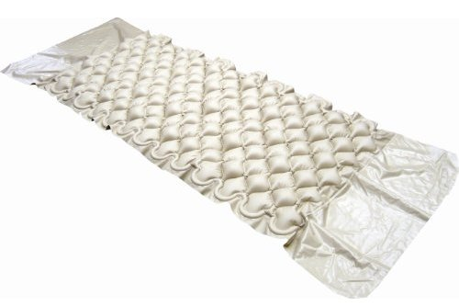
Equipment - Each boy using his own neckerchief.
Action:
- One boy lies about 30 feet in front of the team with arterial bleeding” of the left wrist.
- There is one judge for each victim.
- On signal, the first boy from each team runs up and applies a pressure pad over the simulated would.
- When correct, the judge yells “off’, the boy removes the pad and runs back to the team, tags off the next boy who repeats the operation.
What’s Wrong with Me?

- Write down several different accidents or afflictions. (Example: a broken leg, a nose bleed, choking, shock, etc...)
- Place these in a hat and have the boys draw them out one at a time.
- The boy that drew will have to act out that particular problem.
- The first boy to identify the problem must show how to treat it, he now gets to pick and act out an accident

ADDITIONAL ADVANCEMENT IDEAS
Alice, Golden Empire Council
These are additional ideas. Maybe your Cubs did some advancement in camp and you got to skip a section. Maybe your den is above average and streaking through the program. Maybe you want some ideas to tie into the Core Value of the month. Maybe your presenter or field trip for that week fell through and you need a Plan B. Here are ideas you can use!! CD and Alice
All the ideas in this section are based on the assigned Value for December - RESPECT.
The suggested advancement or elective ideas here are based on the Value of Respect, and those that fit with the suggested activities for Meeting #7 and #8 in the Den & Pack Resource Guide have been underlined.
Since the Value for December is RESPECT, every rank could work on any one of several Belt Loops and Pins – Disabilities Awareness, (respect for those who are different) Good Manners, (Showing respect for self and others by your behavior) Heritages or Language & Culture (showing respect for other cultures and ethnic groups). Respect for the environment is also a big part of the World Conservation Award and the Leave No Trace Award.
And of course, Sports Belt Loops should include Respect – both in showing good sportsmanship and in following the rules. Respect for safety rules is especially important, sometimes life-saving, in winter sports.

Tiger Achievements
Ach. #1F – Talk about how having chores helps us to show respect for yourself, your possessions, and other family members and their possession. Ach. #1D – As you work on a family scrapbook, you can gain new respect for your talents and those of family members.
Ach. #2D – As you practice the pledge and participate in flag ceremonies, you can show respect for country and flag.
Ach. #3D– Show respect for your body when you learn how to take keep healthy and safe, and get enough exercise.
Ach. #4F – Character Connection for Respect Have a good conversation at your family meal – talk about self respect, how to show respect for your family members, or share some stories like that of Rosa Parks. Ach. #4G – Take a field trip to a newspaper, radio or TV station - tell them you are learning about respect and ask if they can be ready to share their stories about Rosa Parks or other people who have demonstrated respect for themselves, others or the world.

Tiger Electives
Elect. #1 – Share with your den how your family celebrates the holidays – learn how other people have different ways of celebrating, and respect the differences.
Elect. #2 – Make some decorations for a celebration – you might choose a different culture and learn more about how they celebrate.
Elect. #5 – Make a family mobile, and focus on the talents and interests that make each one special, and worthy of respect.
Elect. #6 – Sing one of the songs about Respect. Elect. #8 – Get to know the people who lead or teach at your place of worship – talk about how to show them respect
Elect. #9 – Help a new girl or boy get to know other people – remember to treat them with respect
Elect. #18 – Learn to sew on a button, and practice other ways to take care of your clothing
Elective #20 – Write and perform a Public Service Announcement at Pack Night – it could be information about Rosa Parks and how she demonstrated respect for herself and others, or you could videotape a skit about her actions to show at the Pack Meeting.
Elect. #24 – One way to show respect is to help the adult who is preparing a family meal to set the table and clean up afterward-and to appreciate their work!
Elect. #26 – Practice good phone manners and always use them!
Elect. #33 – Show your respect for your home or your neighborhood by playing Cleanup Treasure Hunt.
Elect. #34 – Conserving electricity and water for a week shows your respect for the environment.
Elect. #37 – Take a bicycle ride with your adult partner – be sure to respect your body by wearing a helmet, and respect the environment by carrying out any trash.
Elect. #46 – Healthy teeth and gums, and regular visits to the dentist show you have respect for your body.
Elect. #47 – Reduce, reuse and recycle to show your respect for the environment.

Wolf Achievements
Ach. #2a,b,e, f, g – Always show respect for the flag when participating in a flag ceremony;
Ach.#2c – Tell how to respect the flag.
Ach. #3a,b,c – Show respect for your body by practicing good health habits
Ach. #7a- Character Connection for Respect; Ach. #7b-f – Show your respect for the world and your environment by completing these requirements.
Ach. #8a, b – Show your respect for your body by learning about the Food Guide Pyramid and using that information to plan good family meals
Ach. #9d, e – Show respect for your body by practicing good rules of street and bike safety. Ach. #10d – Read a book or article about another culture or the way they celebrate their holidays
Ach. #12 – as you study the different scenarios, talk about how respect for yourself or others would affect your answers

Wolf Electives
Elect. #1c – Learn to use American Sign Language – it will help you learn to be respectful of someone who uses ASL.
Elect. #1d – Use American Indian Sign Language to tell a story – this is a different kind of code than the Navajo Code Talkers used in WWII.
Elect. #2 – Participate in a skit about Respect.
Elect. #6c – Learn how to take care of books – to show you respect your possessions
Elect. #10 – You can study how American Indians showed respect for their environment as you do these requirements.
Elect. #11a,b – Learn to sing a patriotic song to show your respect for your country.
Elect. #13e – Feed wild birds – but show your respect for nature and the environment by continuing to feed bird while natural food is scarce.
Elect. #14a, c – To show respect for a pet, learn more about it from a book and share with your den; also, remember that every pet needs good care from an owner who loves and respects them.
Elect. #19d, e - When fishing, respect safety rules and laws where you live
Elect. #20b, d, e – Know and respect safety rules and courtesy codes when boating, skiing or ice skating – it not only shows you respect others, but also the dangers of winter sports.
Elect. #22e – Invite a boy to join Cub Scouts or complete his Bobcat – show him respect and be an example of respect to him.

Bear Achievements
Ach. #2 – As you learn more about your religious faith and those who lead it, your respect for both leaders and principles can grow.
Ach. #3a, b – Respect for your country and those who are or have improved our way of life will be strengthened as you learn more about them.
Ach. #3f, g, h, i – whenever you participate in a flag ceremony, remember to show your respect with your actions.
Ach. #5a, b – respect for animals can be shown by learning about them, and by being careful to build a bird feeder or birdhouse that will be appropriate for a particular species – these activities can also be used to earn the World Conservation Award – showing respect for our world and environment.
Ach. #6 – any of the requirements will show respect for our planet – the only one we have!
Ach. #7b, f – know how you can show respect for law enforcement by helping in safe ways.
Ach. #8g – Character Connection for Respect. Discuss with family the different ways we can show respect for ourselves, others, the environment. Ach. #8b – Be respectful as you talk to someone who was a Cub Scouter a long time ago – ask how they showed respect to their leader, parents, teachers and country when they were a Cub. Ach. #8d, e – Find out about your family history or community history – it will help you respect people who lived in different times.
Ach. #9a – Bake some cookies – National Cookie Day is on the 5th. Give them to someone you respect, such as a neighbor, or make a recipe that is honored in your family – a favorite made by Grandma, or another family member.
Ach. #9b, c, d – To show that you have respect for your body and health, make a healthy snack to share with the den or your family; Prepare part of your breakfast, lunch and dinner – make sure you clean up after yourself out of respect for your family cook; Make a list of junk foods and try to remember to eat more healthy choices to show respect for your body.
Ach. #10a – On a day or evening trip with your family, be courteous and use good manners
Ach. #11g – Courage Character Connection – it takes a lot of courage to insist on being shown respect – or to show respect to others. Learn about Rosa Parks and how she stood up for her right to be respected. Learn about the courage it took for people to carry out the bus boycott, for both the African Americans and those white people who gave rides to some of them.
Ach. #14a,f – Show respect by following all safety rules when riding a bike;
Ach. #14c, d, e – Show respect for your bike by learning to take care of it, and always protecting it from theft.
Ach. #15 – Remember to follow the rules and be a good sport when playing a game, to show you have self respect and respect for others.
Ach. #17a – While watching a TV show with an adult, watch for examples of respect or lack of respect.
Ach. #17d – When using a computer, respect family rules and rules you have been taught about internet safety
Ach. #19a, b, d – Show that you respect the rules of knife safety, and also that your know how to take care of a pocketknife.
Ach. #20a – Show how to use and take care of four tools and put them away properly
Ach. #23 - While playing or watching any sport, follow the rules and be a good sport to show your respect.
Ach. #24 – Whenever you are serving as a leader, show respect for yourself and others.

Bear Electives
Elect. #5 – Know and follow safety rules on the water and around boats – show respect for your environment and the possible dangers
Elect. #15- Learn how to take care of water and soil – use these activities as part of the Cub Scout World Conservation Award requirements.
Elect. #20 a, b, c – Follow the rules of safety and courtesy when participating in winter sports
Elect. #24 – Do any or all of these requirements as you learn how American Indians have shown respect for their environment and their country.

Webelos Den
Webelos Badge – While earning this badge, show respect by wearing the uniform properly, showing respect towards the flag at all times, and demonstrating respect for the Scout Oath and Scout Law.
Artist #9 – Art Construction – Make an art construction in honor of Joseph Cornell, and use it to show respect for nature, everyday objects or some other special subject, such as your family
Athlete #3, 4 – Show respect for yourself and your body by learning what you can do to stay healthy and by beginning physical workouts with stretching to protect your body.
Citizen #4, #8, #9. #12, #14 – Explain why you should respect the flag, and show how to do it; show respect by doing a service project that helps protect the environment; talk about a boy who is a good citizen – Tell how his actions show respect for himself, others, and his country; tell what you can do to show respect for the law and help law enforcement agencies.
Communicator #9, 10 – as you learn about another way to communicate, or using another language, be respectful to everyone – ask for ideas on how respect can be shown to those with other ways of communicating.
Communicator #11- #14 – As you use the internet, be sure to have respect for yourself and others; follow family and general rules of internet safety.
Craftsman #1 – Explain how to safely handle tools – respect the potential danger of ignoring safety rules.
Engineer #4 – Explore property lines with a civil engineer and learn how respect for property rights is maintained.
Family Member #5 – During family meetings, show respect for yourself and others, especially in what you say and how you say it.
Family Member #9, 10, 13 – Learn how to clean your home, take care of your clothes and dispose of trash and garbage – proper care of your possessions is part of being respectful.
Fitness # 5-#8 – Learn about and tell an adult why you should avoid tobacco, alcohol and drugs – and how avoiding such things can help encourage self-respect.
Handyman #2 - #10, #15 – Demonstrate respect for possessions by learning how to take care of them; clean and properly store hand tools or garden tools.
Naturalist #1 – Respect Character Connection.
Naturalist # 12, 13 – Clean up litter in your neighborhood to make it safer for animals; earn the Wildlife Conservation Belt Loop.
Outdoorsman #5, #6 – Discuss how to follow Leave No Trace; do an outdoor conservation project with your den or a Boy Scout troop.
Showman #2 – Write a puppet play about Respect.
Showman #16 – Give a monologue about Respect.
Sportsman #2 – Explain what good sportsmanship is.

Arrow of Light Den
Readyman #1 – Courage Connection; It can take courage to stand up for yourself and display self respect. And standing up for others and showing them respect can take even more courage, especially when your peers make someone the target of teasing or bullying.
Readyman #11 – Honor your family and help to keep them safe by helping to make a fire escape plan for your home – be sure everyone know two ways to get out of every room, and how to check before they open any door. Also help younger family members learn how to safely get down to clear air and leave safely if there is a fire.
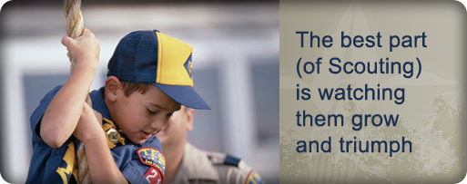

MORE GAMES AND ACTIVITIES
Wendy, Chief Seattle Council
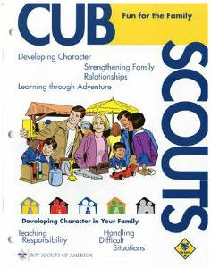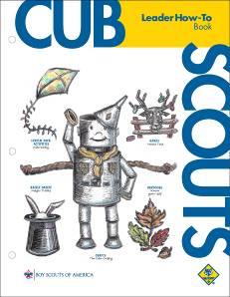
See Fun for the Family, No. 33012, for family activities related to this month’s core value, honesty.

Want to check something in the "How-To Book," and your copy is not available?? Want to copy something quick to use at a meeting?? You can find the "How-To Book" at this address on National's Web Site -
http://www.scouting.org/filestore/hispanic/english/33832_WEB.pdf

CUB GRUB
Cub Grub Cookbook
This is a really great cookbook for Cubs -
http://balboaoaks.bsa-la.org/download/blog/Cub%20Grub%20Cookbook.pdf -
You can save a copy on your PC by selecting
File, Save As... in your web browser's menu bar.
Cinnamon Nachos
2011-2012 CS RT Planning Guide
Ingredients:
Corn tortillas
Vegetable oil
Cinnamon
Sugar
Directions:
- Lightly brush both sides of corn tortillas with vegetable oil.
- Cut into six wedges and bake in a 400-degree oven for four to eight minutes.
- Remove from oven, and quickly drop into a paper bag to which you have added a cinnamon-sugar mixture.
- Close the top of the bag and shake gently to coat the nachos with the mixture.
- Serve and enjoy with the hot chocolate.
Caution: The tortilla chips are very hot when taken out of the oven! An adult should do this and put them into the bag.
Note: Be aware of food allergies and diet restrictions.
Cookies to Make for National Cookie Day
December 18:
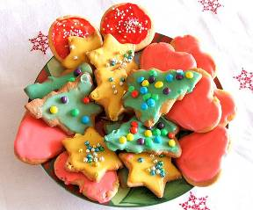
Thumbprint Cookies
Alice, Golden Empire Council
These were a big hit at RT!!
Ingredients:
1 c. butter
2 c. flour
1 tsp. vanilla
1/2 c. powdered sugar
3/4 c. quick oats
Strawberry or grape jam
1 tsp. vanilla
Directions
- Beat butter, sugar, vanilla until fluffy.
- Add flour, oats, mix well.
- Chill dough.
- Remove from refrigerator, form into 1 inch balls and place on baking sheet.
- Press thumb into center of each ball and fill with jam.
- Bake at 350 for 15 minutes.
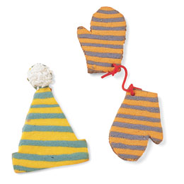Striped Dough:
Alice, Golden Empire Council
This colorful dough is perfect for the Hat & Mittens cookies. Divide the cookie dough in half and tint each a different color. Pat each half into a rectangle, about 5 by 7 inches, wrap in plastic, and refrigerate or freeze until firm. Roll each piece between two sheets of waxed paper to form rectangles that measure 8 by 11 inches and are about 1/4 inch thick.
Stack directly on top of each other. Using a sharp knife, cut the dough into strips about 1/2 inch wide. Turn each strip on its side with the stripes facing up. Place one strip near the end of a large piece of waxed paper. Press the next strip of dough parallel to the first strip, alternating the color. Place a piece of waxed paper on top of the stripes and roll over the top to make them adhere. Remove the top piece of paper and cut out shapes as desired.
Marbleized Dough: Lightly press together any scraps of the striped dough to achieve a marbleized look.
Easy Mexican Bunuelos
Alice, Golden Empire Council
There must be hundreds of recipes for bunuelos – but these are easy ones the boys can make during a den meeting for their snack.
- Use canned biscuits, cut them in half, then drop into hot oil and cook till both sides are golden.
- You can also cut small flour tortillas into quarters, drop them into hot oil and cook till slightly golden.
- Now toss your bunuelos in a paper bag or plastic sealable bag filled part way with cinnamon sugar. Another option is to just drizzle them with maple syrup or honey.
- Eat and enjoy!
Yule Log Cake
Alice, Golden Empire Council
The traditional Buche de Noel or Yule Log cake, is made by baking a cake in a jelly roll pan, frosting it, then carefully rolling it up into a “log.” Usually, a wedge is cut from one end and used to make a “knot” on one side, and the whole thing is frosted. Sometimes, meringue mushrooms are added. You can find recipes for this cake everywhere – but here are two easier versions the boys could help make.
- Make a regular cake mix, but bake in a loaf pan. Remove from pan, let cool thoroughly, then use a knife to round the top edges so you have a log shape. Cut one end at an angle to create a wedge shape – this can be added to one side to make the “knot” where a “branch” would have been. Now frost your cake and decorate with small plastic animals, such as squirrels, or add artificial leaves or berries along the bottom.
- The second version is made like a cheese log – purchase a log or trim cheese to a log shape – then “frost” with cream cheese and add decorations. Serve with crackers for a great snack.
Holly Jolly Dip
Alice, Golden Empire Council
Goes especially well with veggies.
Ingredients: 1 whole roasted red pepper (from a jar), 1 cup crumbled feta, 1 small clove garlic, 2 tablespoons olive oil
Instructions: Combine all the ingredients in a food processor. Pulse for 10 seconds, scrape down the sides, then repeat until combined, about 1 minute. Makes 3/4 cup.
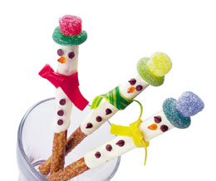Crunchy the Snowmen
Alice, Golden Empire Council
Bag of 8-inch pretzel rods, 1 cup white chocolate chips, mini chocolate chips, orange decorators' gel, fruit leather (various colors), gummy rings, gumdrops
Directions:
- Melt chocolate chips in the top of a double boiler. Dip one end of an 8-inch pretzel rod in the melted chocolate and use a plastic spoon or knife to spread the chocolate two thirds of the way down the rod.
- Set the pretzels on a sheet of waxed paper and press on mini chocolate chips for eyes and buttons. Use orange decorators' gel to add a carrot nose.
- When the chocolate has hardened, stand the pretzels in a mug or glass and tie on strips of fruit leather for scarves. For each hat, stretch a gummy ring over the narrow end of a gumdrop and secure it on the pretzel rod with a dab of melted chocolate.
White Marshmallow Snowflakes
Baltimore Area Council

Ingredients
18 small marshmallows,
1 large marshmallow,
9 toothpicks
Directions
- Break 3 toothpicks in half, leave other whole and
- Assemble snowflake as shown.
Baggie Fudge
Baltimore Area Council
Ingredients
1/4 oz cream cheese
2 tsp butter
1/3 C powdered sugar
2 tsp Cocoa powder
Directions
- Put all ingredients in a sandwich sized zipper bag.
- Allow Cubs to squish and squeeze it until all the lumps are gone and what is left inside looks like fudge.
Holly Jolly Fudge
Utah National Parks Council
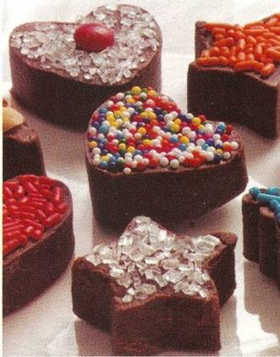
Ingredients:
3 Cups semisweet- or milk-chocolate chips
1 (14-oz) can sweetened condensed milk
1/8 teaspoon salt
1 teaspoon vanilla extract
Assorted sprinkles, sugars and candy decorations
Directions:
- Place the chocolate chips in a 2-quart bowl and microwave for 1 minute, then stir them with a wooden spoon. If the chips are not completely melted, microwave them again for 30 seconds, then stir until they’re smooth.
- Stir in the sweetened condensed milk, salt, and vanilla extract.
- Line a 9-inch square pan with aluminum foil, extending it about 2 inches beyond each side. (This makes it easy to remove the fudge later.) Lightly spray the foil with nonstick cooking spray.
- Spread the mixture evenly in the pan.
- Chill the fudge until firm, about 30 minutes in the freezer or 1 hour in the refrigerator.
- Lift the foil from the pan and place it on a flat work area. Use 1-inch cookie cutters to cut out the fudge, then lightly press decorations onto each piece. Makes about 50 pieces.
Christmas Trees
Utah National Parks Council
Ingredients:
3 Tbsp. butter
3 Cups miniature marshmallows
1/2 tsp. vanilla
1/2 tsp. green food coloring
4 Cups Cheerios
Sliced gumdrops
Toothpicks
Yellow/gold stars
Directions:
- Melt butter and marshmallows; stir often.
- Remove from heat,
- Add vanilla and food coloring.
- Fold in Cheerios.
- Cool.
- While cooling, make stars and slice gumdrops.
- Butter hands and shape 2/3 cup mixture into a tree and place on waxed paper.
- Add gumdrop slices.
- Put star on top with toothpick.
Peanutty Mice
Utah National Parks Council
Ingredients:
1/2 cup butter softened
1/2 cup creamy peanut butter
1/2 cup packed brown sugar
1 large egg
1 teaspoon vanilla extract
1 3/4 cups all-purpose flour
1 teaspoon baking soda
1/2 teaspoon salt
Peanut halves
Mini chocolate chips
Shoestring licorice
Directions:
- Cream the butter, peanut butter, and sugars.
- Beat in the egg and vanilla until fluffy.
- Sift together the flour, baking soda and salt, and stir into the wet mixture just to blend.
- Cover and chill until firm (about 1 hour).
- Shape level tablespoons of dough into balls.
- Pinch one end of the ball to form the pointed mouse nose.
- Then flatten the bottom and pinch sides to create a rounded back.
- Place the mice 2" apart on an ungreased cookie sheet.
- Push in peanut halves for ears and mini chocolate chips for eyes.
- Use a toothpick to make a small rounded hole for the tail.
- Bake in pre-heated 350 degree oven for 8-10 minutes or until firm.
- Cut the licorice into 3" long tails and insert while cookies are still warm.
- Makes 4-5 dozen.
Candy Menorah
Utah National Parks Council
Materials:
Styrofoam pieces for base
9 peppermint sticks
9 candy kisses
Directions:
- Cut a 1" square of foam and glue to center of foam base.
- Push four peppermint sticks into the foam to one side of the center.
- Push four peppermint sticks into the other side.
- Push the central peppermint stick into the center.
- On the first day of Hanukkah, "light" the Shamash and the first "candle" on the right.
To light each candle:
- Dab some frosting onto the top of the candy stick and attach a candy kiss.
- Candles are lit from right to left.
- On the eighth day, the edible parts of the menorah may be eaten in celebration of the holiday.
Penguin Treat
Utah National Parks Council
Ingredients:
1 1/2 Chocolate sandwich cookies
2 colored candies
3 pieces of candy corn
White frosting
Directions:
- Cut the cookie half in half (for wings).
- Divide the full cookie in half.
- Use the half without the white filling for the head, the half with the white filling for the body.
- Attach the eyes, beak, feet, and wings with the white frosting.
Reindeer Food—Birch Bark
Utah National Parks Council
Everyone knows that a reindeer’s favorite food is the tender bark of the birch tree in the early spring. So have your boys whip up a batch of birch bark to feed those reindeer on Christmas Eve.
Ingredients:
2 cups white chocolate
3/4 cup sliced, slivered or coarsely chopped almonds
Directions:
- Place 1 cup of white chocolate in a microwave-safe bowl and microwave on high for one minute.
- Remove and stir well.
- As the mixture cools, replace in microwave and turn on high for 30 seconds.
- Remove and stir.
- As the chocolate melts, add a few more pieces of white chocolate and stir.
- Replace in microwave and turn on high for 20 seconds.
- Continue to stir and add white chocolate.
- When smooth, add almonds and spread with spatula on waxed paper.
- Let harden and store in re-sealable bag with a header stapled to it reading: Birch bark. Save and leave out for Santa’s reindeer.
Seasoned Rice Mixes
Utah National Parks Council
Your cubs can do all the work for this quick, delicious mix. Package the mix in a jar, or Chinese take-out container. Add a homemade label listing the ingredients and a tag with the cooking directions.
Herbed Rice
Ingredients:
1 cup uncooked long-grain white rice
2 beef or vegetable bouillon cubes or two teaspoons powder
1 teaspoon dried green onion flakes
½ teaspoon each: dried rosemary, marjoram or oregano, and thyme leaves
½ teaspoon salt or celery salt
Curried Rice
Ingredients:
1 cup uncooked long-grain white rice
2 chicken or vegetable bouillon cubes
1-1/2 teaspoons curry powder
1 teaspoon dry minced onion
½ teaspoon ground cumin
½ teaspoon salt or celery salt
Instructions for Herbed or Curried Rice:
- In a large mixing bowl, stir all the ingredients for either herbed rice or curried rice and
- Pour into a sealable container.
- Place a tag with instructions on the bag
On the tag write:
- Combine the rice mixture with 2 cups cold water and 1 tablespoon butter or oil in a large saucepan.
- Cover and bring to a boil.
- Reduce heat to low, stir once and simmer about 17 -25 minutes, or until all the liquid is absorbed. Serves 4-6.
Cookies in a Jar
Utah National Parks Council
Ingredients:
¾ cup flour
½ tsp. cinnamon
½ cup raisins
1 tsp. baking soda
½ cup chopped walnuts (optional)
¾ cup brown sugar
½ tsp. salt
1 cup M&Ms candies
1 ¼ cup uncooked quick oats
Directions:
- In medium bowl, combine flour, baking soda, salt and cinnamon.
- In 1-quart clear glass jar with tight fitting lid, layer flour mixture, walnuts, ½ M&Ms and ½ oats.
- Next add layers of raisins and brown sugar and then the rest of the M&Ms and oats.
- Seal the jar.
- Wrap decorative ribbon around the neck of the jar.
Give away with these instructions:
- Preheat oven to 375 degrees.
- Cream ¾ cup of margarine, beat in 1 egg and 1 tsp. vanilla.
- Stir in cookie mix.
- Spoon out 2" apart on ungreased cookie sheets. Bake for 12 to14 minutes.

WEB SITES
And Other Resources
Holiday Festivals around the World:
- www.everythingesl.net/lessons/light_festivals.php lesson plans, summaries of festivals, their meaning, how they are celebrated, how to make your own materials
- www.santas.net/aroundtheworld.htm Check out by country how Christmas is celebrated; how to say Merry Christmas in many languages; links to other Christmas custom sites
- Hanukkah: www.akhlah.com/holidays/hanukkah/hanukkah.php history, meaning, foods, crafts, dances, all about Hanukkah for kids
- www.jewfaq.org/holiday0.htm billed as a “gentile’s guide” to Jewish holidays, games, etc. Good source if a family or leader wants to include Channukah as one of the holidays in a pack or den presentation.
- Diwali: http://wwwdiwalifestival.org/diwali-celebrations-around-the-world.html History, meaning, recipes, patterns, songs, cards
- Philippine Holiday Info: www.seasite.niu.edu/Tagalog/Cynthia/festivals/philippine_christmas.htm all about the customs, festivals, music, dances, crafts
- Christmas Craft Ideas: all kinds of simple crafts for all ages www.enchantedlearning.com/crafts/christmas
www.dltk-holidays.com/Xmas/crafts.html
Wendy, Chief Seattle Council
Kwanzaa Games:
http://ezinearticles.com/?Kwanzaa-Party-Games-Celebrating-in-Style-and-Fun&id=547556
Oware (Mancala): http://www.amazingmoms.com/htm/kwanzaa_owaregame.htm
Mancala (rules variation): http://www.sinasohn.com/crafts/mancala.htm
Diwali Games: http://www.activityvillage.co.uk/diwali.htm
http://www.anthro.uci.edu/html/Programs/Anthro_Money/Diwali.htm
Paragraph 5 talks about dice and card games
Hanukkah Games: http://www.preschooleducation.com/shanukkah.shtml
Latke Toss: http://www.theholidayzone.com/hanukkah/games.html
Tic Tac Dreidel:
http://www.jewishpeople.com/games/tic-tac-dreidel.html
Websites
Crafts & Activities
Wendy, Chief Seattle Council
Reindeer Hand Shadow: http://www.thebestkidsbooksite.com/craftdetails3.cfm?CraftID=1172
Shadow Puppets: http://familyfun.go.com/arts-and-crafts/sew/feature/famf19puppet/famf19puppet5.html
Giraffe Shadow Puppet: http://jas.familyfun.go.com/arts-and-crafts?page=CraftDisplay&craftid=11371
Alligator Shadow Puppet: http://jas.familyfun.go.com/arts-and-crafts?page=CraftDisplay&craftid=11372
Parrot Shadow Puppet: http://jas.familyfun.go.com/arts-and-crafts?page=CraftDisplay&craftid=11370
See-through Shadow Puppets: Cut puppets out of white paper. Decorate one side with markers. Lay the puppet on a paper towel. Dab oil on both sides of puppet with a paper towel; let soak in. With a clean paper towel, wipe the excess oil off puppet. Color a brad with permanent markers to match the puppet. Push the brad through the puppet. Open the brad slightly, and push a pencil between the 2 metal tabs to open them. Put the top of a flexible straw between the 2 tabs, and tape the straw to the tabs. Bend the straw. Hold the puppet next to the sheet to get the best see through effect
Diwali Door Hangings: http://www.crayola.com/lesson-plans/detail/diwali-doorway-lesson-plan/
http://diwali.best2india.com/diwalidoorhangings.html
Diwali Decorations: http://www.diwalimela.com/celebrations/crafts/
You could also glue sequins or beads to the diyas (clay pot candle holders).
Cupcake Liner Displays: Put tea lights in metallic paper cupcake liners, and float in water. Or, use dollar store silicon cupcake liners. Decorate with paint (metallic looks cool) and permanent markers.
Hanukkah Candle Suncatcher: http://www.amazingmoms.com/htm/holiday_hanukkah_crafts.htm#window_sparkler
Pillar Hanukkah candle: http://www.bhg.com/holidays/hanukkah/crafts/star-of-david-candle/
Painted Candle: http://jas.familyfun.go.com/arts-and-crafts?page=CraftDisplay&craftid=11335 Metallic paint would look nice on a dark candle.
Hanging Beaded Jar: http://jas.familyfun.go.com/arts-and-crafts?page=CraftDisplay&craftid=10646
Beaded Candle Jars: http://jas.familyfun.go.com/arts-and-crafts?page=CraftDisplay&craftid=10289
Candle Card: http://jas.familyfun.go.com/crafts?page=CraftDisplay&craftid=11895
Ice Candle Holder: http://jas.familyfun.go.com/arts-and-crafts?page=CraftDisplay&craftid=10748
From Steve Leth, Training Chair,
Books
- Den & Pack Meeting Resource Guide;
- Cub Scout How To Book;
- Boys’ Tiger, Wolf, Bear, Webelos Hand books;
- Cub Scout Leader Book;
- Cub Scout Ceremonies Book;
- Family Fun Magazine.
From Steve Leth, Training Chair,
White Horse District, Southern NJ Council
- www.Scouting.org - The BSA's main website. (By the way - BSA.ORG is actually the Business Software Alliance, a trade group that campaigns against computer software piracy.)
- www.ScoutStuff.org - The BSA National Supply Division
- www.snjscouting.org - Southern New Jersey Council
- www.USScouts.org - An independent treasure trove of Scouting information, including Baloo's Bugle.
- http://balboaoaks.bsa-la.org/download/blog/Cub%20Grub%20Cookbook.pdf - Source for the Cub Grub Cookbook. You can save a copy on your PC by selecting File, Save As... in your web browser's menu bar.
Journey to Excellence:
http://www.scouting.org/scoutsource/Awards/JourneyToExcellence.aspx
Games, Games, Games
If you search the web for group games, you can get hundreds of listings. Here are a few that I have found:
www.Boyscouttrail.com
They have a section for group games. You can search based on the age of the boys, the type of game, or by game name. They also have a listing of all the belt loops to help you play those games as well.
www.Funandgames.org
These games are geared toward kids. They have some of everything and are listed by categories. This site can help with group games as well as pre-openers. It is a database of games compiled by many people, so as you read the rules you can see different people’s style of writing.
www.Gameskidsplay.net
This site lists lots and lots of games. They have some in categories and others are just listed. They have a search engine as well. They are not listed by age so you will have to read the rules of the games to decide if they are right for your group. They do give variations for how to play many games.
www.Funattic.com
This site offers free game ideas as well as sells things for games. It seems to focus on products for disabled children. I haven’t purchased anything from them, but the game listing is organized and easy to understand. They have a newsletter you can subscribe to as well as a monthly game to play.
www.Macscouter.com
This site has what it calls two volumes of games in a PDF format. The first volume is for younger scouts and the second for older scouts. It is easy to navigate and find the type of game you are looking for. They even have a listing of games called Scouting Games by Baden-Powell; great fun all year long. This site has other information for basic cub scouting, as well.
Den & Pack Meeting Help:
Baloo’s Bugle: http://usscouts.org/bbugle.asp
Links to theme related publications:
http://www.scoutingthenet.com/Training/Roundtable/Handouts/11/
Crafts, Games, & Activities:
http://familyfun.go.com/
http://www.dltk-kids.com/scouts/index.htm
Crafts: www.makingfriends.com
Sports & Games: http://www.scoutingweb.com/scoutingweb/program/Games.htm

ONE LAST THING

Christmas Spirit &
the Gimme Pig
Ideas and Stories for the Scoutmaster’s Minute, BSA, 1956
I remember my Scoutmaster, Mr. Jack Bullis, Troop 227, North Bergen County Council (#350) of The Township of Washington, Bergen County, NJ, telling us this Scoutmaster's Minute as if it was yesterday. He was standing there in the gym of Washington School as we all stood and listened. The story and his presentation obviously impressed me.
If you deliver it well, maybe someone will be writing about you 50 years from now! Thank you, Mr. Bullis!! CD
There's a strange animal to be found in especially large numbers at this time of the year. It's called a "gimme pig." You can recognize it very easily. It will be saying something like this, "Gimme a bicycle. Gimme an electric train. Gimme a record player, Gimme a motor scooter. Gimme a pony."
(Okay, so it's a little dated - IPod, IPad. You can update it the popular toys of the current year)
Do you think you have ever seen any of these strange animals?
Surely you haven't seen one in this Scout room!
No Scout could possibly be a gimme pig.
A Scout is pledged to help other people at all times.
He wants to give - that's what he's thinking about.
A real Scout never thinks "gimme."
He thinks about the good he can do, the happiness he can bring to somebody else. Because, as you know, he puts other people ahead of himself.
He is thinking about other people especially at this time of the year.
What will you give this Christmas?
How much service to other people?
How much happiness to your family?
What will you give?
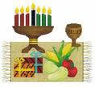

. 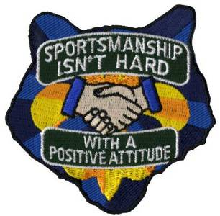
Next Month's Core Value -
POSITIVE ATTITUDE
And the supplemental pack meeting theme is
ABRACADABRA



